
PAPUA NEW GUINEA UNIVERSITY OF TECHNOLOGY
School of Business Studies
Bachelor of Business in Information Technology (BBIT 2)
IS223 Object-Oriented Programming – Major Project
Design and Development of an Online Shopping Mobile Application Using Java and Android Studio: CHM Lae Shop
Group member | Student ID
HEMBASUSE Brendon | 25530218
DAVID Danda | 25530352
BENBARA Moira | 24421302
MARTIN Anthon | 25530225
Lecturer: Raunu Gebo Sarsoruo
Submission date: Thursday, 1 October 2026
Academic Year 2026

Abstract
This project designed and developed CHM Lae Shop, a working Android prototype that lets customers of the CHM store at Top Town, Lae browse products, fill a shopping cart and place a simulated order from a smartphone. The app was built in Java with Android Studio and XML layouts, using CHM’s blue and white brand colours and real CHM product images and prices.
The application has eight screens: splash, home, categories, product list, product details, shopping cart, checkout and order confirmation. It holds 20 products across five categories: Mobile Phones, Computers & Laptops, Smartwatches, Music & Instruments and Home Appliances. Customers can search products, choose quantities, update or remove cart items, and see subtotals and a total in Kina.
The design demonstrates the core Java object-oriented programming concepts required by IS223. A parent class, Product, is extended by five child classes that override three methods. All products are stored in one ArrayList of Product references, which demonstrates polymorphism. Encapsulation, constructors, method overloading and collections are used throughout the Cart, CartItem, Customer and Order classes.
The Java classes were tested with 13 JUnit unit tests, all of which passed, and the Android application was tested in the emulator and on a physical HONOR phone using 24 functional, navigation, validation and calculation test cases. Checkout is clearly marked as a prototype and does not process real payments.

Table of Contents
Abstract 1
Table of Contents 1
1. Introduction 1
2. Problem Statement 1
3. Aim and Objectives 1
4. Target Users 1
5. Requirements Analysis 1
5.1 Functional requirements 1
5.2 Non-functional requirements 1
5.3 User requirements 1
5.4 Hardware requirements 1
5.5 Software requirements 1
6. System Design 1
6.1 Application architecture 1
6.2 Navigation 1
6.3 Interface design 1
7. UML Diagrams 1
7.1 Use case diagram 1
7.2 Class diagram 1
7.3 Activity diagram (placing an order) 1
8. Java OOP Implementation 1
8.1 Class, encapsulation and constructors 1
8.2 Inheritance and method overriding 1
8.3 Polymorphism and ArrayList 1
8.4 Cart methods and total calculation 1
9. Android Application Development 1
10. User Interface Design 1
11. Testing 1
11.1 Unit tests (Java classes) 1
11.2 Application tests (emulator and phone) 1
11.3 Issues found during development 1
12. Results 1
13. Challenges Encountered 1
14. Solutions 1
15. Conclusion 1
16. Recommendations 1
17. References 1
18. Appendices 1
Appendix A – Source code 1
Appendix B – Screenshots 1
Appendix C – Product catalogue 1
Appendix D – Setup and code guides 1

1. Introduction
CHM Lae Shop is a mobile shopping prototype built for the CHM store at Top Town, Lae, Morobe Province. It was developed for the IS223 Object Oriented Programming major project, which asks students to apply Java OOP concepts to a real business problem through an Android application.
CHM is a well-known PNG retailer of electronics, computers, phones, music equipment and home appliances. Its promotional material advertises products and prices, but customers still need to visit the store to check what is available, compare prices and buy.
This report explains the problem, the requirements, the system design and UML diagrams, how Java OOP concepts were implemented, how the Android interface was built, and how the application was tested. It ends with the challenges faced, how they were solved, and recommendations for future work.

2. Problem Statement
CHM Lae customers must visit the Top Town store to find products, check prices and prepare a purchase, and there is no mobile app that lets them do this from their phone.
The business. CHM (branded in its promotions as CHM Tech Haus, “proudly serving PNG for over 75 years”) sells mobile phones, laptops and desktops, smartwatches, musical instruments and home appliances. Its Lae branch serves customers across Lae city and the wider Morobe Province.
Current shopping process.
The customer sees a CHM promotion (social media post, flyer or in-store poster).
The customer travels to the store at Top Town.
The customer looks for the product, asks staff about specifications and price, and compares options.
The customer pays at the counter and takes the product home.
Problems with the current process.
Customers spend time and bus or taxi fare travelling to the store only to check prices or stock.
Promotions are spread across separate images, so customers cannot browse all products and prices in one place.
Customers cannot build a list of items and see the total cost before they visit.
Staff spend time answering the same price and specification questions.
How a mobile app helps. A shopping app gives customers one place to browse CHM products by category, see prices in Kina and specifications, build a cart with a running total, and send their details with an order. This saves customers time and travel, and helps CHM prepare orders before the customer arrives.

3. Aim and Objectives
Aim. To design and develop a functional Android online shopping application for CHM Lae using Java and Android Studio that demonstrates object-oriented programming concepts applied to a real business problem.
Objectives.
1: Analyse the requirements of an online shopping app for CHM Lae.
2: Design a clear, mobile-friendly interface in CHM’s blue and white colours.
3: Implement classes and objects for products, customers, the shopping cart and orders.
4: Use constructors and methods to create and work with these objects.
5: Demonstrate inheritance with a Product parent class and five child classes.
6: Demonstrate method overriding in every child class.
7: Demonstrate polymorphism using an ArrayList of Product references.
8: Build a working shopping cart that calculates subtotals and the total in Kina.
9: Build the Android interface with XML layouts and connect it to Java with event handling.
10: Validate customer input at checkout and clearly mark checkout as a prototype.
11: Test the classes and the application, and document the design, implementation and results.

4. Target Users
The main users are CHM Lae customers who own an Android smartphone and want to check products and prices before visiting the store.
User group | Needs from the app
Students (e.g. PNG Unitech, Lae schools) | Affordable phones, laptops and smartwatches; compare prices quickly
Working adults and families in Lae | Home appliances and electronics; see the total before travelling to Top Town
Small businesses and offices | Desktops, laptops and printer bundles; prepare an order for several items
Musicians and church groups | Keyboards and guitars with included accessories
Customers outside Lae city (Morobe Province) | Browse and prepare an order without an unnecessary trip
Users are expected to have basic smartphone skills, so the interface uses large buttons, clear labels, product photos and simple English.

5. Requirements Analysis

5.1 Functional requirements
ID | Requirement | Implemented in
FR1 | Show a splash screen, then a home screen with business name, image, welcome message and navigation | SplashActivity, MainActivity
FR2 | Display product categories with an image and product count | CategoriesActivity
FR3 | Display products with name, price, category and image | ProductListActivity
FR4 | Search products by name or brand | ProductListActivity
FR5 | Show product details and specifications, and let the customer choose a quantity | ProductDetailsActivity
FR6 | Add a product to the cart from the list or the details screen | Cart.addProduct()
FR7 | Show cart items with price, quantity, subtotal and total | CartActivity
FR8 | Increase, decrease or remove items and clear the cart | Cart methods, CartAdapter
FR9 | Collect customer name, phone number and delivery location with validation | CheckoutActivity, Customer
FR10 | Show an order summary and create a simulated order | Cart.checkout(), Order
FR11 | Show an order confirmation with order number and summary | OrderConfirmationActivity

5.2 Non-functional requirements
- Usability: large touch targets (at least 44 dp), readable fonts, consistent blue header on every screen.
- Performance: screens open without noticeable delay; product data is loaded once and reused.
- Reliability: invalid input (negative prices, zero quantity, empty checkout fields) is rejected without crashing.
- Maintainability: code is split into model, data, adapters and activities packages; text is kept in strings.xml.
- Honesty: checkout and confirmation screens state that no real payment is processed.

5.3 User requirements
Customers must be able to open the app, browse categories, find a product, see its price, add it to a cart, see the total, enter their details and receive an order number, all without training.

5.4 Hardware requirements
Item | Minimum
Development computer | 64-bit, 8 GB RAM (16 GB recommended), 10 GB free disk space
Test device | Android phone with Android 7.0 (API 24) or newer, or the Android Emulator

5.5 Software requirements
Software | Purpose
Android Studio | Development environment
Java (JDK bundled with Android Studio) | Programming language
Android SDK, min API 24 | Android libraries
AndroidX AppCompat, Material Components, Activity | UI components and theme
JUnit 4 | Unit testing
Git and GitHub | Version control

6. System Design
The app separates business logic (plain Java classes) from the Android screens, so the OOP classes can be tested on their own and reused by every screen.

6.1 Application architecture
Package | Classes | Role
model | Product, Smartphone, Computer, Smartwatch, MusicalInstrument, HomeAppliance, Cart, CartItem, Customer, Order, Category | OOP business classes; plain Java with no Android code
data | ProductCatalog, ShopSession | Creates the 20 product objects; holds one shared Cart and the last Order
adapters | CategoryAdapter, ProductAdapter, CartAdapter | Turn lists of objects into rows on screen
activities | BaseActivity + 8 screen classes | Load XML layouts, handle events and navigation
res | layouts, drawables, colours, strings, themes | XML interface, product images and CHM colours
Data flows one way: an Activity asks ProductCatalog or ShopSession for objects, shows them through an adapter, and calls Cart methods when the user taps a button. The Cart then updates its ArrayList and recalculates the total.

6.2 Navigation
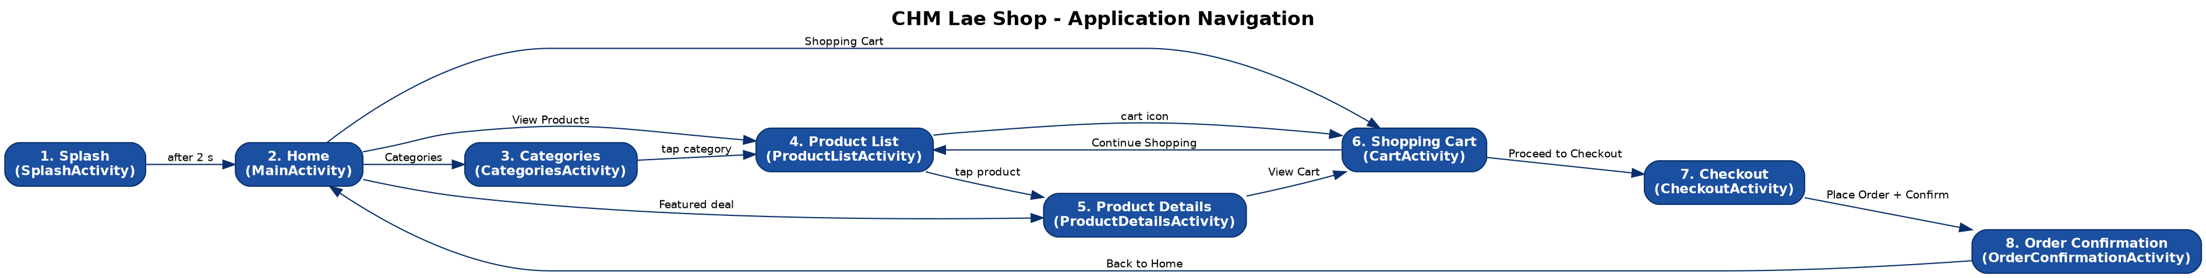
Figure 1: Application navigation diagram
The customer always enters through the splash and home screens. Products can be reached through Categories, View Products or a featured deal, and the cart icon in the header is available from every browsing screen. After an order is confirmed the app returns to Home and the cart is empty.

6.3 Interface design
Every screen follows the same layout: a blue header bar (back arrow, screen title, cart icon with item count), a light content area, and full-width buttons for the main action. Screenshots of each screen are in Appendix B.

7. UML Diagrams

7.1 Use case diagram
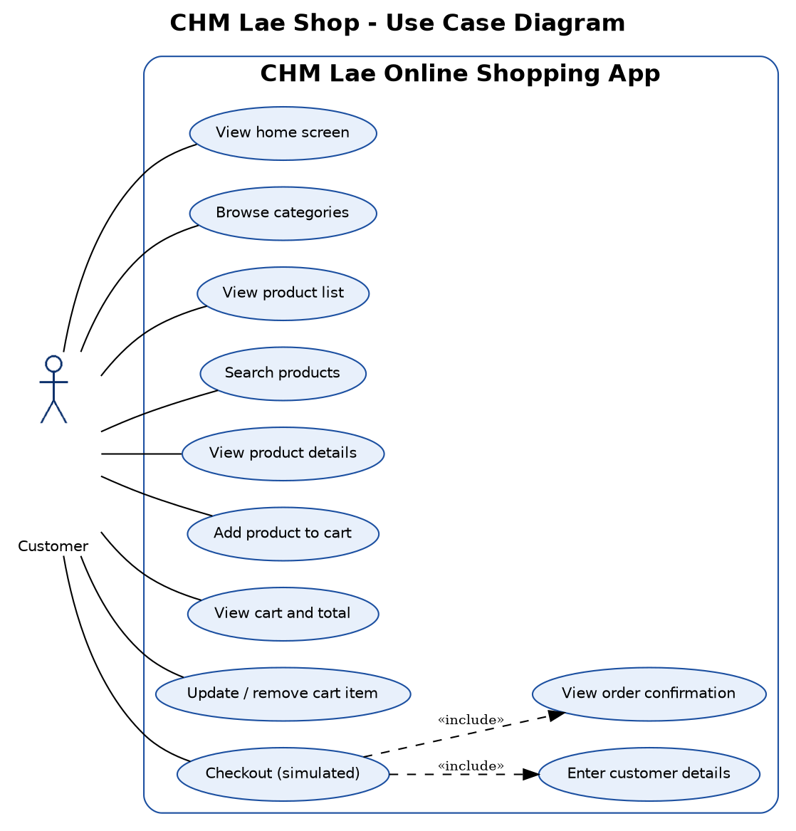
Figure 2: Use case diagram
The customer is the only actor. Checkout always includes entering customer details and viewing the order confirmation.

7.2 Class diagram
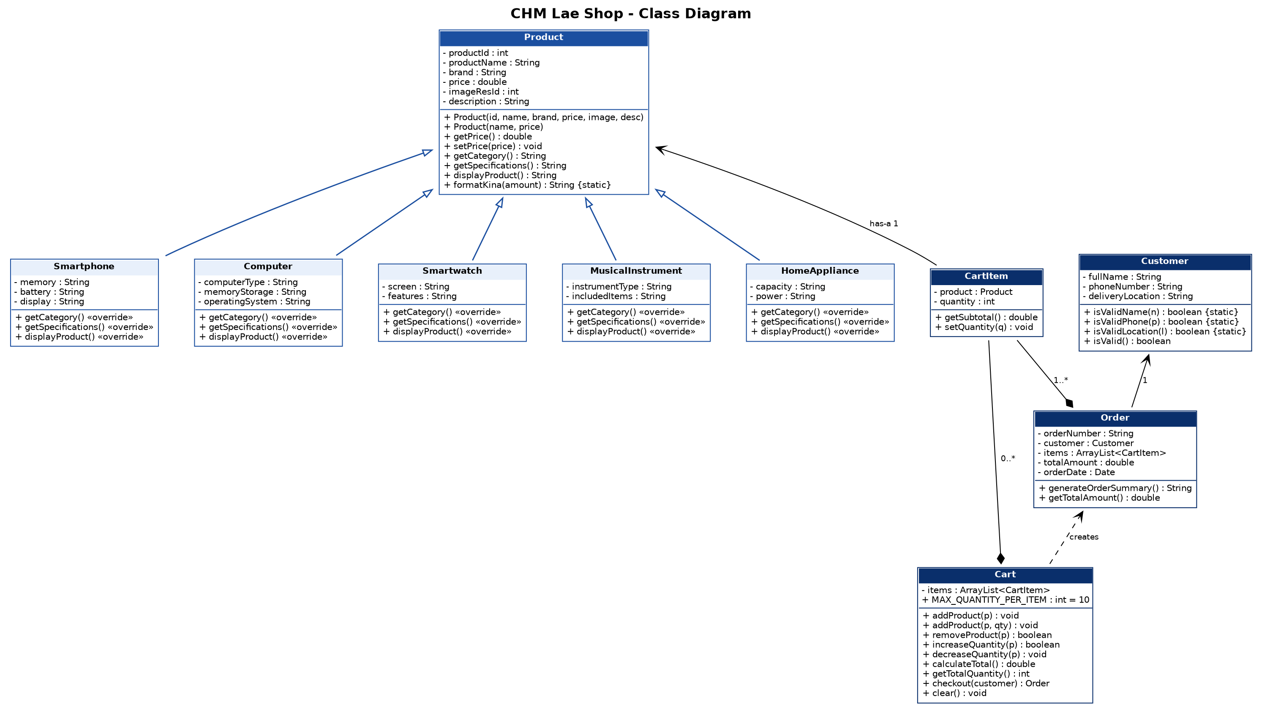
Figure 3: Class diagram
Product is the parent class; the five child classes inherit from it (hollow arrows) and override getCategory(), getSpecifications() and displayProduct(). A Cart is made up of CartItems, each CartItem has one Product, and Cart.checkout() creates an Order that holds a Customer and copies of the CartItems.

7.3 Activity diagram (placing an order)
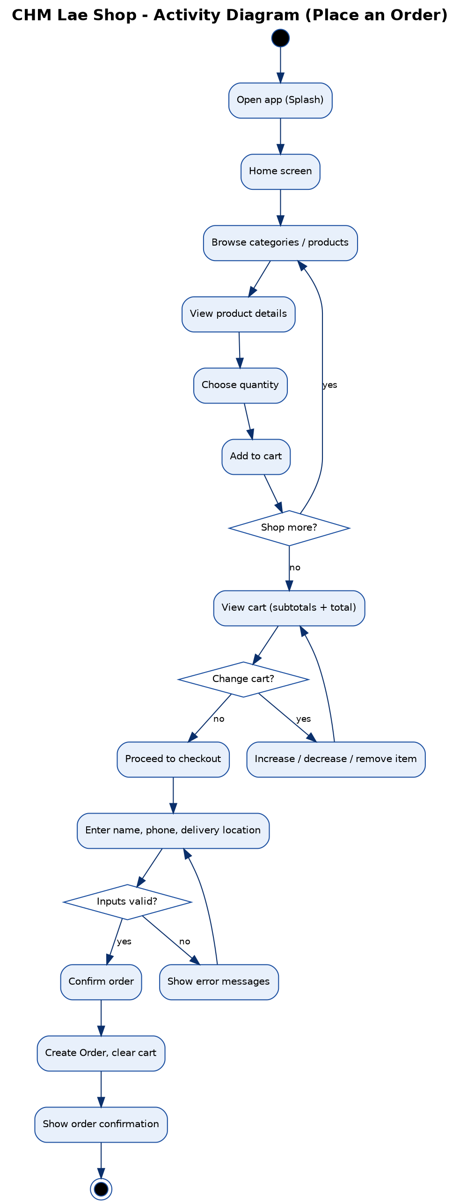
Figure 4: Activity diagram
The customer can loop back to shop more, change the cart, or correct invalid checkout details before the order is created.

8. Java OOP Implementation
All required OOP concepts are implemented in the model package and used by the Android screens.
Concept | Where it is used
Classes | 11 model classes: Product, Smartphone, Computer, Smartwatch, MusicalInstrument, HomeAppliance, Cart, CartItem, Customer, Order, Category
Objects | 20 product objects in ProductCatalog; Customer and Order objects at checkout
Constructors | Full and short Product constructors; child constructors call super(…)
Methods | addProduct(), removeProduct(), calculateTotal(), displayProduct(), checkout(), generateOrderSummary()
Encapsulation | Private fields with getters; setPrice() rejects negative values; getItems() returns a read-only list
Inheritance | 5 child classes extend Product; every screen extends BaseActivity
Method overriding | getCategory(), getSpecifications(), displayProduct() in every child
Polymorphism | ArrayList<Product> holding all child types; overridden methods called through Product references
Overloading | addProduct(Product) and addProduct(Product, int)
Collections | ArrayList in Cart, Order and ProductCatalog

8.1 Class, encapsulation and constructors
public class Product {
private int productId;
private String productName;
private String brand;
private double price;
private int imageResId;
private String description;
public Product(int productId, String productName, String brand,
double price, int imageResId, String description) {
this.productId = productId;
this.productName = productName;
this.brand = brand;
this.price = validatePrice(price);
this.imageResId = imageResId;
this.description = description;
}
public Product(String productName, double price) { // overloaded
this(0, productName, "CHM", price, 0, "");
}
public void setPrice(double price) {
this.price = validatePrice(price); // a price can never be negative
}
}

8.2 Inheritance and method overriding
public class Smartphone extends Product {
private String memory;
private String battery;
private String display;
public Smartphone(int productId, String productName, String brand, double price,
int imageResId, String description,
String memory, String battery, String display) {
super(productId, productName, brand, price, imageResId, description);
this.memory = memory;
this.battery = battery;
this.display = display;
}
@Override
public String getCategory() {
return CATEGORY; // "Mobile Phones"
}
@Override
public String displayProduct() {
return "Phone: " + getProductName() + " - " + getFormattedPrice();
}
}
The parent’s displayProduct() returns only the name and price. Each child overrides it to add its own label, and overrides getSpecifications() to list the details that matter for that kind of product (battery for phones, operating system for computers, capacity and power for appliances).

8.3 Polymorphism and ArrayList
ArrayList<Product> products = ProductCatalog.getAllProducts();
for (Product product : products) {
Log.i("CHM_OOP", product.displayProduct());
}
The list holds Smartphone, Computer, Smartwatch, MusicalInstrument and HomeAppliance objects under one Product type. At runtime Java runs each object’s own overridden method, so every line in Logcat starts with a different label. The same idea filters products by category and fills the product list and details screens.

8.4 Cart methods and total calculation
public double calculateTotal() {
double total = 0;
for (CartItem item : items) {
total += item.getSubtotal(); // price x quantity
}
return total;
}
public Order checkout(Customer customer) {
if (isEmpty()) {
throw new IllegalStateException("Cannot checkout an empty cart");
}
Order order = new Order(customer, items);
clear();
return order;
}
Adding a product already in the cart increases its quantity instead of creating a new row, and each item is limited to 10 units.

9. Android Application Development
The Java classes were written and tested first, then connected to eight Android screens (Activities) built with XML layouts.
Screen | Activity | Main Android elements
1. Splash | SplashActivity | Handler with a 2-second delay, then Intent to Home
2. Home | MainActivity | Store image, welcome text, 3 Buttons, featured-deal cards
3. Categories | CategoriesActivity | ListView + CategoryAdapter; item click opens product list
4. Product List | ProductListActivity | EditText search with TextWatcher, ListView + ProductAdapter
5. Product Details | ProductDetailsActivity | ImageView, specifications, quantity +/− Buttons
6. Shopping Cart | CartActivity | ListView + CartAdapter, totals panel, AlertDialog to clear
7. Checkout | CheckoutActivity | EditTexts with setError validation, confirmation dialog
8. Order Confirmation | OrderConfirmationActivity | Order details, Back to Home, back-button handling
How Java connects to the XML interface.
1: set Content View (R. layout. activity _ cart) loads a screen’s XML layout.
2: find View by Id (R.id. tvCartTotal) gets a view so Java can read or change it.
3: set On Click Listener (v -> …) runs code when the user taps (event handling).
1: new Intent (this, CartActivity.class) with start Activity () opens another screen; putExtra() passes the product id or category name.
2: Adapters inflate item layouts (item_product.xml, item_cart.xml) and fill them from each object’s getters.
Shared behaviour through inheritance. Every screen extends BaseActivity, which extends AppCompatActivity. BaseActivity sets up the blue header, back button, cart badge and spacing around the phone’s status and navigation bars, so this code is written once.
Shared data. ShopSession holds one Cart object for the whole app, so an item added on the product list is visible on the cart and checkout screens.

10. User Interface Design
The interface uses CHM’s own blue and white so customers recognise the brand immediately.
Colour | Hex | Used for
CHM blue | #1B4FA0 | Header bar, main buttons, prices
Dark blue | #0A2F6B | Headings, subtotals
Light blue | #E8F0FB | Category tags, prototype notice
White | #FFFFFF | Cards, product image backgrounds, button text
Error red | #C62828 | Remove and clear buttons, validation errors
Design choices against the brief’s UI requirements.
- Readable fonts: body text 14–16 sp, headings 18–26 sp, prices bold in blue.
- Appropriate buttons: main actions are full-width and 56–60 dp tall; secondary actions use outlined buttons.
- Clear navigation: the same blue header on every screen with a back arrow, title and cart icon showing the item count.
- Product images: real CHM promotional images on the product list, details, cart and featured cards, shown uncropped.
- Consistent layout and spacing: rounded white cards on a light background with 12–16 dp spacing.
- Error messages: checkout fields show a message beside each invalid field; empty cart and empty search results show helpful messages.
- Mobile-first: portrait layouts that scroll, and content that stays clear of the status bar, navigation bar and keyboard.

11. Testing
Testing was done in two stages: the Java classes were unit tested with JUnit before Android integration, then the full app was tested in the Android Emulator and on a physical HONOR phone.

11.1 Unit tests (Java classes)
All 13 JUnit tests in CartUnitTest passed.
No. | JUnit test | Expected result | Result
U1 | addProduct_addsItemToCart | Cart has 1 item | Pass
U2 | addSameProductTwice_increasesQuantityNotRows | 1 row, quantity 3 | Pass
U3 | calculateTotal_isCorrect | K5,894.00 | Pass
U4 | subtotal_isPriceTimesQuantity | 4 × K99 = K396.00 | Pass
U5 | quantityIsCappedAtMaximum | Quantity stops at 10 | Pass
U6 | decreaseToZero_removesProduct | Cart empty | Pass
U7 | removeProduct_removesRow | Total K4,699.00 | Pass
U8 | polymorphism_overriddenMethodsRun | Each child returns its own category | Pass
U9 | parentClassDefaultBehaviour | Product returns “General” | Pass
U10 | negativePrice_isRejected | IllegalArgumentException | Pass
U11 | customerValidation | Valid and invalid inputs detected | Pass
U12 | checkout_createsOrderAndEmptiesCart | Order total K997.00, cart empty | Pass
U13 | checkoutEmptyCart_throws | IllegalStateException | Pass

11.2 Application tests (emulator and phone)
These cover functional, interface, navigation, input validation, shopping cart and calculation testing. Write Pass or Fail in the Status column after testing.
No. | Test case | Expected result | Status
1 | Launch application | Splash shows, then Home after 2 s
2 | Home screen content | CHM Lae name, store image, welcome message, 3 buttons, featured deals
3 | Select Products | Product list with 20 products
4 | Open categories | 5 categories with images and counts
5 | Select Mobile Phones | Only 6 phones displayed
6 | Search “hifuture” | Only 3 HiFuture watches shown
7 | Search with no match (“zzz”) | “No products match your search.”
8 | Open Samsung Galaxy A06 | Image, name, K449.00 and specifications shown
9 | Quantity + twice | Quantity 3, subtotal K1,347.00
10 | Add to cart from details | Toast shown, header badge shows 3
11 | Add to cart from list | Toast shown, badge increases by 1
12 | View cart | Products, prices, quantities and subtotals shown
13 | Calculate total (3 × A06 + 1 × HiFuture Ultra 3) | Total K1,576.00
14 | Increase / decrease in cart | Quantity, subtotal and total update
15 | Remove item | Item removed, total updates
16 | Maximum quantity | + button disabled at 10
17 | Clear cart | Empty cart message shown
18 | Checkout | Checkout screen with prototype notice and summary
19 | Place order with empty fields | Error message on each field
20 | Invalid phone (12345) | “Enter a valid PNG number” error
21 | Submit valid order | Order confirmation with order number
22 | Cart cleared after order | Home cart button shows no count
23 | Back button on confirmation | Returns to Home, not checkout
24 | Polymorphism in Logcat (filter CHM_OOP) | 20 lines, each with its own label

11.3 Issues found during development
Bug | Cause | Fix
Build failed: “resource style/CHM not found” | Android treats a style named CHM.Label as a child of a style called CHM, which did not exist | Added parent=“” to the CHM.SectionTitle, CHM.Label and CHM.Input styles in themes.xml
Polymorphism output did not appear in Logcat on the HONOR test phone | HONOR/Huawei phones hide debug-level (Log.d) messages | Changed Log.d to Log.i in MainActivity so the lines show on all devices
Header and buttons drawn under the phone’s status bar on newer Android versions | Android 15+ draws apps edge to edge | BaseActivity adds padding for the system bars and keyboard
Tapping a list row did nothing when it contained an Add button | The button took focus from the row | Row clicks handled on the card; buttons set to not focusable
Adding the same product twice created two cart rows | New CartItem created every time | addProduct() now finds the existing item and increases its quantity
Customer could press back from confirmation into an empty checkout | Checkout stayed in the back stack | Checkout closes itself; back on confirmation returns to Home

12. Results
The project delivered a working CHM Lae shopping prototype that meets every minimum functional requirement and OOP requirement in the project brief.
Brief requirement | Result
Home screen with name, image, welcome message and navigation | Done, plus featured deals and a visit-the-store card
Product categories | 5 categories with images and product counts
Product list with name, price, category and image | 20 CHM products with real images and Kina prices
Product selection and add to cart | From the list (1 unit) or details screen (chosen quantity)
Shopping cart with prices, quantity, subtotal and total | Done, with +/−, remove and clear
Simulated checkout with customer details and order summary | Done, with validation, confirmation dialog and prototype notice
Suggested 8 screens | All 8 implemented
Classes, objects, constructors, methods, encapsulation | 11 model classes
Inheritance and method overriding | 5 child classes, 3 overridden methods each
Polymorphism and ArrayList | ArrayList<Product> used for filtering, display and totals
Extension features added: product search, product quantity, remove from cart, clear cart, maximum quantity rule, input validation, featured deals and unit tests.
Deliverables: Android source code and XML layouts, UML diagrams, testing report, README, setup guide, code guide, screenshots, APK file and presentation slides.

13. Challenges Encountered
1: Getting real product data. CHM does not publish a product list; prices and specifications only appear on separate promotional images.
2: Keeping business logic separate from Android. Early designs mixed cart calculations into the screens, which made them hard to test.
3: Sharing one cart across screens. Each Activity is a separate object, so items added on one screen were not visible on another.
4: Buttons inside list rows. An Add to Cart button inside a ListView row stopped the row itself from responding to taps.
5: Newer Android versions. Android 15 and later draw apps edge to edge, so the header was hidden under the status bar.
6: Validating PNG phone numbers. Customers may type numbers with spaces or a +675-country code.
7: Build and device issues. A style naming error stopped the first build, and the HONOR test phone hid the debug log output.

14. Solutions
1: Product names, prices and specifications were typed in only from what appears on each CHM image. Images without a CHM price, and one image from another retailer, were not used.
2: All business logic was placed in plain Java classes in the model package and tested with JUnit before connecting them to the screens.
3: A Shop Session class holds one Cart object that every screen uses.
4: Row taps are handled on the card, and the buttons inside rows are set not to take focus.
5: Base Activity adds padding for the status bar, navigation bar and keyboard on every screen.
6: Customer. Is Valid Phone () removes spaces and dashes, accepts an optional +675, then checks for 7 digits (landline) or 8 digits (mobile).
7: The style error was fixed by adding parent= “” to the CHM styles, and Log.d was changed to Log.i so the output shows on HONOR phones.

15. Conclusion
CHM Lae Shop shows how a Lae retailer could let customers browse products, build a cart and prepare an order from their phone instead of travelling to the store first. The project met its aim: a functional Android application built with Java and Android Studio that applies object-oriented programming to a real business problem.
The project also showed why OOP matters in practice. Inheritance let five product types share one Product class, overriding let each type describe itself, and polymorphism let the cart, search and product screens treat every product the same way. Keeping this logic in plain Java classes made it possible to test the cart calculations with JUnit before building the interface.
The chain the brief describes, from Java OOP concepts to application logic to the Android interface, is visible throughout the code.

16. Recommendations
1: Store data in a database. Move products and orders to a local SQLite/Room database or Firebase so the cart and order history survive when the app is closed.
2: Staff product management. Add an administrator screen so CHM staff can add products, update prices and mark items out of stock.
3: Customer accounts and order history. Let customers register, log in and see past orders.
4: Delivery and pickup options. Offer store pickup at Top Town or delivery within Lae, with delivery fees.
5: Real payments (future production version). Integrate a secure mobile payment service only after proper security review; the prototype must keep simulated payments.
6: Wider testing. Test on several real Android phones common in PNG, including low-memory devices, and collect feedback from CHM customers.

17. References
- Android Developers. (n.d.). Activities, Layouts and Display content edge-to-edge. Google. https://developer.android.com/guide
- Google. (n.d.). Material Components for Android and Material Icons (Apache License 2.0). https://m3.material.io
- Oracle. (n.d.). The Java Tutorials: Object-Oriented Programming Concepts. https://docs.oracle.com/javase/tutorial/java/concepts/
- JUnit. (n.d.). JUnit 4 documentation. https://junit.org/junit4/
- Sarsoruo, R. G. (2026). IS223 Major Project Description Guide: Online Shopping Mobile Application. PNG University of Technology.
- CHM. (n.d.). Promotional images for CHM Tech Haus products and prices (used for academic purposes only).
- Anthropic. (2026). Claude [AI assistant]. Used to help generate code, diagrams and a draft of this report; all content was reviewed, tested and explained by the group.

18. Appendices

Appendix A – Source code
GitHub repository: [add link]
Main folders: app/src/main/java/com/chm/laeshop (model, data, adapters, activities) and app/src/main/res (layouts, drawables, values).

Appendix B – Screenshots
The screenshots below were taken on a physical HONOR Android phone running the CHM Lae Shop app. They follow one complete shopping journey, from opening the app to the order confirmation.
  Figure 5: Splash screen | 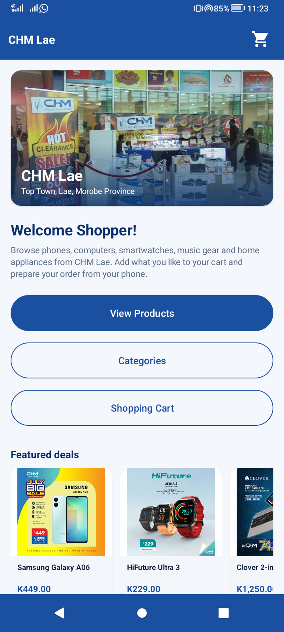  Figure 6: Home screen | 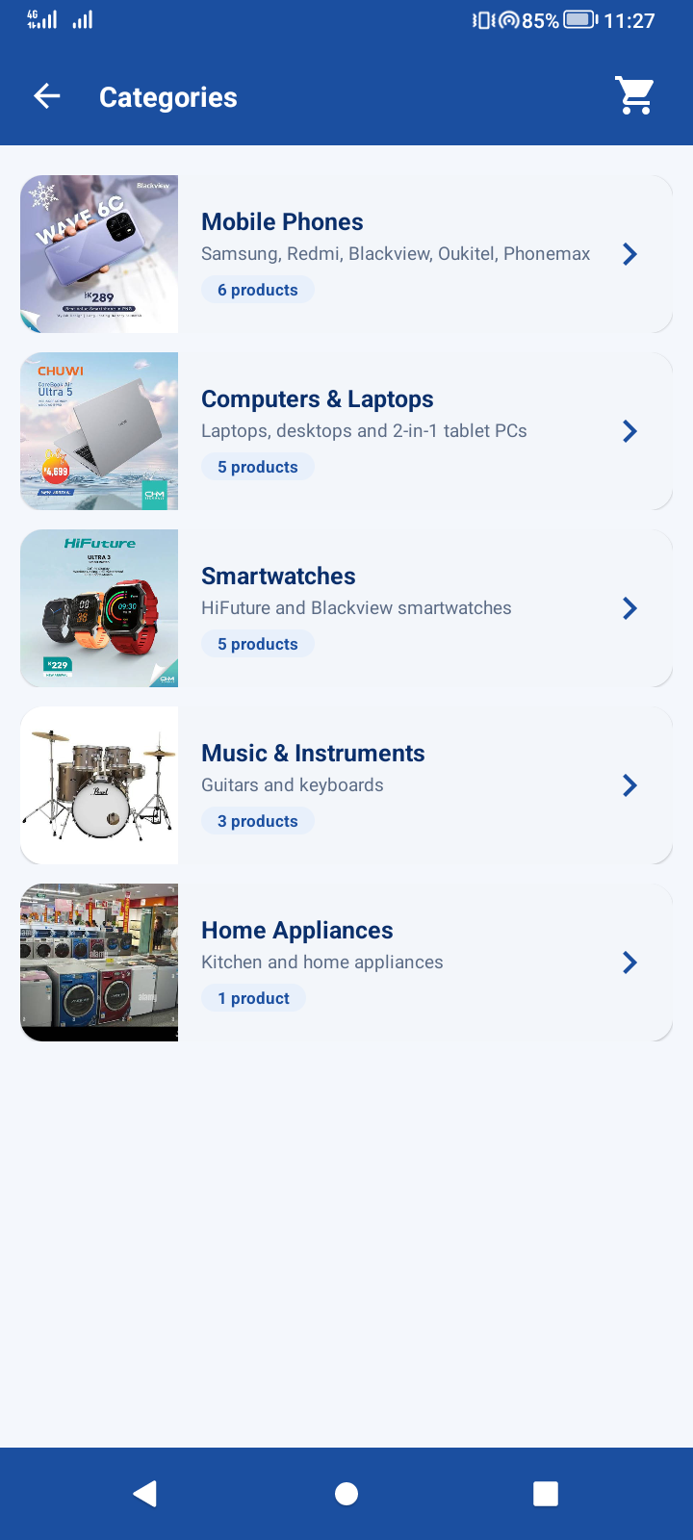  Figure 7: Product categories

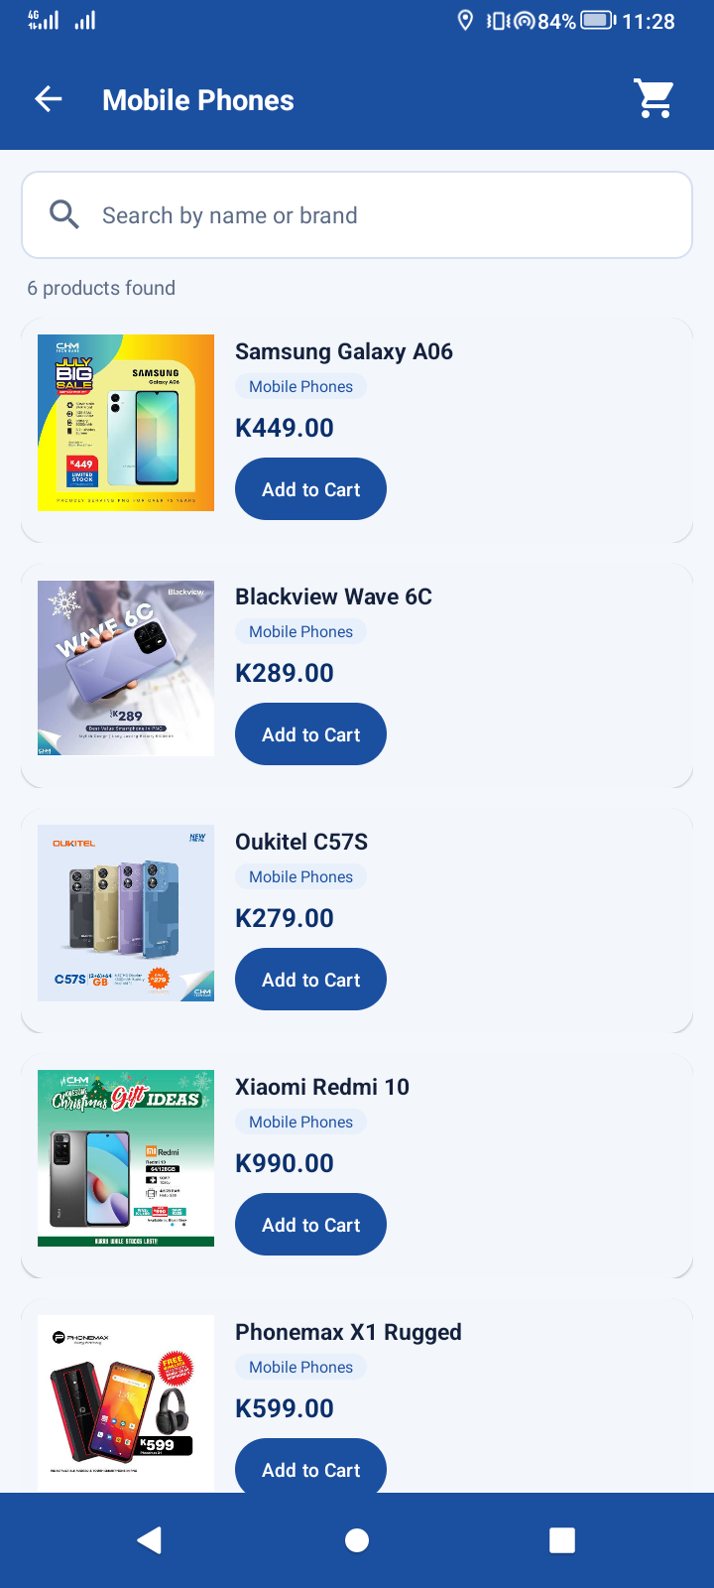  Figure 8: Product list: Mobile Phones | 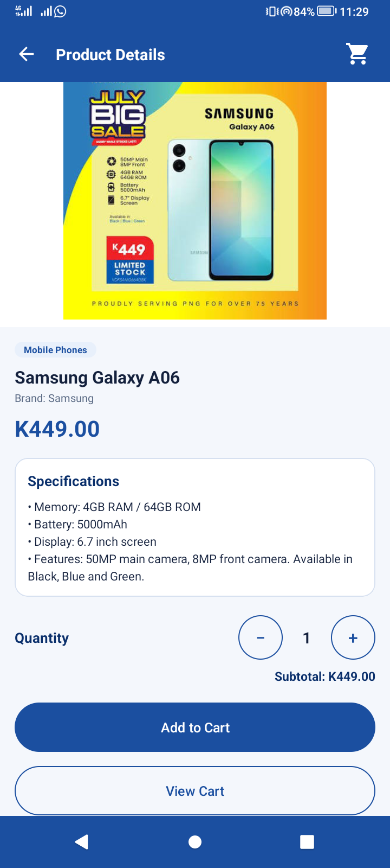  Figure 9: Product details: Samsung Galaxy A06 | 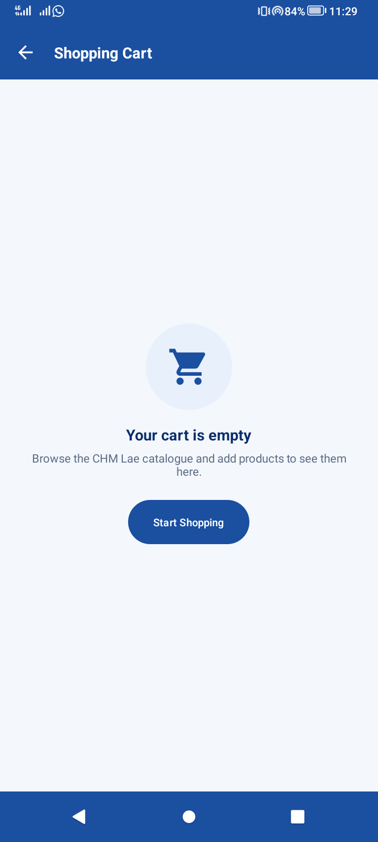  Figure 10: Empty shopping cart

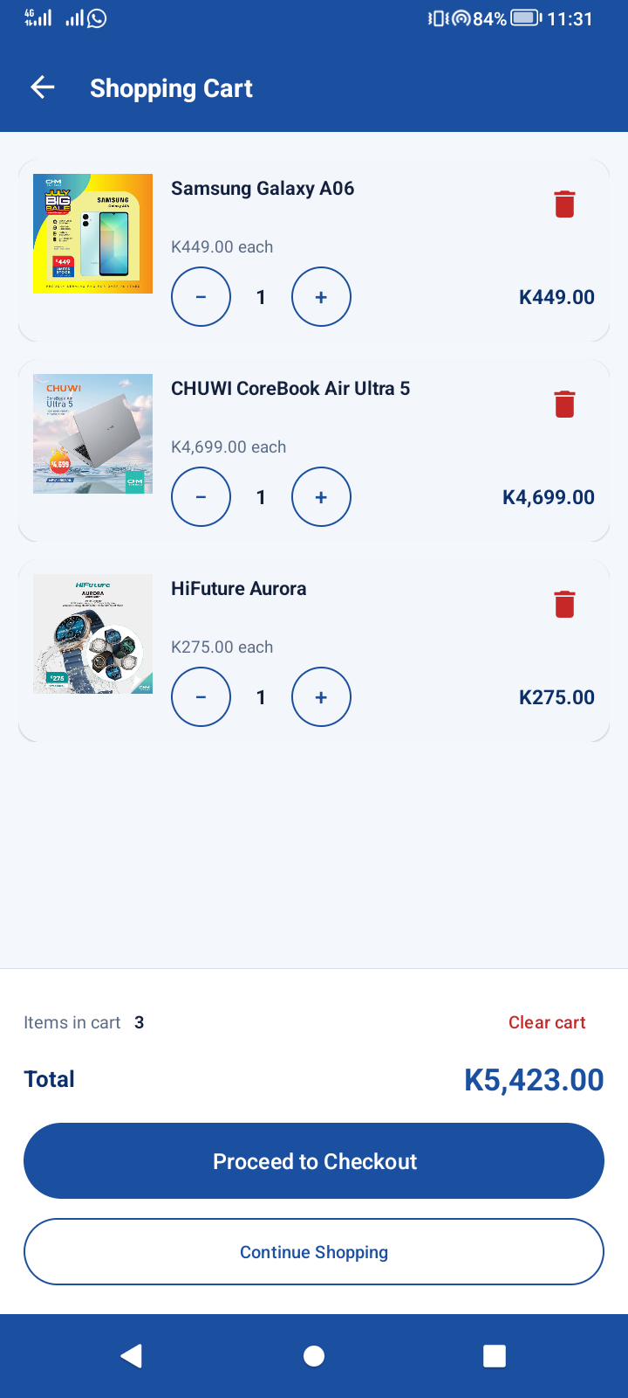  Figure 11: Shopping cart with 3 items (total K5,423.00) | 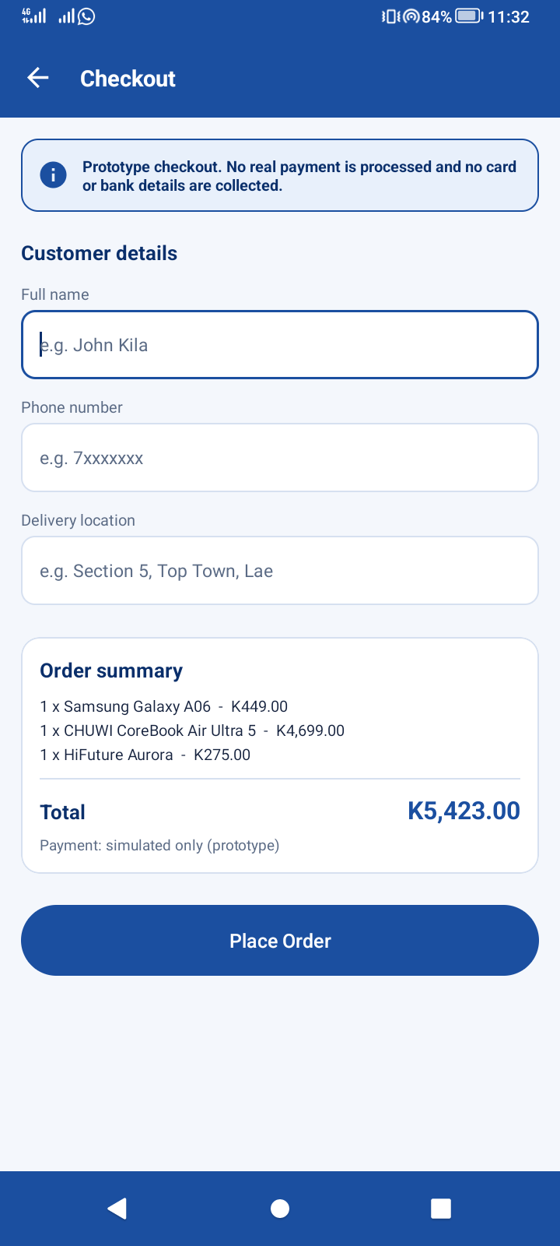  Figure 12: Checkout: customer details form | 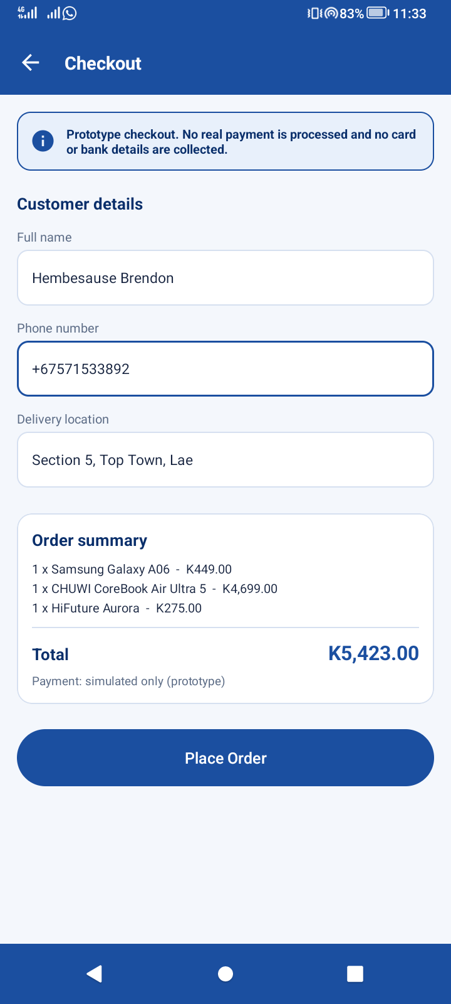  Figure 13: Checkout: details entered

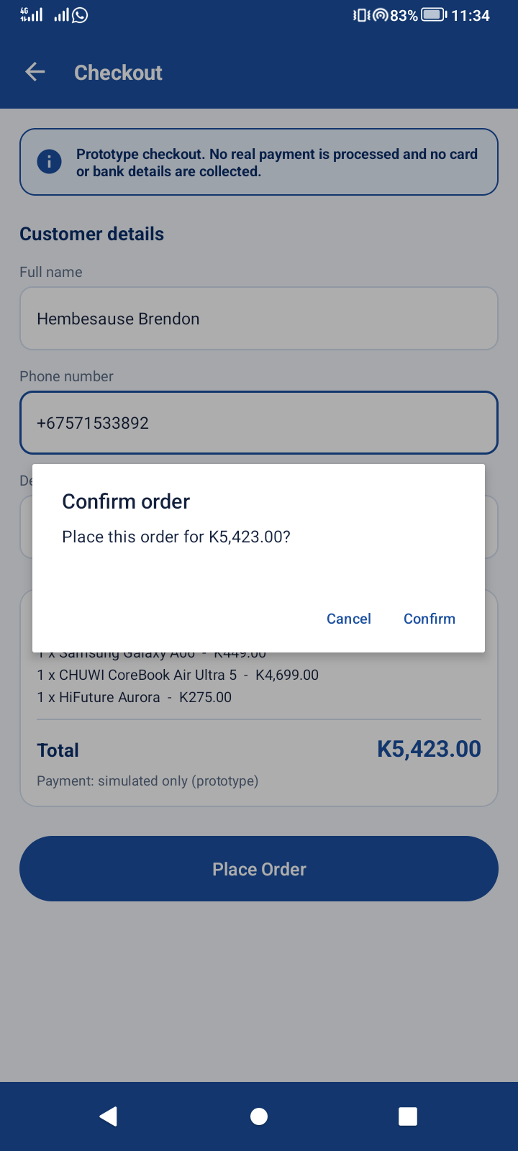  Figure 14: Order confirmation dialog | 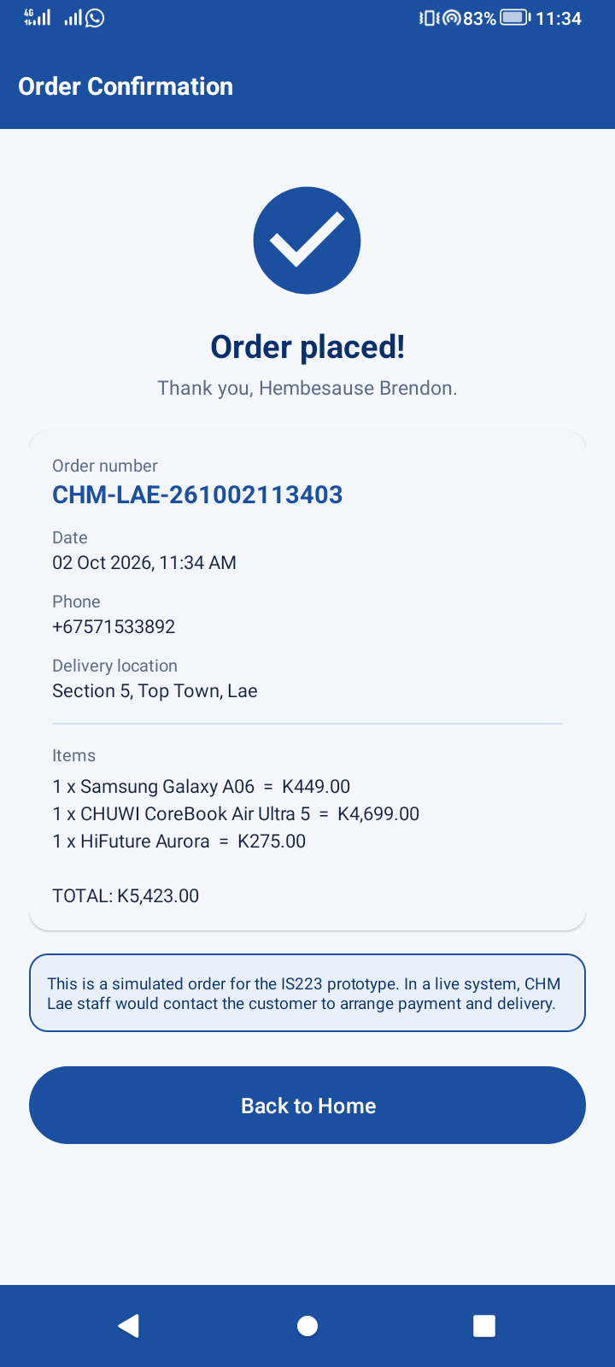  Figure 15: Order confirmation screen

Appendix C – Product catalogue
ID | Product | Category | Price
101 | Samsung Galaxy A06 | Mobile Phones | K449.00
102 | Blackview Wave 6C | Mobile Phones | K289.00
103 | Oukitel C57S | Mobile Phones | K279.00
104 | Xiaomi Redmi 10 | Mobile Phones | K990.00
105 | Phonemax X1 Rugged | Mobile Phones | K599.00
106 | Phonemax PX1 Rugged | Mobile Phones | K1,250.00
201 | Clover Laptop Awesome Bundle | Computers & Laptops | K1,699.00
202 | Clover 2-in-1 Tablet PC | Computers & Laptops | K1,250.00
203 | Mintt Desktop i5 D-15 Bundle | Computers & Laptops | K2,899.00
204 | CHUWI UBook X Pro | Computers & Laptops | K2,999.00
205 | CHUWI CoreBook Air Ultra 5 | Computers & Laptops | K4,699.00
301 | Blackview R30 Smartwatch | Smartwatches | K99.00
302 | HiFuture Flex 2 | Smartwatches | K149.00
303 | Blackview X20 Smartwatch | Smartwatches | K165.00
304 | HiFuture Ultra 3 | Smartwatches | K229.00
305 | HiFuture Aurora | Smartwatches | K275.00
401 | Kumul 39” Rhythm Guitar Pack | Music & Instruments | K399.00
402 | Redding Acoustic Guitar | Music & Instruments | K549.00
403 | Kumul 61-Key Piano Keyboard | Music & Instruments | K669.00
501 | PowerPac 5L Electric Kettle | Home Appliances | K145.00

Appendix D – Setup and code guides
See documentation/SETUP_GUIDE.md and documentation/CODE_GUIDE.md in the repository.

