**A structured website**

**3CWK50**

**Introduction to Web Design and Development 6G4Z2101**

**Department of Computing, Mathematics and Digital Technology**

**Faculty of Science and Engineering**

**08/04/2020**

**ZIVILE APONAVICIUTE 19091621**

**Section A**

**Directory Structure**

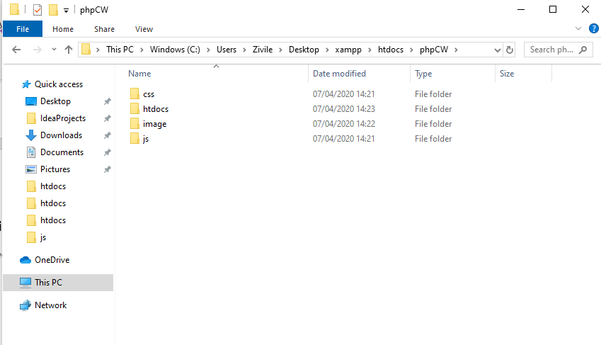

Main folder phpCW holds every folder and file used for the website. Htdocs folder holds index.php and secondpage.php files. CSS folder – style sheet file style.css. Image folder has single image of Mastercard logo and js folder holds JavaScript file script.js.

**Section B**

**Front webpage overview with alert box**

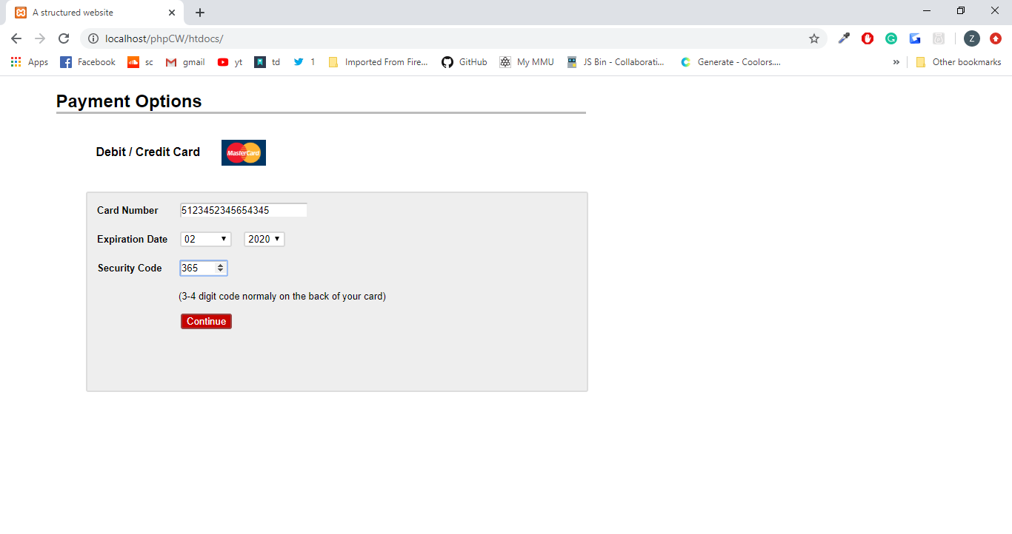

Form with correct infomartion ready to be submitted and shown in second page.

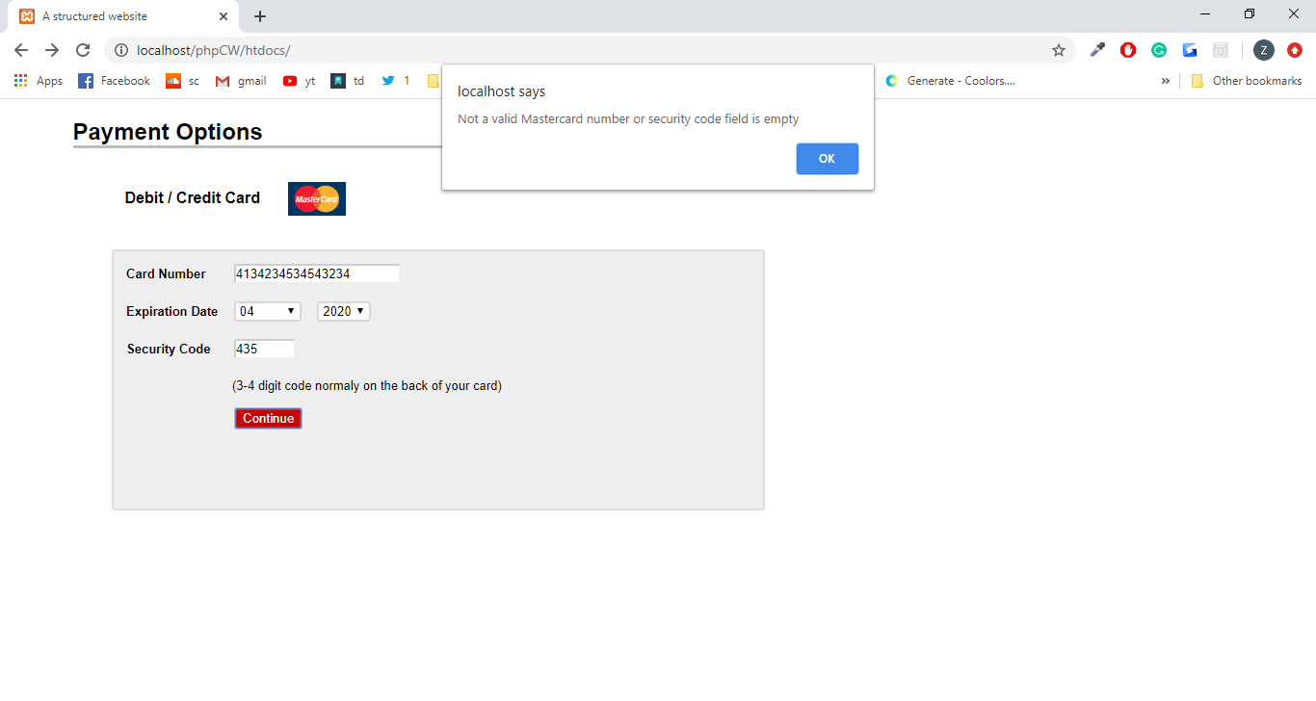

Entered card number is incorrect. Mastercard number must start with number 5, second digit must be between 1 and 5, the rest of the numbers can be between 0 and 9 and consist of 14 digits. Because credit card number does not satisfy the correct Mastercard format, form cannot be submitted, and an alert is shown for the user to know what is wrong.

**Section C**

**Database**

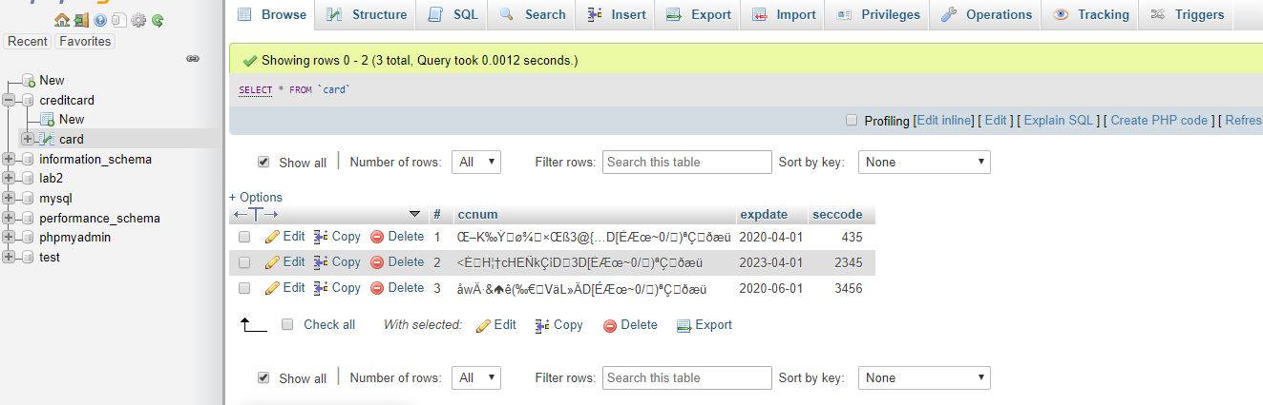

Creditcard database with card table. This table has # column which holds IDs, ccnum column for encrypted credit card numbers, expdate - expiration dates and seccode for security codes. Security codes which start with zero will lose the first zeroes when entered into database. As the seccode column is of int type and this type sees digit 0 as of no value. To keep zeroes the column type should be changed to varchar.

**Section D**

**Code appendix**

**index.php**

<!DOCTYPE html>

<html lang="en">

<head>

<meta charset="utf-8">

<!page title>

<title>A structured website</title>

<!link to css file>

<link rel='stylesheet' href='../../phpCW/css/style.css' type='text/css' />

</head>

<body>

<!headings>

<h2>Payment Options</h2>

<h4>Debit / Credit Card <img src= "../../phpCW/image/MC.jpg" alt= "MasterCard"></h4>

<!main box for the form>

<div class="mail">

<!Form/ action jumps to secondpage if onsubmit cardnumber function returns true/ method post to take input and post it into database>

<! onsubmit works when submit button is pressed>

<form name="form" action="secondpage.php" method="post" onsubmit="return cardnumber(ccnum,seccode);">

<!label for CC number input>

<label for ="cardno">Card Number</label>

<input class ="input" type='number' name='ccnum' id= "cardno"/>

<!new line>

<div>&nbsp;</div>

<!label for expiration date>

<label for= "month">Expiration Date</label>

<!selection box for expiration month>

<select id="month" name= "month">

<option >Month</option>

<option value="1">01</option>

<option value="2">02</option>

<option value="3">03</option>

<option value="4">04</option>

<option value="5">05</option>

<option value="6">06</option>

<option value="7">07</option>

<option value="8">08</option>

<option value="9">09</option>

<option value="10">10</option>

<option value="11">11</option>

<option value="12">12</option>

</select>

<!selection box for expiration year>

<select id="year" name= "year">

<option >Year</option>

<option value="2020">2020</option>

<option value="2021">2021</option>

<option value="2022">2022</option>

<option value="2023">2023</option>

<option value="2024">2024</option>

</select>

<!new line>

<div>&nbsp;</div>

<!label for security code input>

<label for="secode">Security Code</label>

<!set max length for security code, form will not submit until correct amount of numbers are inserted>

<input class ="input" type='number' name='seccode' max="9999" id="secode" />

<!new line>

<div>&nbsp;</div>

<!line of text to guide user>

<span class ="guide">(3-4 digit code normaly on the back of your card)</span>

<!submit button>

<div class="submit"><input type="submit" class ="button" name = "submit" value="Continue"/></div>

<!new line>

<div>&nbsp;</div>

<!end of form>

</form>

<!end of main box>

</div>

<! tell where and which javascript file to use>

<script src="../../phpCW/js/script.js"></script>

</body>

</html>

**secondpage.php**

<?php

//connect to mysql database creditcard

$mysqli = new mysqli("localhost", "root", "", "creditcard");

/* check connection */

if ($mysqli->connect_errno) {

//if connection fails exit website

echo "Connect failed ".$mysqli->connect_error;

exit();

}

//checks if ccnum from form is already in the databse

$query = mysqli_query($mysqli,"SELECT * FROM card WHERE ccnum = AES_ENCRYPT($_POST[ccnum],'1234') ");

//checks SELECT query returns more than 0 rows

//if true prompt alert and close mysql connection so that duplicate wouldnt be entered

if (mysqli_num_rows($query) > 0)

{ //message to print as a javascript alert

$message = "CC number has already been entered.";

echo "<script type='text/javascript'>alert('$message');</script>";

$mysqli->close();

}

//if false insert data

else{

//before inserting data have to find last id to increase it, and if there are no rows set id to 1

//SELECT query to find last inserted id

$query= "SELECT `#` FROM card ORDER BY `#` DESC LIMIT 1";

$result = $mysqli->query($query);

//if SELECT query returns more than 0 rows

if ($result ->num_rows>0) {

//fetch associative array

while ($row = $result->fetch_assoc()) {

//set idincrease variable to the last inserted id

$idincrease= $row["#"];

/*insert new row in database, set id to $idincrease +1 to increase id on every new row

use information entered in html form

in ccnum insert encrypted value using a kye (e.g 1234)

for exp date take year - month - 01 add them as one date(e.g 2020-04-01)*/

mysqli_query($mysqli,"INSERT INTO `card` (`#`,`ccnum`, `expdate`, `seccode`)

VALUES ($idincrease +1 ,AES_ENCRYPT($_POST[ccnum],'1234'), '$_POST[year]-$_POST[month]-01',$_POST[seccode])");

}

}

//if SELECT returns 0 rows

else{

//insert values, use # =1 for the first row in the table

mysqli_query($mysqli,"INSERT INTO `card` (`#`,`ccnum`, `expdate`, `seccode`)

VALUES (1 ,AES_ENCRYPT($_POST[ccnum],'1234'), '$_POST[year]-$_POST[month]-01',$_POST[seccode])");

}

}

?>

<!DOCTYPE html>

<html lang="en">

<head>

<meta charset="utf-8">

<!page title>

<title>A structured website</title>

<!link for css file to use on this page>

<link rel='stylesheet' href='../../phpCW/css/style.css' type='text/css' />

</head>

<body>

<!headings>

<h2>You have successfully entered your credit card details</h2>

<h4>Debit / Credit Card <img src= "../../phpCW/image/MC.jpg" alt= "MasterCard">

Your credit card number ends in **** **** ****

<?php

//connect to databse creditcard

$mysqli = new mysqli("localhost", "root", "", "creditcard");

/* check connection */

if ($mysqli->connect_errno) {

//exit page if connection fails

echo "Connect failed ".$mysqli->connect_error;

exit();

}

/*fetch last entered ccnum, works only if id is increased every time new row is entered */

//SELECT query decrypts cc number and takes 4 digits from the right of the cc number

//order by id in descending order and limit to 1, meaning that it shows only first row with the highest id possible

$query ="SELECT RIGHT (AES_DECRYPT(ccnum, '1234'),4) FROM card ORDER BY `#` DESC LIMIT 1";

if ($result = $mysqli->query($query)) {

/* fetch associative array */

while ($row = $result->fetch_assoc()) {

//print last 4 digits of decrypted cc number

echo $row["RIGHT (AES_DECRYPT(ccnum, '1234'),4)"]." <br />";

}

}

//close connection

$mysqli->close();

?>

</h4>

<!grey empty box>

<div class="secondbox">

</div>

</body>

</html>

**JavaScript script.js**

function cardnumber(inputtxt1,inputtxt2)

{

//function takes to parameters

//function used in index.php form onsubmit inputtxt1 = ccnum inputtxt2=seccode

var cardno = /^(?:5[1-5][0-9]{14})$/;

//check if ccnum value matches cardno requirements

//check if seccode is not empty, otherwise validation passes with no seccode

//code fails to insert data into database because seccode cannot be empty

//and shows previously entered card number.

if(inputtxt1.value.match(cardno) && inputtxt2.value.length!==0)

{

return true;

}

else

{

//show alert if condition is not met

alert("Not a valid Mastercard number or security code field is empty");

return false;

}

}

**CSS style.css**

/* change font for whole page*/

body{

font-family: Arial, Helvetica, sans-serif;

}

/*div container used in index.php

change color,width, move to the right with margin-left

add border,increase size with padding

round corners with boder radius */

.mail {

background-color: #EEEEEE;

width : 48%;

margin-left:8%;

border: 2px solid #DDDDDD;

padding:13px;

border-radius:3px;

padding-bottom:50px;

}

/*div container used in secondpage.php

is exactly the same as .mail only bigger padding*/

.secondbox {

background-color: #EEEEEE;

width : 20%;

margin-left:8%;

border: 2px solid #DDDDDD;

padding:200px;

border-radius:3px;

padding-bottom:50px;

}

/*heading 2, moved to the right with margin-left

increased width, has a border on the bottom, and bold font*/

h2 {

margin-left: 5%;

width :53%;

border-bottom: 3px solid #BCBCBC;

font-weight: bold;

}

/*heading 4, moved to the right with margin-left

added size with padding and bold font*/

h4{

margin-left: 8%;

padding:1%;

font-weight: bold;

}

/*master card image with restricted width

image box moved to the right with margin-left

and added space on the right with margin-right

vertical align to make image in the middle inline with text*/

img {

width : 5%;

margin-left : 2%;

margin-right :2%;

vertical-align : middle;

}

/*style labels by setting font size and weight*/

label{

font-size:13px;

font-weight: bold;

}

/*change input borders making left and top border darker

also round edges of the border*/

.input{

border-radius:3px;

border-left:2px solid #CCCCCC;

border-top:2px solid #CCCCCC;

}

/*move seccode input box and set size*/

#secode{

margin-left:20px;

width:60px;

}

/*move cardno input box*/

#cardno{

margin-left:25px;

}

/*set month select box size */

#month{

width:70px;

}

/*move guide span and set its size*/

.guide{

margin-left:110px;

font-size:13px;

}

/*move select boxes, round corners and change their colour*/

select{

margin-left:12px;

border-radius:3px;

border:2px solid #D8D8D8;

}

/*set size for submit box, move it and increase its size*/

.submit{

font-size: 1em;

margin-left :80px;

padding: 15px;

}

/*change the submit buttons color, add dark border and round corners, move to the right*/

.button{

background-color: #C60400;

color: white;

border: 2px solid #994646;

border-radius: 3px;

margin-left:18px;

}