

Mock project
Details Design Specification
Version 1

Document History

Version | Revision Details | Author | Date
0.1 | Creation | FPT Software | 20 Nov 2009
0.2 | Update Steps and SQL | FPT Software | 2 Dec 2009
0.3 | Update Main Gate Process | FPT Software | 7 Dec 2009
0.4 | Update Out Gate Process | FPT Software | 8 Dec 2009
0.5 | Update mapping in Out Gate Process | FPT Software | 8 Dec 2009
0.6 | Update InGate, OutGate detail | FPT Software | 10 Dec 2009
0.7 | Update mapping in Sub-ADP, UA(T), Pass Out Note | FPT Software | 11 Dec 2009
0.8 | Update comments from Jacky Choong | FPT Software | 14 Dec 2009
0.9 | Update comments from Vani | FPT Software | 21 Dec 2009
1.0 | Update comments from Vani | FPT Software | 23 Dec 2009
1.1 | Latest version | FPT Software | 29 Dec 2009

Table of Contents

Table of Contents 3
1. Introduction 5
1.1. Purpose 5
1.2. Scope 5
1.3. References 5
2. Sub-Authorize the Delivery Party for Shipment 6
2.1. Class diagram 6
2.2. Sequence diagram 7
2.2.1. Search Sub-ADP 7
2.2.2. Delete Sub-ADP 7
2.2.3. Nominate Sub-ADP 8
2.3. Code changes 8
2.4. Screens 10
2.4.1. Top screen 10
2.4.2. List screen 12
2.4.3. Nominate screen 15
3. Delivery Note (DN) 17
3.1. Cargo SST: Cargo Delivery 17
3.1.1. Screens 17
3.2. JP-Online: Create DN 19
3.2.1. Class diagram 19
3.2.2. Screens 20
4. Unloading Advice (UA) 23
4.1. Cargo SST: Cargo Shipment 23
4.1.1. Screens 23
4.2. JP-Online: Create UA 24
4.2.1. Class diagram 24
4.2.2. Screens 25
5. Unloading Advice for Tenant - UA(T) 27
5.1. Class diagram 27
5.2. Sequence diagram 28
5.2.1. Search UA(T) 28
5.2.2. Add UA(T) 29
5.2.3. Delete UA(T) 30
5.2.4. View UA(T) 30
5.3. Code changes 31
5.4. Screens 33
5.4.1. Top screen 33
5.4.2. List screen 35
5.4.3. Create screen 37
5.4.4. Submission screen 38
5.4.5. View screen 40
6. Pass Out Note 44
6.1. Class diagram 44
6.2. Sequence diagram 45
6.2.1. List Pass out Note 45
6.2.2. Add Pass out Note 46
6.2.3. Delete Pass out Note 47
6.2.4. View Pass out Note 47
6.3. Code changes 47
6.4. Screens 49
6.4.1. Top screen 49
6.4.2. List screen 52
6.4.3. Create screen 53
6.4.4. Submission screen 56
6.4.5. View Screen 58
7. Gate Processing 61
7.1. Login to CETS 61
7.1.1. Class diagram 61
7.1.2. Sequence diagram 61
7.1.3. Screens 62
7.2. Change password 64
7.2.1. Class diagram 64
7.2.2. Sequence diagram 64
7.2.3. Screens 65
7.3. Main gate Processing 67
7.3.1. Class diagram 67
7.3.2. Sequence diagram 67
7.3.3. Screens 68
7.4. In Gate Processing 71
7.4.1. Class diagram 71
7.4.2. Sequence diagram 73
7.4.3. Screens 74
7.5. Out Gate Processing 79
7.5.1. Scan Barcode 79
7.5.2. View Scan Document 82

Introduction

Purpose

This document specifies coding methods, legacy code integration, packaging settings as well as requirements in technical view for mock project

- This document will be used as User Acceptance Criteria with Jurong Port
- This document will be used as guideline/tracking document for Developers, Testers, PM and customer.
- This document does not follow usual format and contains much actual code, because customer prefers this format.
- This document was created with assumptions that legacy code works well.

Scope
This software document is applied to features which are described in requirement specification document.

References

Document Number | Title
01 | XDev – project plan
02 | xMock-Q&A
03 | XDev_workflow
04 | XDev_DBDesign
05 | XDev_Software Design Document

Georaphy

Class diagram
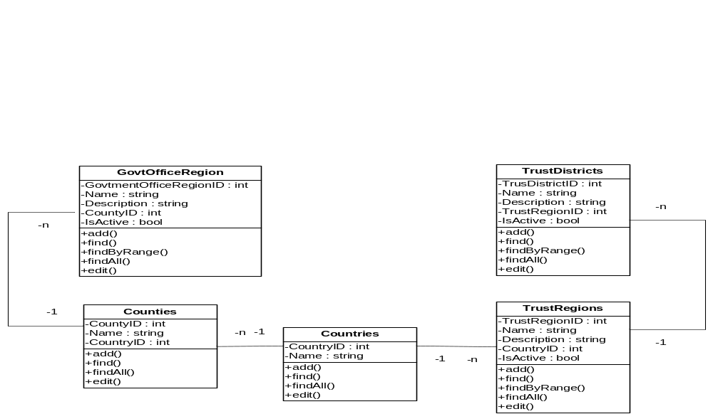

Sequence diagram

Search TrustRegion
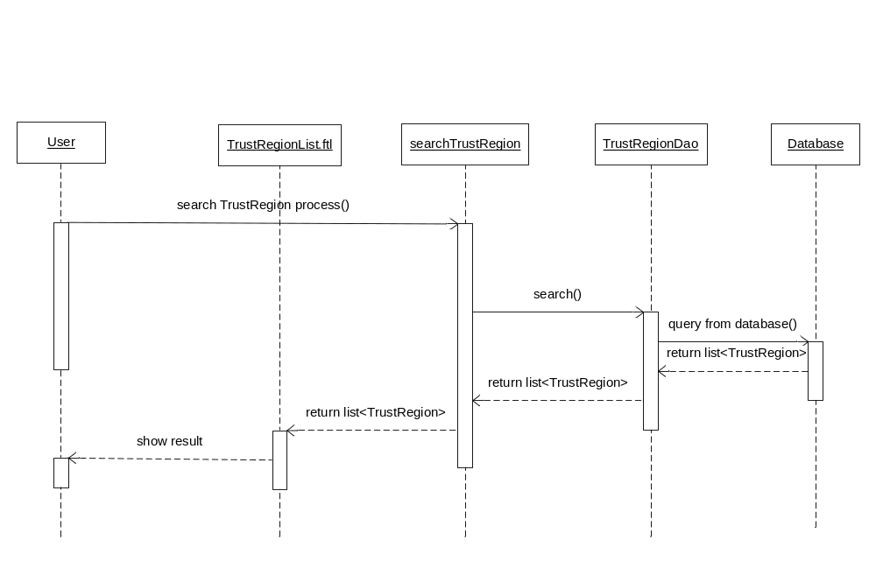

Add TrustRegion

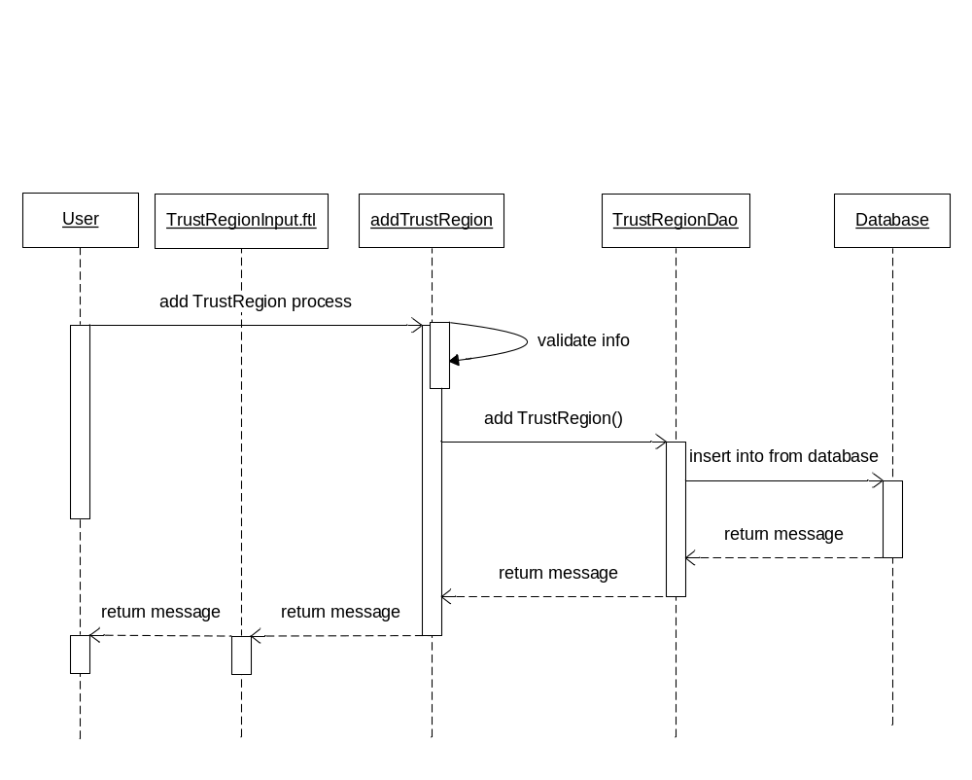

Edit Trust Region
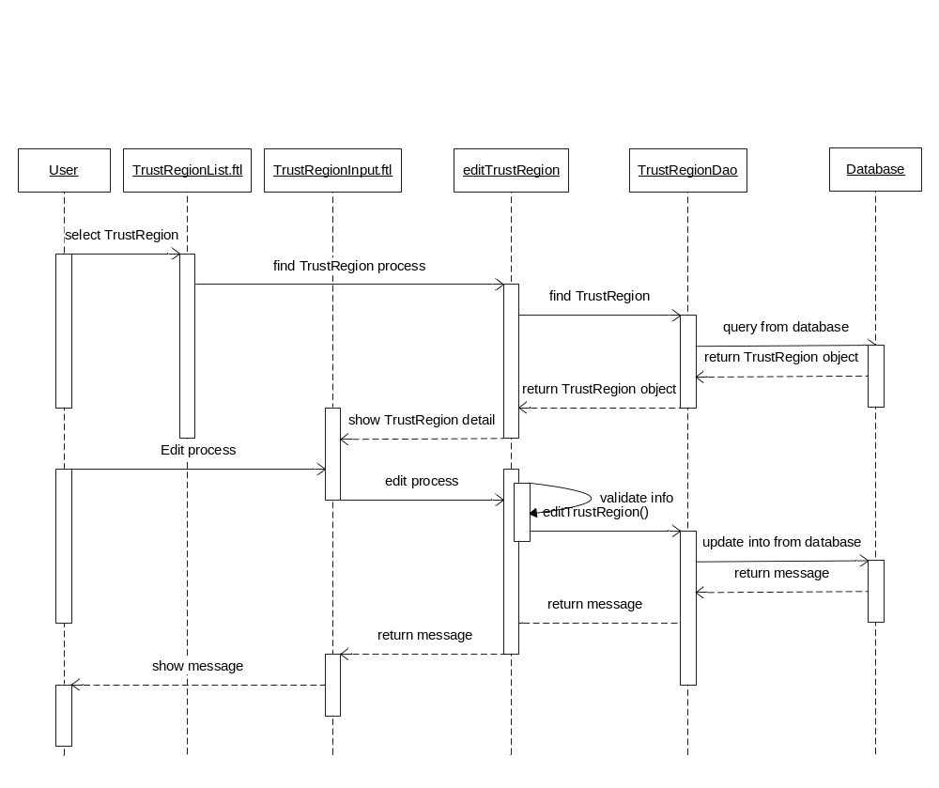

InActive TrustRegion
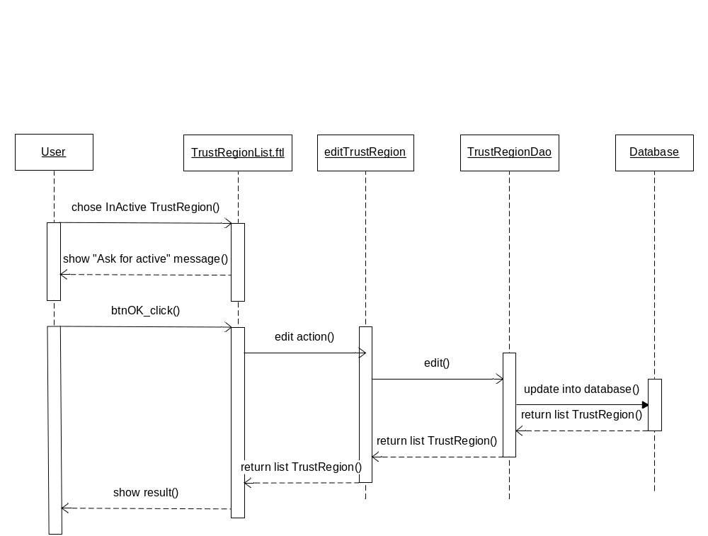

Search TrustDistrict
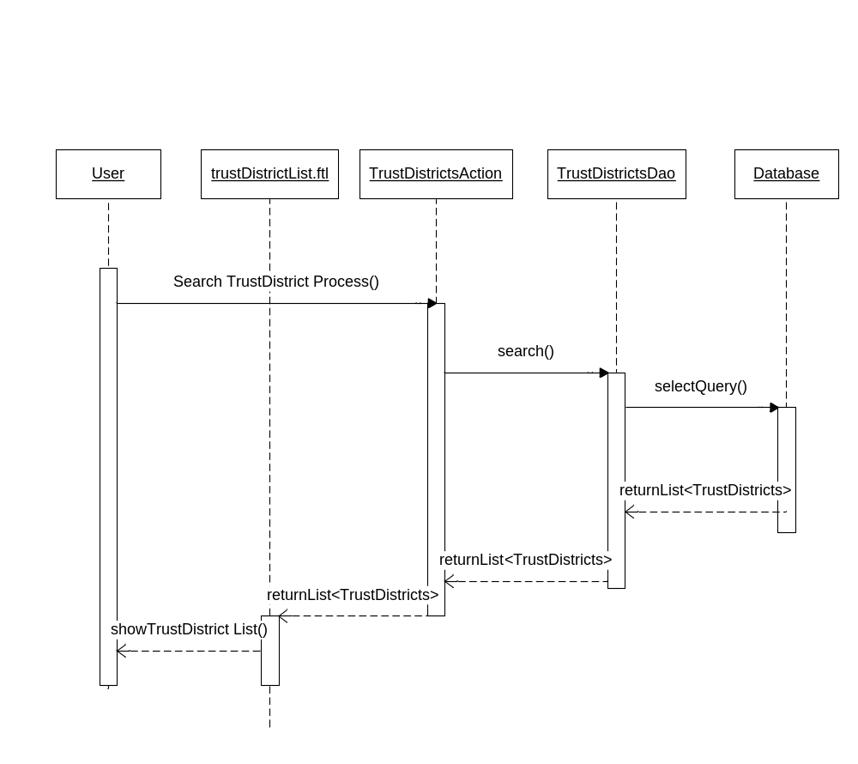

Add TrustDistrict
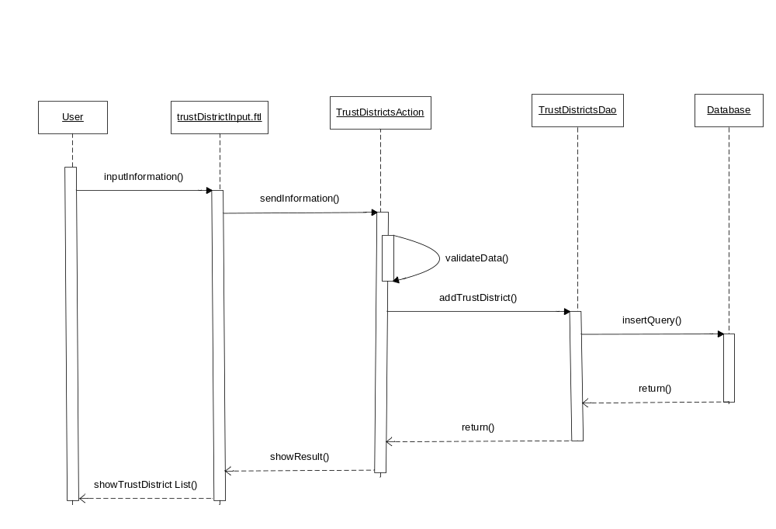

Edit TrustDistrict
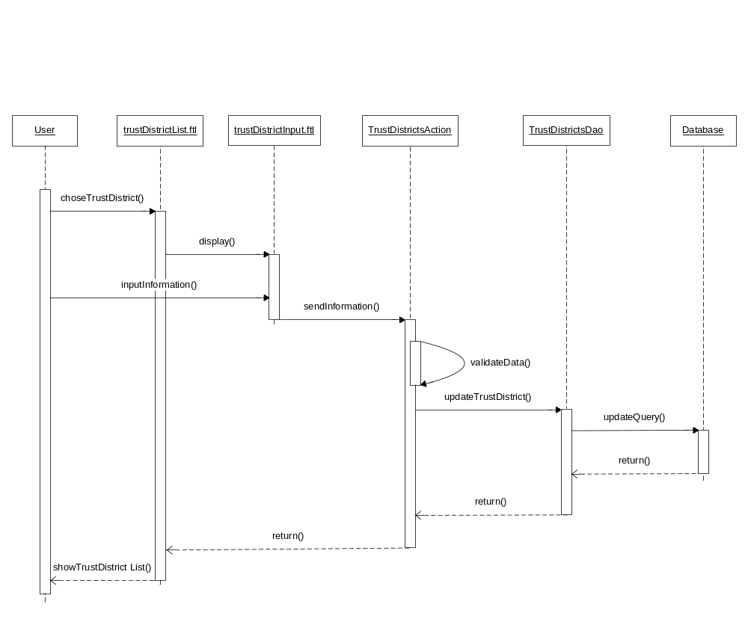

InActive TrustDistrict
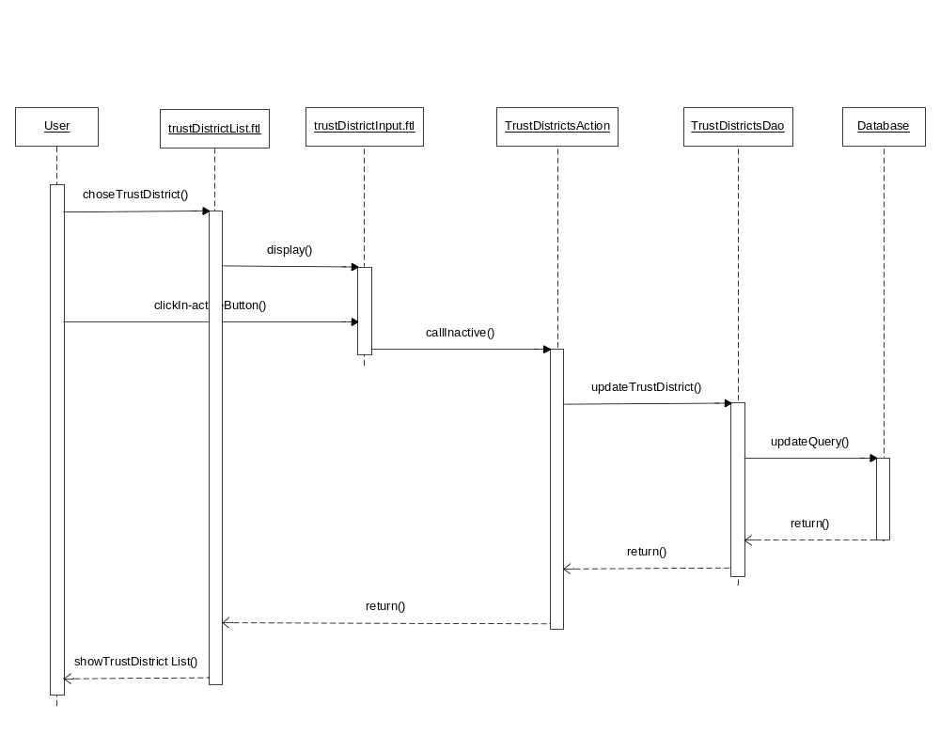

Active TrustDistrict
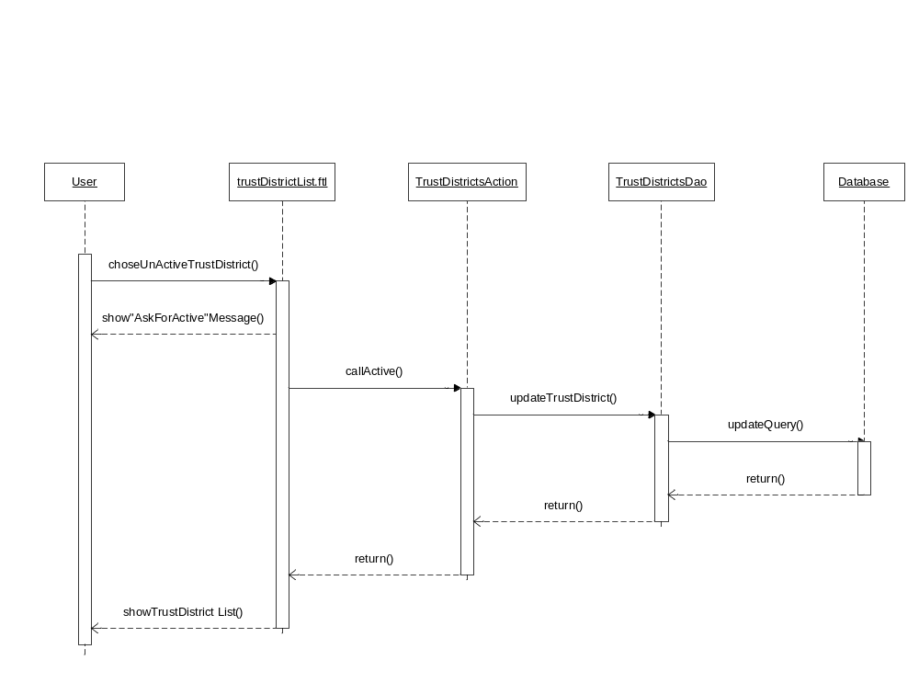

Search Government Office Region
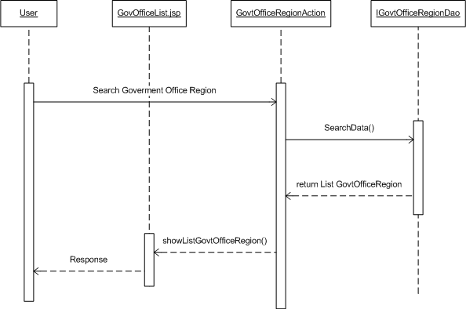

Contact

Class diagram

Sequence diagram

Search Contact

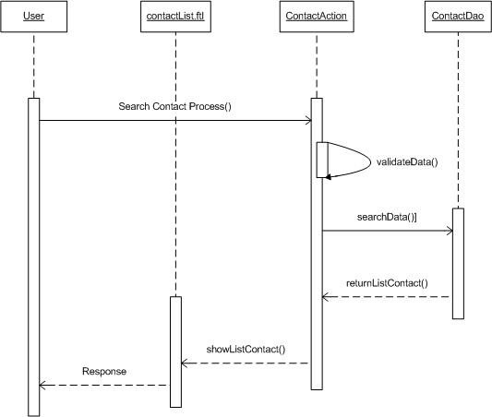

Add Contact
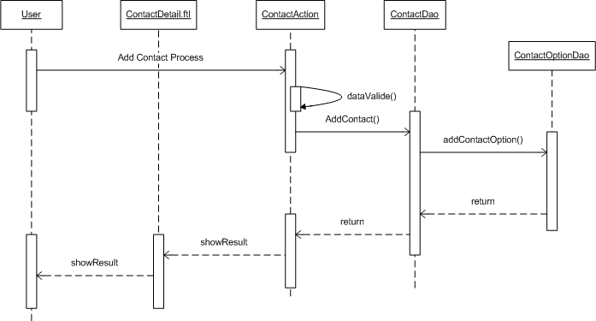

Edit Contact
