AB Service Directory

Installation Guideline for Developer

Author: nhanld

Table of Contents

Tools used in this project 2

Project SVN 3

SVN URL 3

SVN for Eclipse 3

Setup SQL Server 3

Setup Apache Tomcat for Eclipse 3

Install JBoss Hibernate Tools for Eclipse 4

Setup Eclipse Workspace 4

Get project from SVN server 4

Appendix A. Install New Eclipse Plugin 6

# Tools used in this project

Eclipse 3.7 Indigo, Java EE version.

Microsoft SQL Server 2008

SQL Server JDBC

Apache Tomcat 7

Struts 2, Spring, Hibernate

JBoss Hibernate Tools for Eclipse

# Project SVN

This project uses SVN to control version.

## SVN URL

Host: http://10.16.102.138/svn/trunk/WIP/Source code

Folder: fsoft.xdev.mock

## SVN for Eclipse

<http://subclipse.tigris.org/>

Install Subclipse plugin to use SVN in Eclipse.

To install new plugin in eclipse, see Appendix A – Install New Eclipse Plugin.

# Setup SQL Server

This project uses a center database.

Host: 10.16.102.138

Database: XDevMock

Username: sa

Password: 123456

# Setup Apache Tomcat for Eclipse

Tomcat is a JSP/Servlet server.

1. Download Apache Tomcat 7 at <http://tomcat.apache.org/>
2. Unzip to some folder.
3. In Eclispe menu, chose Window > Preferences.
4. In the tree, chose Server > Runtime Environment.
5. Add new Apache Tomcat v7.0 pointed to your tomcat installed location.

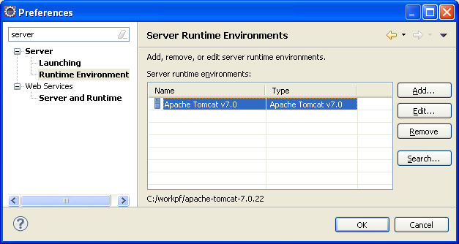

# Install JBoss Hibernate Tools for Eclipse

JBoss Hibernate Tools is an Eclipse plugin. This plugin provides a GUI to manipulate Hibernate easily.

The update site link at <http://www.jboss.org/tools/download>

To install new plugin in eclipse, see Appendix A – Install New Eclipse Plugin.

# Setup Eclipse Workspace

1. Setup Apache Tomcat server

See “Setup Apache Tomcat for Eclipse” section.

1. Setup Web Browser

You can choose your interested web browser for test.

In the case of Chrome, add this options:

--incognito: to open Chrome in no cache mode.

--new-window: to open Chrome in separate window.

# Get project from SVN server

1. In Eclipse menu, chose File > Import.
2. Chose “Checkout Projects from SVN”. Press Next.

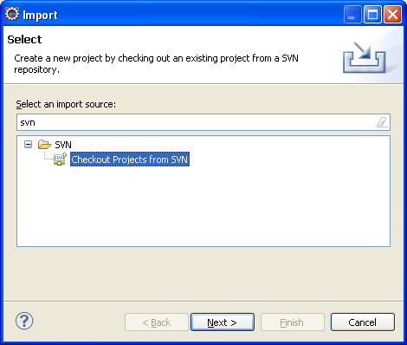

1. Chose “Create a new repository location”. Press Next.
2. Use this url: http://10.16.102.138/svn/trunk/WIP/Source code.

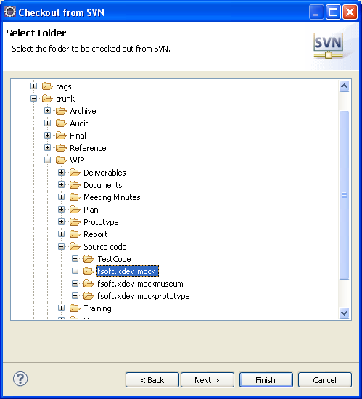

1. Choose project fsoft.xdev.mock. Press Finish.

# Appendix A. Install New Eclipse Plugin

1. Open Eclipse, in menu, chose Help > Install New Software.

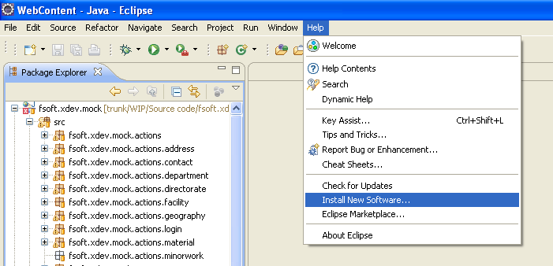

1. Copy plugin’s update link to “Work with” field. Select tools and click Finish.

