Adil Qaisar

CS 362

Professor Theys

4/25/2015

Final Write-up

Arduino Controlled Garage Opener

**Being Assigned Project:**

When we were assigned to do one final Arduino project to finish before the semester ended I quickly thought that the project of a garage opener would be perfect. I felt like it was going to be pretty simple and doable for someone like me who has no prior experience with circuits and such. I also thought that having an extra way to get into my house would be pretty awesome.

**Researching Techniques**

Within the first week I started researching different how-to’s for garage door openers controlled by Arduinos. I saw so many different techniques, I thought I would try doing the most popular choice first. So I clicked on the first guide on how to make a garage door opener with Arduino from Google.com and I saw this article:

<http://www.instructables.com/id/Arduino-Garage-Controller/>

I did some thorough research on this technique for about two weeks. I purchased a Mi Casa Verde home controller on EBay. It took me about two days to give up on this technique as it was way beyond my scope of understanding. I had to keep looking for different techniques.

This was another technique I found on how to create an Arduino controlled garage controller here:

<http://www.instructables.com/id/Arduino-WiFi-Garage-Door-Opener/?ALLSTEPS>

This seemed like the best available how to for this project. The items I needed to buy were very minimal and cost friendly. When I decided that I would follow this instructable I quickly ordered all the parts necessary. Here they are:

1. Soldering Iron
2. Etherten Board
3. 5V Relay Motor

I ordered these items by early-mid March. By the end of March I only received my soldering iron in the mail. Then I got an email saying my EtherTen board would not be shipped because I was sold a sold out item. Then I looked into the project some more to see different alternatives. I got my money back and ordered an Arduino Ethernet shield. I realized I would still be able to do this project with just this.

All that was left was the 5V relay motor I ordered from deal extreme. This became a huge problem. It said it would ship in 15 days which would have been by end of March or early April. I never received in the mail, even until today. I asked on Piazza if anyone had an extra one and luckily Professor Theys had one laying around. But his was not the same one I was looking for. It was a different make and model.

Here is what I was looking for:

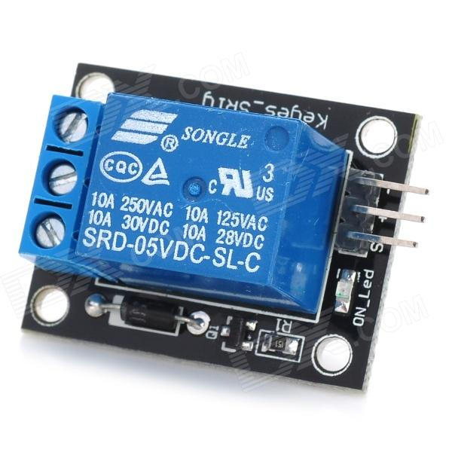

This is what Professor Theys gave me:

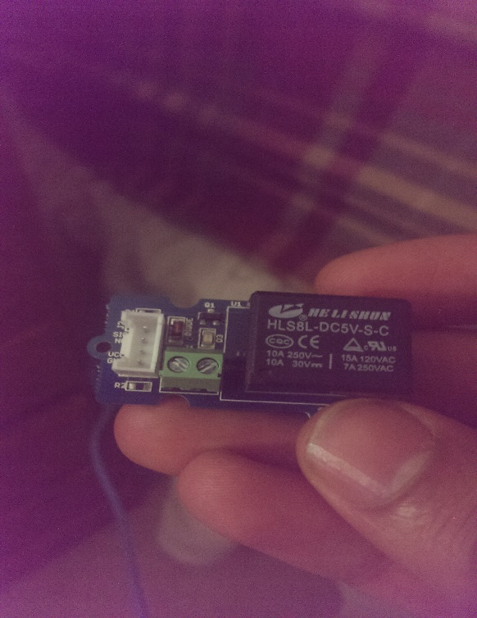

I only had a few days to finish my project because of the delay in shipping of my equipment. So working with Professor Theys’ relay had to be figured out quickly. I spent a good couple hours trying to figure out how to work the relay and to no avail. I had to switch my technique for this project once again.

**Working on Final Design**

This time I did a quick YouTube search and found a couple of tutorials for this project. One that stuck out to me was Jacob Dykstra’s project. He used a completely different technique that I had not seen before. But the good part was that I had all the equipment needed for this project already.

I had an advantage as I already knew how the garage door opener works from my previous attempts at this project using different techniques.

I knew I would have to manipulate the garage door opener as I knew that this was the one universal technique in all the how to’s I went through. And luckily I already did that 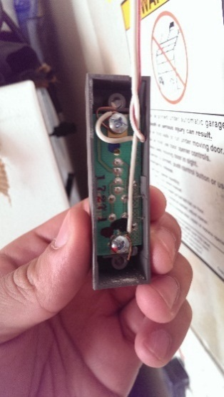research about a month ago. Here is a photo of the back of my garage door remote inside my garage:

After checking with a meter, I figured out that the top wire was the positive wire and the bottom one was the negative or ground wire. I chose not to connect my Arduino garage controller to the actual garage opener located on the ceiling because of the difficulty of having to wire things up there as opposed to something that is eye level like my garage remote opener located in my garage. The next step was finding a wire I could wire to this remote so I could connect it to my breadboard and to the respective garage door remote.

I had some trouble finding a proper wire. I cut up a bunch of old electronic supplies’ wires that I had laying around I only found two that had the proper wires to connect.   
I once again used a battery and a meter to determine which ends of the wire were positive or negative.

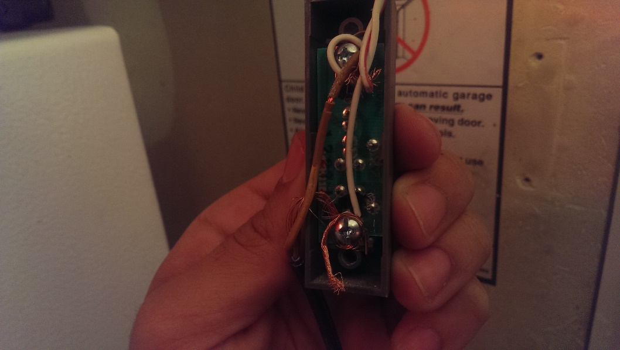Once I figured this out I wrapped the wires around each terminal and screwed them back in. This pretty much eliminated the need to solder anything up for this project. Once I wrapped each of the wires to the correct terminals it looks like this.

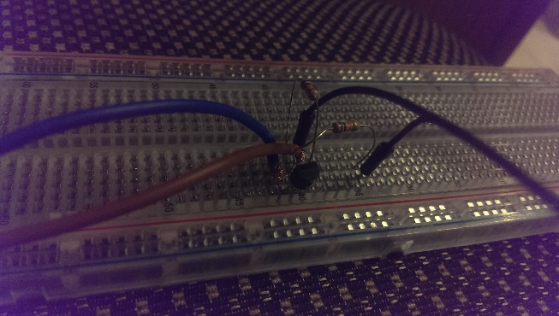After doing this I followed Jacob’s video tutorial on how to set up the circuit. I followed pretty closely and with all the materials in hand it did not take very long at all. Here is a look at the final look at the Arduino board:

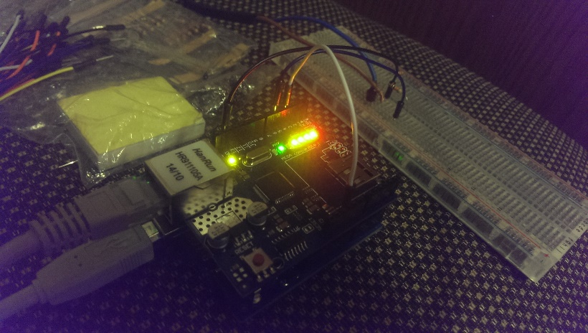

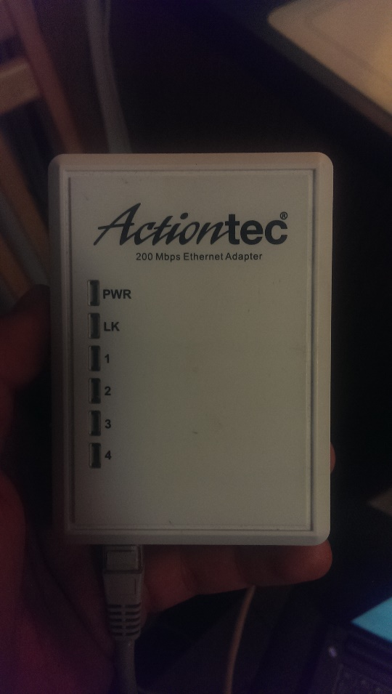I had trouble connecting the Ethernet wire to my Arduino as well. My modem was all the way upstairs so I had to find something to help me solve this. Luckily I had this old number laying around the house. I just took this and connected it to the outlet right by my garage door remote for easy access.

The final part of this project came down to the code. I quickly realized this was not going to be an easy task because I would have to implement HTML inside of my Arduino code. I used some of Jacob’s sample code to help me get started. But I had trouble even setting up the Arduino Ethernet shield.

I did not understand where the IP address comes from. After some research within the Arduino website I found out how it works. I found the IP address of my shield and proceeded with the project.

Here is a little look at the Arduino code. We basically send HTML commands to the web server we create with the Arduino.

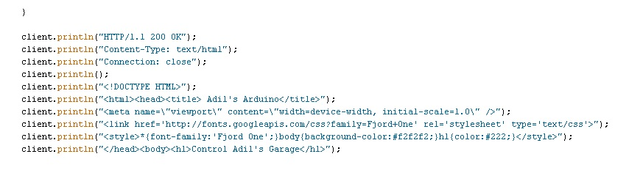

As I uploaded the program onto my Arduino and proceeded to my local browser on my laptop I had trouble viewing the webpage. I could not seem to figure out what was going wrong but I kept receiving errors as if the connection did not exist. I tried again with the basic web server that Arduino provides with same IP address and it showed up. I was not familiar with this problem and I could not seem to figure out what the problem was.

After a few hours of debugging my HTML code I figured out the problem. I got the web server to work and it worked with no issues!

**Demo**

<https://youtu.be/xauehD_8cGg>

**Conclusion**

This garage door opener will work when you are on an internet browser connected to my home Wi-Fi. This project may seem a little insecure for now but I will be trying to figure out different ways this summer to make sure that nobody can hack into the Ethernet shield and break into my house. For now I have my garage door opener disconnected so I can work out these minor bugs to make my project secure for use in the future.

Works Cited

<http://www.instructables.com/id/Arduino-Garage-Controller/>

<http://www.instructables.com/id/Arduino-WiFi-Garage-Door-Opener/?ALLSTEPS>

<https://www.youtube.com/watch?v=SQy-hrKAzJc> - Jacob’s video

http://www.arduino.cc/en/reference/ethernet