Student Name: Andrew Salazar Student ID: 1667674

Undergraduate Student:  Graduate Student

[If applies]

Student Name: Ahson Qazi Student ID:1568998

Undergraduate Student:  Graduate Student

# Image Acquisition Driver:

In this analysis do not acquire the full image. We want to have an image that is “good enough” to identify structures but gather a small amount of data to make the scanning process faster.

1. Acquire the “Cardiac” image using the band trajectory at 35 degrees. Add small description of each step.

Image and mask combined to make noisy image

Band width = 10, length = 50

Regular image of the heart

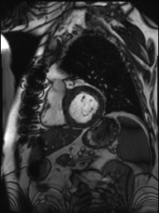 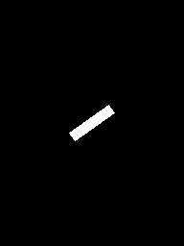 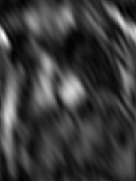

1. Acquire different degrees and band sizes of the same image and analyze the pro and cons of each result. State in the analysis the parameters used on each. Add your observations in the analysis.

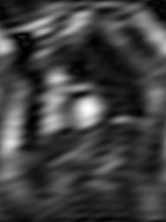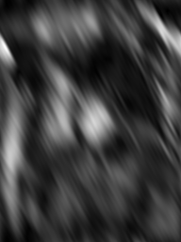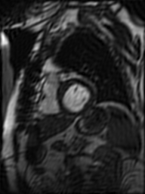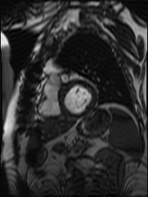

Analysis:

(First w=10, l=50, a=100) – Noisy image with angle high

(Second w=10, l=100, a=35) – Length is bigger which make the image way to blurry

(Third w=100, l=50, a=35) – Clear image with a high width. Possible no change in image

(Fourth w=150, l=75, a=265) – All values high and best clear image

1. Acquire 50% of the “Cardiac” image using the Cartesian trajectory

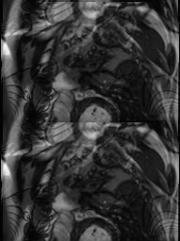

Acquire different percentages of the same image and analyze the pro and cons of each different percentage. State in the analysis the parameters used on each. Add any observations to your analysis

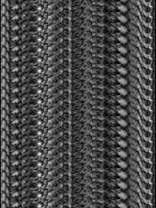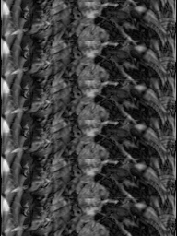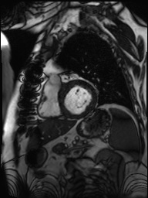

Analysis:

5% - The image is very hard to tell what we are looking at.

15% - image gets better, notice some features but still difficult

35% - Notice more features, not too clear

64% - Best quality image of the heart

1. Acquire the “Cardiac” image using the radial trajectory. Experiment with different parameters and add in your analysis any pro and cons of each option. Add the parameters used on your analysis.

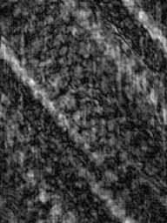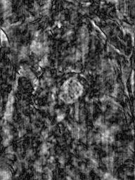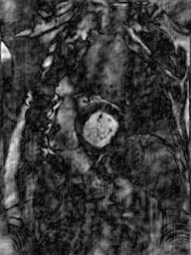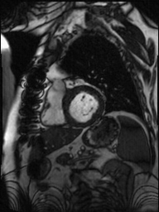

Acquire the “Brain” image using the radial trajectory. Use the same parameters as used before and add in your analysis any observations and comparison with the acquired “Cardiac” results. Does this technique benefits more to the Cardiac or Brain image? What technique is better for each? What did you find to be the best parameters? What technique do you believe would do a better job?

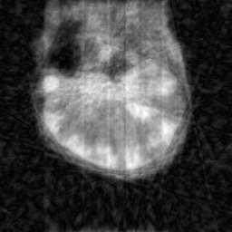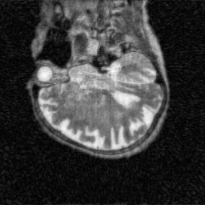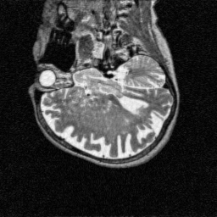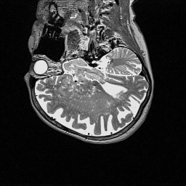

Analysis:

This technique benefits the brain more than the heart as we can still tell by the first image the object is round. Looking at the first image for the heart we realize can’t recognize what the object is. This technique works for both when more rays added. We observed that 180 and 360 are the better choice of parameters for each image. Radial would do the best job.

1. Explore and find a trajectory with its respective parameters that give better results than the ones discussed above. Explain why you believe that is better and if there are downside of using that specific trajectory. You may use the Cardiac or Brain image. Add the result image below and how you came to that result.

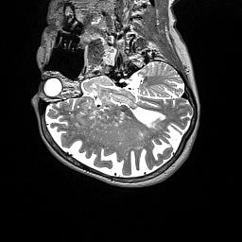

Analysis:

So after testing each trajectory we notice the cartesian pattern outputted the best picture of the brain. This image is the most crisp picture that was produced by our algorithm.

# Image Noise Driver:

1. Apply the Butterworth Lowpass filter to the Brain image. Experiment with the cutoff and order (N) values to identify their relationship and how it affects the resulting image. For each image below, calculate the signal to noise ratio.

|  |  |  |  |  |
| --- | --- | --- | --- | --- |
| Cutoff | N = 1 | N = 2 | N = 3 | N = 4 |
| 10 |  |  |  |  |
|  | SNR= | SNR= | SNR= | SNR= |
| 20 |  |  |  |  |
|  | SNR= | SNR= | SNR= | SNR= |
| 35 |  |  |  |  |
|  | SNR= | SNR= | SNR= | SNR= |
| 65 |  |  |  |  |
|  | SNR= | SNR= | SNR= | SNR= |

Analysis:

We can tell that as cutoff became much larger while N was still low the image quality tended to get better. If we notice that when cutoff = 10, as N got larger we see noisy. While cutoff was = 65 we really don’t notice much of a difference in the image quality.

1. Apply the Gaussian Lowpass and Highpass to the Brain image. Experiment with the cutoff value to identify how it affects the resulting image.

|  |  |  |  |  |
| --- | --- | --- | --- | --- |
| Lowpass | | | | |
| Cutoff |  |  |  |  |
| 1st= 5  2nd=20  3rd=40  4th=100 |  |  |  |  |
| Highpass | | | | |
| Cutoff |  |  |  |  |
| 1st= 250  2nd=200  3rd=150  4th=100 |  |  |  |  |

Analysis:

Although we didn’t see much of a difference when changing the cutoff rate for Highpass, Lowpass showed the most significant change between them.

1. Load the matrix file “noisyimage.npy” and explore multiple techniques to improve the quality of the image. Present below three choices that you have found best results. Explain the process and the parameters used.
2. Result – IdealHighpassFilter (cutoff_size = 100)



Used getImage function in utilities, found length and width and applied those to an empty mask. After calling idealHighpassFilter we applied the new mask to the image and displayed it.

1. Result – idealLowpassFilter (cutoff_size = 100)



Used getImage function in utilities, found length and width and applied those to an empty mask. After calling idealLowpassFilter we applied the new mask to the image and displayed it.

1. Result – ringLowpassFilter (cutoff_size = 100, Thickness = 10)



Used getImage function in utilities, found length and width and applied those to an empty mask. After calling ringLowpassFilter we applied the new mask to the image and displayed it.

[Challenge Bonus]: In comparison to the image below, how does your choices compare? You can achieve the same result with a specific method and cutoff value. Place here the information.

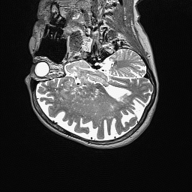

Analysis:

Type here