UNIVERSITI TEKNOLOGI MARA

SECURE CLOUD STORAGE WITH AI MALWARE ANALYZER
AND AES ENCRYPTION

MUHAMMAD AQEEF BIN AZHAR

BACHELOR OF COMPUTER SCIENCE (Hons.) NETCENTRIC COMPUTING

January 2026

UNIVERSITI TEKNOLOGI MARA

SECURE CLOUD STORAGE WITH AI MALWARE ANALYZER
AND AES ENCRYPTION

MUHAMMAD AQEEF BIN AZHAR

Thesis submitted in fulfilment
of the requirements for the degree of
Bachelor of Computer Science (Hons).
Netcentric Computing

Faculty of Computer and Mathematical Sciences

January 2026

SUPERVISOR APPROVAL

Based on this supervision and evaluation of the project formulation thesis met on 7 January 2026 to conduct the final examination of Muhammad Aqeef bin Azhar on his for project formulation thesis entitled “Secure Cloud Storage With AI Malware Analyzer and AES Encryption” in accordance with Universiti Teknologi MARA Act 1976 (Akta 173). It is recommended that the student ne awarded the relevant degree. The Supervisor was as follows:



Approved by,

DR FAKARIAH HANI BINTI MOHD ALI

Supervisor, Lecturer

Faculty of Computer and Mathematical Sciences Universiti Teknologi MARA Date:

AUTHOR’S DECLARATION

I declare that the work in this thesis was carried out in accordance with the regulations of Universiti Teknologi MARA. It is original and is the results of my own work, unless otherwise indicated or acknowledged as referenced work. This thesis has not been submitted to any other academic institution or non-academic institution for any degree or qualification.
I, hereby, acknowledge that I have been supplied with the Academic Rules and Regulations for Undergraduate, Universiti Teknologi MARA, regulating the conduct of my study and research.

Name of Student : MUHAMMAD AQEEF BIN

AZHAR

Student ID. No. : 2023414888
Programme : Bachelor of Computing Science (Hons) Netcentric
Computing
Faculty : Faculty of Computer and Mathematical Sciences

Thesis Title : SECURE CLOUD STORAGE WITH AI MALWARE ANALYZER
AND AES ENCRYPTION


Signature of Student :
……………………………………………..

Date : JULY 2025

ACKNOWLEDGEMENT
First and foremost, I am deeply grateful to God for granting me the opportunity to pursue my degree and for seeing me through this long and challenging journey to its successful completion. My heartfelt appreciation goes to my supervisor, Dr. Fakariah Hani Binti Mohd Ali, whose unwavering support, guidance, and encouragement have been invaluable throughout this project. Her dedication, expertise, and contributions have played a crucial role in its success.
I also extend my sincere gratitude to my CSP650 lecturer, Ts Dr Nurshahrily Idura Binti Haji Ramli s for her support and assistance. Her guidance and expertise in various areas have significantly contributed to the success of this project.
To my beloved parents, Azhar bin Che Omar and Suraya binti Mokhtar, as well as my family members and friends, I am profoundly thankful for your constant understanding, support, and encouragement. Your love and belief in me have been the foundation of my strength throughout this journey.
Lastly, I would like to acknowledge myself for the hard work, dedication, and perseverance I have invested in this project. The challenges along the way have been significant, but through determination and resilience, I was able to overcome them and achieve my goals. I am proud of what has been accomplished, and I am confident that the knowledge and skills gained during this journey will serve me well in the future.
To everyone who contributed to the success of this project, I offer my deepest gratitude.
Your support and contributions will always be remembered and deeply appreciated.

ABSTRACT
The intended project is to establish a secure cloud storage platform based on cutting edge Artificial Intelligence malware analysis and a supporting AES encryption level to protect the users’ data. The system uses the AI malware classified files concerning malware threats and allows keeping clean ones. To ensure against potential threats, in addition to the classification process, all files are additionally encrypted by means of the AES algorithm thus creating a high level of security against unauthorized access. This unique approach of combining file analysis with encryption ensures that the system complies with present-day requirements of modern cloud storage technology with both personal and commercial aspects covered. The malware analysis module uses the Random Forest technique in order to examine each of the files uploaded to the storage system according to the existing malware signatures thus giving permission to the files to get into the system.At the same time, the encryption variant makes use of the AES protocol that not only converts data to an encrypted form, but also preserves their integrity and authenticity by using inbuilt authentication measures. The system applies a simple user interface, which has supported mechanisms and capabilities like auto generation of the AES key, sharing of key in QR codes and policy acknowledgments to make it easy and transparent. The unique combination of effective use of malware identification solutions and powerful encryption algorithm ensures a high-level of security of cloud storage, which is why it can be used by individual people and organizations who need to protect valuable data. The result reveals that it is possible to merge the threat detection in real-time with cryptography to produce a safe, effective, and user-friendly cloud storage system.

TABLE OF CONTENT
SUPERVISOR APPROVAL 3
AUTHOR’S DECLARATION 4
ACKNOWLEDGEMENT 5
ABSTRACT 6
TABLE OF CONTENT 7
LIST OF FIGURES 10
LIST OF TABLE 11
CHAPTER 1: INTRODUCTION 12
1.0 Background Study 12
1.1 Problem Statement 13
1.2 Project Aim and Objectives 14
1.3 Project Scope 15
1.4 Significance of project 16
CHAPTER 2: LITERATURE REVIEW 18
2.0 Introduction 18
2.1 Cloud Storage System Architecture 18
2.1.1 Core Components of Cloud Storage Systems 18
2.1.2 Security Threats in Cloud Storage Environments 20
2.2 Types of Malware 21
2.2.1 Document-Based Malware 21
2.2.2 Executable and Script-Based Malware 22
2.2.3 Archive and Multimedia-Based Malware 23
2.3 Malware Detection Approaches 24
2.3.1 Static Analysis for Malware Detection 24
2.3.2 Dynamic Analysis for Malware Detection 25
2.3.3 Justification for Using Static Analysis 25
2.4 Limitations of Traditional Malware Detection in Cloud Storage 27
2.4.1 Signature-Based Detection Limitations 27
2.4.2 Zero-Day and Polymorphic Malware Challenges 28
2.4.3 False Positives and False Negatives 28
2.5 Machine Learning for Malware Detection 29
2.5.1 Common Machine Learning Algorithms 29
2.5.2 Feature Engineering for Multi-File Malware Detection 29
2.5.3 Recent Studies on AI-Based Malware Detection in Cloud Systems 30
2.6 Feature Extraction Techniques 31
2.6.1 Structural Features 31
2.6.2 Content and Script-Based Features 31
2.6.3 Metadata and Statistical Features 32
2.7 Datasets for Cloud Malware Detection Research 32
2.7.1 Challenges in Dataset Collection 32
2.7.2 Balanced and Imbalanced Dataset Considerations 33
2.8 Encryption Algorithm 34
2.8.1 Advance Encryption Standard (AES) 34
2.8.2 Data Encryption Standard 36
2.8.3 RSA (Rivest-Shamic-Adleman) 37
2.8.4 Eliptic Curve Cryptography (ECC) 37
2.8.5 Comparison of Encryption Algorithms and Focus on AES 38
2.9 Research Gap and Justification 39
2.9 Summary of Related Works 42
2.10 Summary 43
CHAPTER 3 : METHODOLOGY 45
3.1 Introduction 45
3.2 Project Framework 46
3.2.1 Requirement Analysis 49
3.2.2 Software 51
3.2.3 Hardware 55
3.2.4 Project Timeline 55
3.3 System Design 56
3.3.1 Random Forest Machine Learning Model 56
3.3.2 Dataset Used 57
3.3.3 Physical Design 59
3.3.4 Use Case Diagram 60
3.3.5 Flowchart 69
3.3.6 Entity-Relationship Diagram 77
3.3.6.1 USER Entity 78
3.3.6.2 AUTHENTICATION Entity 79
3.3.6.3 FILE Entity 80
3.3.6.4 KEY Entity 81
3.3.6.5 ACTION Entity 82
3.3.7 User Interface 83
3.3.7.1 Log In interface 83
3.3.7.2 Cloud Dashboard 83
3.3.7.3Upload File Interface 84
3.3.7.4 Analyzing Interface 84
3.3.7.5 Successful Analysing 85
3.3.7.6 Encryption Interface 85
3.3.7.7 Successful Encryption Interface 86
3.3.7.8 File Dashboard 86
3.3.7.9 File Decrypt Interface 88
3.3.7.10 Successful Decrypt Interface 89
3.4 Implementation 89
3.5 System Testing 91
3.5.1 Functional testing 91
3.5.2 Test Case Generation 91
3.5.3 Metrics to Measure System Performance 94
3.6 Documentation 97
3.7 Summary 97
CHAPTER 4 : RESULT AND FINDINGS 98
4.1 Introduction 98
4.2 Secure Cloud Storage with AI Malware Detection and AES Encryption 98
4.3 User View 99
4.3.1 Access to Landing Page 99
4.3.2 User Registration 100
4.3.3 Access to Login Page 100
4.3.4 Two-step verification page 101
4.3.5 Access to Dashboard Page 102
4.3.6 Profile Management Page 102
4.3.7 File Upload and Malware Analysis 103
4.3.7 Flagged File and Handling of Malicious Uploads 106
4.3.8 File Encryption 108
4.3.9 File Decryption 110
4.3.10 Download and Delete Files 111
4.4 Testing Results 113
4.4.1 Functional Testing 113
4.4.2 Machine Learning Model Evaluation 114
4.4.3 Held-out Validation of the Model 115
4.4.4 Encryption and Decryption Performance 116
4.4.5 Storage of Encrypted Files on the Server 116
4.4.6 Data Integrity Verification 117
4.4.7 Malware Detection and Corroboration 118
4.5 Discussion 119
4.6 Summary 120
CHAPTER 5 : CONCLUSION 121
5.0 Introduction 121
5.1 Purpose of the Project 121
5.2 Benefits 122
5.3 Limitations 122
5.4 Future Recommendation 123
5.5 Conclusion 123
REFERENCES 124
APPENDIX A: AI DETECTION REPORT 127
APPENDIX B: SIMILARITY INDEX RECEIPT 127

LIST OF FIGURES
Figure 2.1 Basic component for Cloud Storage 19
Figure 2.2 Phishing attack situation. 22
Figure 2.3 Payload Attack Situation. 23
Figure 2.4 AES encryption architecture design 35
Figure 2.5 AES Encryption and decryption process diagram 35
Table 2.2 Comparison of Cryptographic Method 39
Table 2.3 Related Works 42
Figure 3.1 Waterfall Model 46
Figure 3.2 Project Gannt Chart 55
Figure 3.3 Random Forest Model 57
Figure 3.4 Physical Design of System 59
Figure 3.5 Use case diagram 60
Figure 3.6 Flowchart of the system 69
Figure 3.7 Flowchart of the AI Malware Analyzer. 74
Figure 3.8 Entity-Relation Diagram 77
Figure 3.9 Log in interface 83
Figure 3.10 Log in interface 84
Figure 3.11 Log in interface 84
Figure 3.12 Log in interface 85
Figure 3.13 Log in interface 85
Figure 3.14 Log in interface 86
Figure 3.15 Log in interface 86
Figure 3.16 Log in interface 87
Figure 3.17 Log in interface 87
Figure 3.18 Log in interface 88
Figure 4.20 Confusion matrix of the Random Forest classifier 114

LIST OF TABLE
Table 2.1 Comparison analysis method 27
Table 3.1 Waterfall model table 48
Table 3.2 Software Requirements 52
Table 3.3 Hardware Requirements 56
Table 3.3 Use Case Description Table 62
Table 3.4 User Entity 79
Table 3.5 Authentication Entity 80
Table 3.6 File Entity 81
Table 3.7 Key Entity 82
Table 3.8 Action Entity 83
Table 3.9 Test Case Generation 91
Table 3.7 Confusion Matrix Table 96
Table 4.1 Functional Testing Output 113
Table 4.2 Random Forest Performance on the Stratified Test Split 114
Table 4.3 Comparison of Validation Designs 115
Table 4.4 AES-256-CBC Encryption and Decryption Time 116
Table 4.5 Hash Comparison Before and After Encryption 118
Table 4.6 Results of Malware Detection and Corroboration 118

CHAPTER 1: INTRODUCTION

1.0 Background Study
The trend toward using cloud storage for confidential data has created an increased need for high-level data security protocols for both organizations and individuals. Cyberattacks are constantly changing, and as a result, many traditional signature-based scanners identifying malware are unable to identify new types of malware or malware that has been altered to evade detection, nor can they identify previously unknown malware hiding in files uploaded to the cloud. The implications of this are significant for the cloud where organizations face the risk of ransomware attacks, data loss due to large amounts of data being stolen and the potential for large numbers of malicious files being shared. As a result, there is an urgent need for Artificial Intelligence AI based, intelligent, adaptive and automated malware scanning systems to scan files for malware and notify users before they upload them to the cloud.
AI based malware detection is a new concept that relies on machine learning to analyze the characteristics of files to identify emerging patterns of malicious behavior that traditional methods of malware scanning may fail to detect. In contrast to existing methods of threat detection used by cloud service providers, AI-based malware detection provides a better opportunity for organizations to proactively detect threats faster and with a lower likelihood of missing any. Additionally, Organizations can further strengthen their security by using Advanced Encryption Standard (AES) to encrypt legitimate user data so that it remains confidential, thus preventing unauthorized access to that data in the event of a breach.
This initiative addresses the increasing demand for secure cloud storage by combining AI powered Malware detection and AES encryption into an all in one Security platform. By combining intelligent automated Threat Analysis with strict Data Protection methods, the goal is to create a robust, effective and reliable Cloud Storage Solution to help overcome today’s security challenges.

Problem Statement
The fast world transition to digital operations through clouds has resulted in the integration of platforms such as cloud storage as a necessity, but this has also brought in dire security issues, and the absence of security has been seen as the greatest obstacle in the extensive use of cloud computing. Another aspect of the threat environment that has been especially consistent is document-based attacks, in which there has been a rise in the popularity and persistence of malicious files as an attack vector (Liu et al., 2025). Consequently, conventional cloud-based storage often does not identify malware that lies within uploaded files, leaving both users and the system itself vulnerable to severe cyber-attacks (Liu et al., 2025).
Signature-based scanners, including services such as VirusTotal, remain a widely used and effective first line of defence, but they depend on databases of previously identified malware signatures and can therefore struggle to identify entirely new or heavily obfuscated threats (Kim et al., 2025). This restriction is particularly clear when it comes to more developed methods, like zero-day malware, that has been in existence for an insufficiently long time to find a presence in established signature databases (Deldar and Abadi, 2024), and polymorphic malware or malware that occurs in JavaScript form and uses metamorphic methods so it can change its look all the time and avoid being detected. That is why using a signature scanning system on its own creates a certain imbalance since VirusTotal's scanning can only confirm that a file is clean but without relevance to any concealed internal harmful activity.
Therefore, the primary drawback of the current ecosystem is the absence of an integrated solution whereby signature-based detection, artificial intelligence structural analysis, and encryption work cooperatively to handle the management of secure documents effectively. Existing systems treat these components as either standalone tools or a simple pass/fail gate, rather than combining them into a layered decision process. This lack of integration means users do not have an automatic and intelligent system that can weigh multiple, independent indicators of risk to determine the security of an uploaded file prior to encryption and cloud storage, and requires a strong, proactive, layered solution as a scalable means of primary defence (Sinha & Sai, 2023).

1.2 Project Aim and Objectives
    - To extract structural features from files for machine-learning-based malware analysis.

    - To design verdict engine that combines VirusTotal signature-based scanning with the AI classifier's output to produce a three-way file disposition clean, suspicious, or malicious.

    - To develop a Python Flask API that integrates the AI detection module with the cloud storage PHP system.
    - To evaluate a Random Forest classifier to distinguish benign and malicious PDF files based on their structural features.

1.3 Project Scope
The focus of this project is the creation of a secure cloud storage platform advanced with a layered malware detection process combining signature-based scanning and an AI-based structural analyser together with AES-256-CBC encryption. The target users are individuals and organisations that frequently handle sensitive documents, such as personal records, financial statements, contracts, and confidential reports, in PDF format.
The system implements a verdict engine that assesses every PDF file uploaded with the help of two separate signals, VirusTotal’s signature-based analysis is the main method of detection and Random Forest machine learning that assist through structural features of a PDF file. A file could be simply categorized based on the joint outcome as clean, suspicious or malware; malware files are completely discarded, suspicious files are kept in flagged state pending further evaluation and clean files undergo process of encryption. In this way, the application can find threats that might go unnoticed through one of the methods alone, being beyond the scope of ordinary malware scanning.
Additionally, AES-256-CBC encryption is used within the system to safeguard both the confidentiality of the files that are saved in storage with a distinct form of encryption key produced for each specific file. The system does not keep the encryption key in memory; only a SHA256 hash and an initial vector get saved, thus enabling decryption of the file only after entering the corresponding custom key.
The backend is developed with Python and Flask to support the AI malware detection model in the form of an API, while the web platform has been developed in PHP for purposes like user interaction, uploading of files, handling of encryption processes, and authentication. The blobs of encrypted files are stored in a cloud storage bucket while the user details, metadata of files, results, and encryption keys are stored in a managed SQL database in order to demonstrate the characteristics of a stateless cloud environment. Flask API and PHP web application both get deployed on Google Cloud Platform as containerized services in this regard.
The project includes the creation of a basic and user-friendly user interface that allows people to upload documents and scan outcomes as well as obtain AES encryption keys via QR codes through it. In essence, it provides users with a cloud storage service that combines signature-based and AI malware detection with AES encryption thus providing users with a good experience in document storage.

1.4 Significance of project
This project's Cloud-based secure and reliable storage platform to protecting confidential electronic files that include signature-based scanning, AI-based structural malware analysis, and AES-256-CBC encryption. Most current security methods use only signature-based detection, which is quick and effective but only works against known threats, or expensive standalone AI systems that aren't necessarily integrated into the file storage workflow. This project brings together both of these in a single verdict engine for the system to detect threats that cannot be detected by signature-based detection, while maintaining the speed and reliability that signature-based detection already offers. It also minimizes the amount of reliance on a single point of failure in the process of detection, providing greater security than either method alone, and is accessible to small business, organizations and individual users who may not have the resources to implement enterprise-level commercial security solutions. The system prevents financial losses, disruptions and recovery expenses caused by cyber-threats by detecting and marking suspicious or malicious uploads before they are stored.
This project also helps to build more secure digital infrastructures and trust in cloud-based services. Using some structural AI analysis and a solid signature-based detector is a defensible and practical approach to detecting malware that recognizes the strengths and weaknesses of both. In terms of community and society, the system promotes safer file handling practices by fostering a more layered approach to threat detection that becomes an easy and natural part of daily use of the cloud, thereby minimizing the spread of malicious files across shared networks and online services. The cost of the system is kept low by using freely available cloud infrastructure and open-source tools, so that even resource-constrained users and organisations can benefit from the multi layered security approach.
Overall, this project addresses a salient feature in the current cloud security practice, which is the gap between research on the AI aspects of malware and their integration into a deployable end-to-end system. This project shows how structural AI analysis and signature-based scanning can be combined, on the same automated verdict process, with AES-256-CBC encryption for data at rest, while enhancing digital safety, reinforcing cybersecurity awareness and offering a robust, repeatable framework for securing document-based cloud storage against known and unknown threats.

CHAPTER 2: LITERATURE REVIEW

2.0 Introduction
Due to all of the benefits that come with a cloud storage system, including accessibility, scalability, and economical advantages, it has become one of the most commonly used platforms for storing and managing large amounts of data. With its increased popularity comes an increased amount of susceptibility to threats associated with cloud storage. One of the largest threats associated with using cloud storage is the potential for uploading malware into your cloud-hosted data. The risk of malware being uploaded by users includes documents, executable files, image files, and archived/compressed folders, all of which can be leveraged by hackers to infiltrate the infrastructure of the cloud provider as well as users' desktops. An alternative solution to reduce the risk of introducing malware via cloud-based storage into a users desktop would be to use an AI-based Malware Analysis Tool, which can be integrated into every cloud hosted storage service. The remainder of the chapter will only review published papers associated with the threat of malware to multiple types of files associated with cloud storage security, as well as the use of traditional malware detection methods and the use of machine learning for the intelligent detection of malware for all types of files associated with malware.

2.1 Cloud Storage System Architecture
A cloud storage system is a distributed system of servers that store, control and avail user data on the internet. Though this architecture is highly available and scalable, it also provides a centralized point of attack by malware distribution. The cloud storage architecture will be also of significance to determine the possible security vulnerabilities and the malware scanning mechanisms in the cloud storage architecture.

2.1.1 Core Components of Cloud Storage Systems
Cloud storage infrastructures are developed with the reference to the official structure and security rules that are offered by the recognized standardization agencies, including the International Organization of Standardization (ISO), the National Institute of Standards and Technology (NIST), and the Cloud Security Alliance (CSA) These groups present a structured set of recommendations in order to make sure that cloud computing will be secure, dependable, and able to safeguard the data of the users against numerous threats. (Savitha, 2023)
According to the previous studies, there are several key attributes of secure cloud storage system such as data reliability and retrievability. Nevertheless, confidentiality, integrity and availability (CIA) are the main security principles that are mainly discussed in the literature. These three features are generally perceived to be the key components of any safe cloud-based system (Savitha, 2023). Confidentiality is used to make certain that the data stored can only be accessed by authorized individuals, integrity is used to make sure that the data will not be modified or distorted in any way during storage and transmission and availability is used in order to make sure that the data and services are always available when needed.
The concepts of confidentiality and integrity are essential in avoiding unauthorized vistas as well as malicious modification of data stored. Lack of security The cloud storage systems are susceptible to data breach, tampering, and malware-based attacks without appropriate security mechanisms, which can destroy sensitive information and system trust (Savitha, 2023). In the effort of enhancing the security of the system, there are other services that are added to the cloud storage infrastructure to help improve security, access control policies, and malware detection mechanisms. Encryption will ensure data protection at rest and in transit, access control will allow file operations of authorized user only and malware scanning will allow to detect and prevent storage of malicious files. Collectively, these elements guarantee the general integrity, confidentiality and dependability of cloud storage facilities.
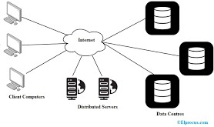

Figure 2.1 Basic component for Cloud Storage
Figure 2.1 demonstrates the minimal constituent to operate a cloud storage. It should have clients, Internet, server and Data bases where the data can be stored on the cloud.

2.1.2 Security Threats in Cloud Storage Environments
Storing a great number of sensitive documents and files leads to cloud storage systems becoming very tempting targets of malware attacks. As Shaikh F. (2021) indicates, an effective cloud storage solution should have good privacy and security assurance in order to secure confidential data that is stored on cloud environments. Nonetheless, irrespective of these security measures, cybercriminals are still using cloud-based services to spread and offer malicious files.
Software attacking cloud storage systems can be integrated into a broad assortment of data file formats, such as document, picture files, and executable files, compressed files, and multimedia files. These rogue files usually serve as vectors to concealed malicious code which occurs when the user downloads, opens, or engages with the compromised information. After activation, the payload can carry out unwelcome activities like installing new malware, backdoor creation, or remote access to the affected system. In contemporary malware attacks, the malware is now more advanced through the use of advanced evasion strategies like encoding, obfuscation, and benign behaviour mimicry to cover a malicious purpose in files (Kim et al., 2025). Harmful code is often disguised with the help of encoding and obfuscation that make it hard to detect the threat, which is identified correctly by the traditional signature-based detection systems. Also, certain malware programs are made to resemble the normal file behaviour which means that they can get by security checks and be in the computer without being detected over a long period.
Such malicious acts may have such dire consequences as stealing sensitive information, obtaining account access illegally, and taking advantage of threats to the cloud infrastructure. The reason is that one infect file in the cloud storage environment can endanger not only individual users but the whole system since the resources are shared, and services are interdependent. Consequently, the different kinds of malwares and their mode of attacks must be known to effectively come up with detection and prevention systems. This, consequently, makes the incorporation of advanced security solutions like AI-powered malware analysers into the cloud storage systems a requirement. Such solutions have the capacity of analysing file features and pattern of behaviour with the view of detecting concealed threats and, thus, promoting the overall privacy, security and credibility of cloud storage systems. (Kim et al., 2025)

2.2 Types of Malware
The malwares are of various types, each having a different malicious function to maliciously operate. Viruses bind themselves to the legal files and proliferate upon the execution of the infected file. The worms are automatically spread throughout networks without human intervention. Trojans will masquerade as authoritative software to trick the user into running the Trojan. Ransomware is an encrypted user data that requires money in order to unlock the data, and spyware is the third software that silently gathers user passwords and other personal data. These varieties of malware indicate how diverse the threat environment of the contemporary computing setting can be.

2.2.1 Document-Based Malware
Document based malware is the malware software that is presented in the form of files and Microsoft office documents like word, Excel, and PowerPoint. The reason why these types of files are often exploited is the fact that they are highly trusted and are commonly transferred both in personal and organizational settings. Consequently, such files have more chances to be opened without any suspicion by the users, and the malware delivery is more likely to be successful.
A document-based attack is when the threat actors use the documents as vectors of shipping and implementing malicious payloads. It is done with the help of taking advantage of the particularities of document formats or the vulnerabilities of a document reader application that allows running the harmful code by opening the file (Liu et al., 2025). The scripts, macros or exploit code embedded in malicious documents will automatically execute when the documents are opened and enable attackers to obtain unauthorized access, or install other malware or steal sensitive information.
The phishing campaigns are particularly vulnerable to document-based malware because it is widely used to deceive users. Attackers usually masquerade as reputable parties or known bodies like banks or government to convince the victims to open the malicious file. By doing so, victims can share their secrets, such as their bank account or credit and debit cards, passwords, and other personal identity details, without realizing it (Yahva et al., 2021). Social engineering and technical exploitation combined further complicate the situation with document-based malware as a constant and a major issue in the contemporary cybersecurity environments.

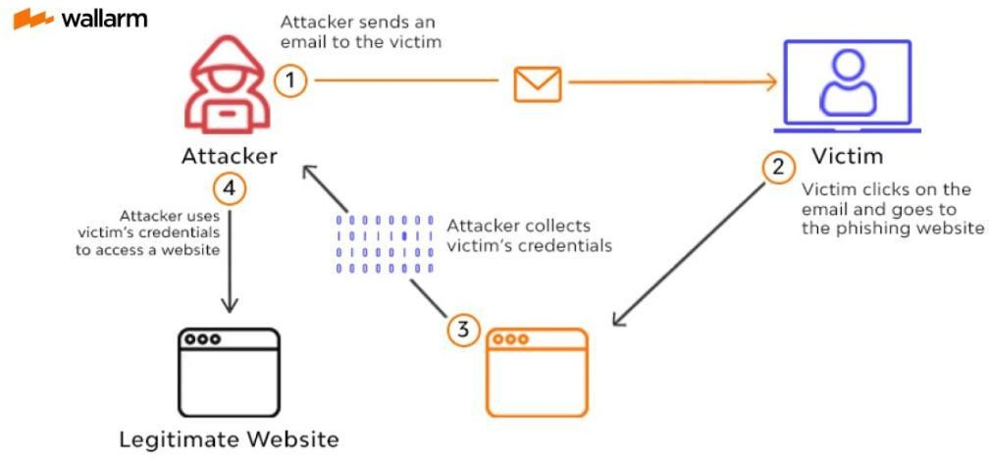

Figure 2.2 Phishing attack situation.

2.2.2 Executable and Script-Based Malware
Executable and script malware Executable and script malware can also be defined as malicious programs presented in these formats: executable (.exe) and script files (.bat, .sh), and scripts written in high-level programming languages such as Python, JavaScript. These files are not the documents based malware, but clearly crafted files, which are set to maliciously operate on the target system once executed. This can be unauthorized access to the system, data leakage, or introduction of other malicious codes. (Cosovan et al., 2021)
The attackers usually take advantage of the popularity and functionality of popular software to share executable and script-based viruses. To illustrate, from the moment the first vulnerability of Adobe Reader was detected in 2008, files have been actively misused as vectors of attack because of a high number of users and the ability to use embedded JavaScript to execute malicious code in the form of scripts within the documents (Cosovan et al., 2021). This has enabled the attackers to integrate executable behaviour with script-based methods to make their attacks more effective.
Executable and script based malware is a major security challenge in cloud storage set ups. The threat actors can also intentionally masquerade as malicious executables as harmless or valid files, e.g. software patches or utility software, to avoid detection systems. After these files have been downloaded and run by the end users, they are able to breach local systems and even connected cloud environments and this points out the necessity of sophisticated methods of detecting malware, especially those that use artificial intelligence. (Cosovan et al., 2021)

2.2.3 Archive and Multimedia-Based Malware
A common attack method is the use of polyglot files containing compressed archive files like ZIP, RAR, and other compressed files as a container to introduce malicious content into a single file system (Koch et al., 2025). These files are designed to be considered as a variety of valid file types, so that malware can be concealed in a way that is not detected by more traditional security services. Similarly, multimedia content can also be weaponized like images, videos and used to carry on the hidden malware via steganography or malformed file structures.
The use of stealthy and malicious communication through the use of information hiding and steganographic channels is increasingly becoming commonplace in real life cyber attacks (Vielhauer et al., 2025). By embedding their malicious software inside harmless-looking media files, cybercriminals can communicate covertly or carry out their plans without suspicion. Such advanced hiding systems allow enemies to circumvent traditional detection tools, which are mainly based on file extensions or the analysis of the file type, which is a great challenge to the current security systems.
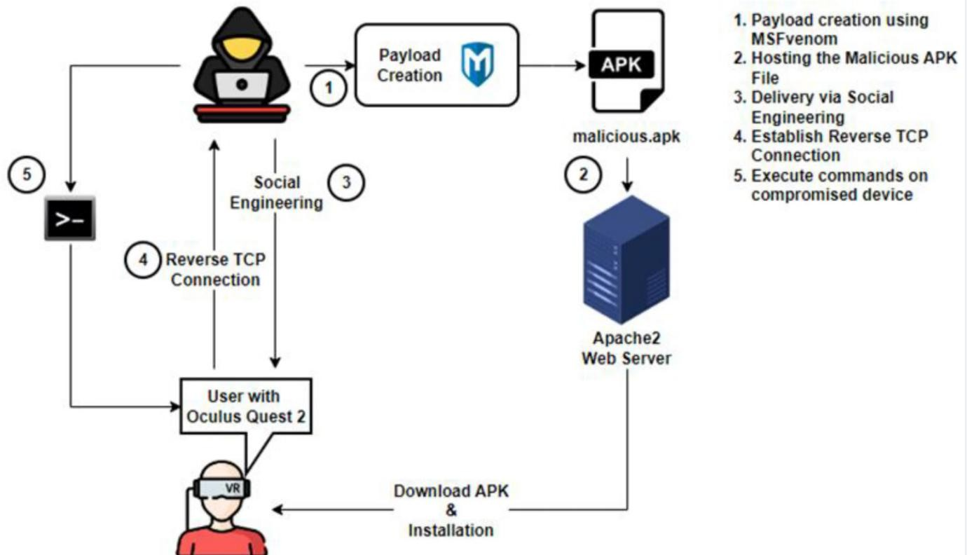

Figure 2.3 Payload Attack Situation.

2.3 Malware Detection Approaches
Malware detection: The cloud-based storage systems constitute a crucial security need because many and varied files are uploaded by the users. Cloud systems usually use dynamic analysis and static analysis as a complementary method of detection to protect as well as function effectively. Although dynamic analysis offers a better understanding of behavior, static analysis would be better since it is the most appropriate detection mechanism in cloud settings because it is fast, scalable, and safe. As such, this project uses the method of malware detection by utilizing the use of a static analysis as the primary choice.

2.3.1 Static Analysis for Malware Detection
The process of examining the code, metadata, and internal structure of a file but not executing the file is called the static analysis (Sinha and Sai, 2023). It is especially efficient in the cloud where it can be dangerous to execute untrusted files. In spite of the fact that the use of the concept of a static analysis can be carried out on its own, very frequently it is accompanied by the dynamic analysis to create a complete malware detection approach (Sinha & Sai, 2023).
Recent studies have gone further to develop the concept of static analysis beyond conventional signature-based detection into an approach where document formats like PDF files are viewed as binary executables. This allows a more in-depth structural and semantic analysis of files, which can identify malicious intent even where the code is highly obfuscated (Liu et al., 2025).
The process of modern static analysis usually involves the following stages of work. The first step involves creating an Intermediate Representation (IR) which in this case is the PDF Object Intermediate Representation (PDFObj IR). This IR can transform PDF objects into an assembly-style, low-level representation that can be analyzed in detail to examine internal code structures (Liu et al., 2025).
This is followed by the extraction of semantic features, based on pre-trained language models, of the IR to allow the system to obtain the underlying intent or purpose of embedded code as opposed to simply relying on the surface-level syntax (Liu et al., 2025).
Lastly, structural features are determined by building a Graph of Object References, which is a model that describes object relationships to each other in the file. This graph has the ability to detect anomalies that are hard to pick up by other tools (v.e. irregular object reference or covert executable) which are powerful indicators of malicious activity (Liu et al., 2025). All these steps
allow the passive files of malware to be converted into rich feature sets which can be used to classify malware using artificial intelligence.

2.3.2 Dynamic Analysis for Malware Detection
Dynamic analysis tracks a file’s behaviour when it runs on a CPU to identify malware by looking for file-processing activity on the Operating System such as memory allocation, creating and deleting files and communicating with other computers via a network (Katkar et al., 2021). This technique is very effective for identifying obfuscated or polymorphic malware which can escape detection using static methods.
In dynamic analysis, it is necessary to run the malware in a safe and secure way; this is done by executing the malware in a separate virtualised environment, or “sandbox” (Sinha & Sai, 2023). Many sandbox technologies are now available to safely run malware to collect extensive behavioural data on the actions of the malware; for example, Docker enables the protection of the host system while allowing detailed analysis of its activities (Sinha & Sai, 2023).

2.3.3 Justification for Using Static Analysis
The use of dynamic analyses to identify malicious programmes relies on the observation of how a programme behaves when it is executed in a computer system. During an execution, dynamic analysis focuses on how a programme interacts with the computer system, such as by manipulating files stored on the computer, using the computer's memory or communicating with the network (Katkar et al., 2021). Dynamic analysis is particularly useful when identifying obfuscated or polymorphic versions of malware that would normally be ignored by a static analysis.
Dynamic analyses, conducted using sandbox software (Sinha & Sai, 2023), are executed in a secure, isolated virtual environment called a sandbox. Technologies such as Docker do not allow any form of malware to escape from the sandbox and inflict damage on the host computer while also providing detailed information about how the malware executes (Sinha & Sai, 2023). Based on the execution trace provided during a sandbox analysis, researchers can develop a "Malware Infection Tree" that graphically depicts how and when malicious actions were taken during the malware's execution (Ghosh K, 2015).
However, dynamic analysis is very resource-intensive compared to static analysis, meaning that it takes a lot of computer processing power to conduct dynamic analysis, making it less
scalable than static analysis. Any malware that detects a sandbox will also often change its behaviour or stop execution to avoid being detected by static analysis techniques (Sinha & Sai, 2023). Therefore, dynamic analysis cannot be relied upon as the primary means to identify malware within a large volume of data in a cloud environment.

Table 2.1 Comparison analysis method

Criteria | Static Analysis | Dynamic Analysis | Signature Based-  detection
Analysis Method | Examines files without executing them by extracting features such as opcode sequences, permissions, metadata, byte  patterns, and  structure | Executes malware in a sandbox or virtual environment and observes runtime behavior | Matches files against a database of known malware signatures
Security Risk | Safe | Risky | Safe
Scalability | High | Poor | High
Detection Speed | Fast | Slow | Very Fast
Suitability for AI Integration | Excellent for ideal for ML classification  models | Limited | Poor
Cloud Storage Compatibility | Highly suitable  because pre-upload scanning | Not suitable for real-time uploads | Suitable but weak security
Overall  Effectiveness | High | Low | Low

Several key reasons exist for adopting Static analysis as the preferred method for this project, as shown in Table 2.1. The primary reason for utilizing Static analysis is its high level of safety. By not executing malicious files, Static analysis removes any chance of a system being compromised. Additionally, Static analysis can be run with much less computational power than traditional methods. As discussed throughout this thesis, Static analysis is well suited to leveraging modern machine learning technologies. By combining Static analysis with Modern Machine Learning technologies, unknown and zero-day threats are also identified. This combination is vital for protecting against malware in today's cloud storage.
Another benefit of Static analysis is that it can be applied to large numbers of files concurrently. As mentioned previously, having the ability to scan large amounts of files using this methodology will greatly improve the performance of a secure cloud storage solution. The AI malware analyzer developed for this project is based on this methodology.

2.4 Limitations of Traditional Malware Detection in Cloud Storage
Traditional malware detectors cannot keep pace with today’s malware, due to the amount of malware that exists and the complexity of the many new forms of malware being created every day (Ghosh et al., 2021), especially in an environment characterized by such a high volume of data such as Cloud Storage.

2.4.1 Signature-Based Detection Limitations
Signature-based Detection Methods, used in conventional Intrusion Detection Systems (IDS), have several inherent limitations that diminish their ability to provide an effective defensive measure against modern threats. The primary limitation is that signature-based methods are incapable of detecting new threats. This limitation is since signature-based methods rely on a signature database composed of previously detected malware signature entries . In addition, these types of systems also produce a high False Positive Rate (FPR) and generate many unnecessary alert notifications and often over-utilize the resources of the detection system . Therefore, traditional malware detection methods cannot be relied upon to provide a reliable identification of unknown malware (Patel & Ghosh, 2024).

2.4.2 Zero-Day and Polymorphic Malware Challenges
New Issues Related To Malware That Nobody Knows About: The term New Issues Related To Malware That Nobody Knows About refers to malware that's newly revealed and/or no one has previously encountered; consequently, there are no existing anti-malware products to deal with them as of yet (Deldar & Abadi, 2024). Because of both the newness of these threats and the complete lack of methodologies for mitigating these kinds of threats, it is extremely difficult for cyber security professionals to identify and defend against these types of malwares .
Malware That Changes Its Structure: This type of malware includes malware that will continually change its code while maintaining its function as malware. Malware embedded within web-based software (e.g., Javascript based) often utilizes metamorphic techniques that continuously alter their appearance (Cosovan et al., 2021). Therefore, the polymorphic characteristic of such malware would be difficult for signature-based detection systems to identify because a single piece of malware may be recognized at the level of tens of thousands based on its changes to its appearance until its finally identified. High rates of false positive and false negative responses typify the general inability of conventional security systems to deal with unknown and polymorphic malware variants (Patel & Ghosh, 2024).

2.4.3 False Positives and False Negatives
The large amount of both false positives (FPs) and false negative (FNs) produced through conventional malware detection methods is a significant aspect of the failure of these methods in protecting computer systems against malicious attacks (Patel & Ghosh, 2024). Specifically, the presence of a high number of FPs creates security fatigue where users regard some legitimate files as malicious and also fail to use up the valuable time and resources that they would use to investigate possible instances of malware in connection with the legitimate file. The high number of FNs associated with traditional malware detection methods means that computer systems continue to be exposed to threats that go undetected until they compromise the security of the computer system (Patel & Ghosh, 2024). For example, optimized and payload-aware IDS frameworks such as those developed with the Xavier-CMAE model are designed to minimize both the amount of time and the amount of effort put into investigations related to detecting FPs; as a result, elite models provide exceptionally low FP Rates, with some reported FP Rates as low as
0.0182% Click or tap here to enter text. clearly demonstrating what modern systems based on AI are striving to achieve.

2.5 Machine Learning for Malware Detection
The use of Machine Learning (ML) to detect malware is quickly becoming the most popular research area associated with malware detection today (Kim et al., 2025). AI-based products are much more flexible and can generalize information for various types of systems than traditional (i.e. signature-based) approaches (Kim et al., 2025). As a result, ML-driven PDF malware classifiers have become popular among researchers because they provide very accurate results when it comes to identifying PDF malware (Liu & Matuszek, 2025). In addition, the use of Large Language Models (LLM) is changing both how threats are detected and how they are created on the fly (Ahi & Valizadeh, 2025).

2.5.1 Common Machine Learning Algorithms
Various models, both in statistical and machine learning, have been developed to assist with the detection of Malware. For the base detection of JavaScript Malware, a recommendation is to implement Hidden Markov Models based on Probability as well as Linear Classifiers. The AMD-XAI-ML framework provided an extensive test of nine different Machine Learning models using a benchmark dataset to highlight the multiple types of algorithms used for this purpose in the Android Malware Detection Field (Liu et al., 2025).

2.5.2 Feature Engineering for Multi-File Malware Detection
High-quality feature engineering is a key determinant of both the accuracy and dependability of any Machine-learning detection system. However, the persistent problem of feature instability remains an obstacle to producing effective detection models, regardless of the sophistication of modern machine-learning methodologies, as evidenced by the continuing reliance upon historical feature engineering strategies when utilizing 'feature extraction' techniques for the classification of different file formats (Liu et al., 2025), therefore, as a solution to this issue, contemporary methodologies are designed to produce highly discriminative features that can better represent an extensive variety of different types of documents.
While examining file types, for example, structural features utilize Object Reference

Graphs to evaluate the file's structure and integrity. On the other hand, semantic features utilize techniques such as PDFObjIR to characterize the relationship between a document's components, but emphasise on a more semantic level through extracting meaning from each component (Liu et al., 2025).
The payload-centric method of identifying malicious activity continues to rise in popularity within current-day Intrusion Detection Systems. This technique identifies distinct non-statistical characteristics associated with the malicious Payloads. The acceleration of this technique comes from the use of the innovative Tokenization techniques, Hex2Int, and the application of Pre-trained Large Language Model Tokenizers. These tokenisation methods allow Intrusion Detection Systems to conduct comprehensive and contextually informed analysis of these sophisticated payload-based attacks (Kim et al., 2025).

2.5.3 Recent Studies on AI-Based Malware Detection in Cloud Systems
Recent research has produced substantial advancements in creating very specialized and effective Artificial Intelligence (AI) models to improve security within both a networked environment and file-based environment. One such advancement is called Payload-Aware Intrusion Detection Systems (IDS), which implements a dual-path design of two different AI Models: Xavier-CMAE, which features real-time scalability with an accuracy percentage of 99.9718% and a False Positive Rate of 0.0182%; and the LLM-CMAE, which uses pre-trained Large Language Model tokenizers so that the alerts are contextually informed, while providing 99.9696% accuracy and an FPR of 0.0194% (Kim et al., 2025).
Another notable innovation is Small Sample Detection, which uses distance-based analytic techniques to allow for effective detection of malware present in files using only a small training dataset—specifically, only twenty (20) benign documents. Research suggests that this technique, has the potential of detecting upwards of 90.50% of malware samples and thus being a valid approach for organisations that may not have the benefit of sufficient training datasets (Liu & Matuszek, 2025).
The incorporation of Explainable AI (XAI) into Malware Detection Frameworks represents a significant advancement in the development of cyber security tools that are interpretable. For example, the AMD-XAI-ML framework will be one of the first systems created with XAI specifically for detecting Android malware (Patel & Ghosh, 2024). By utilising XAI methodology,

security analysts can better understand the reasons for the assigned classifications, which will help to establish greater confidence, accountability and responsiveness in mitigating threats.

2.6 Feature Extraction Techniques
According to Deldar and Abadi (2023), the process of feature extraction is essential and the most important first step of any complex deep learning based malware detection system. Early versions of AI detection systems (i.e. pre-Deep Learning), however, limited the number and types of features used, resulting in very basic feature representations (flow or only statistical information) and therefore, very constrained interpretation of more complex attacks that include payloads, such as (Kim et al., 2025).

2.6.1 Structural Features
The way a file is arranged gives clues to the user about the intent behind it, and that includes documents like PDF files. Structural Features provide detailed insight into the internal structure of the file using an Object Reference Graph that models how these files interact with other files and how they relate to each other; this is especially helpful for identifying malicious documents. Analyzing Structural Features is essential in detecting malicious files.

2.6.2 Content and Script-Based Features
The modern technique of analyzing content through contemporary methods is far superior to prior to 2020 as it provides the analyst with a more diverse and adjustable set of tools to perform their analysis on content. Current algorithms allow the extraction of a much greater range of methods from digital items than simply searching for specific keywords. Prior to 2020, the only technique available for conducting a content analysis was to search for key words.
The development of semantic features is considered a significant step forward as classifiers for semantic features use the semantic representation of a file's attributes so that the classifier can better evaluate the meaning of that file. In addition, classifiers use large language models that have already been trained to analyse the semantic properties of each file (R. Liu et al., 2023)
Another key development is the use of payload characteristics in intrusion detection systems (IDS). IDSs currently use advanced tokenization techniques to analyze malicious payloads more efficiently than was possible before. Some of the methods that IDSs are currently using include Hex2Int and tokenized LLMs. Therefore, IDS can identify low complexity file and

network threats at a more sophisticated level than ever before. This capability is made possible by incorporating method-based analysis with the traditional signature-based approach to intrusion detection (Kim et al, 2025).

2.6.3 Metadata and Statistical Features
Smutz and Stavrou (2021) found that various attributes within malicious files can reveal their intent using metadata attributes to identify the creator/designer of the file, time/date it was created, and other header-type information that can be extracted via different detection techniques. Yet, Smutz and Stavrou (2021) also showed that performing analysis on flow-level or statistical data alone will not provide as great of an analytical capability as when utilizing flow-level and statistical data in conjunction with other types of attacks (Kim et al., 2025).

2.7 Datasets for Cloud Malware Detection Research
The datasets utilized in developing, training, and evaluating AI-based malware-detection systems are key, meaning that the overall performance of the machine-learning model created is heavily dependent on the dataset used. Datasets used to train and test the AI-based malware detection system should also cover as many different file types, attack vectors, and evasion methods as is reasonably possible to ensure the trained AI-based malware detection system's capabilities align with those in real-world environments.

2.7.1 Challenges in Dataset Collection
Creating useful and representative malware datasets is one of the main focuses of document security research since how well a malware detection function operates depends heavily on the quality, diversity and realism of the datasets they’re trained and evaluated on (Nicholas, 2025). Developers of comprehensive datasets should strive to include a variety of malware behaviours, file formats and obfuscation methods so that Detection Models can generalise effectively to real threats. Incomplete datasets will negatively impact the detection rate, lead to increased false positivity rates and, consequently, reduce the level of robustness when faced with unseen malware variations.
There is a need for urgent evaluation concerning Rapid Advancements in and Increased Acceptance of Generative Artificial Intelligence (GenAI) because GenAI permits the automated production of high-scale and evasive types of malware. The capability of GenAI to generate

polymorphic malware, adversarial files and misleading payloads makes it impossible to rely on previous curation and validation of datasets; therefore, the process of ensuring the integrity, consistency and risk-conformity of datasets continues to be more and more difficult.
To solve these problems, researchers have created a Quality Assurance (QA) framework that will assist in developing high-quality multimodal assessment datasets that can identify the many varied risk factors introduced by the use of GenAI (Han et al., 2025). This framework will provide for systematic validation of risk annotation and cross-modal consistency checks for text-based, image-based, execution-based, and script-based layers. The use of a structured QA process will allow for improving the reliability of datasets, increasing the effectiveness of AI-based models for malware detection, and protecting the entire document security system from the new threats created by GenAI.

2.7.2 Balanced and Imbalanced Dataset Considerations
One of the main problems associated with the use of imbalanced datasets for Classification in Machine Learning deals with building classifiers capable of identifying Malicious and Benign files. In most cases, the number of Benign files that are available for use in the training data is significantly more than that of Malicious files within the dataset. As a result, Classifiers built using imbalanced training data sets typically have an inherent Bias toward the majority class (Benign) which causes them to have limited capability to accurately classify Malicious files (especially) and results in poor Generalization performance in real-world situations (Kumar et al., 2025). When trained on skewed training datasets, Models can present a false sense of High Overall Accuracy, even though the Model has Failed to capture/identify the presence of significant threats; this phenomenon (Accuracy Paradox) is well-documented within the literature. To address this issue, researchers have developed numerous techniques for balancing the class distribution in the dataset, prior to building a Machine Learning Model.
Oversampling, undersampling, and hybrid techniques such as SMOTE are data level techniques to balance class imbalances in datasets (Kumar et al. 2025). Ensemble methods combine sampling methods with algorithmic changes to address classifier imbalance issues. These techniques must be used appropriately to train classifiers on a representative sample of data to increase metrics such as precision, recall, and F1 score for minority classes. In file malware analysis, the availability of balanced datasets (i.e., the use of established datasets such as Contagio) is important to fairly evaluate and validate detection models, which in turn allows the development
of reliable and fair AI-based security systems (Kumar et al. 2025).

2.8 Encryption Algorithm
Encryption algorithms protect data in digital forms while it is being stored (Data at Rest), sent across a network (Data in Transit) and processed (Data in use). Encryption algorithms are the basis of all modern cryptography, which provides confidentiality, integrity and authentication of the information it protects. Encryption methods can be grouped into two categories; Symmetric Encryption and Asymmetric Encryption, and both types have specific uses because they operate differently and provide varying levels of security (Shilin et al., 2023; Mallouli et al., 2020).

2.8.1 Advance Encryption Standard (AES)
Widely recognized as a critical element in the contemporary field of information security, the Advanced Encryption Standard (AES) is an established symmetric encryption algorithm. AES applies a fixed block size of 128 bits and supports a broad range of customisable key lengths including 128, 192 and 256 bits. This gives AES a high degree of customisability and allows many different configurations to be derived from it. The AES' substitution-permutation design is robust against differential and linear cryptographic attacks; in fact, AES provides excellent security for many forms of sensitive data including storage and telecommunications applications (Shilin et al., 2023). Additionally, AES's efficient operations will allow it to be used in situations where both speed and security are important. Recent research on enhanced AES includes securing dynamic key generation and providing even higher levels of security while preserving encryption efficiency (Awasthi & Kohli, 2025).


Figure 2.4 AES encryption architecture design
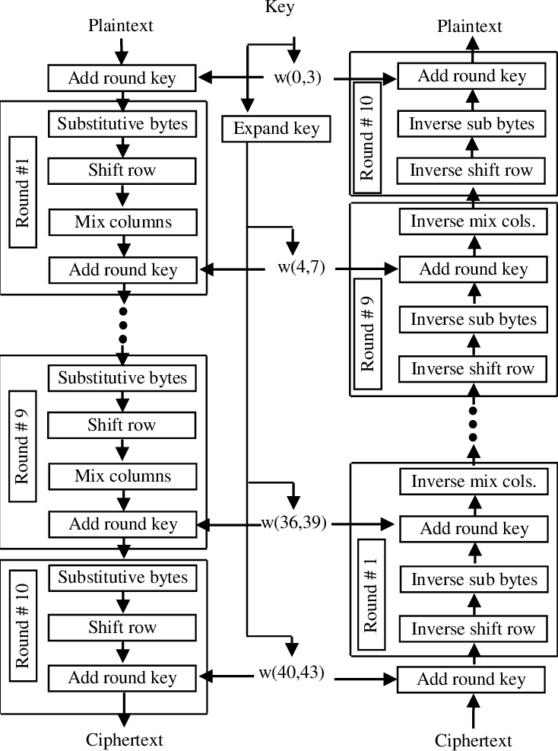

Figure 2.5 AES Encryption and decryption process diagram

Figure 2.4 and 2.5 Illustrate overview on how AES encryption works in storing data and files, including encryption and decryption process to maintain a secure encrypted data in system environment .

2.8.2 Data Encryption Standard
Although the Data Encryption Standard (DES) operated on 64-bit blocks and used a 56-bit key, its functionality has become obsolete due to the significant increase in computing power and therefore vulnerability to brute-force attack. However, DES provided the foundation for the creation of structured methods of securely sharing data and is an important stepping stone toward the development of new encryption technologies (Awasthi & Kohli, 2023). DES developed the building blocks for the creation of more advanced and secure encryption technologies, such as Triple DES (3DES) and AES, which provide longer key lengths and improved ability to withstand cryptanalysis.

2.8.3 RSA (Rivest-Shamic-Adleman)
The RSA algorithm is an asymmetric cryptography method developed by Rivest, Shamir, and Adleman, and is considered a fundamental method of asymmetric cryptography. RSA is based on the production of two secret keys: a public key used to encrypt data, and a private key used to decrypt the data. What makes RSA secure is that current computational techniques (as of February 2023) make it very difficult for attackers to reverse-engineer RSA encryption. RSA is considered the standard for secure data transmission and digital signature validation (Mallouli et al., 2020). Although RSA offers an extremely high level of security, it is computationally expensive, demanding a much larger number of processing resources to use RSA to encrypt data as key sizes grow larger and to then decrypt that data. This has resulted in the use of alternative more efficient algorithms (such as Elliptic Curve Cryptography (ECC))) as a replacement for RSA in some instances (Awasthi & Kohli, 2023; Mallouli et al., 2020).

2.8.4 Eliptic Curve Cryptography (ECC)
Asymmetric Encryption has advanced significantly through the introduction of Elliptic Curve Cryptography (ECC). In contrast to RSA, which has larger key sizes needed to provide the same level of security as ECC (example: 256-bit ECC provides the same level of security as a 3072-bit RSA key (Mallouli et al., 2020)), ECC's small key sizes offer a much more efficient option for users with limited resources, including mobile devices, Internet of Things (IoT) systems, and blockchain technologies. The mathematical basis for ECC is its algebraic structure in the Equation of an Elliptical Curve intersecting a Finite Field. This allows for ECC to provide secure key exchanges, digital signatures, and Encryption. Because of the computational efficiency and scalability of ECC, it is increasingly being adopted in modern Security Protocols (Shilin et al., 2023; Mallouli et al., 2020).

2.8.5 Comparison of Encryption Algorithms and Focus on AES
Encryption algorithms are essential to protecting data sent to and from cloud storage solutions, as well as in "rest mode", meaning it is not actively being accessed or printed. For example, symmetric encryption algorithms (e.g., AES and DES) provide fast encryption speeds and efficient operations. On the other hand, asymmetric encryption algorithms (e.g., RSA and ECC) provide secure methods of managing digital certificates and authenticating users to those certificates. The algorithm selected will depend on the specific security needs of the cloud storage system and the user.
Because the algorithm that has become most commonly used is AES, there is a high demand for the algorithm's ease of use and high level of security with a low amount of computational overhead. AES outperforms DES by providing significantly higher levels of security with greater computational efficiency through its ability to support key lengths of 128, 192, or 256 bits versus DES, which provides only a 56-bit key that is easily broken through brute-force attacks. RSA and ECC provide essential tools for creating secure key exchanges and digital signatures, but the computational overhead produced by these asymmetric algorithms makes them less suitable for encrypting large datasets that stored in cloud servers. For example, a minimum of 3072-bits of RSA key length would be needed to provide equivalent protection to a single 256-bit AES key (Mallouli et al., 2020).
Cloud storage applications are well-suited for AES due to their large amounts of data. AES encrypts/decrypts files with minimum latency, making it easy to integrate into cloud workflows. Furthermore, new implementations of AES, such as using hardware acceleration or parallel processing, have improved overall performance within cloud environments. This improvement allows AES to encrypt data while being transmitted over encrypted communication channels and protect it when stored on servers (Shilin et al., 2023; Awasthi & Kohli, 2023).
AES is also a good fit for secure multi-tenant environments because it can encrypt each user's data independently. This provides isolation and confidentiality for each user. This is particularly useful for public or hybrid cloud infrastructures, which are shared by many different users/organizations who store their data in the same environment. As cloud storage continues to grow and evolve, AES will continue to play a critical role in solving current and future data security issues. Table 2.2 illustrates various cryptographic methods and how they compare and show how AES is an excellent fit for the project.

Table 2.2 Comparison of Cryptographic Method

 | RSA | AES | ECC | DES
ALGORTIHM TYPE | ASYMMETRIC | SYMMETRIC | ASYMMETRIC | SYMMETRIC
KEY LENGTH | 2048 TO 4096 BITS | 128,192 OR 256 BITS | VARIES | 56 BITS
SECURITY | HIGH | HIGH | MODERATE | MODERATE
SPEED | MODERATE TO SLOW | FAST | FAST | FAST
USE CASES | SECURE DATA TRANSMISSION, DIGITAL SIGNATURES | ENCRYPTING ELECTRONIC DATA | ENCRYPTION, SIGNATURES, KEY EXCHANGE | ENCRYTPTION ELECTRONIC DATA

2.9 Research Gap and Justification
Overall, while the literature indicates significant advancements in the use of AI for the identification of malware and the security of data stored in cloud environments, there is still an apparent disconnect between implementing these technologies into a fully-integrated end-to-end secure framework for cloud storage. While there are numerous studies focusing on specific components within the field such as payload-aware Intrusion Detection Systems (IDS), adversarial-robust (AR) file analysis, and cryptography (GDPR-compliant) for safeguarding sensitive information, very few have attempted to create a system that effectively combines the functions of AI-based malware scanning with automated Encryption & Data Storage.while some products have attempted to combine the two functions into one, the majority of current products treat the functions of malware detection and data encryption as separate processes. As a result, there is often a delay in operational effectiveness from when malware is detected until when the encrypted file is saved and this creates multiple points for security failure.
Additionally, a large portion of current research into AI-based malware is limited to narrow and particularised fields such as Android apps (Patel & Ghosh 2024) and network threats but does not take into account the potential for developing cloud-native detection solutions for Document malware types such as PDF files. Though PDF files are widely
accepted and referenced in literature as an attack vector (Liu et al. 2025) there are few well developed and comprehensive frameworks that would integrate the Static Analysis component of an AI powered model directly into a cloud storage file up-load channel prior to transferring the file to an end-user. Lastly, although complex models can produce high correct decision rates when tested in controlled laboratory conditions it is difficult to find sufficient published material outlining how such models can effectively be packaged and provided as simple and low-cost API services that are compatible with popular web programming languages such as PHP and NodeJS, creating a significant disconnect between current theoretical work on AI-based malware protection and how the tools can be practically deployed to produce results on a scalable basis.
The direct response of this project to these gaps represents the justification for this study's inception. This Secure Cloud Storage System with AI-based Malware Analysis that utilizes AES Encryption will create a singular work flow toward attaining holistic security for both organizations and individual users. This Secure Cloud Storage System assures that the security provided by AI Malware Analysis is a prerequisite for both encryption and storage thus reinforcing Confidentiality, Integrity, and Availability (CIA) security principles (Carvalho et al., 2017). This project has a primary focus on Static File Analysis that addresses a common vector for attack through cloud-style environments on a scalable basis (Sinha & Sai, 2023). Building on the concepts of the Python Flask API for the delivery of AI Malware Analysis and the web-based user interface to perform Secure Cloud Storage, this study will provide a working and capable architecture that fills the gap between past academic research in cybersecurity and actual implementation of cybersecurity technologies. This study will provide an automated, proactive defense against future threats of Zero-Day Malware and polymorphic malware by fulfilling a critical demand in the security model for Cloud-style Storage.

2.9 Summary of Related Works

Table 2.3 Related Works

Title | Key Features | Strengths | Limitations | Proposed Solution
Secure File Storage on Cloud Using Hybrid Cryptography (Sharma et al., 2020) | AES, ElGamal encryption, SHA-256, and 2FA | Strong encryption with 2FA  authentication | Lacks malware detection capabilities | Adds malware analyzer to prevent malicious file uploads
Improved Cloud Storage Security Using Three Layers Cryptography Algorithms (Kumar et al., 2020) | AES, ECC, and  RSA-based multi-layer encryption | Robust key management and encryption | High computational cost, no malware detection | Simplifies encryption using AES and integrates malware analyzer
Securing Cloud Storage Data Using Hybrid AES-ECC Cryptographic Approach (Chhabra & Gupta, 2021) | Combination of AES and ECC | Optimized for resource-constrained environments | Lacks malware detection mechanisms | Incorporates malware detection before encryption

Title | Key Features | Strengths | Limitations | Proposed Solution
Development of a Secure Web-Based Cloud Storage System Using 3D-AES Block Cipher Cryptography Algorithm (Ali & Hassan, 2019) | Enhanced AES block cipher | Advanced encryption techniques | Complex implementation, no malware detection | Balances security and efficiency with AES and malware analyzer
Enhanced AES Implementation (Feistel & S-Box  Extensions 2022) | AES enhanced with Feistel structure and SBox algorithm to increase encryption robustness. | Provides high security for data transmission and storage. | Slightly increases encryption and decryption time. | Focus on algorithmic  optimizations to reduce overhead while maintaining encryption strength.

2.10 Summary
In summary, the literature reviewed in this article shows tremendous progress in the security of cloud storage. There have been advances in the areas of encryption, data integrity and artificial intelligence-based malware detection. Past work has focused largely on the use of AES, RSA, ECC, or Hybrid Cryptographic algorithms for providing security to data within the cloud. Encryption alone is an effective means to protect data both at rest and while it is being transferred. However, the vast majority of existing solutions concentrate on encryption and access control, often ignoring malware detection at the time when an end-user uploads a file to a Cloud Service Provider (CSP). Therefore, encrypted cloud storage solutions run the risk of containing malicious files as well posing risks to both end-users and the cloud platform. AI-based malware detection technology has received much attention through studies conducted on various methods for detecting sophisticated threats like zero-day and polymorphic malware with the use of machine learning models and static analysis techniques. These studies show that these technologies can achieve very high levels of accuracy when detecting malware, while at the same time producing very low numbers of false positives,
however most of the time when conducting these studies, it is done in controlled lab environments or testing environments where these technologies have been implemented and used in real-world cloud storage infrastructure. Also, many AI-based malware detection systems focus on specific application domains such as Android applications or network traffic, as opposed to supporting multinomial file types like documents, executables, archives and multimedia files that are processed through cloud storage solutions.
There is a lack of integrated secure cloud storage systems that provide both an AI-based malware analysis process and an efficient encryption mechanism. Malware detection and encryption are treated as separate processes by most current solutions which creates vulnerabilities and reduced operational efficiencies for cloud environments. To address the identified limitation, the proposed system uses static-analysis based AI malware analysis as a prerequisite to secure uploading of files into the cloud environment, followed by AES encryption to securely store the data in the cloud. This integration allows for increased confidentiality, integrity, and availability of the stored data while allowing for continued scalability and suitability for large volume(s) of cloud solutions. The final outcome of this project will be to develop an entirely integrated approach that bridges the gap between theoretical and practical implementations and ultimately provides a cohesive and deployable solution to improve the security of cloud storage from modern and continuously changing types of malware threats.

CHAPTER 3 : METHODOLOGY

Introduction
This section explains how the research was conducted and which approach was taken to complete this project. The approach used by this researcher is the methodology that was used as a structure for the completion of the project on time. Furthermore, this chapter provided a detailed step by step process for the Secure Cloud Storage with AI Malware Analysis and AES Encryption; how this was planned, designed, developed, and tested as part of the project's overall functionality and success.

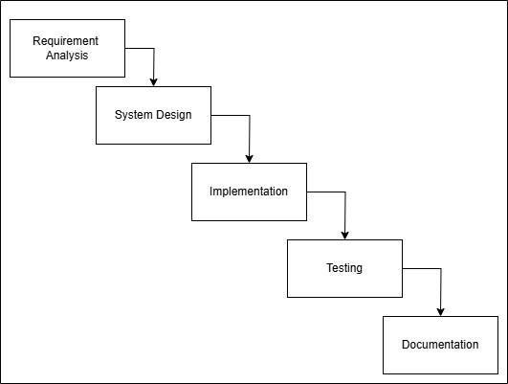
Project Framework

Figure 3.1 Waterfall Model

Figure 3.1 illustrated the Waterfall model used to develop the "Secure Cloud Storage with AI Malware Analyzer and AES Encryption" project, aiming to achieve the objectives outlined in Chapter 1. This research methodology consists of six major phases, each with its own
processes: Requirement Gathering and Analysis, Design, Implementation, Testing and Documentation

Table 3.1 Waterfall model table

STAGES | TASK | DELIVERABLES
Requirement & Analysis | Preliminary research and literature review on the following topic:  - Performed initial research and review existing literature on Cloud Computing, Malware Analysis, Data Breaches, Encryption Algorithms.  - Outlined the background of the study, including the problem statement, objectives, scope, and significance of the research.  - Compared various mechanisms and techniques, identifying their strengths and weaknesses in relation to the proposed project | - A comprehensive review of literature on Cloud Computing, Data  Breaches, Artificial Intelligence, Encryption Algorithms, and Malware  - Clear definition of the background, problem statement, objectives, scope, and significance of the study  - A comparative analysis of different mechanisms and techniques, highlighting their strengths and weaknesses in the context of the Encryption Algorithm and Malware analysis.

STAGES | TASK | DELIVERABLES

System Design | Designed the system architecture, including the Artificial Intelligence, encryption, algorithm, flowchart, use case diagram, entity-relationship diagram, and user interface mock- up. | Detailed designs of the algorithm, flowchart, use case diagram, entity-relationship diagram, and user interface mock-up, providing a blueprint for the implementation phase.  - Implement artificial intelligence malware analysis in the project for file analyzing  - Implement the AES encryption and decryption functions.  - Develop the web application using appropriate technologies such as PHP, HTML,  CSS, Phyton
Implementation | - Implemented AI malware analysis phyton flask in the project for file analyzing  - Implemented the AES encryption and decryption functions.  - Developed the web application using appropriate technologies | A functional web-based secure cloud storage system with AI Malware Analyzer and AES encryption to protect data.

STAGES | TASK | DELIVERABLES
Testing | - Performed functional testing to ensure all components work as expected.  - Generated test cases to validate the system’s functionality, performance, and security. | Test results verifying that the system meets the specified requirements and functions correctly.
Documentation | Gathered and arranged all the project related information. | - Final report  - System of a proposed project

Requirement Analysis
In the first phase of the project, an initial study was conducted and various sources of literature were reviewed for the subject areas of Cloud Computing, Data Breaches, Encryption Algorithms, and Malware analysis. This is an important first step of the study to create a solid foundation and provide theoretical basis for the design and implementation of the project. This phase includes outlining the background of the project, including a problem statement, which outlines the gaps in currently available secure File Storage Systems and supports the identification of system requirements for secure File Storage in a cloud environment; objectives, which establish what the system is intended to achieve; and lastly, the scope of the project defines the boundaries of the project.
The literature review is conducted to compare techniques and technologies. For instance, various encryption algorithms are compared and contrasted based on several criteria, including security, efficiency, and performance. Other methods of Malware detection and analyzer are also analyzed to determine whether the methods can be used for the proposed project; therefore, the comparison will enable the analysis of strengths and weaknesses and allow the design of the proposed system to use tested solutions and improve the existing solutions.

Software
Software requirements are those requirements that outline the exact tools, programs, and systems required for a system to work correctly. As part of the system's requirements, the requirements will include the development tool sets needed (operating system, programming languages), as well as any required software (Development Frameworks) to provide support for implementing/executing features of the system (application software). For example, Phyton, PHP, MySQL, and a Web Server are all tools and systems that need to be in place to successfully implement/deploy this project.

Table 3.2 Software Requirements

Software  Component | Operating  System | Processor | Memory | Description
HTML | - | - | - | Hypertext Markup Language is used to  design the structure and content of online pages.
CSS | - | - | - | Cascading Style Sheets employed for styling and formatting HTML elements, enhancing the visual  presentation of web pages.
JavaScript | - | - | - | Programming language used to create dynamic and interactive effects within  web browsers.
Phyton | - | - | - | Main programming language for implementing the AI-based malware analyzer. It enables the development of machine learning models for static malware detection.

MySQL | Windows,  Linux, | 1.6 GHz  dual-core | 4 GB  RAM | Relational database management  system (RDBMS) used for storing and

Software  Component | Operating  System | Processor | Memory | Description
 | macOS | processor  or equivalent |  | managing project data.
PHP | Windows, Linux, macOS | 2.0 GHz  dual-core processor or equivalent | 2 GB RAM | PHP serves as the core programming language for the backend, managing file encryption (AES), malware scanning integration using Phyton flask for AI malware analyzing and server-side logic. It ensures seamless processing of user requests and secure  file handling.
Virus Total` API | - | - | - | An API service used to support analyze uploaded files for potential malware. Provides integration for secure file  scanning before storing in the cloud.
Google Cloud Platform (GCP) | Windows, Linux, macOS | 2.0 GHz  dual-core processor or equivalent | 2 GB RAM | GCP is cloud-based platform designed to simplify the deployment of web applications, APIs, and static websites. It is particularly popular for hosting applications due to its developer-friendly approach, seamless integration with Git, and support serverless  architecture and pay-per-use feature.
Visual Studio Code | Windows, Linux, macOS | 1.6 GHz or faster processor | 1 GB RAM | Microsoft released a free source-code editor for Windows, Linux, and macOS. Supported features include debugging, syntax highlighting, intelligent code completion, snippets, code refactoring, and Git integration.

Hardware
The main hardware requirements for a given system are the hardware resources or devices that must be available, including servers, storage systems, Ethernet (networking equipment), and all user-available I/O peripherals needed to run the system. The selection of the hardware required for running any system is based on the performance needs of the system, the scalability of the system as it grows over time, and how well the selected hardware works with the software being used by the system.

Table 3.3 Hardware Requirements

Hardware Component | Requirement Specifications
Laptop | 11th Gen Intel ® Core ™
Chipset | I5-1135g7
Ram | 16.0 GB
Operating System | Windows 11

Project Timeline
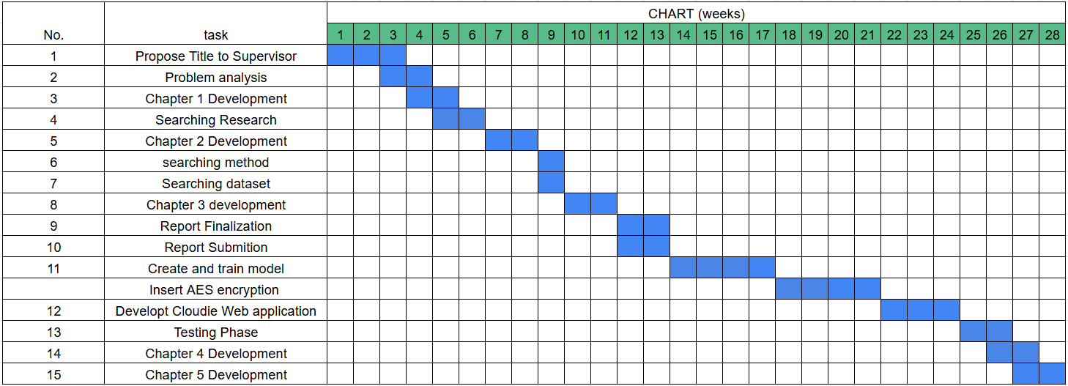

Figure 3.2 Project Gannt Chart

Table 3.4 Shows the timeline for this project for the whole development

System Design
In the "Secure Cloud Storage with AI Malware Analyzer and AES Encryption" project, the system design phase focused on a comprehensive architecture for integrating AI malware analysis combined with encryption technology to create a more secure environment for data. During this phase, the logical and physical elements of the system were defined and the structure and processes necessary to provide secure and easy-to-use cloud storage were established. The design phase is a process to design the system, and within this process, use case, flow chart, and interface designs were compiled to show how the proposed system would function.

Random Forest Machine Learning Model
In this work, a Random Forest is chosen as the primary machine learning tool for malware detection because it is effective, very accurate in classifying, and very effective at modelling high dimensional space or complicated sets of features. The Random Forest is built using the approach of an ensemble (the combination of many trees) which allows it to build multiple decision trees and produces its prediction from the majority vote of those trees, thus reducing overfitting and improving the accuracy of the Random Forest model. In this case, the Random Forest is trained on the statically derived feature set of different file types in a cloud storage system, using the metadata of the files, the structure of the files, and their statistical analysis. The Random Forest has the ability to model non-linear relationships and to withstand the effects of noise and redundant features, so it is very well-suited to static malware investigation. Furthermore, the trained Random Forest model comes along with different indicators that tell us which of the features are the most significant in determining if the document is malicious or not, thereby enhancing the malware detection process and adding transparency to the entire system.
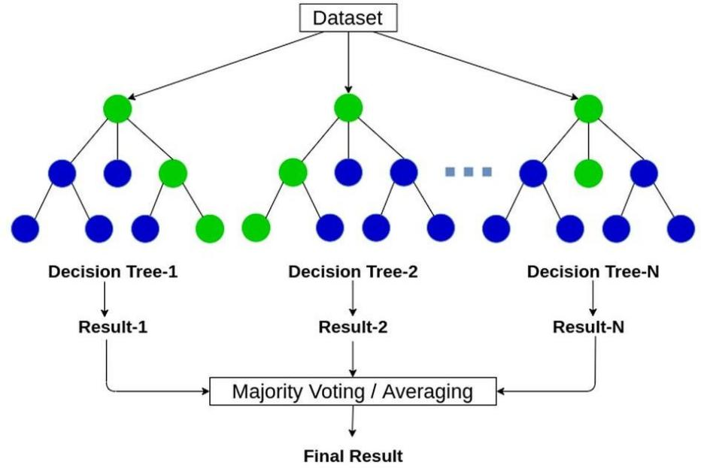

Figure 3.4 Random Forest Model

Dataset Used
Researchers employed a publicly available dataset of malware PDFs comprising 18,126 records that allow categorization between benign and malware PDFs. The researchers opted for this dataset because of its richness structurally and behaviorally in order to be used in attacks using malware PDFs. Each file from this collection was pre-analysed to extract relevant distinguishing traits for identifying malware and has the class label to identify if a file is benign or malicious, which will allow for supervised machine learning classification.
The dataset consisted of 32 feature extractions (excluding the filename) detailing the internal structure, content behavior, and metadata properties of PDF files. They are aimed to identify an individual's patterns of benign usage and the malicious behaviors of many PDF files, including embedded scripts, self-execution actions, and more suspicious object structure. The large dataset and the numerous features make this dataset ideal for developing and testing AI-based malware detection models.
The chosen dataset fits the goals and objectives of the proposed AI-based malware analysis tool for Cloud Storage systems. Because of how often a Cloud Storage Platform manages PDF files uploaded by users, it is imperative that the identification of malicious PDF files provides confidence in the integrity and privacy of user's data. Since the dataset is focused on specification of low-level PDF structures and embedded code execution behaviors, training models on this dataset can enable the identification of both "known" and "unknown" variants of malware.
Also, features including JavaScript execution, Embedded File Types and Automated Actions also are beneficial in identifying advanced and obfuscated malware exploitation techniques. This makes the dataset well suited to benchmark the performance of machine learning classification methods in identifying malicious files located in Cloud Storage environments.

Physical Design
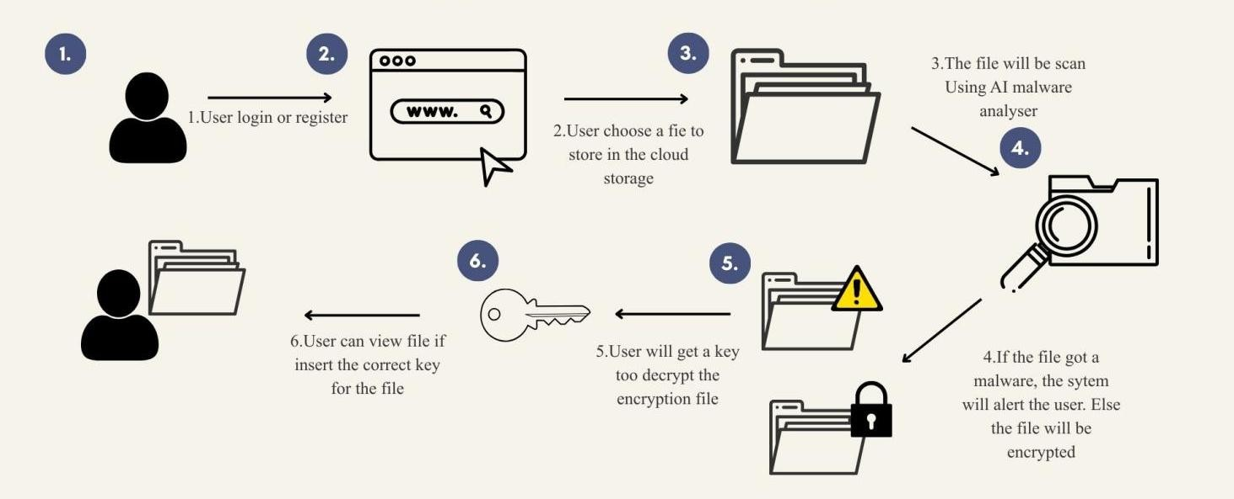

Figure 3.5 Physical Design of System

"Figure 3.5 depicts a physical diagram of the Cloudie system. The process starts when the user logs in or registers. After a successful login, the user selects a file to store. The system submits the file to a verdict engine that runs two checks in parallel: a VirusTotal signature-based scan and an AI-based structural analysis using the trained Random Forest model. For any file to be flagged as harmful or dangerous, it must first undergo a review by VirusTotal, which can render one of three decisions: flagging the file as malicious, marking it as clean, or classifying it as suspicious. If any file is labeled as malicious by VirusTotal, it cannot be saved, irrespective of what the AI analysis found. In the event that the report from VirusTotal indicates that the file is clean, but the analysis from AI reveals some doubts, while the file is stored, it is marked as suspicious, just to bring some awareness to the user. If both signals state that the file is clean, it is then saved just like any other file. An encrypted file is stored in a cloud storage bucket, while information about the file, the verdict, and the encryption key are stored in a managed SQL database. The encrypted file itself is stored in a cloud storage bucket, while file metadata, the verdict, a SHA-256 hash of the encryption key, and the initialisation vector are recorded in a separate managed SQL database. The key itself is never persisted: the user is provided with the AES key once, as both plain text and a QR code, and must supply it for any future decryption. . The user is then provided with the AES key as both plain text and a QR code for future decryption.

Use Case Diagram
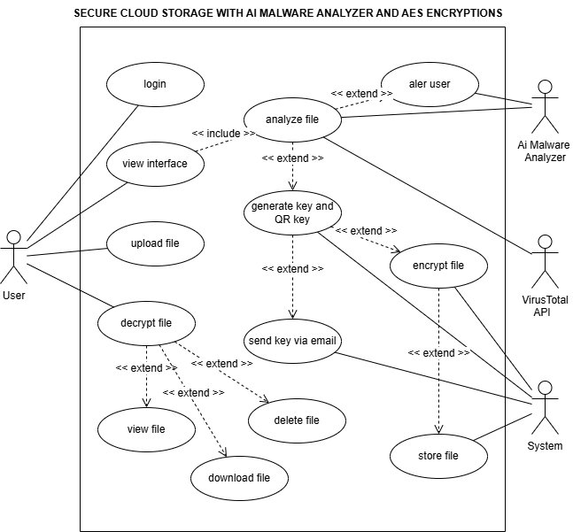

Figure 3.6 Use case diagram

In Figure 3.6, we see an illustration that helps to make clear the interaction between users, the system, and also the AI malware analyzer. Among the functions that we have discussed in this figure are file upload, malware analysis, encryption, secure storage, and file management. In the following table (see table 3.5) we will analyze the details of the proposed use case.

Table 3.3 Use Case Description Table

Use Case Diagram | Login
Actors | User
Description | The user input their login credentials to gain access to the cloudie  Basic Path:  1. User enters valid credentials and is authenticated by the system.  Alternate Path:  Invalid credentials trigger an error and retry prompt.

Use Case Diagram | View Interface
Actors | User
Description | After logging in, the use able to see the dashboard interface where they can upload file or take action to the stored file  Basic Path:  - The interface loads successfully.  - User choose the action on the interface  Alternate Path:  System fails to load the interface and shows an error message.

Use Case Diagram | Upload File
Actors | User
Description | The user uploads a file to the system,  Basic Path:  - The user chooses the file to be upload.  - The fie is successfully uploaded.  Alternate Path:  Upload fails due to file format issues, size, or network errors.

Use Case Diagram | Analyze File
Actors | AI Malware Analyzer, VirusTotal API
Description | Upon uploading, the system forwards the file to VirusTotal for signature-based detection and to the AI algorithms for structural inspection. The verdict engine synthesizes the findings into one of the three categories: clean, suspicious, or malicious.  Basic Path:  - File is scanned by AI model and Virus total in parallel  - Results will be noticed to the user  Alternate Path:  The analyzer encounters errors and notifies the user to retry.

Use Case Diagram | Alert User
Actors | AI Malware Analyzer, User
Description | The system alerts the user about the malware analysis results, recommending further actions if threats are found.  Basic Path:  1. The user receives an alert regarding threats.  Alternate Path:  Alerts fail, and results are displayed manually.

Use Case Diagram | Generate Key and QR Key
Actors | System
Description | The system produces a distinct AES key in order to protect the file that has been uploaded, as well as QR from the key produced so that the user can save the key with confidence.  Basic Path:  1. Key and QR Key is generated successfully.  Alternate Path:  Key generation fails, and the user is prompted to retry.

Use Case Diagram | Encrypt File

Actors | System, User
Description | The uploaded file is encrypted using the generated AES key, ensuring its confidentiality.  Basic Path:  - User input the AES key generated  - File is successfully encrypted.  Alternate Path:  Encryption fails due to resource or compatibility issues, prompting the user to retry.

Use Case Diagram | Store File
Actors | System
Description | The encrypted file is securely stored in the system's cloud storage for future access.  Basic Path:  1. File is stored securely after encrypted.  Alternate Path:  Storage fails, and the user is notified of insufficient space or system errors.

Use Case Diagram | Send Key
Actors | System
Description | The key is displayed by the system only once in the form of a plain text and a QR code. Additionally, users receive a copy of the key through their registered email address. Users are instructed to save the key as the system will not keep it for them.  Basic Path:  1. Key is securely sent or stored by the user  Alternate Path:  Key transfer fails, and the user is notified of the error.

Use Case Diagram | Decrypt File
Actors | User, System
Description | The user input the key or upload the QR key to interact with the file.  Basic Path:  - User input the AES key saved from the system  - File is decrypted successfully.  Alternate Path:  Decryption fails due to mismatched keys or system errors, prompting an error message.

Use Case Diagram | Delete File
Actors | User, System
Description | The user deletes a file from the cloud storage, permanently removing it from the system.  Basic Path:  - User decrypt the file using matched AES key  - User performs action to delete the file  - The file is deleted successfully.  Alternate Path:  Deletion fails due to system issues, and the user is notified to retry.

Use Case Diagram | View File
Actors | User, System
Description | The user views the contents of a decrypted file through the system interface.  Basic Path:  - User decrypt the file using matched AES key  - User performs action to view the file  - File content is displayed successfully.  Alternate Path:  File fails to load, and an error message is displayed.

Use Case Diagram | Download File
Actors | User, System
Description | The user downloads a decrypted file from the system to their local device.  Basic Path:  - User decrypt the file using matched AES key  - User performs action to download the file  - File is downloaded successfully  Alternate Path:  Download fails due to network issues, prompting the user to retry.

Use Case Diagram | Send Key via Email
Actors | System
Description | Upon successful upload and encryption, the system sends the AES key to the user's registered email address  Basic Path:  1. File is successfully encrypted.  2. System sends the key by email (non-blocking).  Alternate Path:  Email delivery fails silently; the upload process is not interrupted, and the user can still retrieve the key from the on-screen display or QR code.

Table 3.5 summarized the key use cases for the Secure Cloud System Using AI Malware Analyzer and AES Encryption, outlined the interactions between the user, system, and AI malware analyzer. These use cases include logging in, uploading files, analyzing files for malware, alerting the user, encrypting files using AES, securely storing and retrieving files, and managing file access and deletion.

Flowchart
The system flowchart is shown during the design process to illustrate the system's flows and is represented by symbols. It shows the sequence of steps needed to complete the process to secure a file in the Secure Cloud System using AI malware analyzer, VirusTotal and AES encryption.
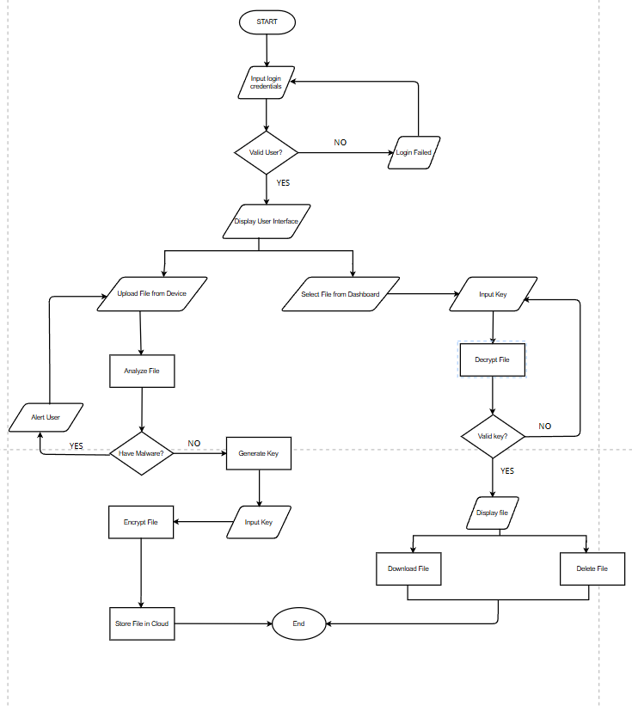

Figure 3.6 Flowchart of the system

Figure 3.3 provides a detailed process of a Secure Cloud System Using AI Malware Analyzer and AES Encryption, showing the whole flow process of a proposed system.

Below is a comprehensive explanation based on the flowchart:

      - Start and Login Process

Input Login Credentials: The process begins with the user entering their credentials (username and password).
Validation: The system checks whether the credentials are valid.

        - If the credentials are invalid, the system displays a "Login Failed" message, and the process terminates.
        - If valid, the system allows the user to proceed by displaying the user interface.

      - User Interface Options

From the user interface, the user has two primary options:

        - Upload File from Device

        - Select File from Dashboard

      - File Upload and Malware Analysis

If the user uploads a file, the system submits it in parallel to VirusTotal for signature-based scanning and to the AI model for structural analysis. The verdict engine combines both results into one of three outcomes:

1 ) Malicious (flagged by VirusTotal, regardless of the AI result) — the system alerts the user and rejects the file.

2) Suspicious (clean by VirusTotal but flagged by the AI model) — the file proceeds to encryption but is tagged for the user's awareness.

3) Clean (both signals agree) — the file proceeds to encryption normally.

      - File Encryption and Storage

If no malware is detected:

        - The system generate the user to input a key.
        - The file is encrypted using the provided key.
        - The encrypted file is stored in the cloud storage.

      - File Decryption and Management

If the user selects a file from the dashboard:

        - The system prompts the user to input the decryption key.
        - Decision Point - Key Validation:
          - If the decryption key is invalid, the decryption fails, and the user is prompted to re-enter the key.
          - If the key is valid, the system successfully decrypts the file and displays its content.
      - File Actions

After decryption, the user has two options:

        - Download File: The user can save the decrypted file locally.

        - Delete File: The user can delete the file from the cloud storage.

      - End

The process concludes after the file is either downloaded or deleted or the new file stored in cloud storage

The attached flowchart depicts a complete and highly secured process for storing files in the cloud. With the assistance of artificial intelligence (AI) to detect malware threats, files are protected before they are stored, and files are encrypted using Advanced Encryption Standard (AES) when they are stored. User authentication, malware alerts (email or text notifications), encryption and decryption of files, and file management all work together to create an ideal and secure experience for the user.

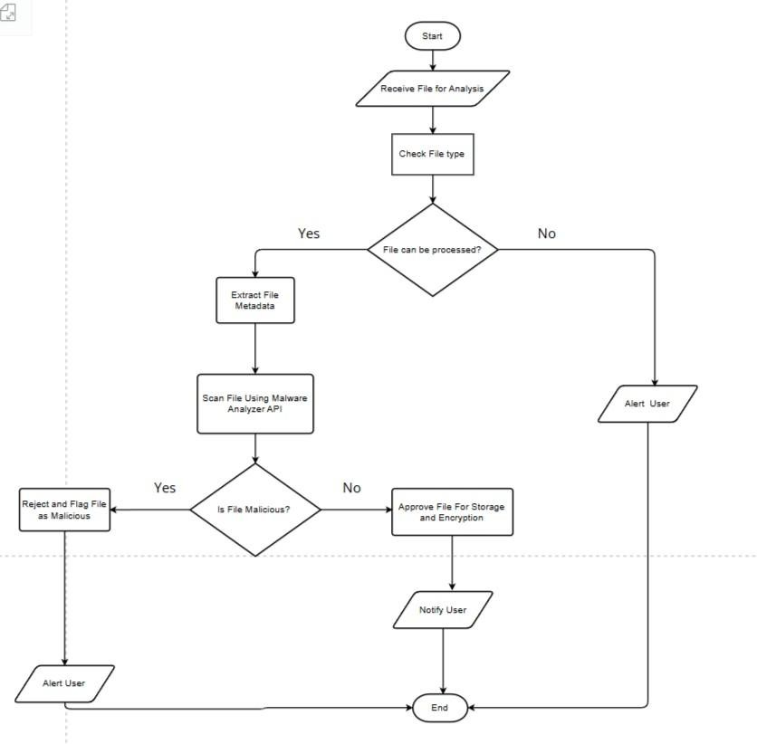

Figure 3.7 Flowchart of the AI Malware Analyzer.

As shown in figure 3.7, a complete outline or flow chart of how the AI Malware analyzer will perform its functions and analysis when analyzing incoming files which will ultimately be stored on the computer after completing analysis of that file. Below is a detailed outline explaining step by step each part of the flow chart provided above.

- Start

The process start when a user uploads a file.

- Receive File for Analysis

The system get the file and prepares it for further analysis.

- Check File Type

The file type is checked to determine if it is supported by the system.

  - If the file cannot be processed: The system alerts the user and ends the process.

  - If the file is supported: The process moves to the next step.

- Extract File Metadata

Essential file details such as size, type, and format are extracted to aid in the analysis.

- Scan File Using AI Malware Analyzer

The file is scanned for potential malware threats using AI malware analyzer.

Is File Malicious?

The results of the scan are analyzed:

  - If the file is malicious: The system rejects the file, flags it as a threat, and alerts the user.
  - If the file is safe: The file is approved for storage and encryption.

- Approve File for Storage and Encryption

Safe files will be proceed to another process which encryption and storing file in the cloud.

- Notify User

The user is notified about the status of their file (whether it was safely stored or rejected due to malicious content).

- End

The process concludes after the necessary actions have been taken

Entity-Relationship Diagram
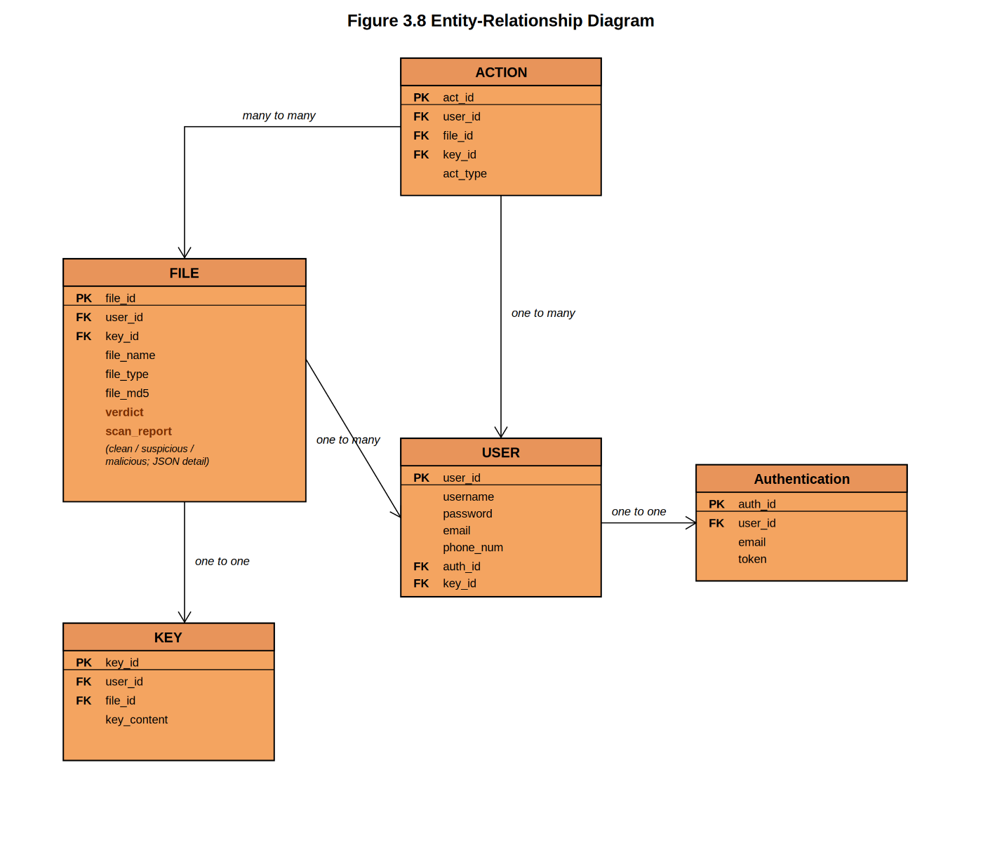

Figure 3.8 Entity-Relation Diagram
Figure 3.5 shows ERD for the project Secure Cloud System using AI Malware Analyzer and AES encryption. This diagram provides a clear view for each entity and attributes for the system.

3.3.6.1 USER Entity

Table 3.4 User Entity

Attribute | Description | Key | Data Type
user_id | Unique identifier for the user | Primary Key | Integer
username | Username of the user |  | Varchar/String
password | Password of the user |  | Varchar/String
email | Email address of the user |  | Varchar/String
phone_num | Phone number of the user |  | Varchar/String
Table 3.6 shows User Entity to represent the users of the system. Relationships:
        - One-to-One with AUTHENTICATION (for managing secure user login and tokens).
        - One-to-Many with ACTION (a user can perform multiple actions).
        - One-to-Many with FILE (a user can upload multiple files).

3.3.6.2 AUTHENTICATION Entity

Table 3.5 Authentication Entity

Attribute | Description | Key | Data Type
auth_id | Unique identifier for authentication | Primary Key | Integer
user_id | References user_id in USER | Foreign Key | Integer
email | Email used for authentication |  | Varchar
token | Authentication token |  | String
Table 3.7 shows Authentication Entity to stores user authentication details. Relationship:
        - One-to-One with USER (linked to user login).

3.3.6.3 FILE Entity

Table 3.6 File Entity

Attribute | Description | Key | Data Type
file_id | Unique identifier for the file | Primary Key | Integer
user_id | References user_id in USER | Foreign Key | Integer
key_id | References key_id in KEY | Foreign Key | Integer
file_name | Name of the file |  | Varchar/String
file_type | Type of the file (e.g., .txt) |  | Varchar/String
file_md5 | MD5 hash for file integrity |  | Varchar/String
verdict | Combined VirusTotal + AI classification: clean, suspicious, or malicious |  | Varchar (16)
Scan_report | Stores the detailed VirusTotal and AI scan output for later review |  | JSON
Table 3.8 shows File Entity to represents files stored in the cloud Relationships:

- One-to-Many with USER (multiple files can belong to one user).
- One-to-One with KEY (each file has a unique encryption key).

- Many-to-Many with ACTION (files are associated with various actions).

3.3.6.4 KEY Entity

Table 3.7 Key Entity

Attribute | Description | Key | Data Type
key_id | Unique identifier for the key | Primary Key | Integer
user_id | References user_id in USER | Foreign Key | Integer
file_id | References file_id in FILE | Foreign Key | Integer
key_content | Content of the encryption key |  | Varchar/String

Table 3.9 represents Key Entity to manages encryption keys for secure file storage. Relationship:
- One-to-One with FILE (each file is assigned one unique key).

3.3.6.5 ACTION Entity

Table 3.8 Action Entity

Attribute | Description | Key | Data Type
act_id | Unique identifier for the action | Primary Key | Integer
user_id | References user_id in USER | Foreign Key | Integer
file_id | References file_id in FILE | Foreign Key | Integer
key_id | References key_id in KEY | Foreign Key | Integer
act_type | Type of action (e.g., upload) |  | Varchar/String

Table 3.10 represents Action Entity to tracks actions performed in the system, such as uploading, downloading, or scanning files.
Relationships:

- Many-to-Many with FILE.
- One-to-Many with USER.

This ERD ensures secure cloud storage by integrating AI malware analysis and AES encryption, with clear relationships between users, files, actions, keys, and authentication details

User Interface
The user interface mock-up is presented during the design process to make a design prototype before proceeding to develop the front end.

3.3.7.1 Log In interface
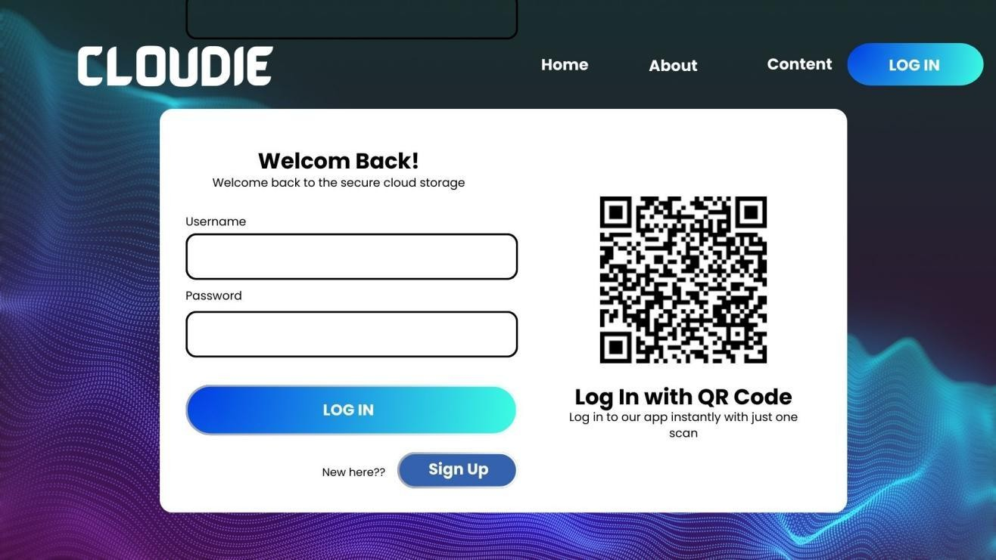

Figure 3.9 Log in interface
Figure 3.6 shows the login interface in the cloud system for the user

3.3.7.2 Cloud Dashboard
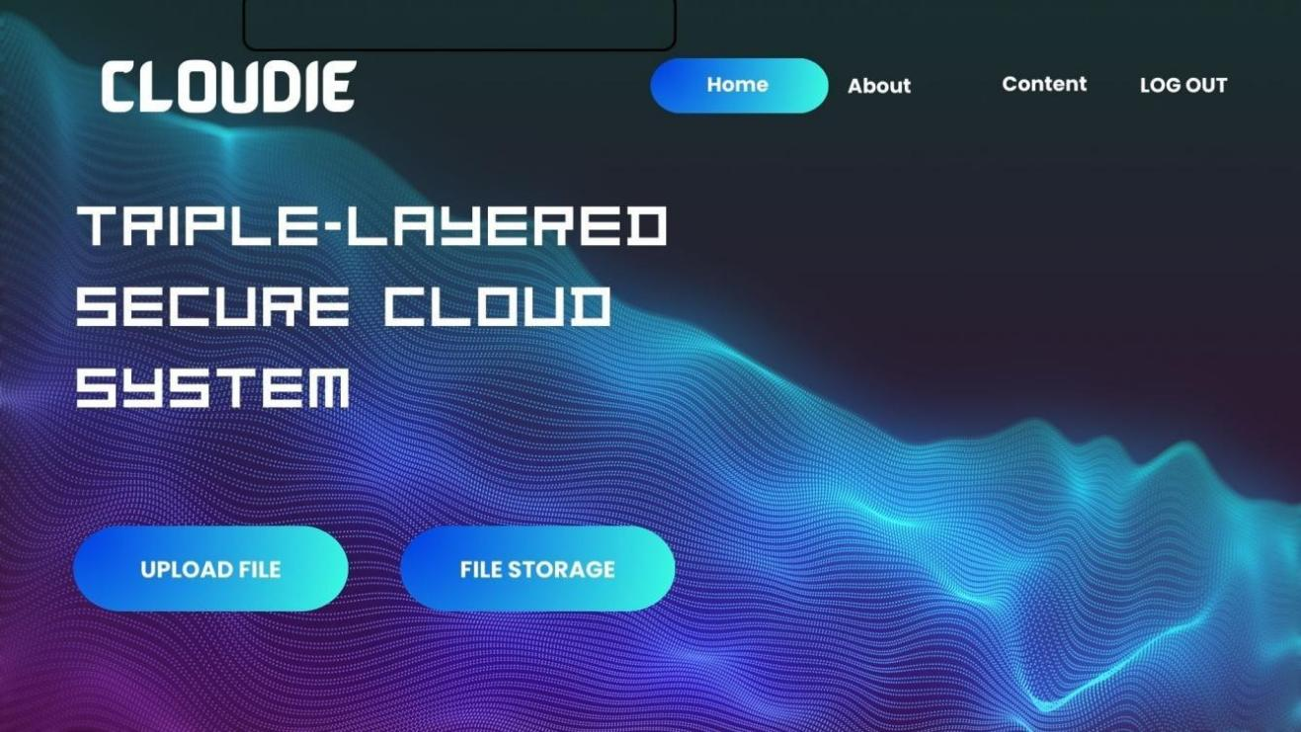

Figure 3.10 Log in interface
Figure 3.7 shows the homepage after the user successful log in.

3.3.7.3Upload File Interface
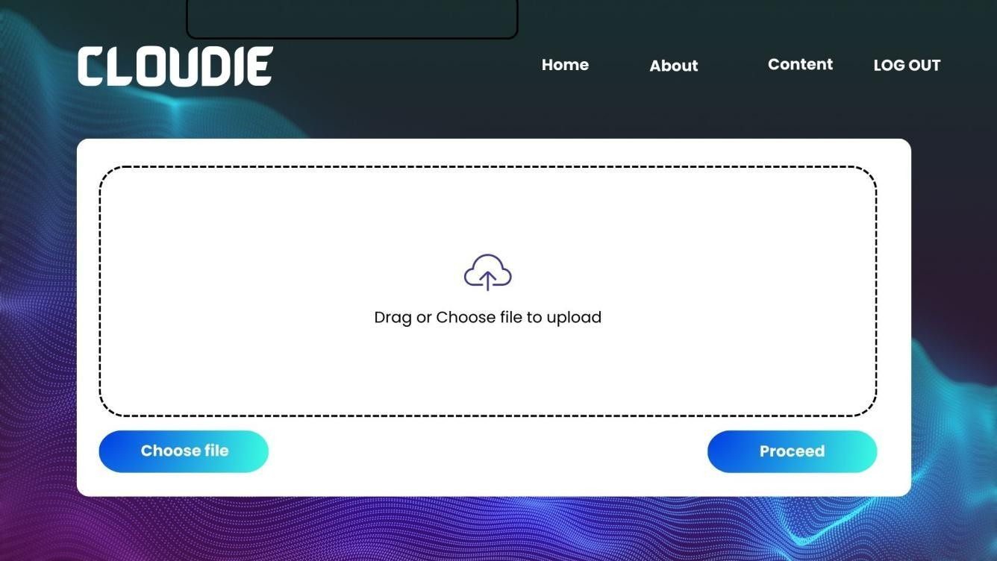

Figure 3.11 Log in interface
Figure 3.8 shows the Upload Interface if the user choose to upload a file.

3.3.7.4 Analyzing Interface
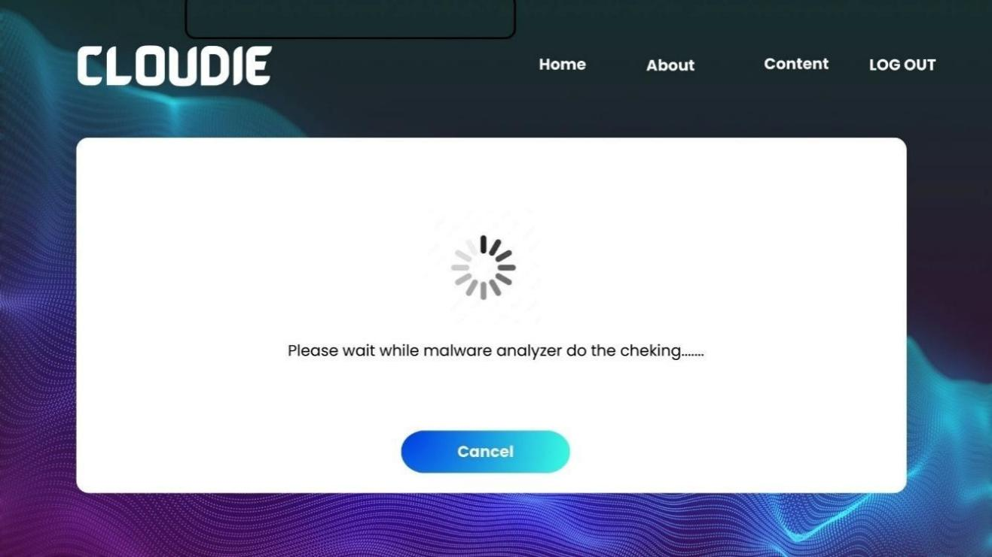

Figure 3.12 Log in interface
Figure 3.9 shows the AI malware analysing the file before reporting the findings to the user.

3.3.7.5 Successful Analysing
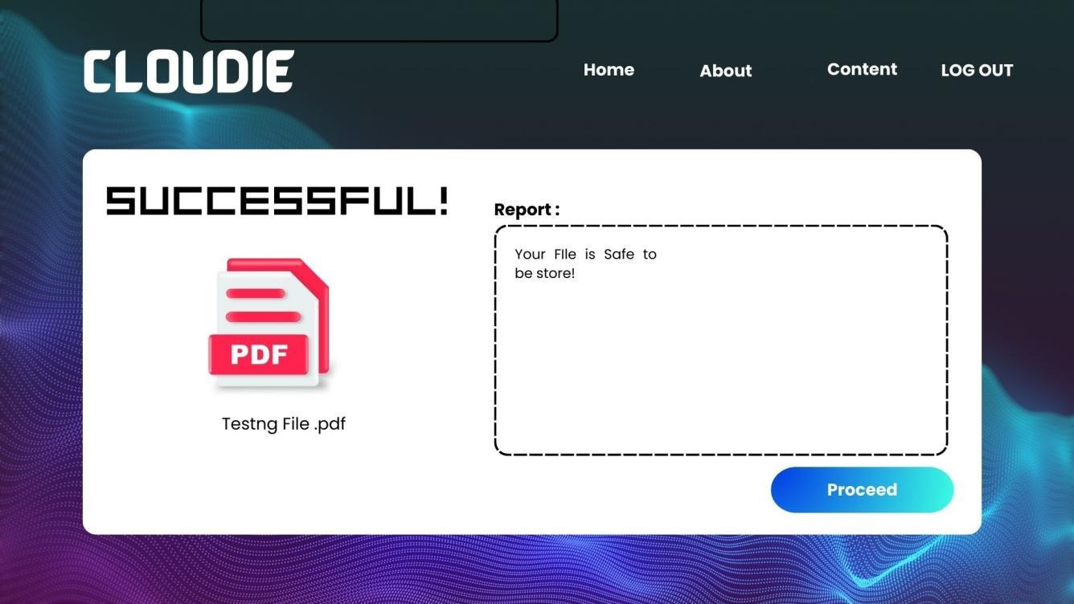

Figure 3.13 Log in interface
Figure 3.10 shows the successful if the file is clean from malware and generating the report for the user to know the details for the malware detection.

3.3.7.6 Encryption Interface


Figure 3.14 Log in interface
Figure 3.11 shows the login interface in the cloud system for the user

3.3.7.7 Successful Encryption Interface
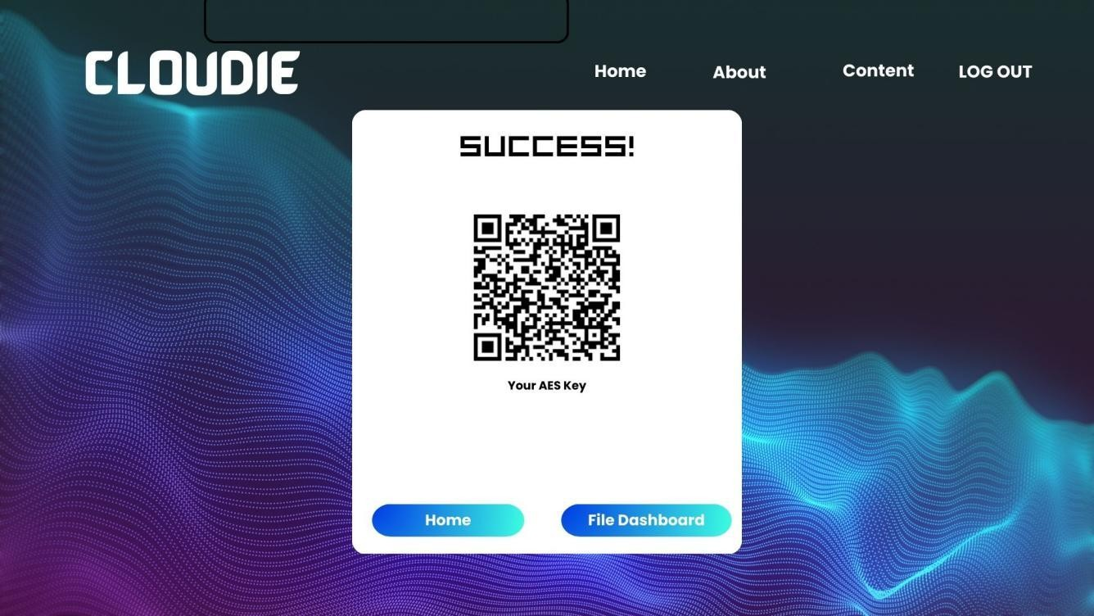

Figure 3.15 Log in interface
Figure 3.12 shows the encryption interface in the cloud system for the user after user has clean result for malware analysing. Encryption key and QR key will be generated.

3.3.7.8 File Dashboard
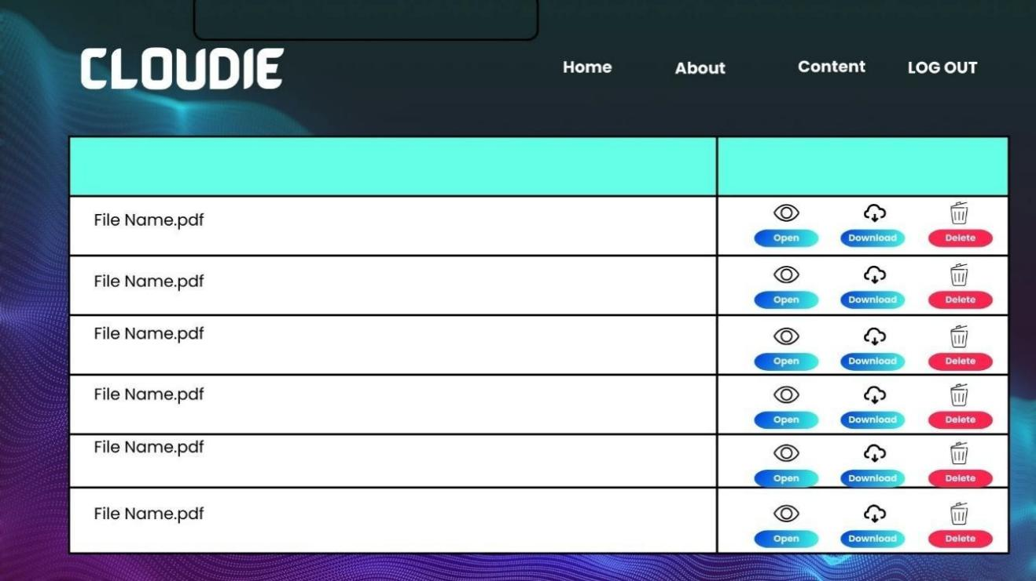

Figure 3.16 Log in interface
Figure 3.13 shows the file dashboard in the cloud system for he user to check their uploaded files. The user can view , download and delete files in this dashboard files.

3.3.7.9 File Decrypt Interface
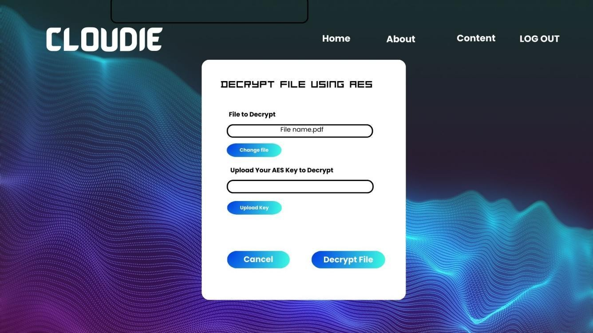

Figure 3.17 Log in interface
Figure 3.14 shows the file file decryption interface for the user after user done choosing file to view. This page requires the user to input the AES key or QR AES key before user can view the file

3.3.7.10 Successful Decrypt Interface
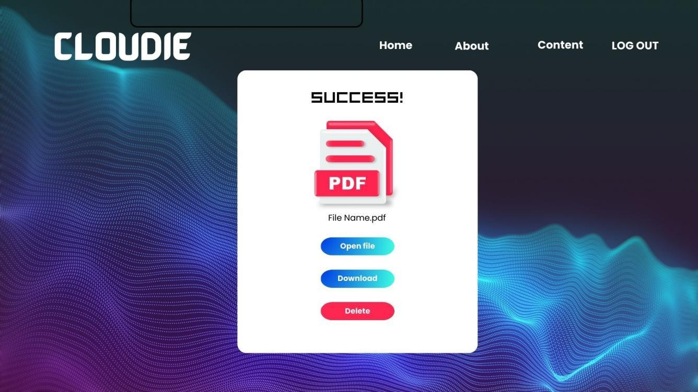

Figure 3.18 Log in interface
Figure 3.15 shows successful decrypt interface after the user success to input the correct key to view the file

Implementation
With the combination of VirusTotal signature-based scanning, an AI-based structural malware analysis model, and AES-256-CBC encryption, this Secure Cloud Storage System brings everything together for a verdict-driven workflow. This combination creates an added layer of protection for the cloud environment: Users upload their files directly to the web-based architecture, and each file uploaded goes through parallel submissions to VirusTotal for signature-based scanning and to the AI model for structural analysis before being stored.
The techniques of machine learning are used to try to analyze the characteristics of the PDF files being uploaded, so that the AI can look for suspicious structures that the signature-based scanner might not yet have a signature for, especially the new ones and those that are obfuscated. VirusTotal, in turn, still offers quick and accurate detection of files that have known “wormhole” signatures. Both are used together as complementary and independent detection signals, not one way supplants the other.
A verdict engine aggregates the two signals and gives one of three verdicts. If the AI model returns a non-rejecting result, but the VirusTotal detection engine does detect the file as malicious, it is rejected. If VirusTotal has no opinion about the file is safe, but the AI model detects suspicious structural characteristics, the file is still encrypted and stored, but marked with a “suspicious” label to alert the user. If both signals are in agreement that the file is clean, then it goes straight to the encryption and storage procedure without any restrictions. This verdict engine determines if the file has been denied, if not, then AES-256-CBC encryption is used, and the encrypted file is protected from unauthorised access and its confidentiality is maintained by the use of an encryption key that is not tied to the file itself. A user will need to provide the right decryption key to obtain the data stored.
The file blobs are encrypted and stored separately in a cloud storage bucket, and file metadata, verdicts, scan reports and encryption keys are stored in a managed SQL database, which is a stateless, containerised hosting environment. This separation guarantees consistent file data storage across container restarts and the scaling event. Also, all user activity on the system, such as uploads, downloads and deletions, are recorded to ensure the integrity of the data held and to ensure that those responsible for their actions on the system are held to account. The encryption key is also provided to the registered email of the user through the secondary convenience service, together with the on screen display and QR code, after successful upload.
The test has demonstrated the ability of the combined VirusTotal and AI verdict engine and has also confirmed the integrity of the AES-256-CBC encryption and decryption process. The overall performance of the system has been analysed when tests are performed under different level of workload. With the final release of the product the emphasis is on scalability; the product is designed and built to support both the personal user and enterprise environments. The design and construction process seek to balance a high degree of layered security, where both signature-based and AI-based detection techniques find and restrict threats, and a high degree of efficiency, in terms of system performance, yet with maintaining the usability of the system.

System Testing
System Testing comes next in the waterfall technique. The primary purpose of System Testing is to ensure that the site meets all its functional and business requirements. In this project, Functional Testing will be used as a method of System Testing.

Functional testing
Functionality testing is a type of testing that ensures that the system performs as expected and meets its criteria. It is frequently used to test the system's general functionality, including registration, login, and encryption procedures.
During functional testing, test cases are created to address all the system's functional needs, such as user registration, login, displaying encrypted files, and the server-side client. Testers then run the test cases and compare the actual results to the predicted outcomes. Any differences between the actual and expected results are then identified as flaws or defects.

Test Case Generation
The process of developing a collection of test cases that were used to confirm that a software system satisfies its functional requirements and performs as planned is known as test case generation. Before the system is made available to end users, test case generation seeks to find and capture as many potential flaws or problems as possible. The table for creating test cases for this project is shown below.

Table 3.9 Test Case Generation

Test ID | Test Case | Test Description | Preconditions | Test Input | Expected Output
1. | Login | Verify that a registered user can login | User has registered and confirmed email address | Valid email and password | User is granted access to the main page
2. | Login | Verify that an unregistered user or invalid login information is rejected | None | Invalid email or password | Error message displayed

Test ID | Test Case | Test Description | Preconditions | Test Input | Expected Output
3, | Login | Verify that a registered user receives an OTP and can enter it to login | User has registered and been authorized by admin | Valid email, password, and OTP | User is granted access to the main page
4. | Upload File | Verify that a logged-in user can upload a file | User is logged in | Valid file upload | File is encrypted and uploaded successfully; success message displayed
5. | Download File | Verify that a logged-in user can download an encrypted file and decrypt it | User is logged in and file is uploaded | Request to download a specific file | File is downloaded and decrypted correctly
6. | Delete File | Verify that a logged-in user can delete a file | User is logged in and file is uploaded | Request to delete a specific file | File is deleted successfully, success message displayed

7. | AI Malware & VirusTotal Analyze file | Evaluate whether the file processed using malware are accurate and precise before  encryption | File must be uploaded before analyzing | Upload file and analyze | Alert user when there are malware in the file
8. | Verify MD5 Hash | Verify that the MD5 hash before encryption and after decryption matches | User is logged in and file is uploaded | Upload and then download a file | MD5 hash of the original file and decrypted file matches
9. | Generate Key | Verify that a user can generate an AES key and download the QR code | User is logged in | Click “Generate Key” button | AES key is generated, QR code is displayed and downloadable

Test ID | Test Case | Test Description | Preconditions | Test Input | Expected Output
12. | File Encryption | Verify whether file can be encrypted successfully before store to the cloud | User uploaded files and analysed | Encrypt uploaded file using key given | System handles encryption efficiently, performance metrics recorded
13. | File Decryption | Verify whether file can be decrypted successfully before any  further action on files | User must have the matched key to decrypt | Decrypt using matched AES key | System handles encryption efficiently, performance metrics recorded

Table 3.11 represents test case, including preconditions, test input and expected output for every test case in the test case generation table.

Metrics to Measure System Performance
The testing will start by splitting the dataset into training and testing subsets. Typically, 80% of the dataset will be allocated for training the model, while the remaining 20% will be used to test its performance on unseen data.

      - Accuracy: The ratio of correctly classified instances (malware and benign) to the total number of instances. This provides a general measure of how well the model performs overall.
Accuracy = (TP + TN) / (TP + TN + FP + FN)

      - Precision: Precision indicates the proportion of instances classified as malware that are actually malicious. It helps assess how well the system avoids false positives.
Precision = TP / (TP + FP)

      - Recall (Sensitivity): Recall measures the system's ability to detect all actual malware instances, minimizing false negatives.
Recall = TP / (TP + FN)

      - F1-Score: The F1-score provides a balance between precision and recall, especially useful when the dataset is imbalanced.
F1 score = 2 * (Precision * Recall) / (Precision + Recall)

      - Confusion Matrix: Table 3.1 is a detailed table showing true positives, true negatives, false positives, and false negatives. This provides insight into the types of errors the model makes.

Table 3.7 Confusion Matrix Table

Prediction | Malicious(positive) | Benign (negative)
Malware(positive) | True Positive (TP): The system correctly detects a malicious app as  malware. | False Positive (FP): The system incorrectly detects a benign app as  malware.
Benign(negative) | False Negative (FN): The system incorrectly classifies a malicious  app as benign. | True Negative (TN): The system correctly classifies a benign app  as non-malicious.

Documentation
The documentation phase concludes the software development process in the Waterfall Model of Software Development. During this time, any technical documentation that is relevant to the development process of the system was created (including technical documentation and system specifications) to ensure that it would be easily maintained and operated throughout its entire life cycle. Comprehensive technical documentation assists both the end-user and technical personnel who will be charged with maintaining the system, enabling them to use and maintain the system now and into the future. In addition, during this phase of the process, all documentation relating to the overall development process (i.e., all testing results and design decisions) were compiled for reference in future upgrades or problem resolution.

Summary
The research methodology has been outlined throughout this chapter. The overall research framework has been organized around the Waterfall model; this model has five distinct phases that must be carried out in sequence. The first phase of the model involves determining and collecting all requirements needed for the system as well as conducting thorough analysis of the requirements. This analysis also established the rationale for combining VirusTotal's signature-based scanning with an AI-based structural analysis model into a single verdict engine, rather than relying on either detection method in isolation. The second phase of the Waterfall, which is concerned with the design of the final system, includes the use of algorithm, flowchart, and use-case diagrams. The third phase of the Waterfall, which is the phase responsible for the development of the system, specifies both the software and hardware needed for the new application. The fourth phase, system testing, includes performing a series of functional tests that will verify the system's reliability, and finally, the process concluded with the creation of documentation including system design and development plans.

CHAPTER 4 : RESULT AND FINDINGS

4.1 Introduction
This chapter discusses the results achieved during the design and testing of Cloudie: Secure Cloud Storage with AI-Based Malware Detection and AES-256 Encryption. The results are discussed in connection to the goals set at the previous stages of the project. The discussion includes the key features of the product such as the verdict engine that uses VirusTotal signature-based detection as the primary detection signal and supports AI-based structural analysis of the files which relies on a Random Forest classifier, the AES-256-CBC encryption and decryption of the files stored in the database, and the secure storage of information in the database.
Moreover, functional and performance testing results are presented in this chapter which verify the reliability and security of the system. Every section describes the operation of the system under different conditions enabling to assess the degree of achievement of the objectives, especially concerning the protection of users' files from malware and unauthorized access. The chapter also includes an overview of the performance of the system, including its responsiveness and the correctness of the results of the machine learning model.

4.2 Secure Cloud Storage with AI Malware Detection and AES Encryption
The Cloudie is a cloud storage system designed to tackle cloud security issues of malware attacks and data breaches. It has two security features: one using AI to detect malware and the other encrypting data stored on the device with Advanced Encryption Standard (AES). Cloudie performs two independent checks on each PDF file before it is uploaded to storage: a VirusTotal signature-based check, which is the main check; and a trained Random Forest classifier that identifies the file's structural features as an AI signal. A verdict engine handles the two results: Files that VirusTotal marks as safe are marked as safe; files not marked as safe by VirusTotal, but as safe by the AI model, are stored under a 'suspicious' status; and files that are both marked as safe by VirusTotal and the AI model are encrypted. The result of passing a file through the scanner is encrypted with AES-256-CBC and saved as an encrypted file; the key itself is only shown once to the user, and never stored, only a hash of the key (SHA-256) and an initialisation vector (IV) are retained. The layered system increases the security and protection of critical documents, and provides a boost to traditional cloud storage services that use signature-based scanning.
Other attributes of the system include user account management, file management (upload, download, view, and delete), per-scan logging, and a highly secured recovery mechanism of sending recovery PINs by email. The interface is user friendly so that users can carry out an encryption or scanning operation without having to know the internal workings of the encryption or scanning. Built locally on an Apache/MySQL stack and deployed in Google Cloud Run as two separate services, Cloudie is a PHP web application that receives user inputs, encrypts data and manages files, and a Python Flask API that hosts the Random Forest model while coordinating the VirusTotal integration. Encrypted file blobs are stored in a bucket within Google Cloud Storage, and user records, file metadata, verdicts and key verification material are stored in a managed MySQL database. Cloudie’s ability to combine AI-powered malicious file analysis and encryption in a single solution showcases the potential of a proactive and intelligence-driven security strategy in a realistic file storage environment.

4.3 User View
Cloudie's user interface is made to be easy to use, making it easier for its users to handle files safely the subsections below outline the user experience starting from registration till file handling.

4.3.1 Access to Landing Page
Upon accessing the site, users are redirected to the first point of contact, the landing page, where they enter the website.
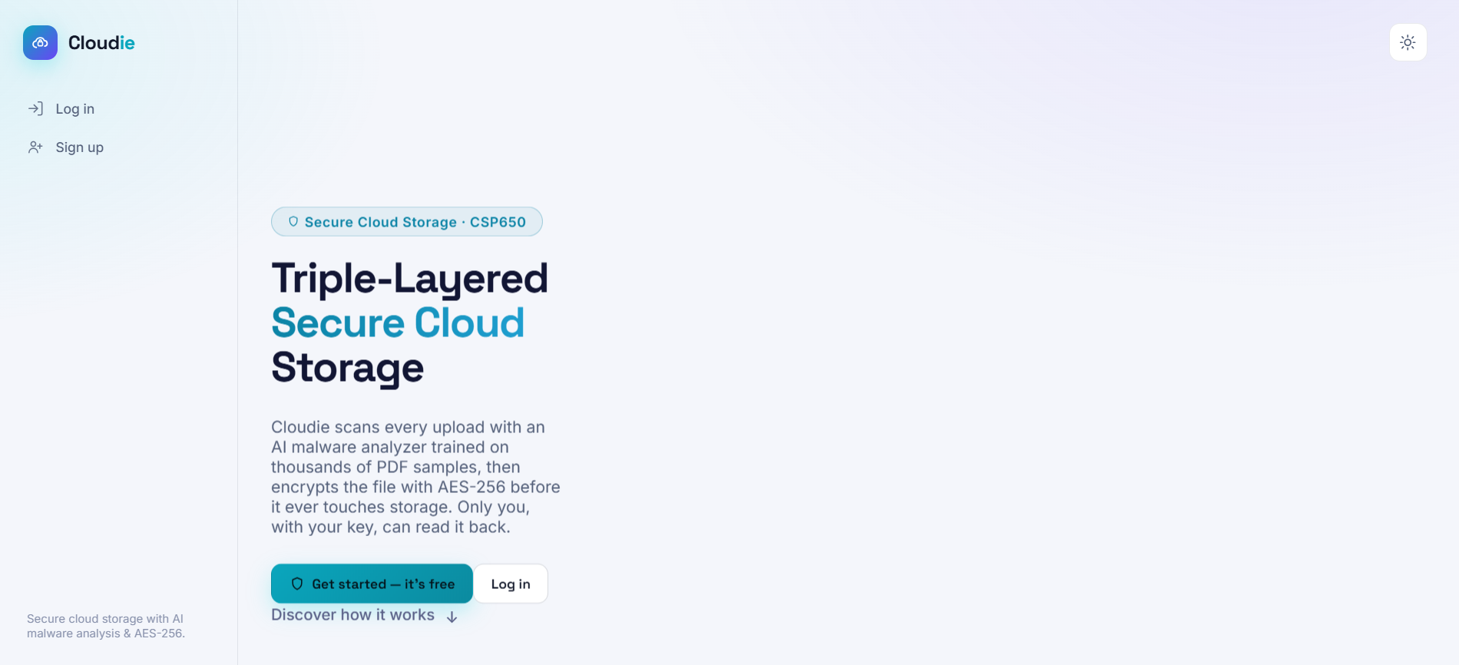Figure 4.1 Landing page view
Figure 4.1 shows the the initial page that specifies the Cloudie's purpose and acts as the entering point for a user to proceed to either login or registration page.

4.3.2 User Registration
The first step for the users to sign up is filling out the registration form wherein the user has to fill in their name, email address, password, and other required details. After successful submission, the information is verified and stored in the database.
Figure 4.2 Registration page
Figure 4.2 displays the area where new users can sign up for the service. Through the completion of the registration form, the system completes creating the user in the database from the user's input records before ever entering the system.

4.3.3 Access to Login Page
The user need to fill out the credential like username and password before getting access to the Cloudie
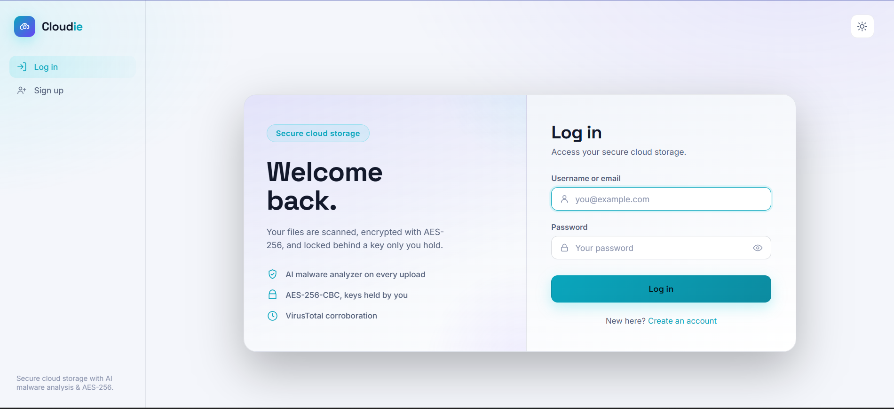Figure 4.3 Login page
. The login screen is depicted in figure 4.3 above. The page verifies the username and password given and once authenticated, moves the user onto the dashboard.

4.3.4 Two-step verification page
After user successful enter their credential, user will need to do the Two-step verification which is acts as another layer of security
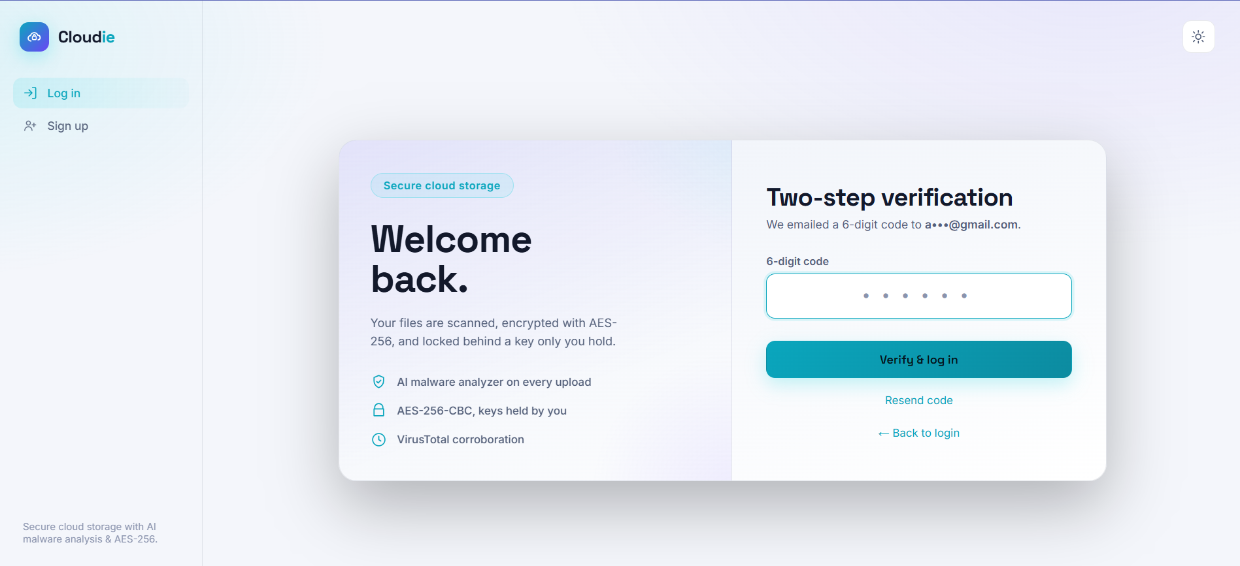Figure 4.4 Dashboard interface
On the main interface shown in Figure 4.4 after users have logged in, they can see the Two-Step verification page that asks them to fill in a 6-digit pin that is sent to them via email.

4.3.5 Access to Dashboard Page
When the user successful with a login page, user will be redirected to the dashboard page which user can upload the fie or take action to the file
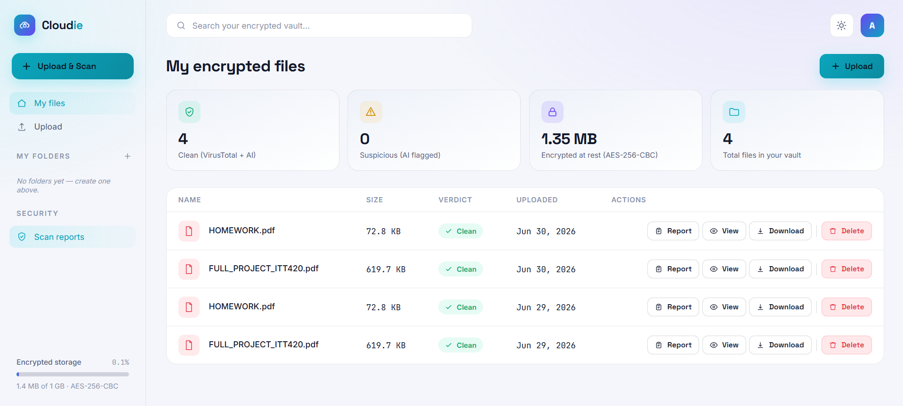Figure 4.5 Dashboard interface
Figure 4.5 shows the user's interface after successfully logging in. The dashboard contains essential system functions like uploading, scanning, encrypting, decrypting, downloading, and deleting files. The dashboard serves as the basic console for the user to manage files.

4.3.6 Profile Management Page
The user can view their profile, update their personal information and change their password where necessary.
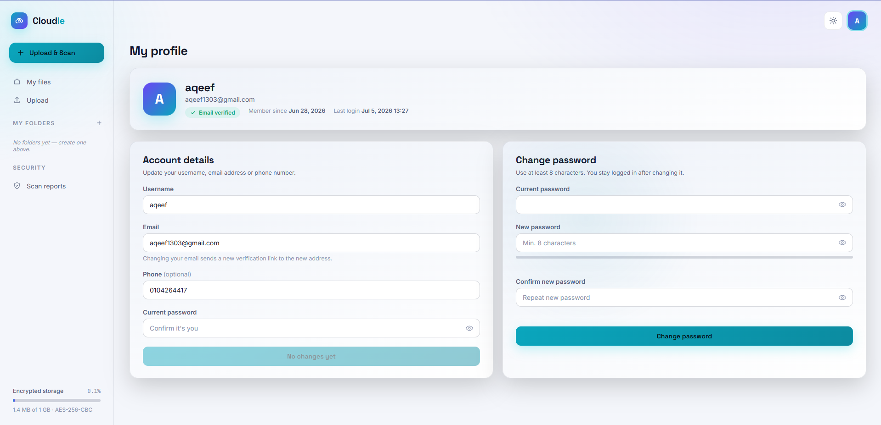Figure 4.6 Profile management page
Figure 4.5 illustrates the profile page where users can view their personal information and update their password. This ensures that users are able to maintain account security and keep their details up to date. On the upload page, users select a PDF file from their local device. The file is sent to the Flask API, which submits it to VirusTotal for signature-based scanning and, in parallel, passes the structural characteristics extracted by the feature extractor to the Random Forest classifier. The verdict engine then combines the primary VirusTotal result with the supporting AI result to produce the final verdict

4.3.7 File Upload and Malware Analysis
On the upload page, users select a PDF file from their local device. The file is sent to the Flask API, which submits it to VirusTotal for signature-based scanning and, in parallel, passes the structural characteristics extracted by the feature extractor to the Random Forest classifier. The verdict engine then combines the primary VirusTotal result with the supporting AI result to produce the final verdict

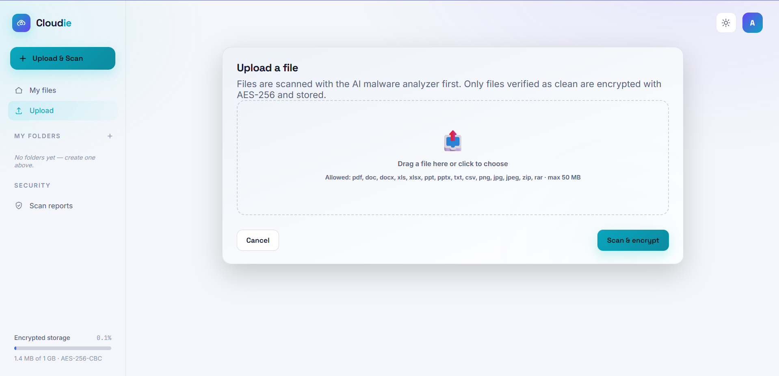Figure 4.7 File upload interface
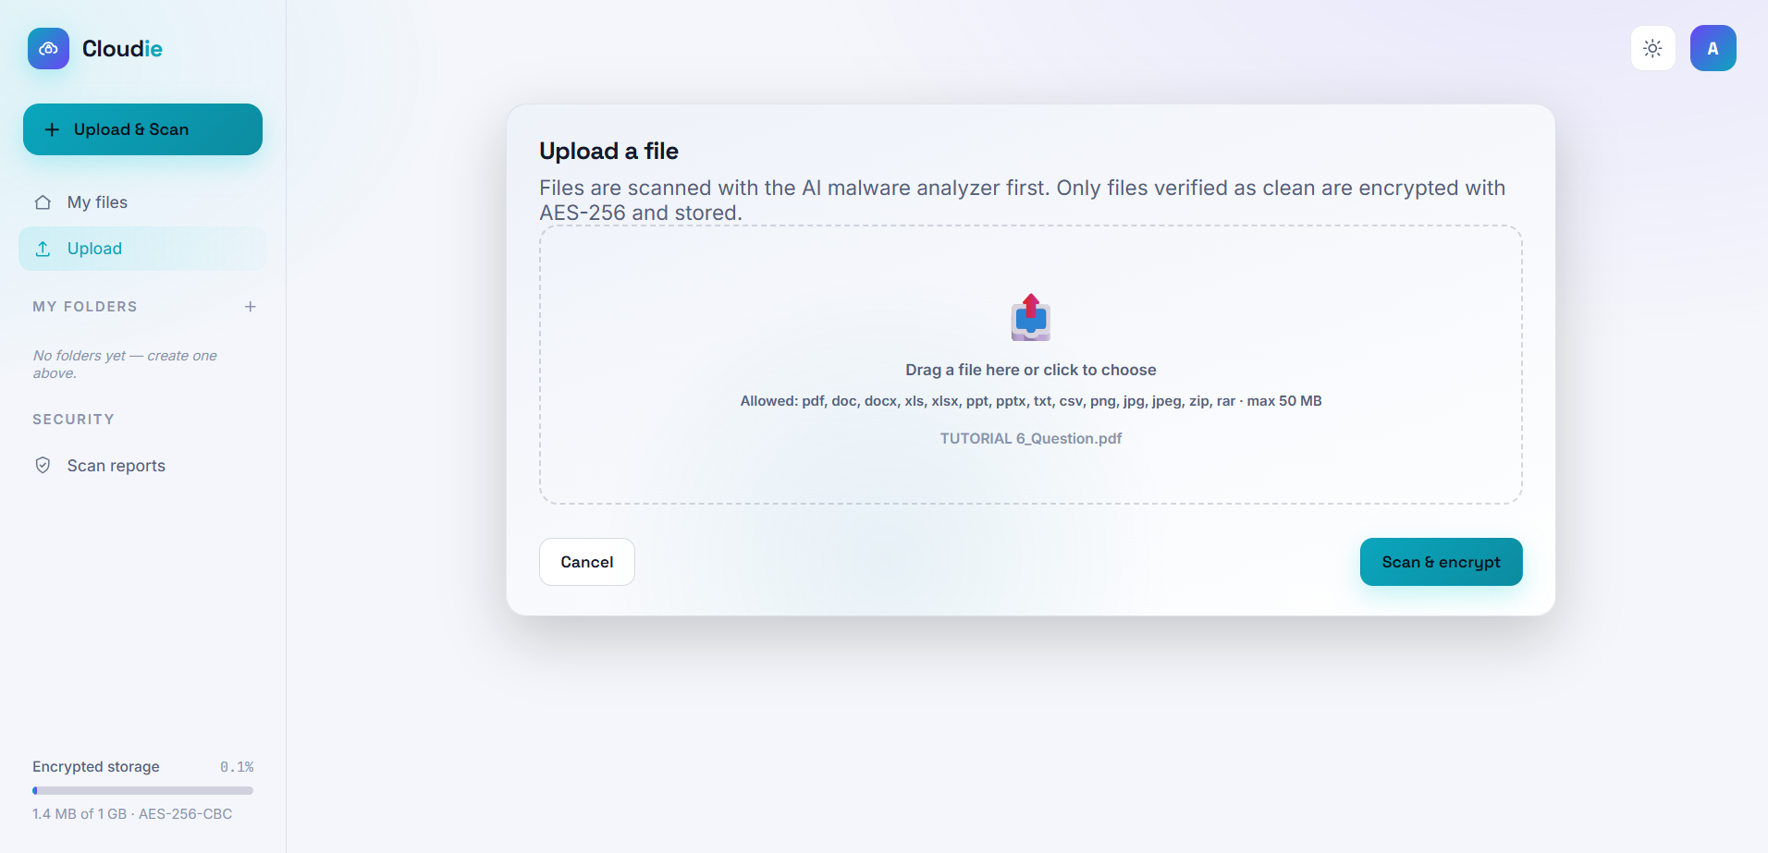Figure 4.8 File selected for analysis
Based on Figure 4.7 and Figure 4.8, the user selects a PDF file to be uploaded and analysed by the malware detection engine. The system submits the file to VirusTotal and, in parallel, extracts its structural features, such as the number of JavaScript objects, embedded files, object streams and other indicators, and submits this feature vector to the trained model.
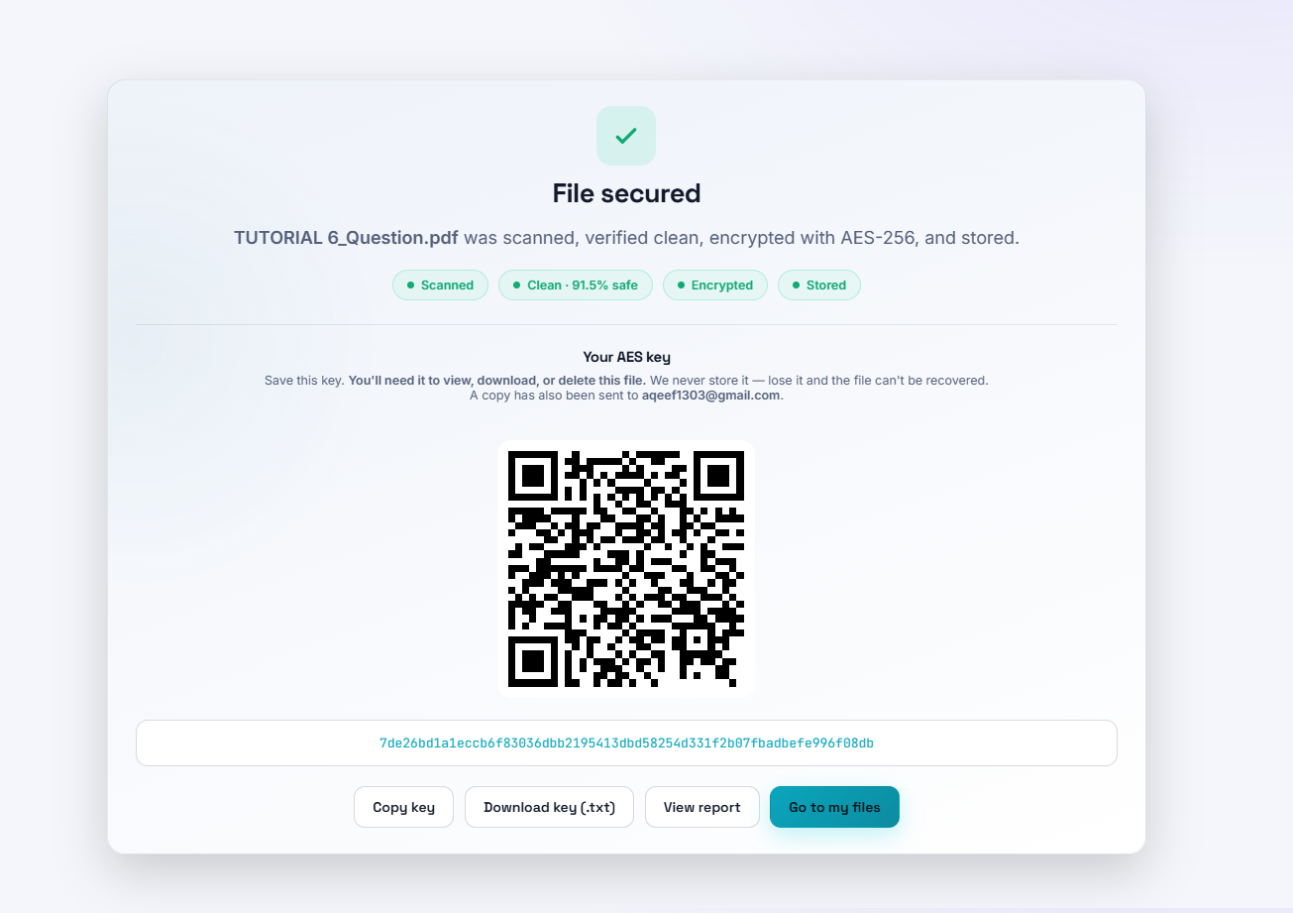Figure 4.9 File scan result for a clean file
Figure 4.9 shows a file that has been successfully scanned with a clean result, indicating that the file can be securely stored after encryption. The result is presented in a table listing the file details, including the file name, file hash, file size, file type, the AI verdict, the VirusTotal and the analysis date.
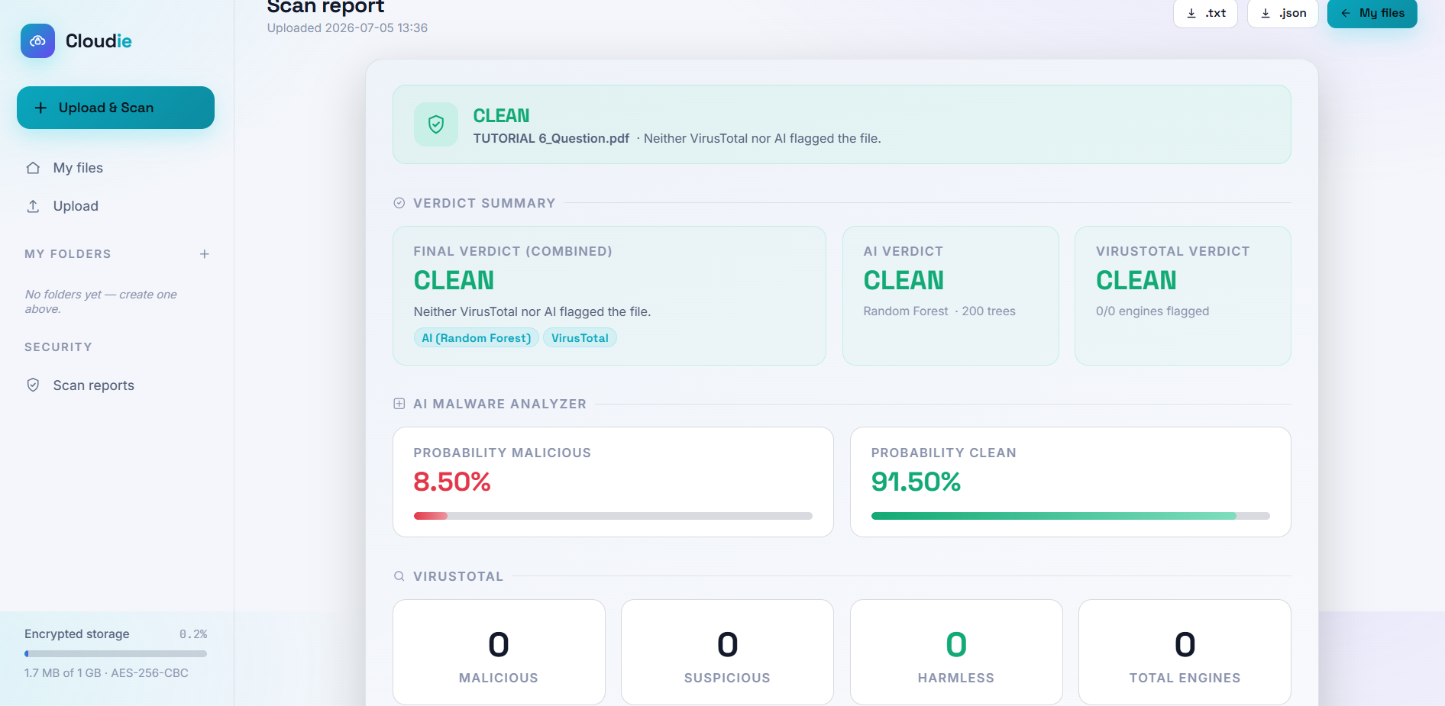Figure 4.9 Scan report download
As shown in Figure 4.9, the user is able to download a report of the scanned file. The report summarises the AI verdict, the structural indicators that contributed to the decision, and the VirusTotal result for the user's records.

4.3.7 Flagged File and Handling of Malicious Uploads
When the detection engine determines that a file is malicious, the file is flagged and prevented from proceeding to encryption and storage.
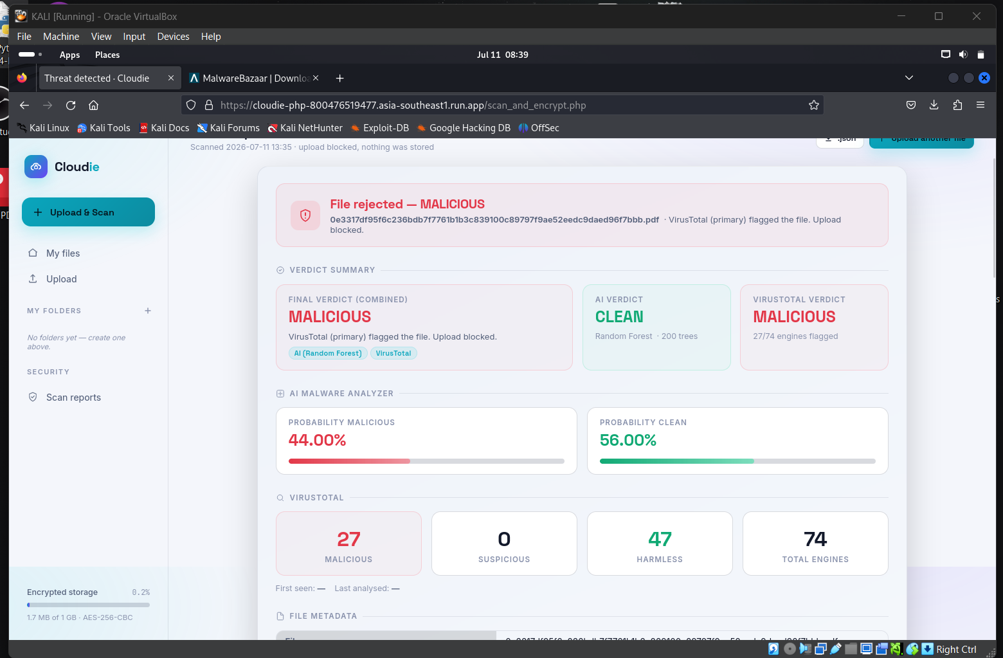Figure 4.10 Flagged file result
Figure 4.10 shows the result for a flagged file that contains malicious structural indicators. A flagged file cannot proceed to encryption or be stored in the system, ensuring that malicious content is never written to the encrypted store.
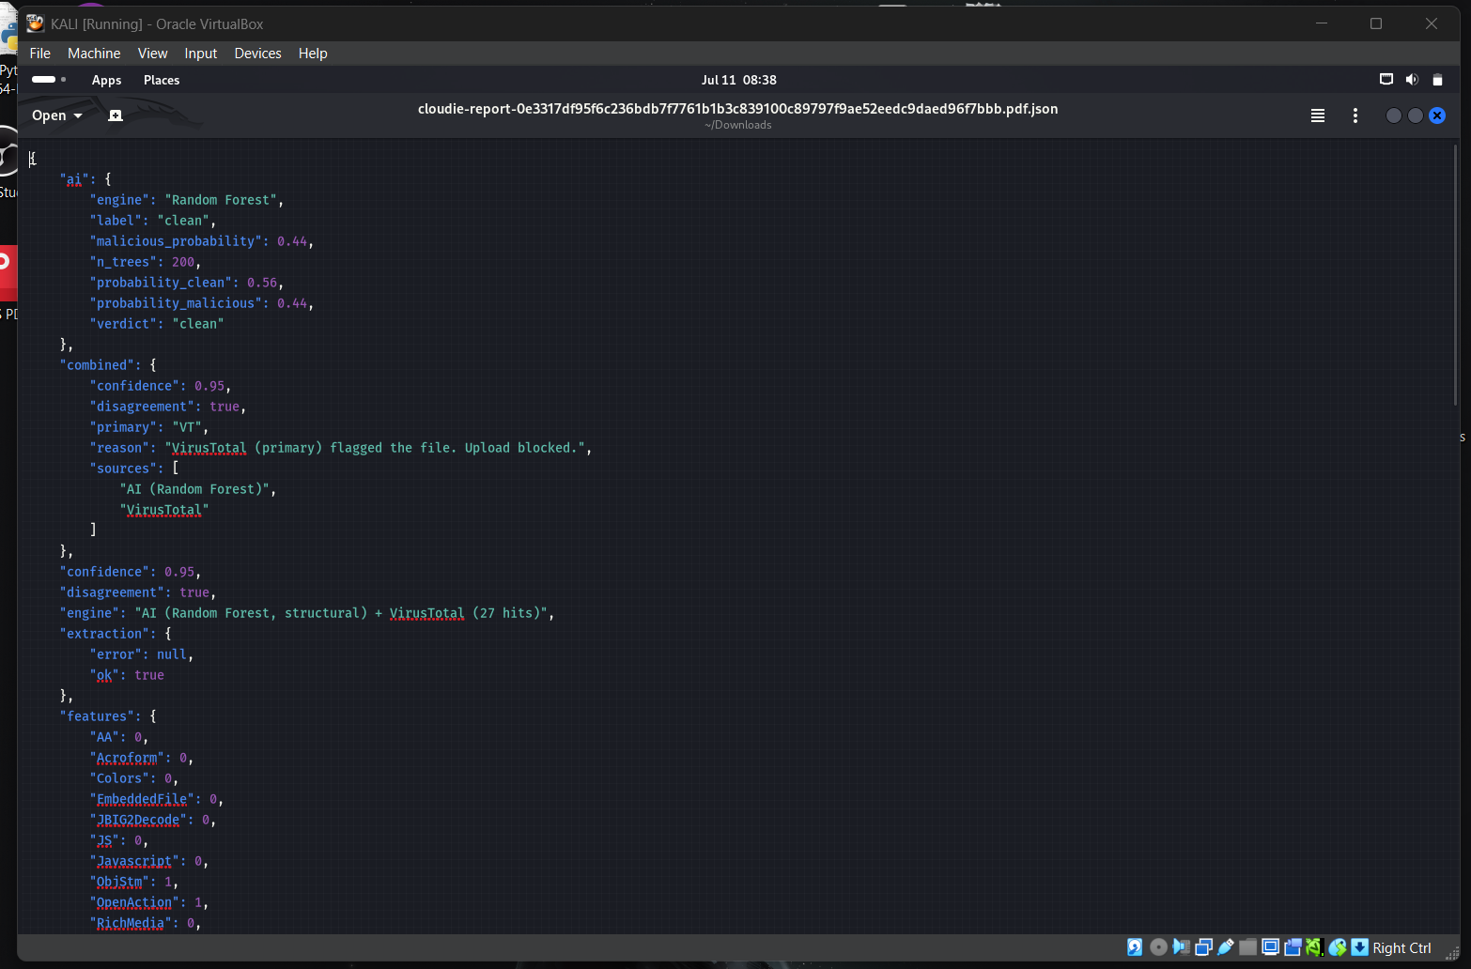Figure 4.11 Malicious file report
Based on Figure 4.11, the user is able to download the report for a flagged file. The report includes the final combined verdict, the VirusTotal detection summary that led to the malicious classification, and the AI's supporting structural assessment.

4.3.8 File Encryption
After a file has been confirmed as clean, the user can proceed to encrypt it using AES-256-CBC before it is stored. 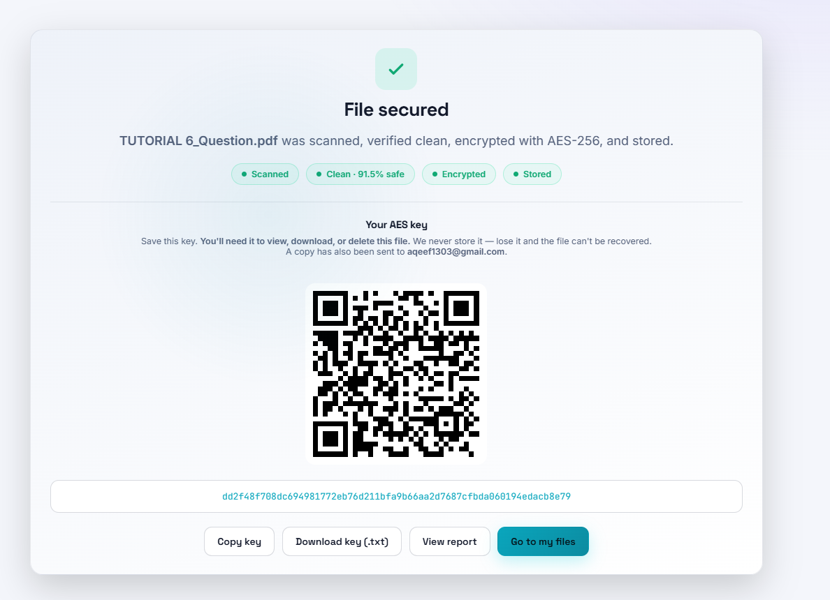Figure 4.13 Successful encryption
Based on Figure 4.12 and Figure 4.13, the system generates a unique AES-256 key for the file, encrypts the file content using the AES-256-CBC algorithm with a random initialisation vector, and stores the encrypted file in the cloud storage bucket. The encryption key is stored separately in the file_keys table so that the ciphertext and the key are not held together.
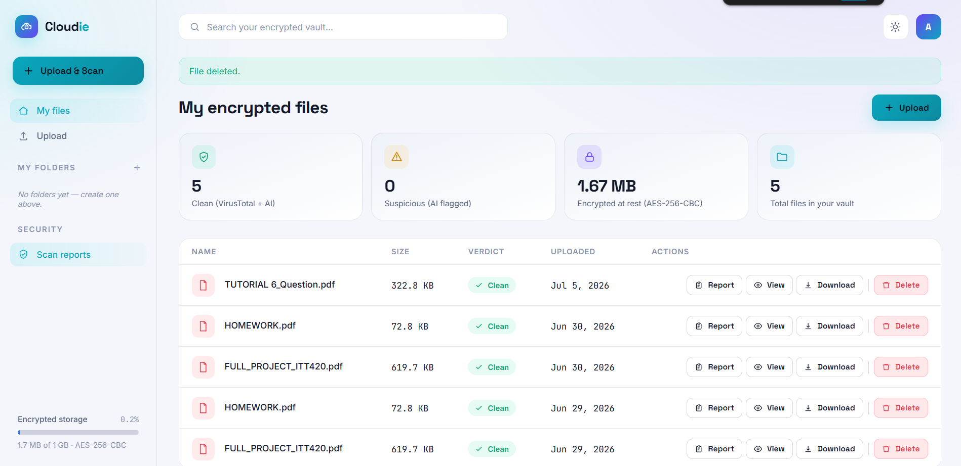Figure 4.14 Encrypted file stored on the dashboard
Figure 4.14 shows the encrypted file as it appears on the dashboard after a successful encryption. From the dashboard, the user is able to organise, view, download and delete their stored files.

4.3.9 File Decryption
To decrypt a file, the user requests decryption from the dashboard and supplies the AES key saved at upload time, either by pasting the 64-character hexadecimal key or by scanning the QR code. The system verifies the supplied key against the SHA-256 hash stored in the file_keys table and, only if it matches, combines the key with the stored initialization vector to reconstruct the original file content.
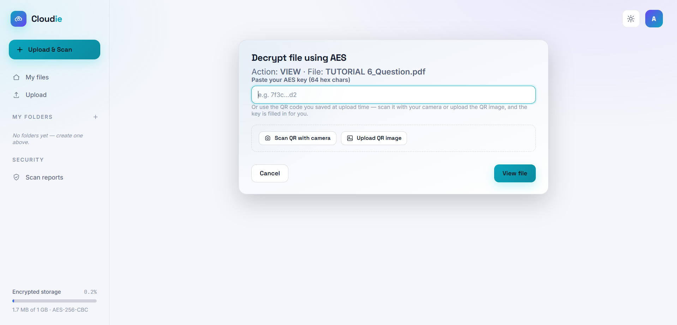Figure 4.15 File decryption interface
Figure 4.15 illustrates the decryption interface. Decryption is only performed for the authenticated owner of the file who supplies the correct key failed key attempts are logged. This ensures that only authorized users in possession of the key can access the content of encrypted files.
Figure 4.16 File view after decryption
Figure 4.16 shows a file being viewed after decryption. The system reconstructs the decrypted content and presents it securely to the user within the browser while preserving the integrity of the original file.

4.3.10 Download and Delete Files
The user can also download and delete files from the dashboard.
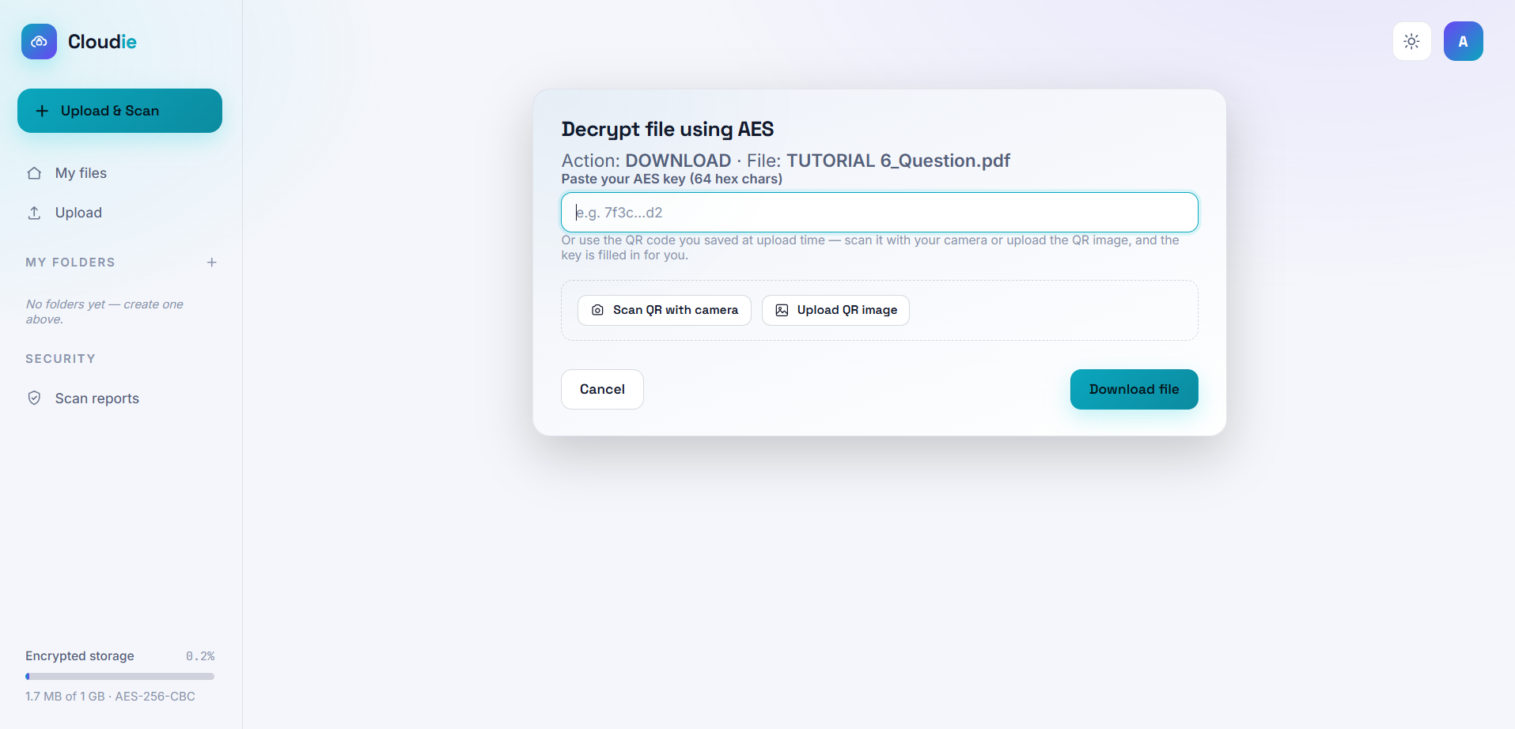Figure 4.18 File download interface

Figure 4.18 The user is able to select a file from their storage and proceed with the download or delete on their device after decrypting it, whereby the integrity of the content will be assured by the system.
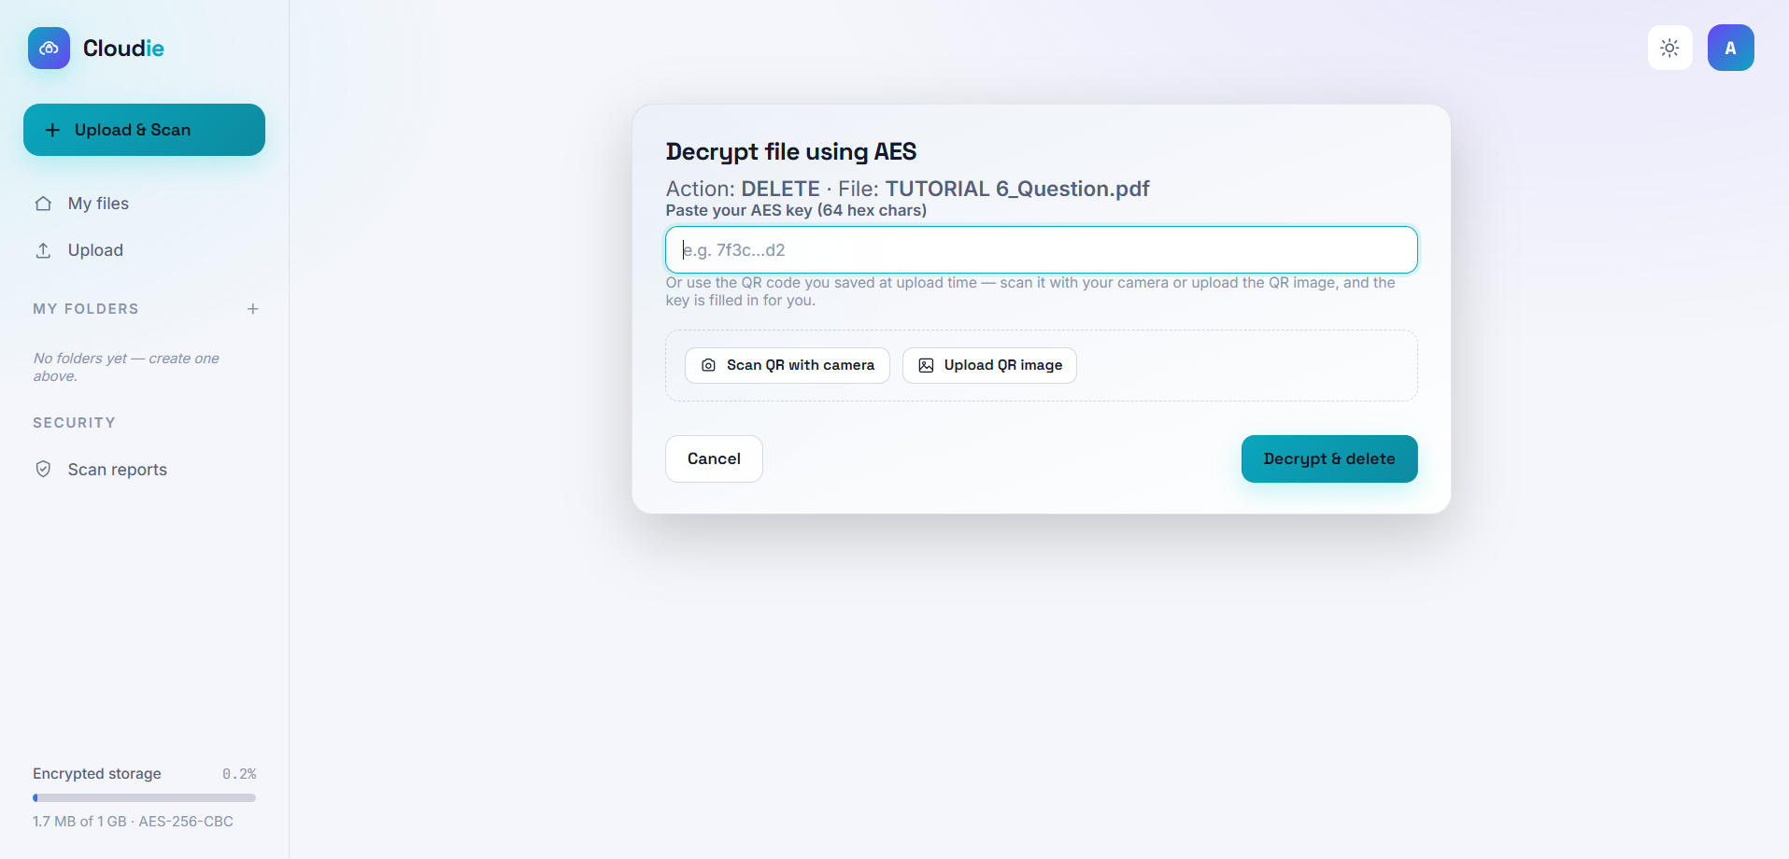Figure 4.19 File delete interface
Figure 4.19 illustrates the interface for deleting files from the system. Users can select the files they do not want anymore and delete them, thereby removing the encrypted file together with its corresponding key record from the database.

4.4 Testing Results
The testing process was divided into several categories in order to thoroughly evaluate the performance, accuracy and security of the system:
- Functional testing
- Machine learning model evaluation
- Held-out validation of the model
- Encryption and decryption performance
- Storage of encrypted files
- Data integrity verification
- Malware detection

4.4.1 Functional Testing
In order to assess the functionality, accuracy and usability of the Cloudie system, thorough functional testing was conducted. The testing process was in accordance with industry best practices and included both positive and negative scenarios to gauge the response of the system in various cases. Cloudie functional testing results can be found in Table 4.1.

Table 4.1 Functional Testing Output
Test ID | Test Case Description | Expected Output | Result
1 | User registration | Success | Pass
2 | User login | Success | Pass
3 | File upload | Success | Pass
4 | AI malware detection (clean file) | File accepted | Pass
5 | AI malware detection (malicious file) | File rejected | Pass
6 | VirusTotal corroboration | Success | Pass
7 | File encryption (AES-256-CBC) | Success | Pass
8 | File decryption | Success | Pass
9 | File download | Success | Pass
10 | File deletion | Success | Pass
As shown in Table 4.1, all functional test cases produced the expected output, confirming that the core features of Cloudie operate correctly under both normal and adversarial conditions.

4.4.2 Machine Learning Model Evaluation
The malware detection capability of Cloudie is provided by a Random Forest classifier trained on the CIC-Evasive-PDFMal2022 dataset. The dataset used for training and evaluation, stored as Final.csv, contains 18,126 records described by 32 structural features extracted from PDF files, with the records labelled as benign or malicious in a balanced distribution. The model was trained using the scikit-learn implementation of the Random Forest algorithm, and the trained classifier together with the ordered list of features was saved as a single model bundle for use by the Flask API.
The performance of the model was first evaluated using a stratified 80/20 hold-out split, consistent with the testing design described in Chapter 3, 80% of the 18,126 records were used for training and the remaining 3,626 records were reserved for testing, with the class balance preserved in both portions. The resulting performance metrics are presented in Table 4.2.

Table 4.2 Random Forest Performance on the Stratified Test Split
Metric | Value
Accuracy | 99.86%
Precision | 100%
Recall | 99.72%
F1-score | 99.86%
Table 4.2 shows that the Random Forest classifier achieved very high accuracy and recall on the stratified test split. The precision of 100% means that no benign file was misclassified as malicious in this split, while the recall of 99.72% indicates that only 5 of the 1,813 malicious files in the test set evaded detection. High recall is particularly important in a security context because it measures how rarely a malicious file is allowed to pass undetected. The confusion matrix produced during this evaluation is illustrated in Figure 4.20.
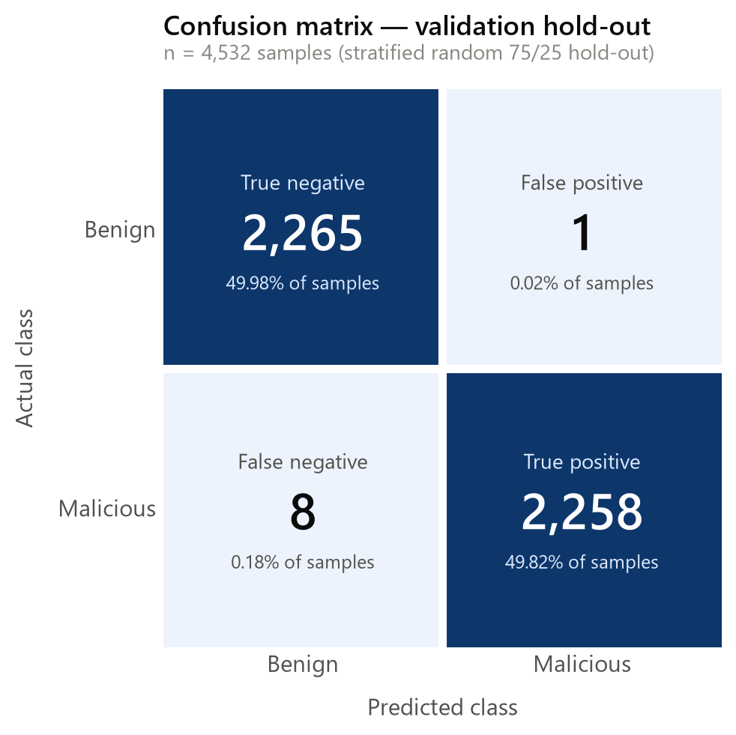

Figure 4.20 Confusion matrix of the Random Forest classifier

4.4.3 Held-out Validation of the Model
Because a single stratified random split can produce results that appear optimistic, a second held-out validation was carried out to provide a more robust assessment of the model's generalisation. In this design, the data was partitioned according to the distribution of the file size feature rather than at random: the top quartile of files by size (4,643 files) was held out for testing, and the model was trained only on the remaining 13,483 files. The model was therefore evaluated entirely on files larger than any it had seen during training. This distribution-based hold-out provides a stronger test of whether the model has learned generalisable structural patterns rather than artefacts of a particular random partition.

Table 4.3 Comparison of Validation Designs
Validation design | Accuracy | Recall
Stratified random split | 99.86% | 99.72%
Distribution hold-out (pdf_size top quartile, n = 4,643) | 99.53% | 97.00%
Table 4.3 compares the two validation designs. The model maintained high accuracy and recall under the distribution-based hold-out, indicating that its strong performance is not an artefact of a single favourable random split. Reporting both designs together provides an honest and defensible picture of the model's behaviour and demonstrates that the detection capability is robust across different partitions of the data.

4.4.4 Encryption and Decryption Performance
The AES-256-CBC encryption and decryption performance was determined by the size of various files. The times taken for encryption and decryption were recorded for files of sizes of 1 KB, 100 KB, 1 MB, and 10 MB. AES encryption is performed using a 256-bit key and a random initialisation vector, and the time used for both encryption and decryption was noted. These times are displayed in the Table 4.4.

Table 4.4 AES-256-CBC Encryption and Decryption Time
File type | File size | Encryption time (ms) | Decryption time (ms)
.pdf | 1 KB | 0.5 | 0.4
.pdf | 100 KB | 0.7 | 0.6
.pdf | 1 MB | 1.2 | 1.0
.pdf | 10 MB | 3.5 | 3.1
It is shown in Table 4.4 that encryption times increase with file size, which is understandable since for larger files more data is handled by the algorithm. The times taken for decryption are shorter than those taken for encryption, which indicates the effectiveness of decryption. The time figures are low and constant for all possible sizes confirming that AES-256-CBC adds negligible overhead and is suitable for the interactive file storage applications.

4.4.5 Storage of Encrypted Files on the Server
Files uploaded by the user are encrypted using AES-256-CBC before being stored in the cloud storage bucket, so that the files remain secure and cannot be read without the corresponding key. The encrypted file content is written to storage while the encryption key is recorded separately in the file_keys table. This separation ensures that obtaining the ciphertext alone is not sufficient to recover the plaintext.
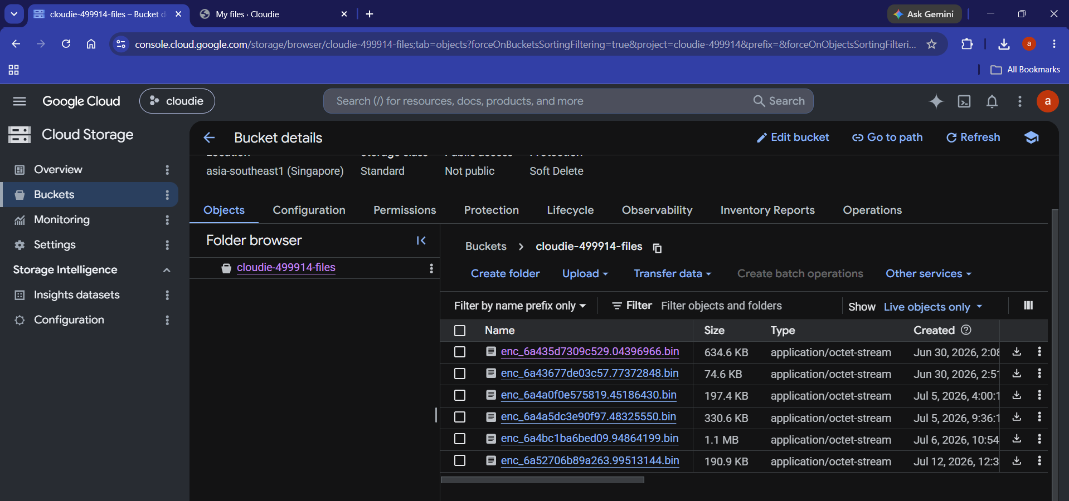Figure 4.22 Encrypted file content stored on the server
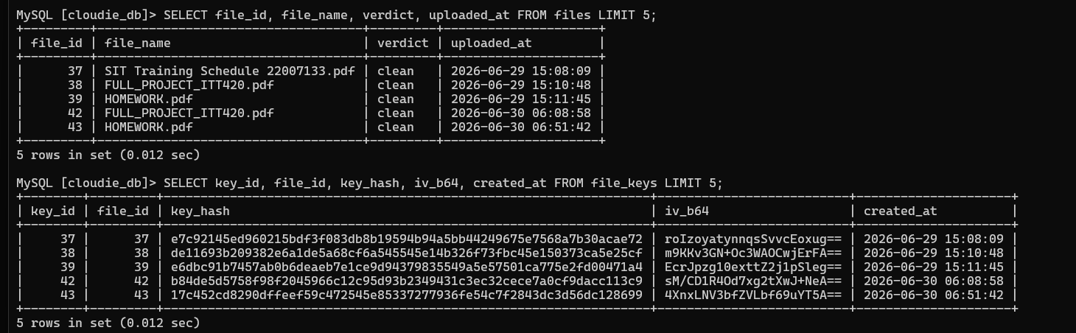Figure 4.23 File and key records in the MySQL database
Figure 4.22 highlights the format of the encrypted file as stored in the cloud storage bucket, and Figure 4.23 shows how the file metadata, the key hash and the initialisation vector are recorded across the files and file_keys tables in the MySQL database. Together these figures illustrate the storage design, in which the encrypted content is stored apart from the key verification material, while the key itself remains solely in the user's possession.

4.4.6 Data Integrity Verification
Ensuring data integrity is essential for maintaining the reliability of a secure file storage system. This section describes the process used to verify that data remains intact and unaltered throughout the encryption and decryption cycle. A hash value is generated for each original file before encryption, and a second hash value is generated for the file after it has been decrypted.

Table 4.5 Hash Comparison Before and After Encryption
File type | File size | Hash match (yes/no)
.pdf | 1 KB | Yes
.pdf | 100 KB | Yes
.pdf | 1 MB | Yes
.pdf | 10 MB | Yes
As indicated in the data from Table 4.5, the hash values of all the files before and after performing the encryption process matched perfectly. This indicates there was no data corruption involved during the entire process and the encryption cycles do not affect file contents in any way. Hence, an integrity check guarantees that the Cloudie application does not interfere with any of the user data while securing it.

4.4.7 Malware Detection and Corroboration
To ensure that uploaded files are non-malicious in a secure cloud storage system, this section assesses the effectiveness of malware detection functionality that utilizes AI-supported Random Forest model and VirusTotal’s signature-based detection features.
Upon uploading a file, the VirusTotal API is used to verify it using various signature-based technologies and provide the verdict in return. At the same time, the file passes through a feature extractor that investigates the structural attributes of the file and sends it to the Random Forest classifier for an AI-based verdict. The algorithm then combines the two pieces of evidence: if VirusTotal detection results in finding a file to be infected, it will be classified as malicious regardless of the results from the AI model. In a situation where the file passed the VirusTotal investigation but AI is suspicious about it, the file will be tagged as 'suspicious' for the user to be informed. Only those files will be accepted for storage, the verdict about which is the same in terms of AI and Virus total results. The system was tested in the following situations:
- Uploading a clean file with no malicious indicators.
- Uploading a known malicious PDF.
- Uploading a file recognised by VirusTotal as safe.
- Uploading a structurally suspicious file not yet present in the VirusTotal database.

Table 4.6 Results of Malware Detection and Corroboration

Scenario | Expected result | Actual result
Uploading a clean file | File accepted | File accepted
Uploading a known malicious PDF | File rejected | File rejected
Uploading a file known-safe to VirusTotal | File accepted | File accepted
Uploading a structurally suspicious file | Stored with 'suspicious' verdict | Stored with 'suspicious' verdict
Table 4.6 shows the system has rightly accepted the benign files, while the malicious ones have been denied entry. In the last case scenario, the AI system identified a file with some suspicious characteristics that was not yet included in VirusTotal's records, which shows that the structural detection component helps in identifying the threats that are otherwise missed by signature-based scanning engines such as VirusTotal. This implies that it is not a mistake but rather the expected behavior for the outcomes of AI and VirusTotal to differ, because distinct threat detection mechanisms are employed by the two methods. The reason for this is that while VirusTotal employs its structure-based mechanism to detect threats, VirusTotal gathers the information on signature-based detections from other detection engines.
Moreover, there is a log recorded for each scan activity that comprises file hash, file type, AI verdict, VirusTotal result, and timestamp of the scan. The log is stored in CSV format and works as a useful evidence that can be used for security review purposes. The analysis of the information shows that the feature of malware detection successfully stops the inflow of malicious files and that the layered design of the verdict combines the positive aspects of the AI and signature-based scanning mechanisms.

4.5 Discussion
The findings detailed in the current chapter indicate that Cloudie successfully protects against harmful uploads using its detection system powered by artificial intelligence. It is able to check every PDF due to VirusTotal's sign-based engines and assess its format based on Random Forest model trained previously to catch and remove harmful files even before they are stored. Thanks to this system, no harmful content, such as JavaScript, payloads or documents containing exploits, can penetrate the storage system, thus protecting the server and users in general.
The design's noteworthy feature is that it employs an intelligence-based structural detection method instead of relying on signatures. The fact that the Random Forest model processes structural information makes it capable of detecting new evasion techniques or otherwise unknown files, which other signature-based systems might miss out on. The validation testing has proven that the model generalises well and that the accuracy is not simply the result of a lucky random split. The decision-making engine, which considers the VirusTotal result to be the main input and the AI analysis to serve only as a supporting factor, enables the two sources to be compared with respect to their inconsistencies; the judgment can thereby be interpreted meaningfully rather than being discarded without drawing any conclusions.
The detection layer is complemented by the encryption layer,. Files that pass the malware check are encrypted using AES-256-CBC with a 256-bit key and a random initialisation vector; the system retains only a SHA-256 hash of each key for verification, so the key never resides alongside the ciphertext. The performance tests showed that AES-256-CBC processes files of different sizes efficiently, with only a small encryption and decryption overhead. The integrity tests confirmed that the encryption and decryption cycle preserves the content of files exactly, with all hash comparisons matching before and after processing.
Taken together, the AI-based malware detection, AES-256-CBC encryption, separate key storage, data-integrity verification and the secure email-based recovery mechanism constitute a layered, defence-in-depth approach. The system is able to prevent the upload of malicious files while ensuring that stored data remains confidential and unaltered throughout its lifecycle.

4.6 Summary
This chapter has introduced and analyzed the outcomes from the research on the creation and evaluation of Cloudie. This software consists of a layered malware detection system VirusTotal signature-based scanning acting as the main detector in conjunction with a Random Forest structural classifier along with AES-256-CBC encryption for ensuring the confidentiality of files being kept in the software. The functional experiments led to the conclusion that all the features work correctly including the machine learning assessment involving the held-out validation process resulting in confirming the high degree of accuracy and recall of the detection model.

CHAPTER 5 : CONCLUSION

5.0 Introduction
This chapter covers all aspects of the project, namely what it aims to achieve, what benefits it brings and what problems are encountered during the process. This accomplishment is exemplified by the development of Cloudie, a secure cloud storage solution which uses AI-based PDF malware detection and AES-256-CBC encryption. The chapter also includes a summary of the most important points of the project and specifies the importance of the work.

5.1 Purpose of the Project
The main goal of this project was to create a safe cloud storage system that checks uploaded files for viruses and encrypts them with the AES method to protect files with confidential data. The system was supposed to guarantee that valuable information is available to only authorized users and has been made safe. The goal of the project is to secure data storage through tight encryption and advanced virus detection.
The first objective, which was to design a secure cloud storage system incorporating a malware analyser mechanism and encryption for protecting highly sensitive files, was achieved through the development of a working web-based storage application. Cloudie allows users to store their files in a personal cloud space, with each uploaded file scanned for malware and encrypted before storage so that unauthorised users cannot access the files and malicious content cannot enter the system.
The second objective, which was to develop a malware analyser together with AES encryption to provide layered security for uploaded files, was met by combining VirusTotal signature-based scanning as the primary detector, an AI-based Random Forest structural analysis as a supporting signal, and AES-256-CBC encryption. Uploaded files are analysed and only clean files are stored, while the encryption ensures that the stored data remains confidential. In addition, a secure email-based recovery PIN mechanism was implemented to protect the account recovery process, replacing a simple key-handling step with a hashed, time-limited and single-use recovery code.
The final objective, which was to test the secure cloud system for its security and resilience through encryption and file upload accessibility, was fulfilled through systematic testing. Functional testing, machine learning evaluation with a held-out validation, encryption and decryption performance measurement, data integrity verification, and malware detection testing were all carried out. The results confirmed that the system secures files using AES-256-CBC, detects and blocks malicious uploads using the AI model, and preserves data integrity throughout the encryption and decryption process.

5.2 Benefits
There are a number of important benefits to Cloudie. One is that AES-256-CBC encryption ensures high-level protection for stored files, making it difficult to read the encrypted files without the key, so that sensitive files are protected. Second, the layered malware detection engine is able to detect and block malicious files before they are stored, and the AI-based structural analysis offers a proactive layer of defence that can flag suspicious files even when they are not yet known to be malicious by signature-based scanners. Finally, the verdict engine merges the merits of signature-based detection and structural analysis, yielding more meaningful verdicts than either of these approaches. Lastly, the system offers an easy to use user interface and a secure recovery system by means of email, where customers could upload, scan, encrypt, decrypt and regain access to their files without having to know the technical aspects of the security procedures.

5.3 Limitations
Although there are several advantages in the project, there are also some drawbacks. First, the malware detection model is specialised to PDF files since the features it uses to detect PDF malcontent were extracted from structural features of the PDF format and the model was trained on the CIC-Evasive-PDFMal2022 dataset. It is not currently able to detect malcontent files in other formats. Secondly, the computations involved for scanning, encryption and decryption are larger with bigger files, which can make a difference when dealing with very big files. Third, in order to reach the VirusTotal API and the email server, it needs a stable internet connection, which can be a limitation in areas with low connectivity. Finally, the system also only supports AES-256-CBC as its sole encryption scheme, AES is secure and efficient, but other algorithms might be useful for various use cases.

5.4 Future Recommendation
For the future, there are several directionalities suggested. Secondly, the malware detection capability could be expanded to other widely used document types, like Office documents and executables, by training more models on appropriate sets of data which would create a more robust protection that the system offers. Second, one might try to validate the model's generalisation with a different dataset in the PDF malware domain, keeping in mind that a validation with too many overlaps with the training set would be methodologically circular. Finally, the current Google Cloud Run deployment could be hardened for production deployment, such as load testing during concurrent uploads, auto-scaling deployment configuration and multi-region redundancy for the deployment. Fourth, the encryption layer could be extended to provide the option of using other encryption schemes, e.g., RSA or Elliptic Curve Cryptography. Finally, the detection model and the security components of the system should be regularly reviewed and updated to make sure that the system is effective against the new threats that emerge.

5.5 Conclusion
Overall, this project achieved the goal of creating a cloud storage system called Cloudie that leverages artificial intelligence to detect PDF malware and provides 256-bit AES-CBC encryption for the stored data, resulting in a robust and secure solution. This verdict engine is a multi-layered, proactive defense against malicious uploads: VirusTotal's signature-based scanning is the primary detector, while a Random Forest structural analysis is used as a supporting signal and AES-256-CBC is used to encrypt stored files for their confidentiality. Secure email-based recovery provides an additional layer of security for account access. The system offers intuitive user experience along with the principles of confidentiality, integrity and availability. While there were some limitations found, the project has laid the groundwork for future developments and the recommendations from the work would create a more powerful and adaptable file storage system to keep files safe in the cloud.

REFERENCES
Savitha, N. (2023). Privacy-Preserving Techniques for Secure Cloud Computing: A Survey of Recent Advances. International Journal of Scientific Research in Science and Technology, 736–742. https://doi.org/10.32628/ijsrst523103129
Awasthi, S., & Kohli, N. (2025). Efficient Data Encryption for Securing HDFS Using DQN-Enhanced Deep Reinforcement Learning Techniques. Journal of Computer Science, 21(4), 741–760. https://doi.org/10.3844/jcssp.2025.741.760

Cosovan, D., Benchea, R., & Gavrilut, D. (2015). A practical guide for detecting the java script-based malware using hidden markov models and linear classifiers. Proceedings - 16th International Symposium on Symbolic and Numeric Algorithms for Scientific Computing, SYNASC 2014, 236–243. https://doi.org/10.1109/SYNASC.2014.39

Deldar, F., & Abadi, M. (2024). Deep Learning for Zero-day Malware Detection and Classification: A Survey. ACM Computing Surveys, 56(2). https://doi.org/10.1145/3605775

Han, S. H., Han, J., Lee, D., & Choi, H. J. (2025). Quality Assurance Framework for Multimodal Assessment Datasets on AI Risk Factors. Proceedings of the IEEE International Conference on Big Data and Smart Computing, BIGCOMP, 2025, 401–405. https://doi.org/10.1109/BigComp64353.2025.00082

Kim, Y. C., Lee, C., & Yoon, Y. (2025). Payload-Aware Intrusion Detection with CMAE and Large Language Models. ACM Transactions on Privacy and Security. https://doi.org/10.1145/3769682
Koch, L., Oesch, S., Sadovnik, A., Weber, B., Chaulagain, A., Dixson, M., Dixon, J., Huettel, M., Watson, C., Hartman, J., & Patulski, R. (2025). On the Abuse and Detection of Polyglot Files. WWW 2025 - Proceedings of the ACM Web Conference, 4810–4822. https://doi.org/10.1145/3696410.3714814

Kumar, R., Gujjar, J. P., Prasad, M. S. G., Devadas, R. M., Preethi, & Kumar, U. (2025). Balancing the Imbalanced Datasets for Machine Learning Classification Problems. Proceedings - International Conference on Next Generation Communication and Information Processing, INCIP 2025, 1–4. https://doi.org/10.1109/INCIP64058.2025.11019446

Liu, R., Matuszek, C., & Nicholas, C. (2023). A PDF Malware Detection Method Using Extremely Small Training Sample Size. https://doi.org/10.1145/3
Liu, S., Ming, J., Zhou, G., Liu, X., Fu, J., & Peng, G. (2025). Analyzing PDFs like Binaries: Adversarially Robust PDF Malware Analysis via Intermediate Representation and Language Model. 1334–1348. https://doi.org/10.1145/3719027.3744829
Patel, A., & Ghosh, S. M. (2024). AMD-XAI-ML: Android Malware Detection based on an Explainable AI using Machine Learning for Smart Computing Environment. 2024 OPJU International Technology Conference on Smart Computing for Innovation and Advancement in Industry 4.0, OTCON 2024. https://doi.org/10.1109/OTCON60325.2024.10687629

Shaikh F. (2011). 2011 International Conference for Internet Technology and Secured
Transactions : 11-14 December 2011 : Abu Dhabi, United Arab Emirites. IEEE.

Sinha, A. K., & Sai, S. (2023). Integrated Malware Analysis Sandbox for Static and Dynamic Analysis. 2023 14th International Conference on Computing Communication and Networking Technologies, ICCCNT 2023. https://doi.org/10.1109/ICCCNT56998.2023.10306805

Vielhauer, C., Loewe, F., & Pilgermann, M. (2025). Towards Modeling Hidden & Steganographic Malware Communication based on Images. 52–63. https://doi.org/10.1145/3733102.3733152

Yahva, F., Mahibol, R. I. W., Ying, C. K., Anai, M. Bin, Frankie, S. A., Wei, E. L. N., & Utomo,
R. G. (2021). Detection of Phising Websites using Machine Learning Approaches. 2021 International Conference on Data Science and Its Applications, ICoDSA 2021, 40–47. https://doi.org/10.1109/ICoDSA53588.2021.9617482

APPENDIX A: AI DETECTION REPORT

APPENDIX B: SIMILARITY INDEX RECEIPT

