WORK ORDER FOR TRAINING SERVICES
WORK ORDER NO : DATE: 06-Apr-2026
NAME (As per Bank):
ADDRESS :
PHONE NO :
ENGAGEMENT TYPE : CONTRACTUAL
PAN :
ACCOUNT NUMBER :
BRANCH :
IFSC :
GPAY NUMBER :
Dear Mr/Mrs. RAMIREDDI AKHILA
We are pleased to issue this Work Order pursuant to the Consulting Agreement dated 06-Apr-2026 between TrueNook India Pvt Ltd (“Company”) and RAMIREDDI AKHILA (Trainer) holding Aadhar number as 5842 1243 1629. This engagement reflects our mutual commitment to delivering high-quality training services.
SCOPE OF THE WORK
The Trainer shall deliver training services as per the syllabus or curriculum provided by the Company. The sessions will be conducted for students of Dr. M.G.R Educational and Research Institute under the program titled Java / Aptitude / Soft Skills – Placement Assistance Training Program.
The engagement period will be from 15-Apr-2026 to 03-Jun-2026. The mode of delivery shall be mutually coordinated based on institutional requirements.
Payment Terms
The Trainer shall be paid a professional fee of ₹3,500 per day, inclusive of applicable taxes. TDS at 10% will be deducted as per statutory regulations.
Payments will be processed via NEFT/IMPS/RTGS to the Trainer’s registered bank account upon submission of a valid invoice.
Payment Schedule:
The Trainer may raise the first invoice upon completion of the initial 20 working days. Payment will be released within 7–10 working days from invoice submission, subject to completion of scheduled sessions and adherence to agreed standards.
The second invoice may be raised upon completion of the remaining training days. Payment will be processed within 7–10 working days under similar conditions.
1st Claim 20 x ₹3,500 = ₹70,000 Less 10% TDS
2nd Claim 20 x ₹3,500 = ₹70,000 Less 10% TDS
Terms & Conditions
Contracter Engagement Clause
This is a contractual engagement and does not constitute permanent employment. The Company may engage additional trainers as required for smooth execution of the project.
Confidentiality
The Trainer shall maintain strict confidentiality of all training materials, student data, and institutional information associated with the engagement.
Code of Conduct
The Trainer is expected to maintain professionalism, punctuality, and quality in delivery, ensuring a positive learning experience for students.
Termination Clause
This Work Order may be terminated by the Company under the following conditions:
- With prior notice: 7 days’ written notice for administrative or project-related reasons
- Immediate termination: In case of serious misconduct, non-compliance, or breach of agreed terms
The Company will strive to communicate and resolve concerns wherever possible before taking such action.
Ownership of Content
Any training material developed specifically for this engagement shall remain the intellectual property of the Company.
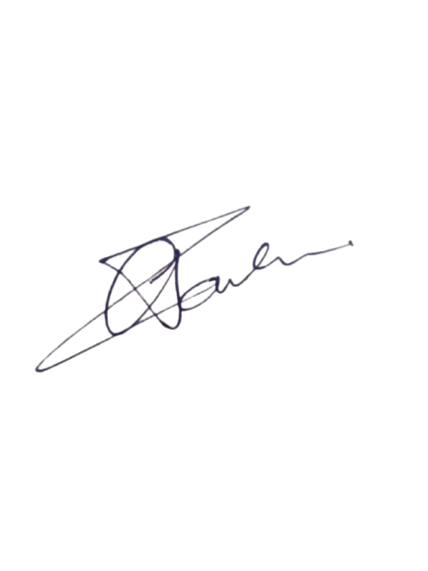
TrueNook India Pvt Ltd. Contracter
Name: Tarun Shiva Sai Gummadi Name:_____________________
Signature: Signature: _________________
Date: 06-Apr-2026 Date: _____________________

