1)Project tittle:
- IoT-Based Anti-Theft Floor Mat with Email Alerts
2)Research Supervisor/Designation / Department / Campus :
- Engr. Abid Ullah/Professor/Electrical/Jalozai

3)Area of Research:
- Internet of Things (IoT)

Targeted Industry :
- Security & Surveillance Industry

UN SDGs:
- SDG 9 – Industry, Innovation, and Infrastructure

Because your project uses innovative technology (IoT + sensors).

- SDG 11 – Sustainable Cities and Communities

Because it contributes to safer, smarter living spaces.

- SDG 16 – Peace, Justice, and Strong Institutions

Because it helps reduce theft and improves security.

4.Research Objective:
1)Create an anti-theft floor mat utilizing a Piezoelectric vibration sensor.
2)Integrate Arduino and NodeMCU (ESP8266) for signal processing and wireless communication
3)Implement IFTTT webhooks to send instant Gmail alerts upon vibration or pressure detection
4)Assess system accuracy and response time for effective intrusion detection.

5. Methodology :

System Overview
The Piezoelectric sensor generates an analog voltage when mechanical stress (such as a footstep) is applied to the mat. The Arduino processes this signal and determines if the vibration exceeds a set threshold. When it does, Arduino sends an “ALERT” message via serial communication to the NodeMCU, which is connected to Wi-Fi. The NodeMCU then triggers an IFTTT Webhook, which sends an email notification to the registered Gmail account.

System Design

Block Diagram
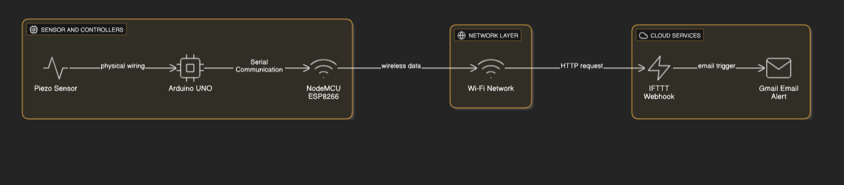

Hardware Requirements
Component | Description
Arduino UNO / Nano | Reads analog signal from Piezo sensor
NodeMCU (ESP8266) | Provides Wi-Fi connectivity and sends alerts via Internet
Piezoelectric Sensor | Detects vibration or mechanical stress
10kΩ Resistor | Used in voltage divider circuit
Breadboard and Jumper Wires | For circuit connections
Power Supply (5V USB or battery) | Powers Arduino and NodeMCU
LED/Buzzer (optional) | For local alarm indication

Software Requirements
- Arduino IDE (for coding Arduino and NodeMCU)
- IFTTT Account (for triggering Gmail alerts)
- Wi-Fi Connection
- Gmail Account (for receiving alerts)

Working Principle
- The Piezo sensor, placed under a mat, detects vibrations when someone steps on it or tampers with it.
- The sensor generates an analog voltage proportional to the vibration intensity.
- Arduino reads the sensor value and checks if it exceeds a defined threshold.
- When triggered, Arduino sends a message (“ALERT”) to NodeMCU through serial communication.
- NodeMCU, connected to Wi-Fi, sends a web request to IFTTT.
IFTTT executes the Gmail service to send an email notification like:
“Alert! Vibration detected on floor mat

6.Research Outcomes :
- Piezo sensor successfully detects vibration or footsteps.
- Gmail alert received within 5–10 seconds after detection.
- Minimal false triggers after proper threshold calibration.
- Low-cost and portable anti-theft system.
7.Relevant Industry :

- Internet of Things (IoT)
- Security & Surveillance Industry

8.Cost Estimation / Budget Required (Millions PKR) :

- PKR.45000

9. Any funding received?
- NO

10.FYP Members :

Student Name | Registration Number
Aqeel Khan | 22JZELE0461
Mashal Ahmad | 22JZELE0466
Mobeen Dawood Khan | 22JZELE0493

