University of Engineering and Technology, Peshawar
Department of Electrical Engineering

Project Proposal

Project Title:
IoT-Based Anti-Theft Floor Mat with Gmail Email Alerts using Arduino and NodeMCU (Piezo Sensor-Based)

Submitted By:
Student Name | Registration Number
Aqeel Khan | 22JZELE0461
Mashal Ahmad | 22JZELE0466
Mobeen Dawood Khan | 22JZELE0493

Supervisor:
Engr. Abid Ullah
Email: abidullah@uetpeshawar.edu.pk

Contents
University of Engineering and Technology, Peshawar
Project Proposal
Project Title:
Submitted By:
Supervisor:
Project Proposal
Project Title:
1. Introduction
2. Problem Statement
3. Objectives
4. Scope of the Project
5. System Overview
6. System Design
6.1 Block Diagram
7. Hardware Requirements
8. Software Requirements
9. Working Principle
10. Expected Results
11. Applications
12. Advantages
13. Future Enhancements
14. Conclusion

1. Introduction
With the rise in theft and unauthorized access, smart security systems are becoming essential. Traditional alarm systems are either expensive or lack instant remote alert capabilities. To overcome this limitation, this project proposes an IoT-based Anti-Theft Floor Mat that uses a piezoelectric sensor to detect vibrations or footsteps and instantly sends a Gmail email alert through NodeMCU (ESP8266).
The integration of Arduino and IoT technology enables the system to send real-time alerts via the internet whenever the mat detects vibration or impact, ensuring immediate response to possible theft or intrusion attempts.

2. Problem Statement
Conventional anti-theft systems such as CCTV and infrared alarms are either costly, require complex installation, or are not easily portable. There is a need for a simple, low-cost, and efficient anti-theft device that can detect suspicious movement or vibration and notify the user instantly via the internet.

3. Objectives
The main objectives of this project are:
- To design and develop an anti-theft floor mat using a Piezoelectric vibration sensor.
- To interface Arduino and NodeMCU (ESP8266) for signal processing and wireless communication.
- To send real-time Gmail alerts through IFTTT webhooks when vibration or pressure is detected.
- To create a cost-effective and portable IoT security device suitable for homes, offices, or storage areas.
- To evaluate system performance based on detection accuracy and alert response time.

4. Scope of the Project
This project provides a vibration-based intrusion detection system capable of sending email alerts to the user. The system:
- Detects vibrations when someone steps on or moves the mat.
- Sends an instant Gmail alert through the Internet.
- Can be installed in front of doors, windows, safes, or valuables.
- Is easy to set up, portable, and cost-effective.
The project focuses on detection and notification; it does not include automated defense mechanisms or camera integration, which can be added later.

5. System Overview
The Piezoelectric sensor generates an analog voltage when mechanical stress (such as a footstep) is applied to the mat. The Arduino processes this signal and determines if the vibration exceeds a set threshold. When it does, Arduino sends an “ALERT” message via serial communication to the NodeMCU, which is connected to Wi-Fi. The NodeMCU then triggers an IFTTT Webhook, which sends an email notification to the registered Gmail account.

6. System Design

6.1 Block Diagram
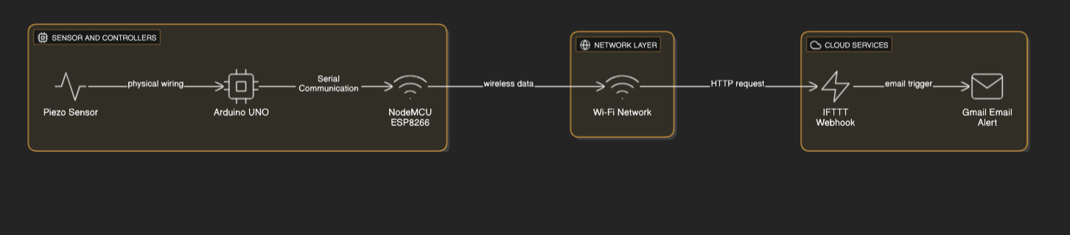

7. Hardware Requirements
Component | Description
Arduino UNO / Nano | Reads analog signal from Piezo sensor
NodeMCU (ESP8266) | Provides Wi-Fi connectivity and sends alerts via Internet
Piezoelectric Sensor | Detects vibration or mechanical stress
10kΩ Resistor | Used in voltage divider circuit
Breadboard and Jumper Wires | For circuit connections
Power Supply (5V USB or battery) | Powers Arduino and NodeMCU
LED/Buzzer (optional) | For local alarm indication

8. Software Requirements
- Arduino IDE (for coding Arduino and NodeMCU)
- IFTTT Account (for triggering Gmail alerts)
- Wi-Fi Connection
- Gmail Account (for receiving alerts)

9. Working Principle
- The Piezo sensor, placed under a mat, detects vibrations when someone steps on it or tampers with it.
- The sensor generates an analog voltage proportional to the vibration intensity.
- Arduino reads the sensor value and checks if it exceeds a defined threshold.
- When triggered, Arduino sends a message (“ALERT”) to NodeMCU through serial communication.
- NodeMCU, connected to Wi-Fi, sends a web request to IFTTT.
- IFTTT executes the Gmail service to send an email notification like:
“Alert! Vibration detected on floor mat — possible intrusion.”
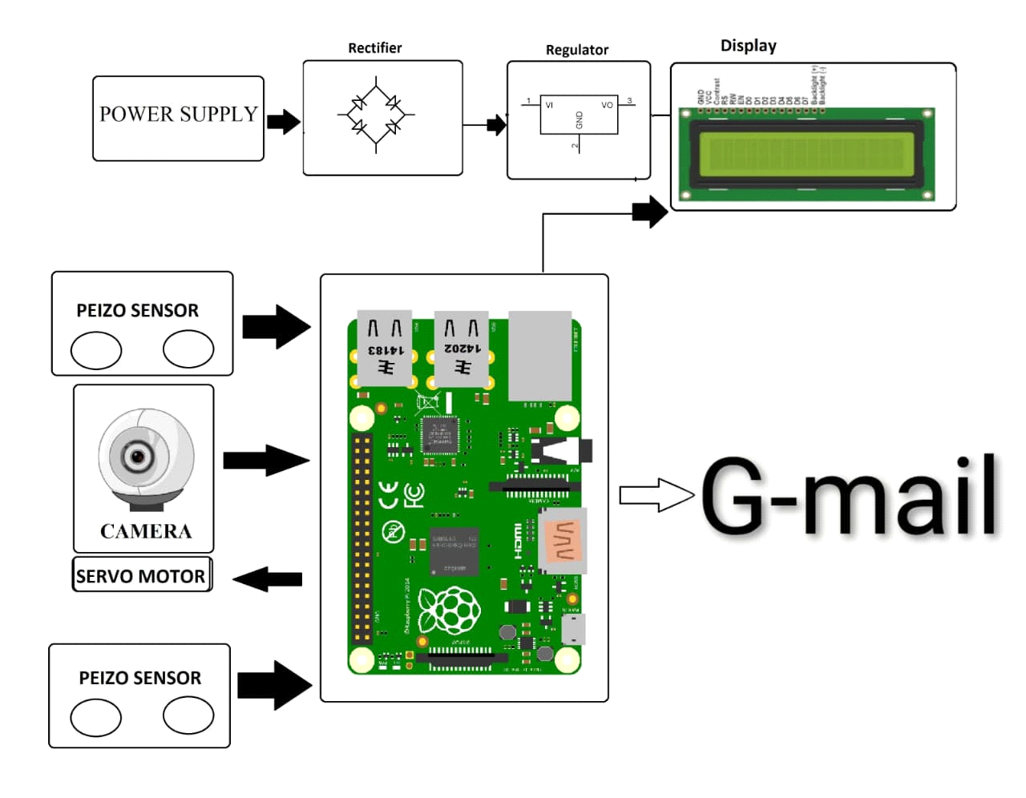

10. Expected Results
- Piezo sensor successfully detects vibration or footsteps.
- Gmail alert received within 5–10 seconds after detection.
- Minimal false triggers after proper threshold calibration.
- Low-cost and portable anti-theft system.

11. Applications
- Home and office entry monitoring.
- Securing valuable items or safes.
- Detecting intrusion in restricted areas.
- Portable vibration-sensitive security mats for exhibitions or shops.

12. Advantages
- Low-cost, easy-to-build IoT security system.
- Wireless alerting through Gmail.
- No complex sensors or cameras needed.
- Highly sensitive and quick response.
- Scalable and customizable.

13. Future Enhancements
- Add Blynk or Telegram alerts for mobile notifications.
- Integrate buzzer and LED indicators.
- Use multiple piezo sensors for wider coverage.
- Store intrusion logs in Google Sheets via IFTTT.
- Include camera module to capture intruder image.

14. Conclusion
This project successfully demonstrates a low-cost, IoT-based anti-theft system using a Piezoelectric vibration sensor, Arduino, and NodeMCU. The system effectively detects vibration events, sends instant Gmail alerts, and offers an innovative and practical solution for theft prevention in residential and commercial environments.

