Localization with EV3 robot

LOTI.05.010 Robotics

Spring semester 2015/16

Practice session 7
In this session you will learn how to use ROBOTC, MINDSTORMS sensors, EV3 motors movement, synchronisation and also to use open loop control to move the robot to the position (x,y) and check it's angle between x-axis.

You will learn to:
- Use distance sensor(sonar) to detect distances and make the robot act on that
- Movement details of MINDSTORMS robot, use of syncrhonisation
- Drive to position (x,y) when robot initial position is (0,0) with no obstacles, robot is oriented along x axis
- Make the robot to calculate it's angle
- Make the robot to calculate it's coordinates (bonus)

Tools needed:
- ROBOTC 4.x or newer
- USB cable
- Tape measure
- LEGO robot
- Taxi drive field

Work description
1. Move the robot
ROBOTC is a useful tool for programming following platforms:
- ARDUINO
- CORTEX
- NXT
- EV3
- PIC
- TETRIX
1.1 Open the ROBOTC program “ROBOTC for LEGO Mindstorms 4.X” from Desktop.
1.2 Connect the EV3 with USB cable. Turn EV3 robot on from the middle button (1).
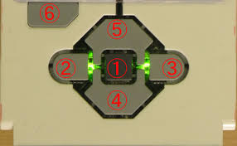
1.3 Press “Firmware Download” button on the top menu. If it gives an error then also download the ROBOTC EV3 Linux kernel to the robot (Robot->Download EV3 Linux kernel->Standard File) You only need to do this once.

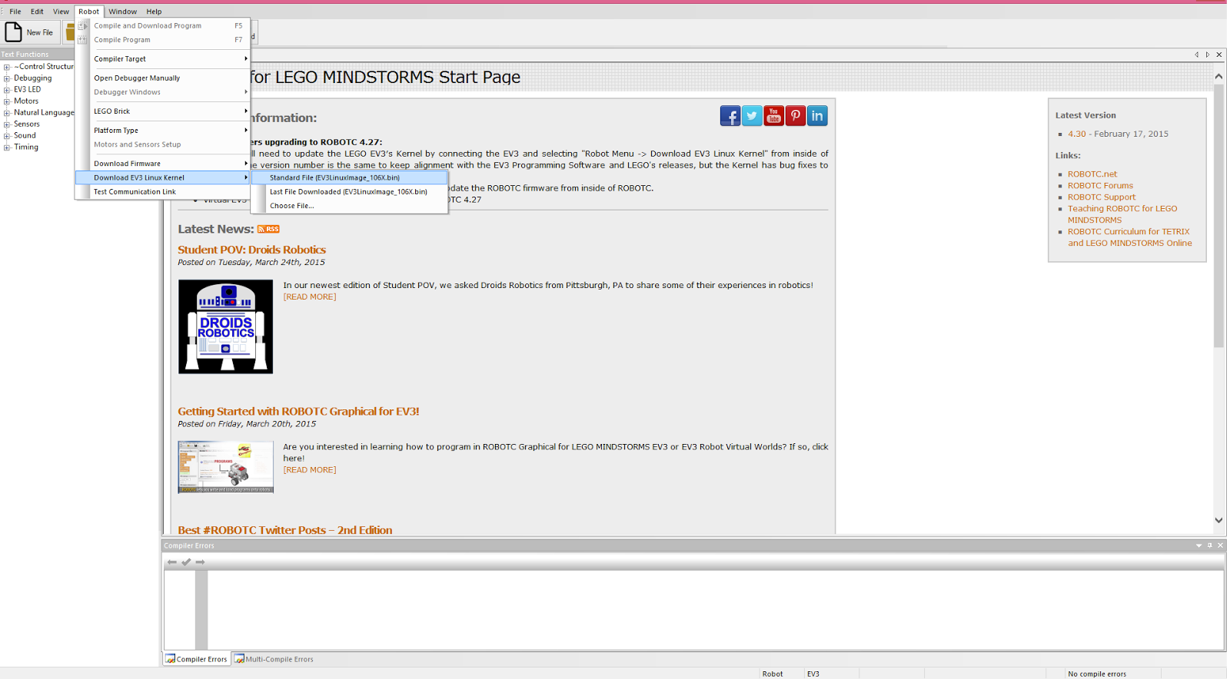
1.4 You can use ROBOTC online help Wiki. There is all the information you need to know about programming EV3 in ROBOTC. Go to link http://help.robotc.net/WebHelpMindstorms/index.htm
2. Try the following sample program:
task main()
{
//motor B and motor C speed is set 50
setMotorSpeed(motorB, 50);
setMotorSpeed(motorC, 50);
//wait one second
sleep(1000);
}
2.1 Make the robot drive forward 2 seconds with full speed
2.2 Make the robot to drive in curve one second left and another curve to right one second.


2.3 Make the robot to go straight 200 cm. Measure how far is robot driving with one second. Then apply right time to make the robot drive 200 cm.

Did you notice that robot might not drive straight when it needs to go in longer distances? Although motors are given the same commands, there will be difference in their resulting work. This is not only problem of LEGO robots but generally in robotics. How to make a robot that drives straight? One way to deal with it is to use rotation sensors inside motors to detect if there is increasing difference in motor distances. If one motor is rotating more, then that motor is little bit “stopped” to help the other motor to catch up.
Let’s try the code that is doing such control for us.
int taskname()
{
setMotorSyncEncoder(motorB, motorC, 0, 360, 50);
waitUntilMotorStop(motorB);
}
Find setMotorSyncEncoder command from Help and read what arguments are meaning.
Based on knowledge from the lecture, calculate how many degrees one motor has to turn to make robot turn physically 90°.
Set arguments according to your calculations into this command:
task main()
{
setMotorSyncEncoder(motorB, motorC, ??, ???, 50);
waitUntilMotorStop(motorB);
}

3. Make the robot to follow the pathline in a small city. Start from "start" square and finish in one of the parking lots. Do not use trial-and-error method. Make the robot to drive based on distances you measure and physical turns. For example, you will measure that first thing need to do is to drive forward 80 cm and then turn right 90°. You insert these numbers into your program and robot knows how many rotations it needs to do to drive 80 cm and how many rotations it needs to do to turn 90°.
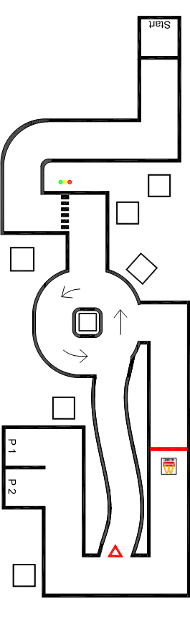
4. Make the robot to do the following command:
setMotorSyncEncoder(motorB, motorC, -100, 89, 40);
waitUntilMotorStop(motorB);
4. 1 Make the robot to calculate angle between it's own direction and x axis. This angle is named Θ (theta). Let the robot to show angle on screen. Angle calculation must be based on encoder values. Use following command for retreiving encoder values: getMotorEncoder(motorX)

Previous command would make the robot in standard Mindstorms configuration to turn 45 ° left. Does robot show that?

