**Introduction to Python**

**Lab#7**

**Aqeel Javaid**

**32354**

**11/7/2022**

**Activity:1**

def addition(a,b):  
 result = a + b  
 return str(result)  
  
def multiply(a,b):  
 result = a * b  
 return str(result)  
  
def subtract(a,b):  
 result = a - b  
 return str(result)  
  
def division(a,b):  
 result = a / b  
 return str(result)  
  
def menu():  
 print(**"Addition: 1"**)  
 print(**"Subtraction: 2"**)  
 print(**"Multipy: 3"**)  
 print(**"Division: 4"**)  
 print(**"Quit: 5"**)  
 val = int(input(**"Enter choice :"**))  
 a = int(input(**"Enter first num :"**))  
 b = int(input(**"Enter second num :"**))  
 if val == 1:  
 print(**"Result = "** + addition(a,b))  
 menu()  
 elif val == 2:  
 print(**"Result = "** + subtract(a,b))  
 menu()  
 elif val == 3:  
 print(**"Result = "** + multiply(a,b))  
 menu()  
 elif val == 4:  
 print(**"Result = "** + division(a,b))  
 menu()  
 elif val == 5:  
 return 0  
 else:  
 print(**"Enter valid choice"**)  
 menu()  
  
menu()

**Output:**

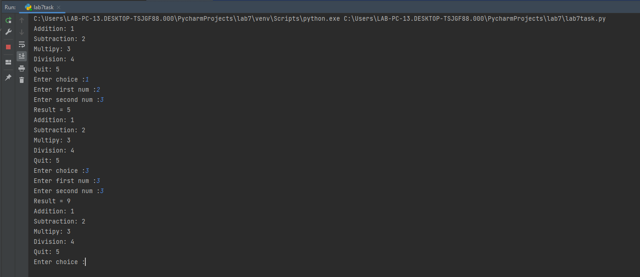

**Activity:2**

import math  
  
def addition(a, b):  
 result = a + b  
 return str(result)  
  
def multiply(a, b):  
 result = a * b  
 return str(result)  
  
def subtract(a, b):  
 result = a - b  
 return str(result)  
  
def division(a, b):  
 result = a / b  
 return str(result)  
  
def factorial(a):  
 fact = 1  
 for i in range(1, a + 1):  
 fact = fact * i  
 result = fact  
 return str(result)  
  
def power(a, b):  
 result = pow(a,b)  
 return str(result)  
  
def log(a):  
 result = math.log(a)  
 return str(result)  
  
def menu():  
 print(**"Addition: 1"**)  
 print(**"Subtraction: 2"**)  
 print(**"Multipy: 3"**)  
 print(**"Division: 4"**)  
 print(**"Factorial: 5"**)  
 print(**"Power: 6"**)  
 print(**"Log: 7"**)  
 print(**"Quit: 8"**)  
 val = int(input(**"Enter choice :"**))  
  
 if val == 1:  
 a = int(input(**"Enter first num :"**))  
 b = int(input(**"Enter second num :"**))  
 print(**"Result = "** + addition(a, b))  
 menu()  
 elif val == 2:  
 a = int(input(**"Enter first num :"**))  
 b = int(input(**"Enter second num :"**))  
 print(**"Result = "** + subtract(a, b))  
 menu()  
 elif val == 3:  
 a = int(input(**"Enter first num :"**))  
 b = int(input(**"Enter second num :"**))  
 print(**"Result = "** + multiply(a, b))  
 menu()  
 elif val == 4:  
 a = int(input(**"Enter first num :"**))  
 b = int(input(**"Enter second num :"**))  
 print(**"Result = "** + division(a, b))  
 menu()  
 elif val == 5:  
 a = int(input(**"Enter num :"**))  
 print(**"Factorial of "** + str(a) + **" is "** + factorial(a))  
 menu()  
 elif val == 6:  
 a = int(input(**"Enter first num :"**))  
 b = int(input(**"Enter second num :"**))  
 print(str(a)+**" power "** + str(b) + **" is "** + power(a,b))  
 menu()  
 elif val == 7:  
 a = int(input(**"Enter num :"**))  
 print(**"Log of "** + str(a) + **" is "** + log(a))  
 menu()  
 elif val == 8:  
 return 0  
 else:  
 print(**"Enter valid choice"**)  
 menu()  
  
menu()

**Output**

