Software Design Specifications

The Decorum

Version: [1.0]

Project Code
Supervisor | Dr. Fahad Samad
Co Supervisor
Project Team | Syed Muhammad Aqeel Abbas(17k-3701)  Muhammad Furqan(17k-3836)  Muneeb Ul Hasan(17k-3717)
Submission Date | 14/12/2020

[Instructions]
- No section of template should be deleted. You can write ‘Not applicable’ if a section is not applicable to your project. But all sections must exist in the final document.
- All comments/examples mentioned in square brackets ([]) are in the template for explanation purposes and must be replaced / removed in final document.
- This’ Instruction’ section should also be removed in final document.
- MS-Word Reviewing feature must be used to get the document reviewed by PMs or supervisors.

Document History
Version | Name of Person | Date | Description of change
 |  |  | [e.g. Document Created]
 |  |  | [Added Non-functional requirements]
 |  |  | [Added UseCase x.x.xx]

Distribution List
Name | Role
Dr.Fahad Samad | Supervisor
 | Co Supervisor

Document Sign-Off
Version | Sign-off Authority | Project Role | Signature | Sign-off Date

Document Information

Category | Information
Customer | FAST-NU
Project | The Decorum
Document | Software Design Specification
Document Version | 1.0
Status | Draft
Author(s) | Muhammad Furqan,Syed Muhammad Aqeel Abbas, Muneeb ul Hasan
Approver(s) | Dr.Fahad Samad
Issue Date
Document Location
Distribution | Advisor  Project Coordinator’s Office (through Advisor)

Definition of Terms, Acronyms and Abbreviations
Term | Description
AR | Augmented Reality

Table of Contents
1 Introduction 8
1.1 Purpose of Document 8
1.2 Intended Audience 8
1.3 Document Convention 8
1.4 Project Overview 8
1.5 Scope 9

2 Design Considerations 9
2.1 Assumptions and Dependencies 9
2.2 Risks and Volatile Areas 9
3 System Architecture 10
3.1 System Level Architecture 10
3.2 Software Architecture 10
4 Design Strategy 10-11
5 Detailed System Design 11-12
5.1 Database Design 12
5.1.1 ER Diagram 12
5.1.2 Data Dictionary 12
5.1.2.1 Data 1 12
5.2 Application Design 13
5.2.1 Sequence Diagram 13
5.2.1.1 <Sequence Diagram 1> 13
5.2.1.2 <Sequence Diagram 2> 14
5.2.1.3 <Sequence Diagram 3> 15
5.2.1.4 <Sequence Diagram 4> 16
5.2.1.5 <Sequence Diagram 5> 17

5.2.2 State Diagram 14
5.2.2.1 <State Diagram 1> 14
5.2.2.2 <State Diagram 2> 14
5.2.2.3 <State Diagram n> 14
6 References 15
7 Appendices 16

Introduction

Purpose of Document
This SRS is written in order to give a software development team overall guidance to the architecture of the software project.

Intended Audience

The intended audience would be the developers and approvers or the technical and academic staff of FAST NUCES karachi.

Document Convention
For Headings : Font is Calibri and font size is 14.
For Paragraph : Font is calibri and font size is 12.

Project Overview
As our project is linked with another project, the first thing that we will do is that we will make an app which will be fetching data to our app from the database of the other project. Then if the customer searching on the web wants to see the product via AR, there will be an option beside the product on the web, like (“Click to check this product on AR”), then from there our Application will open on customers mobile, app will first ask the customer for permission to open camera, then the customer can check out the product by placing it anywhere he/she likes in his/her room. Customer can also check out the sizes in which that product is available, suppose if the customers selects a vase of medium size than the order of selected size will go towards the web and from there customer can check out.
For a new customer, not coming directly from the Web Button but installing our app directly from Play store. The App will first ask permission of camera and then the app will open. He will see a list of items that our currently available on the web. If he wishes to check out the product, he can click on it and see details or he can check that product in AR and then checkout towards the web to further process the order. There will also be buttons of login and signup which will redirect users towards web and from there they will be able to login or make a new account.

Scope

In scope features of our Application:

- 3d Object Tracking.
- Able to select angle of product.
- Take pictures while using AR.
- Share pictures.
- Select available color.
- Search items.[FYP2]
- Click on product to see details of it on web(other project) [FYP2]
- Recommendation of products[FYP2]

Not In Scope
- Product details.
- Add to cart products.
- Signup/Login

Design Considerations

Assumptions and Dependencies
We are making assumption that the mobile phone that will be using our app will be having Android version(7.0.0) or higher because AR only works on Android version(7.0.0) or higher.

Risks and Volatile Areas
Since we will be using 3d models of the products , a slight change in the real life product will make us change the 3dmodel so that the product that is shown will be same when delivered at the doorstep.

System Architecture

System Level Architecture

COMPONENT DIAGRAM:

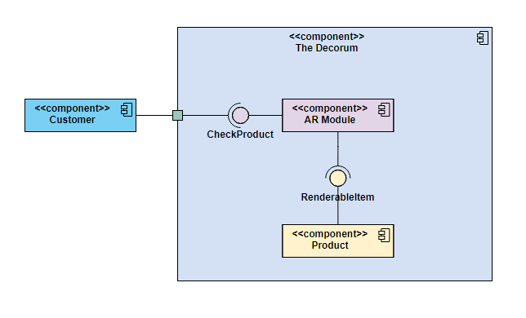PACKAGE DIAGRAM:

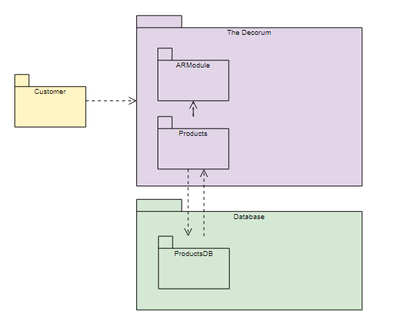

Software Architecture
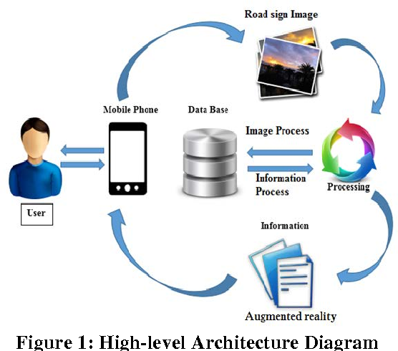
Software Architecture Diagram

Design Strategy

Future System Extension
In future, if we intend to extend our system then our main objective overcome the system constraints, expand the scope of our products from only homedecor categories to other categories too.

System Reuse
The system will be designed to follow the reusability principle of design by making use of design patterns that allow developers to achieve reusability in their system.

4.3 User Interface Paradigms

The user interface paradigms must be considered while making design decisions. These include smooth user-friendly navigation, eye-catching buttons principles,elegent 3d models etc

Database Management
The database design decision will be taken by keeping in mind the performance aspects of the system, efficient storage,etc.

Detailed System Design
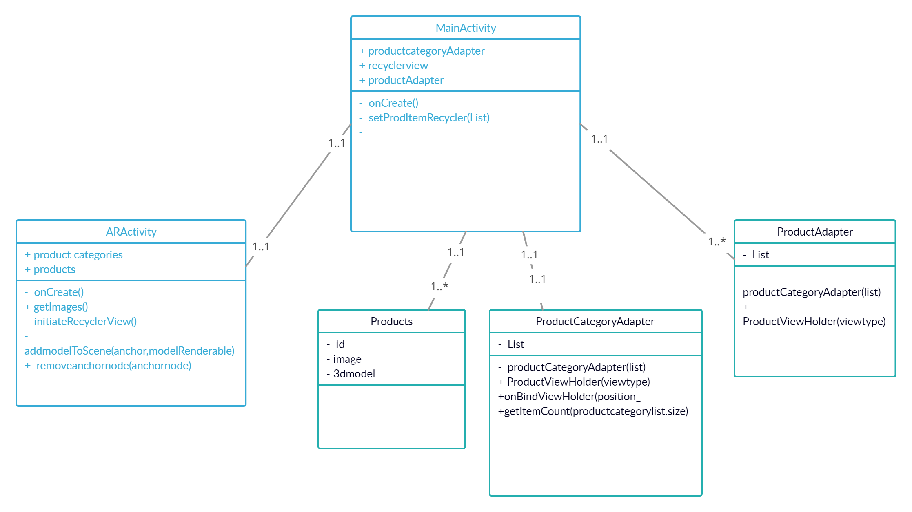

Database Design

ER Diagram
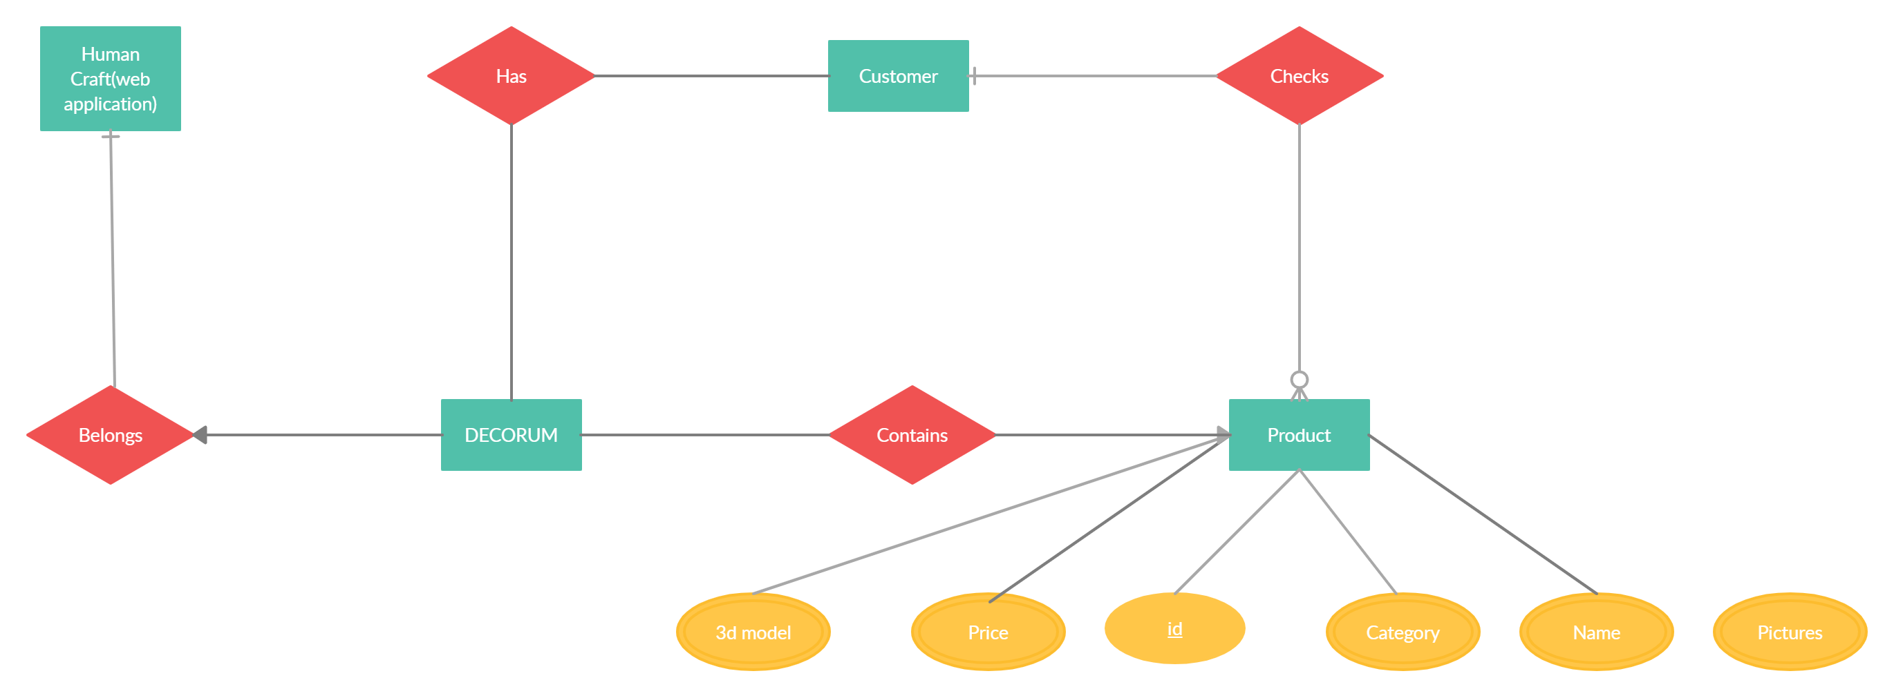

Data Dictionary

Data 1

Product
Name |  | Product
Alias |  | -
Where-used/how-used |  | Product category uses products.  ARActivity uses products id.
Content description |  | {}n
Column Name | Description |  | Type | Length | Null able | Default Value | Key Type
Id | Product id |  | Int | 50 | No | 1 | PK
Price | Product price |  | Int | 10 | No | 0 | PK
Category | Product category |  | String | 50 | No | - | PK
Name | Product name |  | String | 50 | No | - | PK
3dmodel | Product model |  | String | 20 | No | - | PK
Picture | Product price |  | String | 20 | No | - | PK

Application Design

Sequence Diagram

<Sequence Diagram 1>
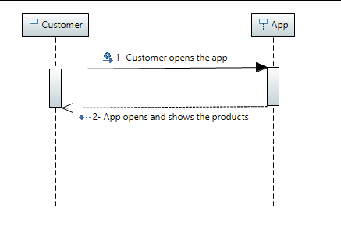

<Sequence Diagram 2>
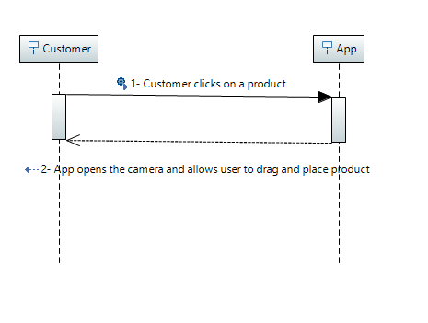

<Sequence Diagram 3>
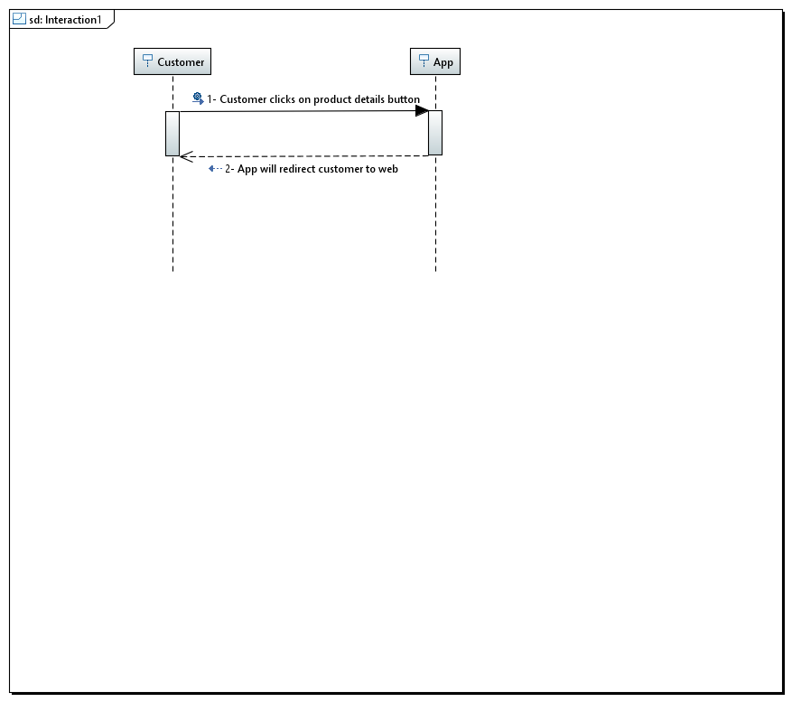

<Sequence Diagram 4>
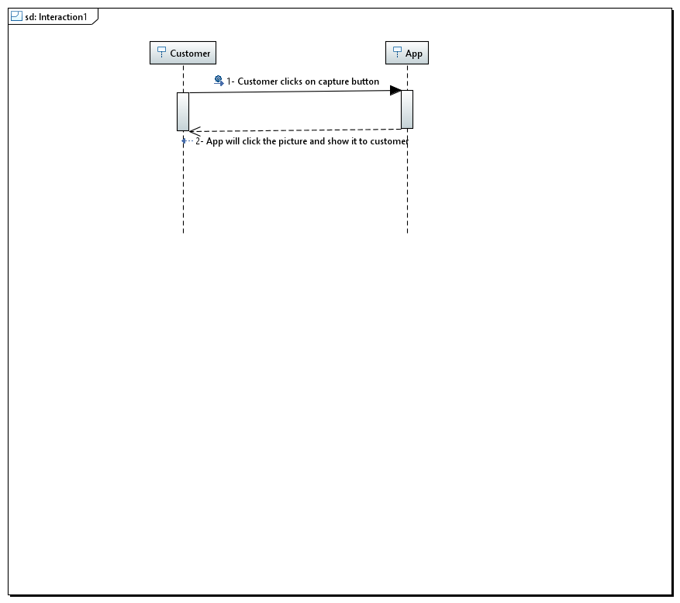

<Sequence Diagram 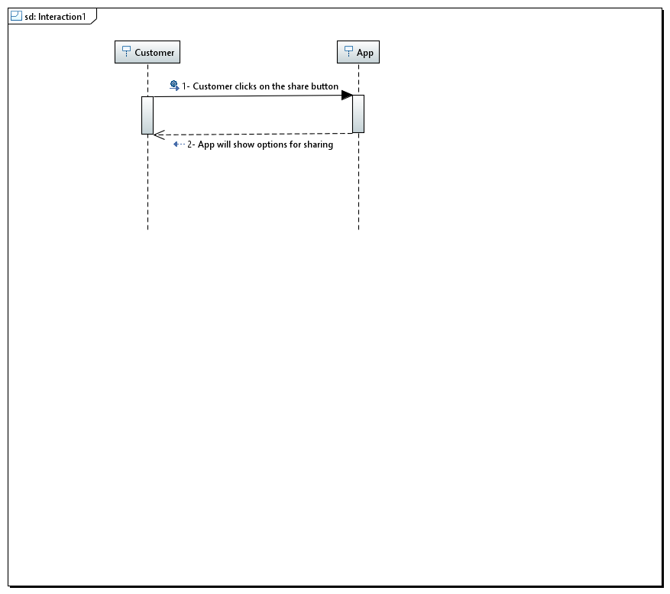

State Diagram

<State Diagram 1>
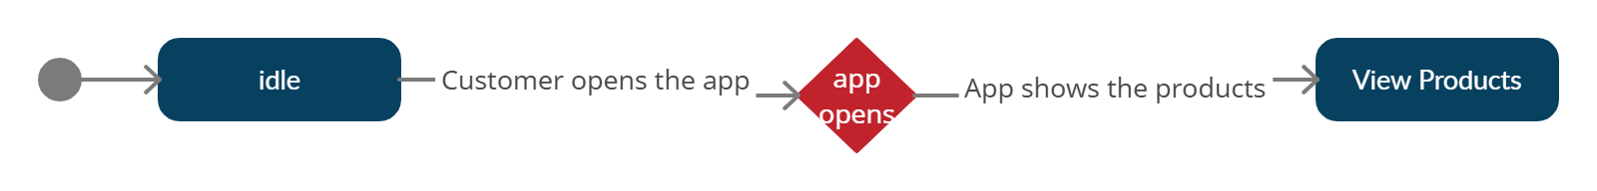

<State Diagram 2>
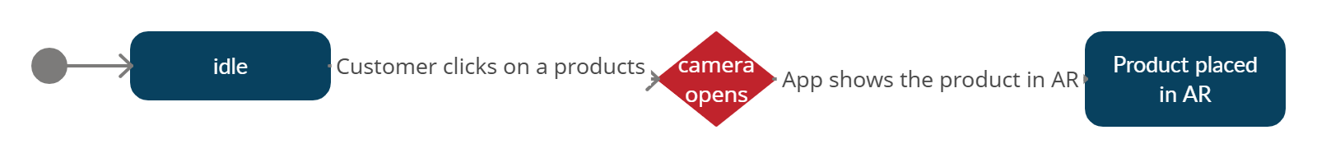

<State Diagram 3>
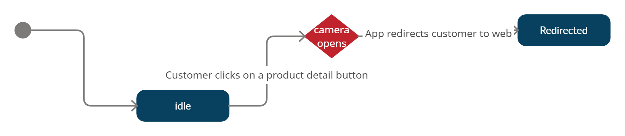

<State Diagram 4>
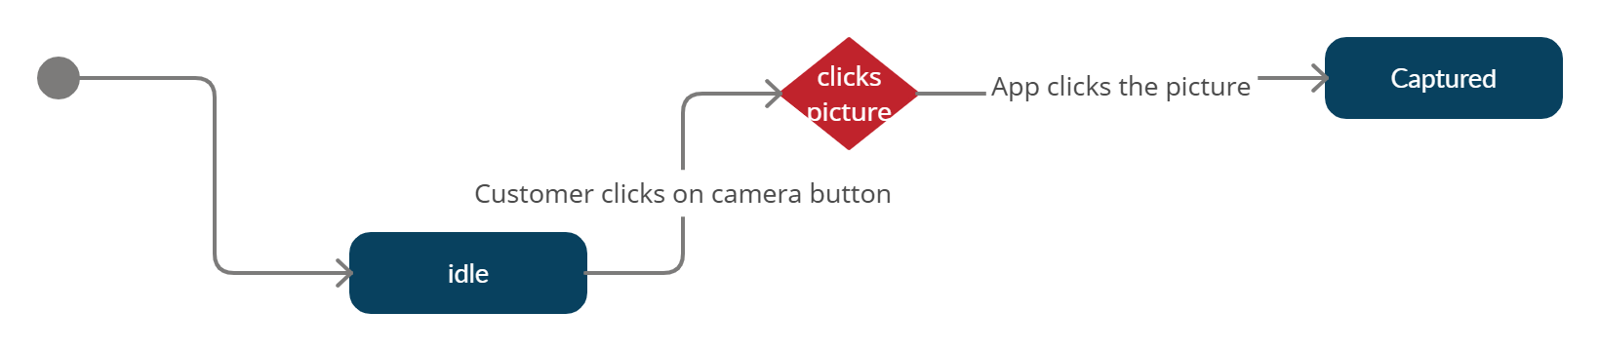

<State Diagram 5>
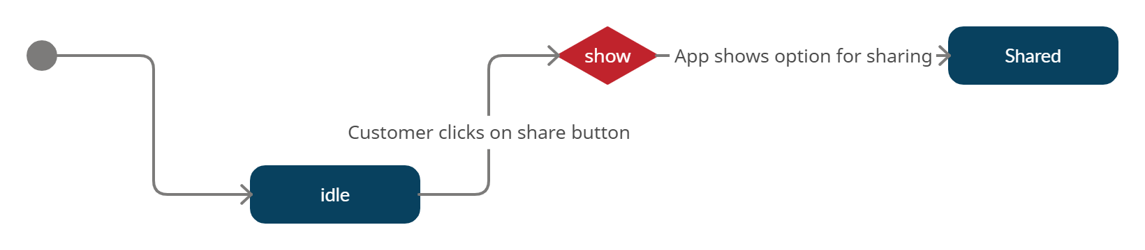

6. References

- Maxst.com. 2020. [online] Available at: <http://maxst.com/#/en/arguide> [Accessed 16 October 2020].
- Google Developers. 2020. Quickstart For Android | Arcore | Google Developers. [online] Available at: <https://developers.google.com/ar/develop/java/quickstart> [Accessed 16 October 2020].
- "Augmented Reality App Development - A Guide To Getting Started". 2020. Waracle. https://waracle.com/blog/augmented-reality/introduction-augmented-reality-app-development/.
- "Best AR SDK For Development For Ios And Android". 2020. Thinkmobiles. https://thinkmobiles.com/blog/best-ar-sdk-review/.
- "The Rise Of Augmented Reality In Interior Design And Property Development". 2020. Iflexion. https://www.iflexion.com/blog/augmented-reality-interior-design.

7. Appendices

MAIN ACTIVITY:
package com.example.secondar;
import androidx.appcompat.app.AppCompatActivity;
import androidx.recyclerview.widget.LinearLayoutManager;
import androidx.recyclerview.widget.RecyclerView;
import android.net.Uri;
import android.os.Bundle;
import android.view.View;
import android.widget.Button;
import com.google.ar.core.Anchor;
import com.google.ar.sceneform.AnchorNode;
import com.google.ar.sceneform.rendering.ModelRenderable;
import com.google.ar.sceneform.ux.ArFragment;
import com.google.ar.sceneform.ux.TransformableNode;
import java.util.ArrayList;
public class MainActivity extends AppCompatActivity {
private ArFragment arFragment;
private ArrayList<Integer> imagesPath = new ArrayList<Integer>();
private ArrayList<String> namesPath = new ArrayList<>();
private ArrayList<String> modelNames = new ArrayList<>();
AnchorNode anchorNode;
private Button btnRemove;
@Override
protected void onCreate(Bundle savedInstanceState) {
super.onCreate(savedInstanceState);
setContentView(R.layout.activity_main);
arFragment = (ArFragment)getSupportFragmentManager().findFragmentById(R.id.fragment);
btnRemove = (Button)findViewById(R.id.remove);
getImages();
arFragment.setOnTapArPlaneListener((hitResult, plane, motionEvent) -> {
Anchor anchor = hitResult.createAnchor();
ModelRenderable.builder()
.setSource(this,Uri.parse(Common.model))
.build()
.thenAccept(modelRenderable -> addModelToScene(anchor,modelRenderable));
});
btnRemove.setOnClickListener(view -> removeAnchorNode(anchorNode));
}
private void getImages() {
imagesPath.add(R.drawable.table);
imagesPath.add(R.drawable.bookshelf);
imagesPath.add(R.drawable.lamp);
imagesPath.add(R.drawable.odltv);
imagesPath.add(R.drawable.clothdryer);
imagesPath.add(R.drawable.chair);
namesPath.add("Table");
namesPath.add("BookShelf");
namesPath.add("Lamp");
namesPath.add("Old Tv");
namesPath.add("Cloth Dryer");
namesPath.add("Chair");
modelNames.add("table.sfb");
modelNames.add("model.sfb");
modelNames.add("lamp.sfb");
modelNames.add("tv.sfb");
modelNames.add("cloth.sfb");
modelNames.add("chair.sfb");
initaiteRecyclerview();
}
private void initaiteRecyclerview() {
LinearLayoutManager layoutManager = new LinearLayoutManager(this,LinearLayoutManager.HORIZONTAL,false);
RecyclerView recyclerView = (RecyclerView)findViewById(R.id.recyclerview);
recyclerView.setLayoutManager(layoutManager);
RecyclerviewAdapter adapter = new RecyclerviewAdapter(this,namesPath,imagesPath,modelNames);
recyclerView.setAdapter(adapter);
}
private void addModelToScene(Anchor anchor, ModelRenderable modelRenderable) {
anchorNode = new AnchorNode(anchor);
TransformableNode node = new TransformableNode(arFragment.getTransformationSystem());
node.setParent(anchorNode);
node.setRenderable(modelRenderable);
arFragment.getArSceneView().getScene().addChild(anchorNode);
node.select();
}
public void removeAnchorNode(AnchorNode nodeToremove) {
if (nodeToremove != null) {
arFragment.getArSceneView().getScene().removeChild(nodeToremove);
nodeToremove.getAnchor().detach();
nodeToremove.setParent(null);
nodeToremove = null;
}
}
}

RECYCLERVIEW ADAPTER:
package com.example.secondar;
import android.content.Context;
import android.graphics.drawable.Drawable;
import android.view.LayoutInflater;
import android.view.View;
import android.view.ViewGroup;
import android.widget.ArrayAdapter;
import android.widget.ImageView;
import android.widget.TextView;
import androidx.annotation.NonNull;
import androidx.recyclerview.widget.RecyclerView;
import java.util.ArrayList;
public class RecyclerviewAdapter extends RecyclerView.Adapter<RecyclerviewAdapter.ViewHolder>{
private ArrayList<String> textNames = new ArrayList<>();
private ArrayList<Integer> imagesPath = new ArrayList<>();
private Context context;
private ArrayList<String> modelNames = new ArrayList<>();
public RecyclerviewAdapter(Context context,ArrayList<String> textNames, ArrayList<Integer> imagesPath,ArrayList<String> modelNames) {
this.textNames = textNames;
this.imagesPath = imagesPath;
this.modelNames = modelNames;
this.context = context;
}
@NonNull
@Override
public ViewHolder onCreateViewHolder(@NonNull ViewGroup parent, int viewType) {
View view = LayoutInflater.from(parent.getContext()).inflate(R.layout.layout_list_item,parent,false);
return new ViewHolder(view);
}
@Override
public void onBindViewHolder(@NonNull ViewHolder holder, int position) {
holder.imageView.setImageResource(imagesPath.get(position));
holder.textView.setText(textNames.get(position));
holder.imageView.setOnClickListener(new View.OnClickListener() {
@Override
public void onClick(View view) {
Common.model = modelNames.get(position);
}
});
}
@Override
public int getItemCount() {
return imagesPath.size();
}
public class ViewHolder extends RecyclerView.ViewHolder{
ImageView imageView;
TextView textView;
public ViewHolder(@NonNull View itemView) {
super(itemView);
imageView = itemView.findViewById(R.id.imageview);
textView = itemView.findViewById(R.id.text);
}
}
}

