Journal of Information and Organizational Sciences  Volume XX, Number X (20XX)  Journal homepage: jios.foi.hr | JIOS

DOI: 10.31341/jios.XX.X.X UDC Signature
Open Access Paper

How Much Do Click-Based Activity Features Add Beyond Course Context? A Within/Between Decomposition and Early-Prediction Audit on OULAD

PAPER INFO |  | ABSTRACT
Paper history:  Received XX Month YYYY  Accepted XX Month YYYY  Published XX Month YYYY  Citation:  [Citation withheld for blind review]  Copyright:  © 2024 The Authors. This work is licensed under a Creative Commons Attribution BY-NC-ND 4.0. For more information, see https://creativecommons.org/licenses/by-nc-nd/4.0/ |  | Early-warning systems that flag students at risk of failing are often justified by showing that a new feature family raises accuracy under random cross-validation. For an institution deciding what to log, build and trust, this evidence can mislead when the features also reveal which course a student is in. We audit this problem for activity-type click shares (shares of clicks on 20 activity types plus their entropy) in the Open University Learning Analytics Dataset (32,593 enrolments, 22 presentations of seven modules), using logistic regression and gradient boosting. Under stratified cross-validation, adding the click shares to performance and engagement-count features raised accuracy by 2.6 percentage points, but when course identity was in the model the gain fell to 0.02 points (logistic regression) and 0.33 points (gradient boosting). In early prediction (day 28 and day 56, cutoff-first truncation), a small within-course signal of 0.4 to 1.7 points remained in three of four settings. It was strongest without assessment data, was not robust once assessment data and a course-normalised baseline were used, partly reflected breadth of engagement, and varied across modules. The gender gap in false-negative rates was present for every feature family. We recommend that course-aware baselines, early cutoffs and held-out-course checks accompany any claim that a behavioural feature adds value, and we report all 610 tests across analysis rounds as exploratory.  Keywords: Early-warning systems, Learning analytics, Course context, Clickstream features, Model validation, OULAD

Introduction
Universities and online providers increasingly deploy early-warning systems that use learning-management-system (LMS) logs to flag students at risk of failing or withdrawing. Three decisions follow from such systems. An institution must decide which behavioural data to log and keep, whether richer feature engineering is worth its cost, and whether a model that performs well on past courses can be trusted on a new one. The evidence offered for these decisions is usually the same: a new feature family raises accuracy under random cross-validation. This paper asks whether that evidence is a sound basis for the decision.
A common design breaks clicks down by the type of resource or activity a student used, such as forum, quiz or course content, in addition to total activity (Hlosta et al., 2014; Lim, 2026). The Open University Learning Analytics Dataset (OULAD; Kuzilek et al., 2017) is the most widely reused public benchmark for this purpose. It links daily click counts by activity type to assessment records and final results for 32,593 enrolments in 22 module presentations.
A recurring finding in learning analytics is that such models depend on the course in which they were built. Comparisons of course-specific and generalised models (Gašević et al., 2016), an analysis of 17 blended courses in one institution (Conijn et al., 2017) and a feasibility study of general models of course failure (Cui et al., 2020) all report that predictive power or informative predictors differ between courses. On OULAD itself, Lim (2026) reports that evaluating on a held-out module rather than on student-disjoint random folds lowers day-28 AUROC from 0.716 to 0.661 and attributes the difference to contextual optimism in validation that mixes courses.
This matters for how the benefit of a feature family should be judged. Under a random split that mixes courses, a feature block can raise accuracy for two different reasons. It can carry information about how a student differs from classmates in the same course (a within-course signal), or it can tell the model which course the student is in, and therefore which base rates and feature meanings apply (a between-course, contextual signal). Only the first is plausibly portable to a new course, and only the first justifies the cost of collecting and maintaining the feature. Multilevel and mixed-effects regression have been used to separate course-level from student-level variation in LMS-based prediction (Conijn et al., 2017; Jovanović et al., 2021). In the literature we searched, we did not find a study that applies this distinction to the gain from adding activity-type click features in a classification setting on OULAD. That search was brief and not systematic, so we make no novelty claim on this basis.
The paper is a methodological audit written for institutional decision-making, not a proposal for a new predictor. It asks four questions.
RQ1. How much of the apparent gain from activity-type click features is attributable to course context rather than to within-course differences between students?
RQ2. When prediction uses only information available at an early cutoff (day 28 and day 56), does a within-course signal remain, and does it exceed what total engagement and breadth of use already provide?
RQ3. Which activity types carry that signal, and is the pattern consistent across modules?
RQ4. Does the choice of feature family change gender differences in false-negative rates?
We compare logistic regression and histogram gradient boosting under stratified cross-validation, leave-one-presentation-out validation and leave-one-module-out validation. Controls include course identity, within-course centering, within-course shuffling of the click-share block, random noise columns of equal dimension, and a breadth-of-engagement baseline. Early-prediction settings use cutoff-first truncation and a risk set of students still registered at the cutoff. All comparisons are paired at the student level, uncertainty is quantified by a student-level bootstrap, and multiplicity is handled within declared families.
The contributions are the following. First, a control-based protocol that separates course-level from student-level contributions of a feature block. Second, evidence from OULAD that most of the apparent full-course gain of activity-type features does not survive controls for course context, and that a small, heterogeneous within-course signal remains in early prediction, strongest for click-only features. Third, a fairness check showing that the gender gap in false-negative rate is present for every feature family examined. Fourth, a transparent account of analytic flexibility: we report the number of tests run across all rounds and which rounds had a written plan before running. We do not claim a causal effect or any link between the features and motivation or interest; the features are behavioural traces. Results come from one institution's dataset and are hypothesis-generating.

Related Work

Clickstream Features and Outcome Prediction on OULAD
OULAD (Kuzilek et al., 2017) links demographics, registration, assessments and daily VLE interactions for seven anonymised modules. Within-dataset prediction with deep and ensemble models has been reported to be strong (Waheed et al., 2020; Al-Zawqari et al., 2022, as characterised by Lim, 2026). Lim (2026) builds VLE features from total, recent and first-week clicks, active days, unique resources and clicks in 14 activity categories. Le et al. (2026, preprint) benchmark cutoff-based early prediction on OULAD under a leakage-excluded protocol (cutoff-first truncation with provenance checks). They report best ROC-AUC rising from 0.7151 at day 7 to 0.8602 at day 56, and a shift in feature importance from engagement volume early on to assessment scores later. Their leaky variants show that post-cutoff assessment information can inflate apparent early performance. Both studies treat the availability of each feature at prediction time as a validity condition, which we adopt in the early-prediction settings.

Course Context and Cross-Course Generalisation
The dependence of LMS-based models on course context has been documented repeatedly. Atif et al. (2015) found real differences in the predictive power of an engagement-analytics plugin between three courses and linked them to differences in the extent and structure of the LMS activities captured. Gašević et al. (2016) studied nine blended courses (n = 4,134) and found differences in predictive power and significant predictors between course-specific and generalised models. Conijn et al. (2017) analysed 17 blended courses with 4,989 students in one institution and reported strongly varying results, low portability, and little additional value of LMS data when in-between assessment grades were available. Cui et al. (2020) concluded that building a general model of course failure across variable courses was not desirable. Marras et al. (2021) found that the best feature sets differ with course setting and structure. Kleter et al. (2024) found better model stability within a course than across courses or cohorts. A study of 15 courses and 50 offerings with mixed-effects models found that behaviour indicators explained a low proportion of variance, with much variability attributed to learners' internal conditions (Jovanović et al., 2021), and a single-paper meta-analysis of the same kind of data reported moderate variability within iterations of a course and across courses (Saqr et al., 2022). Schwerter et al. (2026) report that models strong within one course did not automatically generalise across courses or institutions.
Most of these studies compare whole models or whole predictor sets across courses. The multilevel analyses decompose variance for regression outcomes. We apply the same within/between logic to one specific feature block in classification, on the benchmark dataset most often used for click-based prediction.

Validation Design and Leakage
Lim (2026) separates both modules and learners between training and test, removing from training every learner who also appears in the held-out module, and compares this with student-disjoint random folds. The held-out-module design lowered day-28 AUROC by 0.055 and increased calibration error more than fourfold. Leakage and distribution mismatch have been argued to inflate claims in machine-learning-based science more generally (Kapoor & Narayanan, 2023, as cited by Lim, 2026), and time-aware validation for educational prediction has been proposed (Esbenshade et al., 2024, as cited by Le et al., 2026). We use cutoff-first truncation, student-disjoint variants and held-out presentation and module validation, and report each against stratified random folds.

Fairness of At-Risk Prediction
Riazy and Simbeck (2019) showed on OULAD that at-risk models with satisfactory accuracy perform differently across student subgroups, especially by gender and for students with disabilities. Calibration and fairness in early dropout prediction have also been examined (Karimi-Haghighi et al., 2021). Recent work on bias metrics stresses statistical power and false-positive risks when conclusions rest on finite samples (Borchers, 2025), which motivates reporting uncertainty for group gaps. We report the female-minus-male false-negative-rate gap with student-level bootstrap intervals and ask whether it changes with the feature family.

Data and Methods

Data
We use OULAD (Kuzilek et al., 2017), released under CC BY 4.0. It contains 32,593 enrolments in 22 module presentations of seven modules (AAA to GGG). A module presentation (module code plus presentation code) is the unit we call a course. The data are anonymised and public, and we contacted no participants. A student can enrol in more than one presentation; in our main row set, 2,345 of 23,326 students do.
The outcome is binary: success (final result Pass or Distinction) versus non-success (Fail or Withdrawn). Cleaning removed records with missing final result, duplicate student-module-presentation entries, VLE records with no resolvable activity type, negative click counts, and assessment scores outside 0 to 100.

Analysis Settings
Table 1 lists the settings. FULL uses whole-course records for the 25,770 enrolments that have complete performance, behaviour and click-share data. The feature join drops 6,823 of the 32,593 enrolments: 3,458 have VLE records but no scored assessment, 50 have scored assessments but no VLE record, and 3,315 have neither. Of the dropped enrolments, 5,503 are Withdrawn, 1,315 Fail and 5 Pass, so FULL is a population of students who stayed long enough to be scored. The EARLY settings avoid this selection by using a risk set defined at the cutoff.
Setting | N | Dropped | Reason dropped (of 32,593 enrolments) | Base features
Day 28 VLE-only | 27,538 | 5,055 | risk set: unregistered by t | C
Day 28 with assessments | 27,538 | 5,055 | risk set: unregistered by t | B+C
Day 56 VLE-only | 26,522 | 6,071 | risk set: unregistered by t | C
Day 56 with assessments | 26,522 | 6,071 | risk set: unregistered by t | B+C
FULL | 25,770 | 6,823 | no complete B/C/interest set | B+C
Table 1. Analysis settings, sample sizes and dropped enrolments.
Success rates by presentation range from 0.469 to 0.764 in FULL, from 0.443 to 0.751 at day 28 and from 0.469 to 0.762 at day 56. A sensitivity sample that also excludes Withdrawn students (N = 21,117; success rate 0.728) is reported in Section 4.6.

Features
Three blocks are built per student. The performance block (B), from assessment records, contains mean score, weight-adjusted mean score, number of scored assessments and standard deviation of scores. The behaviour block (C), from the VLE, contains total clicks, number of distinct active days, and mean clicks per VLE record (one record per student, resource and day). The activity-type block (I) has 21 columns: for each of the 20 activity types, the share of the student's clicks on that type, plus the entropy of the share distribution, H = −Σ s_k ln s_k with 0 ln 0 = 0. Shares are 0 for a student with no clicks. Some columns are constant in some settings (folder and repeatactivity are never used at day 28), so the effective dimension is smaller than 21.
The base feature family E is B plus C. The extended family D is E plus I. In VLE-only settings the base is C and the extended set is C plus I. We call block I "activity-type click shares". We do not call it interest, because nothing in the data tests a motivational interpretation. A breadth baseline has two columns, the entropy and the number of activity types with at least one click. A secondary variant adds the number of distinct resources used.

Early-Prediction Protocol
For a cutoff t of 28 or 56 days, the VLE records (date at most t, including pre-course days) and the assessment submissions (date submitted at most t) are truncated before any join, aggregation, share or entropy computation. The risk set excludes students whose unregistration date is present and at most t; students who withdraw after t remain. Students with no clicks by t receive zero click shares and zero behaviour counts. Students with no scored submission by t receive a score standard deviation of 0 and missing mean scores, which logistic regression imputes with the median and gradient boosting handles natively. OULAD does not record when a grade was released, so scores are treated as observable at submission; this is an explicit assumption. Two families are analysed per cutoff: VLE-only and with assessments.
Provenance was audited. The maximum timestamp of every raw record feeding each feature group was at most t for every student (zero violations), and an independent from-scratch implementation of all 31 compared feature columns matched the pipeline within 1e-9.

Controls for Course Context
We use five controls. Course identity is a one-hot encoding of the 22 presentations. Course centering subtracts from each column of block I the mean of that column over the students of the same presentation in the analysed sample; this is unsupervised and uses test-fold features but no labels. In leave-one-out validation the held-out course is centred using only its own students. Course means give each student the presentation mean of the same columns. Within-course shuffling permutes the whole block I across students of the same presentation, which preserves its joint distribution within a course but removes its link to the individual student. Noise columns are 21 independent standard normal columns that match the dimensionality of block I. For early settings we also evaluate a course-normalised base in which every base column is z-scored within presentation (features only).

Models and Validation
Logistic regression (median imputation, standardisation, L2 penalty, 1,000 iterations) and histogram gradient boosting (scikit-learn defaults, untuned) are used throughout with random seed 42. Validation schemes are stratified 5-fold cross-validation; leave-one-presentation-out (22 held-out presentations, no course identity features); student-disjoint variants (GroupKFold by student, and leave-one-presentation-out with removal from training of every student enrolled in the held-out presentation); and leave-one-module-out (seven folds, with the same removal). Metrics are pooled out-of-fold accuracy, macro-F1 and AUC; accuracy differences are the primary quantity.

Statistical Comparison
Models are compared pairwise on the same students, matched by student, module and presentation. We use McNemar's test on correctness (exact when fewer than 25 discordant pairs, otherwise chi-square with continuity correction), the odds ratio of discordant counts with a Wald 95% interval, and a student-level cluster bootstrap (1,000 resamples of students, percentile intervals) for differences in pooled accuracy and AUC. Benjamini-Hochberg (BH) correction is applied within each declared family (setting by model family by comparison set), and each result file states its family. For the per-module analysis we pool module-level accuracy differences with a DerSimonian-Laird random-effects model and report tau-squared, I-squared and a Hartung-Knapp interval with 6 degrees of freedom.

Primary Comparison and Analysis Transparency
The primary comparison is a base that includes course identity versus the same base plus course-centred click shares (21 columns), in the four EARLY settings. We declared that a "signal beyond course-relative engagement" exists in a setting if the student-level bootstrap 95% interval of the accuracy difference excludes 0 in the same direction for both model families and the BH-adjusted p-value is below 0.05.
The analyses were run in successive rounds on the same dataset. Across all rounds there are 610 unique hypothesis tests (Appendix A), 438 of them in rounds whose written plan, time-stamped and hashed, preceded the output. Because the dataset had been analysed before every round, and because the primary comparison had already appeared in an earlier round, all inference is exploratory and post hoc. An earlier version of our pairing script matched predictions by row position; every comparison reported here is key-aligned. The 171 headline claims were re-derived independently from raw prediction files (all within 1e-9), and every other number is copied from an output file. The code and aggregate result files are available in an anonymised repository [link withheld for blind review].

Results

The Full-Course Gain and What It Is Made Of
Adding click shares to performance and behaviour features (E to D) raised pooled accuracy from 0.856 to 0.882 for logistic regression (+2.6 percentage points, 95% CI 2.3 to 2.9, BH p = 8.9e-57) and from 0.890 to 0.917 for gradient boosting (+2.7 points, CI 2.4 to 3.0, BH p = 4.1e-70; Table 2). Adding 21 random noise columns did not raise accuracy (0.8555 versus 0.8562 and 0.8867 versus 0.8900), so the gain is not an effect of dimensionality. But shuffling the click shares within presentation, which keeps their distribution within each course and removes their link to the individual student, already recovered 71% (logistic regression) and 83% (gradient boosting) of the gain, calculated from the pooled accuracies in Table 2. The real click shares exceeded the shuffled ones by 0.75 points (CI 0.45 to 1.04) and 0.46 points (CI 0.21 to 0.70).
Arm | LR accuracy | LR AUC | GBM accuracy | GBM AUC
E (base: B+C) | 0.856 | 0.922 | 0.890 | 0.951
D (E + 21 interest) | 0.882 | 0.941 | 0.917 | 0.968
course one-hot only | 0.599 | 0.590 | 0.599 | 0.589
E_course | 0.907 | 0.961 | 0.919 | 0.969
D_course | 0.907 | 0.962 | 0.922 | 0.971
E_course + centered 21 | 0.907 | 0.962 | 0.921 | 0.971
E_course + shuffled centered 21 | 0.906 | 0.960 | 0.918 | 0.968
E + shuffled 21 (within pres.) | 0.875 | 0.935 | 0.912 | 0.965
E + 21 noise columns | 0.856 | 0.922 | 0.887 | 0.948
Table 2. FULL setting, pooled out-of-fold accuracy and AUC, stratified 5-fold (N = 25,770). LR = logistic regression, GBM = gradient boosting.
A model that knows only the presentation reaches 0.599 accuracy with either family, which is the success share of the sample (about 0.60). Adding course identity to E raised accuracy to 0.907 (logistic regression) and 0.919 (gradient boosting). With course identity in both models, adding the click shares changed accuracy by 0.02 points for logistic regression (0.9067 to 0.9069) and 0.33 points for gradient boosting (0.9189 to 0.9222). When the baseline was also z-scored within presentation, the remaining gain from the click shares in FULL was 0.19 points (CI 0.06 to 0.33, BH p = 0.023) for logistic regression and 0.20 points (CI 0.02 to 0.40, BH p = 0.060) for gradient boosting.
The within/between decomposition (Table 3 and Figure 1) shows where the information sits. In FULL, adding only course-centred click shares (arm W, no course identity) raised accuracy over the base by 1.25 points (CI 0.99 to 1.48) for logistic regression and 3.09 points (CI 2.78 to 3.40) for gradient boosting. Adding only course means of the same columns (arm M) raised it by 5.02 points (CI 4.62 to 5.40) and 2.94 points (CI 2.65 to 3.26). Adding the centred shares to the course means (WB versus M) changed accuracy by −0.02 points (CI −0.18 to 0.15, BH p = 0.85) for logistic regression and +0.37 points (CI 0.19 to 0.55) for gradient boosting. For logistic regression, course-level means therefore carried about four times the gain of course-centred shares; for gradient boosting the two carried similar amounts, a point we return to in Section 6. The intraclass correlation explains why course-level information is large: across the 22 presentations the ICC(1) of the outcome is only 0.027, whereas the ICCs of the click shares reach 0.63 (oucontent), 0.59 (quiz), 0.55 (ouwiki) and 0.51 (externalquiz), and 0.29 for entropy (Figure 2).
Setting | Model | Base to W | Base to M | M to WB
FULL | LR | +1.25 [0.99, 1.48] | +5.02 [4.62, 5.40] | −0.02 [−0.18, 0.15]
FULL | GBM | +3.09 [2.78, 3.40] | +2.94 [2.65, 3.26] | +0.37 [0.19, 0.55]
Day 28 | LR | +2.80 [2.27, 3.26] | +4.12 [3.52, 4.68] | +0.84 [0.46, 1.21]
Day 28 | GBM | +5.47 [4.88, 6.02] | +4.79 [4.25, 5.32] | +0.80 [0.40, 1.21]
Day 56 | LR | +2.97 [2.52, 3.46] | +3.79 [3.22, 4.38] | +1.38 [0.96, 1.77]
Day 56 | GBM | +4.77 [4.18, 5.34] | +3.57 [3.04, 4.14] | +1.51 [1.10, 1.90]
Table 3. Within/between decomposition. Accuracy change in percentage points [95% student-level bootstrap interval]. W = base plus course-centred click shares, M = base plus course means, WB = both. BH within setting and model family.
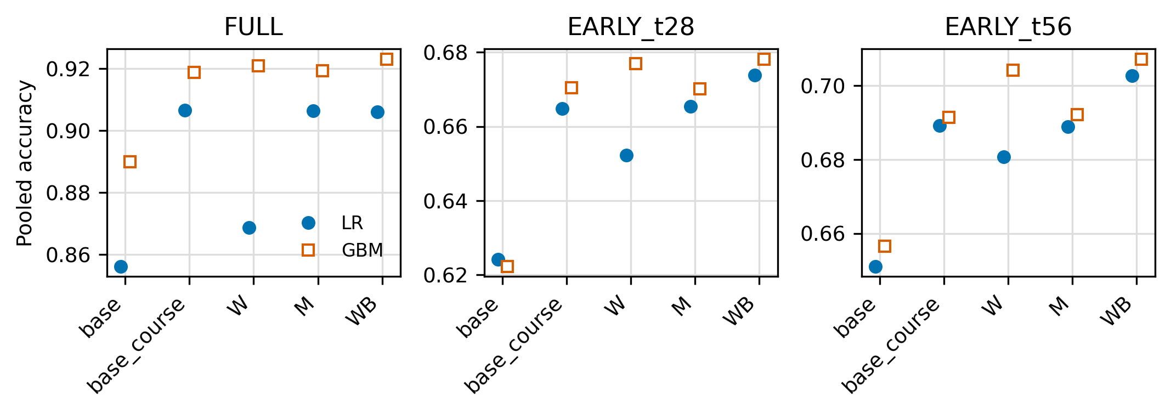
Figure 1. Pooled out-of-fold accuracy by feature arm and setting (see text for arms).
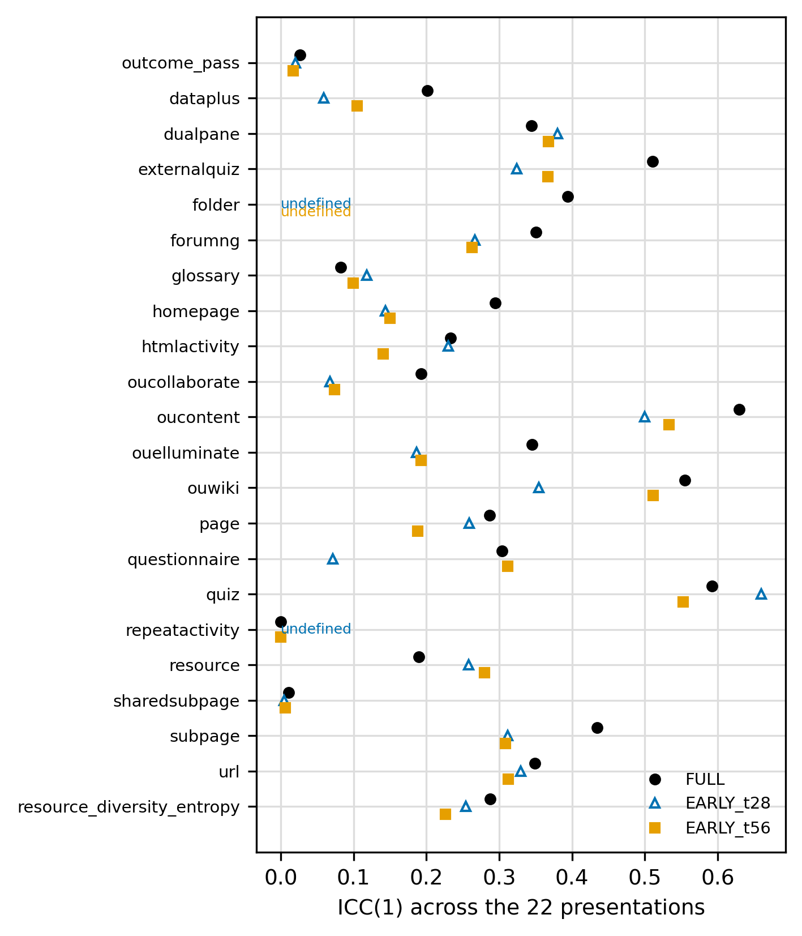
Figure 2. Intraclass correlation ICC(1) across the 22 presentations for the outcome and for each click-share column.

Held-Out Courses
Under leave-one-presentation-out validation the E to D difference shrank from about 2.6 points to 0.41 points (0.8496 to 0.8537) for logistic regression and 0.89 points (0.8677 to 0.8766) for gradient boosting. Per held-out presentation, the difference was positive in 16 of 22, zero in 1 and negative in 5 for logistic regression (mean 1.15 points, SD 3.48), and positive in 18, zero in 2 and negative in 2 for gradient boosting (mean 1.29 points, SD 4.45). In leave-one-module-out validation, with students who also appear in the held-out module removed from training, adding course-centred click shares to the base lowered FULL accuracy by 0.99 points (CI −1.27 to −0.69) for logistic regression and 1.13 points (CI −1.50 to −0.77) for gradient boosting, but raised early accuracy: at day 28 by 2.74 points (CI 2.27 to 3.19) and 1.28 points (CI 0.81 to 1.74), and at day 56 by 1.58 points (CI 1.09 to 2.04) and 0.98 points (CI 0.60 to 1.41). A student-disjoint 5-fold variant, run in an earlier round, gave E to D differences of about 2.5 points for both families, so student overlap across folds does not explain the full-course gain.

Early Prediction
Table 4 gives the primary comparison. The rule for a signal beyond course-relative engagement was met in three of four settings: day 28 VLE-only (logistic regression +0.92 points, gradient boosting +0.78 points), day 28 with assessments (+0.58 and +0.41) and day 56 VLE-only (+1.38 and +1.65). It was not met at day 56 with assessments, where logistic regression gained 0.41 points but gradient boosting gained −0.01 points (CI −0.31 to 0.30, BH p = 0.96). Gains were largest without assessment data, which is consistent with assessment scores already carrying most of the information at later cutoffs (Le et al., 2026).
Setting, model | Primary | BH p | Rule | z-base | BH p | Breadth | BH p
Day 28 VLE-only, LR | +0.92 [0.54, 1.27] | 5.3e−6 | 1 | +1.08 [0.70, 1.45] | 8.7e−8 | +0.48 [0.13, 0.84] | 0.010
Day 28 VLE-only, GBM | +0.78 [0.36, 1.19] | 3.4e−4 | 1 | +0.75 [0.37, 1.13] | 2.2e−4 | +0.85 [0.45, 1.23] | 7.6e−5
Day 28 with assessments, LR | +0.58 [0.25, 0.93] | 0.002 | 1 | +0.62 [0.30, 0.94] | 3.0e−4 | +0.00 [−0.28, 0.27] | 1.000
Day 28 with assessments, GBM | +0.41 [0.10, 0.73] | 0.026 | 1 | −0.07 [−0.37, 0.23] | 0.676 | +0.52 [0.17, 0.85] | 0.004
Day 56 VLE-only, LR | +1.38 [0.97, 1.78] | 5.8e−12 | 1 | +1.63 [1.19, 2.00] | 1.8e−15 | +1.05 [0.68, 1.40] | 2.9e−8
Day 56 VLE-only, GBM | +1.65 [1.25, 2.07] | 3.7e−15 | 1 | +1.36 [0.98, 1.75] | 4.3e−11 | +1.37 [0.96, 1.76] | 3.3e−11
Day 56 with assessments, LR | +0.41 [0.14, 0.67] | 0.016 | 0 | +0.51 [0.23, 0.77] | 0.001 | +0.27 [0.02, 0.51] | 0.076
Day 56 with assessments, GBM | −0.01 [−0.31, 0.30] | 0.962 | 0 | +0.32 [0.07, 0.57] | 0.038 | +0.40 [0.08, 0.68] | 0.038
Table 4. Early prediction, change in accuracy (percentage points) [95% interval] and BH p-value. Primary = base with course identity to the same base plus course-centred click shares; rule = primary criterion met (1) or not (0); z-base = base z-scored within presentation; breadth = breadth baseline to full click shares.
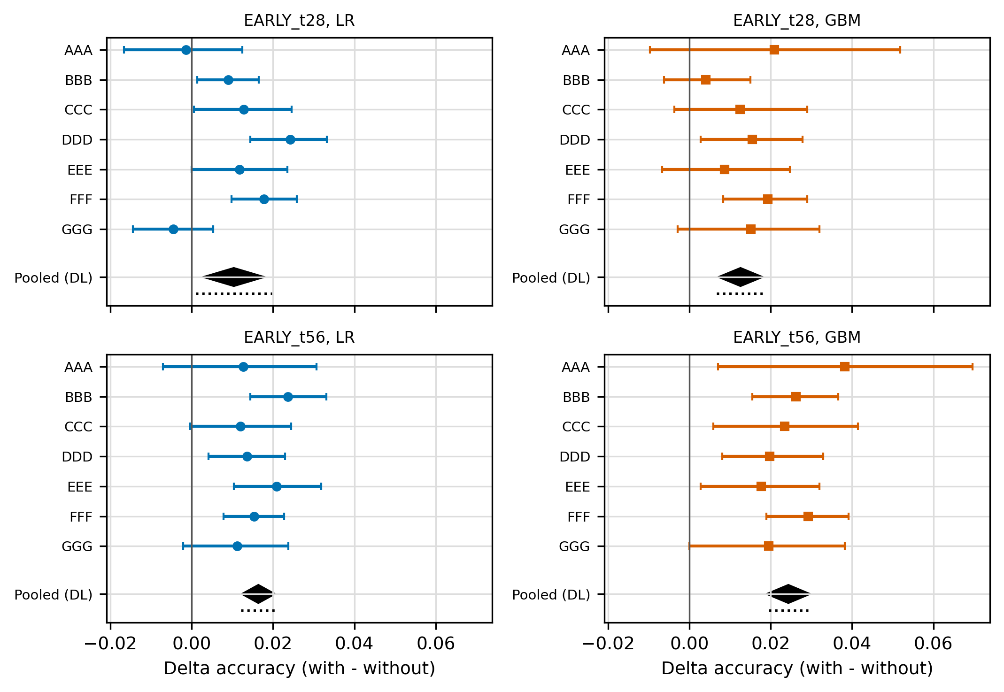
Figure 3. Change in accuracy from adding course-centred click shares, by module, with random-effects pooled estimates.
Two checks qualify this result (Table 4, lower block). First, when the base was z-scored within presentation, the VLE-only gains remained (for example +1.08 and +0.75 points at day 28, +1.63 and +1.36 points at day 56, all BH p < 0.001), but at day 28 with assessments the gradient-boosting gain became −0.07 points (CI −0.37 to 0.23, BH p = 0.68) while the logistic-regression gain stayed at 0.62 points. Z-scoring the base itself raised logistic-regression accuracy by 1.42 points at day 28 with assessments, so a part of what appeared to be a click-share effect in that setting is attributable to how the base is made course-relative. Second, a breadth baseline of entropy and number of activity types used (Table 4, breadth) accounts for part of the signal. Beyond breadth, the click shares added 0.48 and 0.85 points at day 28 VLE-only and 1.05 and 1.37 points at day 56 VLE-only (all BH p < 0.01), but with assessments the gain was 0.00 and 0.52 points at day 28 and 0.27 points (BH p = 0.076) and 0.40 points (BH p = 0.038) at day 56. Excluding the students with no clicks by the cutoff (921 at day 28, success rate 0.177; 603 at day 56, success rate 0.108) did not change which settings met the criterion.
Relative to course means, centred click shares added 0.84 and 0.80 points at day 28 and 1.38 and 1.51 points at day 56 for logistic regression and gradient boosting respectively (WB versus M in Table 3, all BH p < 0.001), which agrees in size with the primary comparison.

Which Activity Types
We attributed the early signal to individual units (20 activity types and entropy) with add-one-in, leave-one-out and permutation importance in the VLE-only settings. Under the pre-declared flag rule, which required agreement across both model families after BH correction, only one of 21 units, page, was flagged, in leave-one-out at day 56 (BH p = 0.039 for logistic regression and 0.034 for gradient boosting; accuracy fell by 0.23 and 0.38 points when it was removed). Other units were significant in one family only. At day 28, adding ouwiki alone raised logistic-regression accuracy by 0.44 points (CI 0.24 to 0.63, BH p = 7.5e-4) with no gradient-boosting counterpart. At day 56 gradient boosting gained from quiz (+0.76 points, BH p = 3.1e-5), oucontent, ouwiki and page (+0.36 to +0.41 points, BH p = 0.023). The three attribution designs agree in rank (absolute Spearman correlations of 0.47 to 0.91 over 21 units; leave-one-out is signed as without minus with, so negative values indicate agreement), yet no single activity type carries the signal. We interpret this as a diffuse, low-amplitude signal.

Heterogeneity Across Modules
Within each of the seven modules, the primary comparison in the VLE-only settings (Table 5 and Figure 3) met the replication criterion, that is, both intervals excluded 0 in the same direction, in two of seven modules at day 28 (DDD and FFF) and four of seven at day 56 (BBB, DDD, EEE and FFF); in the remaining modules at least one interval contained 0. Two of the 28 module-level estimates were negative (AAA, −0.14 points, and GGG, −0.45 points, both logistic regression at day 28), and both intervals included 0. Pooled random-effects estimates were positive in all four cell: day 28, +1.04 points (CI 0.29 to 1.78, I² = 73%) for logistic regression and +1.26 points (CI 0.72 to 1.79, I² = 0%) for gradient boosting; day 56, +1.64 points (CI 1.24 to 2.04, I² = 0%) and +2.43 points (CI 1.91 to 2.96, I² = 0%). The Hartung-Knapp interval for day-28 logistic regression (0.10 to 1.97 points) was wider than the normal-approximation interval. Under our prespecified rule (consistent if at least five of seven modules meet the criterion and I² is below 50%; course-specific if fewer than five meet it and I² is at least 50%; otherwise mixed), the label is mixed at both cutoffs: the pooled signal is small and positive, but module-level confirmation is partial.
Module | N d28 | d28 LR | d28 GBM | Met | N d56 | d56 LR | d56 GBM | Met
AAA | 718 | −0.14 [−1.66, 1.24] | +2.09 [−0.97, 5.18] | N | 707 | +1.27 [−0.71, 3.07] | +3.82 [0.71, 6.96] | N
BBB | 6,434 | +0.90 [0.14, 1.65] | +0.40 [−0.62, 1.50] | N | 6,255 | +2.37 [1.44, 3.31] | +2.62 [1.55, 3.66] | Y
CCC | 3,519 | +1.28 [0.06, 2.46] | +1.25 [−0.37, 2.90] | N | 3,239 | +1.20 [−0.03, 2.44] | +2.35 [0.58, 4.14] | N
DDD | 5,284 | +2.42 [1.44, 3.32] | +1.55 [0.28, 2.78] | Y | 5,051 | +1.37 [0.42, 2.29] | +1.98 [0.81, 3.29] | Y
EEE | 2,553 | +1.18 [0.00, 2.36] | +0.86 [−0.67, 2.47] | N | 2,490 | +2.09 [1.04, 3.19] | +1.77 [0.28, 3.20] | Y
FFF | 6,593 | +1.77 [0.98, 2.59] | +1.93 [0.83, 2.90] | Y | 6,373 | +1.54 [0.79, 2.27] | +2.92 [1.90, 3.91] | Y
GGG | 2,437 | −0.45 [−1.44, 0.53] | +1.52 [−0.29, 3.20] | N | 2,407 | +1.12 [−0.21, 2.37] | +1.95 [−0.00, 3.82] | N
Pooled (DL) |  | +1.04 [0.29, 1.78] | +1.26 [0.72, 1.79] | 2/7 |  | +1.64 [1.24, 2.04] | +2.43 [1.91, 2.96] | 4/7
Hartung-Knapp |  | [0.10, 1.97] | [0.67, 1.85] |  |  | [1.21, 2.07] | [1.95, 2.92]
I² (%) |  | 73.5 | 0.0 |  |  | 0.0 | 0.0
Table 5. Per-module replication in VLE-only settings, accuracy change in percentage points [95% interval]. Pooled rows use DerSimonian-Laird random effects with I-squared; HK = Hartung-Knapp interval.

Sensitivity to Withdrawn Students
Excluding Withdrawn students (N = 21,117) left the base at 0.8958 (logistic regression) and 0.9120 (gradient boosting) with course identity, and adding the click shares changed accuracy to 0.8972 and 0.9129. The pre-registered criterion was not met for the click shares in this sample; in six stratified comparisons it was met once, for a control (shuffled versus real centred shares) in the variant that also dropped three more students. This agrees with the full-course result: once course identity is in the model, the click shares add little.

Gender Differences in False-Negative Rates
The false-negative rate is the share of non-successful students predicted to succeed. Women had higher false-negative rates than men for all six models (Table 6): the gap was 4.6 points (CI 2.9 to 6.3) for the performance block B alone, 1.8 points (CI 0.2 to 3.3) for E and 3.6 points (CI 2.1 to 5.1) for D with logistic regression, and 5.7, 4.0 and 3.8 points for B, E and D with gradient boosting. Differences between the gaps had no consistent direction. For logistic regression, D increased the gap relative to E by 1.77 points (CI 0.71 to 2.85) and did not change it relative to B (−0.95 points, CI −2.31 to 0.41). For gradient boosting, D reduced the gap relative to B by 1.96 points (CI 0.65 to 3.30) and did not change it relative to E (−0.18 points, CI −1.26 to 0.94). The gap therefore cannot be attributed to any one feature block.
Family | Model | N | FNR women | FNR men | Gap (pp) [95% CI]
LR | B | 25,820 | 0.246 | 0.200 | +4.59 [2.86, 6.33]
LR | E | 25,770 | 0.210 | 0.192 | +1.81 [0.23, 3.33]
LR | D | 25,770 | 0.199 | 0.163 | +3.58 [2.09, 5.11]
GBM | B | 25,820 | 0.269 | 0.212 | +5.71 [3.88, 7.45]
GBM | E | 25,770 | 0.219 | 0.180 | +3.95 [2.33, 5.57]
GBM | D | 25,770 | 0.167 | 0.129 | +3.77 [2.35, 5.15]
Table 6. Gender gap in false-negative rate (women minus men), FULL, stratified 5-fold. FNR = share of non-successful students predicted to succeed; gap in percentage points [95% bootstrap interval].
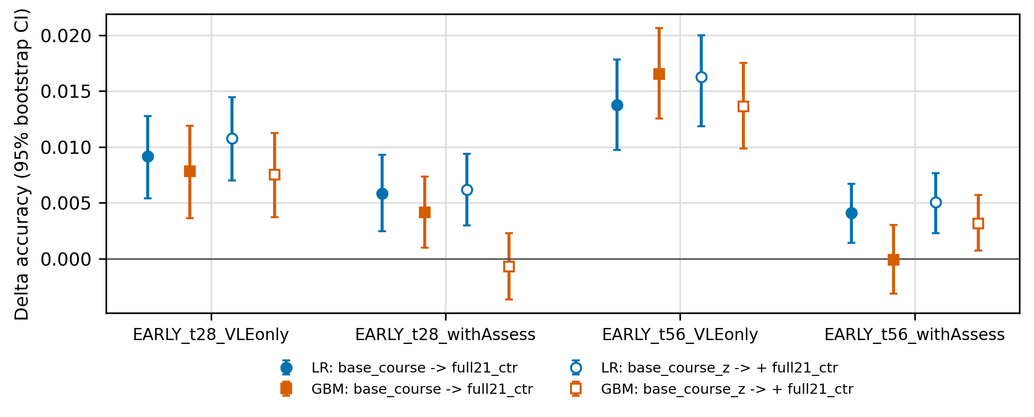
Figure 4. Change in accuracy from adding click shares in EARLY settings, with and without a course-normalised base.

Discussion
Under random cross-validation, the click shares appear to add 2.6 points of accuracy to performance and behaviour features. Our controls indicate that this headline figure reflects mostly course context. Shuffling the shares within presentation recovers most of the gain, presentation identity alone predicts at the base rate yet adds 2.9 to 5.1 points to E, and once identity is in the model the click shares add 0.02 to 0.33 points. The evidence agrees with the course-context literature (Gašević et al., 2016; Conijn et al., 2017; Cui et al., 2020; Lim, 2026) and shows that the effect is large enough to dominate the benefit that a feature-engineering study might report on this dataset.
A small within-course signal remains in early prediction. It is larger without assessment data and shrinks, or depends on how the base is normalised, once assessments are available; part of it reflects breadth of engagement; it is spread over many activity types rather than concentrated in one; and it is confirmed in some modules and inconclusive in others. A reading that fits the pattern is that click shares serve as a weak proxy for how engaged a student is relative to classmates in the first weeks, a proxy that is largely superseded by graded work once it exists. We have not tested this explanation.

Implications for Institutional Practice
The results suggest four practices for organisations that develop or buy early-warning systems.
Evaluate feature value against a course-aware baseline. A comparison with a context-free baseline can attribute to a behavioural feature what is really information about the course. In this dataset the difference is 2.6 points versus 0.02 to 0.33 points.
Validate on held-out courses and early cutoffs. Random folds mixing courses overstate full-course gains, and full-course aggregates are unavailable at the time a warning is useful. In our data, centred click shares lowered accuracy in held-out modules with full-course features and raised it by 1 to 2.7 points in early windows.
Weigh the size of the benefit against the cost of collecting and governing the data. The early signal of 0.4 to 1.7 points corresponds to roughly 4 to 17 additional correctly classified students per 1,000 in the settings where it was found. Whether this justifies fine-grained logging depends on local costs and on how the warnings are used; that judgement is not a statistical one.
Monitor group differences for every feature family. The false-negative gap for women was present for models built from assessment features alone and did not disappear with any block, so switching features is not a remedy in itself.
These implications concern one dataset from one institution and one outcome definition. They should be read as hypotheses to check in an institution's own courses, using the protocol we release, and not as general rules.

Limitations
The study uses one dataset from one distance-learning institution; the findings may not carry over to other institutions, outcome definitions or platforms. Every analysis is exploratory and post hoc: the 610 tests were run in rounds on the same data, only 438 of them in rounds with a plan that preceded the output, and even those rounds followed earlier looks at the data. Correction for multiplicity is applied within families, not across rounds, so isolated p-values near 0.05 should be read with caution. Models are untuned library defaults, and accuracy and AUC are the main metrics; calibration, which matters for deployed warnings, is not evaluated here.
Several design choices could affect the results. FULL is restricted to students with both assessment and VLE data, and 6,823 enrolments, mostly Withdrawn or Fail, are excluded. The early settings treat scores as observable at submission, which is an assumption. Course centring and z-scoring use the features of all students in a presentation, including test-fold students, though no labels; in a live system the presentation's statistics would need to be estimated from students observed so far. With gradient boosting, the click shares may allow the model to re-infer course context through interactions with uncentred base features, so the within/between decomposition separates the two contributions more cleanly for logistic regression than for gradient boosting. Stratified folds are not student-disjoint, and 2,345 students appear in more than one presentation; the student-disjoint variants we ran were consistent with the main results. Finally, the behaviour feature named "mean clicks per active day" in our code is the mean clicks per VLE record, which we have renamed in this paper; gender is a binary attribute as supplied by the dataset.

Conclusion
The apparent value of activity-type click shares for predicting course outcomes on OULAD is mostly course context. After controlling for it, what remains is a small, early, partly breadth-related and module-heterogeneous signal that weakens when assessment data are present and when the base is normalised by course. For organisations that decide what to log, build and trust, the practical conclusion is a protocol: compare against a course-aware baseline, validate on held-out courses and early cutoffs, quantify uncertainty at the level of students, and report the analytic flexibility behind any claimed gain. Replication in other institutions' courses, with calibration and downstream intervention outcomes, is the necessary next step.

Appendix A: Analysis Rounds and Multiplicity
Table A1 lists the analysis rounds. A round counts as planned if a written plan with timestamp and SHA-256 hash preceded its outputs. Unique tests exclude copies of tests that appear in more than one file. The dataset had been analysed before every round.
Round | Unique tests | Planned before running
Original study | 32 | No
Robustness | 92 | No
Course identity | 48 | No
Withdrawn-excluded and early prediction | 66 | Yes
Leakage audit and breadth control | 88 | Yes
Attribution and no-click sensitivity (post hoc plan) | 212 | Yes
Within/between decomposition, held-out module, per-module replication | 52 | Yes
Course-normalised base and final numbers | 20 | Yes
Total | 610 | 438 planned
Table A1. Analysis rounds and number of unique hypothesis tests.

References
- Al-Zawqari, A., Peumans, D., & Vandersteen, G. (2022). A flexible feature selection approach for predicting students' academic performance in online courses. Computers and Education: Artificial Intelligence, 3, Article 100103. https://doi.org/10.1016/j.caeai.2022.100103
- Atif, A., Froissard, C., Liu, D., & Richards, D. (2015). Validating the effectiveness of the Moodle Engagement Analytics Plugin to predict student academic performance. AMCIS 2015 Proceedings. https://aisel.aisnet.org/amcis2015/ISEdu/GeneralPresentations/12
- Borchers, C. (2025). Toward sufficient statistical power in algorithmic bias assessment: A test for ABROCA (arXiv:2501.04683). arXiv. https://arxiv.org/abs/2501.04683
- Conijn, R., Snijders, C., Kleingeld, A., & Matzat, U. (2017). Predicting student performance from LMS data: A comparison of 17 blended courses using Moodle LMS. IEEE Transactions on Learning Technologies, 10(1), 17–29. https://doi.org/10.1109/TLT.2016.2616312
- Cui, Y., Chen, F., & Shiri, A. (2020). Scale up predictive models for early detection of at-risk students: A feasibility study. Information and Learning Sciences, 121(3/4), 97–116. https://doi.org/10.1108/ILS-05-2019-0041
- Esbenshade, L., Vitale, J., & Baker, R. S. (2024). Non-overlapping leave future out validation (NOLFO): Implications for graduation prediction. In Proceedings of the 17th International Conference on Educational Data Mining (pp. 602–609). International Educational Data Mining Society. https://doi.org/10.5281/zenodo.12729894
- Gašević, D., Dawson, S., Rogers, T., & Gašević, D. (2016). Learning analytics should not promote one size fits all: The effects of instructional conditions in predicting academic success. The Internet and Higher Education, 28, 68–84. https://doi.org/10.1016/j.iheduc.2015.10.002
- Hlosta, M., Herrmannova, D., Vachova, L., Kuzilek, J., Zdrahal, Z., & Wolff, A. (2014). Modelling student online behaviour in a virtual learning environment (arXiv:1811.06369). arXiv. https://arxiv.org/abs/1811.06369
- Jovanović, J., Saqr, M., Joksimović, S., & Gašević, D. (2021). Students matter the most in learning analytics: The effects of internal and instructional conditions in predicting academic success. Computers & Education, 172, Article 104251. https://doi.org/10.1016/j.compedu.2021.104251
- Kapoor, S., & Narayanan, A. (2023). Leakage and the reproducibility crisis in machine-learning-based science. Patterns, 4(9), Article 100804. https://doi.org/10.1016/j.patter.2023.100804
- Karimi-Haghighi, M., Castillo, C., Hernández-Leo, D., & Moreno Oliver, V. (2021). Predicting early dropout: Calibration and algorithmic fairness considerations (arXiv:2103.09068). arXiv. https://arxiv.org/abs/2103.09068
- Kleter, S., Matzat, U., & Conijn, R. (2024). Boundary conditions of generalizing predictive models for academic performance: Within cohort versus within course. IEEE Transactions on Learning Technologies, 17, 2183–2194. https://doi.org/10.1109/TLT.2024.3443079
- Kuzilek, J., Hlosta, M., & Zdrahal, Z. (2017). Open University Learning Analytics dataset. Scientific Data, 4, Article 170171. https://doi.org/10.1038/sdata.2017.171
- Le, N. L., Abel, M.-H., & Laforge, B. (2026). When can we trust early warnings? Leakage-excluded early outcome prediction from LMS interaction logs (arXiv:2605.25794). arXiv. https://arxiv.org/abs/2605.25794
- Lim, M. (2026). Student-disjoint cross-module benchmarking for calibrated early warning in online learning. International Journal of Advanced Computer Science and Applications, 17(9), 617–623. https://doi.org/10.14569/IJACSA.2026.0170958
- Marras, M., Vignoud, J. T. T., & Käser, T. (2021). Can feature predictive power generalize? Benchmarking early predictors of student success across flipped and online courses. In Proceedings of the 14th International Conference on Educational Data Mining. https://educationaldatamining.org/EDM2021/virtual/static/pdf/EDM21_paper_202.pdf
- Riazy, S., & Simbeck, K. (2019). Predictive algorithms in learning analytics and their fairness. In DELFI 2019 (pp. 223–228). Gesellschaft für Informatik. https://doi.org/10.18420/delfi2019_305
- Saqr, M., Jovanović, J., Viberg, O., & Gašević, D. (2022). Is there order in the mess? A single paper meta-analysis approach to identification of predictors of success in learning analytics. Studies in Higher Education, 47(12), 2370–2391. https://doi.org/10.1080/03075079.2022.2061450
- Schwerter, J., Sabel, L., Bose, J., Bernacki, M. L., Xu, D., Schmellenkamp, M., Zeume, T., & Doebler, P. (2026). Cross-course generalizability of SRL-aligned predictive models using digital learning traces. Computers & Education, 253, Article 105670. https://doi.org/10.1016/j.compedu.2026.105670
- Waheed, H., Hassan, S.-U., Aljohani, N. R., Hardman, J., Alelyani, S., & Nawaz, R. (2020). Predicting academic performance of students from VLE big data using deep learning models. Computers in Human Behavior, 104, Article 106189. https://doi.org/10.1016/j.chb.2019.106189

A footnote should appear like this. Please ensure that your footnotes are complete, fully punctuated sentences.

