

**Pakistan Air Force**

**Karachi Institute of Economics & Technology**

**Sentiment Analysis for News Channels Feedback**

**Developed with PYTHON**

**Submitted by:**

**Aqeel Mehmood & Muhammad Zeeshan Iqbal**

**Advisor:**

**Muhammad Kamil**

College of Computing & Information Sciences

A final year project report presented to the College of Computing & Information Sciences,  
Pakistan Air Force – Karachi Institute of Economics & Technology in partial fulfilment of the requirements of the degree of Bachelor of Science

2020/21

Table of Contents

Abstract i.

Acknowledgements ii

1. Introduction 5

1.1. Motivations 5

1.2. Objectives and Scope 6

2. Methodology 6

3. Design and Implementation 7

3.1. Design 7

3.1.1 ERD **8**

3.1.2 Use Cases **9**

3.1.3 Activity Diagram **9**

3.1.4 UML Diagrams **10**

4.Results 10

4.1.1 Overall Description **1****0**

4.1.2 Product Features **1****1**

4.1.3 Features Overview **12**

5. Conclusion and Future Work 12

5.1. Conclusion 12

5.2. Recommendations/Suggestions of Future Work 12

References 13

Appendix A – Development Environment 14

▪ Operating Systems(s) 14

o Windows **14**

Programming Language(s) 14

Python **14**

Appendix B – Tools and Software 15

Appendix C – Team Members 16

Annexure I – Copy of Approved FYP Proposal 17

Annexure II – Software Planning 21

Annexure III – Use Case Specifications 24

Annexure IV – Test Case Specifications 25

# Abstract:

# In this era of life, news channels feedback is important to measure the quality of news. News channels feedback can be analyzed using to identify the news positive or negative attitude. In most of the existing news evaluation system, the intensifier words and blind negation words are not considered. The level of opinion result isn't displayed: whether positive or negative opinion. To address this problem, we propose to analyze the news text feedback automatically to predict the level of news performance. A database of English sentiment words is created as a lexical source to get the polarity of words. By analyzing the sentiment information including intensifier words extracting from news channels feedback, we are able to determine opinion result of news, describing the level of positive or negative opinions. This system shows the opinion result of channels that is represented as to whether strongly positive, moderately positive, weakly positive, strongly negative, moderately negative, weakly negative or neutral.

**Acknowledgements**

First of all, we would like to acknowledge our parents, all the teachers, institutes and mentors that have always supported us and helped us reach this level. Our most humble regards to the Director CoCIS, Khalid Khan, our Program Managers, Kashif Bashir, yet again, Sir Zubair, Miss Samrina, and the outstanding FYP committee members, that have time and again guided us, tested us and clarified many problematic aspects of our work.Adding to the long list we are grateful to have had Muhammad Kamil as our advisor. And saving the best for the last we would like to acknowledge Our Lord the Almighty Allah for everything He blessed us with and without Whom no endeavor including this one could have been successful.

Aqeel Mehmood

Muhammad Zeeshan Iqbal

December 2020

# Introduction

We all have seen the bidding concept in our lives. Some may experience it in buying an item from auction other may have seen this in movie. One person says that price other declares a higher amount and all that in the end the person who bids highest amount can buy that item. Why this is just limited to luxury and unique Items. Why not for small items? Why you have to go to that auction not avail that opportunity at home? These are the questions arises on everyone’s mind. So, we are providing a best solution and a secure one to avail the opportunity of bidding at anywhere any corner of the world without any hesitation.

We are providing a user-friendly platform about collecting news channels feedback of different channels following and displaying them in domains other than that user will be able to see the news weather it is positive news or negative. This system shows the opinion result of news channels that is represented as to whether strongly positive, moderately positive, weakly positive, strongly negative, moderately negative, weakly negative or neutral.

## Motivations

This project could be the wishful fulfillment for any news channel categorized for ther sentiment on any news. While designing **Sentiment Analysis for News Channels Feedback**, two main concerns were to be addressed, platform independency and a user-centric approach. A further concern was to build the system in a generic way. It has to be possible for future developers to expand the system. Therefore, the system will have a modular structure.

## Objectives and Scope

In this project, sentiment analysis will be used to evaluate the level of news channels performance from news textual feedback comment. A database of English sentiment words is constructed to identify the polarity of words as a lexical source. Our sentiment word database contains the opinion words concerning with the academic domain to achieve the better result. Every opinion word in the database is given a value. The sentiment value will have a rang. This project proposes the level of news evaluation method. This method analyzes automatically the news channel feedback comments to strongly negative, or moderately negative, or weakly negative, or strongly positive, or moderately positive, or weakly positive or neutral category using two lexicons. The level of opinion result for any channels is given out from news channel feedback comments.

The scope and goals kept in view are summarized as follows

* Easy tracking of news
* Analyzing their performance
* Instant report generation
* The entire data is offline and secure, any analysis can be done at any desired point of time.
* Easy User interface design makes using the system easier for different channels
* Can be easily customized to the channels needs if requested
* Built on powerful PYTHON technology

# Methodology

Sentiment Analysis is greatly used in Python, an open source tool for comprehensive statistical analysis. Python performs the important task of Sentiment Analysis and provides visual representation of this analysis. For a comprehensive explanation, read our post on Business Analytics with Python and Reasons to learn Python. There are plenty of reasons on why a Marketer should go for Python, as he is one of the people who will greatly benefit from Python.

## ****There are 5 steps to analyze sentiment data:****

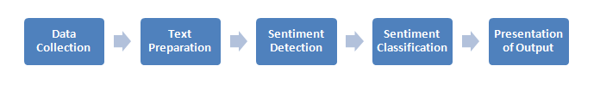

**Methods of Sentiment Analysis**

**Data Collection:**

Consumers usually express their sentiments on public forums like the blogs, discussion boards, product reviews as well as on their private logs – Social network sites like Facebook and Twitter. Opinions and feelings are expressed in different way, with different vocabulary, context of writing, usage of short forms and slang, making the data huge and disorganized. Manual analysis of sentiment data is virtually impossible. Therefore, programming languages like ‘Python’ are used to process and analyze the data.

**Text Preparation:**

Text preparation is nothing but filtering the extracted data before analysis.  It includes identifying and eliminating non-textual content and content that is irrelevant to the area of study from the data.

**Sentiment Detection:**

At this stage, each sentence of the review and opinion is examined for subjectivity. Sentences with subjective expressions are retained and that which conveys objective expressions are discarded. Sentiment analysis is done at different levels using common computational techniques like Unigrams, lemmas, negation and so on.

**Sentiment Classification:**

Sentiments can be broadly classified into two groups, positive and negative. At this stage of sentiment analysis methodology, each subjective sentence detected is classified into groups-positive, negative, good, bad, like, dislike.

**Presentation of Output:**

The main idea of sentiment analysis is to convert unstructured text into meaningful information. After the completion of analysis, the text results are displayed on graphs like pie chart, bar chart and line graphs.

# Design and Implementation

## Design



### 3.1.1. ERD

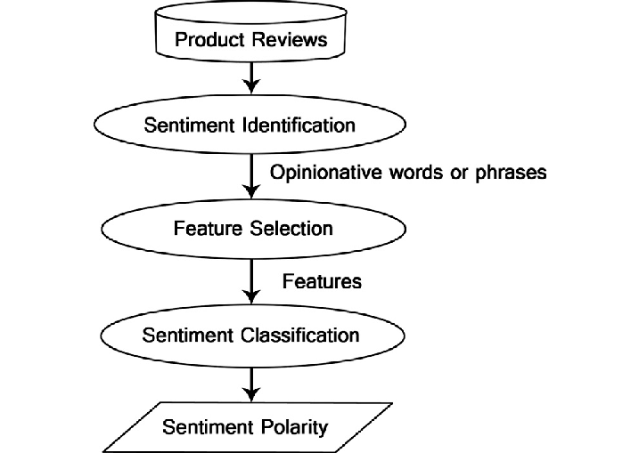

### 3.1.2. Use Cases

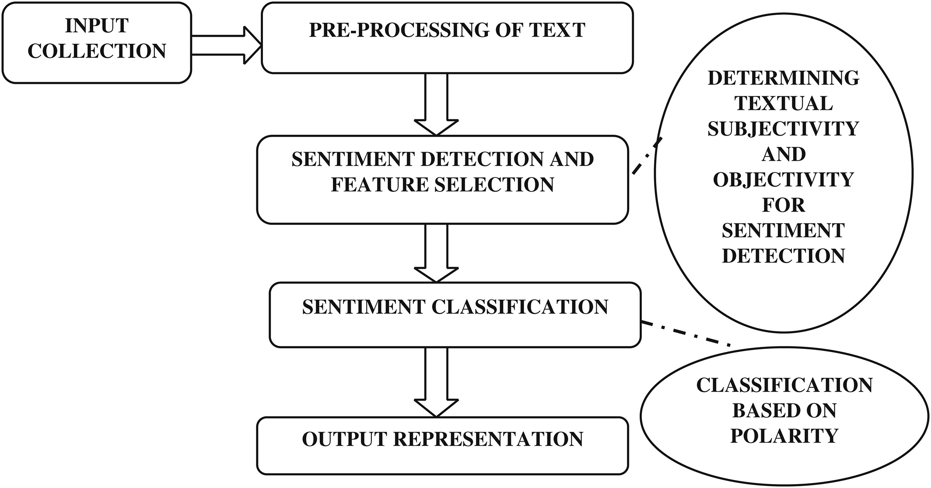

### 3.1.3. Activity Diagram

### 

### 3.1.4. UML Diagram

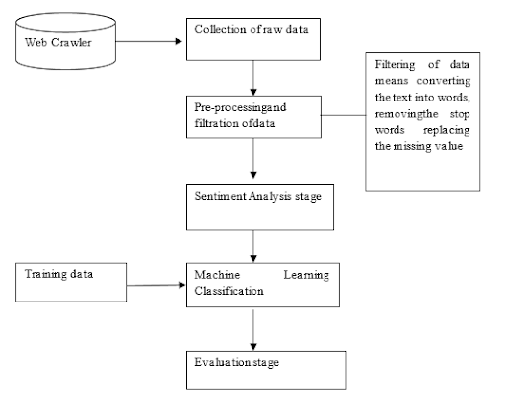

## Results

### Overall Description

In this project, sentiment analysis will be used to evaluate the level of news channels performance from news textual feedback comment. A database of English sentiment words is constructed to identify the polarity of words as a lexical source. Our sentiment word database contains the opinion words concerning with the academic domain to achieve the better result. Every opinion word in the database is given a value. The sentiment value will have a rang. This project proposes the level of news evaluation method. This method analyzes automatically the news channel feedback comments to strongly negative, or moderately negative, or weakly negative, or strongly positive, or moderately positive, or weakly positive or neutral category using two lexicons. The level of opinion result for any channels is given out from news channel feedback comments.

**Product Functions**

* **Tweets:** User can review his desire news.
* **Classification:** The news of other users related to anything will be classified according to its main positivity and its negativity and it will be easy for user to search news according to domains related to anything.
* **Clustering the Tweets:** News feedback from people or pages user is following will be clustered and shown on dashboard according to them are classified.
* **Following:** User can follow any other user people or pages he wants to follow so he can watch the desire news channel



### 4.1.3. Features Overview

* The aim of this project is facilitating news channels by providing classified news on their screens of their laptops.
* Then user will view the news of positive and negative type.
* After the successful posting of the news everyone can view the news by its rating according to it.

# Conclusion and Future Work

## Conclusion

The goal of this project is to make such as efficient tool for news channels users so they don't miss any update of their interest for example few days ago there was a hype of election and there were too many news's around different channels some of them are positive and some of them are negative of it so this software will start collecting every news feedback related to news from the time and categorize on the basis of domain e.g. (positive, negative etc.).

## Recommendations/Suggestions of Future Work

The only thing that motivates us for doing this project is that why news’s are not classified according to their positivity and negativity and their sub domains? Why we have to search for a news without knowing about it weather it’s a positive news or negative and can cause a great impact on us? So, to sum up all these problems and comes up with a mind-blowing solution. We made this possible through our project that is web based that can be access by any user.

# References

1. [https://developer.youtube.com/en/products/accounts-and-users/account-activity-api.html](https://developer.twitter.com/en/products/accounts-and-users/account-activity-api.html)
2. [https://developer.youtubecom/en/account/environments](https://developer.twitter.com/en/account/environments)
3. [https://developer.youtube.com/en/dashboard](https://developer.twitter.com/en/dashboard)
4. [https://developer.youtube.com/en/apps/15975602](https://developer.twitter.com/en/apps/15975602)
5. [https://developer.youtube.com/en/apps](https://developer.twitter.com/en/apps)
6. <https://en.wikipedia.org/wiki/Use_case_diagram>
7. <https://en.wikipedia.org/wiki/Activity_diagram>
8. <https://en.wikipedia.org/wiki/Activity_diagram>
9. <https://www.smartdraw.com/entity-relationship-diagram/>
10. <https://ieeexplore.ieee.org/document/7556121>

# Appendix A – Development Environment

## Operating Systems(s)

### Windows

**Microsoft Windows** is a series of [graphical interface](http://en.wikipedia.org/wiki/Graphical_user_interface) [operating systems](http://en.wikipedia.org/wiki/Operating_system) developed, marketed, and sold by [Microsoft](http://en.wikipedia.org/wiki/Microsoft).

Microsoft introduced an [operating environment](http://en.wikipedia.org/wiki/Operating_environment) named *Windows* on November 20, 1985 as a graphical [operating system shell](http://en.wikipedia.org/wiki/Operating_system_shell) for [MS-DOS](http://en.wikipedia.org/wiki/MS-DOS) in response to the growing interest in [graphical user interfaces](http://en.wikipedia.org/wiki/Graphical_user_interface) (GUIs).[[5]](http://en.wikipedia.org/wiki/Microsoft_Windows#cite_note-aboutcomnov-5) Microsoft Windows came to [dominate](http://en.wikipedia.org/wiki/Dominance_(economics)) the world's [personal computer](http://en.wikipedia.org/wiki/Personal_computer) market with [over 90% market share](http://en.wikipedia.org/wiki/Usage_share_of_operating_systems), overtaking [Mac OS](http://en.wikipedia.org/wiki/Mac_OS), which had been introduced in 1984.

As of April 2014, the most recent versions of Windows for [personal computers](http://en.wikipedia.org/wiki/Personal_computer), [smartphones](http://en.wikipedia.org/wiki/Smartphone), [server computers](http://en.wikipedia.org/wiki/Server_(computing)) and [embedded devices](http://en.wikipedia.org/wiki/Embedded_system) are respectively [Windows 8.1](http://en.wikipedia.org/wiki/Windows_8.1),[Windows Phone 8.1](http://en.wikipedia.org/wiki/Windows_Phone_8.1), [Windows Server 2012 R2](http://en.wikipedia.org/wiki/Windows_Server_2012_R2) and [Windows Embedded 8](http://en.wikipedia.org/wiki/Windows_Embedded_8).

*Developer* – Microsoft  
*Version –* Windows 10

*Environment –* 64 Bit

*Website*–[windows.microsoft.com](https://apple.com/mac)

## Programming Language(s)

## Python:

**Python** is an interpreted, high-level, general-purpose programming language. Created by Guido van Possum and first released in 1991, Python has a design philosophy that emphasizes code readability, notably using significant whitespace. It provides constructs that enable clear programming on both small and large scales. In July 2018, Van Possum stepped down as the leader in the language community.

Python features a dynamic type system and automatic memory management. It supports multiple programming paradigms, including object-oriented, imperative, functional and procedural, and has a large and comprehensive standard library.

Python interpreters are available for many operating systems. Python, the reference implementation of Python, is open-source software and has a community-based development model, as do nearly all of Python's other implementations. Python and Python are managed by the non-profit Python Software Foundation.

# Appendix B – Tools and Software

PYCHARM:

### Be More Productive

Save time while PyCharm takes care of the routine. Focus on the bigger things and embrace the keyboard-centric approach to get the most of PyCharm's many productivity features.

### Get Smart Assistance

PyCharm knows everything about your code. Rely on it for intelligent code completion, on-the-fly error checking and quick-fixes, easy project navigation, and much more.

### Boost Code Quality

Write neat and maintainable code while the IDE helps you keep control of the quality with PEP8 checks, testing assistance, smart refactoring's, and a host of inspections.

### Simply All You Need

PyCharm is designed by programmers, for programmers, to provide all the tools you need for productive Python development.

ANACONDA:

With over 20 million users worldwide, the open-source Individual Edition (Distribution) is the easiest way to perform Python/R data science and machine learning on a single machine. Developed for solo practitioners, it is the toolkit that equips you to work with thousands of open-source packages and libraries.

# Appendix C – Team Members

**Aqeel Mehmood** I am a student of Bachelor's of Science Specializing in Software Engineering and I am currently in the final semester at PAF-KIET. Have furnished my skills at the PYTHON developer Email: **Aqeelmehmood82@gmail.com**

**Muhammad Zeeshan Iqbal** I am a student of Bachelor's of Science Specializing in Software Engineering and data science in Software Engineering. Possesses an advanced-level skill set and has command over PYTHON, C#, database.

Email: **shezokhan5242@gmail.com**

# Annexure I – Copy of Approved FYP Proposal

**FINAL YEAR PROJECT PROPOSAL**   
**[FALL 2020/2021]**

**Summary Table**

|  |  |  |  |  |  |  |  |  |  |  |  |  |
| --- | --- | --- | --- | --- | --- | --- | --- | --- | --- | --- | --- | --- |
| **SEMESTER** | | | | **FALL 2020** | | | **YEAR** | | | | **2020-2021** | |
| **TITLE OF PROPOSED PROJECT** | | | | | | | | | | | | |
| **Sentiment Analysis on Students Feedback** | | | | | | | | | | | | |
| **Project Category (choose one)** | | | | | **□ Product based** | | | | | **□ Research-based** | | |
| **SUPERVISOR INFORMATION** | | | | | | | | | | | | |
| **Supervisor Name:** | | | **(leave blank)** | | | | | | **Organization/**  **Designation** | | | **(leave blank)** |
| **Contact No:** | | | **(leave blank)** | | | | | | **email:** | | | **(leave blank)** |
| **STUDENT(S) INFORMATION** | | | | | | | | | | | | |
| **S#** | **Student ID** | | | | | **Name** | | | | | | |
| **1** | **7643** | | | | | **Aqeel Mehmood** | | | | | | |
| **Contact No:** | | **0316-8935481** | | | | **email:** | | [**Aqeelmehmood82@gmail.com**](mailto:Aqeelmehmood82@gmail.com) | | | | |
| **2** | **7488** | | | | | **Muhammad Zeeshan Iqbal** | | | | | | |
| **Contact No:** | | **0333-2007240** | | | | **email:** | | [**Shezokhan5242@gmail.com**](mailto:Shezokhan5242@gmail.com) | | | | |
| **PROJECT AREA/TOOLS** | | | | | | | | | | | | |
| **Tools Required:** | | | Anaconda Navigator/PyCharm | | | | | | | | | |
| **Area/Specialization:** | | | Data Science with Machine Learning & NLP | | | | | | | | | |
| **SUMMARY OF PROPOSED PROJECT (MAXIMUM 300 WORDS)** | | | | | | | | | | | | |
| **In education system, students' feedback is important to measure the quality of teaching. Students' feedback can be analyzed using to identify the students' positive or negative attitude. In most of the existing teaching evaluation system, the intensifier words and blind negation words are not considered. The level of opinion result isn't displayed: whether positive or negative opinion. To address this problem, we propose to analyze the students' text feedback automatically to predict the level of teaching performance. A database of English sentiment words is created as a lexical source to get the polarity of words. By analyzing the sentiment information including intensifier words extracting from students' feedback, we are able to determine opinion result of teachers, describing the level of positive or negative opinions. This system shows the opinion result of teachers that is represented as to whether strongly positive, moderately positive, weakly positive, strongly negative, moderately negative, weakly negative or neutral.** | | | | | | | | | | | | |
| **PROJECT OBJECTIVE(S)/OUTCOMES** | | | | | | | | | | | | |
| **In this project, sentiment analysis will be used to evaluate the level of teaching performance from students' textual feedback comment. A database of English sentiment words is constructed to identify the polarity of words as a lexical source. Our sentiment word database contains the opinion words concerning with the academic domain to achieve the better result. Every opinion word in the database is given a value. The sentiment value will have a rang. This project proposes the level of teaching evaluation method. This method analyzes automatically the students' feedback comments to strongly negative, or moderately negative, or weakly negative, or strongly positive, or moderately positive, or weakly positive or neutral category using two lexicons. The level of opinion result for any teacher is given out from students' feedback comments.** | | | | | | | | | | | | |
|  | | | | | | | | | | | | |

**FUNCTIONAL FEATURES**

**For FYP 1:**

1. **Collecting Data**
2. **Cleaning Data**
3. **Creating Database**
4. **Subtracting Intensifier Words**
5. **Applying Lexical Source**
6. **Applying Sentiment Analysis**

**For FYP 2:**

1. **Creating Files filled with students' feedback comments to strongly negative, or moderately negative, or weakly negative, or strongly positive, or moderately positive, or weakly positive or neutral category**

**For Proposal Defense Purpose**

|  |  |  |
| --- | --- | --- |
| **PROPOSED ADVISORY COMMITTEE** | | |
| **S#** | **Faculty Name** | **Signature** |
| 1 |  |  |
| 2 |  |  |
| 3 |  |  |
| 4 |  |  |

**FYP Committee**

|  |  |  |  |
| --- | --- | --- | --- |
| **FYP COMMITTEE** | | | |
| **S#** | **Member(s) Name** | **Designation** | **Signature** |
| **1** | **Syed Nabeel Ali (FYP Coordinator)** | Lecturer |  |
| **2** | **Mr. Kashif Bashir (Head of the Department)** | Asst. Professor |  |
| **3** | **Dr. Muhammad Khalid Khan (Director CoCIS)** | Professor |  |
| **Date** | | 00/00/0000 | |

1. **Nature of End-Product**  
   * **Type:** It will be a web and application capable of running on browsers such as Firefox or chrome. All the information will be saved in databases
   * **Applicability / Impact on People’s life**: The product is aimed for all stakeholders within any news channel; the management, and channels faculty for gathering, sharing and posting information to accumulate and improve upon the transactions of
2. **Learning Out Comes**

Through this project we are hoping to learn handling various modules and databases with a hint of social networking and archiving the contents of many channels.

* + **Software Development:**  
    Project will be developed using sentiment analysis
  + **Code Pattern:**  
     Python

1. **Testing Criteria**  
   * **Test Environment:** Automated and Manual Testing
   * **Testing Approach: White** Box, Black Box
   * **Testing Type:**
     1. System Testing
     2. Integration Testing
     3. User Testing
     4. User Integration Testing
2. **Project Planning & WBS**  
   * **Time per activity - division in weeks & percentage**

|  |  |  |
| --- | --- | --- |
| **Activity** | **Weeks** | **%age of time** |
| Requirement Analysis | 4 weeks | 15% |
| Design | 4 weeks | 15% |
| Implementation | 8 weeks | 25% |
| Testing | 4 weeks | 13.75% |
| Evaluation | 4 weeks | 12.5% |
| Documentation | 6 weeks | 18.75% |

* + **Milestones for Semester One**

|  |  |  |
| --- | --- | --- |
| **Week** | **Student 1 Task** | **Student 2 Task** |
| Week 1 & 2 | Searching for data | Searching for data |
| Week 3 | Set up and install required tools | Set up and install required tools |
| Week 4 | Note down key components of current channels | Note down key components of current channels |
| Week 5 | Feasibility of structure | Feasibility of structure |
| Week 6 | Analyzing data | Analyzing data |
| Week 7 | JAD (joint application development) | JAD (joint application development) |
| Week 8 | Collecting Data | Collecting Data |
| Week 9 | Cleaning Data | Collecting Data |
| Week 10 | Cleaning Data | Collecting Data |
| Week 11 | NLP Implementation | Searching Algorithm |
| Week 12 | NLP Implementation | Studying Algorithm |
| Week 13 | Implementing Algorithm | Implementing Algorithm |
| Week 14 | Implementing Algorithm | Implementing Algorithm |
| Week 15 | Recording Bugs | Recording Bugs |
| Week 16 | Testing | Testing |

**Milestones for Semester Two**

|  |  |  |
| --- | --- | --- |
| **Week** | **Student 1 Task** | **Student 2 Task** |
| Week 1 & 2 | Removing Flaws | Removing Flaws |
| Week 3 & 4 | Testing | Testing |
| Week 5 & 6 | Web Site Development & Testing | Web Site Development & Testing |
| Week 7 & 8 | Creating Databases & Testing | Creating Databases & Testing |
| Week 9 & 10 | Web Site Development & Testing | Web Site Development & Testing |
| Week 11 & 12 | SQA Testing | SQA Testing |
| Week 13 & 14 | Documentation | Documentation |
| Week 15 & 16 | Finalizing | Finalizing |

1. **Hardware &Software Requirements**  
   * **Hardware**
     1. Laptop
   * **Software**
     1. Jupyter Notebook/Spyder
     2. Anaconda Navigator
     3. Web
     4. Database
     5. Excel
2. **Language & Skills**

|  |  |
| --- | --- |
| **Language / Skill** | **Expertise Level** (out of 10) |
| PYHTON | 7 out of 10 |

1. **References**

* [https://developer.youtube.com/en/products/accounts-and-users/account-activity-api.html](https://developer.twitter.com/en/products/accounts-and-users/account-activity-api.html)
* [https://developer.youtubecom/en/account/environments](https://developer.twitter.com/en/account/environments)
* [https://developer.youtube.com/en/dashboard](https://developer.twitter.com/en/dashboard)
* [https://developer.youtube.com/en/apps/15975602](https://developer.twitter.com/en/apps/15975602)
* [https://developer.youtube.com/en/apps](https://developer.twitter.com/en/apps)
* <https://en.wikipedia.org/wiki/Use_case_diagram>
* <https://en.wikipedia.org/wiki/Activity_diagram>
* <https://en.wikipedia.org/wiki/Activity_diagram>
* <https://www.smartdraw.com/entity-relationship-diagram/>
* <https://ieeexplore.ieee.org/document/7556121>

# Annexure II – Use Case Specifications

# Annexure III – Test Case Specifications

Tests Designed By: Aqeel Mehmood & Muhammad Zeeshan Iqbal

Tests Executed By: Aqeel Mehmood & Muhammad Zeeshan Iqbal

##### TEST CASE # 1

**Test Case Title:**  Authentication

|  |  |
| --- | --- |
| Preconditions Login |  |
| Actions | Incorrect username & Password given |
| Expected Results | Fail |
| Tested By | User |
| Result | **Fail** |

##### TEST CASE # 2

**Test Case Title:**  Cleaning Data

|  |  |
| --- | --- |
| Preconditions | Data must be sorted. |
| Actions | Invalid input of Data Or model. |
| Expected Results | Fail. |
| Tested By | User |
| Result | **Fail** |

##### TEST CASE # 3

**Test Case Title:**  Categorizing data

|  |  |
| --- | --- |
| Preconditions None |  |
| Actions | Data must be categorized according to labels |
| Expected Results | Not proceed to next page. |
| Tested By | User |
| Result | Pass |

##### TEST CASE # 4

**Test Case Title:**  Classification

|  |  |
| --- | --- |
| Preconditions | Data must be classified. |
| Actions | Add data in related domain |
| Expected Results | Accuracy |
| Tested By | User. |
| Result | Pass |