Bahria University,

Karachi Campus



LAB EXPERIMENT NO.

01

LIST OF TASKS

|  |  |
| --- | --- |
| TASK NO | OBJECTIVE |
| 01 | Take two inputs and Subtract. |
| 02 | To take two hardcoded input and Add them. |
|  |  |
|  |  |
|  |  |
|  |  |
|  |  |
|  |  |

Submitted On:

01/10/2019

Q:- Take two inputs and Subtract.

Input:-

IN

STO 98

IN

STO 99

LDA 98

SUB 99

OUT

HLT

Output:-

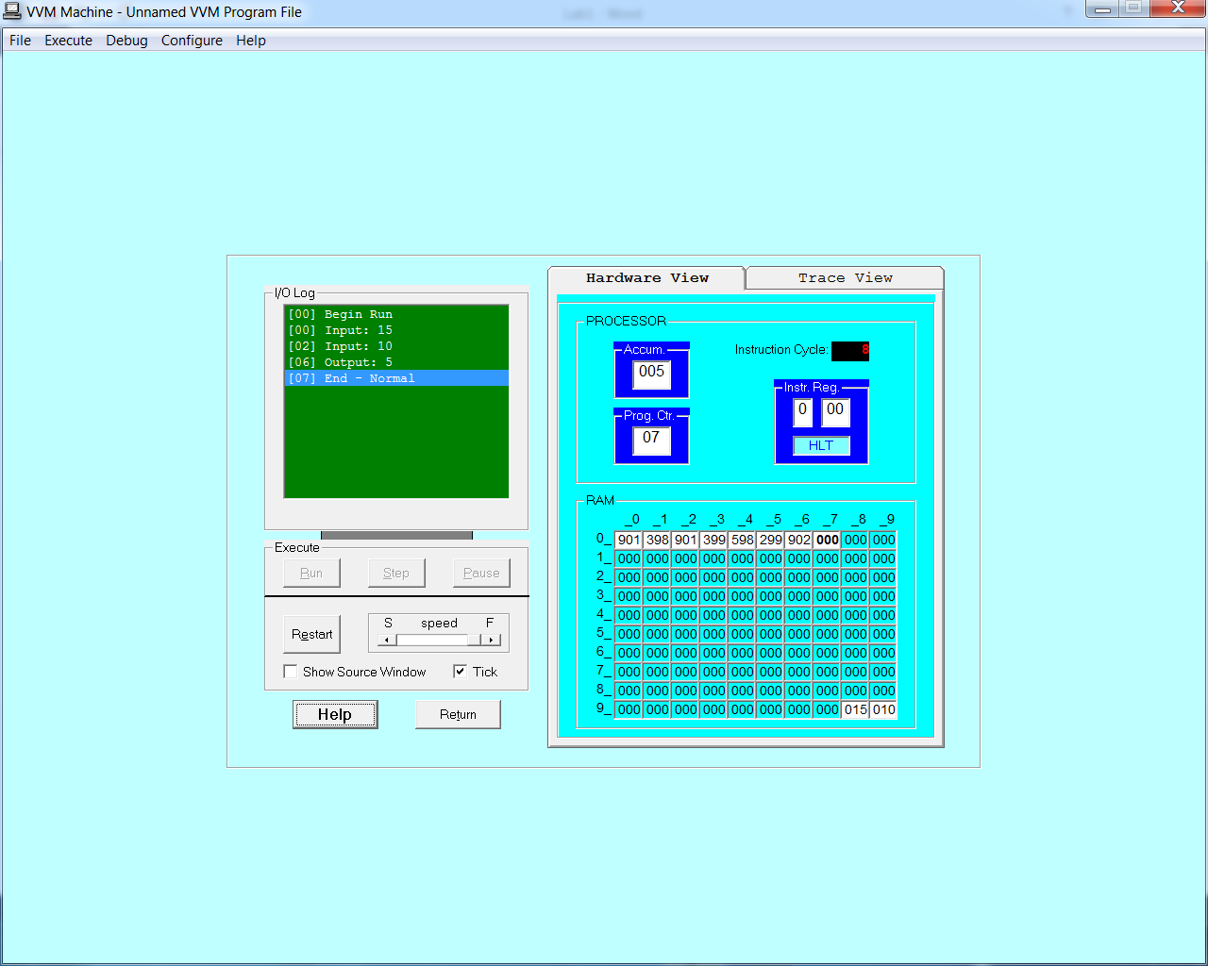

Q:- To take two hardcoded input and Add them.

Input:-

LDA 98

ADD 99

OUT

HLT

*98

DAT 020

*99

DAT 010

Output:-

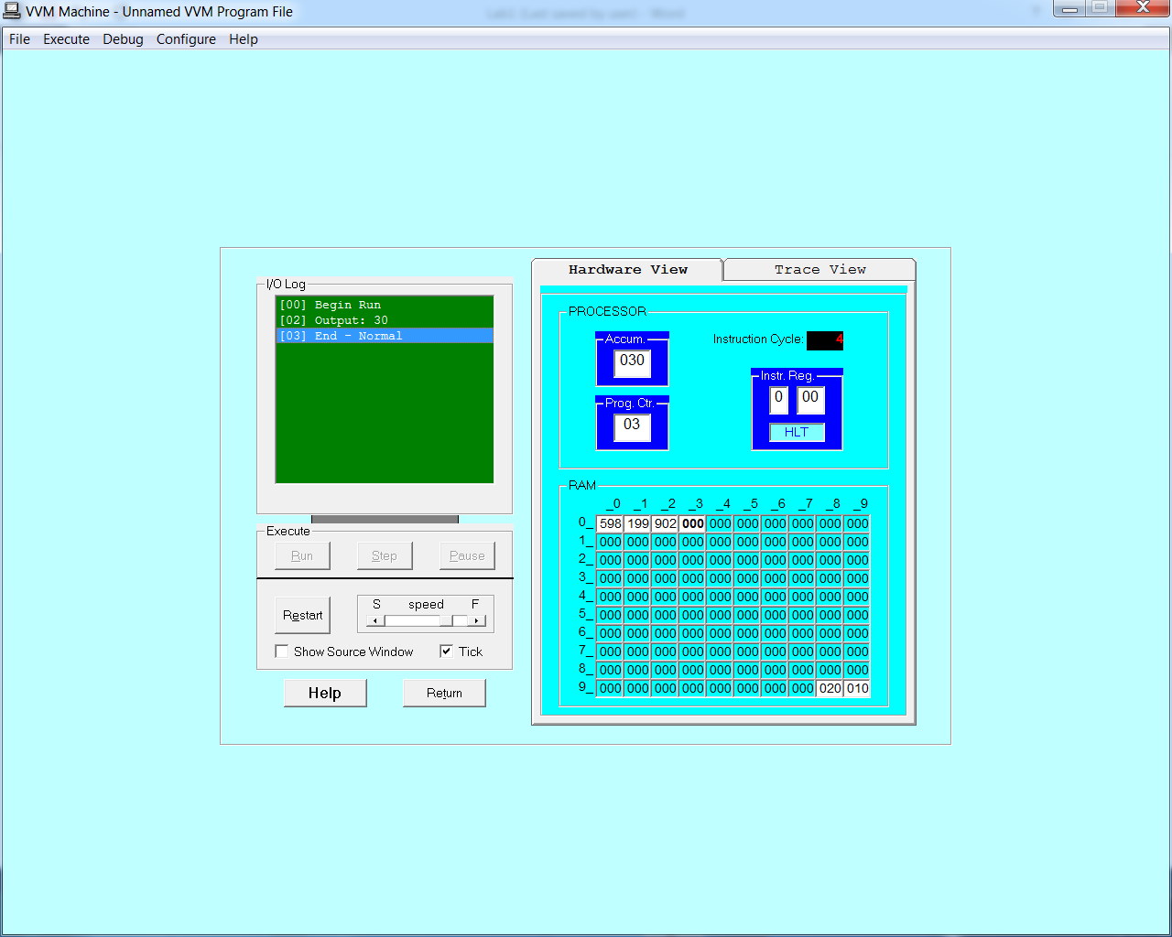

~~~~~~**/**THE END**/**~~~~~~