Bahria University,

Karachi Campus



LAB EXPERIMENT NO.

02

LIST OF TASKS

|  |  |
| --- | --- |
| TASK NO | OBJECTIVE |
| 01 | Take any integer as input, if the number is greater than 5 print it  If a >5, print a  Else if a = 0, then Halt  Else if a < 5, then halt |
| 02 | Take two numbers as input and print the larger number. |
|  |  |
|  |  |
|  |  |
|  |  |
|  |  |
|  |  |

Submitted On:

01/10/2019

Q:- Take any integer as input, if the number is greater than 5 print it

If a >5, print a

Else if a = 0, then Halt

Else if a < 5, then halt

Input:-

IN

STO 97 //a

LDA 98

SUB 98

BRP 06

BR 08

LDA 97

OUT

HLT

*98

DAT 005

Output:-

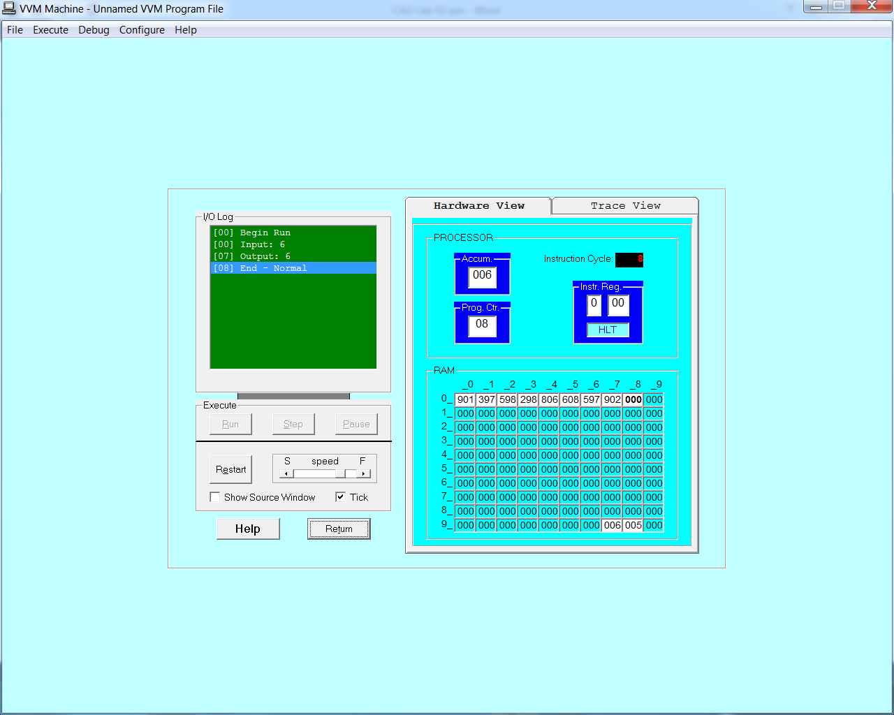

Q:- Take two numbers as input and print the larger number.

Input:-

IN

STO 97 //a

IN

STO 98 //b

LDA 97

SUB 98

BRP 10

LDA 98

OUT

BR 12

LDA 97

OUT

HLT

Output:-

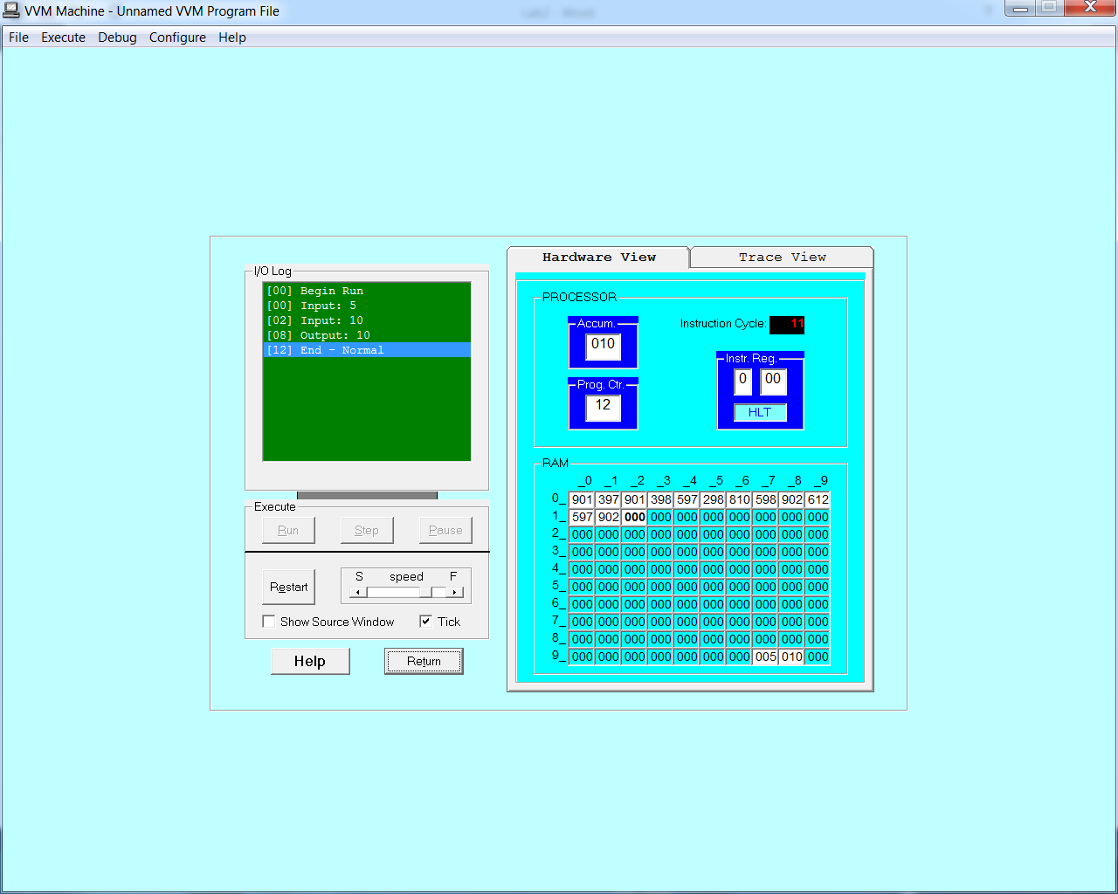

~~~~~~**/**THE END**/**~~~~~~