Bahria University,

Karachi Campus



LAB EXPERIMENT NO.

04

LIST OF TASKS

|  |  |
| --- | --- |
| TASK NO | OBJECTIVE |
| 01 | Where (to which window) is the output data displayed? |
| 02 | Write down the address of the first instruction of the program (see the text window)? |
| 03 | Write down the values of $a0 and $v0 after execution in Register window? |
| 04 | Write an assembly program that print char. |
|  |  |
|  |  |
|  |  |
|  |  |
|  |  |

Submitted On:

22/10/2019

**Q 1:-** Where (to which window) is the output data displayed?

Output:-

The below window shown the Output data.

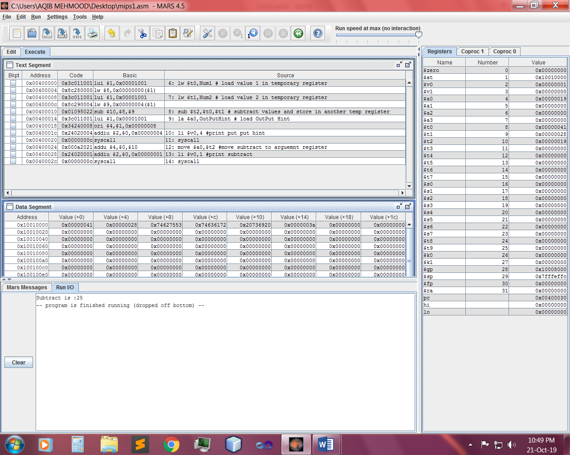

**Q 2:-** Write down the address of the first instruction of the program (see the text window)?

Output:-

During execution, the instruction being executed is highlighted in yellow address.

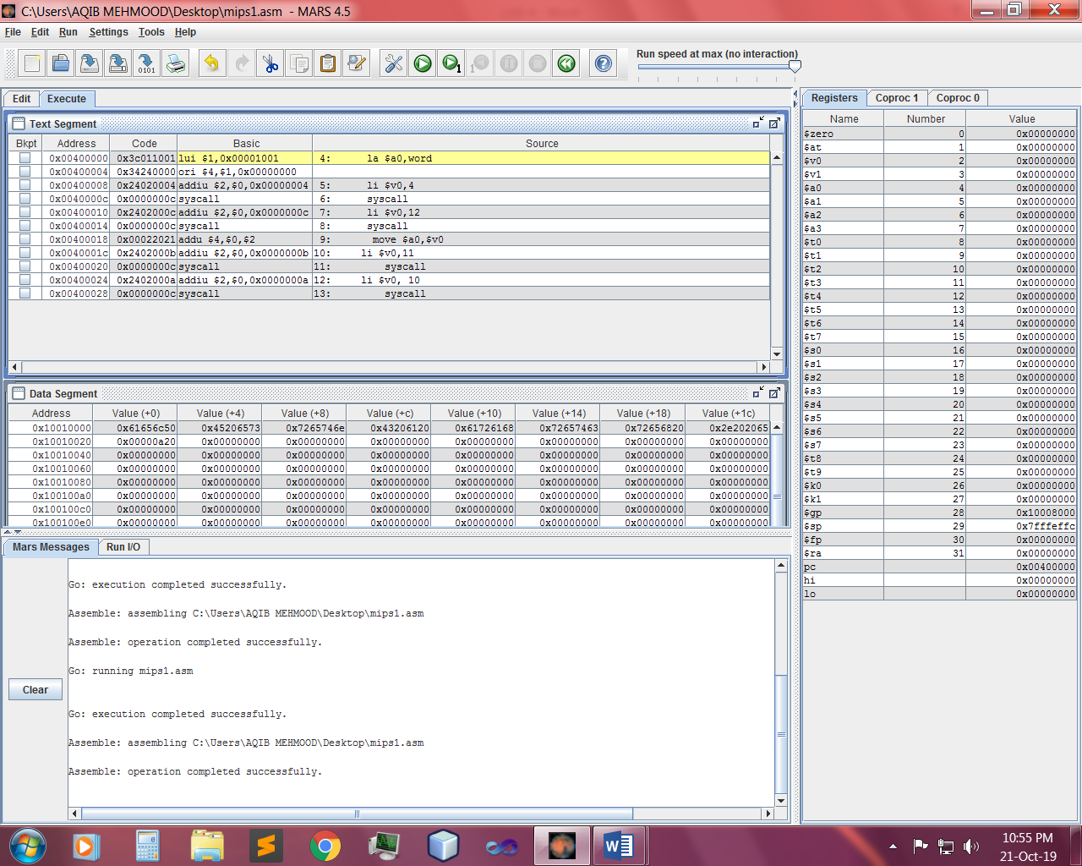

**Q 3:-** Write down the values of $a0 and $v0 after execution in Register window?

Output:-

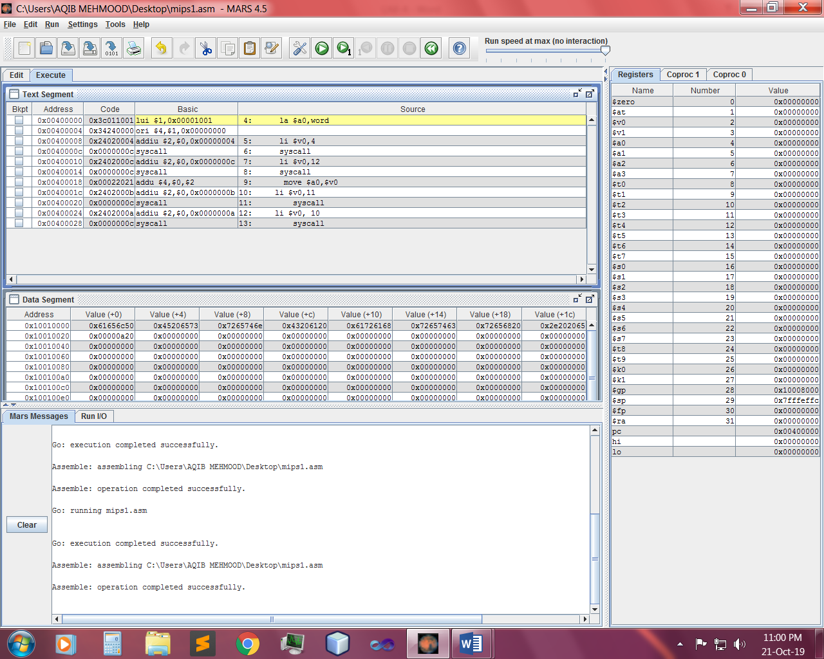

**Q 4:-** Write an assembly program that print char.

Input:-

.data

word : .asciiz "Please Enter a Character here . \n"

.text main:

la $a0,word

li $v0,4

syscall

li $v0,12

syscall

move $a0,$v0

li $v0,11

syscall

li $v0, 10

syscall

Output:-

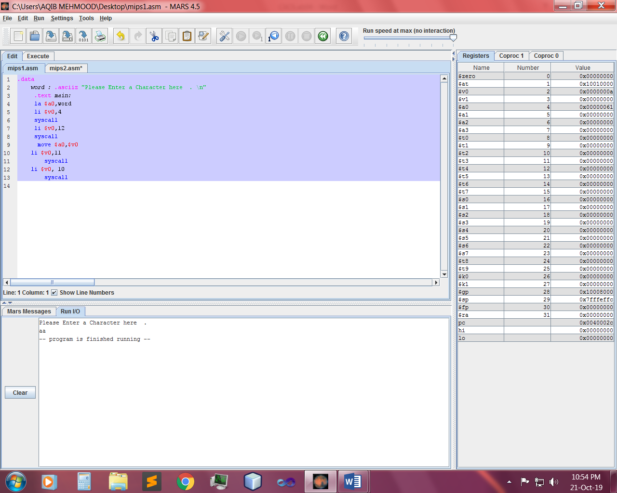

~~~~~~**/**THE END**/**~~~~~