Bahria University,

Karachi Campus



LAB EXPERIMENT NO.

06

LIST OF TASKS

|  |  |
| --- | --- |
| TASK NO | OBJECTIVE |
| 01 | Write the same program with small variation i.e. this time the program will ask for 3 integers twice and displays the result for each addition separately;  Output will look like as follows:  Enter 3 integers for 1st addition  2  2  2  Enter 3 integers for 2nd addition  3  3  3  The sum of 1st addition is 6  The sum of 2nd addition is 9 |
| 02 | Write an assembly program that Multiply three number. |
| 03 | Write an assembly program that Divide two number. |
|  |  |

Submitted On:

29/10/2019

**Q:-** *Write the same program with small variation i.e. this time the program will ask for 3 integers twice and displays the result for each addition separately;*

*Output will look like as follows:*

*Enter 3 integers for 1st addition*

*2*

*2*

*2*

*Enter 3 integers for 2nd addition*

*3*

*3*

*3*

*The sum of 1st addition is 6*

*The sum of 2nd addition is 9*

Input:-

.data

add1: .asciiz "Enter three integer for 1st Addition : \n"

add2: .asciiz "\nEnter three integer for 2nd Addition : \n"

result1:.asciiz"Result for 1st Addtion is : "

result2:.asciiz"\nResult for 2nd Addition is : "

.text

la $a0,add1

li $v0,4

syscall

li $v0,5

syscall

move $t0,$v0

li $v0,5

syscall

add $t1,$t0,$v0

move $t2,$t1

li $v0,5

syscall

add $t3,$t2,$v0

#second addition

la $a0,add2

li $v0,4

syscall

li $v0,5

syscall

move $t0,$v0

li $v0,5

syscall

add $t1,$t0,$v0

move $t2,$t1

li $v0,5

syscall

add $t4,$t2,$v0

la $a0,result1

li $v0,4

syscall

move $a0,$t3

li $v0,1

syscall

la $a0,result2

li $v0,4

syscall

move $a0,$t4

li $v0,1

syscall

Output:-

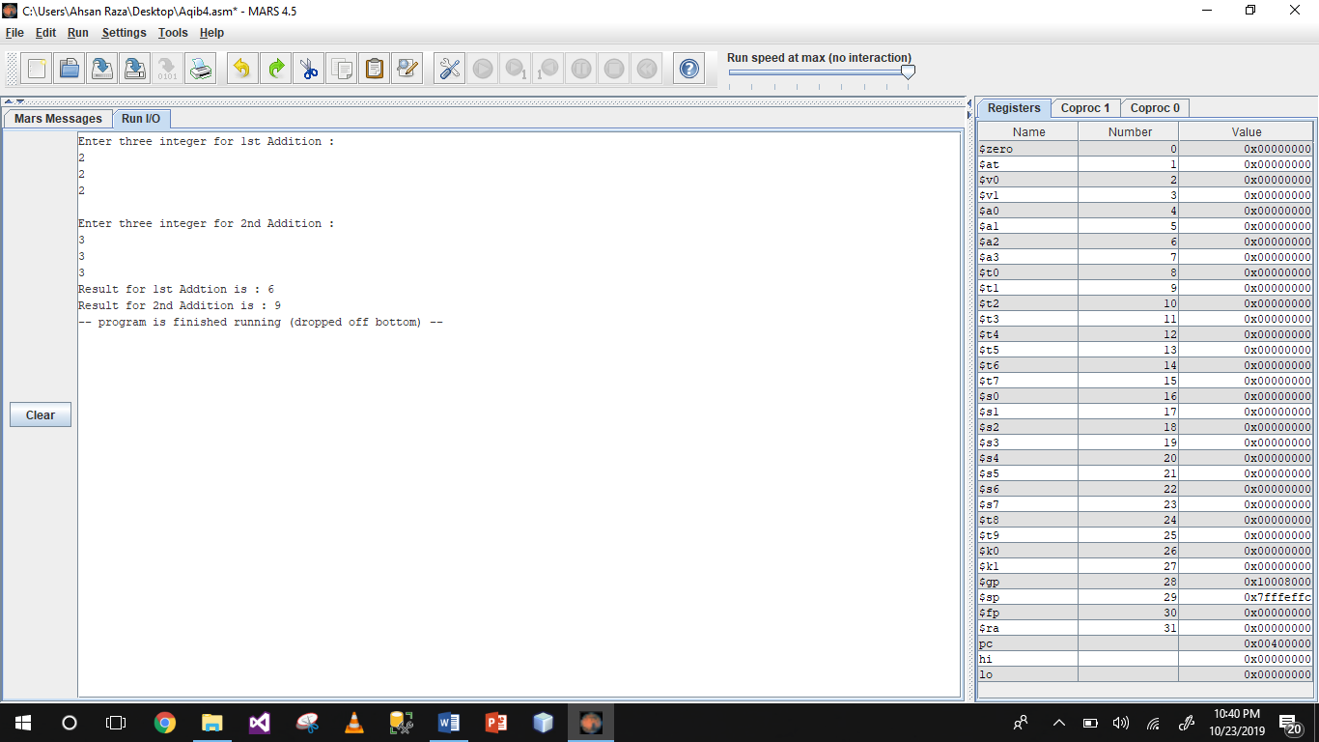

**Q:-** *Write an assembly program that Multiply three number.*

Input:-

.data

input1: .asciiz "Enter number 1\n"

input2: .asciiz "Enter number 2\n"

input3: .asciiz "Enter number 3 \n"

result: .ascii "Result = "

.text

la $a0,input1

li $v0,4

syscall

li $v0,5

syscall

move $t0,$v0

la $a0,input2

li $v0,4

syscall

li $v0,5

syscall

move $t1,$v0

mul $t2,$t0,$t1

move $t3,$t2

la $a0,input3

li $v0,4

syscall

li $v0,5

syscall

move $t4,$v0

mul $t5,$t4,$t2

la $a0,result

li $v0,4

syscall

move $a0,$t5

li $v0,1

syscall

Output:-

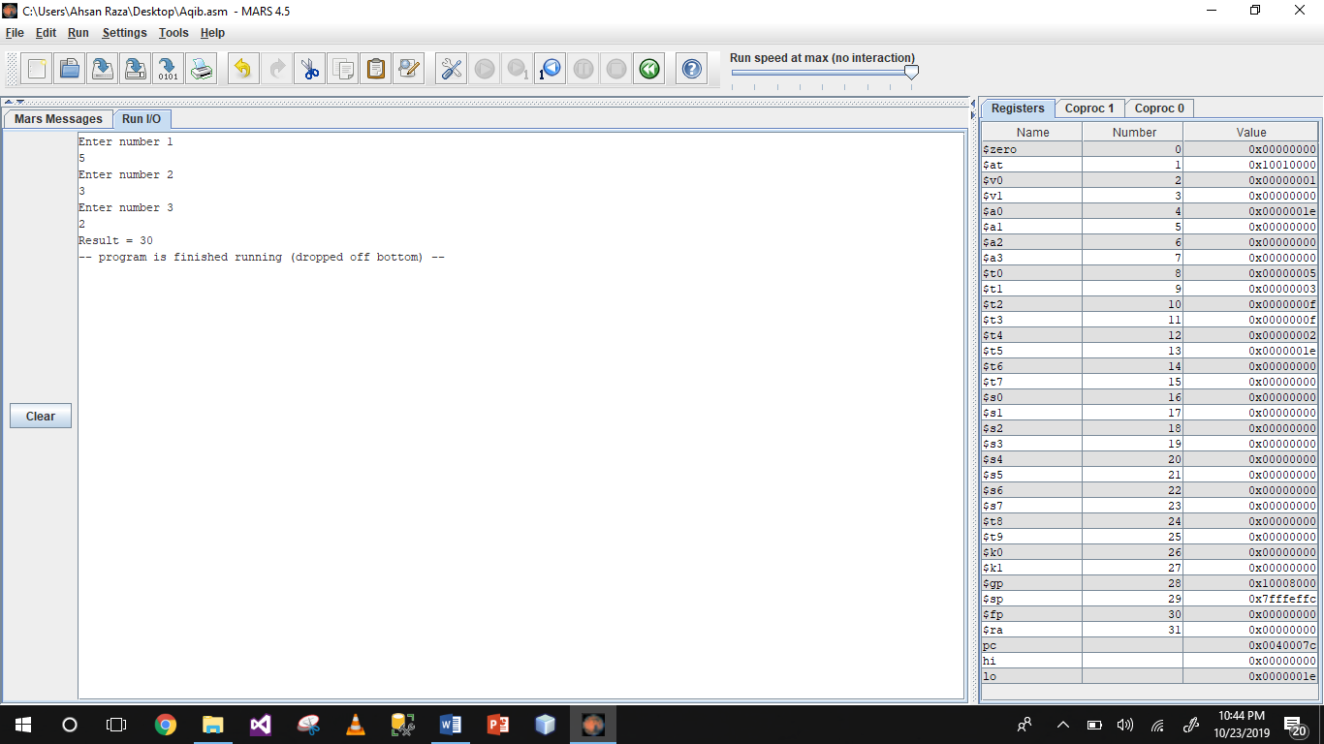

**Q:-** *Write an assembly program that Divide two number.*

Input:-

.data

input: .asciiz "Enter Number 1:\n"

input2: .asciiz "Enter Number 2:\n"

remainder: .asciiz "Remainder : "

qout:.asciiz "\nQuotient : "

.text

la $a0,input

li $v0,4

syscall

li $v0,5

syscall

move $t0,$v0

la $a0,input2

li $v0,4

syscall

li $v0,5

syscall

move $t1,$v0

div $t0,$t1

mflo $t2

mfhi $t3

la $a0,remainder

li $v0,4

syscall

move $a0,$t3

li $v0,1

syscall

la $a0,qout

li $v0,4

syscall

move $a0,$t2

li $v0,1

syscall

li $v0,10

syscall

Output:-

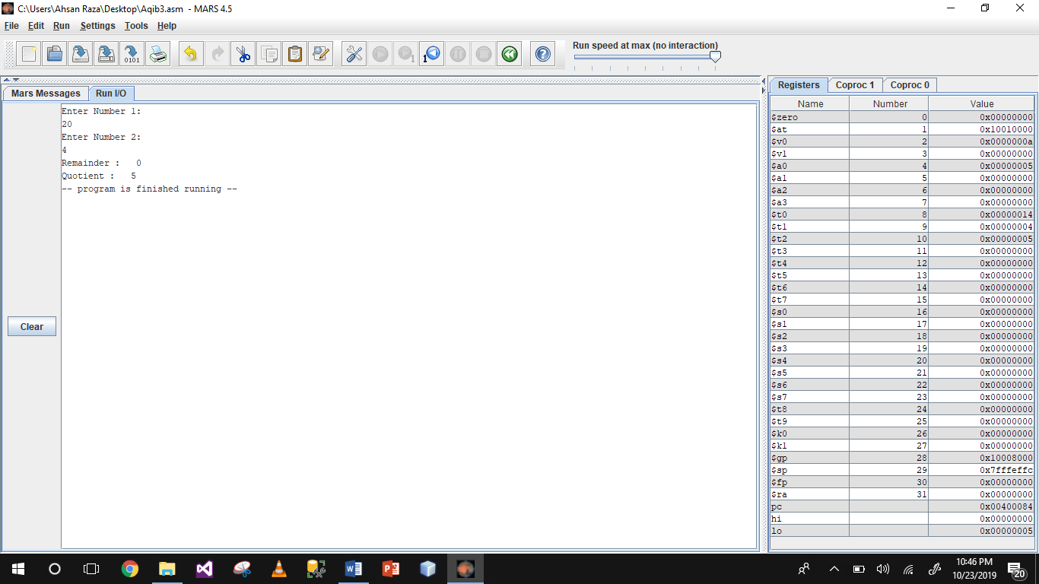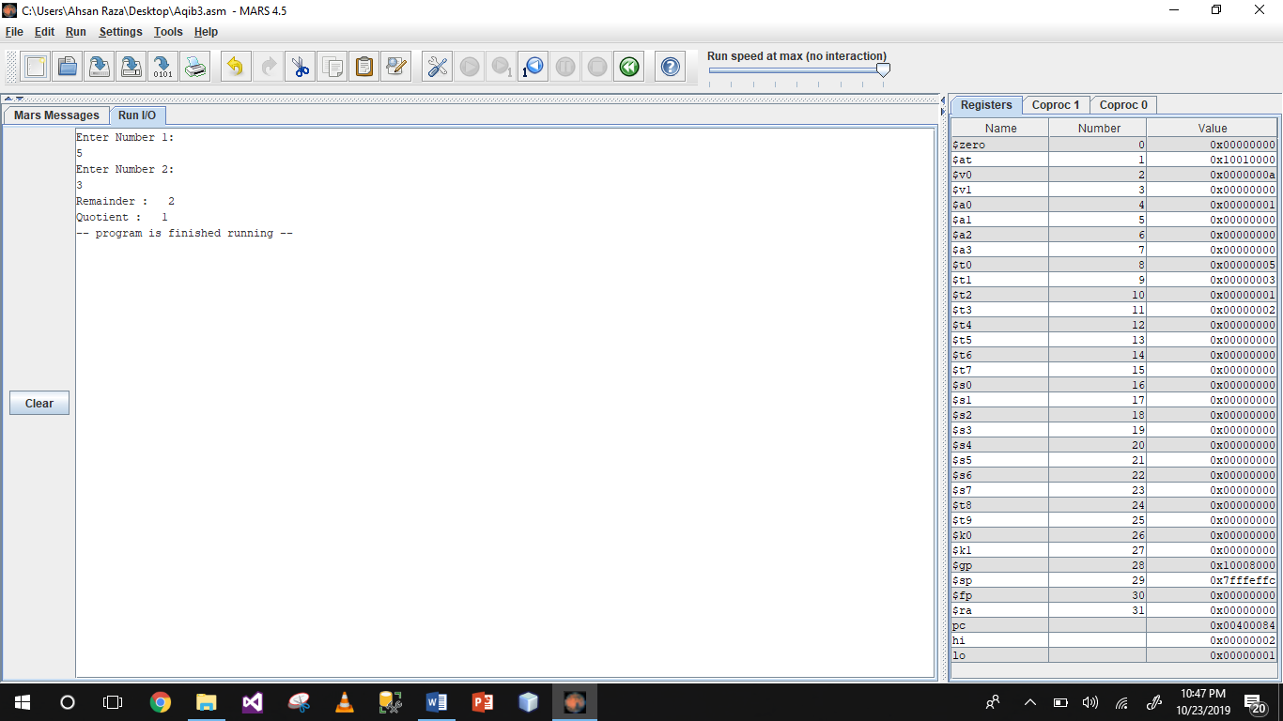

~~~~~~**/**THE END**/**~~~~~~