Bahria University,

Karachi Campus



LAB EXPERIMENT NO.

07

LIST OF TASKS

|  |  |
| --- | --- |
| TASK NO | OBJECTIVE |
| 01 | Write a MIPS assembly language program that takes an input if value is zero or less than zero halt a program else print the number. |
| 02 | Write a MIPS assembly language program that takes an input if the input value is zero only halt a program else print the number. |
|  |  |
|  |  |

Submitted On:

26/11/2019

**Q:-** *Write a MIPS assembly language program that takes an input if value is zero or less than zero halt a program else print the number.*

Input:-

.data

input: .asciiz "\nEnter a Value = "

output: .asciiz "\n<<<<<<---Output--->>>>>\n"

end: .asciiz "\nGood Bye"

.text

.global main

main:

la $a0,input

li $v0,4

syscall

li $v0,5

syscall

move $t1,$v0

blez $t1,Halt

la $a0,output

li $v0,4

syscall

move $a0,$t1

li $v0,1

syscall

li $v0,10

syscall

Halt:

la $a0,output

li $v0,4

syscall

la $a0,end

li $v0,4

syscall

Output:-

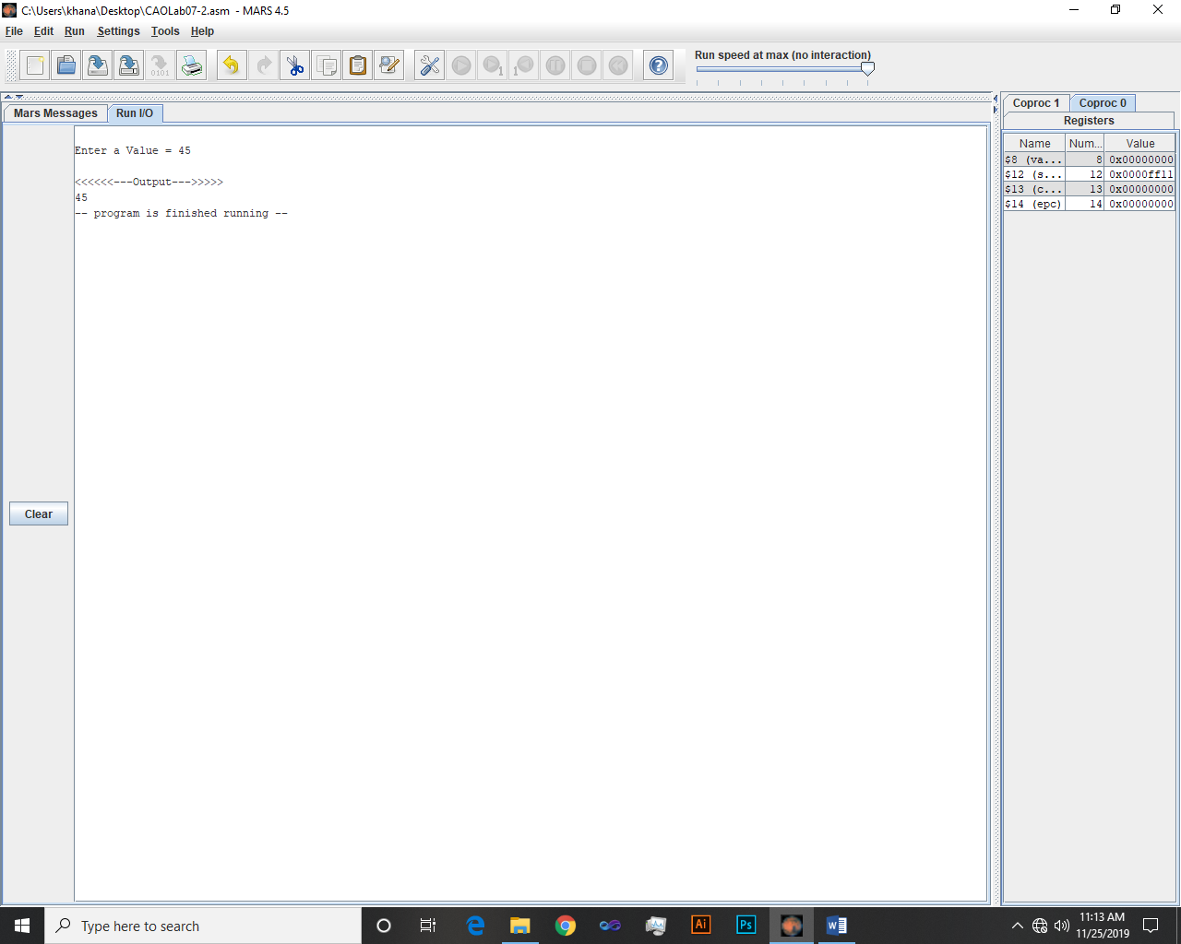 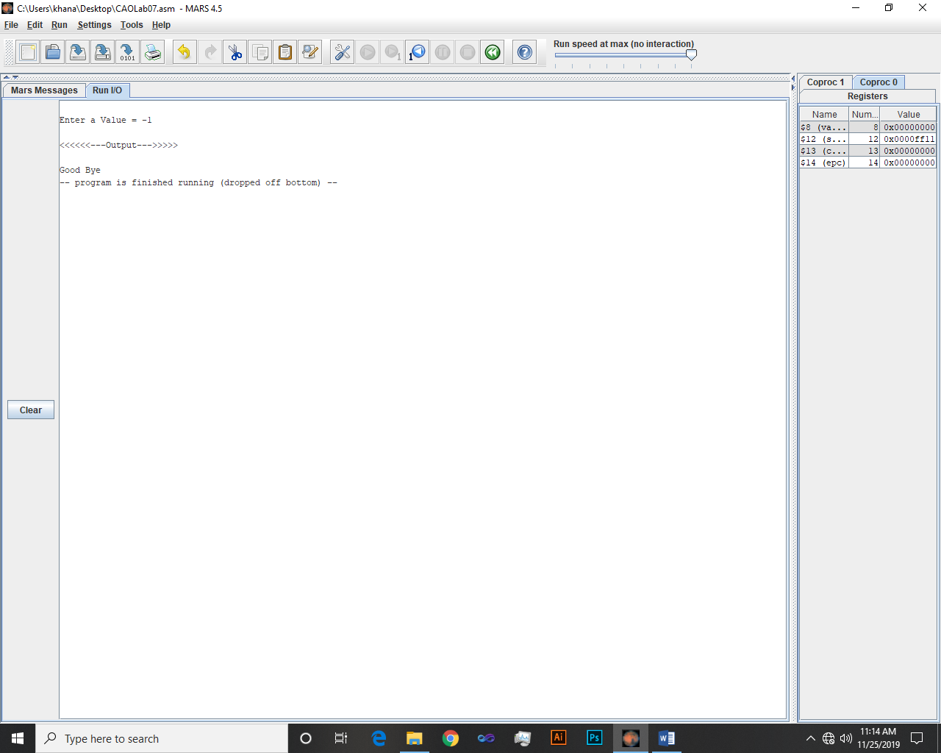

**Q:-** *Write a MIPS assembly language program that takes an input if the input value is zero only halt a program else print the number.*

Input:-

.data

input: .asciiz "\nEnter a Value = "

output: .asciiz "\n<<<<<<---Output--->>>>>\n"

end: .asciiz "\nGood Bye"

.text

.global main

main:

la $a0,input

li $v0,4

syscall

li $v0,5

syscall

move $t1,$v0

bnez $t1,Halt

la $a0,output

la $a0,output

li $v0,4

syscall

la $a0,end

li $v0,4

syscall

li $v0,10

syscall

Halt:

la $a0,output

li $v0,4

syscall

move $a0,$t1

li $v0,1

syscall

Output:-

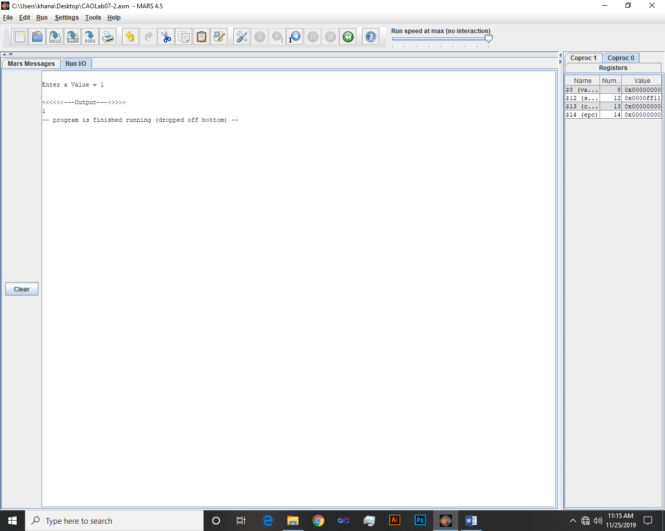

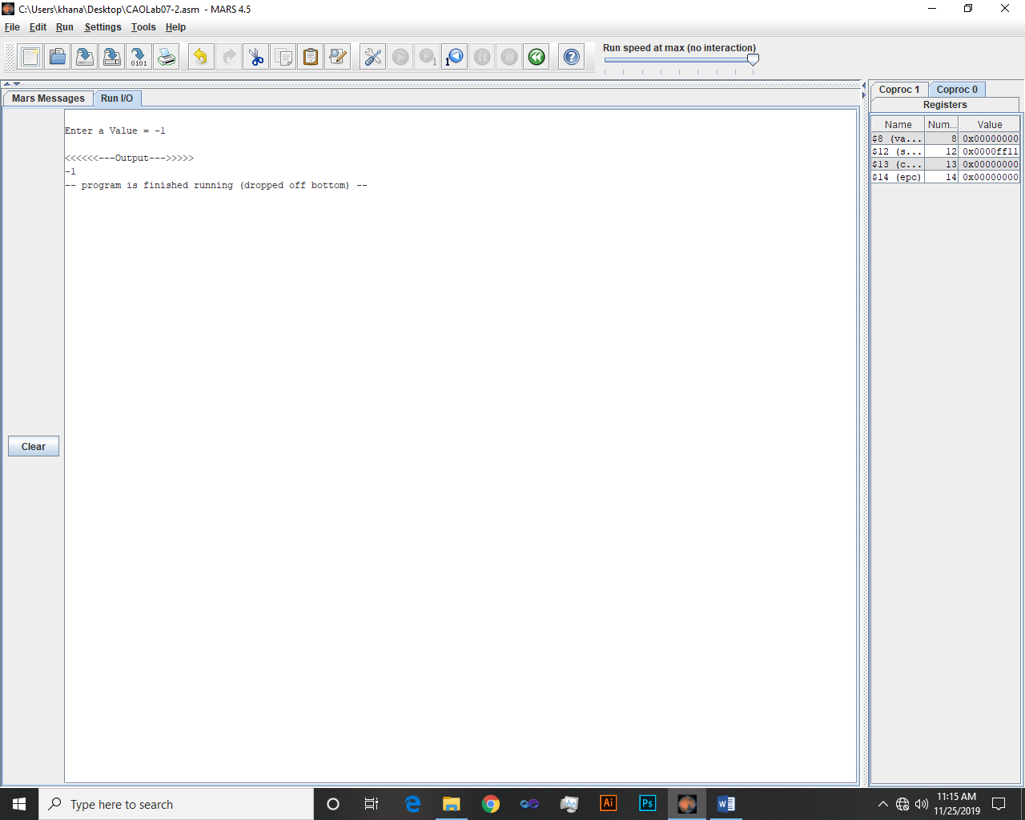

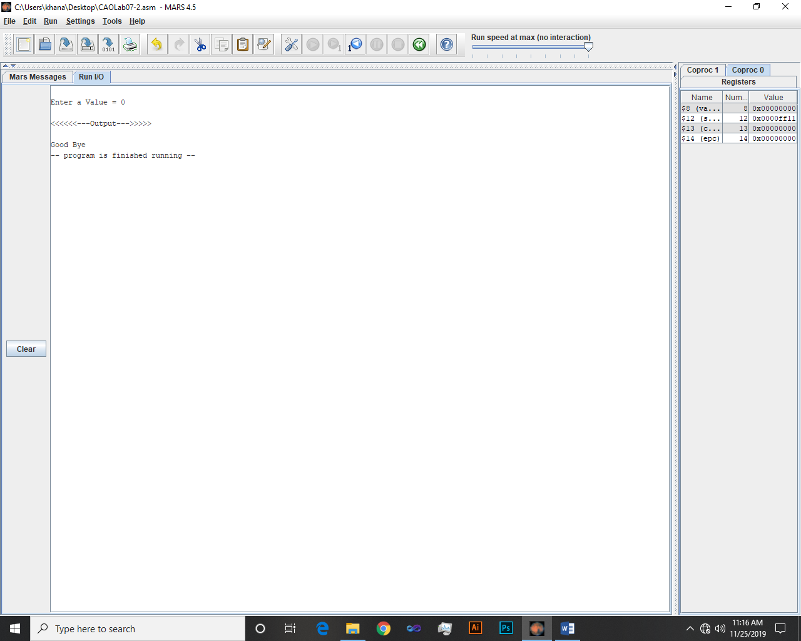

~~~~~~**/**THE END**/**~~~~~~