Bahria University,

Karachi Campus



LAB EXPERIMENT NO.

08

LIST OF TASKS

|  |  |
| --- | --- |
| TASK NO | OBJECTIVE |
| 01 | Write a MIPS assembly language program that takes an integer input and multiply that integer with 3 and display the message that is the result is even or odd. |
|  |  |
|  |  |
|  |  |

Submitted On:

03/12/2019

**Q:-** *Write a MIPS assembly language program that takes an integer input and multiply that integer with 3 and display the message that is the result is even or odd.*

Input:-

.data

input: .asciiz"\nEnter a Num N = "

output: .asciiz "\n<<<<<<<<<<-----Output---->>>>>>>>> \n"

multi: .asciiz"\nAfter multiplying with Integer 3 \n"

even: .asciiz"\nNumber is Even\n"

odd: .asciiz"\nNumber is Odd\n"

.text

la $a0,input

li $v0,4

syscall

li $v0,5

syscall

move $t0,$v0

li $t1,3

mul $t2,$t0,$t1

li $t3,2

div $t4,$t2,$t3

mfhi $t5

bnez $t5,label1

la $a0,output

li $v0,4

syscall

la $a0,multi

li $v0,4

syscall

la $a0,even

li $v0,4

syscall

##move $a0,$t5

##li $v0,1

##syscall

li $v0,10

syscall

label1:

la $a0,output

li $v0,4

syscall

la $a0,multi

li $v0,4

syscall

la $a0,odd

li $v0,4

syscall

##move $a0,$t5

##li $v0,1

##syscall

Output:-

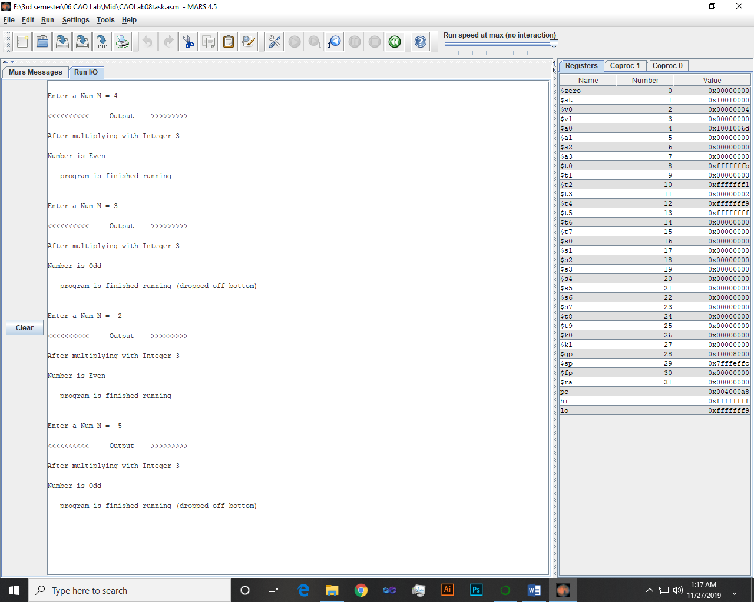

~~~~~~**/**THE END**/**~~~~~~