Bahria University,

Karachi Campus



LAB EXPERIMENT NO.

09

LIST OF TASKS

|  |  |
| --- | --- |
| TASK NO | OBJECTIVE |
| 01. | Execute above mention program and analyze outputs. |
| 02. | Write a program which perform bitwise inversion using XOR function i.e input value = 0, output value = 1 |
|  |  |
|  |  |

Submitted On:

17/12/2019

**Q:-** Execute above mention program and analyze outputs.

**Performing Bitwise OR Instruction with Mask 00000001**

Input:-

.data

input: .asciiz"Before"

output:.asciiz"\nAfter"

newLine: .asciiz "\n"

.text

main:

la $a0,input

li $v0,4

syscall

li $a1,6

jal showNumber

li $a1,6

jal AddBitOne

la $a0,output

li $v0,4

syscall

move $a1,$v1

jal showNumber

li $v0,10

syscall

# Expecta a number in a1

showNumber:

la $a0,newLine

li $v0,4

syscall

move $a0,$a1

li $v0,1

syscall

jr $ra

AddBitOne:

# Mask a mask

li $s0,1

or $v1,$a1,$s0

jr $ra

Output:-

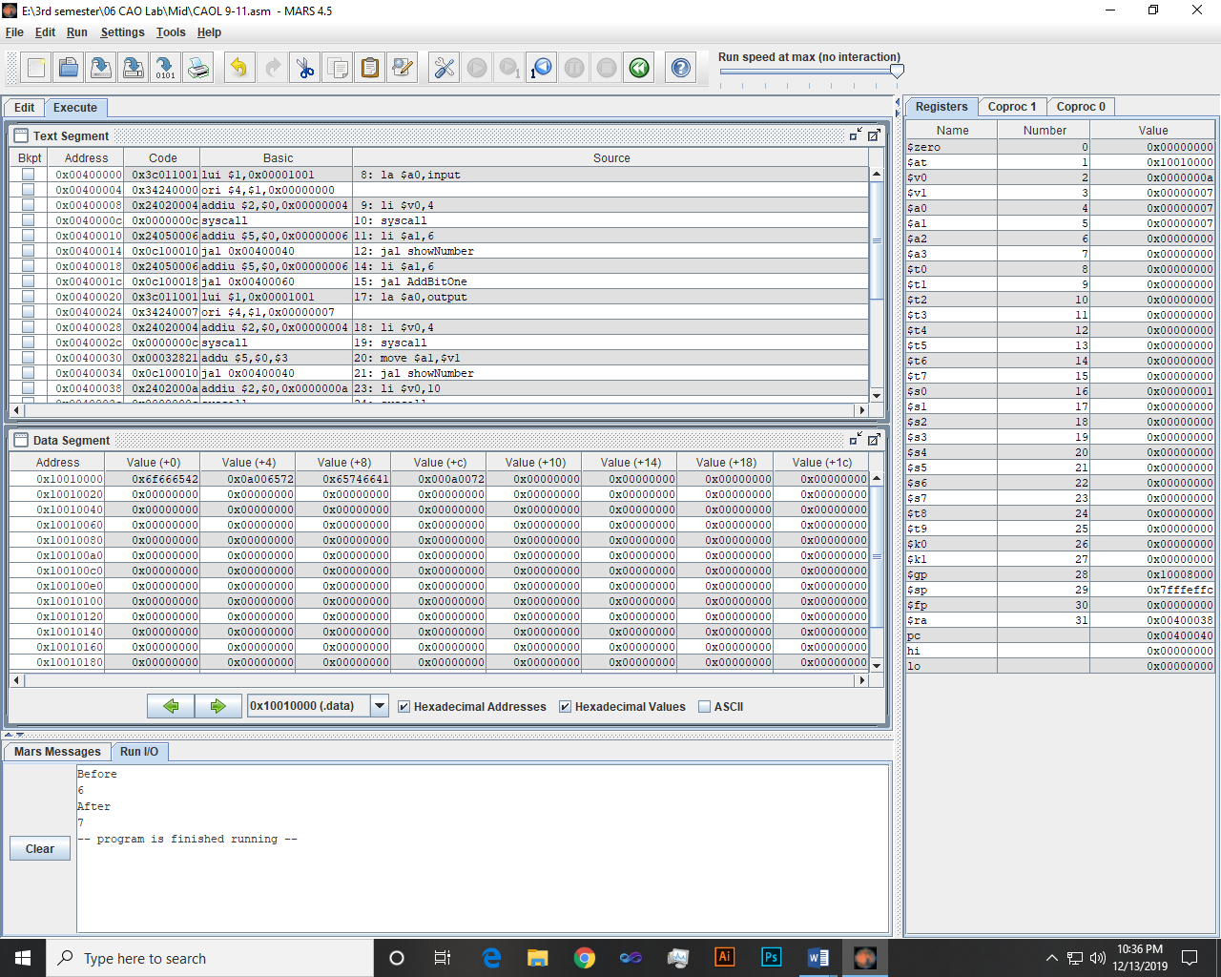

**Performing Bitwise AND Instruction with Mask 11111110**

Input:-

.data

input: .asciiz"Before"

output:.asciiz"\nAfter"

newLine: .asciiz "\n"

.text

main:

la $a0,input

li $v0,4

syscall

li $a1,10

jal showNumber

li $a1,10

jal AddBitOne

la $a0,output

li $v0,4

syscall

move $a1,$v1

jal showNumber

li $v0,10

syscall

# Expecta a number in a1

showNumber:

la $a0,newLine

li $v0,4

syscall

move $a0,$a1

li $v0,1

syscall

jr $ra

AddBitOne:

# Mask a mask

li $s0,-1

and $v1,$a1,$s0

jr $ra

Output:-

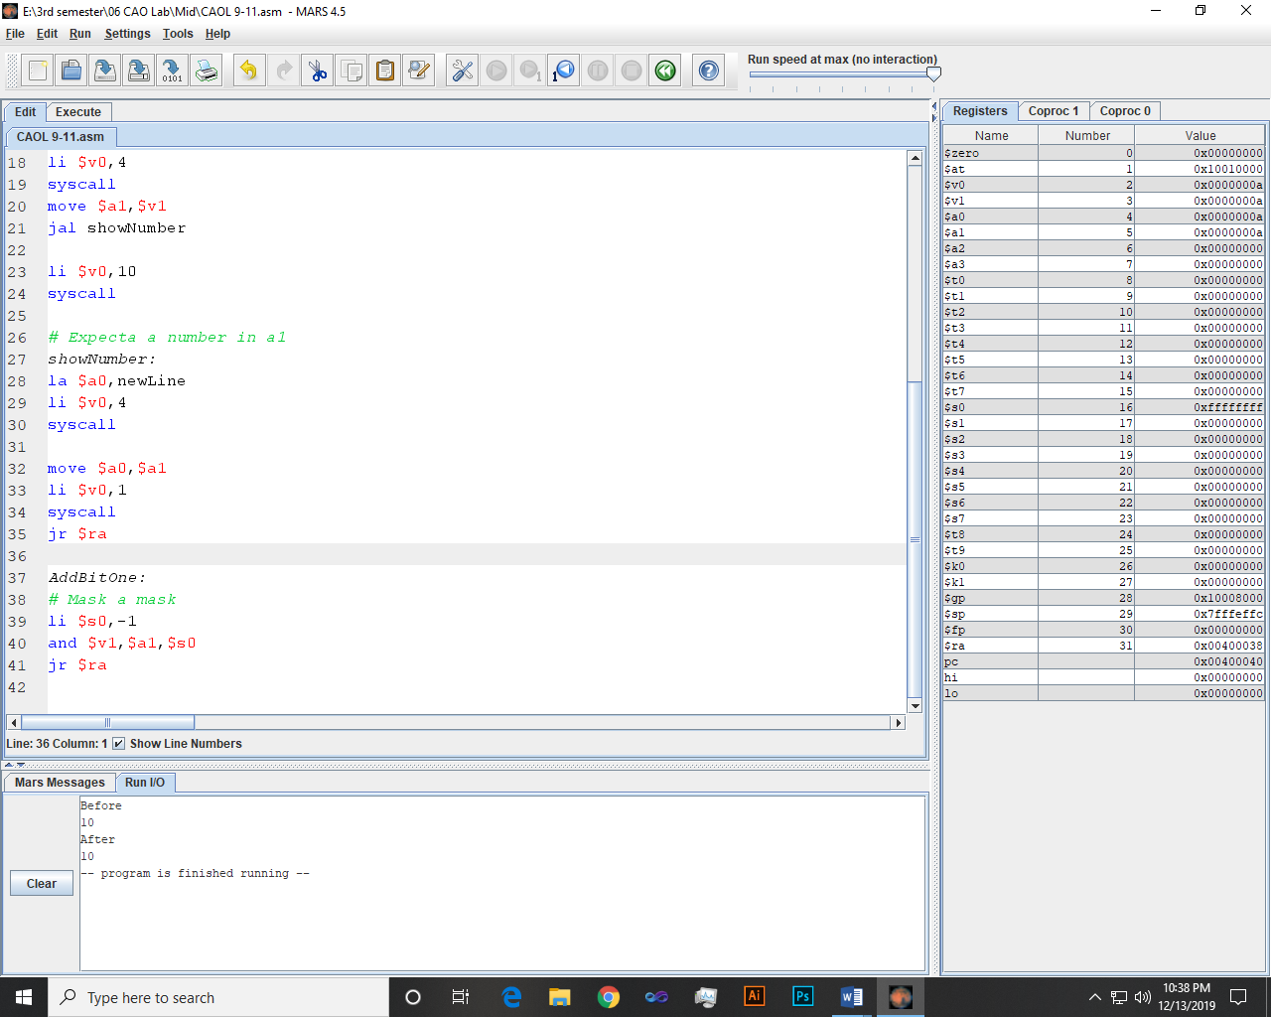

**Q:-** Write a program which perform bitwise inversion using XOR function i.e input value = 0, output value = 1

Input:-

.data

input: .asciiz"Input"

output:.asciiz"\nOutput"

newLine: .asciiz "\n"

.text

main:

la $a0,input

li $v0,4

syscall

li $a1,0

jal showNumber

li $a1,0

jal AddBitOne

la $a0,output

li $v0,4

syscall

move $a1,$v1

jal showNumber

li $v0,10

syscall

# Expecta a number in a1

showNumber:

la $a0,newLine

li $v0,4

syscall

move $a0,$a1

li $v0,1

syscall

jr $ra

AddBitOne:

# Mask a mask

li $s0,1

xor $v1,$a1,$s0

jr $ra

Output:-

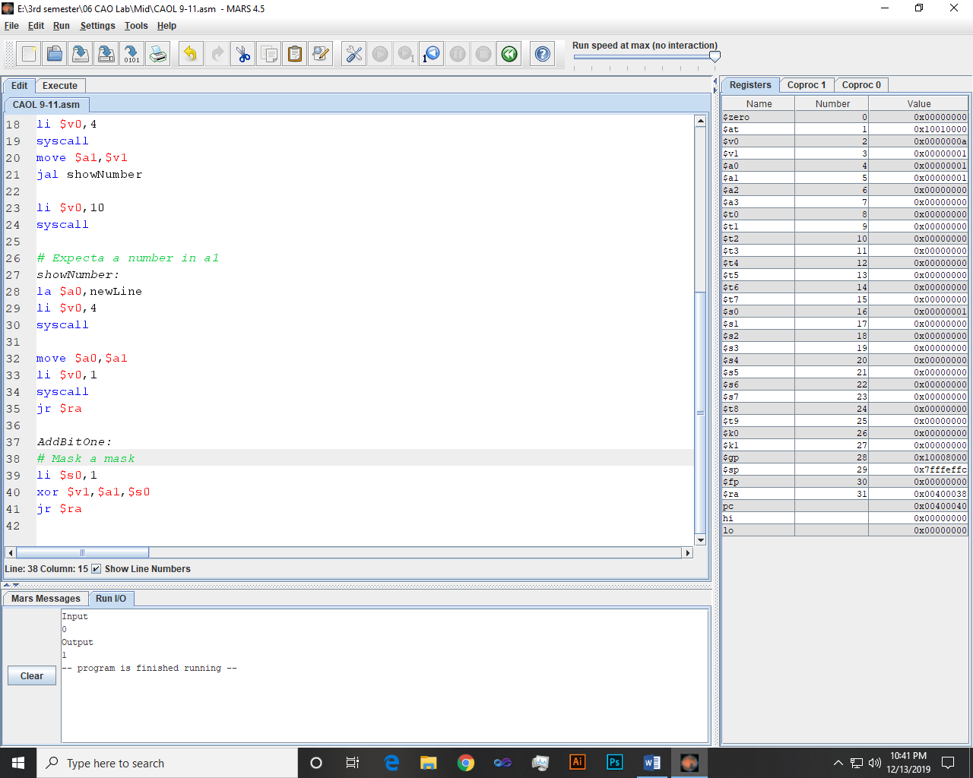

~~~~~~**/**THE END**/**~~~~~~