Bahria University,

Karachi Campus



LAB EXPERIMENT NO.

10

LIST OF TASKS

|  |  |
| --- | --- |
| TASK NO | OBJECTIVE |
| 01. | Write a program in MIPS assembly language that takes input from user and print whether the input is greater-than equal to or less than 10 and also shift input left and right 4 bits. |
|  |  |
|  |  |
|  |  |

Submitted On:

17/12/2019

**Q:-** *Write a program in MIPS assembly language that takes input from user and print whether the input is greater-than equal to or less than 10 and also shift input left and right 4 bits.*

Input:-

.data

input: .asciiz "Enter any Number\n"

greater: .asciiz "The Number is Greater than 10"

less: .asciiz "The Number is Less than 10"

equal: .asciiz "The Number is Equal to 10"

sleft: .asciiz "\nShift Left Logical\n"

sright: .asciiz "\nShift Right Logical\n"

.text

la $a0,input

li $v0,4

syscall

li $v0,5

syscall

move $t0,$v0

subi $t1,$t0,10

bgez $t1,else

la $a0,less

li $v0,4

syscall

b shleft

b shright

li $v0,10

syscall

else:

bgtz $t1,else1

la $a0,equal

li $v0,4

syscall

b shleft

b shright

li $v0,10

syscall

else1:

la $a0,greater

li $v0,4

syscall

b shleft

b shright

li $v0,10

syscall

shleft:

sll $t1,$t0,4

la $a0,sleft

li $v0,4

syscall

move $a0,$t1

li $v0,1

syscall

shright:

srl $t1,$t0,4

la $a0,sright

li $v0,4

syscall

move $a0,$t1

li $v0,1

syscall

Output:-

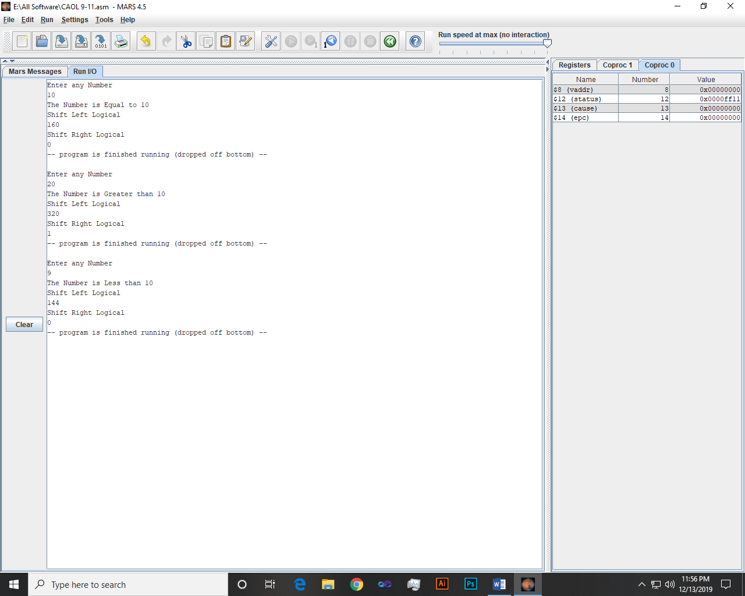

~~~~~~**/**THE END**/**~~~~~~