Bahria University,

Karachi Campus



LAB EXPERIMENT NO.

12

LIST OF TASKS

|  |  |
| --- | --- |
| TASK NO | OBJECTIVE |
| 01. | Your task is to solve the puzzle with 4 disks and calculate the minimal number of moves? |
|  |  |
|  |  |
|  |  |
|  |  |

Submitted On:

17/12/2019

**Q:-** *Your task is to solve the puzzle with 4 disks and calculate the minimal number of moves?*

Input:-

.data

output: .asciiz "Number of moves with Four disks are : "

error: .asciiz "Invalid Input"

.text

la $a0,output

li $v0,4

syscall

li $t0,1

li $t1,2

li $t2,1

bgtz $t0,moves

la $a0,error

li $v0,4

syscall

moves:

mul $t2,$t2,$t1

addi $t0,$t0,1

blt $t0,5,moves

sub $t2,$t2,1

move $a0,$t2

li $v0,1

syscall

li $v0,10

syscall

Output:-

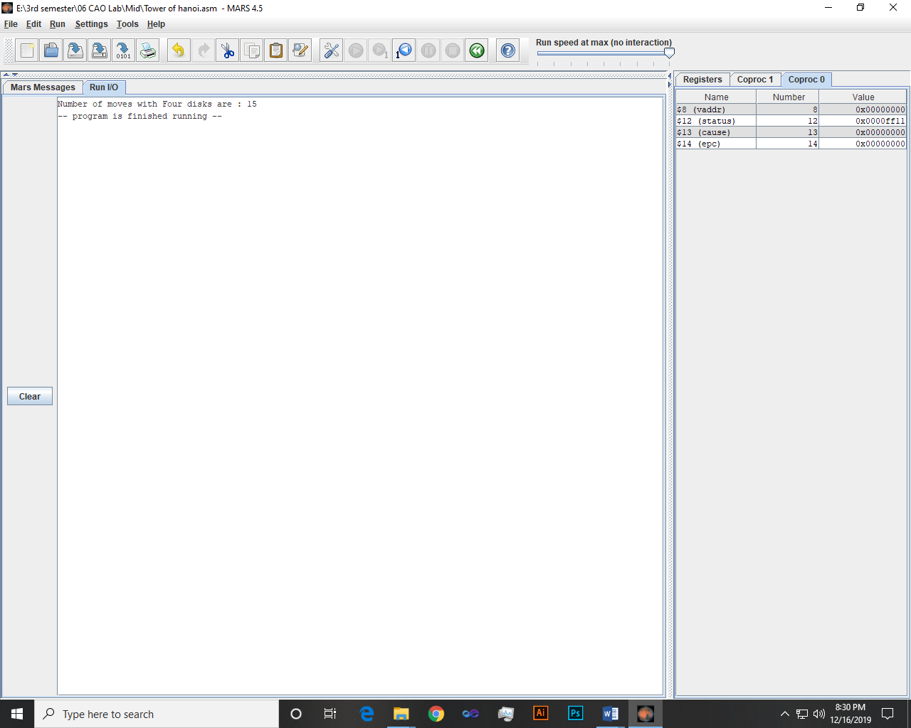

~~~~~~**/**THE END**/**~~~~~~