**Bahria University**

**Software Engineering Department**



**Course: CSC 221 DATA STRUCTURE & ALGORITHMS**

**Term: Fall 2019, Class: BSE 3(B)**

**Assignment No:**

|  |  |
| --- | --- |
| **0** | **1** |

**Submitted By:**

|  |  |  |  |  |  |  |  |  |  |  |  |
| --- | --- | --- | --- | --- | --- | --- | --- | --- | --- | --- | --- |
| **A** | **Q** | **I** | **B** |  | **M** | **E** | **H** | **M** | **O** | **O** | **D** |

**Enrollment No.:**

|  |  |  |  |  |  |  |  |  |  |  |  |  |
| --- | --- | --- | --- | --- | --- | --- | --- | --- | --- | --- | --- | --- |
| 0 | 2 | - | 1 | 3 | 1 | 1 | 8 | 2 | - | 0 | 1 | 4 |

|  |  |  |  |  |  |  |  |  |  |  |  |  |  |  |  |  |
| --- | --- | --- | --- | --- | --- | --- | --- | --- | --- | --- | --- | --- | --- | --- | --- | --- |
| **Submission Date** | | | | | | | |  | **Date Submitted** | | | | | | | |
| **3** | **1** | **/** | **1** | **0** | **/** | **1** | **9** | **3** | **1** | **/** | **1** | **0** | **/** | **1** | **9** |

**Submitted To:**

**Engr. Saniya Sarim**

**Signature: ________________ Max Marks: ___________ Marks Obtained: _____________**

Bahria University,

Karachi Campus



LAB Assignment NO.

01.

LIST OF TASKS

|  |  |
| --- | --- |
| TASK NO | OBJECTIVE |
| 01. | Write an algorithm that finds the smallest and largest number in a list (an array) of n numbers. |
| 02. | Write an algorithm that prints out all the subset of four elements of a set of n elements the elements of this set are sorted in a list that is input to the algorithm |
| 03. | Design a program where user gives one string argument and generate result.  Example:   * If input is “**abc**” then output should be “**klm**”. * If input is “**xyz**” then output should be “**HIJ**” * If input is “**gsm**” then output should be “**qCw**” * If input is “**XYZ**” then output should be “**hij**” |
| 04. | Take 10 inputs from the user and assign them into two string arrays (make 2 unsorted string arrays of 5 lengths each), merge those arrays and obtain the result in the sorted manner. |
| 05. | Delete the string (taken from the user) from the array of strings that was inserted by the user. Use searching algorithm. |
| 06. | Write a program which takes two input values from user and sums up all the even numbers between these numbers. Using recursion |

Submitted On:

31-10-2019

(Date: DD/MM/YY)

Q 1: - Write an algorithm that finds the smallest and largest number in a list (an array) of n numbers.

Input:-

public static void BubbleSort(int[] A)

{

for (int i = 0; i < A.Length; i++)

{

for (int j = 1; j < A.Length; j++)

{

int k = j - 1;

if (A[k] > A[j])

{

int temp = A[k];

A[k] = A[j];

A[j] = temp;

}

}

}

}

static void Main(string[] args)

{

Console.WriteLine("Enter Length of an Array");

int n = int.Parse(Console.ReadLine());

int[] A = new int[n];

for (int i = 0; i < A.Length; i++)

{

Console.Write("A[{0}]= ",i);

A[i]=int.Parse(Console.ReadLine());

}

BubbleSort(A);

Console.WriteLine();

Console.WriteLine("Smallest Num = {0}",A[0]);

Console.WriteLine("Largest Num = {0}",A[n-1]);

}

Output:-

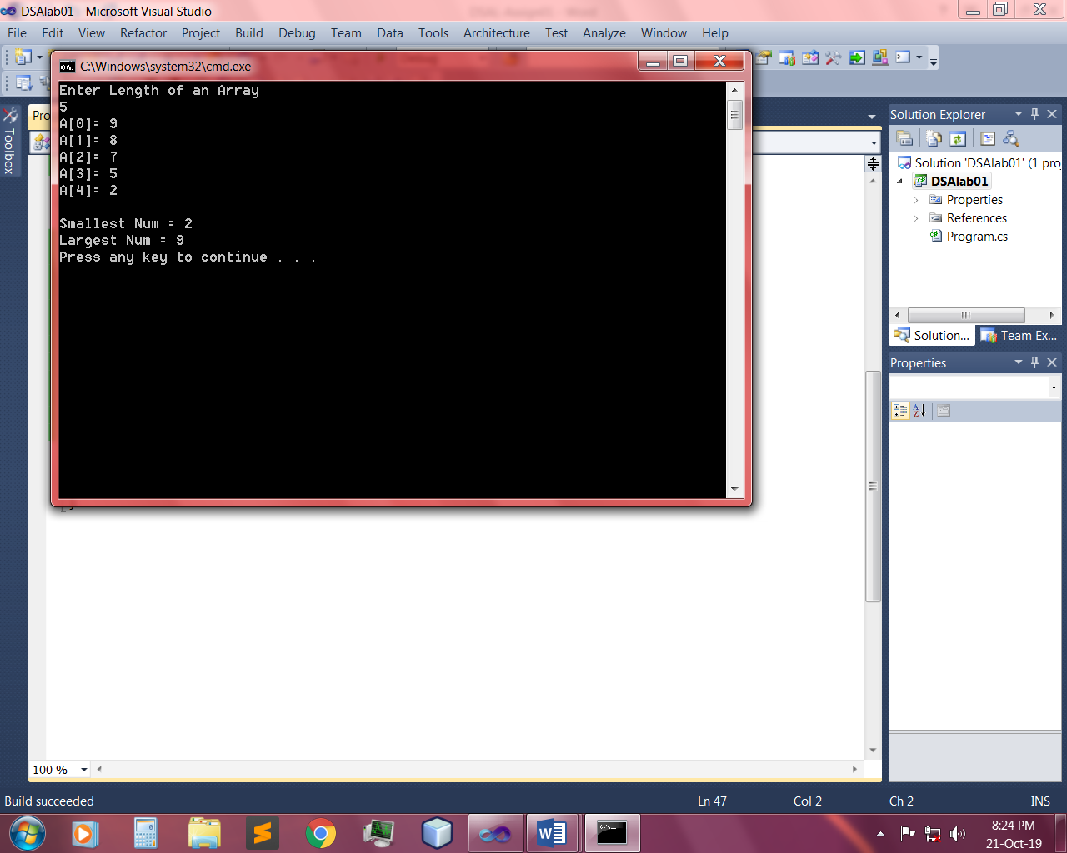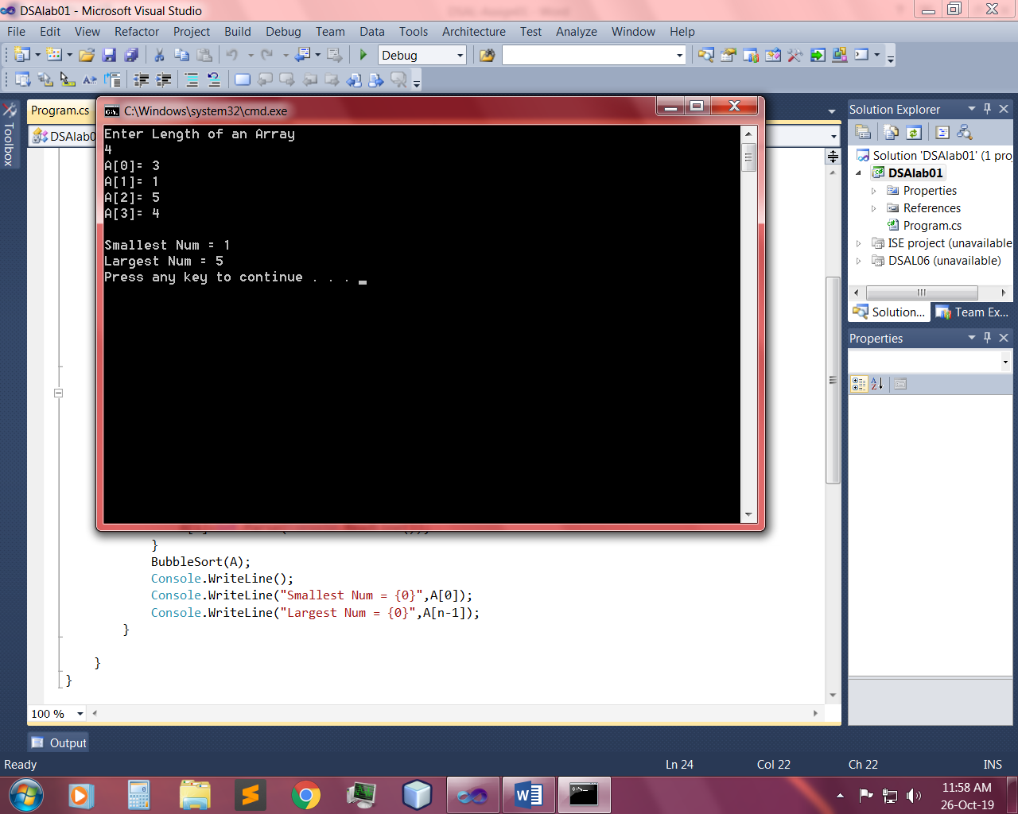

Q 2: - Write an algorithm that prints out all the subset of four elements of a set of n elements the elements of this set are sorted in a list that is input to the algorithm.

Input:-

public static void BubbleSort(string[] A)

{

for (int i = 0; i < A.Length; i++)

{

for (int j = 1; j < A.Length; j++)

{

int k = j - 1;

if (A[k].CompareTo(A[j])>0)

{

string temp = A[k];

A[k] = A[j];

A[j] = temp;

}

}

}

}

public static void SubSet(string[] A)

{

for (int i = 0; i < 4; i++)

{

Console.Write("{");

for (int j = 0; j < 4; j++)

{

Console.Write("["+A[i]+A[j]+"],");

}

Console.WriteLine("}");

}

Console.WriteLine();

}

static void Main(string[] args)

{

Console.WriteLine("Enter Length of element greater than four");

int n = int.Parse(Console.ReadLine());

if (n >= 4)

{

Console.WriteLine("Enter Element");

string[] A = new string[n];

for (int i = 0; i < A.Length; i++)

{

A[i] = Console.ReadLine();

}

Console.WriteLine("Elements are now Sorted");

BubbleSort(A);

foreach (string item in A)

{

Console.WriteLine(item);

}

Console.WriteLine("||---- Subsets of Four Elements ----||");

SubSet(A);

}

else

{

Console.WriteLine("At least four element are required");

}

Console.WriteLine("Program End Successfully.\n");

}

Output:-

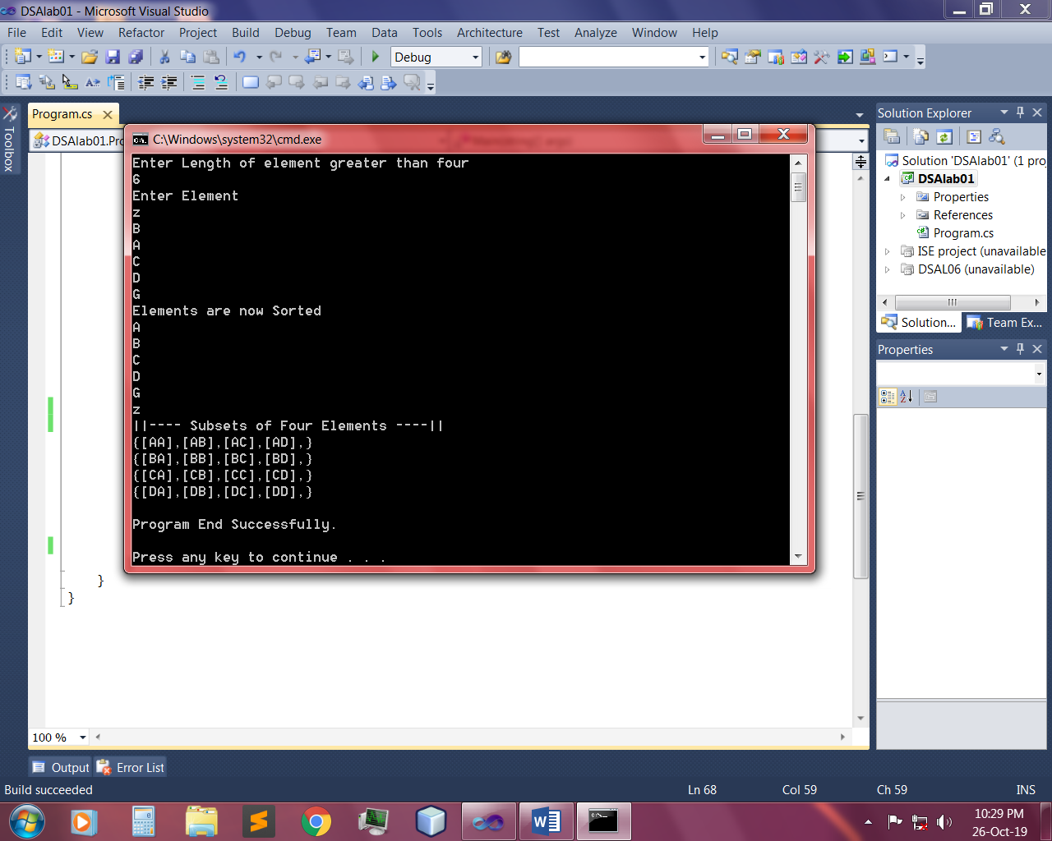 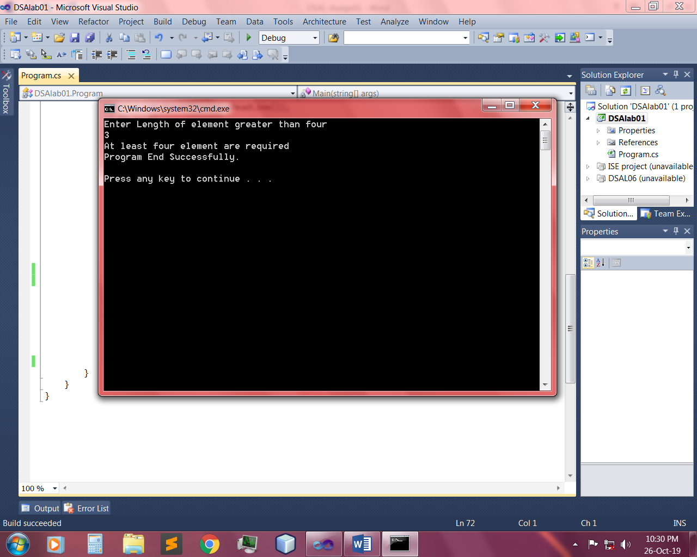

Q 3: - Design a program where user gives one string argument and generate result.

Example:

* If input is “**abc**” then output should be “**klm**”.
* If input is “**xyz**” then output should be “**HIJ**”
* If input is “**gsm**” then output should be “**qCw**”
* If input is “**XYZ**” then output should be “**hij**”

Input:-

static void Main(string[] args)

{

Console.WriteLine("Enter a String Argument"); //65,91,97,123

string val = Console.ReadLine();

char[] conv = val.ToCharArray();

for (int i = 0; i < conv.Length; i++)

{

int ascii = (int)conv[i];

int j = 0;

while (j<10)

{

if (ascii==91)

{

ascii = 97;

}

if (ascii==123)

{

ascii = 65;

}

ascii++;

j++;

}

conv[i] = (char)ascii;

}

foreach (char item in conv)

{

Console.Write(item);

}

Console.WriteLine();

Console.WriteLine("\nProgram End Successfully.\n");

}

Output:-

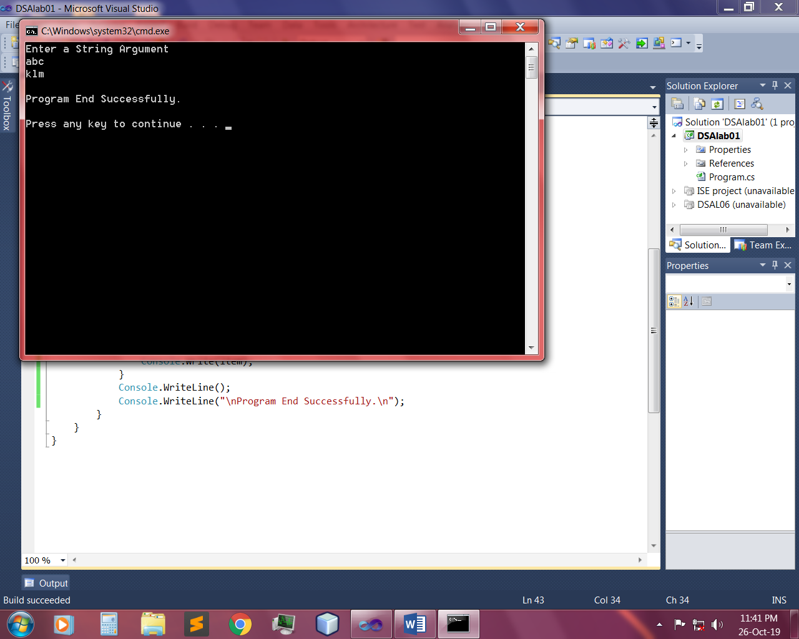 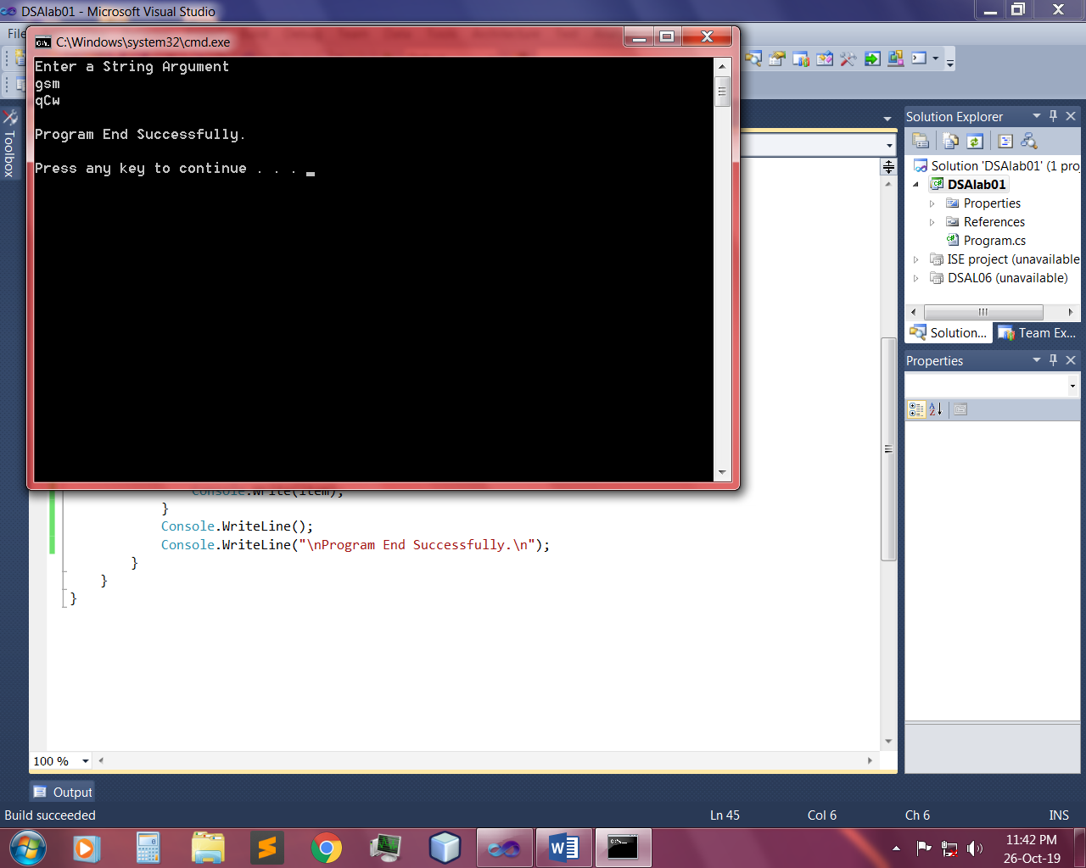

Q 4: - Take 10 inputs from the user and assign them into two string arrays (make 2 unsorted string arrays of 5 lengths each), merge those arrays and obtain the result in the sorted manner.

Input:-

public static void MergeSort(string[] D, int lb, int ub)

{

int mid = (lb + ub) / 2;

if (lb < ub)

{

MergeSort(D, lb, mid);

MergeSort(D, mid + 1, ub);

Merge(D, lb, mid, mid + 1, ub);

}

}

public static void Merge(string[] Arr, int lb1, int ub1, int lb2, int ub2)

{

int i, j, k;

string[] Copy = new string[Arr.Length];

for (i = 0; i < Arr.Length; i++)

{

Copy[i] = Arr[i];

}

for (i = lb1, j = lb2, k = lb1; i <= ub1 && j <= ub2 && k <= ub2; k++)

{

if (Copy[i].CompareTo(Copy[j])<0)

{

Arr[k] = Copy[i];

i++;

}

else

{

Arr[k] = Copy[j];

j++;

}

}

for (; i <= ub1; i++, k++)

{

Arr[k] = Copy[i];

}

for (; j <= ub2; k++, j++)

{

Arr[k] = Copy[j];

}

}

static void Main(string[] args)

{

Console.WriteLine("<<<< Enter 10 Strings >>>>");

string[] A = new string[5];

string[] B = new string[5];

for (int i = 0; i < A.Length; i++)

{

Console.Write("[{0}] = ", i + 1);

A[i] = Console.ReadLine();

}

for (int j = 0; j < B.Length; j++)

{

Console.Write("[{0}] = ", j + 6);

B[j] = Console.ReadLine();

}

string[] a = new string[A.Length+B.Length];

for (int k = 0; k < A.Length; k++)

{

a[k] = A[k];

}

for (int l = 0; l < B.Length; l++)

{

a[l + 5] = B[l];

}

Console.WriteLine("Loading...");

Thread.Sleep(5000);

Console.WriteLine();

Console.WriteLine("<<<<< Sorted Array >>>>>>");

MergeSort(a, 0, a.Length - 1);

foreach (string item in a)

{

Console.WriteLine(item);

}

Console.WriteLine("Program End Successfully.");

Console.ReadKey();

}

Output:-

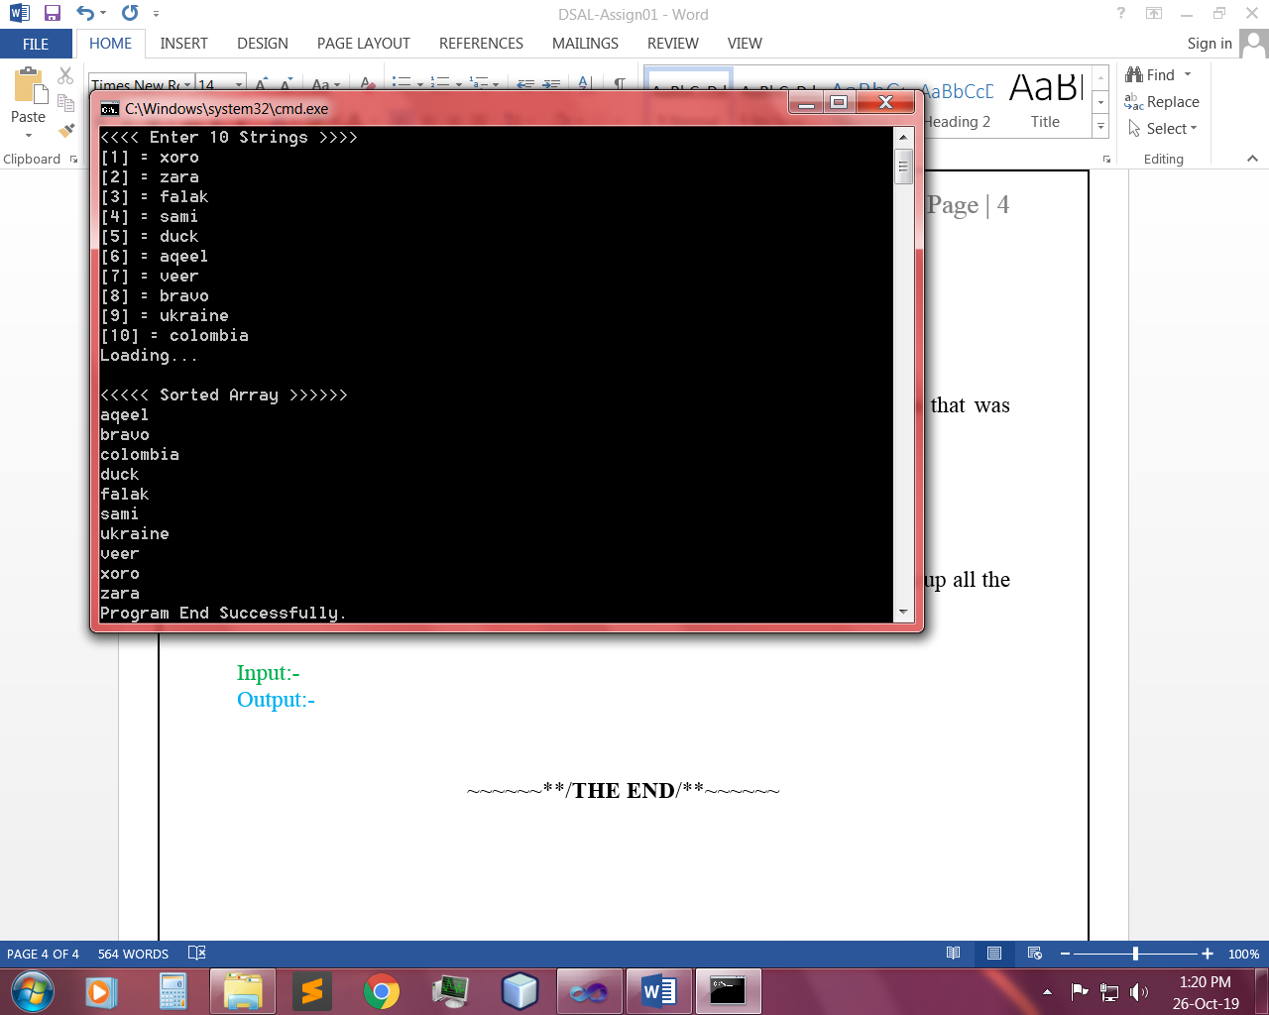

Q 5: - Delete the string (taken from the user) from the array of strings that was inserted by the user. Use searching algorithm.

Input:-

public static void LinearSearch(string[] A,string val)

{

for (int i = 0; i < A.Length; i++)

{

if (A[i]==val)

{

A = A.Except(new string[] { val }).ToArray();

}

}

foreach (string item in A)

{

Console.WriteLine(item);

}

}

static void Main(string[] args)

{

Console.WriteLine("Enter length of String Array.");

int limit=int.Parse(Console.ReadLine());

string[] A = new string[limit];

Console.WriteLine("Enter values of String Array");

for (int i = 0; i < A.Length; i++)

{

Console.Write("A[{0}] = ",i);

A[i] = Console.ReadLine();

}

Console.WriteLine();

Console.WriteLine("Enter string you want Delete!");

string del = Console.ReadLine();

Console.WriteLine("After deleting {0} New Array is given below",del);

Console.WriteLine("Loading..");

Thread.Sleep(5000);

LinearSearch(A, del);

Console.WriteLine("Program End Successfully.");

}

Output:-

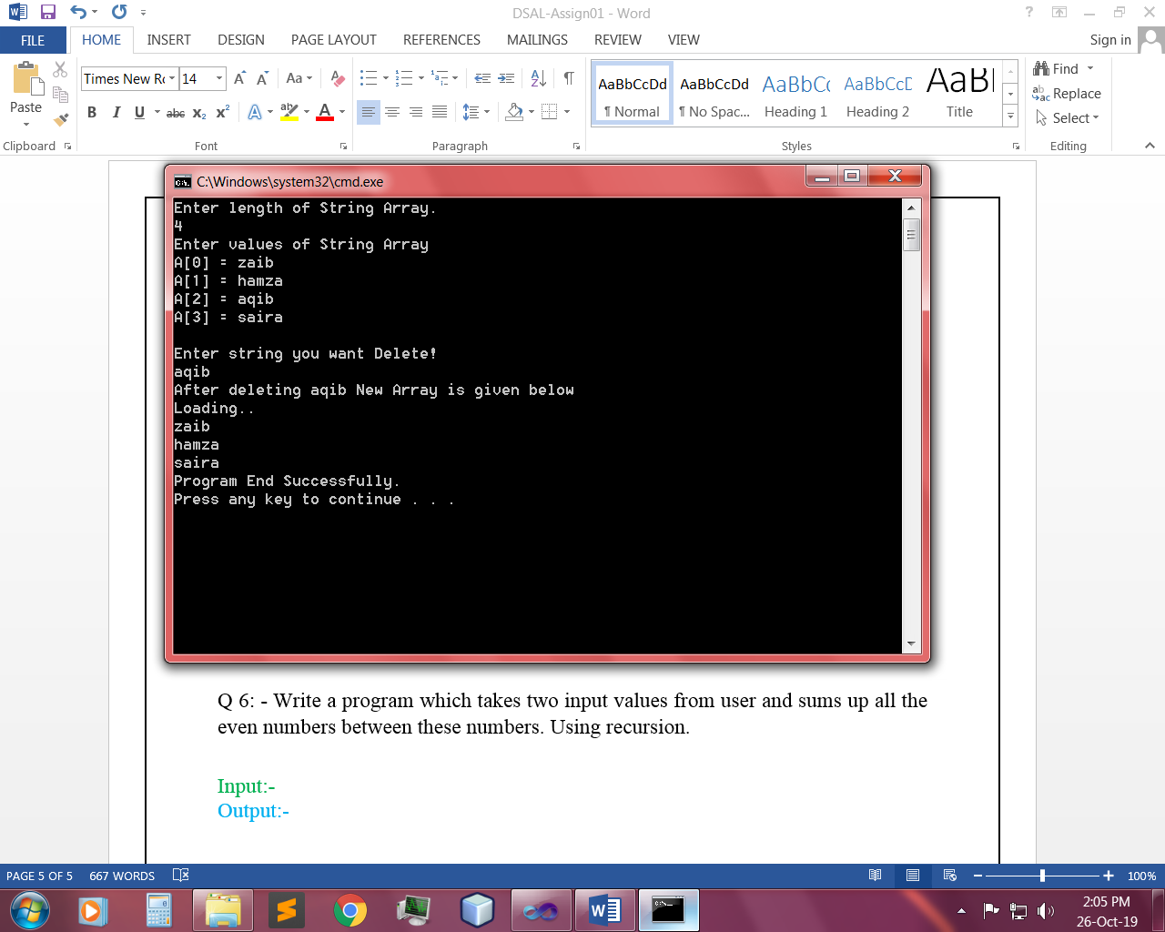

Q 6: - Write a program which takes two input values from user and sums up all the even numbers between these numbers. Using recursion.

Input:-

public static void EvenSum(int num1, int num2,int sum)

{

if (num2<=num1)

{

Console.WriteLine(sum);

}

if (num1 < num2)

{

if (num2 % 2 == 0)

{

sum += num2;

}

EvenSum(num1, num2-1,sum);

}

}

static void Main(string[] args)

{

Console.Write("Enter Number 1 :");

int num1 = int.Parse(Console.ReadLine());

Console.Write("Enter Number 2 :");

int num2 = int.Parse(Console.ReadLine());

int sum=0;

Console.WriteLine("Sum of All Even Number is : ");

EvenSum(num1,num2,sum);

Console.WriteLine();

//---------------ITERATIVE-----------

//int sum = 0;

//for (int i = 0; i < num2; i++)

//{

// if (num1 % 2 == 0)

// {

// sum = sum + num1;

// }

// num1++;

//}

//Console.WriteLine(sum);

Console.WriteLine("Program End Successfully.\n");

}

Output:-

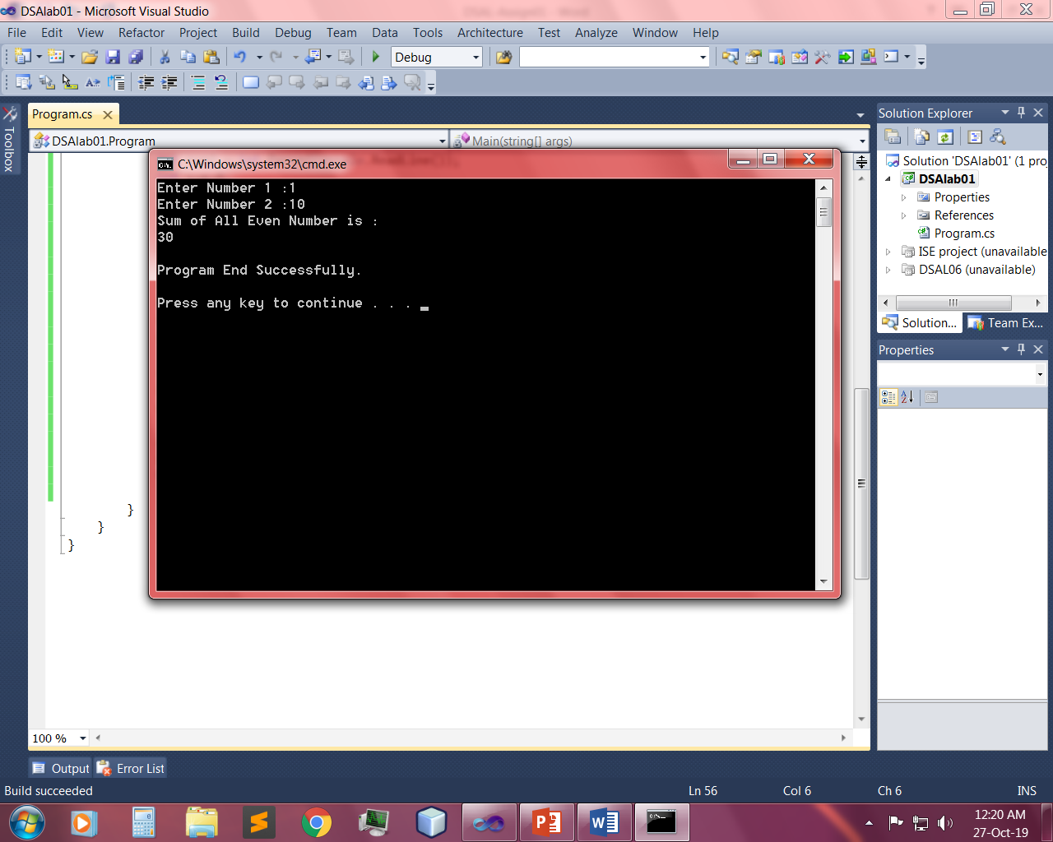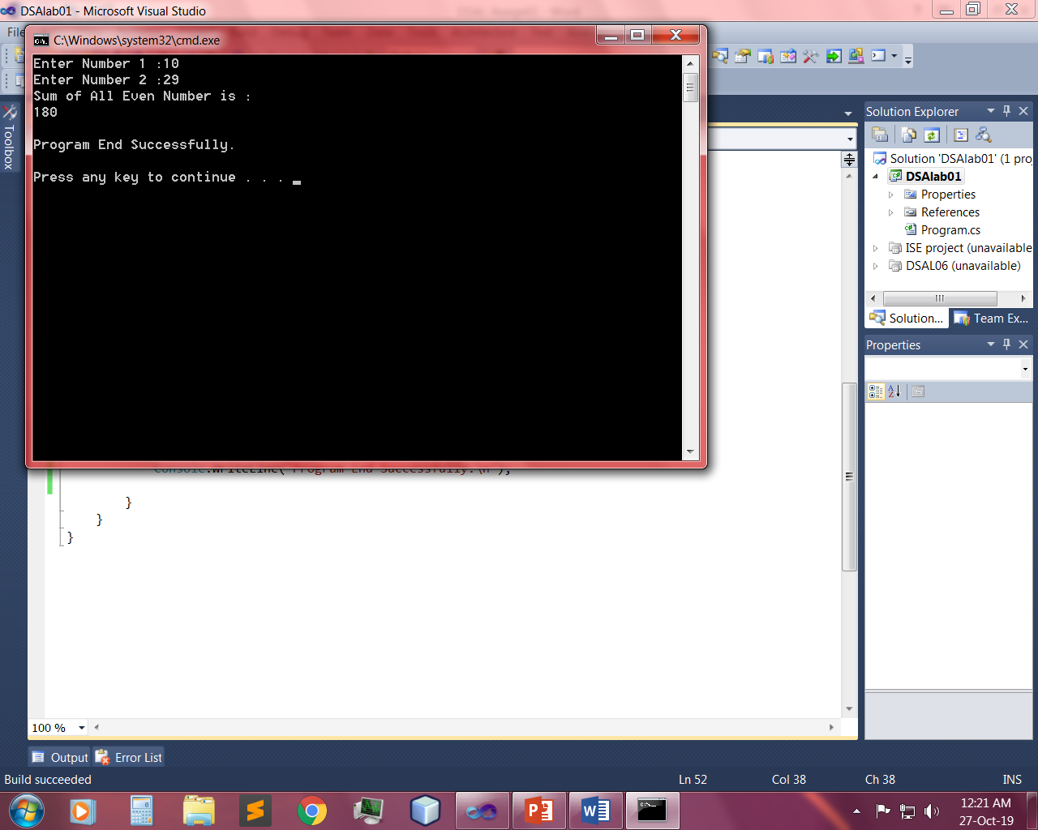

~~~~~~**/**THE END**/**~~~~~~