Bahria University,

Karachi Campus



LAB EXPERIMENT NO.

01

LIST OF TASKS

|  |  |
| --- | --- |
| TASK NO | OBJECTIVE |
|  | **1D ARRAY** |
| Q | Create an array of length 10 of integers. Values ranging from 1 to 50. |
| 1 | Find all pair of elements whose sum is 25. |
| 2 | Find the number of elements of A which are even, and the number of elements of A which are odd. |
| 3 | Write a procedure which finds the average of the value of A |
| 4 | Write a procedure which adds an element in an array at a given index. Take the value to add and the index from the user by using Shift down technique. |
| 5 | Write a procedure which looks for 2 numbers 45 and 14 in an array and delete them if they are present in the array by using Shift up technique. |
|  | **2D ARRAY** |
| Q | Write a program which input 2 matrix of user defined rows and columns and perform following operation |
| A | Display/Print as a Matrix |
| B | Addition of Matrix |
| C | Subtraction of Matrix |
| D | matrix multiplication |
| E | Determinant |
| F | Inverse |

Submitted On:

19/09/2018

Q. Create an array of length 10 of integers. Values ranging from 1 to 50.

1. Find all pair of elements whose sum is 25.

Input:-

static void Main(string[] args)

{

int[] arr = new int[10];

Console.WriteLine("Enter 10 values from 1-50");

for (int i = 0; i < arr.Length; i++)

{

arr[i] = int.Parse(Console.ReadLine());

if (arr[i]<1||arr[i]>50)

{

Console.WriteLine("Ooops..value out of range..\nRest of array is.");

break;

}

}

for (int i = 0; i < arr.Length; i++)

{

Console.WriteLine("arr[{0}]={1}",i,arr[i]);

}

int sum;

Console.WriteLine("Sum of Pairs ");

for (int i = 0; i < arr.Length-1; i++)

{

sum = arr[i] + arr[i+1];

if (sum==25)

{

Console.WriteLine(arr[i]+"+"+arr[i+1]+"="+sum);

} }

Output:-

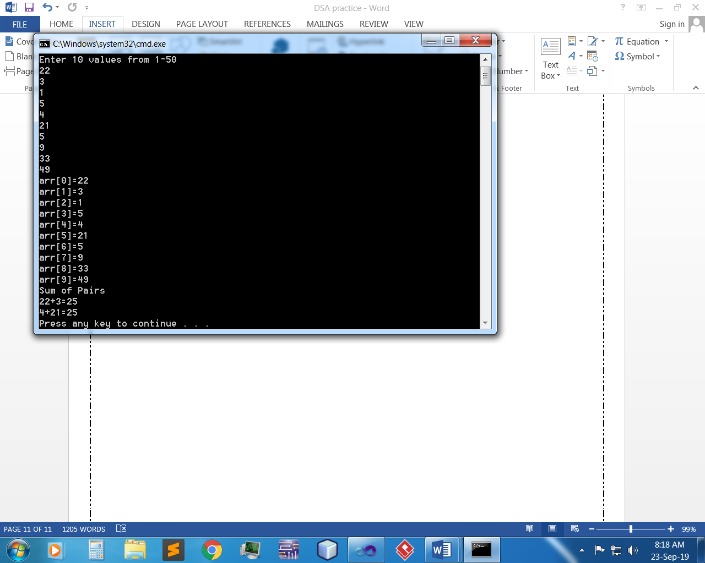

2. Find the number of elements of A which are even, and the number of elements of A which are odd.

Input:-

static void Main(string[] args)

{

int[] arr = new int[10];

Console.WriteLine("Enter 10 values from 1-50");

for (int i = 0; i < arr.Length; i++)

{

arr[i] = int.Parse(Console.ReadLine());

if (arr[i]<1||arr[i]>50)

{

Console.WriteLine("Ooops..value out of range..\nRest of array is.");

break;

}

}

for (int i = 0; i < arr.Length; i++)

{

Console.WriteLine("arr[{0}]={1}",i,arr[i]);

}

for (int i = 0; i < arr.Length; i++)

{

if (arr[i] % 2 == 0)

{

Console.WriteLine("Even num at arr[{0}] are = {1}",i, arr[i]);

}

}

for (int i = 0; i < arr.Length; i++)

{

if (arr[i] % 2 != 0)

{

Console.WriteLine("Odd num at arr[{0}] are = {1}", i, arr[i]);

}

}

Output:-

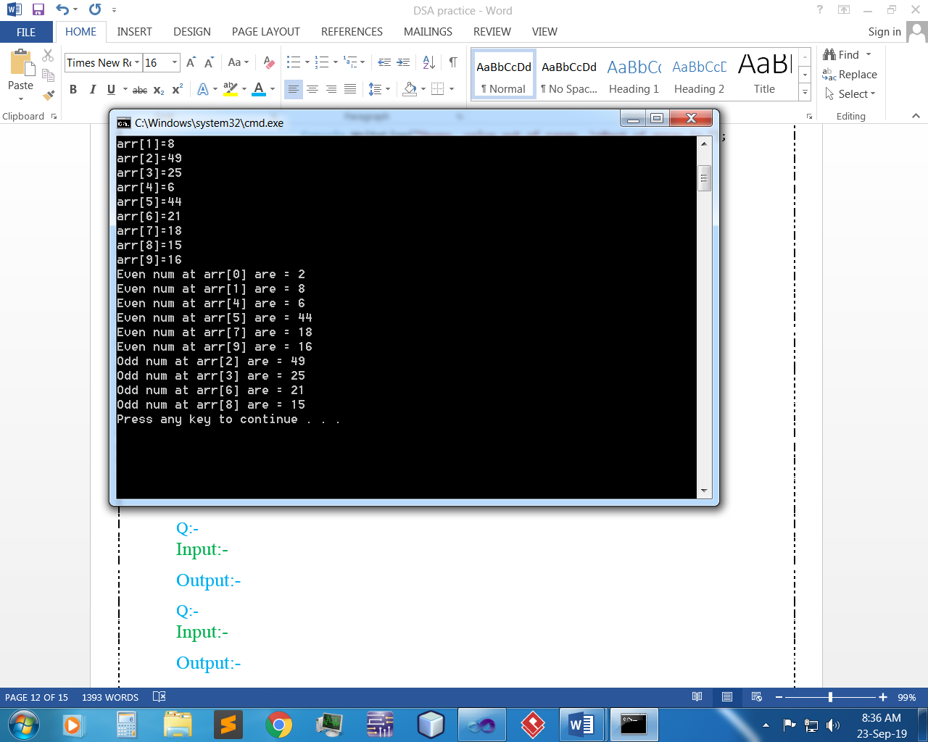

3. Write a procedure which finds the average of the value of A.

Input:-

static void Main(string[] args)

{

int[] arr = new int[10];

Console.WriteLine("Enter 10 values from 1-50");

for (int i = 0; i < arr.Length; i++)

{

arr[i] = int.Parse(Console.ReadLine());

if (arr[i]<1||arr[i]>50)

{

Console.WriteLine("Ooops..value out of range..\nRest of array is.");

break;

}

}

for (int i = 0; i < arr.Length; i++)

{

Console.WriteLine("arr[{0}]={1}",i,arr[i]);

}

double avg=0;

int sum=0;

for (int i = 0; i < arr.Length; i++)

{

sum+=arr[i];

}

avg = (sum / arr.Length);

Console.WriteLine("sum="+sum);

Console.WriteLine("Average of Array values = "+avg);

Output:-

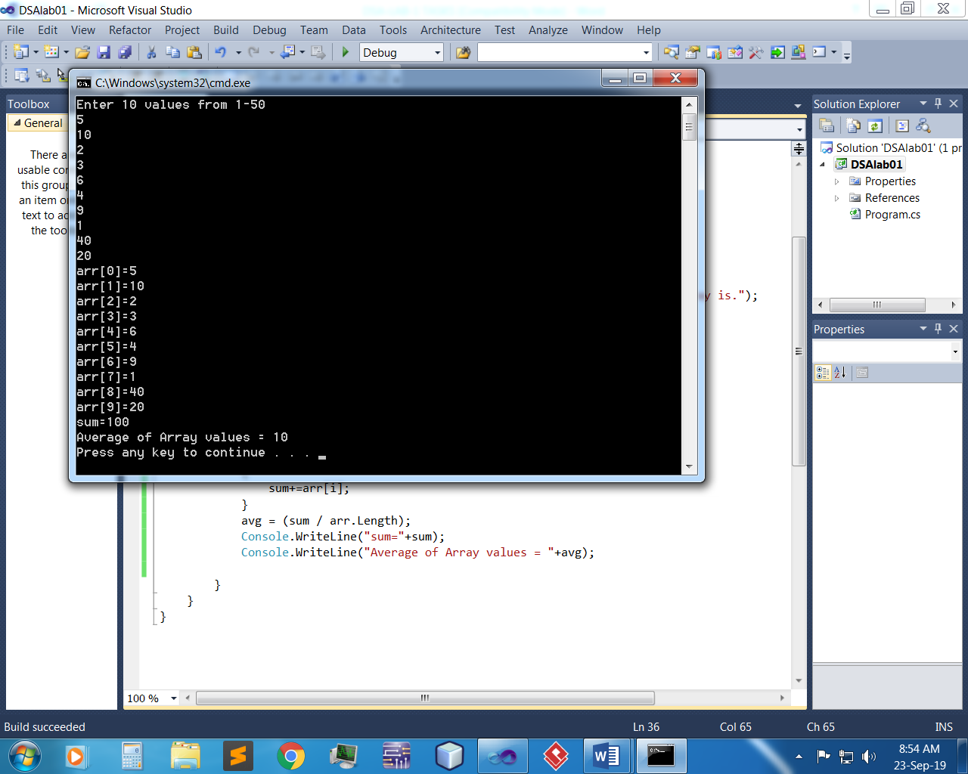

4. Write a procedure which adds an element in an array at a given index. Take the value to add and the index from the user by using Shift down technique.

Input:-

static void Main(string[] args)

{

int[] arr = new int[10];

Console.WriteLine("Enter 10 values from 1-50");

for (int i = 0; i < arr.Length; i++)

{

arr[i] = int.Parse(Console.ReadLine());

if (arr[i]<1||arr[i]>50)

{

Console.WriteLine("Ooops..value out of range..\nRest of array is.");

break;

}

}

for (int i = 0; i < arr.Length; i++)

{

Console.WriteLine("arr[{0}]={1}",i,arr[i]);

}

Console.WriteLine("Enter index where you want to save new value");

int indx = int.Parse(Console.ReadLine());

Console.WriteLine("Enter new value");

int newval=int.Parse(Console.ReadLine());

for (int i = 0; i < arr.Length; i++)

{

if (indx==i)

{

arr[i] = newval;

break;

}

}

Console.WriteLine("Updated Array List");

for (int i = 0; i < arr.Length; i++)

{

Console.WriteLine("arr[{0}]={1}", i, arr[i]);

}

Output:-

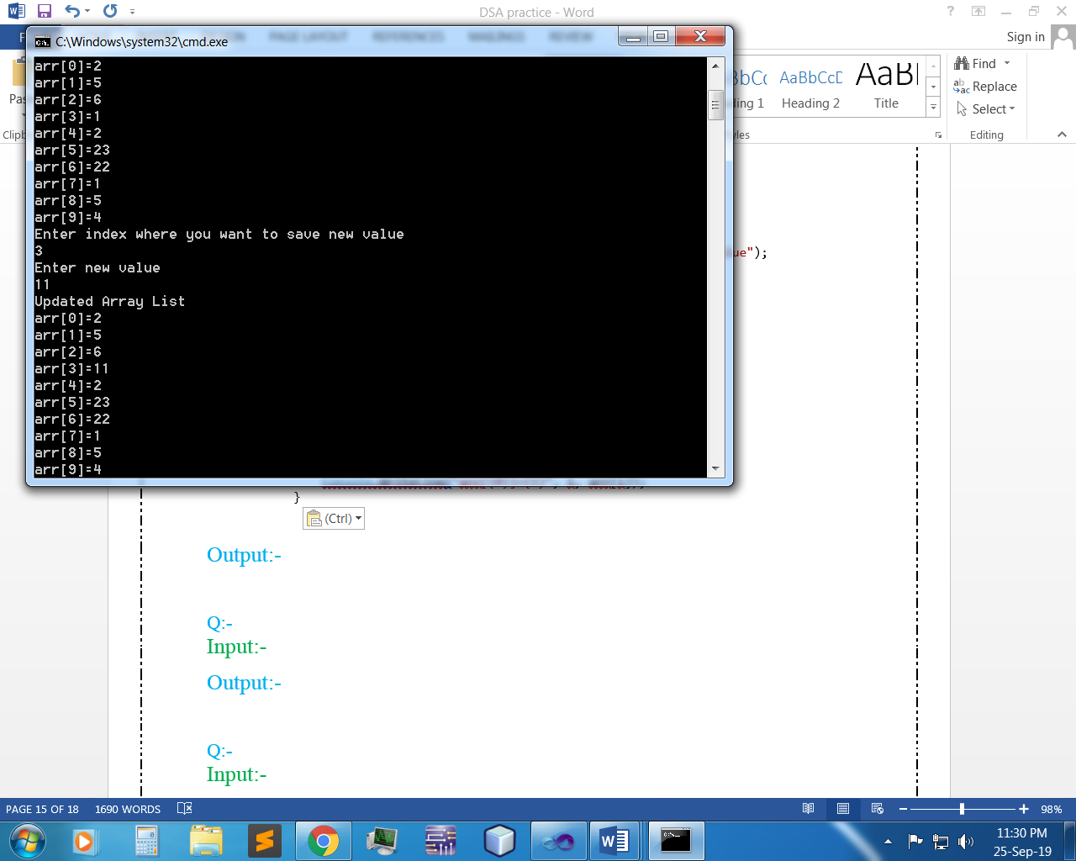

1. Write a procedure which looks for 2 numbers 45 and 14 in an array and delete them if they are present in the array by using Shift up technique.

Input:-

static void Main(string[] args)

{

int N1 = 14, N2 = 45;

int[] arr = new int[10];

Console.WriteLine("Enter 10 values from 1-50");

for (int i = 0; i < arr.Length; i++)

{

arr[i] = int.Parse(Console.ReadLine());

if (arr[i]<1||arr[i]>50)

{

Console.WriteLine("Ooops..value out of range..\nRest of array is.");

break;

}

}

for (int i = 0; i < arr.Length; i++)

{

Console.WriteLine("arr[{0}]={1}",i,arr[i]);

}

for (int i = 0; i < arr.Length; i++)

{

if ((arr[i]==N1)||(arr[i]==N2))

{

arr = arr.Except(new int[] { 14 }).ToArray();

arr = arr.Except(new int[] { 45 }).ToArray();

}

}

Console.WriteLine("Updated Array List");

for (int i = 0; i < arr.Length; i++)

{

Console.WriteLine("arr[{0}]={1}", i, arr[i]);}

Output:-

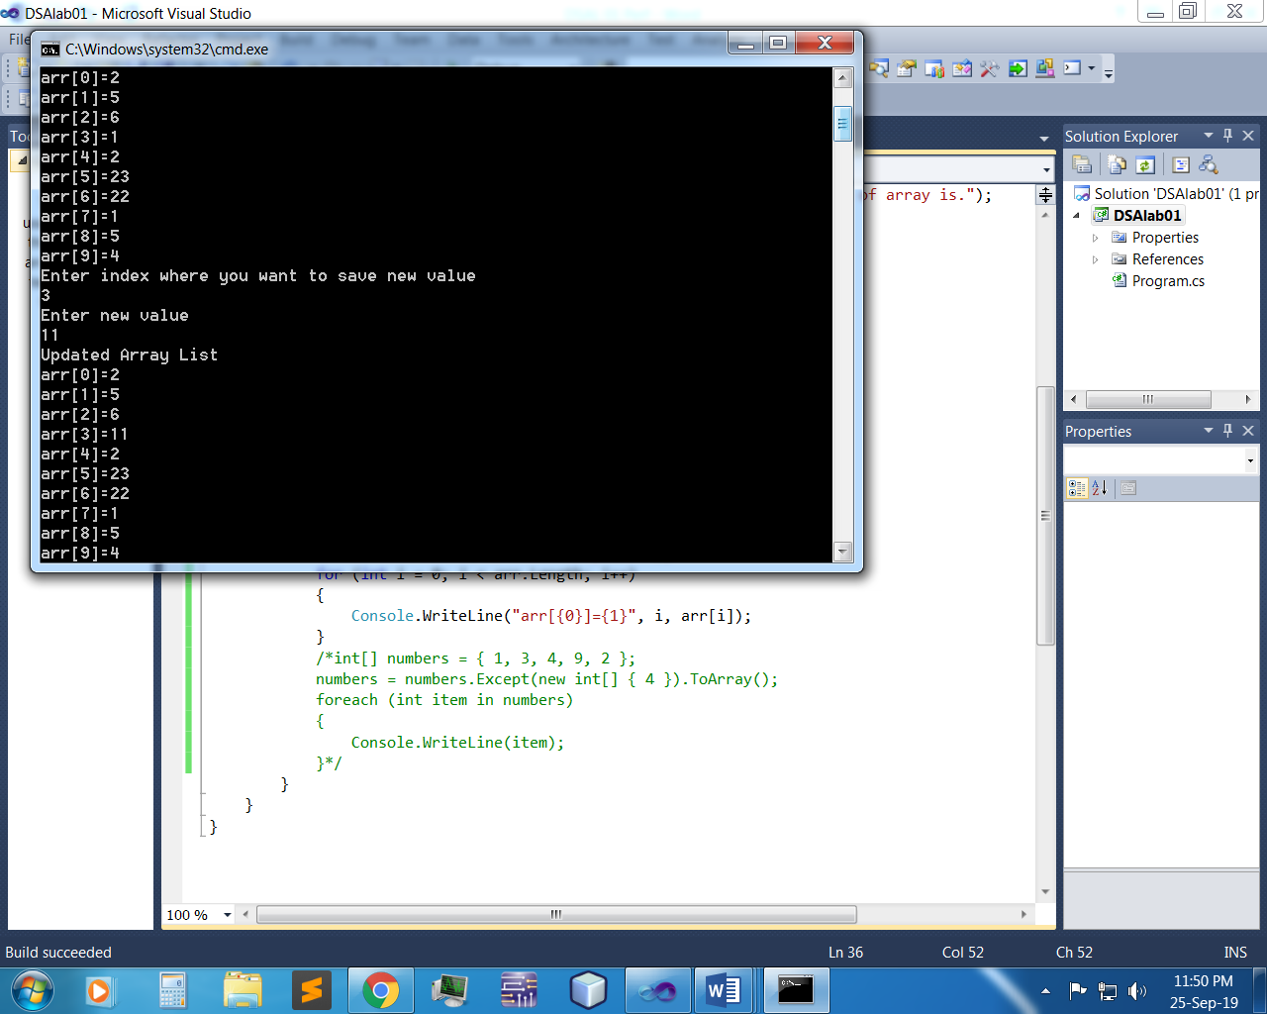

Q 2:- Write a program which input 2 matrix of user defined rows and columns and perform following operation:-

1. Display/Print as a Matrix

Input:-

static void Main(string[] args)

{

int i, j;

int[,] matrx1 = new int[5, 5];

int[,] matrx2 = new int[5, 5];

int[,] matrx3 = new int[5, 5];

Console.Write("Enter the size of matrix= ");

int n = int.Parse(Console.ReadLine());

Console.Write("Enter elements in the first matrix =\n");

for (i = 0; i < n; i++)

{

for (j = 0; j < n; j++)

{

Console.Write("Element - [{0},{1}] : ", i, j);

matrx1[i, j] = Convert.ToInt32(Console.ReadLine());

if (matrx1[i, j] < 0 || matrx1[i, j] > 50)

{

Console.WriteLine("No out of range");

}

}

}

Console.Write("Enter elements in the second matrix :\n");

for (i = 0; i < n; i++)

{

for (j = 0; j < n; j++)

{

Console.Write("element - [{0},{1}] : ", i, j);

matrx2[i, j] = Convert.ToInt32(Console.ReadLine());

if (matrx2[i, j] < 0 || matrx2[i, j] > 50)

{

Console.WriteLine("No out of range");

}

}

}

Console.Write("\nThe First matrix is :\n");

for (i = 0; i < n; i++)

{

Console.Write("\n");

for (j = 0; j < n; j++)

Console.Write("{0}\t", matrx1[i, j]);

}

Console.Write("\nThe Second matrix is :\n");

for (i = 0; i < n; i++)

{

Console.Write("\n");

for (j = 0; j < n; j++)

Console.Write("{0}\t", matrx2[i, j]);

}

Console.WriteLine();

Output:-

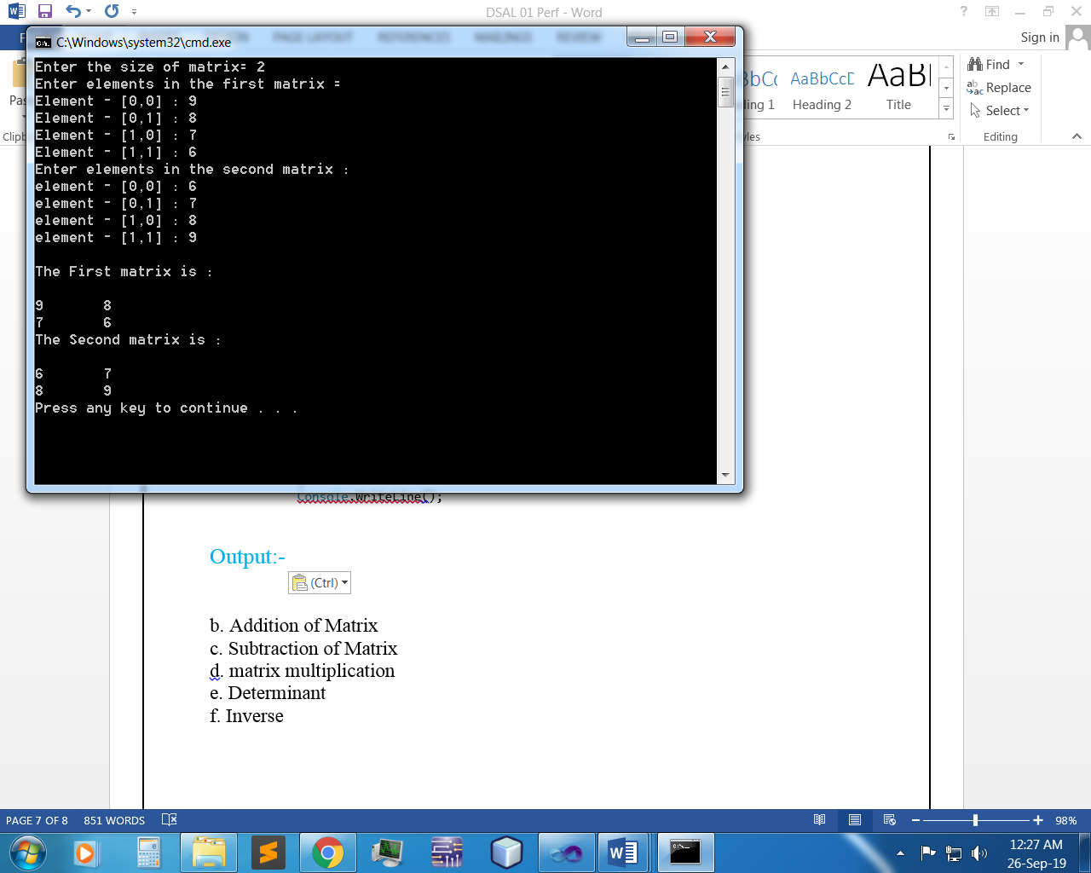

1. Addition of Matrix

Input:-

static void Main(string[] args)

{

int i, j, n;

int[,] matrx1 = new int[5, 5];

int[,] matrx2 = new int[5, 5];

int[,] matrx3 = new int[5, 5];

Console.Write("Enter the size of matrix= ");

n = Convert.ToInt32(Console.ReadLine());

Console.Write("Enter elements in the first matrix= \n");

for (i = 0; i < n; i++)

{

for (j = 0; j < n; j++)

{

Console.Write("element - [{0},{1}] : ", i, j);

matrx1[i, j] = Convert.ToInt32(Console.ReadLine());

}

}

Console.Write("Enter elements in the second matrix =\n");

for (i = 0; i < n; i++)

{

for (j = 0; j < n; j++)

{

Console.Write("element - [{0},{1}] : ", i, j);

matrx2[i, j] = Convert.ToInt32(Console.ReadLine());

}

}

Console.Write("\nThe First matrix is :\n");

for (i = 0; i < n; i++)

{

Console.Write("\n");

for (j = 0; j < n; j++)

Console.Write("{0}\t", matrx1[i, j]);

}

Console.Write("\nThe Second matrix is :\n");

for (i = 0; i < n; i++)

{

Console.Write("\n");

for (j = 0; j < n; j++)

Console.Write("{0}\t", matrx2[i, j]);

}

for (i = 0; i < n; i++)

for (j = 0; j < n; j++)

matrx3[i, j] = matrx1[i, j] + matrx2[i, j];

Console.Write("\nThe Addition of two matrix is : \n");

for (i = 0; i < n; i++)

{

Console.Write("\n");

for (j = 0; j < n; j++)

Console.Write("{0}\t", matrx3[i, j]);

}

Output:-

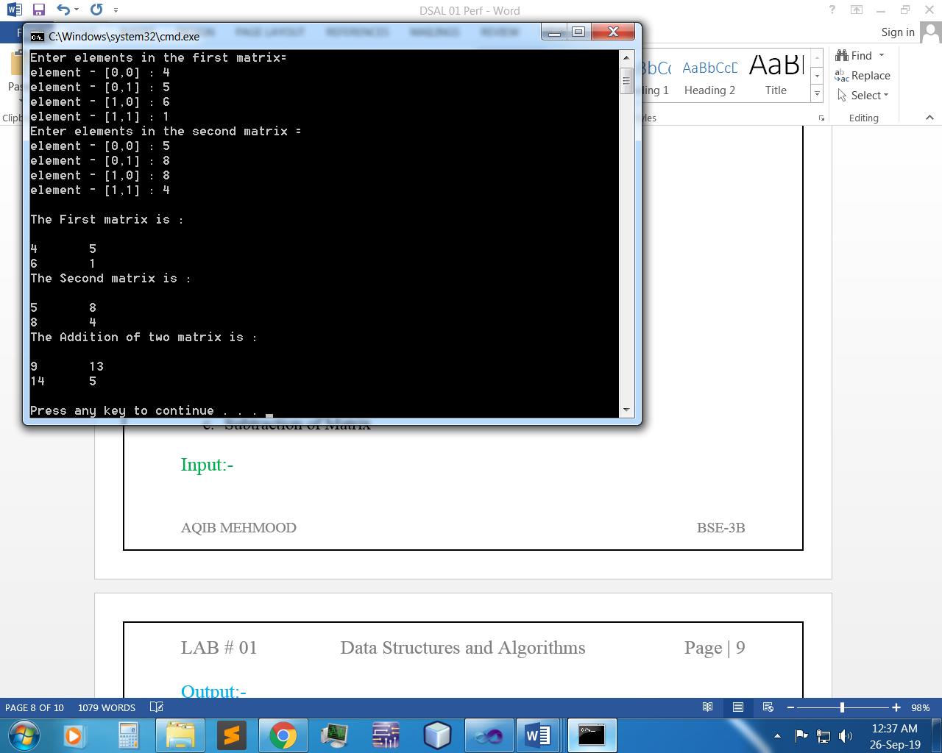

1. Subtraction of Matrix

Input:-

int i, j, n;

int[,] arr1 = new int[50, 50];

int[,] brr1 = new int[50, 50];

int[,] crr1 = new int[50, 50];

Console.Write("Input the size of the square matrix: ");

n = Convert.ToInt32(Console.ReadLine());

Console.Write("Input elements in the first matrix :\n");

for (i = 0; i < n; i++)

{

for (j = 0; j < n; j++)

{

Console.Write("element - [{0},{1}] : ", i, j);

arr1[i, j] = Convert.ToInt32(Console.ReadLine());

}

}

Console.Write("Input elements in the second matrix :\n");

for (i = 0; i < n; i++)

{

for (j = 0; j < n; j++)

{

Console.Write("element - [{0},{1}] : ", i, j);

brr1[i, j] = Convert.ToInt32(Console.ReadLine());

}

}

Console.Write("\nThe First matrix is :\n");

for (i = 0; i < n; i++)

{

Console.Write("\n");

for (j = 0; j < n; j++)

Console.Write("{0}\t", arr1[i, j]);

}

Console.Write("\nThe Second matrix is :\n");

for (i = 0; i < n; i++)

{

Console.Write("\n");

for (j = 0; j < n; j++)

Console.Write("{0}\t", brr1[i, j]);

}

for (i = 0; i < n; i++)

for (j = 0; j < n; j++)

crr1[i, j] = arr1[i, j] - brr1[i, j];

Console.Write("\nThe Subtraction of two matrix is : \n");

for (i = 0; i < n; i++)

{

Console.Write("\n");

for (j = 0; j < n; j++)

Console.Write("{0}\t", crr1[i, j]);

}

Output:-

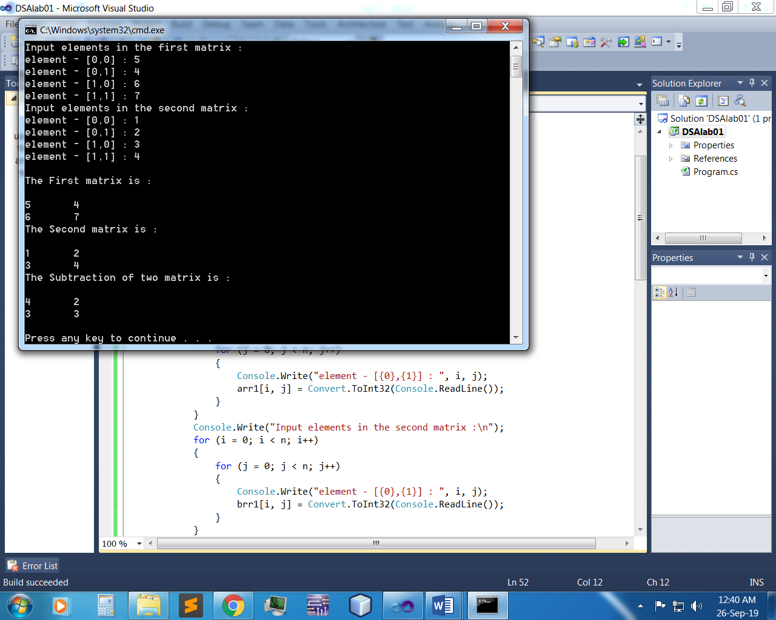

1. matrix multiplication

Input:-

static void Main(string[] args)

{

int i, j, n;

int[,] arr1 = new int[50, 50];

int[,] brr1 = new int[50, 50];

int[,] crr1 = new int[50, 50];

Console.Write("Input the size of the square matrix: ");

n = Convert.ToInt32(Console.ReadLine());

Console.Write("Input elements in the first matrix :\n");

for (i = 0; i < n; i++)

{

for (j = 0; j < n; j++)

{

Console.Write("element - [{0},{1}] : ", i, j);

arr1[i, j] = Convert.ToInt32(Console.ReadLine());

}

}

Console.Write("Input elements in the second matrix :\n");

for (i = 0; i < n; i++)

{

for (j = 0; j < n; j++)

{

Console.Write("element - [{0},{1}] : ", i, j);

brr1[i, j] = Convert.ToInt32(Console.ReadLine());

}

}

Console.Write("\nThe First matrix is :\n");

for (i = 0; i < n; i++)

{

Console.Write("\n");

for (j = 0; j < n; j++)

Console.Write("{0}\t", arr1[i, j]);

}

Console.Write("\nThe Second matrix is :\n");

for (i = 0; i < n; i++)

{

Console.Write("\n");

for (j = 0; j < n; j++)

Console.Write("{0}\t", brr1[i, j]);

}

/* calculate the sum of the matrix */

for (i = 0; i < n; i++)

for (j = 0; j < n; j++)

crr1[i, j] = arr1[i, j] * brr1[i, j];

Console.Write("\nThe Mutiplication of two matrix is : \n");

for (i = 0; i < n; i++)

{

Console.Write("\n");

for (j = 0; j < n; j++)

Console.Write("{0}\t", crr1[i, j]);

} Console.Write("\n\n");

Output:-

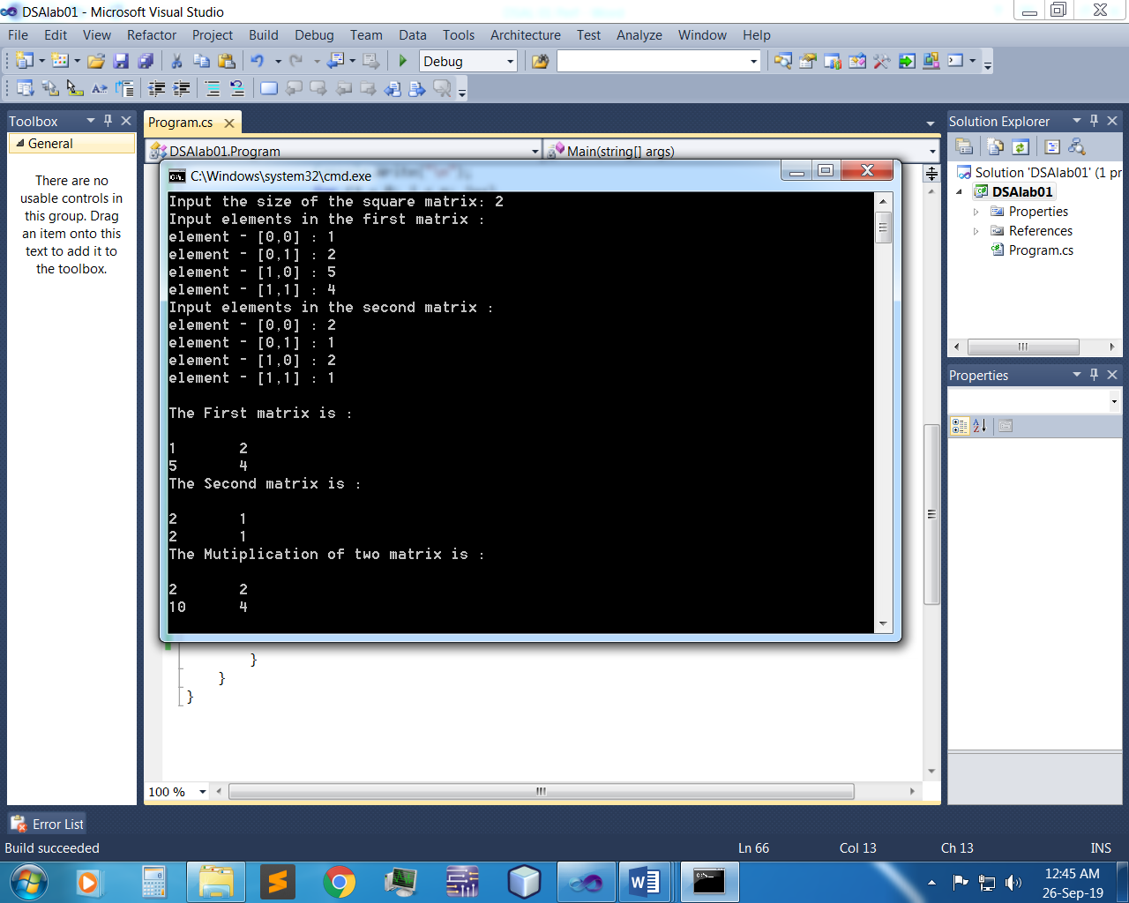

1. Determinant

Input:-

static void Main(string[] args)

{

int[,] matrix = new int[2, 2];

for (int i = 0; i < 2; i++)

{

for (int j = 0; j < 2; j++)

{

Console.WriteLine("Enter the Value for index [{0},{1}]", i, j);

matrix[i, j] = Convert.ToInt32(Console.ReadLine());

}

}

int c = 0;

Console.WriteLine("\n");

for (int i = 0; i < 1; i++)

{

for (int j = 0; j < 1; j++)

{

c = matrix[i, j];

}

}

int d = 0;

for (int i = 1; i < 2; i++)

{

for (int j = 1; j < 2; j++)

{

d = matrix[i, j];

}

}

int diagnol1 = d * c;

Console.WriteLine("Diagnol 1 :" + diagnol1);

int e = 0;

for (int i = 0; i < 1; i++)

{

for (int j = 1; j < 2; j++)

{

e = matrix[i, j];

}

}

int f = 0;

for (int i = 1; i < 2; i++)

{

for (int j = 0; j < 1; j++)

{

f = matrix[i, j];

}

}

int diagonal2 = f * e;

Console.WriteLine("Diagnol 2 :" + diagonal2);

int determinant = diagnol1 - diagonal2;

Console.WriteLine("\t = {0} - {1} = {2}", diagnol1, diagonal2, diagnol1 - diagonal2);

Console.WriteLine("Determinant: {0}", determinant);

Output:-

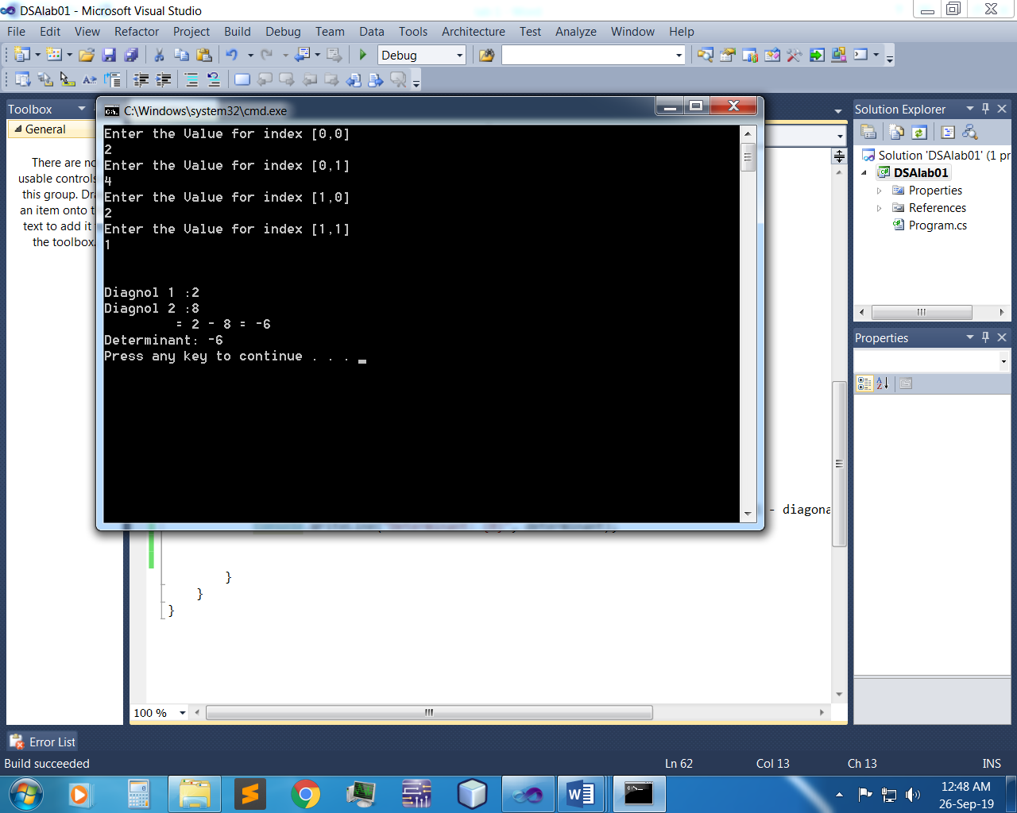

Inverse:-

int[,] matrix1 = new int[2,2];

Console.WriteLine("MATRIX 1");

Console.WriteLine();

for (int i = 0; i < 2; i++)

{

for (int j = 0; j < 2; j++)

{

Console.WriteLine("Enter value for index :[{0},{1}]",i,j);

matrix1[i, j] = Convert.ToInt32(Console.ReadLine());

}

}

Console.WriteLine("\n");

Console.WriteLine("MATRIX 2");

Console.WriteLine();

int[,] matrix2 = new int[2, 2];

for (int i = 0; i < 2; i++)

{

for (int j = 0; j < 2; j++)

{

Console.WriteLine("Enter value for index :[{0},{1}]", i, j);

matrix2[i, j] = Convert.ToInt32(Console.ReadLine());

}

}

int[,] matrix3 = new int[2,2];

for (int i = 0; i < 2; i++)

{

for (int j = 0; j < 2; j++)

{

matrix3[i, j] += matrix1[i,j] - matrix2[i, j];

}

}

for (int i = 0; i < 2; i++)

{

for (int j = 0; j < 2; j++)

{

Console.WriteLine("[{0},{1}]:{2}",i,j, matrix3[i,j]);

}

}

Output:-

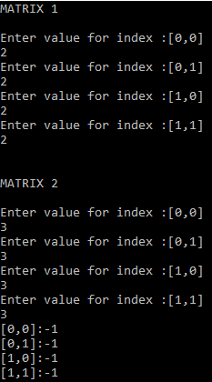

~~~~~~**/**THE END**/**~~~~~~