Bahria University,

Karachi Campus



LAB EXPERIMENT NO.

03

LIST OF TASKS

|  |  |
| --- | --- |
| TASK NO | OBJECTIVE |
| 01 | Write a code which prints the following series:  2 4 8 - - - - n |
| 02 | Write a program which calculates the square of a number using odd number series implemented with the help of recursion concept. |
| 03 | Write a program which takes input of an integer number and returns the sum of all numbers. i.e., if input is 3453 then the output should be 15 (3+4+5+3). |
| 04 | Write a program to calculate binomial coefficients of any given number using recursion. |
| 05 | Calculation of number of moves for N number of disk in Tower of Hanoi problem using recursion. |
| 06 | Write a program to calculate H.C.F of two numbers, using recursion. |
|  |  |

Submitted On:

10-10-2019

(Date: DD/MM/YY)

Q:-Write a program which calculates the square of a number using odd number series implemented with the help of recursion concept.

Input:-

public static void Series(int n)

{

if (n<1)

{

return;

}

else

{

Series(n-2);

Console.Write(Math.Pow(n,2)+" ");

}

}

static void Main(string[] args)

{

Series(9);

Console.WriteLine();

}

Output:-

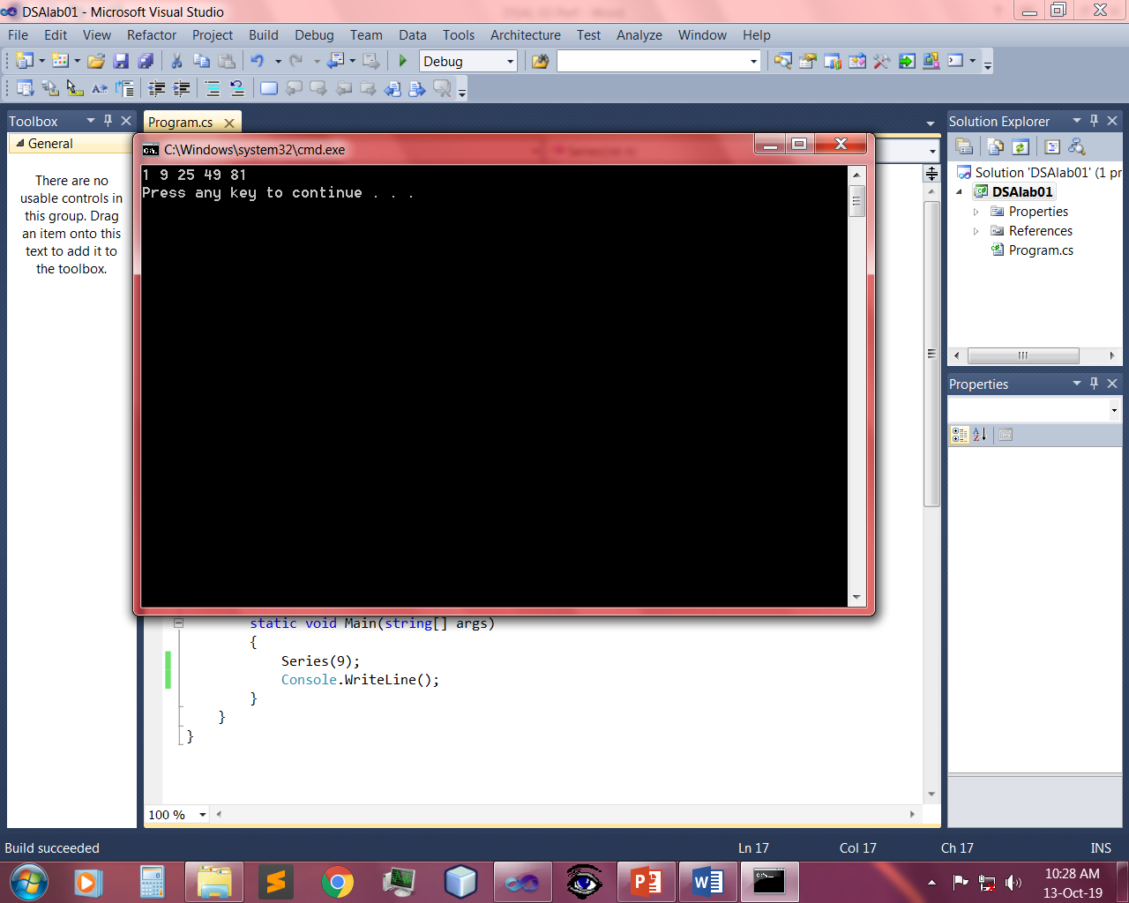

Q:- Write a program which takes input of an integer number and returns the sum of all numbers. i.e., if input is 3453 then the output should be 15 (3+4+5+3).

CODE:

static int sum_of_digit(int n)

{

if (n == 0)

return 0;

return (n % 10 + sum_of_digit(n / 10));

}

public static void Main()

{

Console.WriteLine("Enter digits wihout space");

int num = int.Parse(Console.ReadLine());

int result = sum_of_digit(num);

Console.WriteLine("Sum of digits in " + num + " is " + result);

}

Output:-



Q:- Write a program to calculate binomial coefficients of any given number using recursion.

Input:-

static int binomialCoeff(int n, int k)

{

if (k == 0 || k == n)

return 1;

return binomialCoeff(n - 1, k - 1) + binomialCoeff(n - 1, k);

}

public static void Main()

{

int n = 5, k = 2;

Console.Write("Value of C(" + n + "," + k + ") is " + binomialCoeff(n, k));

}

Output:-



Q:- Calculation of number of moves for N number of disk in Tower of Hanoi problem using recursion.

Input:-

static void Main(string[] args)

{ Console.WriteLine("Enter No of discs");

int discs = int.Parse(Console.ReadLine());

Console.WriteLine("no of moves are : "+moves(discs));

}

public static int moves(int disc)

{

if (disc == 1)

{

return 1;

}

else {

return 2 * moves(disc - 1) + 1;

}

Output:-



**Q:-** Write a program to calculate H.C.F of two numbers, using recursion.

Input:-

static void Main(string[] args)

{

Console.WriteLine("Enter two integers");

long x = Convert.ToInt64(Console.ReadLine());

long y = Convert.ToInt64(Console.ReadLine());

long hcf = gcd(x, y);

Console.WriteLine("HCF of {0} and {1} = {2}\n", x, y, hcf);

}

static long gcd(long a, long b)

{

if (b == 0)

{

return a;

}

else

{

return gcd(b, a % b);

}

}

Output:-

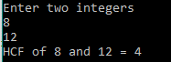

Q:-Write a code which prints the following series:

2 4 8 - - - - n

Input:-

public static void Series(int n)

{

if (n<1)

{

return;

}

else

{

Series(n - 1);

Console.WriteLine(Math.Pow(2,n));

}

}

static void Main(string[] args)

{

Series(5);

}

Output:-

