Q: - Write a program which uses Iterative Binary Search algorithm to search age of the person using his/her name.

Input:-

public static string BinarySearch(string[,] A,string name)

{

for (int i = 0; i < A.GetLength(0); i++)

{

for (int j = 0; j < A.GetLength(1); j++)

{

if (A[i, j] == name)

{

return A[i,j+1];

}

}

}

return "NOt found OR invalid input";

}

static void Main(string[] args)

{

string[,] A = new string[,] { { "aqib", "19", "ali", "18" }, { "hamza", "20", "arsal", "21" } };

Console.WriteLine("We have an Array Shown Below.");

for (int i = 0; i < A.GetLength(0); i++)

{

for (int j = 0; j < A.GetLength(1); j++)

{

Console.Write(A[i, j] + " \t");

}

Console.WriteLine();

}

Console.WriteLine();

Console.Write("Enter name to Search Age >>");

string name = Console.ReadLine();

Console.WriteLine(name+"= "+BinarySearch(A,name));

Console.WriteLine();

}

Output:-

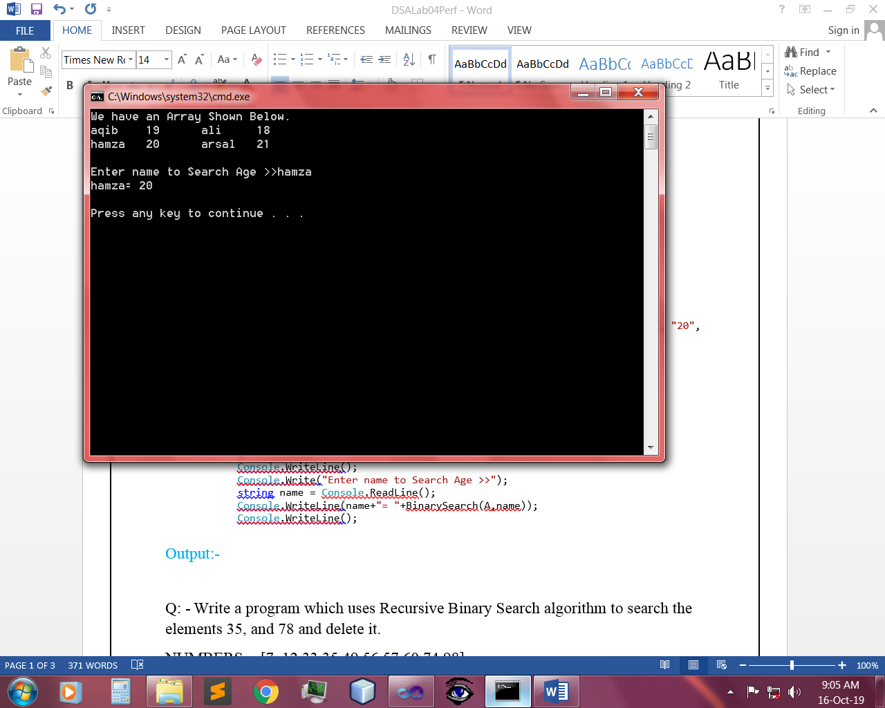 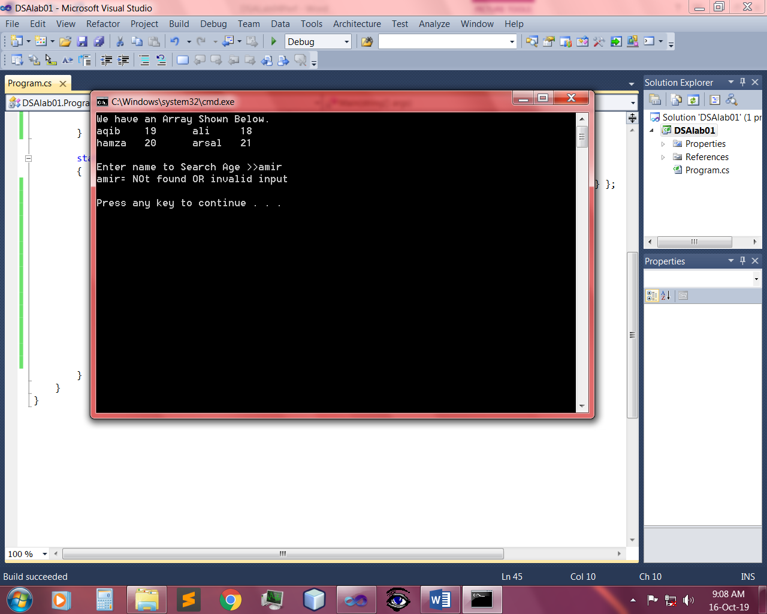

Q: - Write a program which uses Recursive Binary Search algorithm to search the elements 35, and 78 and delete it.

NUMBERS = [7, 12,33,35,49,56,57,60,74,98]

Input:-

public static int BinarySearch(int[] A, int lb, int ub, int num)

{

int mid = (lb + ub) / 2;

if (lb>ub)

{

return -1;

}

else if (A[mid] == num)

{

return mid;

}

else if (A[mid] > num)

{

return BinarySearch(A, lb, mid - 1, num);

}

else if (A[mid] < num)

{

return BinarySearch(A, mid + 1, ub, num);

}

else

{

return -1;

}

}

static void Main(string[] args)

{

int[] A = new int[] { 7, 12, 33, 35, 49, 56, 57, 60, 74, 98 };

Console.WriteLine("We have an Array Shown Below.");

foreach (int nums in A)

{

Console.Write(nums + " ");

}

Console.WriteLine();

int lb = 0;

int ub = A.Length - 1;

Console.WriteLine("35 is persent at index = " + BinarySearch(A, lb, ub, 35) + "\n");

Console.WriteLine("78 is persent at index = {" + BinarySearch(A, lb, ub, 78)+"}=Means Not Found" + "\n");

Console.WriteLine("Now I am going to delete 35.....\nDeleting...\nPress any Key");

Console.ReadLine();

for (int i = 0; i < A.Length; i++)

{

if (A[i]==35||A[i]==78)

{

A = A.Except(new int[] { 35 }).ToArray();

A = A.Except(new int[] { 78 }).ToArray();

}

}

Console.WriteLine("After Deleting the Num New Array is.");

foreach (int nums in A)

{

Console.Write(nums+" ");

}

Console.WriteLine();

Output:-

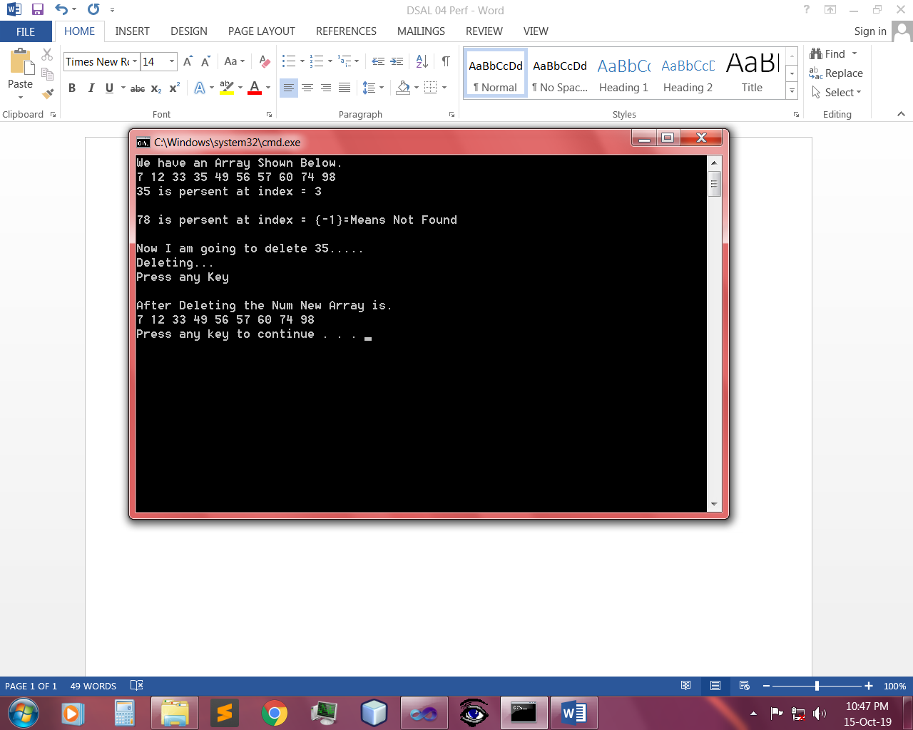

~~~~~~**/**THE END**/**~~~~~~