Q1: - Create a program to implement Hash function and generate Hash Table.

Input:-

Hashing:-

class Hashing

{

public Hashing() { }

public string ImplementHash(string val)

{

char[] array = val.ToCharArray();

for (int i = 0; i < array.Length; i++)

{

if (array[i] == ' ')

{

continue;

}

int asci = (int)array[i];

int count = 0;

while (count < 3) //means print after 2 alphabets

{

if (asci == 91)

{

asci = 97;

}

if (asci == 123)

{

asci = 65;

}

asci++;

count++;

}

array[i] = (char)asci;

}

string hashed = "";

for (int i = 0; i < array.Length; i++)

{

hashed += array[i];

}

return hashed;

}

public string DecodeHash(string val)

{

char[] array = val.ToCharArray();

for (int i = 0; i < array.Length; i++)

{

if (array[i] == ' ')

{

continue;

}

int asci = (int)array[i];

int count = 3; //means print after 2 alphabets

while (count > 0)

{

if (asci == 96)

{

asci = 90;

}

if (asci == 65)

{

asci = 123;

}

asci--;

count--;

}

array[i] = (char)asci;

}

string decoded = "";

for (int i = 0; i < array.Length; i++)

{

decoded += array[i];

}

return decoded;

}

Main:-

Console.WriteLine("Welcome Lab 14 \tTask No 1\n");

Hashing obj = new Hashing();

while (true)

{

Console.WriteLine("What Action you want to perform");

Console.WriteLine("1-Hash \n2-Decode \n0-Exit");

int choice = int.Parse(Console.ReadLine());

if (choice == 1)

{

Console.WriteLine("Enter any string");

string value = Console.ReadLine();

string decoded = obj.ImplementHash(value);

Console.WriteLine("Your hashed code is = " + decoded);

Console.WriteLine();

}

else if (choice == 2)

{

Console.WriteLine("Kindly enter your hash code");

string value = Console.ReadLine();

string original = obj.DecodeHash(value);

Console.WriteLine("Your original data is = " + original);

}

else if (choice == 0)

{

Console.WriteLine("Successfully Exit..!");

break;

}

else

{

Console.WriteLine("Invalid Input..!");

}

}

Output:-

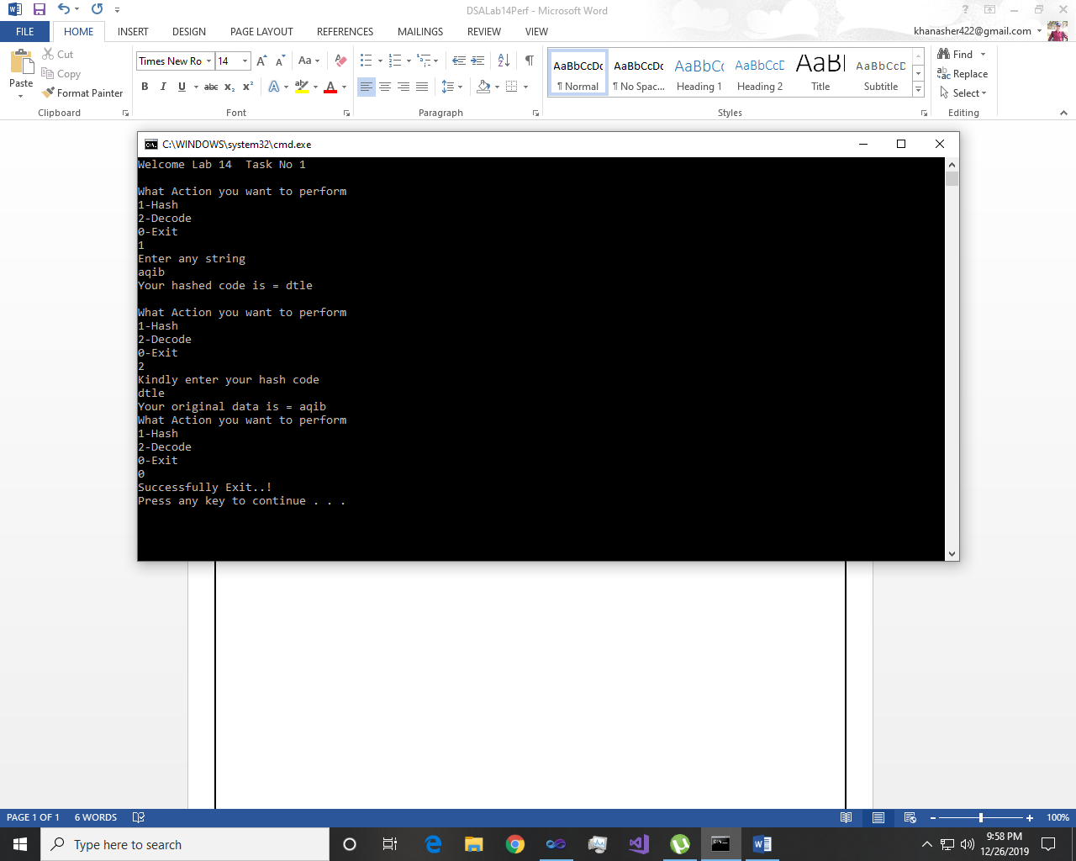

~~~~~~**/**THE END**/**~~~~~~