***Q1:***- Implement the Banker’s Algorithm explained above in C language.

Code:

#include <stdio.h>

int current[3][3], maximum_claim[3][3], available[3];

int allocation[3] = {0, 0, 0};

int maxres[3], running[3], safe = 0;

int counter = 0, i, j, exec, resources, processes, k = 1;

int main()

{

  printf("\nEnter number of processes: ");

  scanf("%d", &processes);

  for (i = 0; i < processes; i++)

  {

  running[i] = 1;

  counter++;

  }

  printf("\nEnter number of resources: ");

  scanf("%d", &resources);

  printf("\nEnter Claim Vector:");

  for (i = 0; i < resources; i++)

  {

   scanf("%d", &maxres[i]);

  }

 printf("\nEnter Allocated Resource Table:\n");

  for (i = 0; i < processes; i++)

  {

   for(j = 0; j < resources; j++)

    {

      scanf("%d", &current[i][j]);

  }

  }

  printf("\nEnter Maximum Claim Table:\n");

  for (i = 0; i < processes; i++)

  {

  for(j = 0; j < resources; j++)

    {

    scanf("%d", &maximum_claim[i][j]);

  }

  }

  printf("\nThe Claim Vector is: ");

  for (i = 0; i < resources; i++)

  {

   printf("\t%d", maxres[i]);

  }

  printf("\nThe Allocated Resource Table:\n");

  for (i = 0; i < processes; i++)

  {

   for (j = 0; j < resources; j++)

    {

    printf("\t%d", current[i][j]);

  }

    printf("\n");

  }

  printf("\nThe Maximum Claim Table:\n");

  for (i = 0; i < processes; i++)

  {

  for (j = 0; j < resources; j++)

    {

     printf("\t%d", maximum_claim[i][j]);

  }

  printf("\n");

  }

  for (i = 0; i < processes; i++)

  {

  for (j = 0; j < resources; j++)

    {

    allocation[j] += current[i][j];

  }

  }

  printf("\nAllocated resources:");

  for (i = 0; i < resources; i++)

  {

  printf("\t%d", allocation[i]);

  }

  for (i = 0; i < resources; i++)

  {

   available[i] = maxres[i] - allocation[i];

  }

  printf("\nAvailable resources:");

  for (i = 0; i < resources; i++)

  {

  printf("\t%d", available[i]);

  }

  printf("\n");

  while (counter != 0)

  {

  safe = 0;

  for (i = 0; i < processes; i++)

    {

    if (running[i])

      {

    exec = 1;

    for (j = 0; j < resources; j++)

        {

      if (maximum_claim[i][j] - current[i][j] > available[j])

          {

      exec = 0;

      break;

      }

    }

    if (exec)

        {

      printf("\nProcess%d is executing\n", i + 1);

      running[i] = 0;

      counter--;

      safe = 1;

      for (j = 0; j < resources; j++)

          {

      available[j] += current[i][j];

      }

       break;

    }

    }

  }

  if (!safe)

    {

    printf("\nThe processes are in unsafe state.\n");

    break;

  }

    else

    {

    printf("\nThe process is in safe state");

    printf("\nAvailable vector:");

    for (i = 0; i < resources; i++)

      {

    printf("\t%d", available[i]);

    }

     printf("\n");

  }

  }

  return 0;

}

***Output:-***

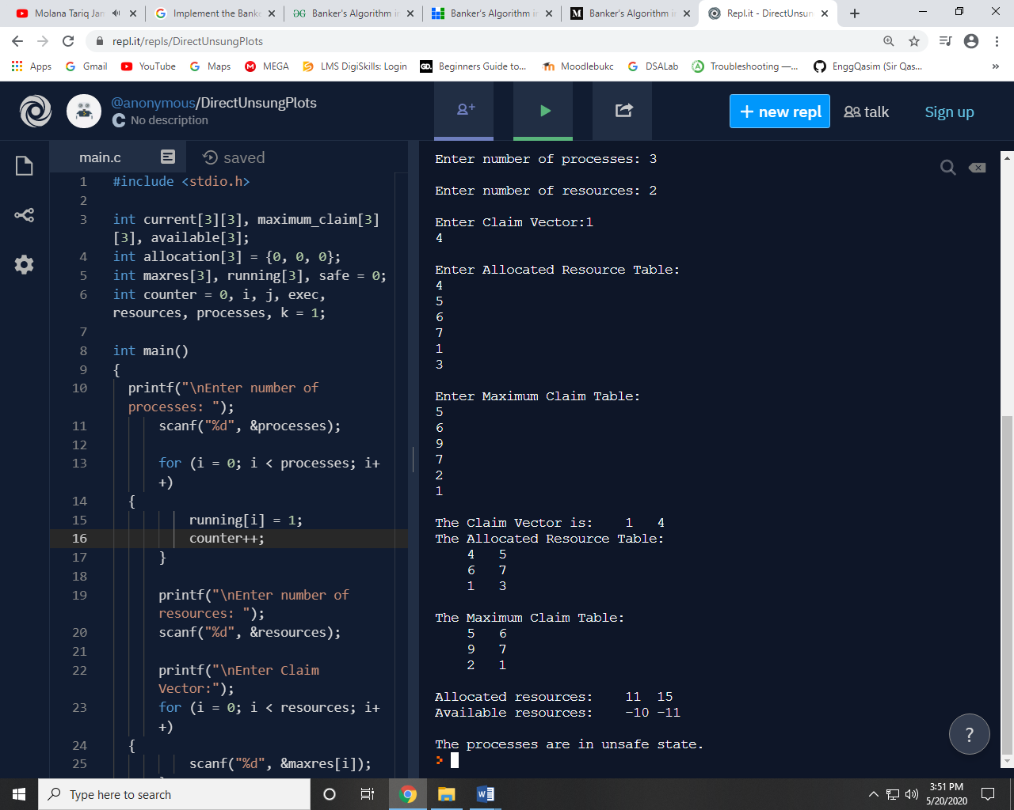

***Q2:-*** Study and implement Safety algorithm and Resource-Request Algorithm in the above program.

***Code:***

#include <stdio.h>

int current[3][3], maximum_claim[3][3], available[3];

int allocation[3] = {0, 0, 0};

int maxres[3], running[3], safe = 0;

int counter = 0, i, j, exec, resources, processes, k = 1;

int main()

{

printf("\nEnter number of processes: ");

scanf("%d", &processes);

for (i = 0; i < processes; i++)

{

running[i] = 1;

counter++;

}

printf("\nEnter number of resources: ");

scanf("%d", &resources);

printf("\nEnter Claim Vector:");

for (i = 0; i < resources; i++)

{

scanf("%d", &maxres[i]);

}

printf("\nEnter Allocated Resource Table:\n");

for (i = 0; i < processes; i++)

{

for(j = 0; j < resources; j++)

{

scanf("%d", &current[i][j]);

}

}

printf("\nEnter Maximum Claim Table:\n");

for (i = 0; i < processes; i++)

{

for(j = 0; j < resources; j++)

{

scanf("%d", &maximum_claim[i][j]);

}

}

printf("\nThe Claim Vector is: ");

for (i = 0; i < resources; i++)

{

printf("\t%d", maxres[i]);

}

printf("\nThe Allocated Resource Table:\n");

for (i = 0; i < processes; i++)

{

for (j = 0; j < resources; j++)

{

printf("\t%d", current[i][j]);

}

printf("\n");

}

printf("\nThe Maximum Claim Table:\n");

for (i = 0; i < processes; i++)

{

for (j = 0; j < resources; j++)

{

printf("\t%d", maximum_claim[i][j]);

}

printf("\n");

}

for (i = 0; i < processes; i++)

{

for (j = 0; j < resources; j++)

{

allocation[j] += current[i][j];

}

}

printf("\nAllocated resources:");

for (i = 0; i < resources; i++)

{

printf("\t%d", allocation[i]);

}

for (i = 0; i < resources; i++)

{

available[i] = maxres[i] - allocation[i];

}

printf("\nAvailable resources:");

for (i = 0; i < resources; i++)

{

printf("\t%d", available[i]);

}

printf("\n");

while (counter != 0)

{

safe = 0;

for (i = 0; i < processes; i++)

{

if (running[i])

{

exec = 1;

for (j = 0; j < resources; j++)

{

if (maximum_claim[i][j] - current[i][j] > available[j])

{

exec = 0;

break;

}

}

if (exec)

{

printf("\nProcess%d is executing\n", i + 1);

running[i] = 0;

counter--;

safe = 1;

for (j = 0; j < resources; j++)

{

available[j] += current[i][j];

}

break;

}

}

}

if (!safe)

{

printf("\nThe processes are in unsafe state.\n");

break;

}

else

{

printf("\nThe process is in safe state");

printf("\nAvailable vector:");

for (i = 0; i < resources; i++)

{

printf("\t%d", available[i]);

}

printf("\n");

}

}

return 0;

}

***Output:-***

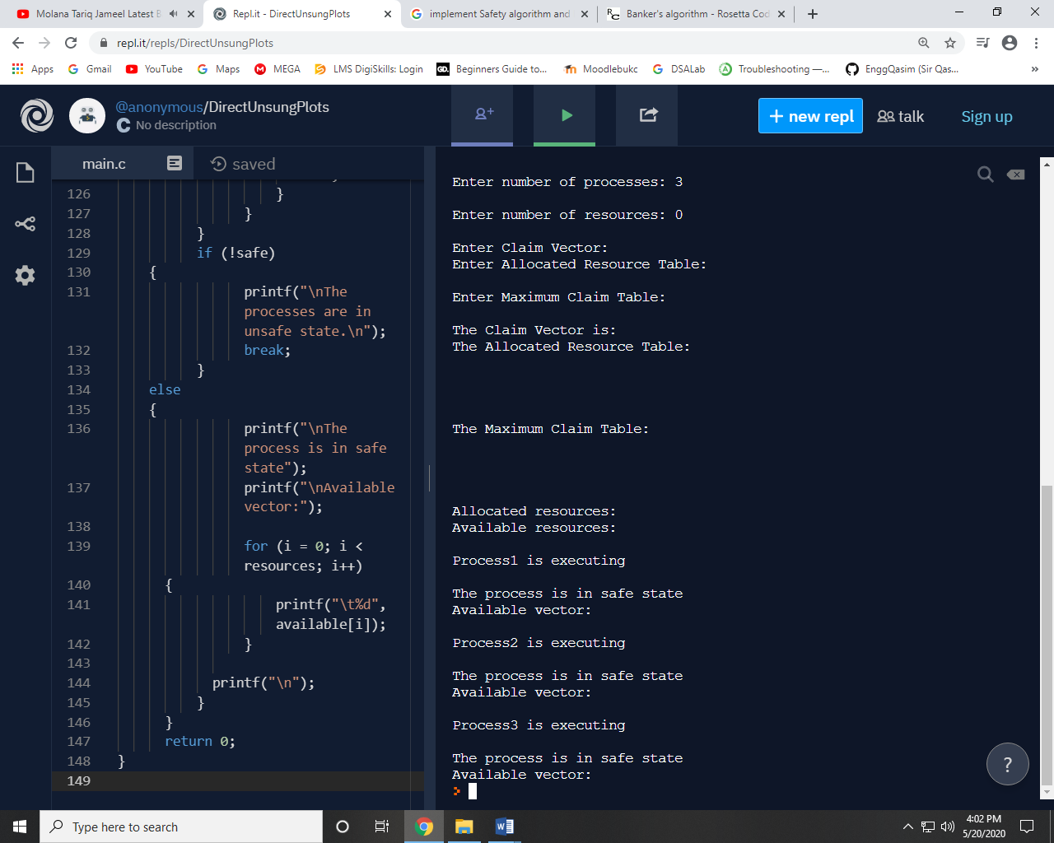

~~~~~~**/**THE END**/**~~~~~~