Q1:- Execute both commands with all the options. You can use man to see all the options too and observe the results. What have you learnt? Discuss.

***Code:-***

***PS command:***

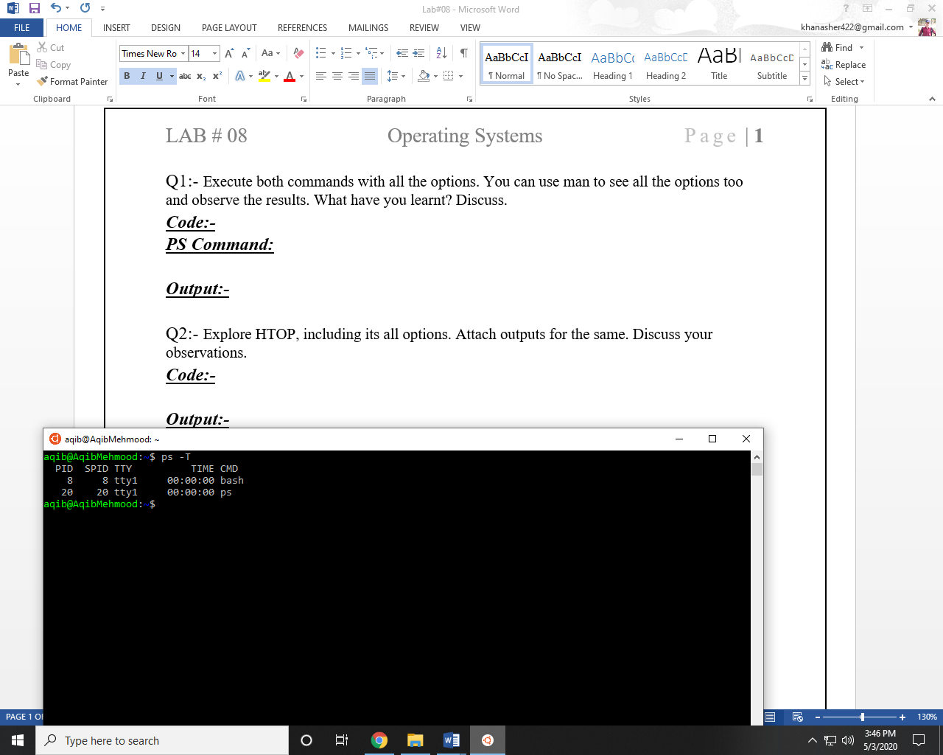

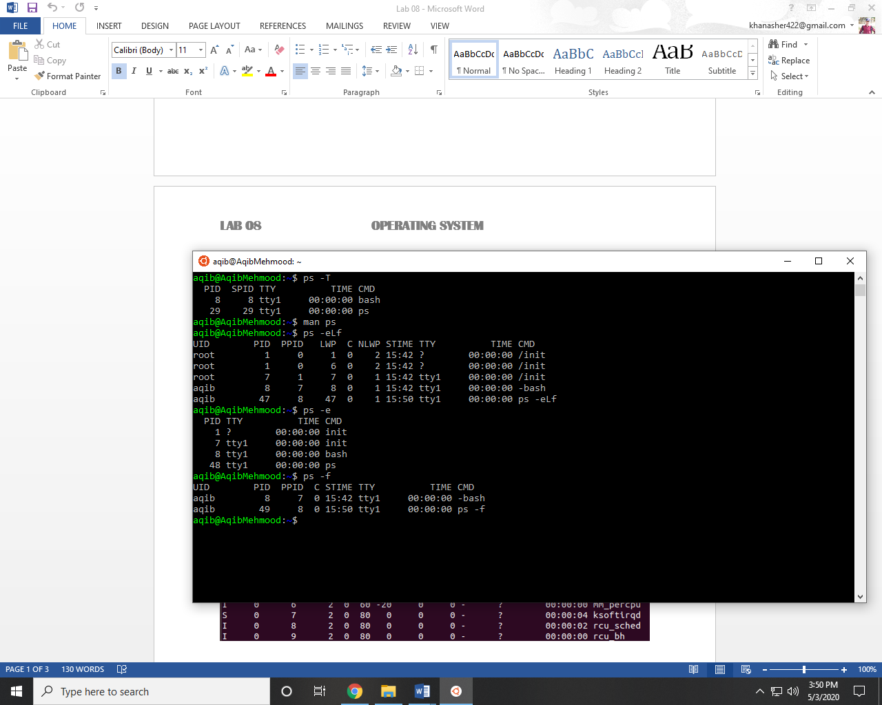

***Top command:***

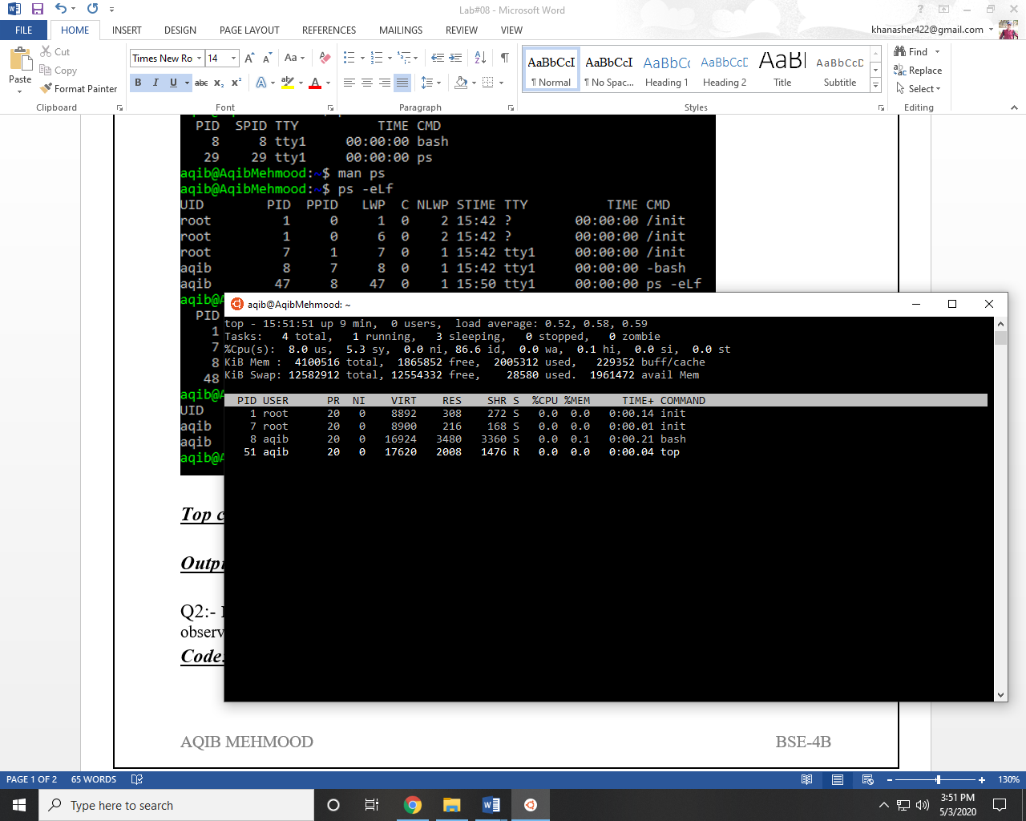

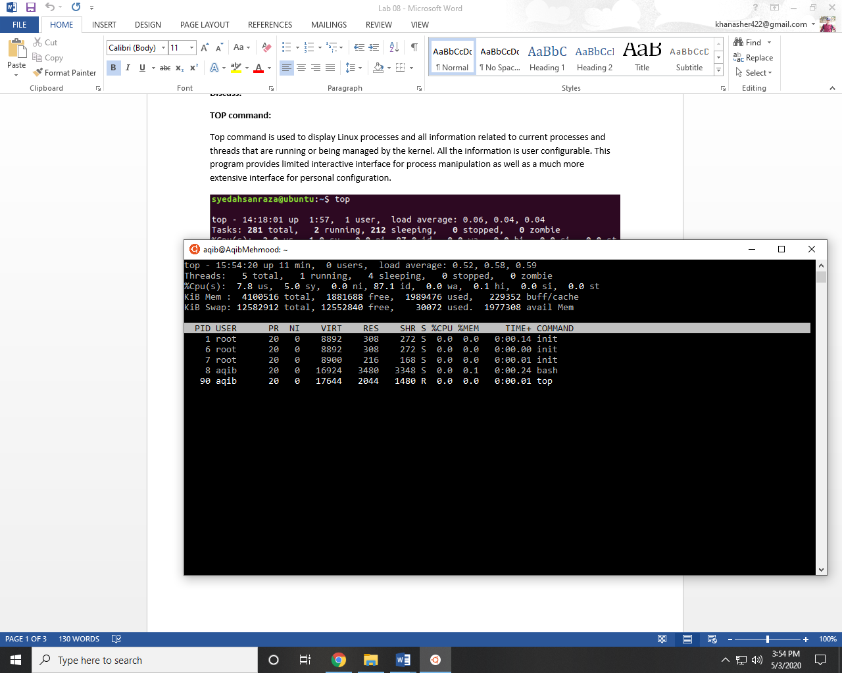

Q2:- Explore HTOP, including its all options. Attach outputs for the same. Discuss your observations.

***Code:-***

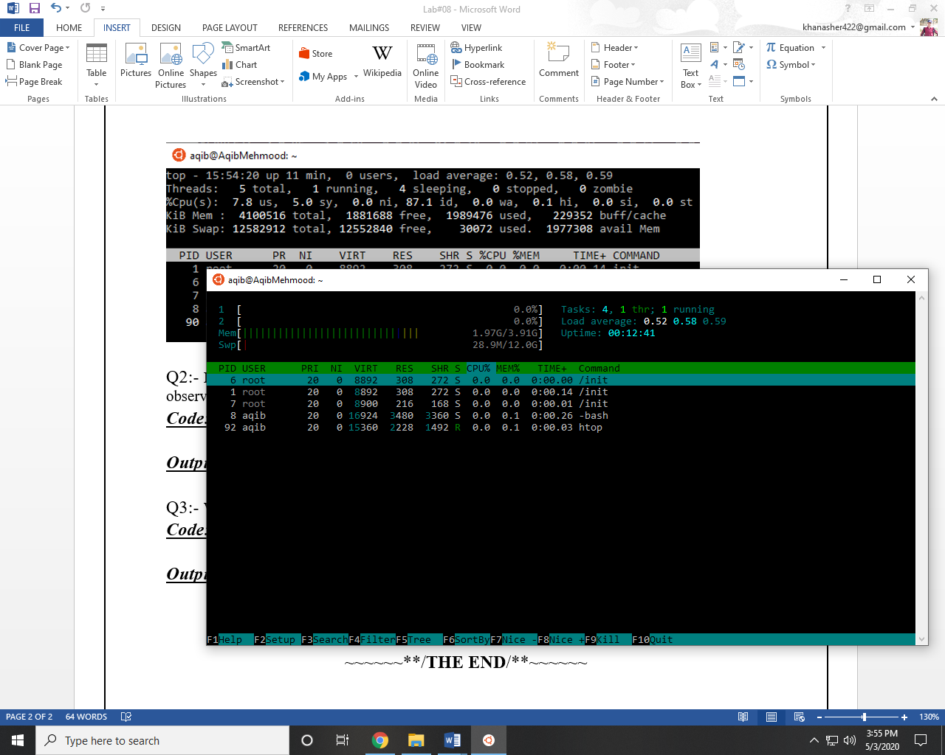

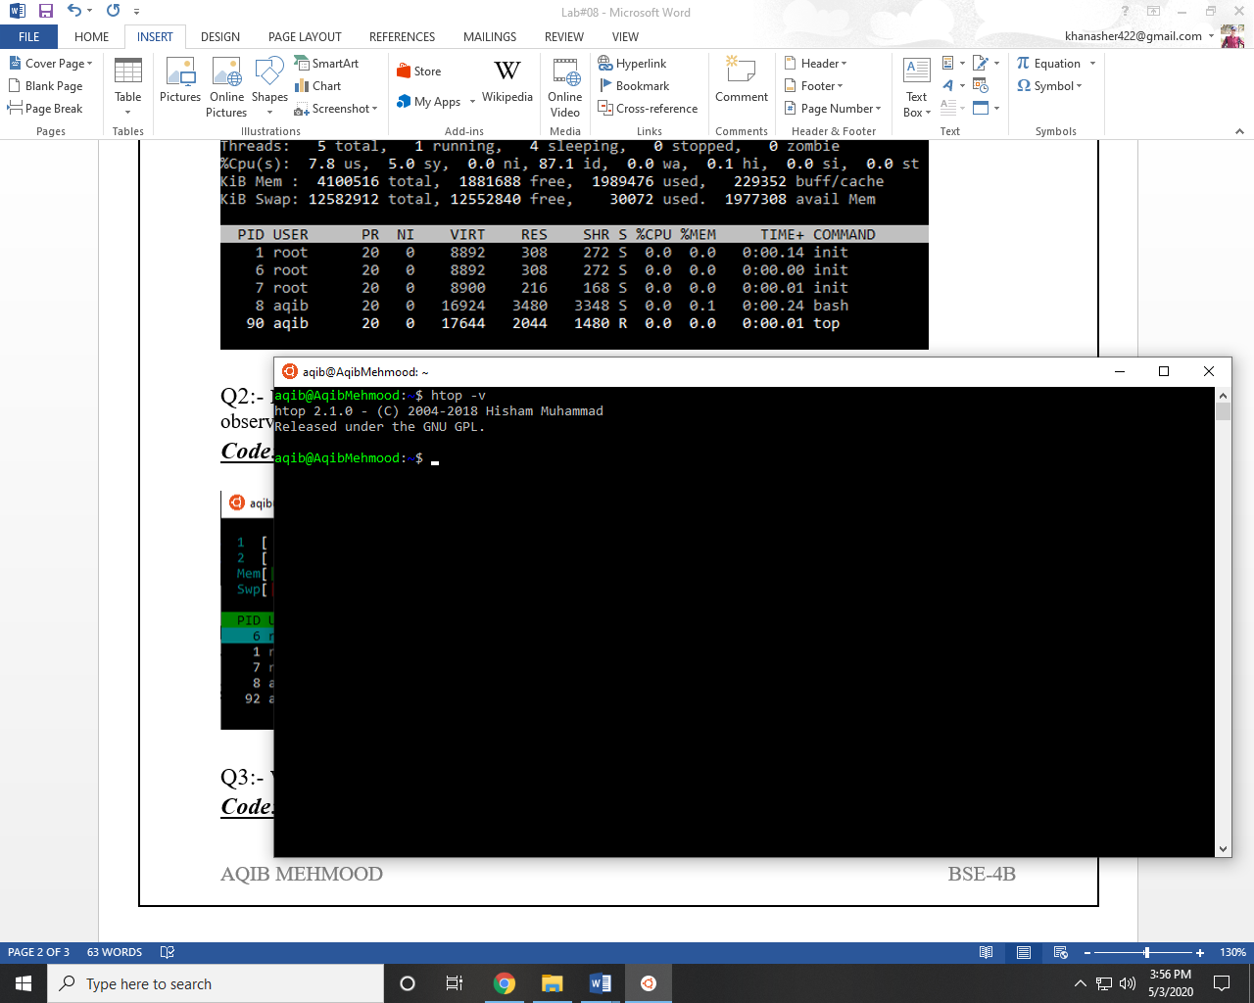

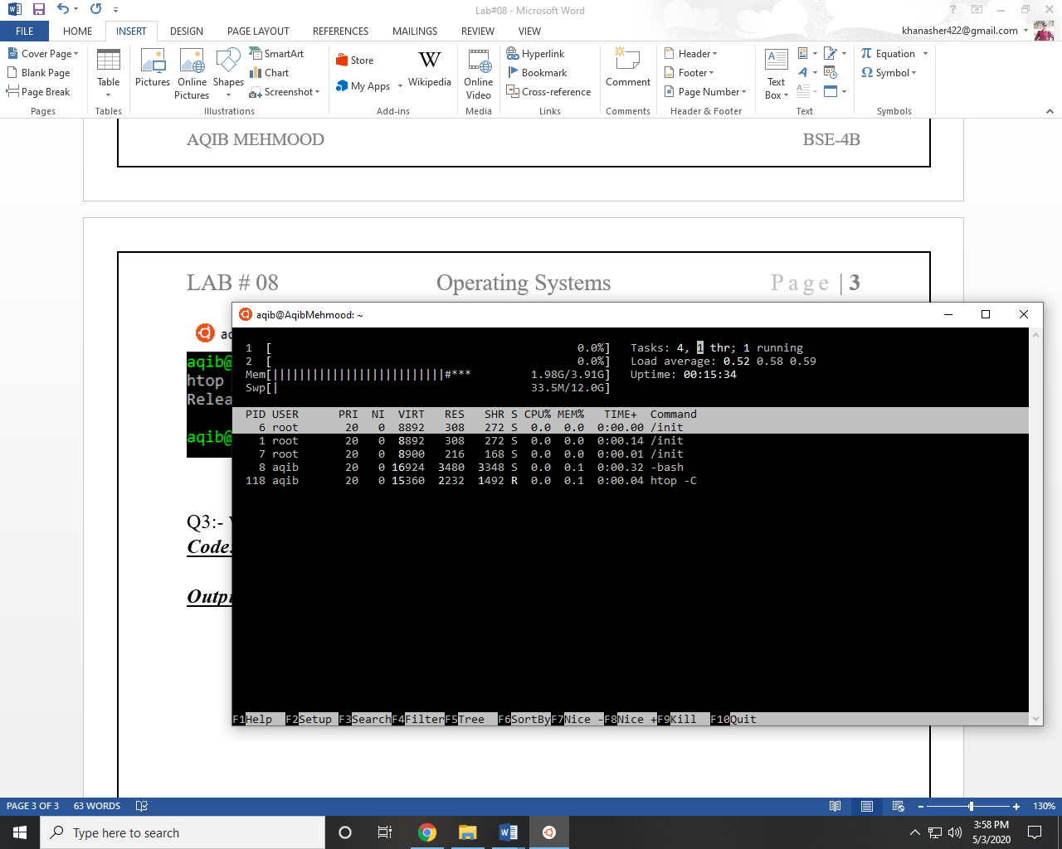

Q3:- Write a multithreaded C program for performing summation of numbers.

***Code:-***

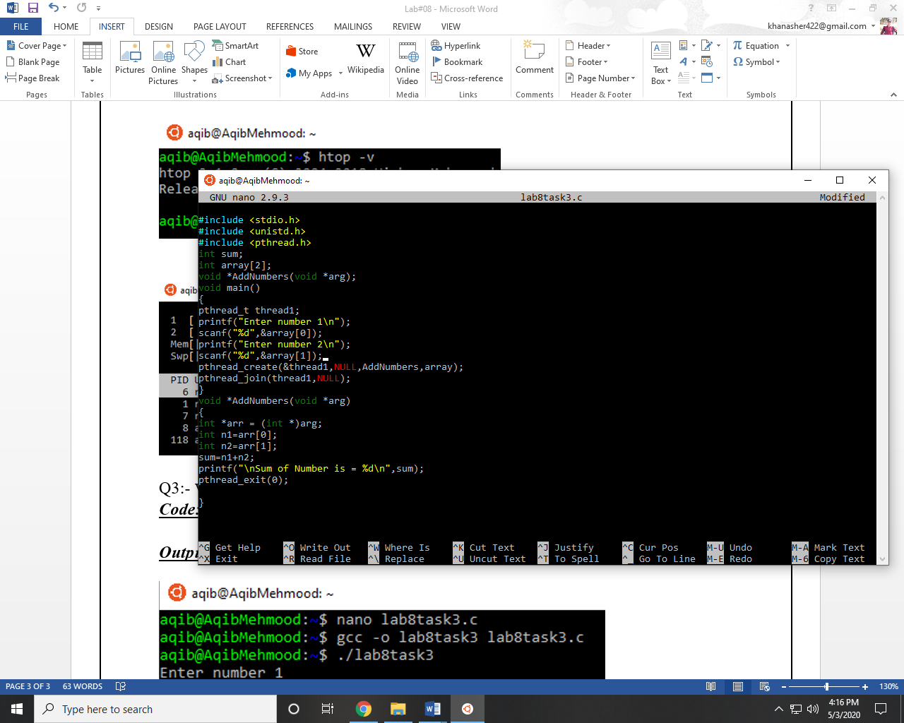

***Output:-***

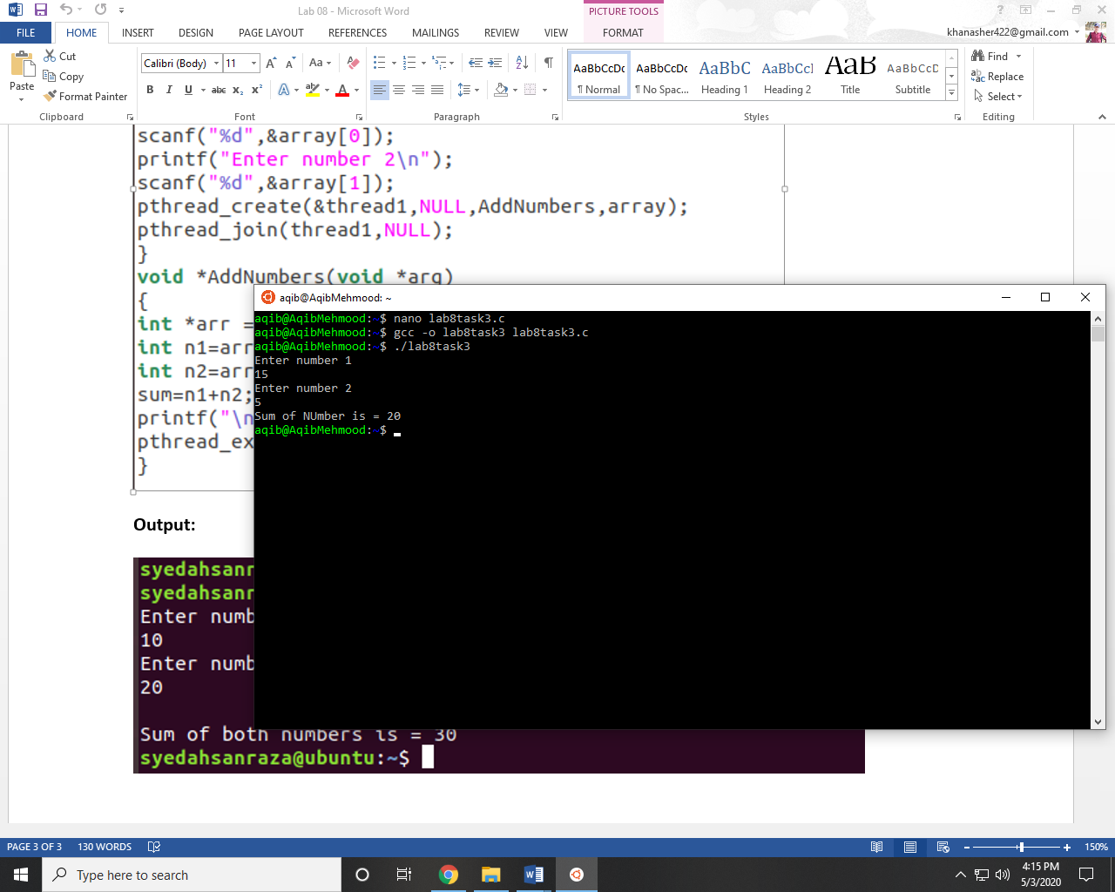

~~~~~~**/**THE END**/**~~~~~~