Bahria University,

Karachi Campus



Course: CSC-220 - Database Management System

Term: Spring 2020, Class: BSE- 4(B)

Submitted By:

**Aqib Mehmood 57231**

(Name) (Reg. No.)

***“Assignment # 03’’***

ReSubmission Date:

“24-03-2020”

Submitted To:

Engr. Bushra Fazal Khan

Signed Remarks: Score:

**Question 1:-**

Create ER Diagram for following Schema

**ER Diagram:**

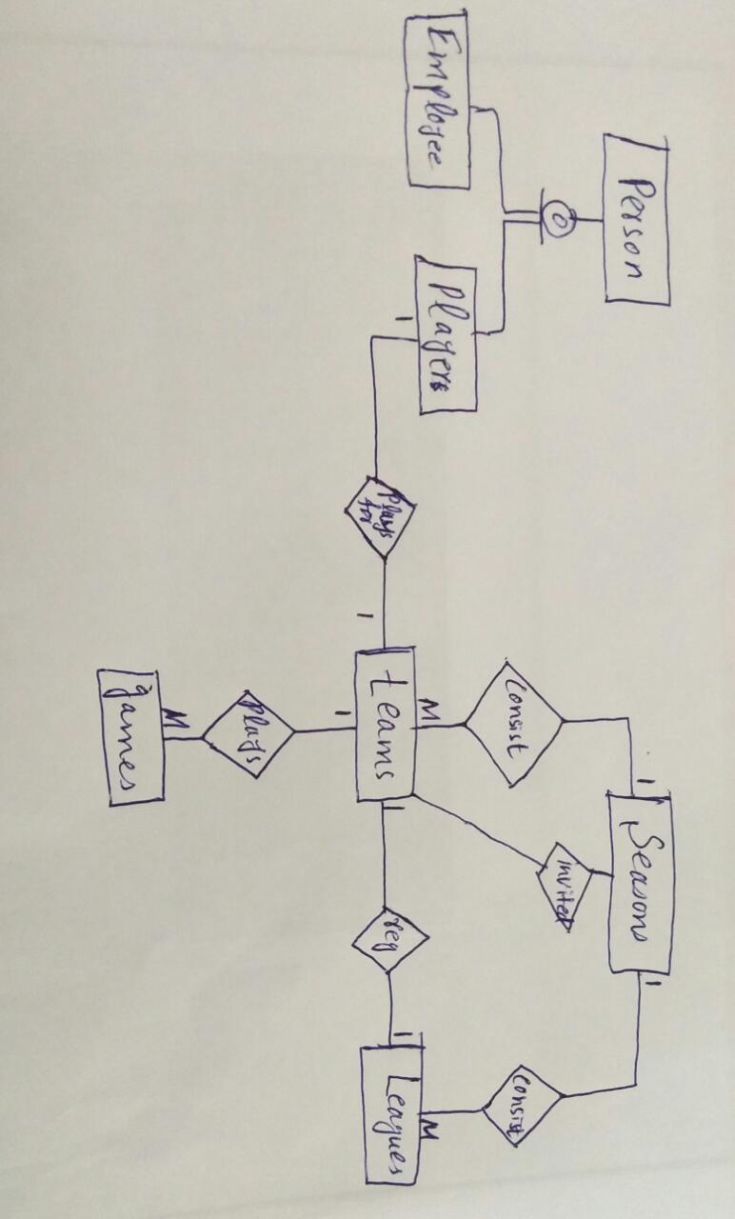

~~~~~~**/**THE END**/**~~~~~~