Bahria University,

Karachi Campus



Course: CSC-220 - Database Management System

Term: Spring 2020, Class: BSE- 4(B)

Submitted By:

**Aqib Mehmood 57231**

(Name) (Reg. No.)

***“Assignment # 01’’***

Submitted To:

Engr. Bushra Fazal Khan

Signed Remarks: Score:

**Question 1:-**

**Write a detailed essay on Evolution of Data Models along with advantages and disadvantages of each model.**

**Solution:**

The following are the data models are in DBMS:

1. **Hierarchical Model:-**

A hierarchical database model is a data model in which data is represented in the tree-like structure. In this model, data is stored in the form of records which are the collection of fields.

A hierarchical database model must have only one parent for each child node but parent nodes can have more than one child. Multiple parents are not allowed. This is the major difference between the hierarchical and network database model. The first node of the tree is called the root node. When data needs to be retrieved then the whole tree is traversed starting from the root node.

These types of models are designed basically for the early mainframe database management systems, like the Information Management System (IMS) by IBM.

This model structure allows the one-to-one and a one-to-many relationship between two various types of data. This structure is very helpful in describing many relationships in the real world; table of contents, any nested and sorted information.

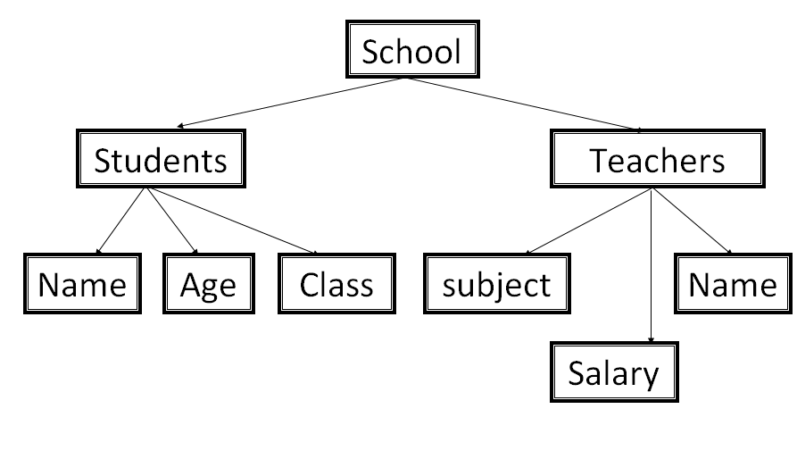

**Advantages & Disadvantages:-**

|  |  |
| --- | --- |
| Advantages | Disadvantages |
| Data can be retrieved easily due to the explicit links present between the table structures. | If the parent table and child table are unrelated then adding a new entry in the child table is difficult because additional entry must be added in the parent table. |
| Promotes data sharing. | Complex relationships are not supported. |
| Database security and integrity. | Not flexible or Poor flexibility. |
| High performance. | Data redundancy still exists which results in inaccurate information. |
| Clear results. | No data manipulation or data definition language. |

1. **Network Model:-**

This is an extension of the Hierarchical model. In this model data is organized more like a graph, and are allowed to have more than one parent node. The network model was created to represent complex data relationships more effectively than the hierarchical model, to improve database performance, and to impose a database standard.

 In this type of model, a child can be linked to multiple parents, a feature that was not supported by the hierarchical data model. The parent nodes are known as owners and the child nodes are called members.

In this database model data is more related as more relationships are established in this database model. Also, as the data is more related, hence accessing the data is also easier and fast. This database model was used to map many-to-many data relationships.

This was the most widely used database model, before Relational Model was introduced.

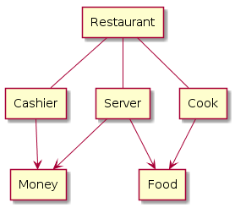

**Advantages & Disadvantages:-**

|  |  |
| --- | --- |
| Advantages | Disadvantages |
| The network model can support many to many relationships. | System complexity and difficult to design and maintain. |
| Easy to design the Network Model. | The structure of the Network Model is quite complicated to understand well. |
| Based on standards and conventions. | It still has flexibility problems. |
| represent complex data relationships more effectively |  |
| Data Integrity. No member can exist without owner. |  |

1. **Relational Model:-**

In 1970, Edgar F. Codd’s ideas were published. His ideas offered a significantly different way of handling data, suggesting all data within a database could be displayed as tables using columns and rows, which would be called “relations.” These “relations” would be accessible using a non-procedural, or declarative, language. Rather than writing an algorithm to access data, this approach only required a file name be entered to identify the desired information. This clever idea led to much higher productivity. It was faster, more efficient, and prompted IBM to create SQL.

The tables have primary keys and alternative keys. Primary keys form a relation with the alternative keys. This property makes this model extremely flexible.

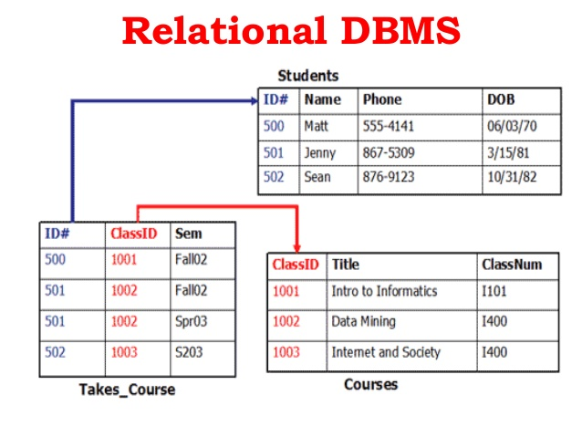

**Advantages & Disadvantages:-**

|  |  |
| --- | --- |
| Advantages | Disadvantages |
| The Relational Model does not have any issues that we saw in the previous two models i.e. update, insert and delete anomalies have nothing to do in this model. | The overheads of using relational data model come with the cost of using powerful hardware and devices. |
| Changes in the database do not require you to affect the complete database. | Database inefficiencies hide and arise when the model has large volumes of data. |
| Implementation of a Relational Model is easy. | Expensive setup and maintenance. |
| Authorization control can be implemented, making it secure. | Queries take time to execute if the relationships between tables are complex or the tables are big. |

1. **ER Model:-**

The ER model defines the conceptual view of a database. It works around real-world entities and the associations among them. At view level, the ER model is considered a good option for designing databases.

Entity-relationship model is a model used for design and representation of relationships between data. The main data objects are termed as Entities, with their details defined as attributes, some of these attributes are important and are used to identity the entity, and different entities are related using relationships.

The model is based on three concepts: entity, relationship and attributes. The entities can be physical objects or conceptual ideas.

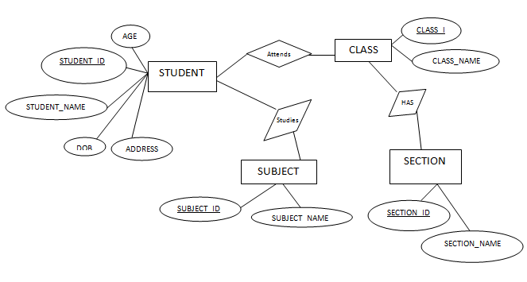

**Advantages & Disadvantages:-**

|  |  |
| --- | --- |
| Advantages | Disadvantages |
| ER model is very simple because if we know relationship between entities and attributes, then we can easily draw an ER diagram. | ER model is very popular for designing high level design |
| **Straightforward relation representation.** | There is no industry standard notation for developing an E-R diagram. |
| **Easy conversion for E-R to other data model.** | Limited constraints and specification. |
| Easy to relate tables. |  |

1. **OODM:-**

The ODBMS which is an abbreviation for object oriented database management system, is the data model in which data is stored in form of objects, which are instances of classes. These classes and objects together makes an object oriented data model.

Object oriented data model is based upon real world situations. These situations are represented as objects, with different attributes. All these object have multiple relationships between them.

It supports the modelling and creation of the data as objects. Object oriented data model blends the object oriented programming concepts with the old database models.

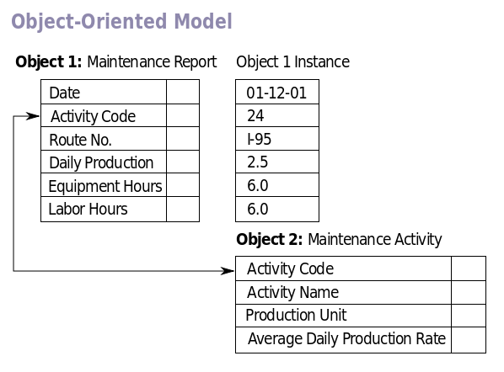

**Advantages & Disadvantages:-**

|  |  |
| --- | --- |
| Advantages | Disadvantages |
| Database integrity. | Creates problems when deleting data in bulk. |
| Structural and data independence. | Complex navigational data access. |
| Can efficiently manage a large number of different data types. | Switching an existing database to OODBMS requires a lot of changes. |

1. **Extended ER Model:-**

Todays the complexity of the data is increasing so it becomes more and more difficult to use the traditional ER model for database modeling. To reduce this complexity of modeling we have to make improvements or enhancements were made to the existing ER model to make it able to handle the complex application in a better way.

EER is a high-level data model that incorporates the extensions to the original ER model. Enhanced ERD are high level models that represent the requirements and complexities of complex database.

In addition to ER model concepts EE-R includes −

* Subclasses and Super classes.
* Specialization and Generalization.
* Category or union type.
* Aggregation.

These concepts are used to create EE-R diagrams

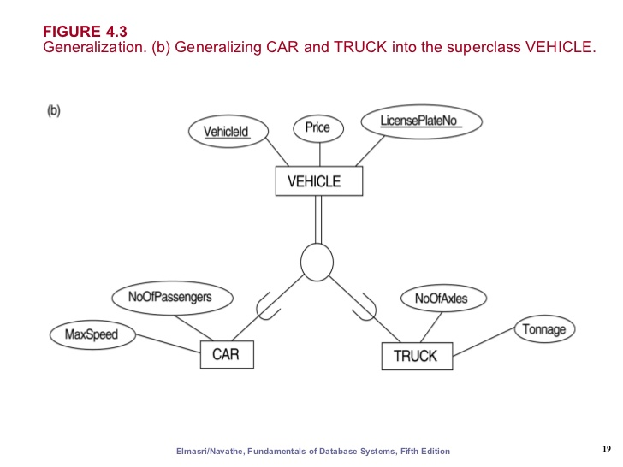

**Advantages & Disadvantages:-**

|  |  |
| --- | --- |
| Advantages | Disadvantages |
| It is the most popular data modeling approach for database applications. | No set standard of EER Diagram. |
| Allows you to clearly express constraints. |  |

1. **NoSQL:-**

The original version of NoSQL is a database developed by Carlo Strozzi in 1998. He created a relational, open-source database, which “did not expose” the SQL connections, “but was still relational.” Later versions of NoSQL dropped the relational model aspects completely.

NoSQL is an approach to database design that can accommodate a wide variety of data models, including key-value, document, columnar and graph formats. NoSQL, which stands for "not only SQL," is an alternative to traditional relational databases in which data is placed in tables and data schema is carefully designed before the database is built.

NoSQL databases are especially useful for working with large sets of distributed data. NoSQL systems store and retrieve data from many formats: key-value stores, graph databases, and even rows in tables.

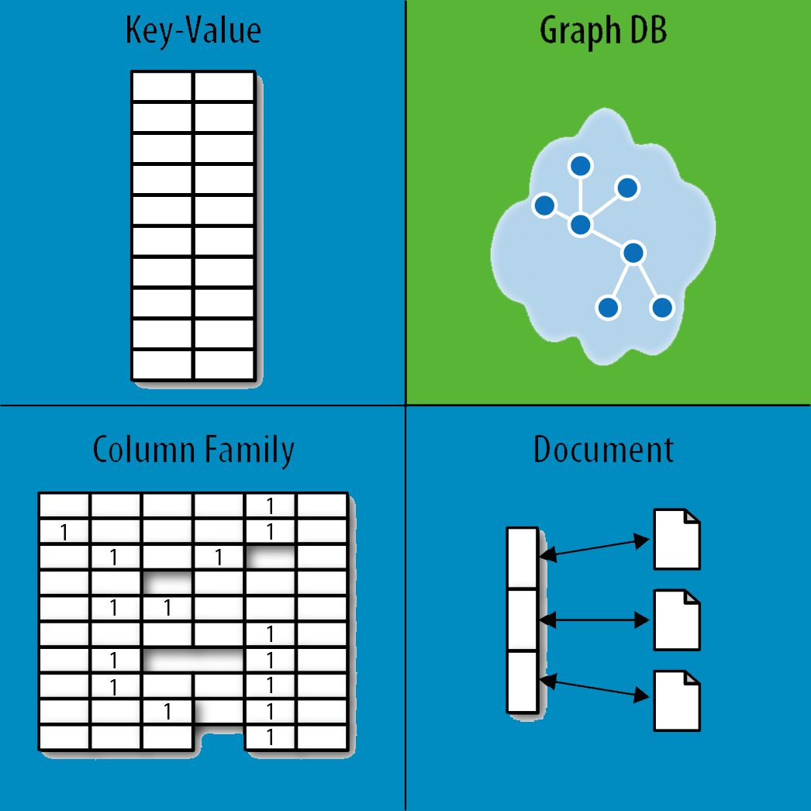

**Advantages & Disadvantages:-**

|  |  |
| --- | --- |
| Advantages | Disadvantages |
| The main advantages are high scalability and high availability. | NoSQL databases have very narrow focus as it is mainly designed for storage but it provides very little functionality. |
| No need to define structure as database schema. | GUI is not available |
| Structurally independent. | Not secure. |

1. **NewSQL:-**

NewSQL is a type of database language that incorporates and builds on the concepts and principles of Structured Query Language (SQL) and NoSQL languages. By combining the reliability of SQL with the speed and performance of NoSQL, NewSQL provides improved functionality and services.

Conceived in 2011 to address challenges faced by traditional SQL-based systems, NewSQL was designed for online transaction processing (OLTP) systems, while complying with atomicity, consistency, isolation and durability (ACID). NewSQL architecture natively supports applications that have a large number of transactions, are repetitive in their processes and utilize a small subset of data retrieving processes.

VoltDB is a NewSQL database system that provides speed up to 50 times faster than SQL and more than eight times faster than NoSQL.

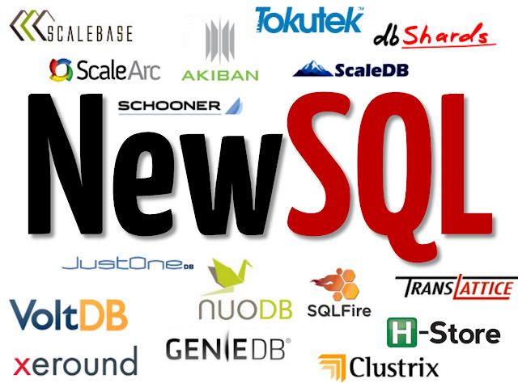

**Advantages & Disadvantages:-**

|  |  |
| --- | --- |
| Advantages | Disadvantages |
| It has full transactional support, minimum application complexity, and stronger consistency. | It is not set for general purpose as traditional SQL Systems. |
| Recognizable SQL and standard tooling. | There is only partial access to rich tooling of SQL systems. |
| Highly efficient to process complex queries and smaller queries. |  |

~~~~~~**/**THE END**/**~~~~~~