Q1: - Get Order id, Product id, Unit price from Order Details.

Query:-

select OrderID, ProductID, UnitPrice from [Order Details]

Result:-

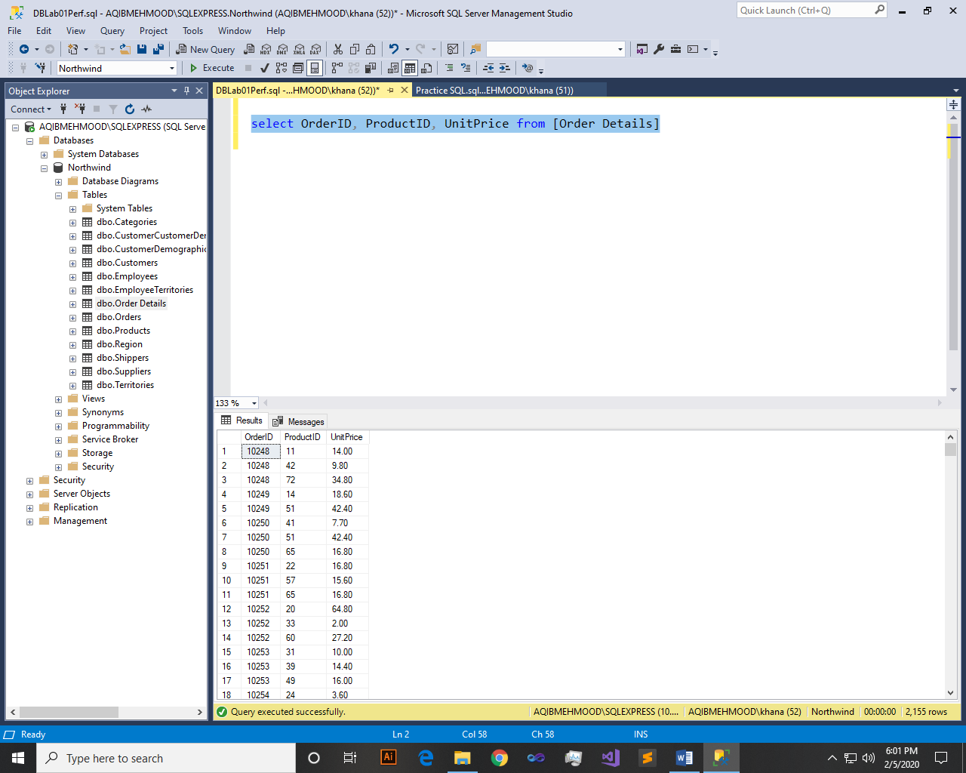

Q2: - Find Title of employee Nancy.

Query:-

select FirstName,Title from Employees where FirstName = 'Nancy'

Result:-

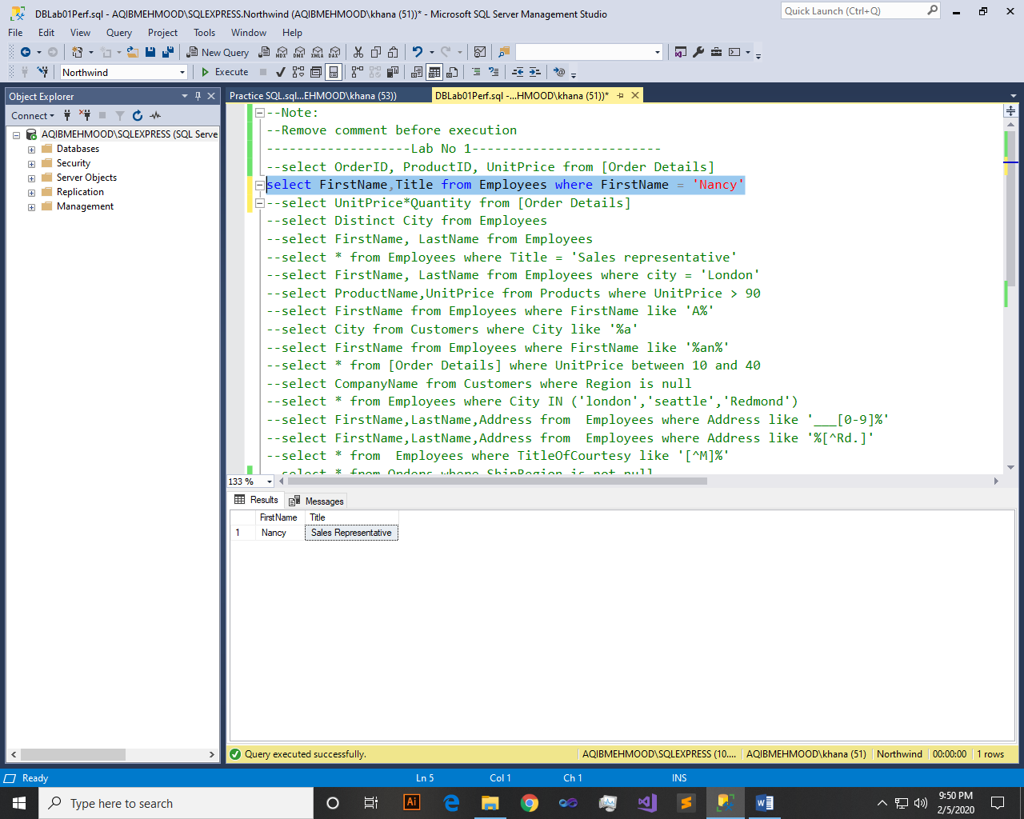

Q3: - Get the price of an order (by multiplying unit price by quantity).

Query:-

select UnitPrice*Quantity from [Order Details]

Result:-

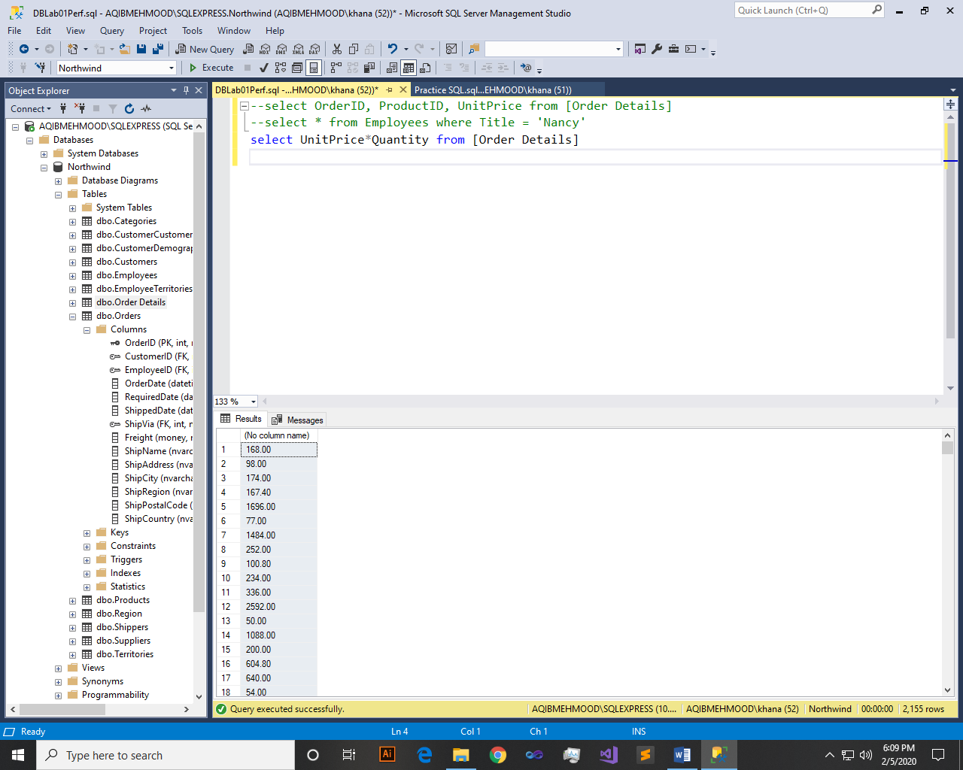

Q4: - Display all cities that employees belong to but don’t allow repetition.

Query:-

select Distinct City from Employees

Result:-

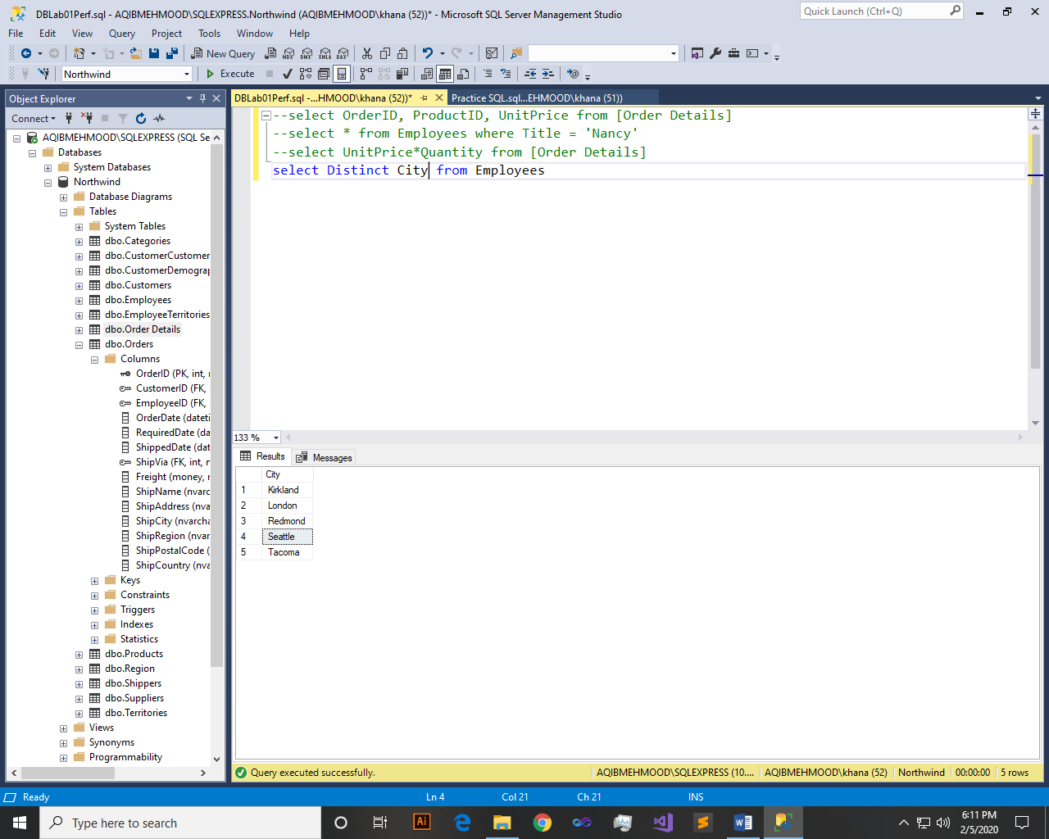

Q5: - Find complete name of all employees.

Query:-

select FirstName, LastName from Employees

Result:-

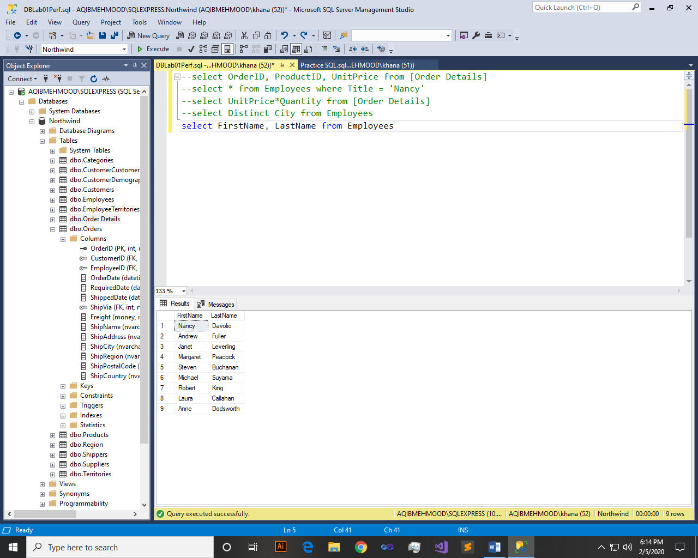

Q6: - Display data of all employees those working as Sales Representative.

Query:-

select * from Employees where Title = 'Sales representative'

Result:-

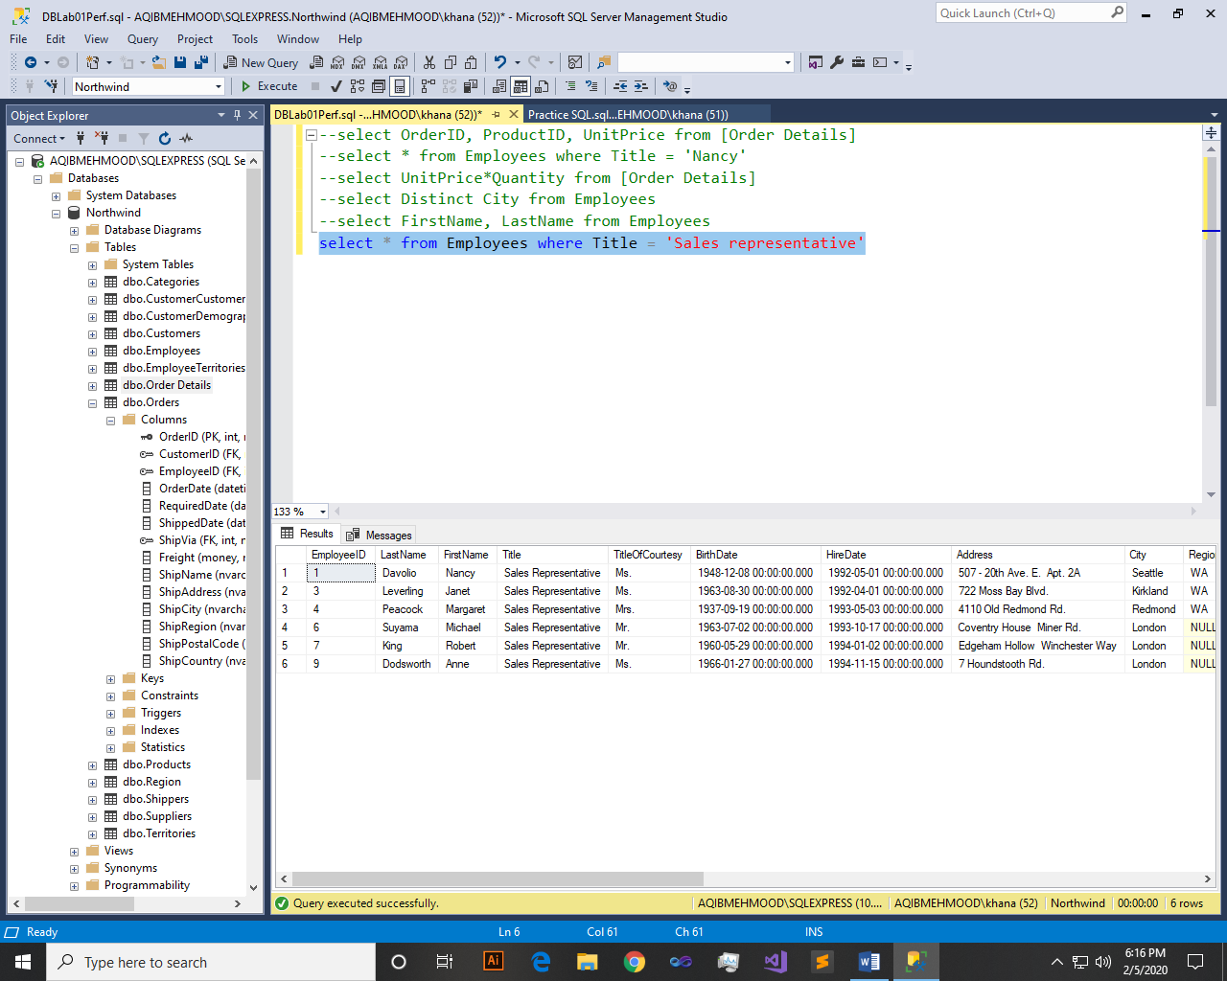

Q7: - Display complete name of employees those lives in London.

Query:-

select FirstName, LastName from Employees where city = 'London'

Result:-

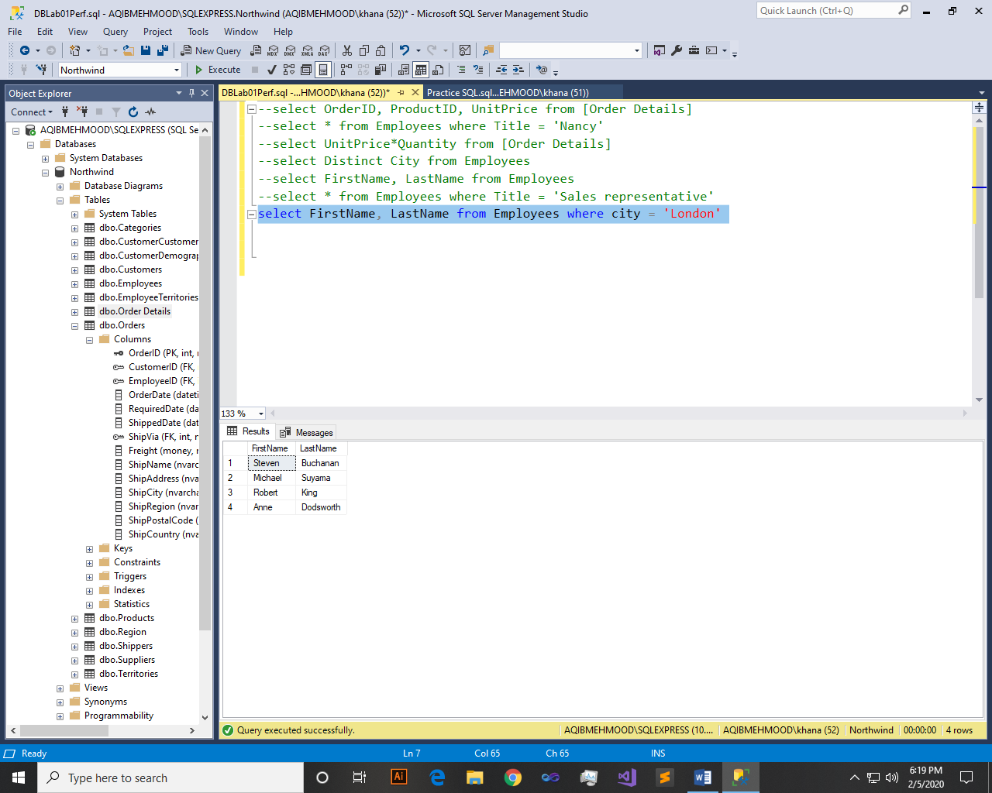

Q8: - Display product name whose unit price are greater than 90$.

Query:-

select ProductName,UnitPrice from Products where UnitPrice > 90

Result:-

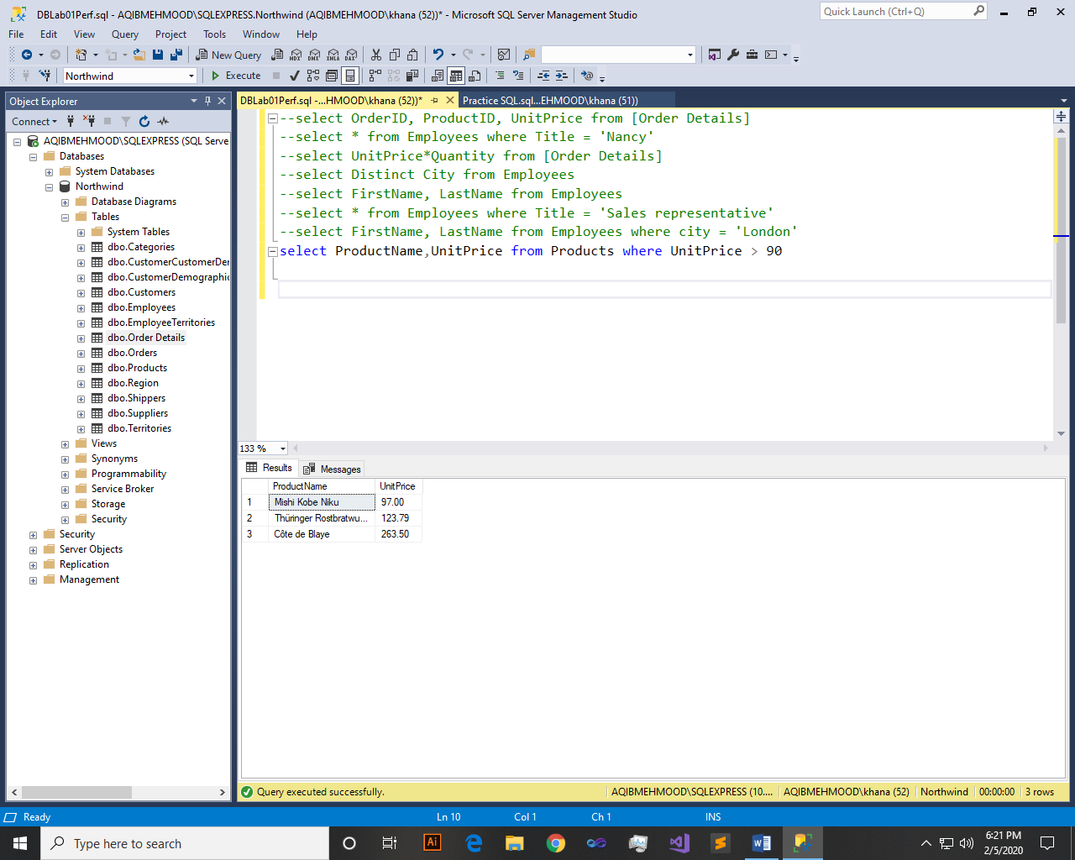

Q9: - List the name of all employees whose first name starts with the letter ‘A’.

Query:-

select FirstName from Employees where FirstName like 'A%'

Result:-

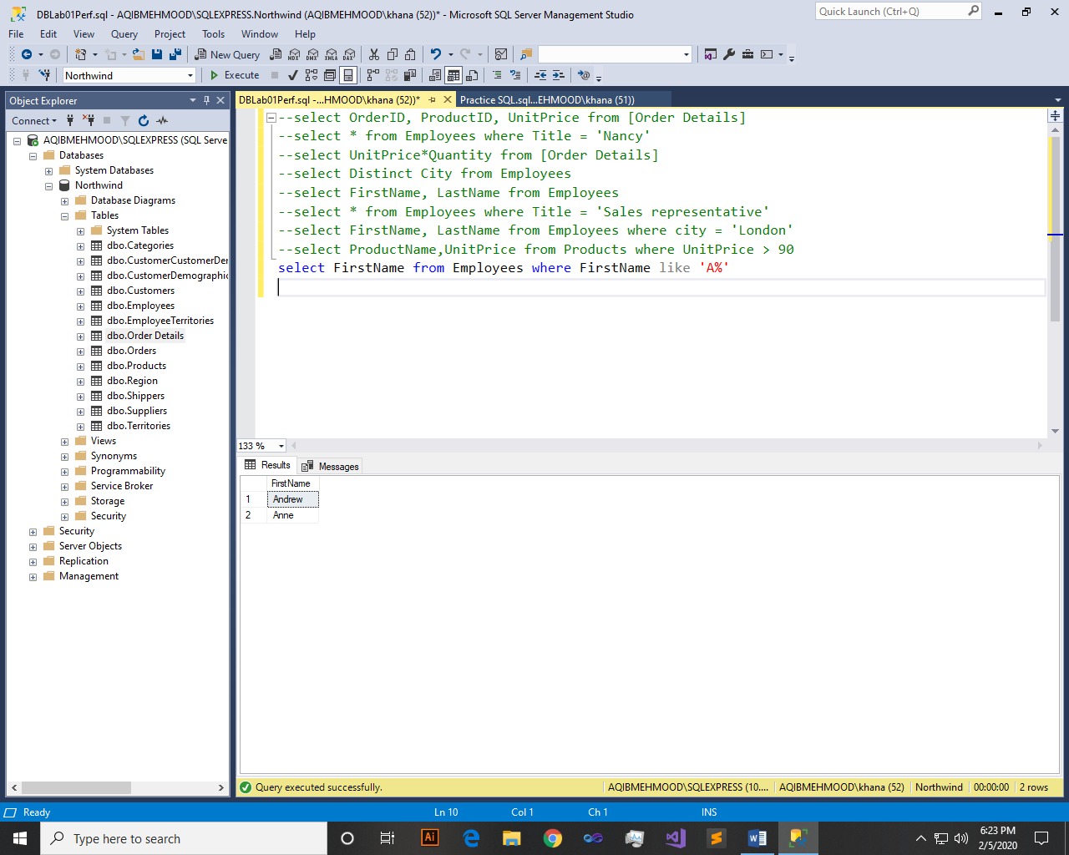

Q10: - In Customer table, display all cities that ends with the letter ‘a’.

Query:-

select City from Customers where City like '%a'

Result:-

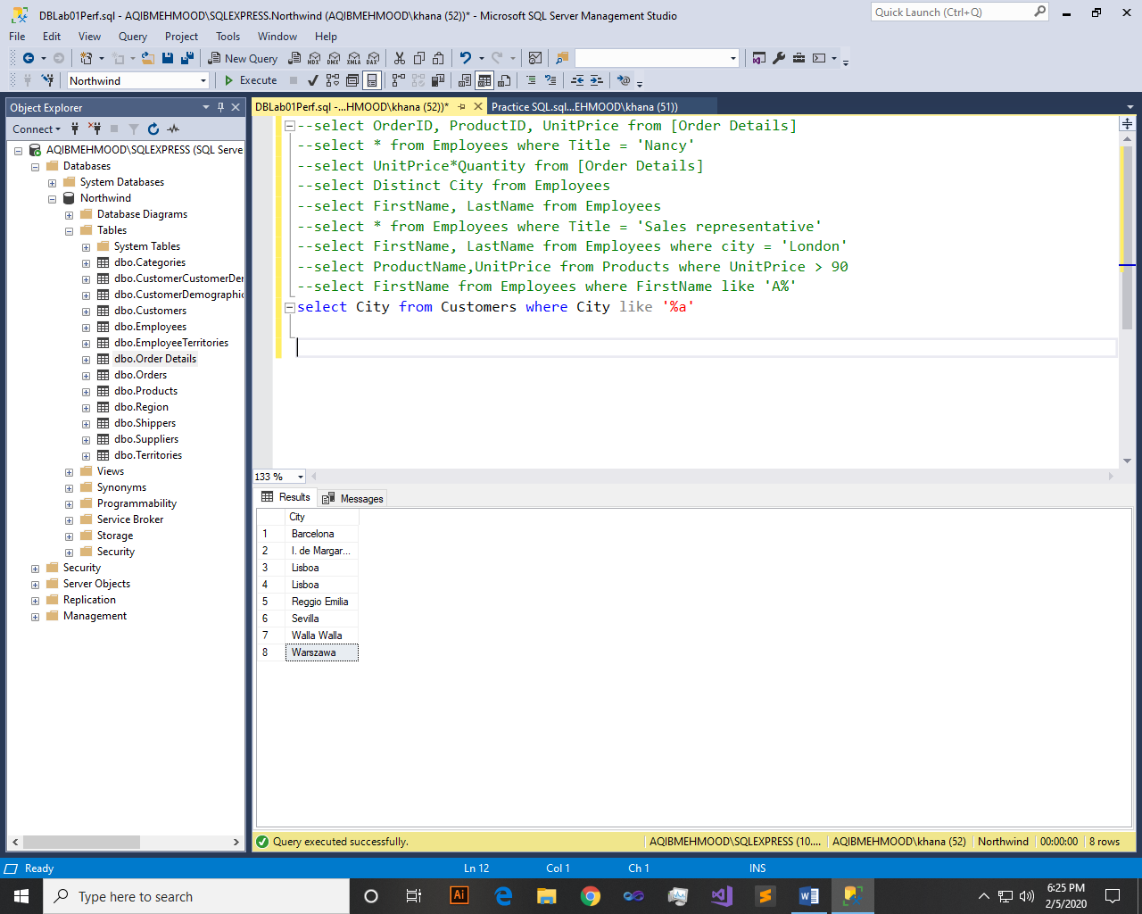

Q11: - Display names of all employees whose name contain ‘an’.

Query:-

select FirstName from Employees where FirstName like '%an%'

Result:-

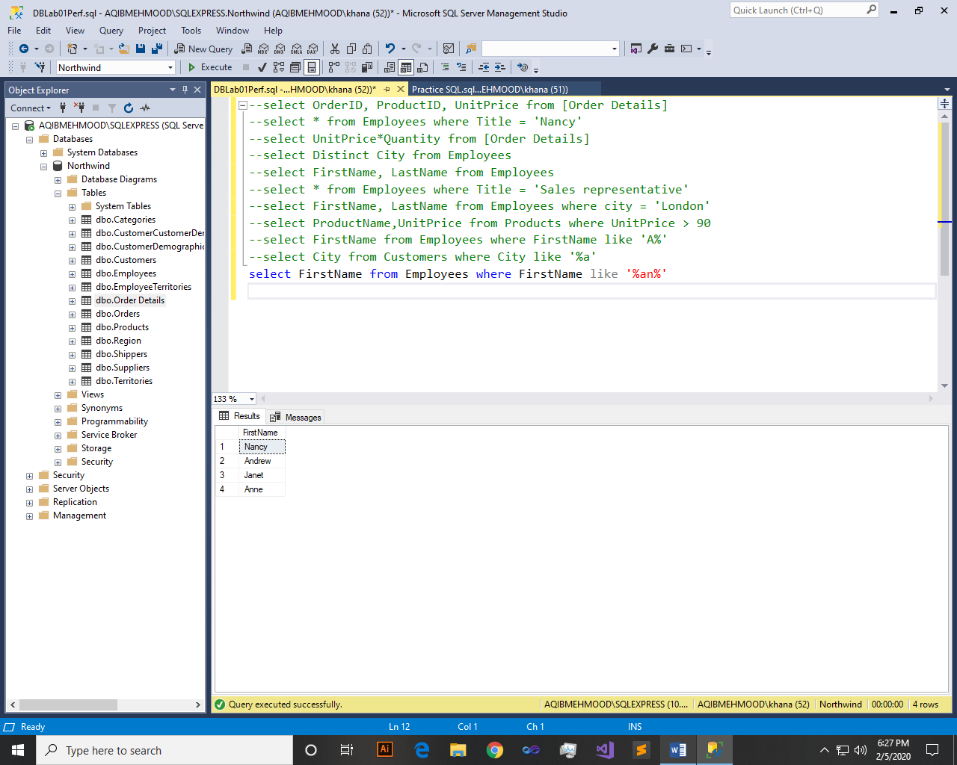

Q12: - Display all the orders where unit price lies in the range of 10$ to 40$.

Query:-

select * from [Order Details] where UnitPrice between 10 and 40

Result:-

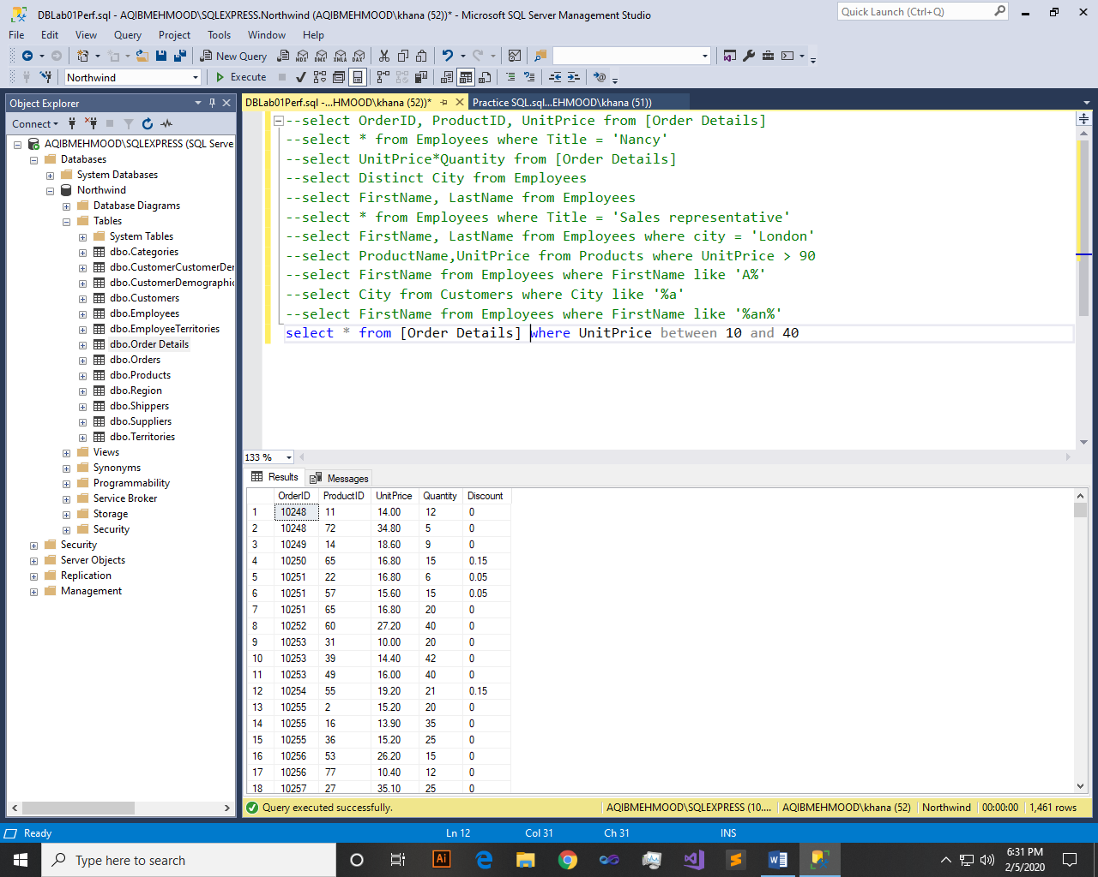

Q13: - Display the company name where Region is NULL in Customer Table.

Query:-

select CompanyName from Customers where Region is null

Result:-

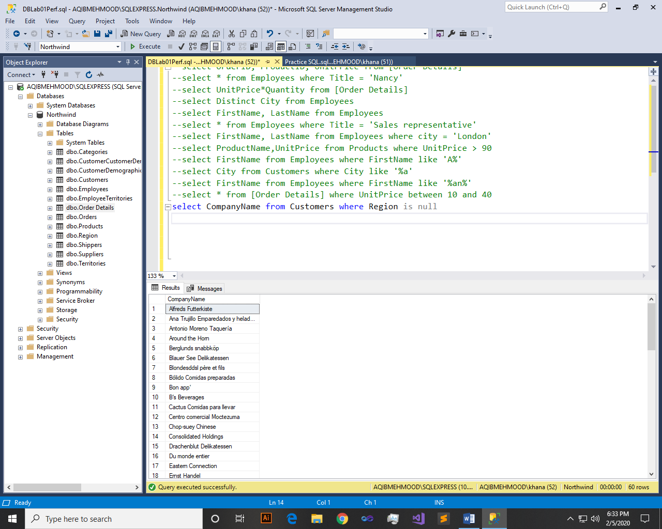

Q14: - Write a query to list employees who live in London, Seattle or Redmond

Query:-

select * from Employees where City IN ('london','seattle','Redmond')

Result:-

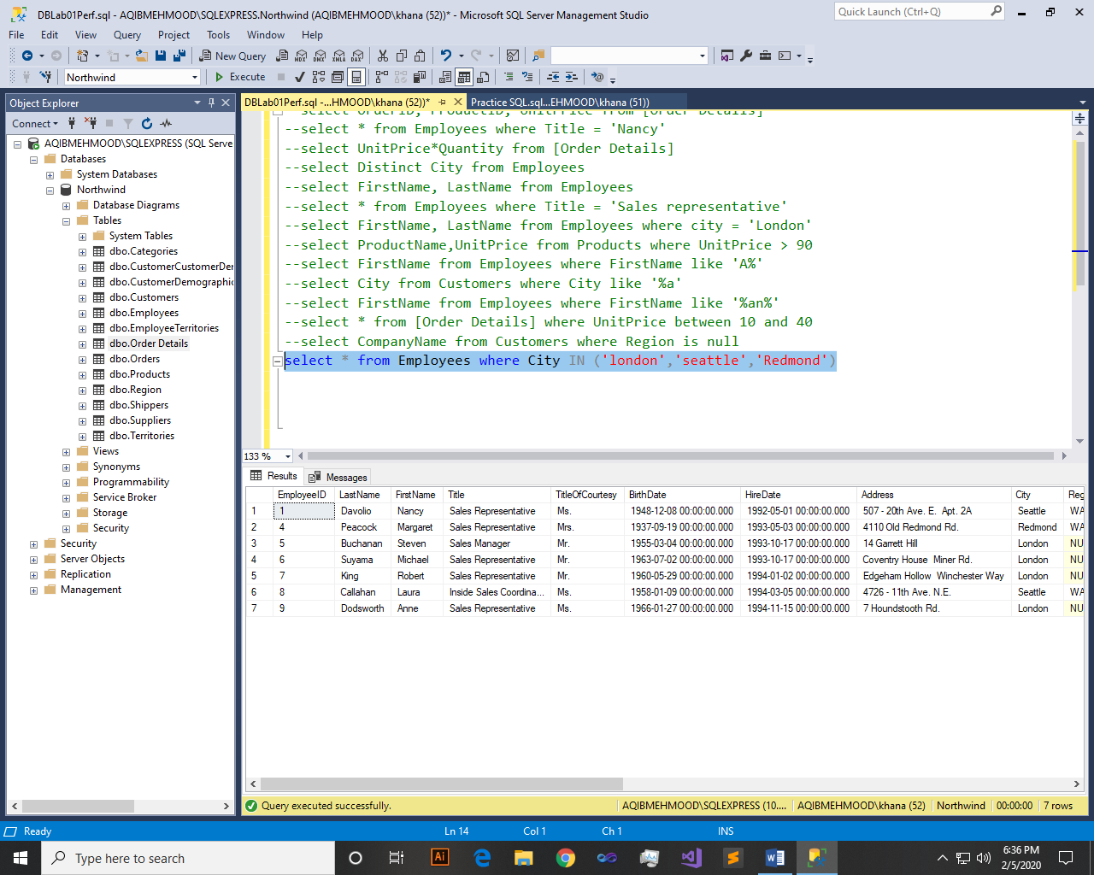

Q15: - Write a query to list employees whose address contains 3 numbers in its start.

Query:-

select FirstName,LastName,Address from Employees where Address like '___[0-9]%'

Result:-

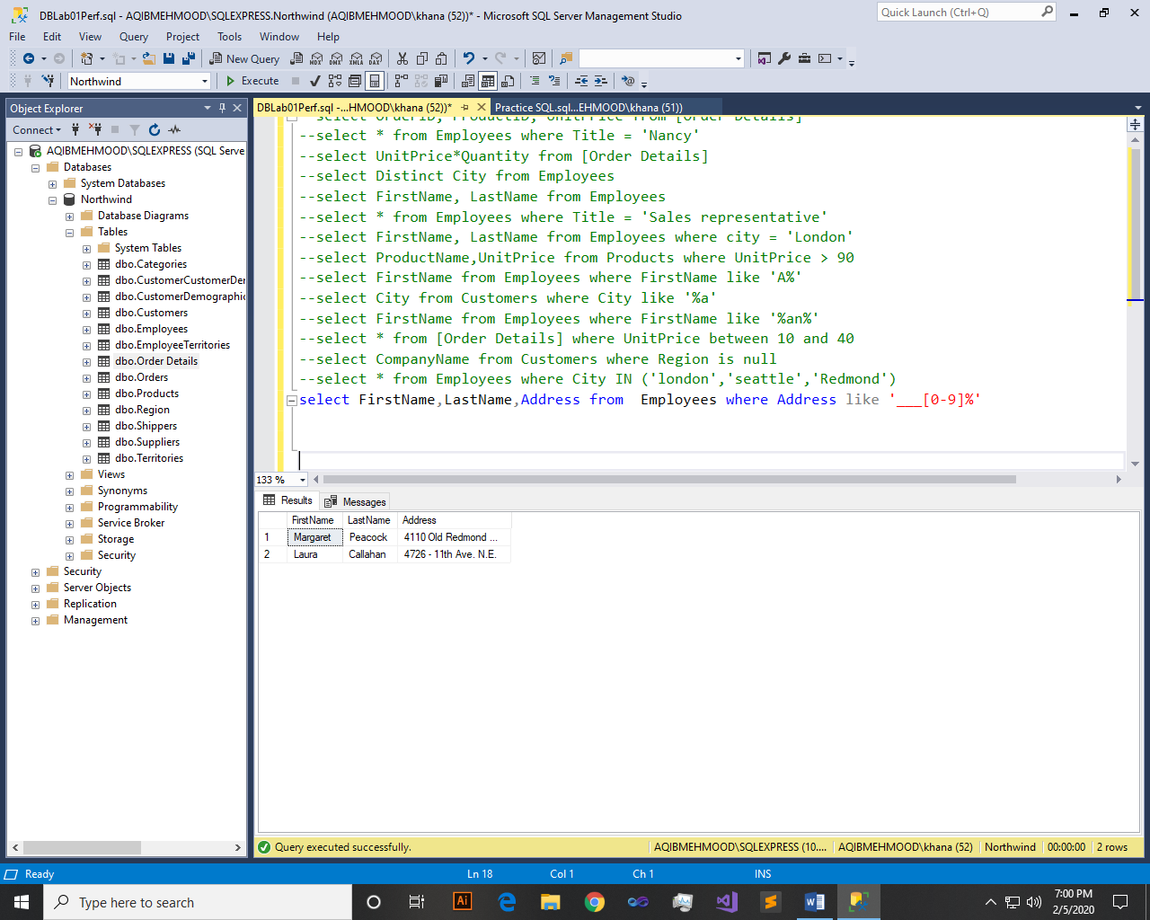

Q16: - Write a query to list employees whose address does not contain Rd.

Query:-

select FirstName,LastName,Address from Employees where Address like '%[^Rd.]'

Result:-

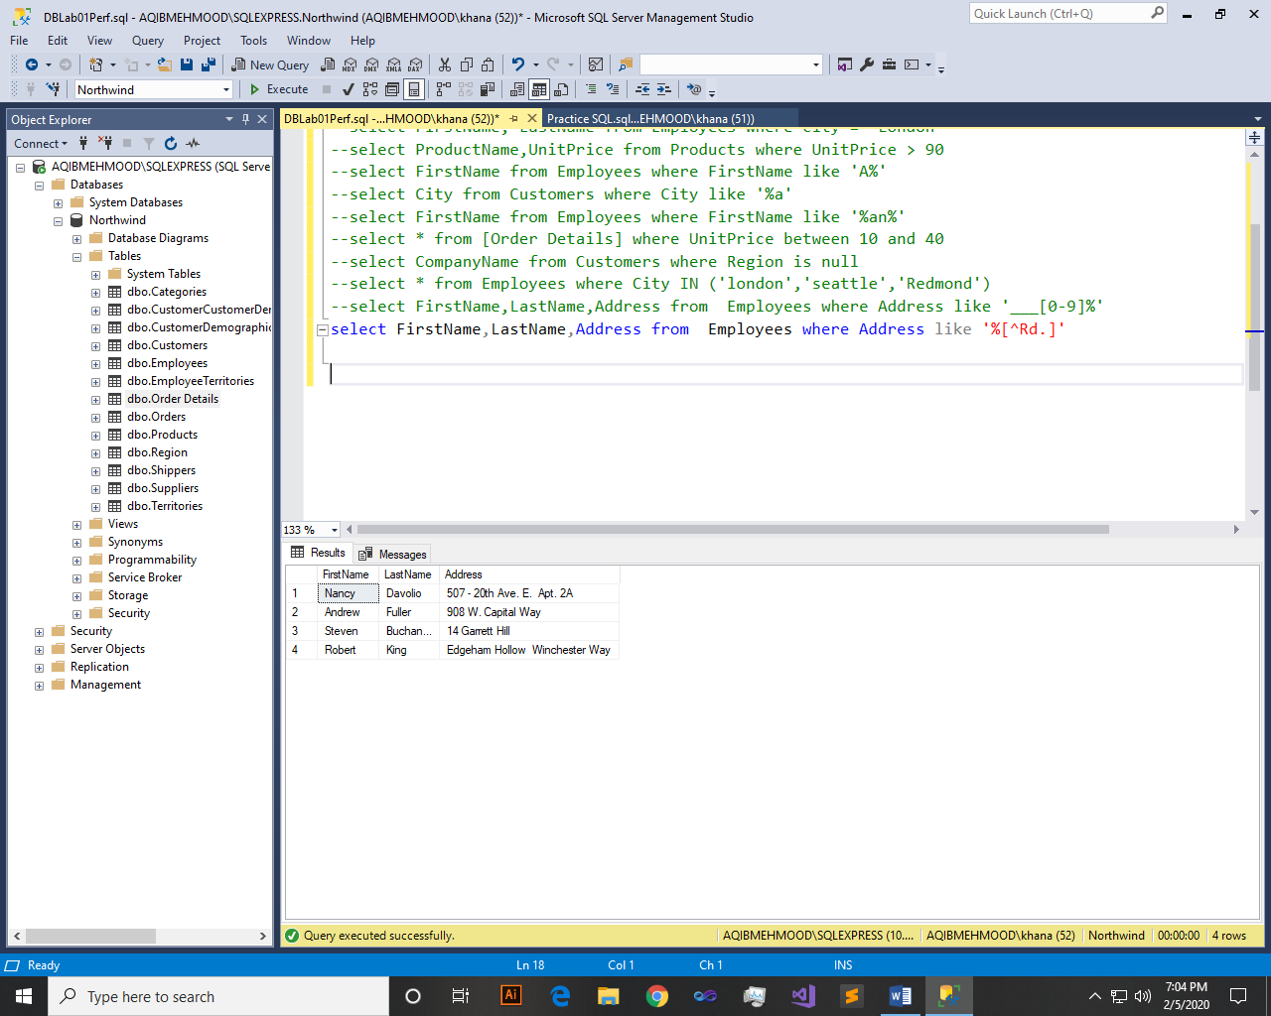

Q17: - Write a query to list all those employees whose TitleofCourtesydoes not starts with M.

Query:-

select * from Employees where TitleOfCourtesy like '[^M]%'

Result:-

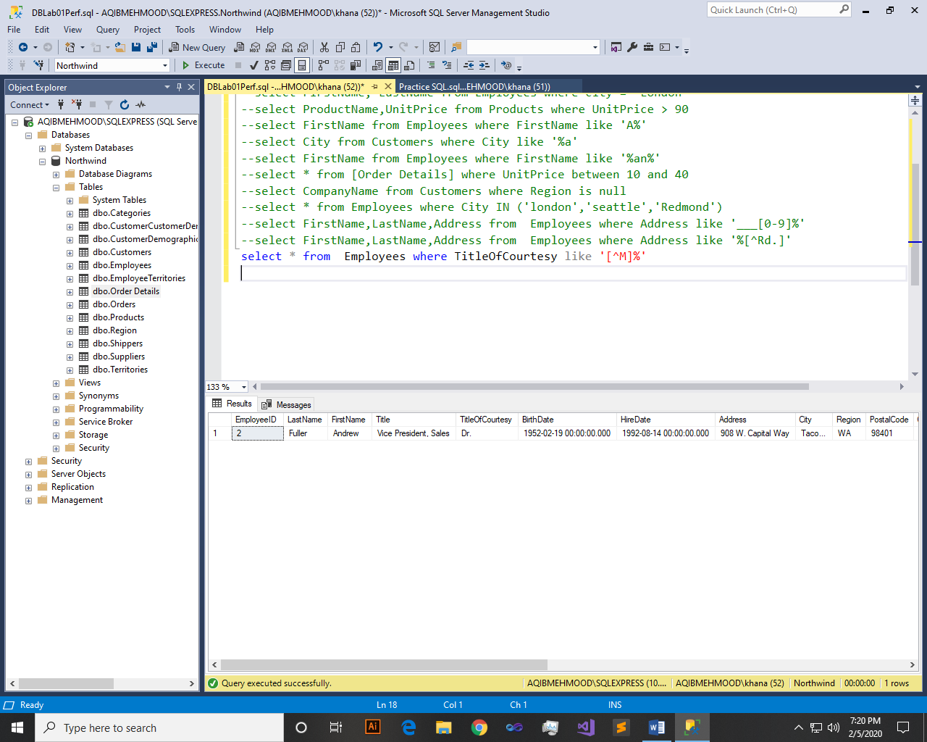

Q18: - List order details whose ShipRegion is not Null.

Query:-

select * from Orders where ShipRegion is not null

Result:-

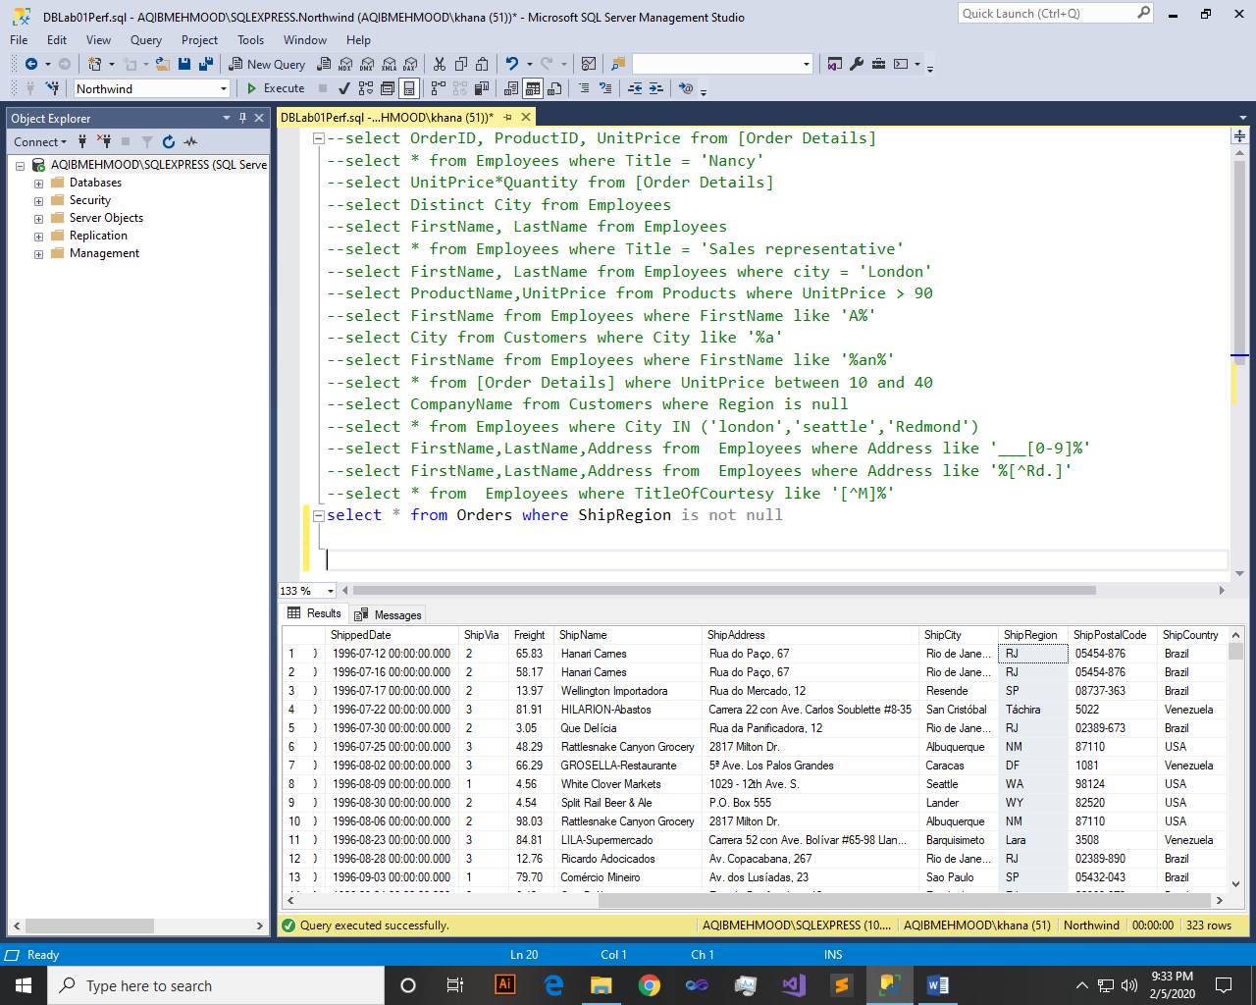

Q19: - List all products where UnitPrice is between 10 and 15 and QuantityPerUnit contains “bottles”

Query:-

select ProductName, UnitPrice, QuantityPerUnit from Products where UnitPrice between 10 and 15 and QuantityPerUnit like '%bottles'

Result:-

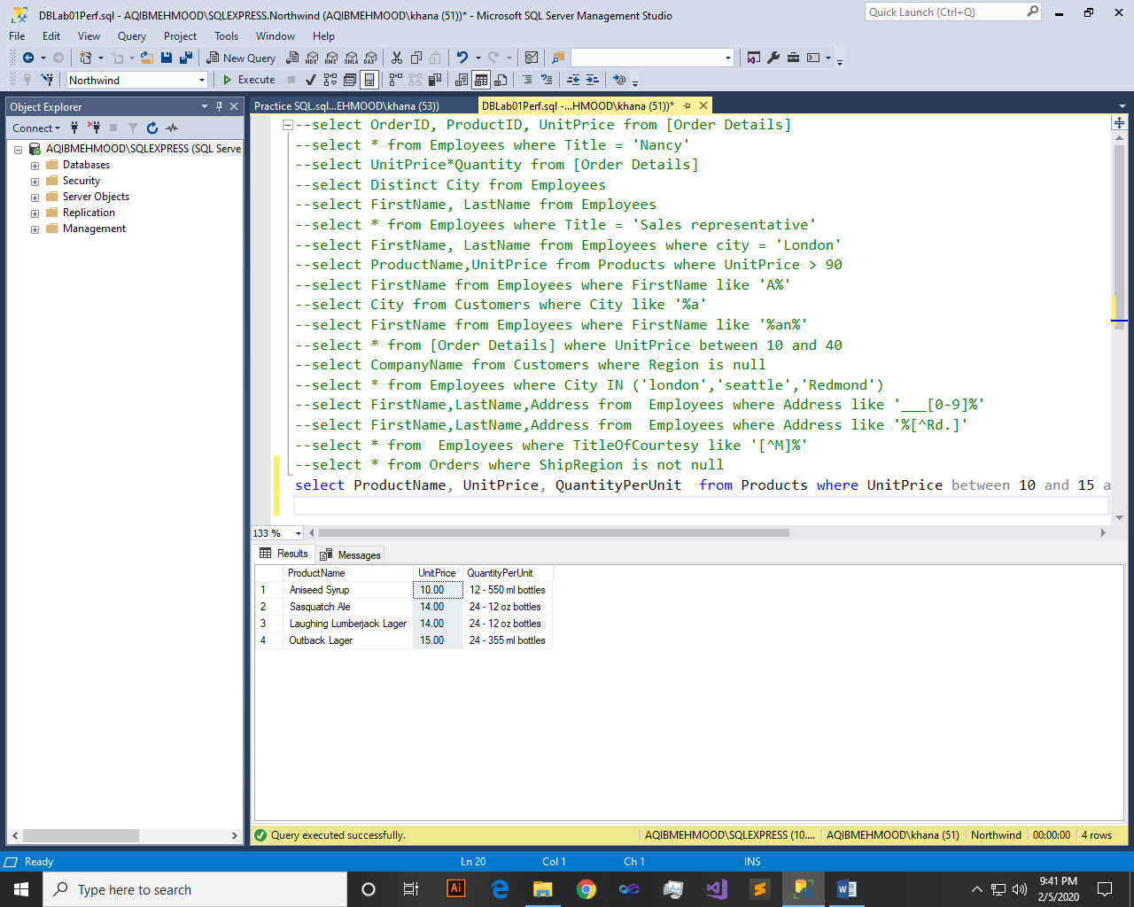

Q20: - List all products where UnitPrice is not in 10,12,15,17 or 19

Query:-

select * from Products where UnitPrice not in (10,12,15,17,19)

Result:-

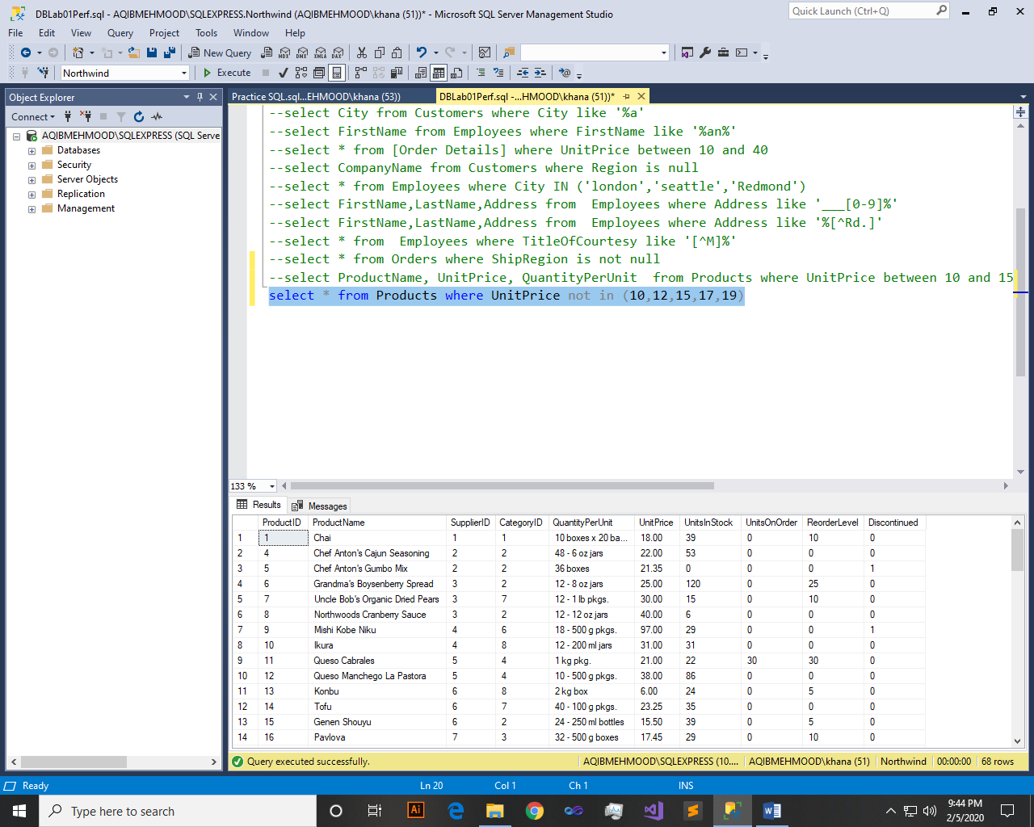

~~~~~~**/**THE END**/**~~~~~~