Q1: - Get shipper’s Company Name for an order using inner join. (Display only orderID from orders and comapnayName from Customers table)

Query:-

select Orders.OrderID,Customers.CompanyName from Customers inner join Orders on Customers.CustomerID=Orders.CustomerID

Result:-

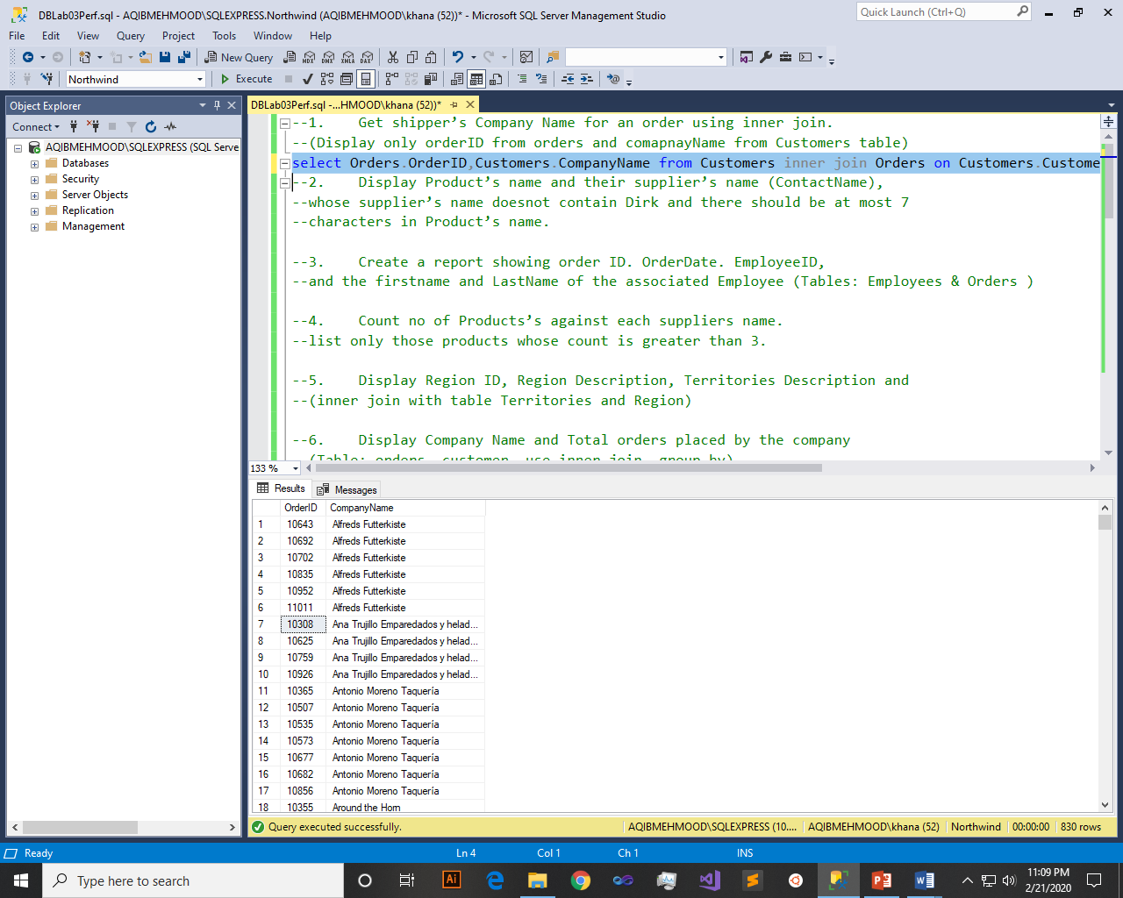

Q2: - Display Product’s name and their supplier’s name (ContactName), whose supplier’s name doesnot contain Dirk and there should be at most 7 characters in Product’s name.

Query:-

select Products.ProductName,Suppliers.ContactName from Suppliers inner join Products on Products.SupplierID=Suppliers.SupplierID where ContactName not like 'Dirk' and len(ProductName)<=7

Result:-

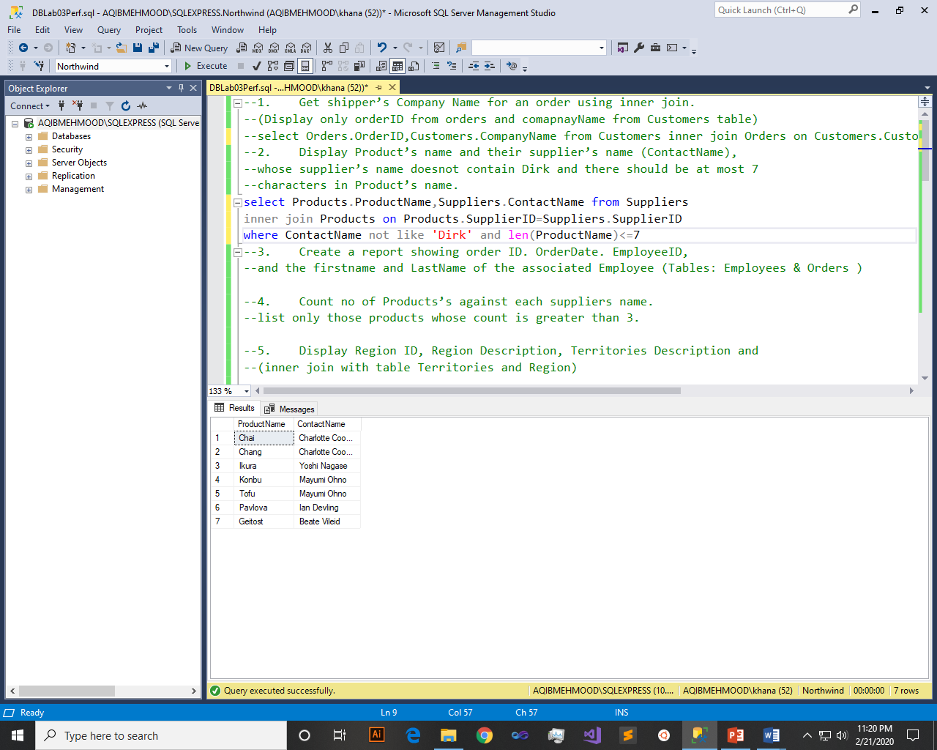

Q3: - Create a report showing order ID. OrderDate. EmployeeID, and the firstname and LastName of the associated Employee (Tables: Employees & Orders )

Query:-

select Orders.OrderID,Orders.OrderDate,Employees.EmployeeID,Employees.FirstName,Employees.LastName from Employees inner join Orders on Orders.EmployeeID=Employees.EmployeeID

Result:-

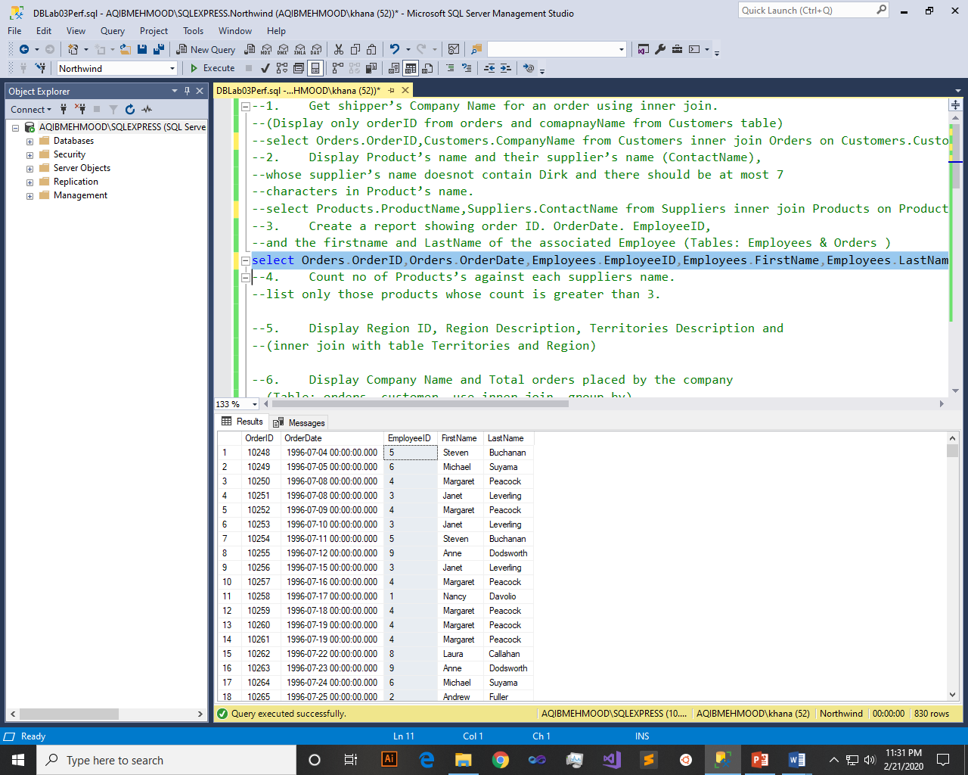

Q4: - Count no of Products’s against each suppliers name. list only those products whose count is greater than 3.

Query:-

select Suppliers.ContactName,count(Products.ProductID) as No_of_Products from Suppliers inner join Products on Products.SupplierID=Suppliers.SupplierID group by Suppliers.ContactName having count(Products.ProductID)>3

Result:-

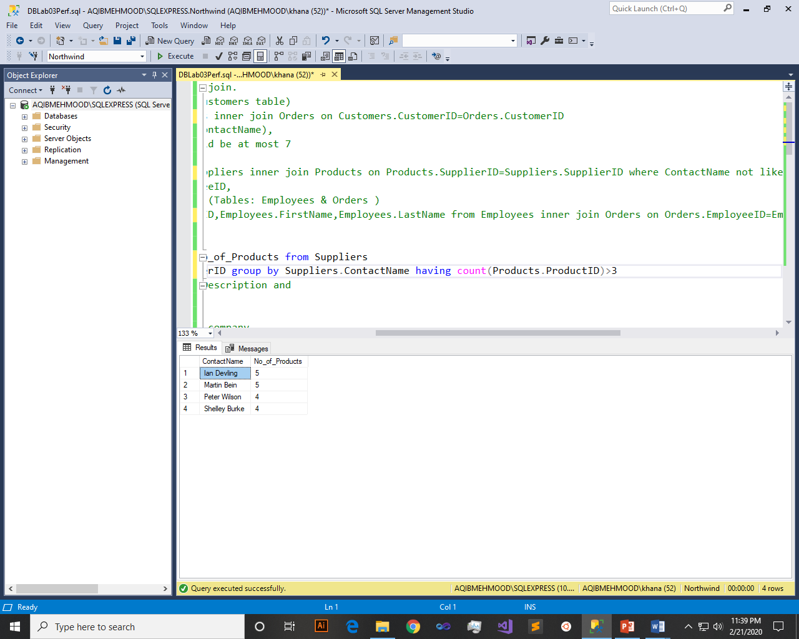

Q5: - Display Region ID, Region Description, Territories Description and (inner join with table Territories and Region)

Query:-

select Region.RegionID,Region.RegionDescription,Territories.TerritoryDescription from Region inner join Territories on Region.RegionID=Territories.RegionID

Result:-

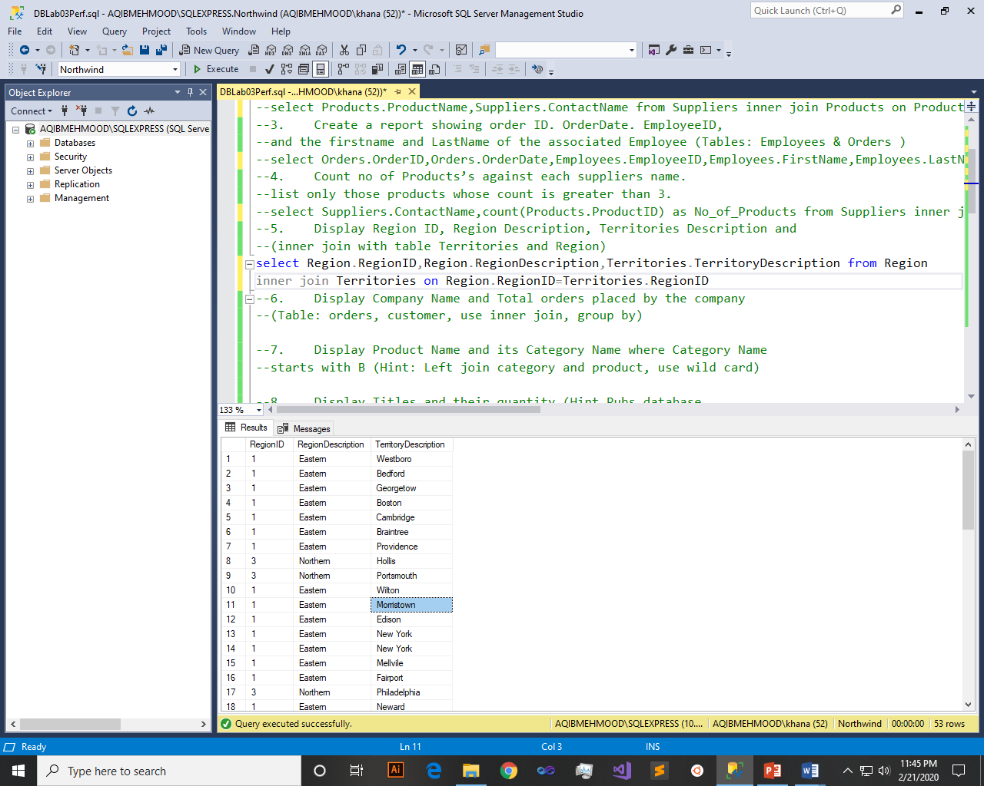

Q6: - Display Company Name and Total orders placed by the company (Table: orders, customer, use inner join, group by)

Query:-

select Customers.CompanyName,count(Orders.OrderID) as Total_Orders from Orders inner join Customers on Customers.CustomerID=Orders.CustomerID group by CompanyName

Result:-

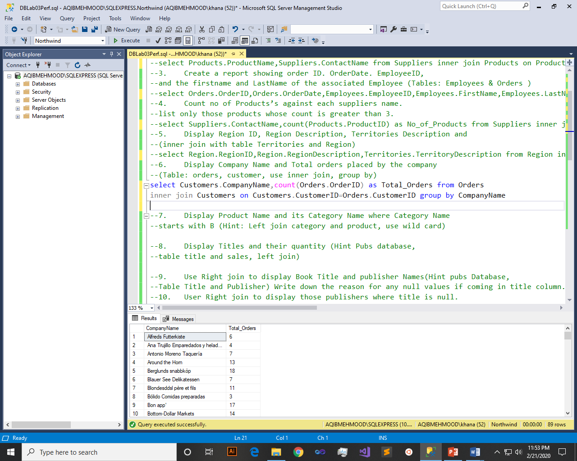

Q7: - Display Product Name and its Category Name where Category Name starts with B (Hint: Left join category and product, use wild card)

Query:-

select p.ProductName,c.CategoryName from Products p left join Categories c on c.CategoryID=p.CategoryID where c.CategoryName like 'B%'

Result:-

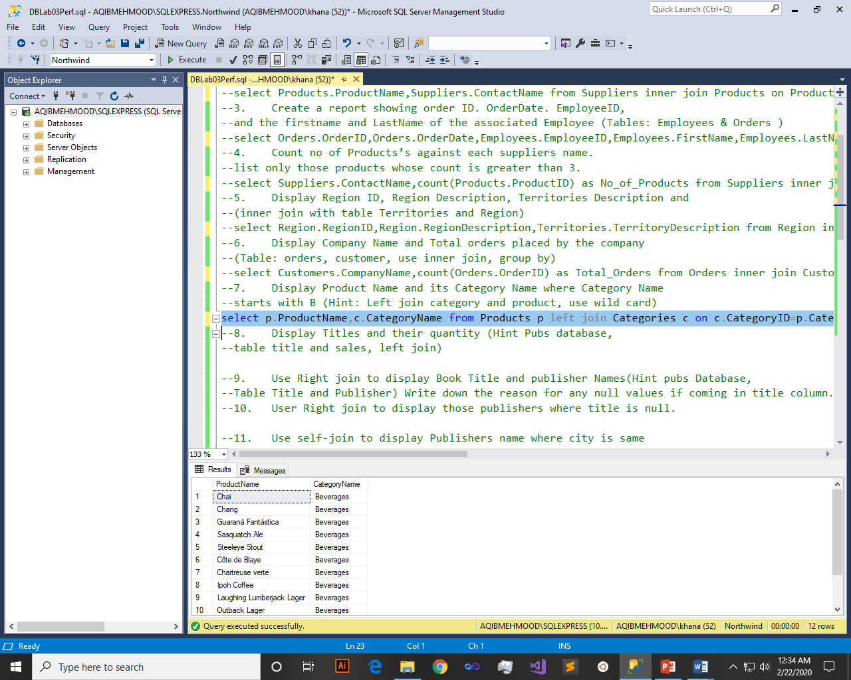

Q8: - Display Titles and their quantity (Hint Pubs database, table title and sales, left join)

Query:-

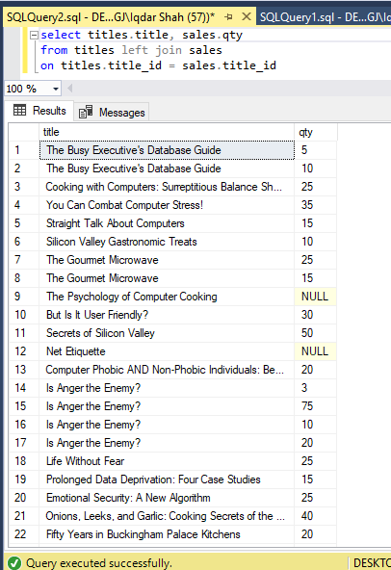

Result:-



Q9: - Use Right join to display Book Title and publisher Names (Hint pubs Database, Table Title and Publisher) Write down the reason for any null values if coming in title column.

Query:-

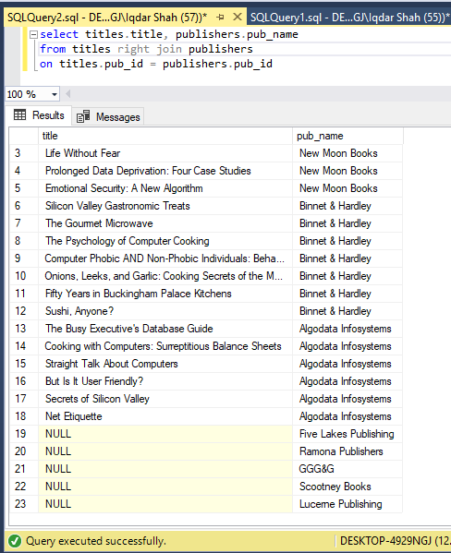

Result:-



Q10: - User Right join to display those publishers where title is null.

Query:-

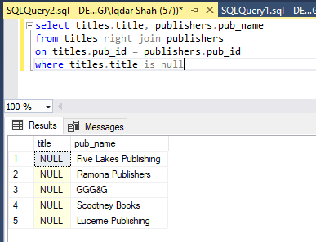

Result:-



Q11: - Use self-join to display Publishers name where city is same (Publisher id should be different) Sample example

Query:-

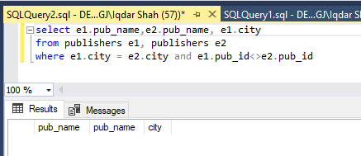

Result:-



Q12: - Use cross join (Cartesian join) to Display Book Title and Publisher Name.

Query:-

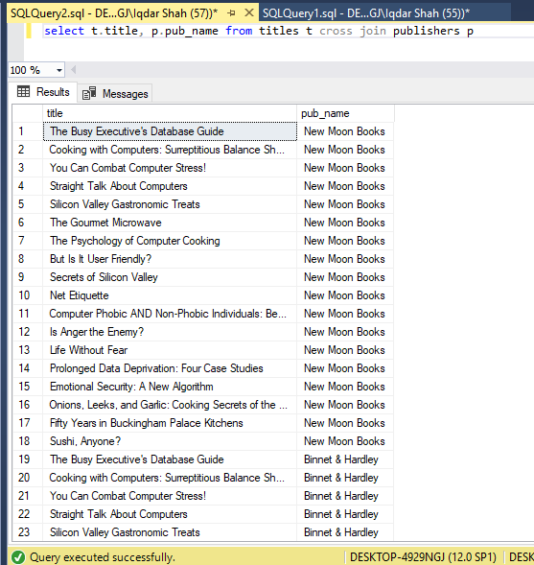

Result:-



Q13: - Use two full joins to Display Product Name, Category Name and Supplier Name (Hint: Below Example)

Query:-

select p.ProductName,c.CategoryName,s.ContactName from Products p full join Categories c on p.CategoryID=c.CategoryID full join Suppliers s on s.SupplierID=p.SupplierID

Result:-

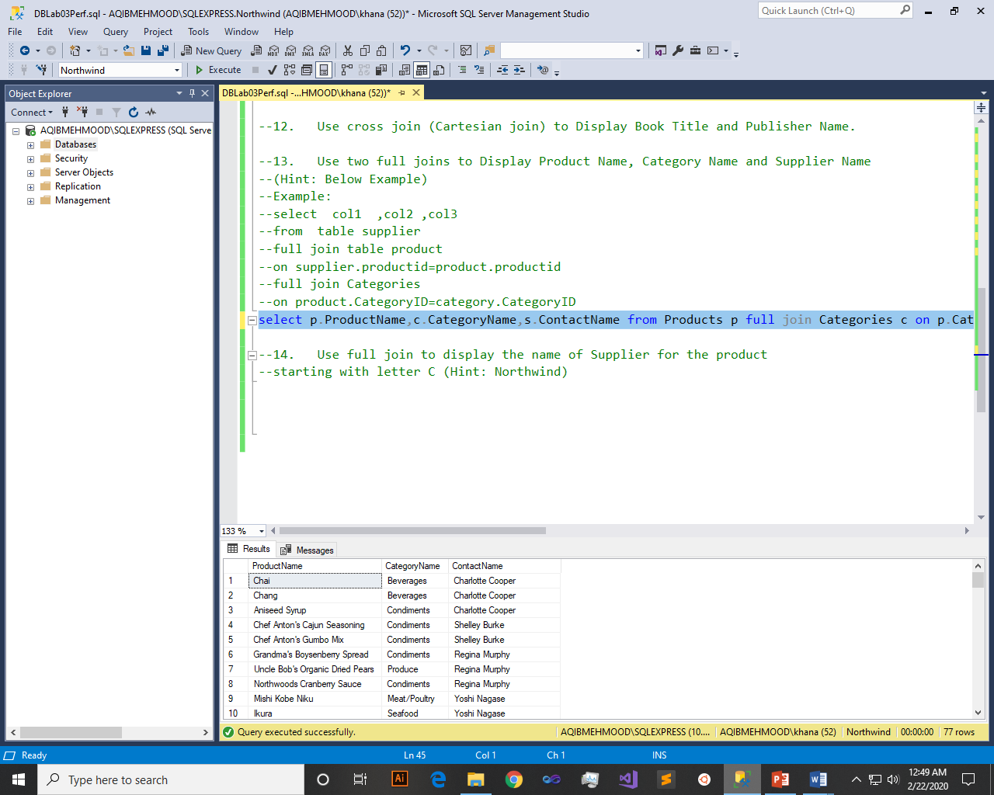

Q14: - Use full join to display the name of Supplier for the product starting with letter C (Hint: Northwind)

Query:-

select s.ContactName,p.ProductName from Suppliers s full join Products p on p.SupplierID=s.SupplierID where s.ContactName like 'C%'

Result:-

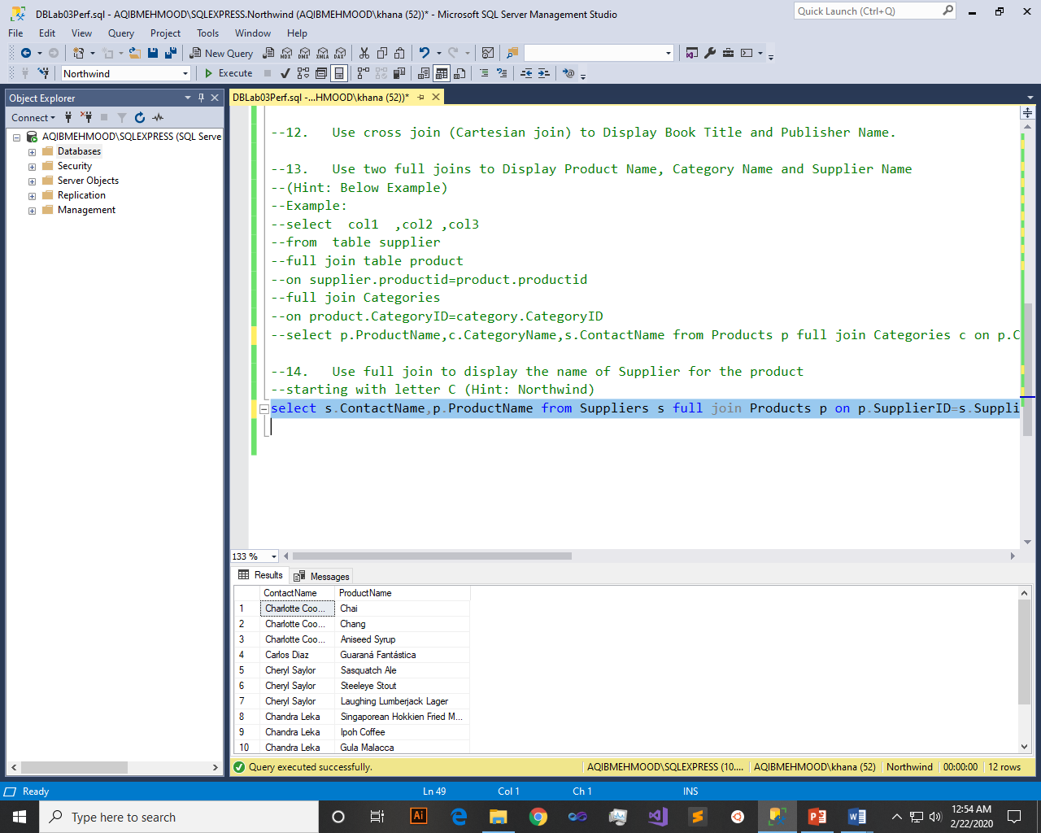

~~~~~~**/**THE END**/**~~~~~~