Q1: - Write a query to list the names of employees that belongs to the same location as the employee named Nancy.

Query:-

select E1.FirstName,E2.FirstName,E1.City from Employees as E1,Employees as E2 where e1.City=e2.City and e1.FirstName='nancy' and e2.FirstName!=e1.FirstName

Result:-

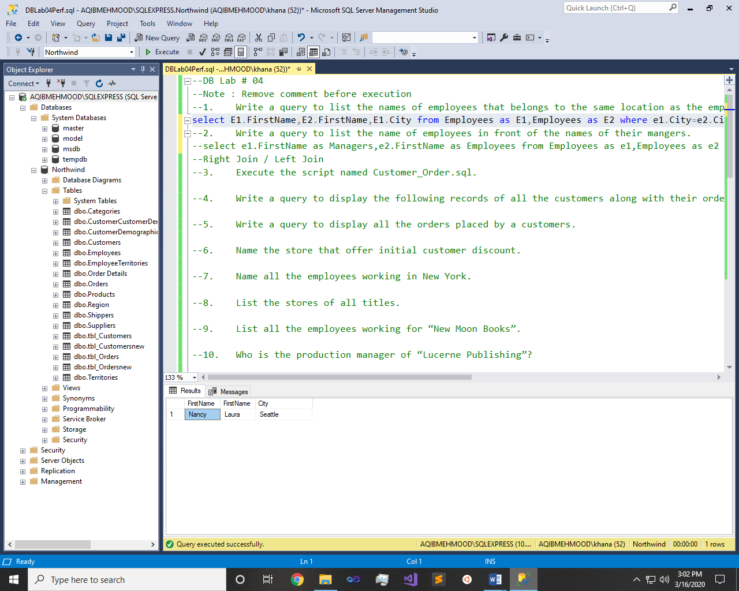

Q2: - Write a query to list the name of employees in front of the names of their mangers.

Query:-

select e1.FirstName as Managers,e2.FirstName as Employees from Employees as e1,Employees as e2 where e1.EmployeeID=e2.ReportsTo

Result:-

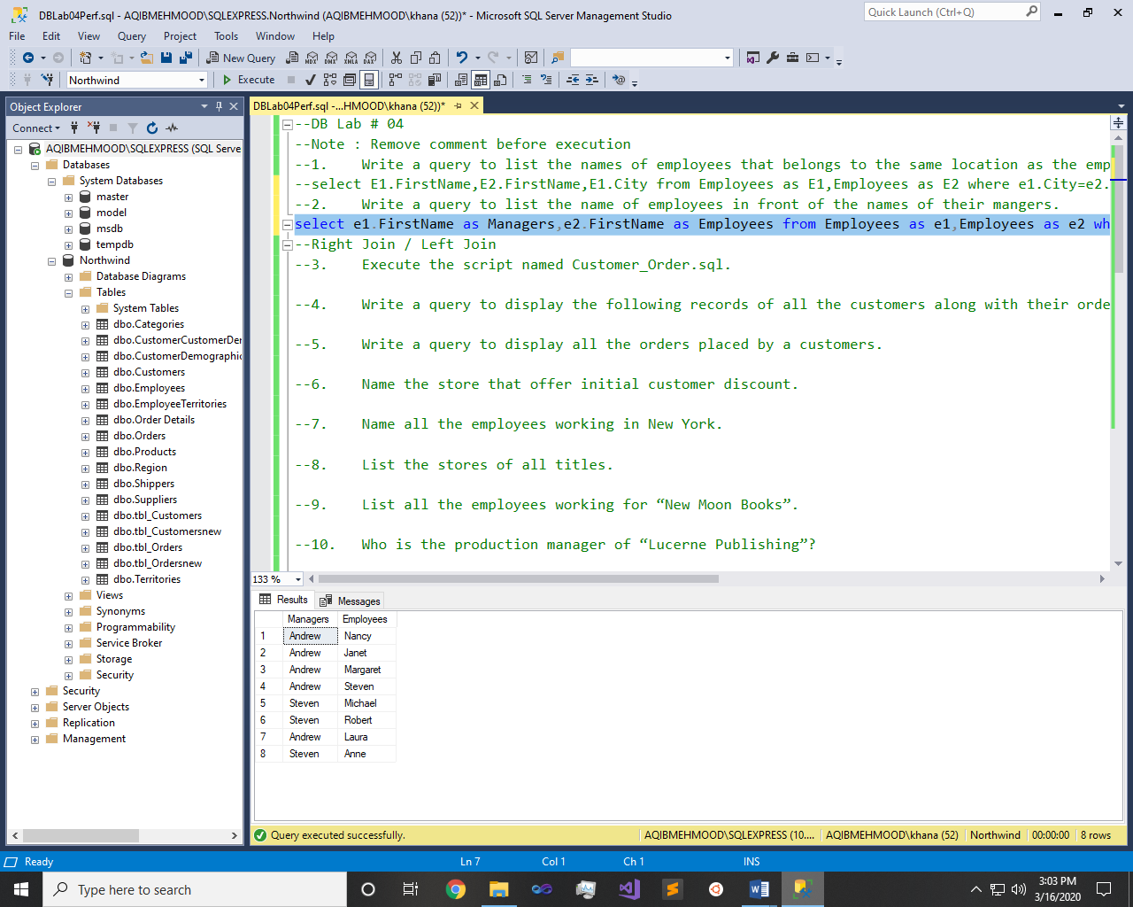

Q3: - Execute the script named Customer_Order.sql.

Result:-

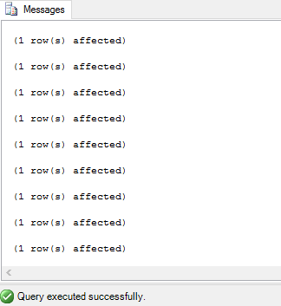

Q4: - Write a query to display the following records of all the customers along with their order details (if any).

Query:-

select distinct ID,OID,Name,Amount,Date from tbl_Customers left join tbl_Orders on tbl_Customers.ID=tbl_Orders.Customer_Id

Result:-

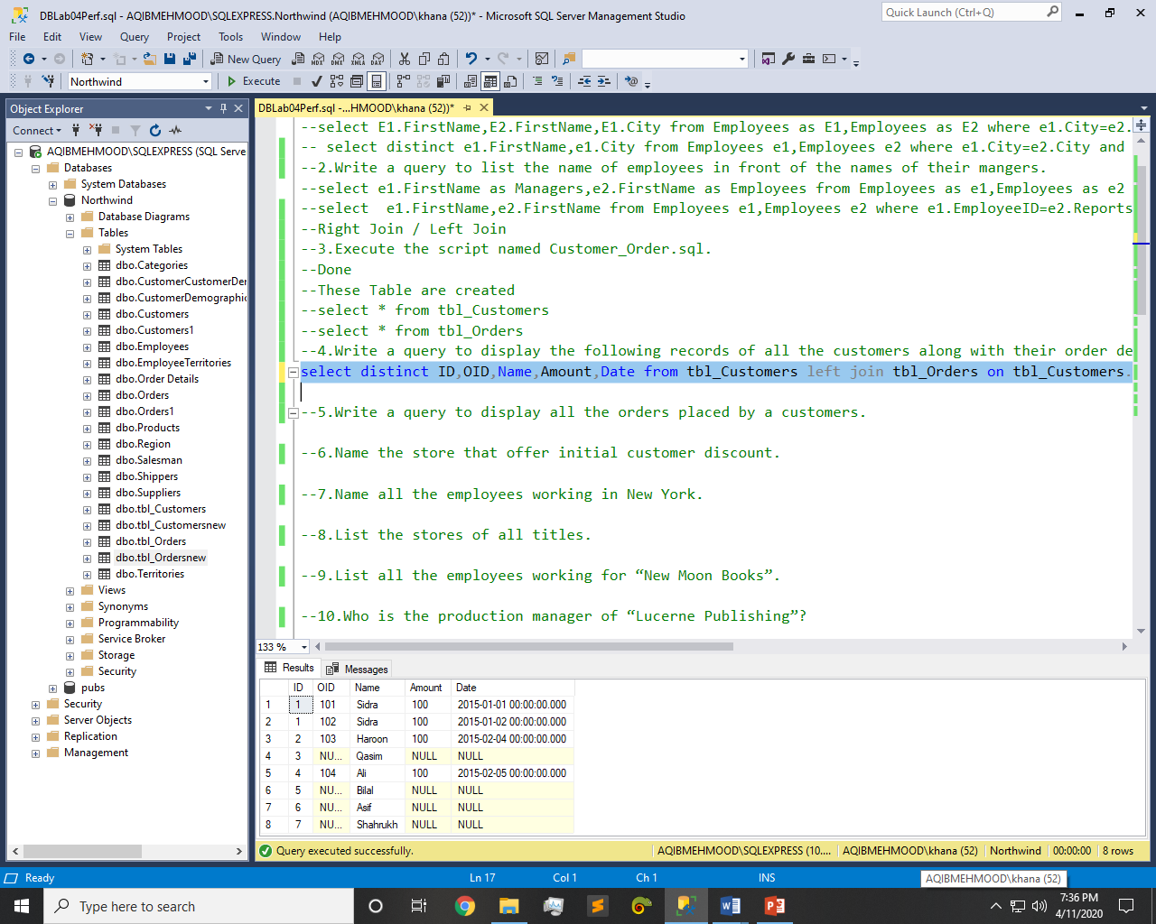

Q5: - Write a query to display all the orders placed by a customers.

Query:-

select distinct Name,OID,ID,Amount,Date from tbl_Orders left join tbl_Customers on tbl_Orders.Customer_Id=tbl_Customers.ID

Result:-

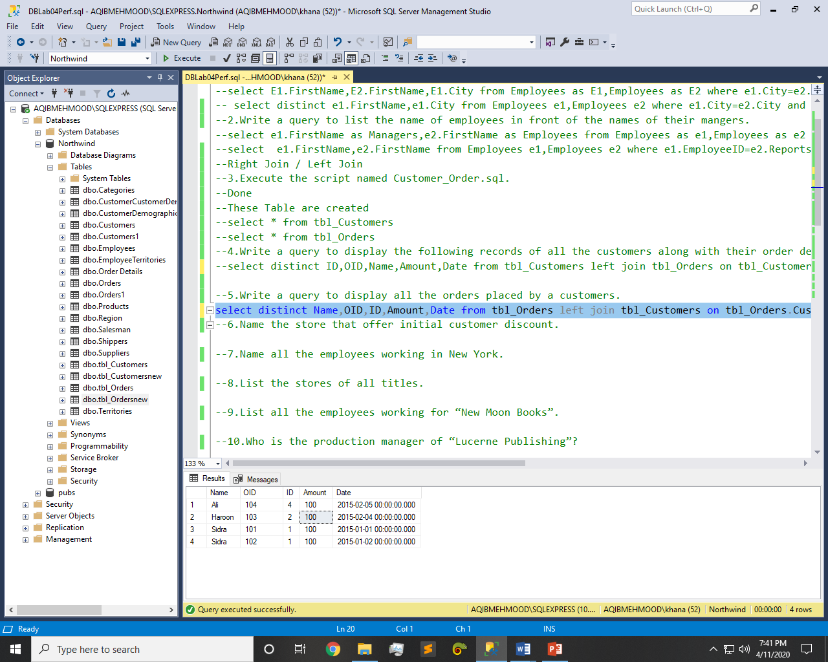

Q6: - Name the store that offer initial customer discount.

Query:-

select discounttype,stores.stor_name from discounts left join stores on discounts.stor_id=stores.stor_id where discounttype='Initial Customer'

Result:-

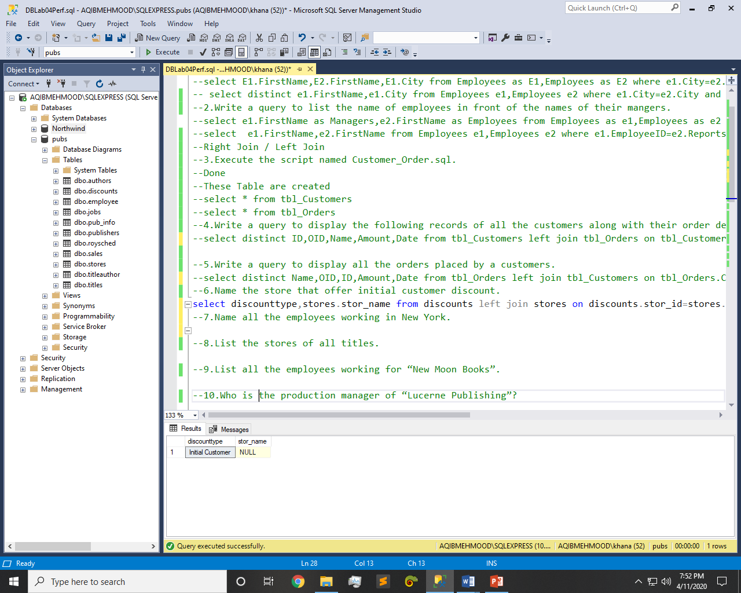

Q7: - Name all the employees working in New York.

Query:-

select fname,publishers.city from employee left join publishers on publishers.pub_id=employee.pub_id where publishers.city='New York'

Result:-

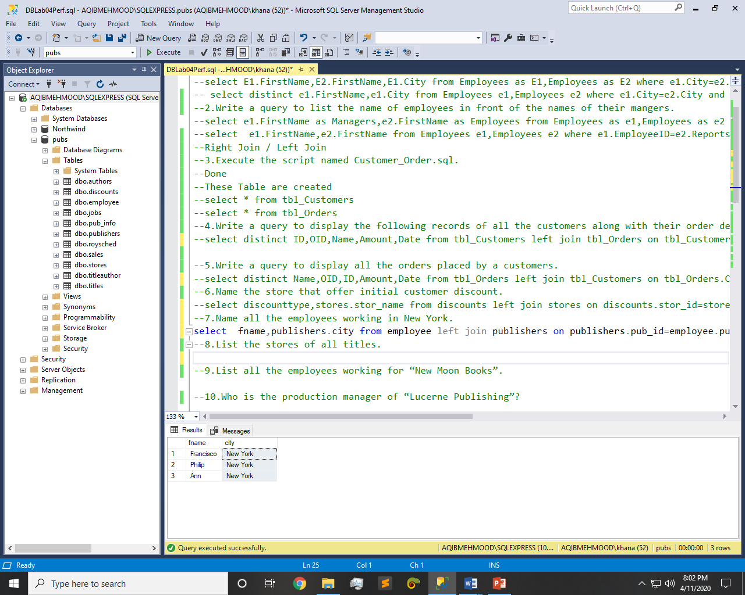

Q8: - List the stores of all titles.

Query:-

select titles.title,stores.stor_name from titles left join sales on titles.title_id=sales.title_id left join stores on stores.stor_id=sales.stor_id

Result:-

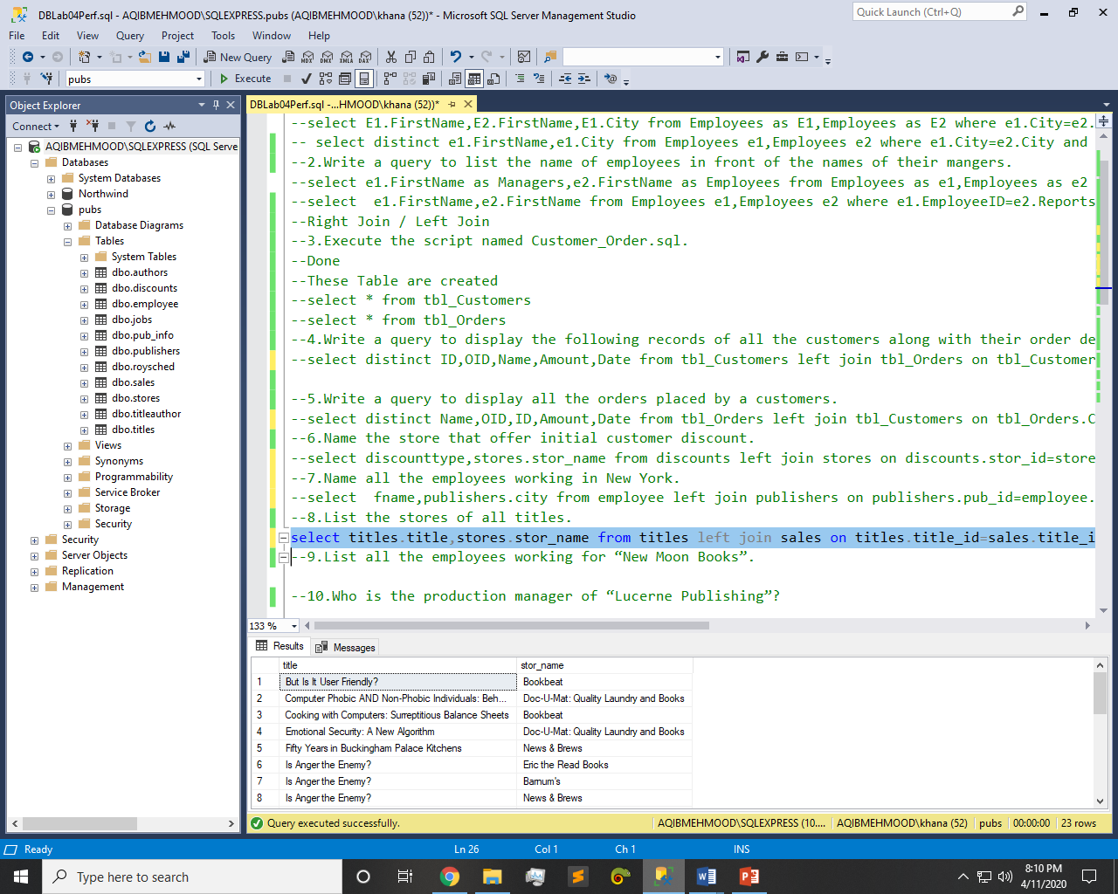

Q9: - List all the employees working for “New Moon Books”.

Query:-

select employee.fname,publishers.pub_name from publishers left join employee on publishers.pub_id=employee.pub_id where publishers.pub_name='New Moon Books'

Result:-

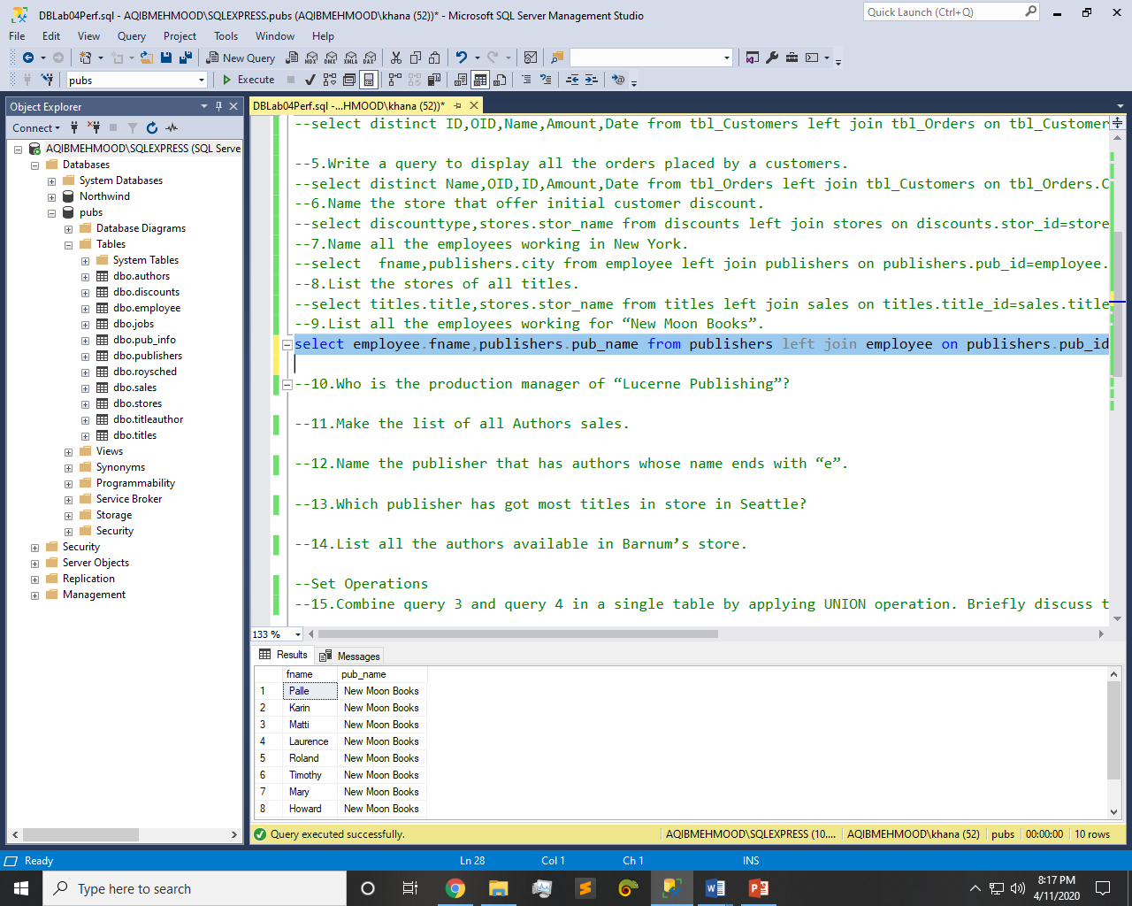

Q10: - Who is the production manager of “Lucerne Publishing”?

Query:-

select distinct fname+' '+lname as Manager, pub_name from publishers left join employee on publishers.pub_id=employee.pub_id where pub_name='Lucerne Publishing'

Result:-

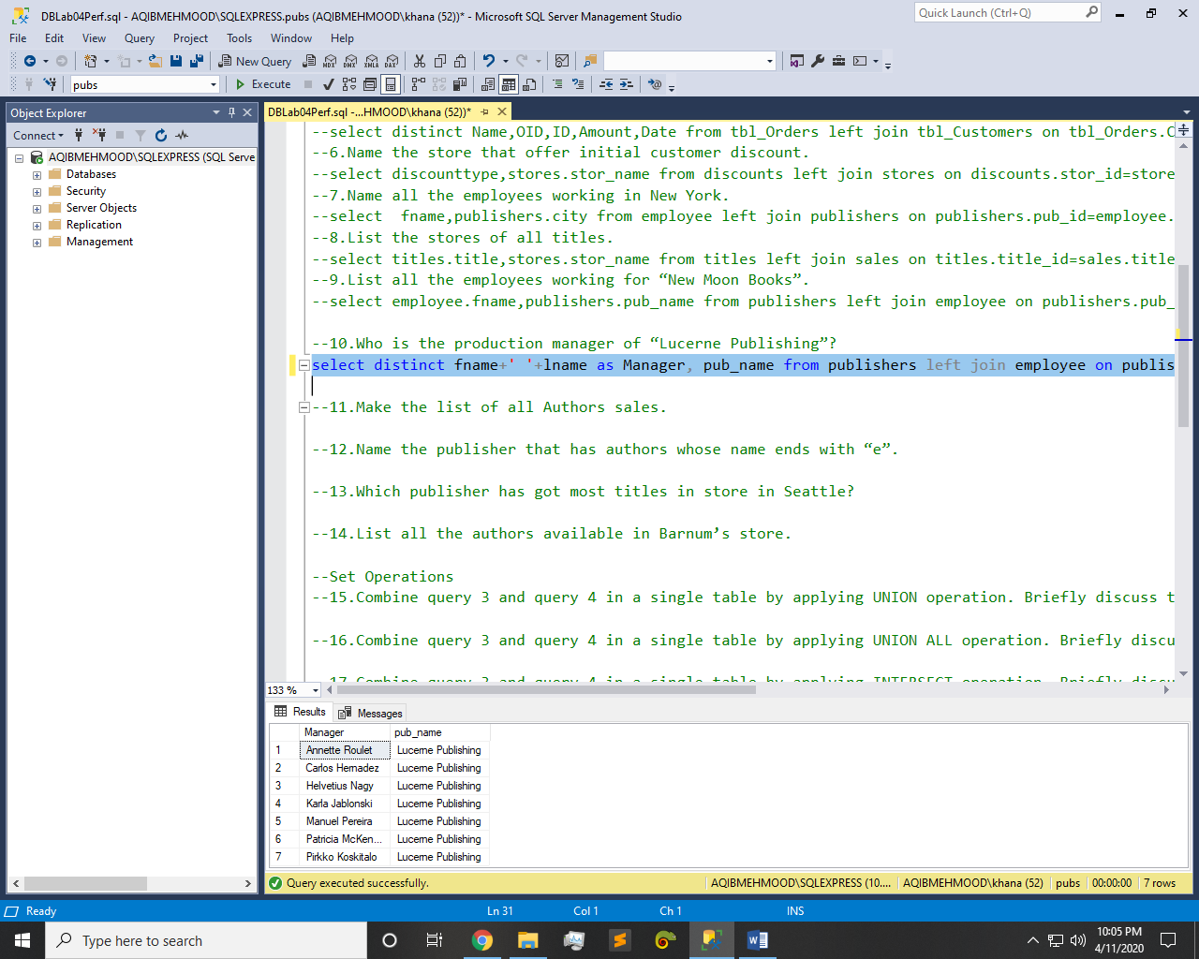

Q11: - Make the list of all Authors sales.

Query:-

select ord_num,ord_date,qty,payterms from sales left join titles on sales.title_id=titles.title_id left join titleauthor on titleauthor.title_id=titles.title_id left join authors on authors.au_id=titleauthor.au_id

Result:-

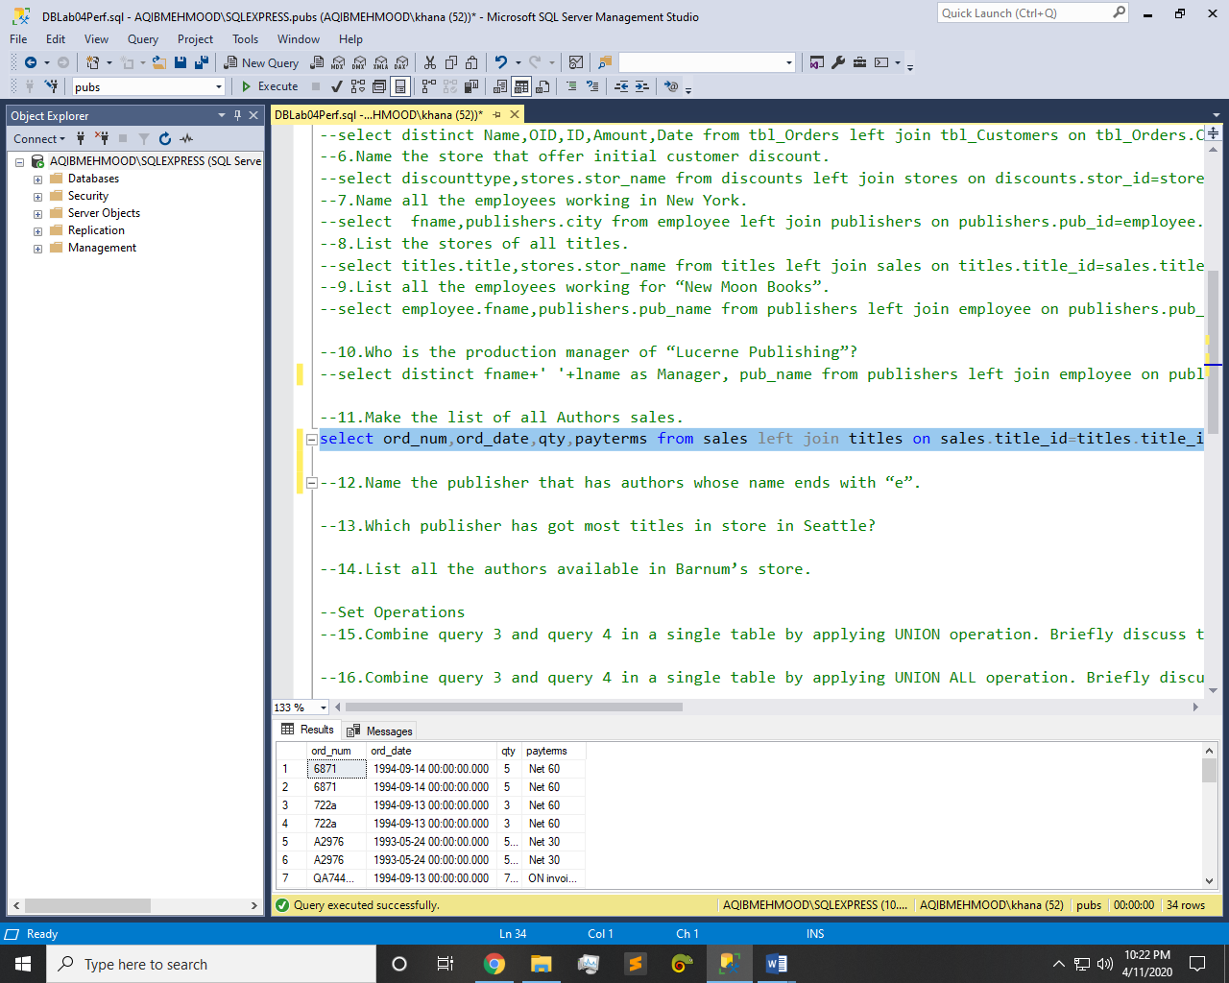

Q12: - Name the publisher that has authors whose name ends with “e”.

Query:-

select au_fname,publishers.pub_name from authors left join titleauthor on authors.au_id=titleauthor.au_id left join titles on titleauthor.title_id=titles.title_id left join publishers on titles.pub_id=publishers.pub_id where authors.au_fname like '%e'

Result:-

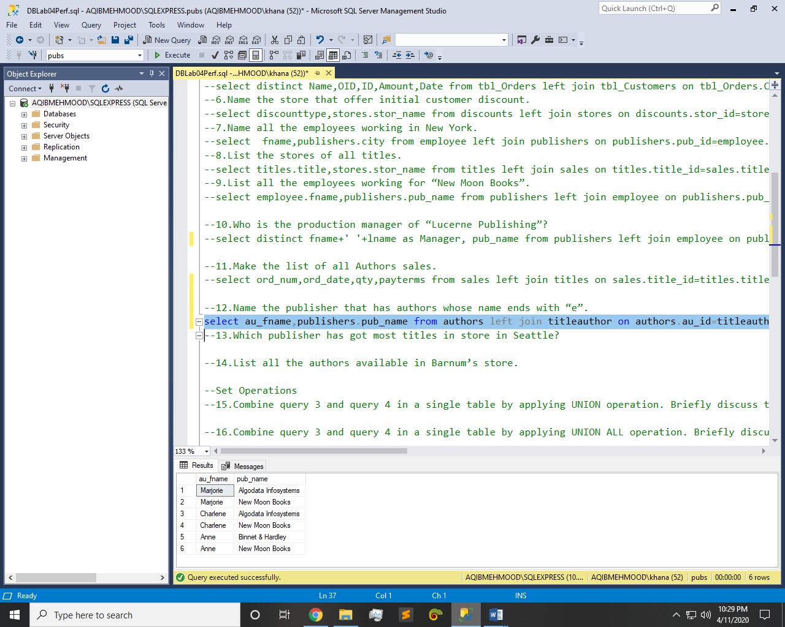

Q13: - Which publisher has got most titles in store in Seattle?

Query:-

select pub_name,stores.city from publishers left join titles on publishers.pub_id=titles.pub_id left join sales on titles.title_id=sales.title_id left join stores on sales.stor_id=stores.stor_id where stores.city='Seattle'

Result:-

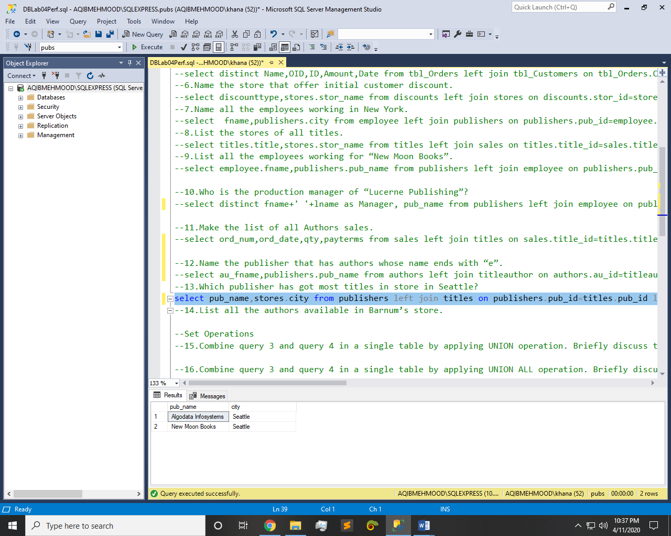

Q14: - List all the authors available in Barnum’s store.

Query:-

select stores.stor_name,authors.au_fname from stores left join sales on stores.stor_id=sales.stor_id left join titles on sales.title_id=titles.title_id left join titleauthor on titleauthor.title_id=titles.title_id left join authors on authors.au_id=titleauthor.au_id where stores.stor_name='Barnum''s'

Result:-

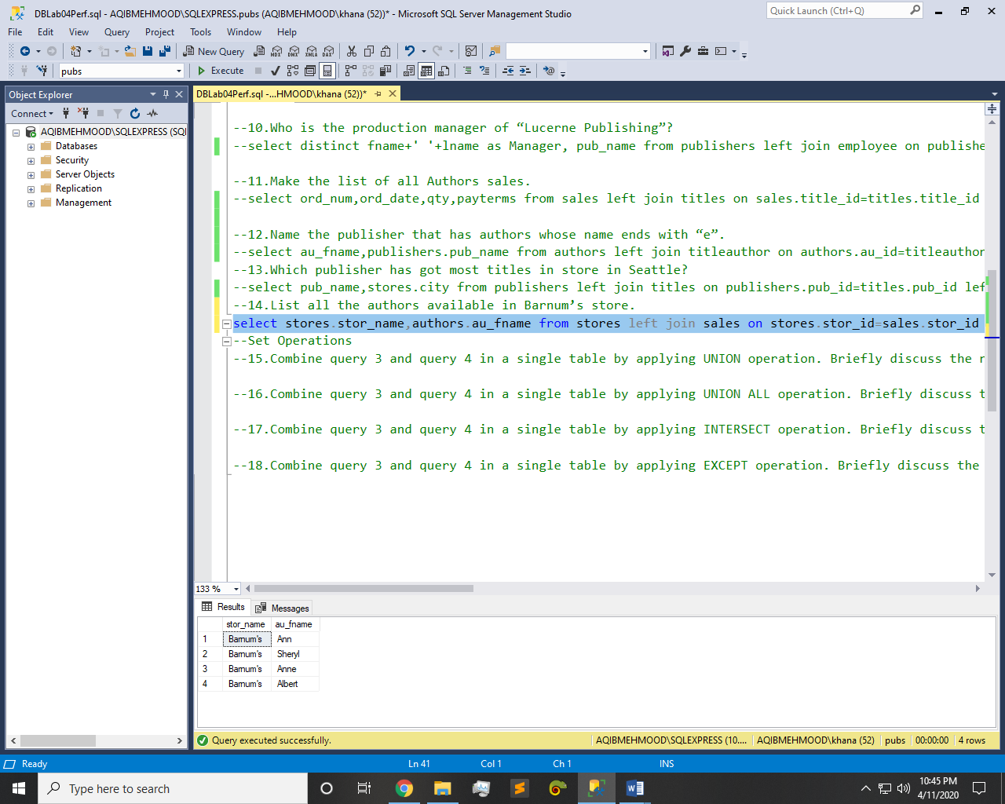

Q15: - Combine query 3 and query 4 in a single table by applying **UNION** operation. Briefly discuss the results.

Query:-

select tbl_Customers.ID,tbl_Orders.OID,tbl_Customers.Salary,tbl_Orders.Date from tbl_Customers,tbl_Orders union select tbl_Customers.ID,tbl_Orders.OID,tbl_Customers.Salary,tbl_Orders.Date from tbl_Orders,tbl_Customers

Result:-

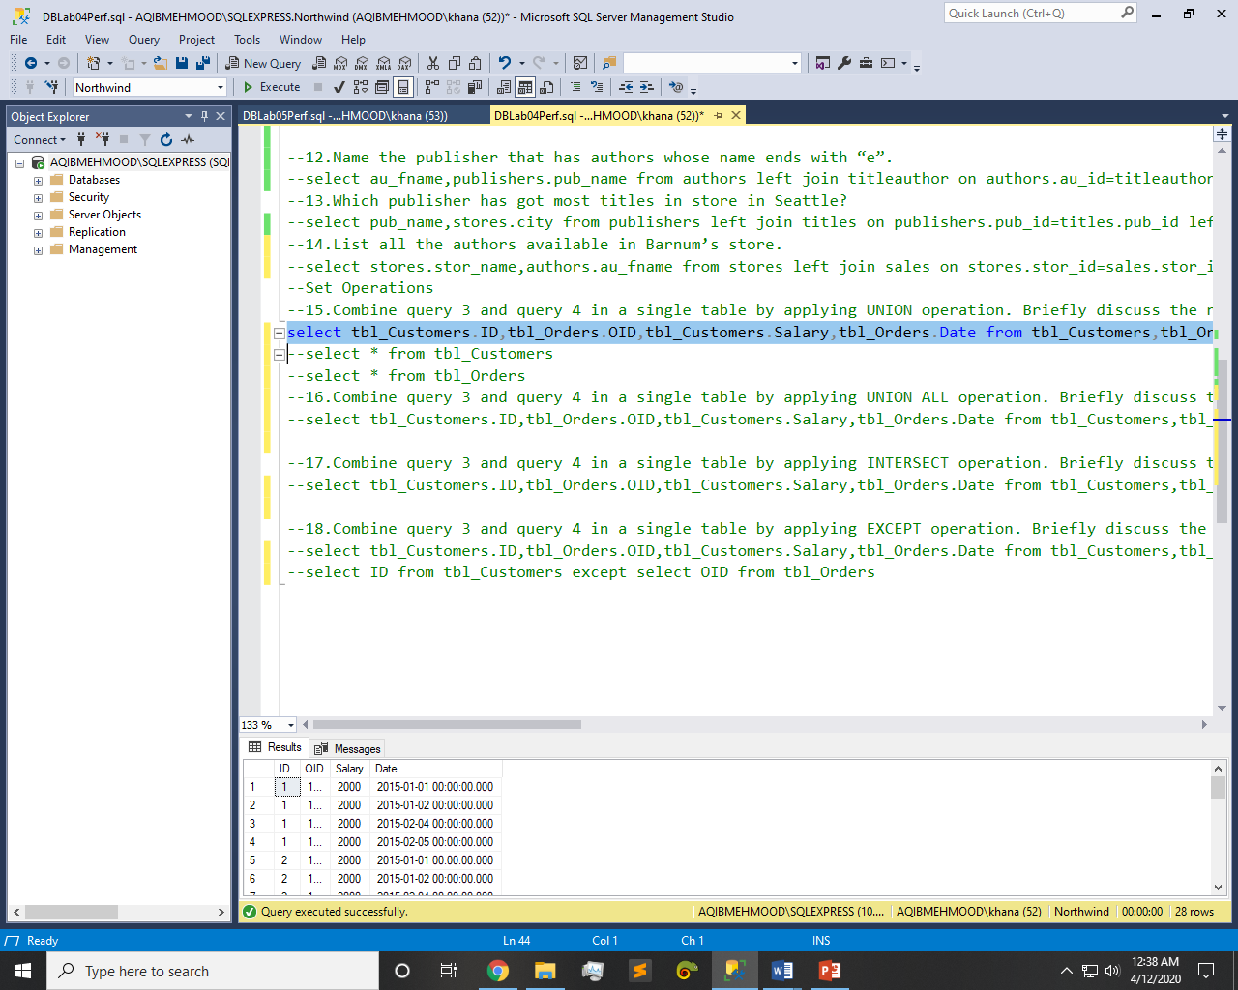

Q16: - Combine query 3 and query 4 in a single table by applying **UNION ALL** operation. Briefly discuss the results.

Query:-

select tbl_Customers.ID,tbl_Orders.OID,tbl_Customers.Salary,tbl_Orders.Date from tbl_Customers,tbl_Orders union all select tbl_Customers.ID,tbl_Orders.OID,tbl_Customers.Salary,tbl_Orders.Date from tbl_Orders,tbl_Customers

Result:-

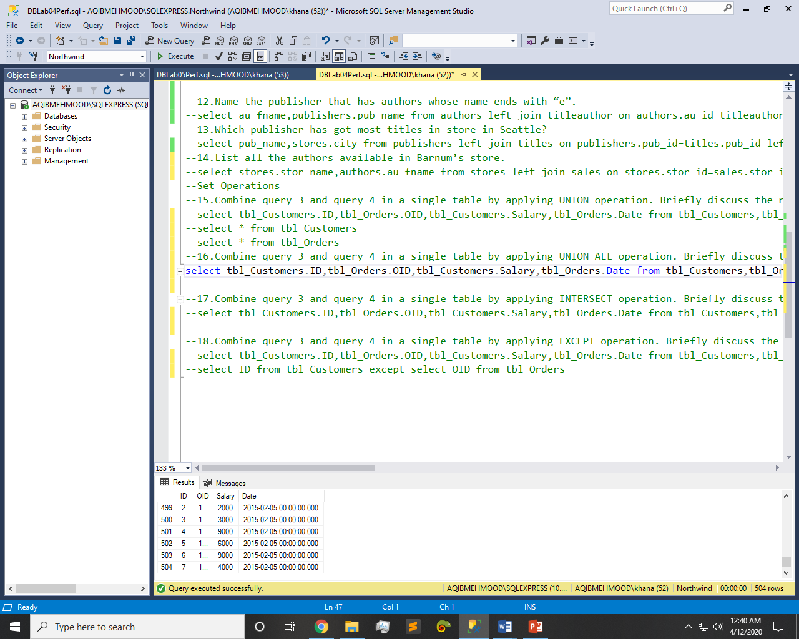

Q17: - Combine query 3 and query 4 in a single table by applying **INTERSECT** operation. Briefly discuss the results.

Query:-

select tbl_Customers.ID,tbl_Orders.OID,tbl_Customers.Salary,tbl_Orders.Date from tbl_Customers,tbl_Orders intersect select tbl_Customers.ID,tbl_Orders.OID,tbl_Customers.Salary,tbl_Orders.Date from tbl_Orders,tbl_Customers

Result:-

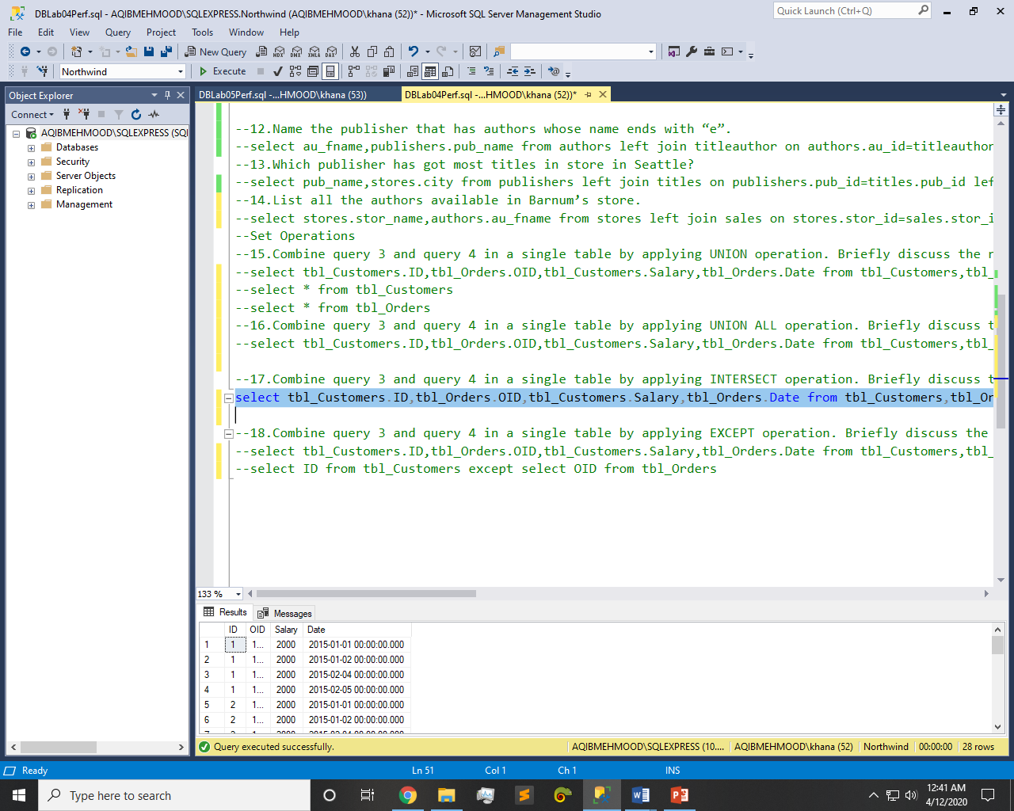

Q18: - Combine query 3 and query 4 in a single table by applying **EXCEPT** operation. Briefly discuss the results.

Query:-

select tbl_Customers.ID,tbl_Orders.OID,tbl_Customers.Salary,tbl_Orders.Date from tbl_Customers,tbl_Orders except select tbl_Customers.ID,tbl_Orders.OID,tbl_Customers.Salary,tbl_Orders.Date from tbl_Orders,tbl_Customers

Result:-

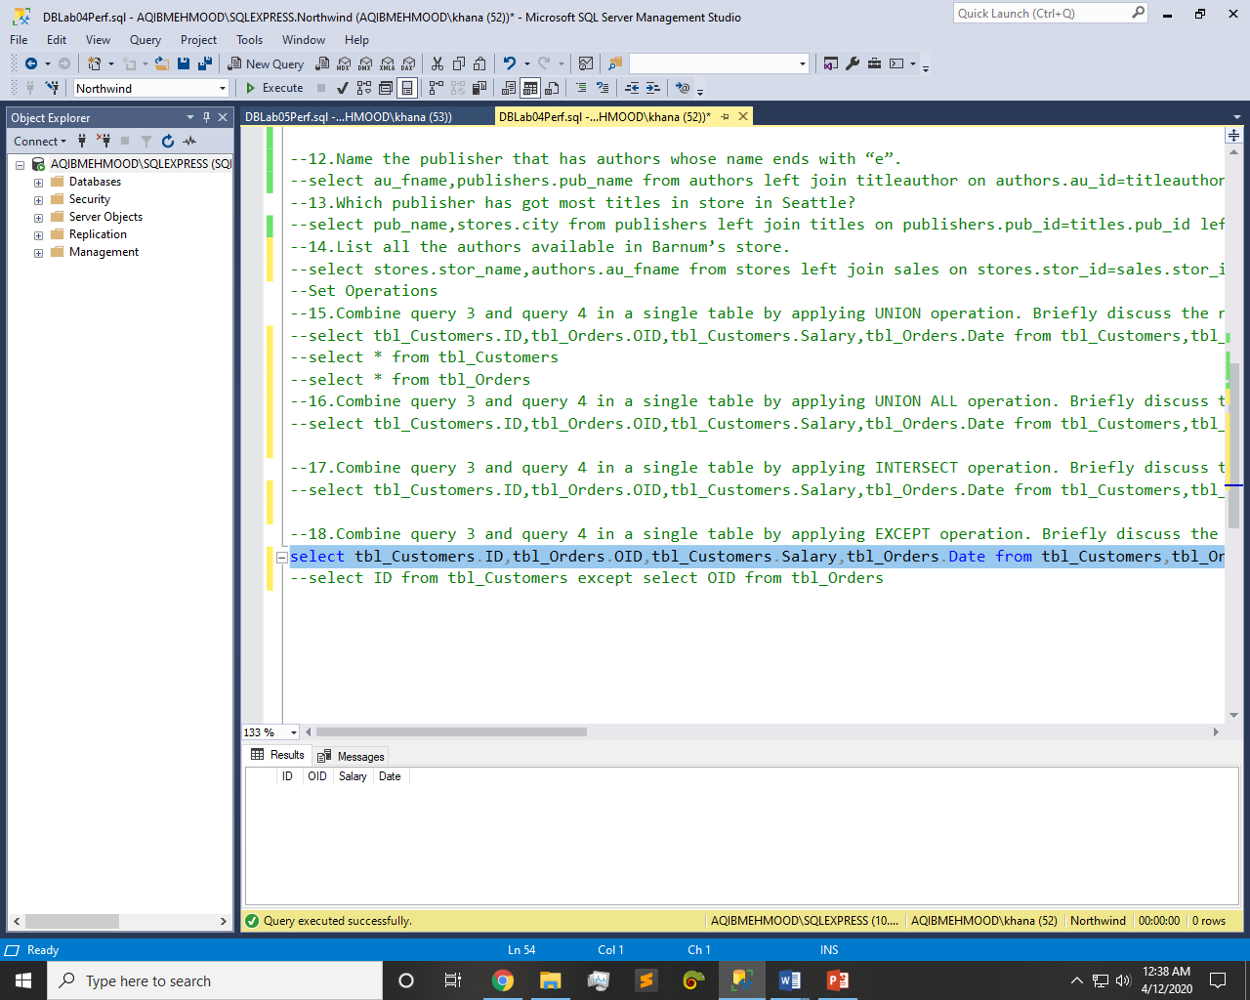

Another:-

select ID from tbl_Customers except select OID from tbl_Orders

Result:-

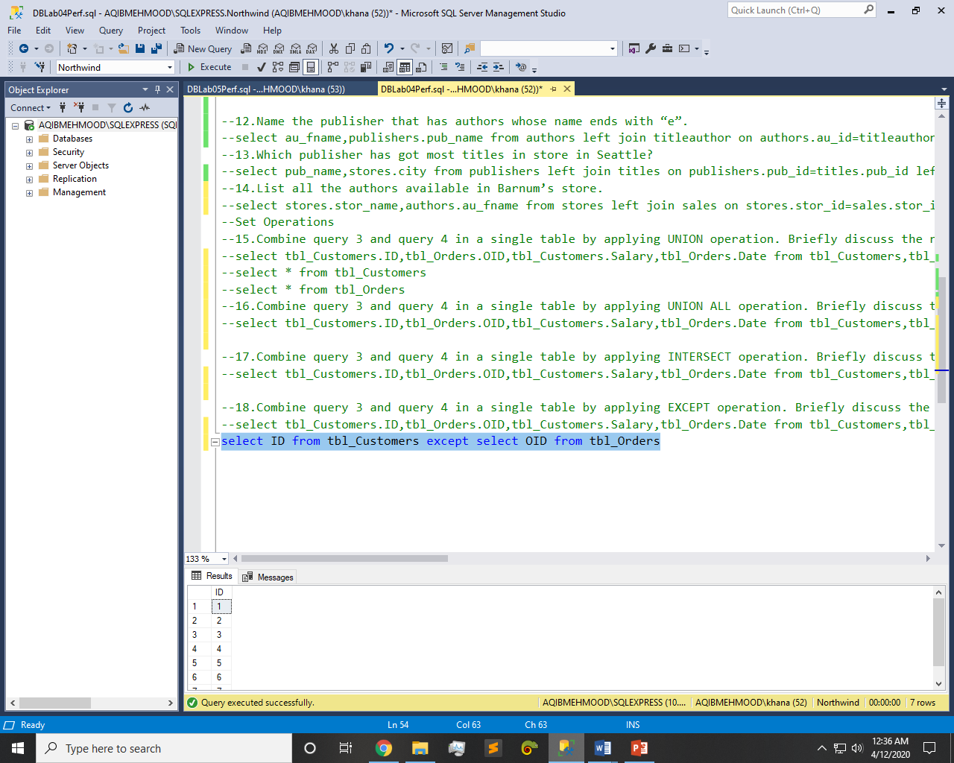

~~~~~~**/**THE END**/**~~~~~~