Q1: -

Query:-

select CustomerID,CompanyName from Customers where CustomerID = (select CustomerID from Orders where OrderID=10290)

Result:-

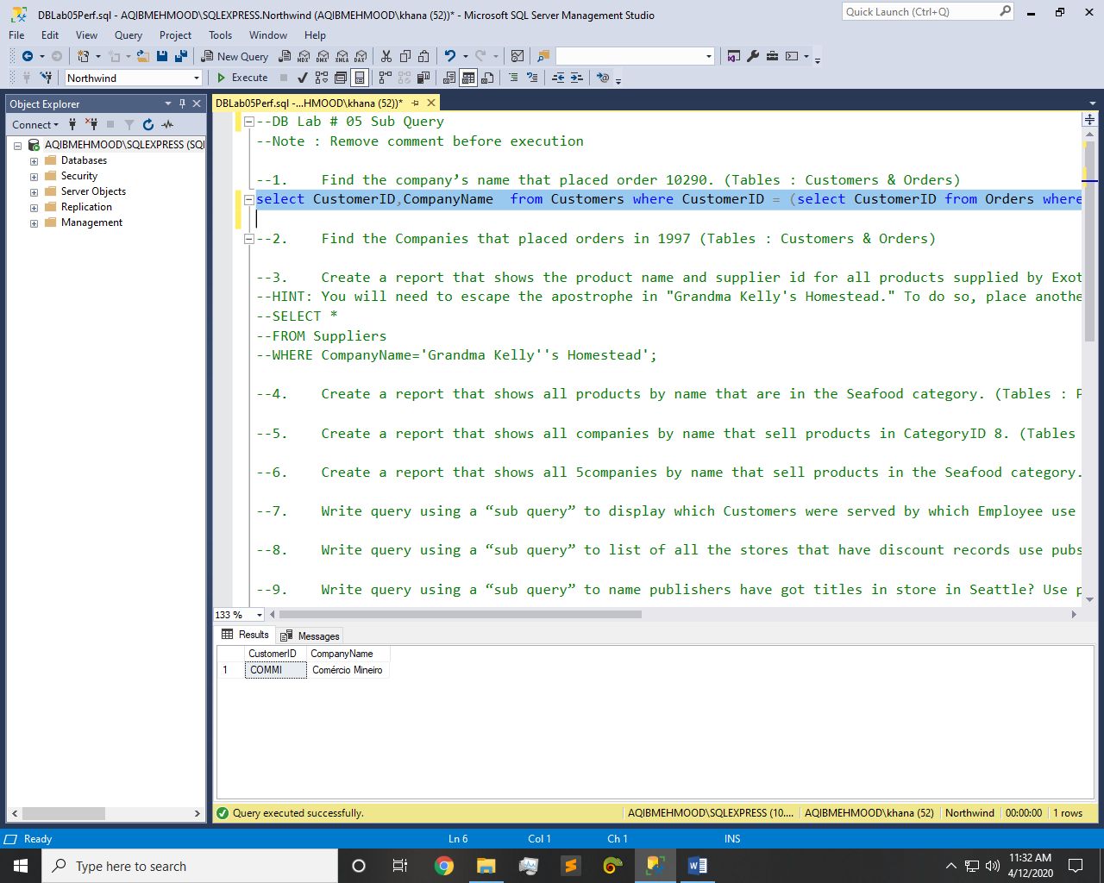

Q2: -

Query:-

select CustomerID,CompanyName from Customers where CustomerID IN (select CustomerID from Orders where DATEPART(yyyy,OrderDate)=1997)

Result:-

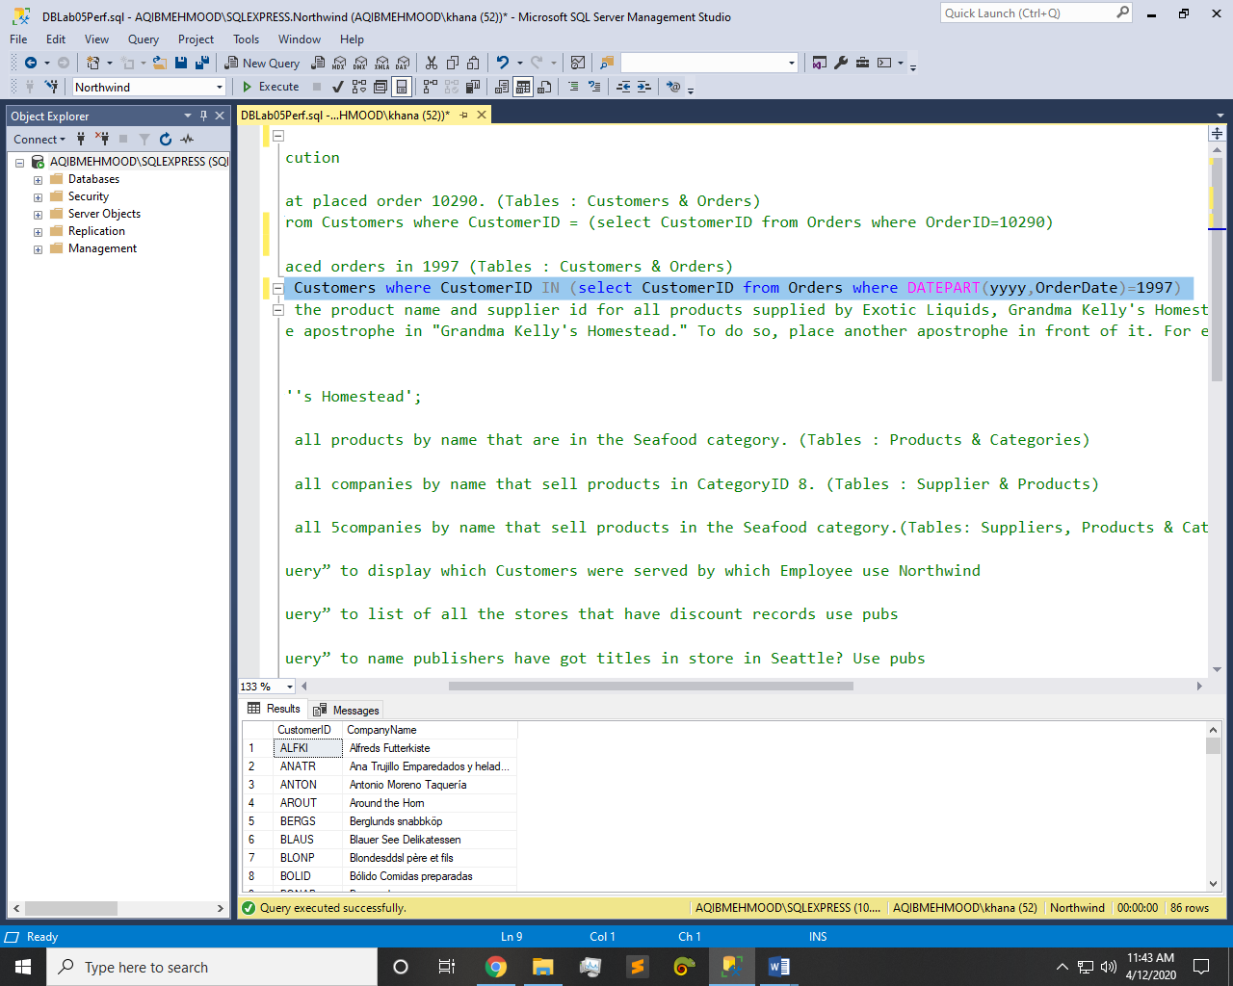

Q3: -

Query:-

select SupplierID,ProductName from Products where SupplierID in (select Suppliers.SupplierID from Suppliers where CompanyName IN('Exotic Liquids','Grandma Kelly''s Homestead','Tokyo Traders'))

Result:-

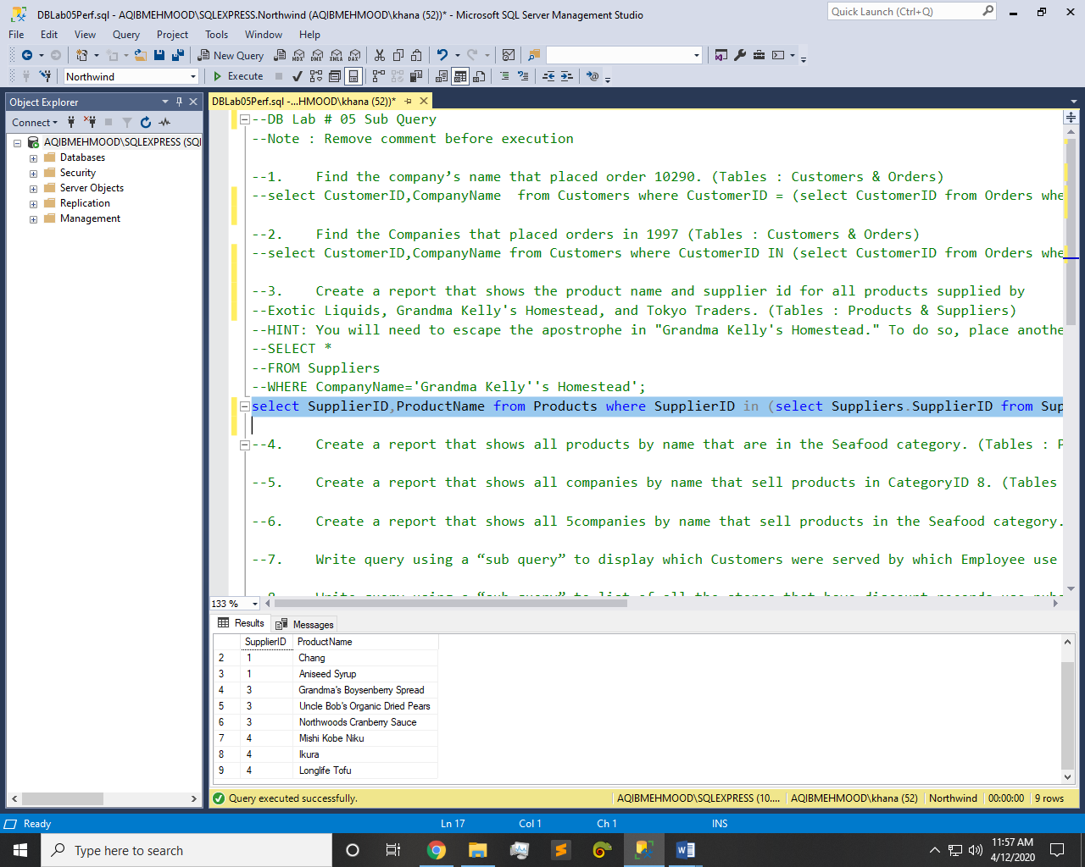

Q4: -

Query:-

select ProductName from Products where CategoryID = (select CategoryID from Categories where CategoryName='Seafood')

Result:-

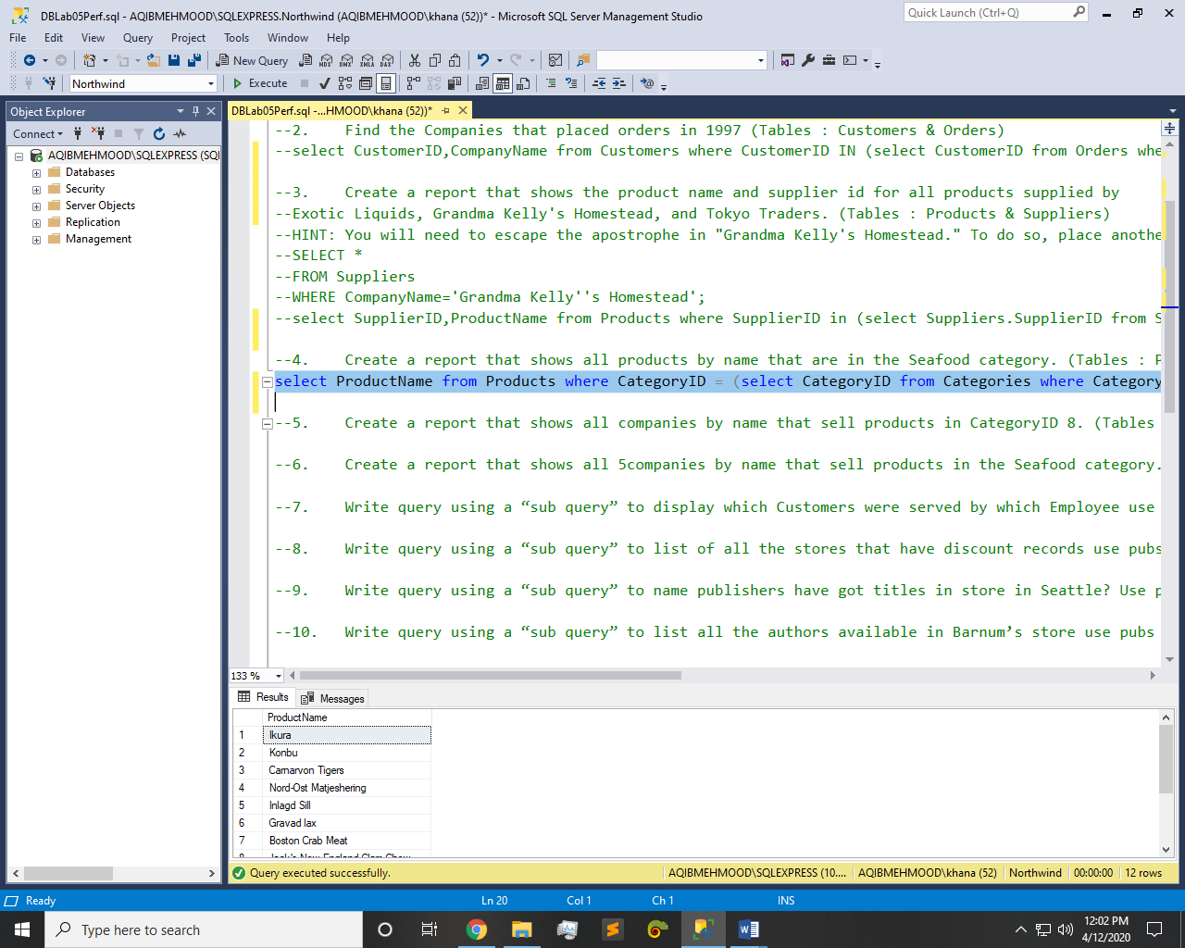

Q5: -

Query:-

select CompanyName from Suppliers where SupplierID in (select SupplierID from Products where CategoryID=8)

Result:-

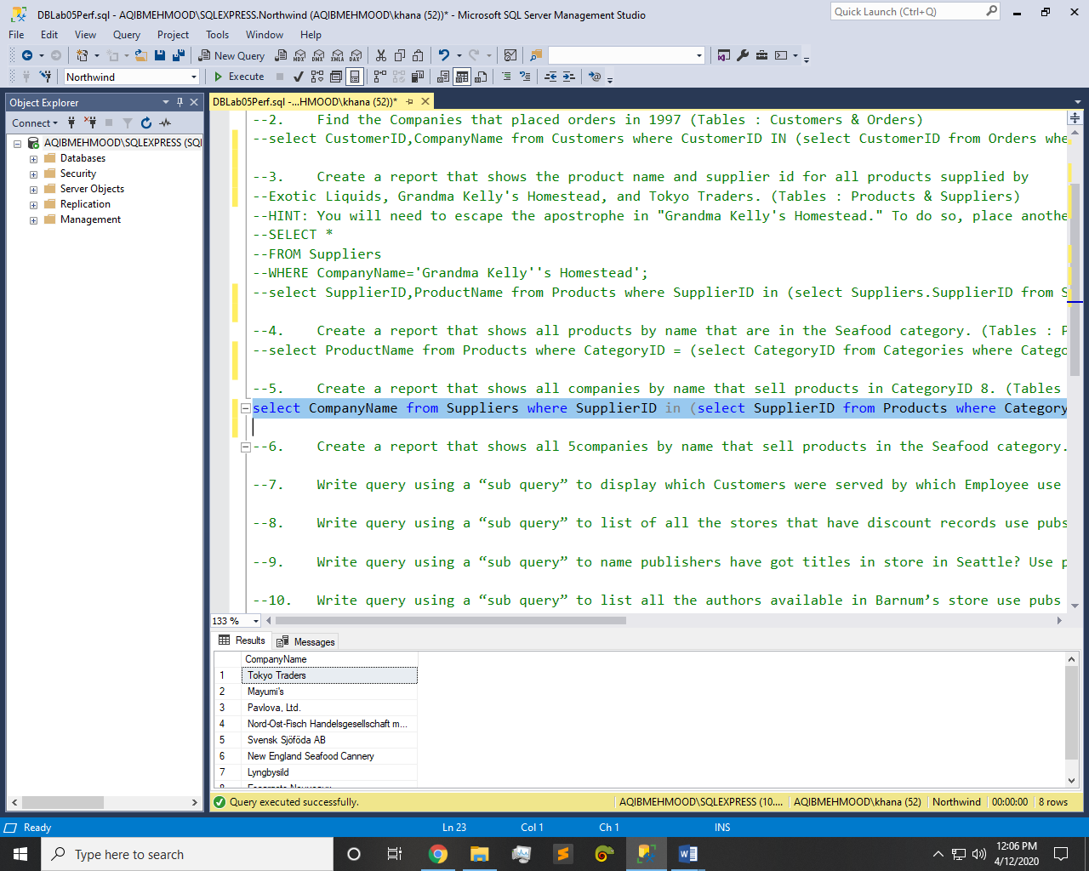

Q6: -

Query:-

select top 5 CompanyName from Suppliers where SupplierID in (select SupplierID from Products where CategoryID = (select CategoryID from Categories where CategoryName='Seafood'))

Result:-

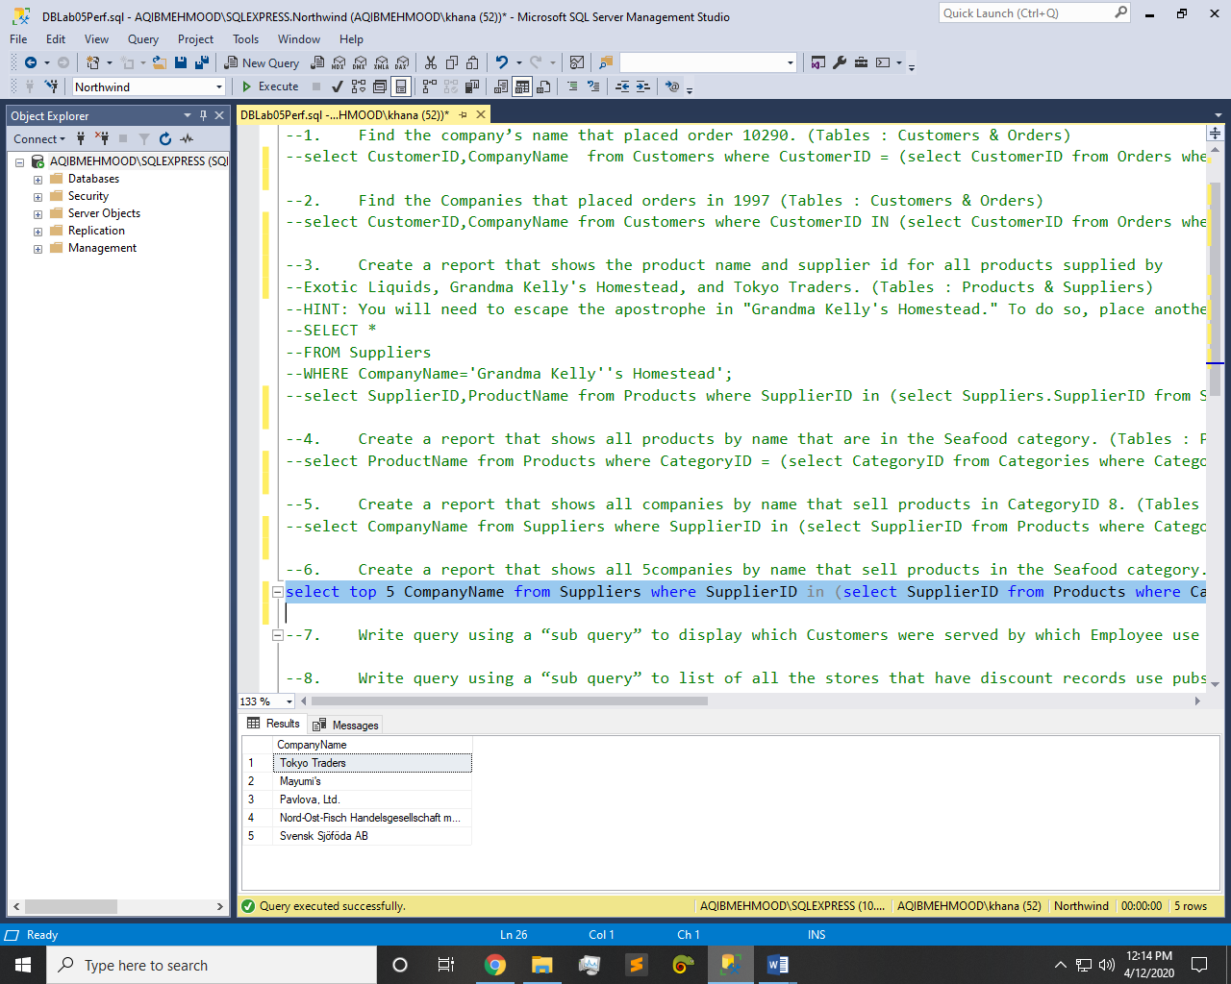

Q7: -

Query:-

Result:-

Q8: -

Query:-

select * from stores where stor_id in (select stor_id from discounts)

Result:-

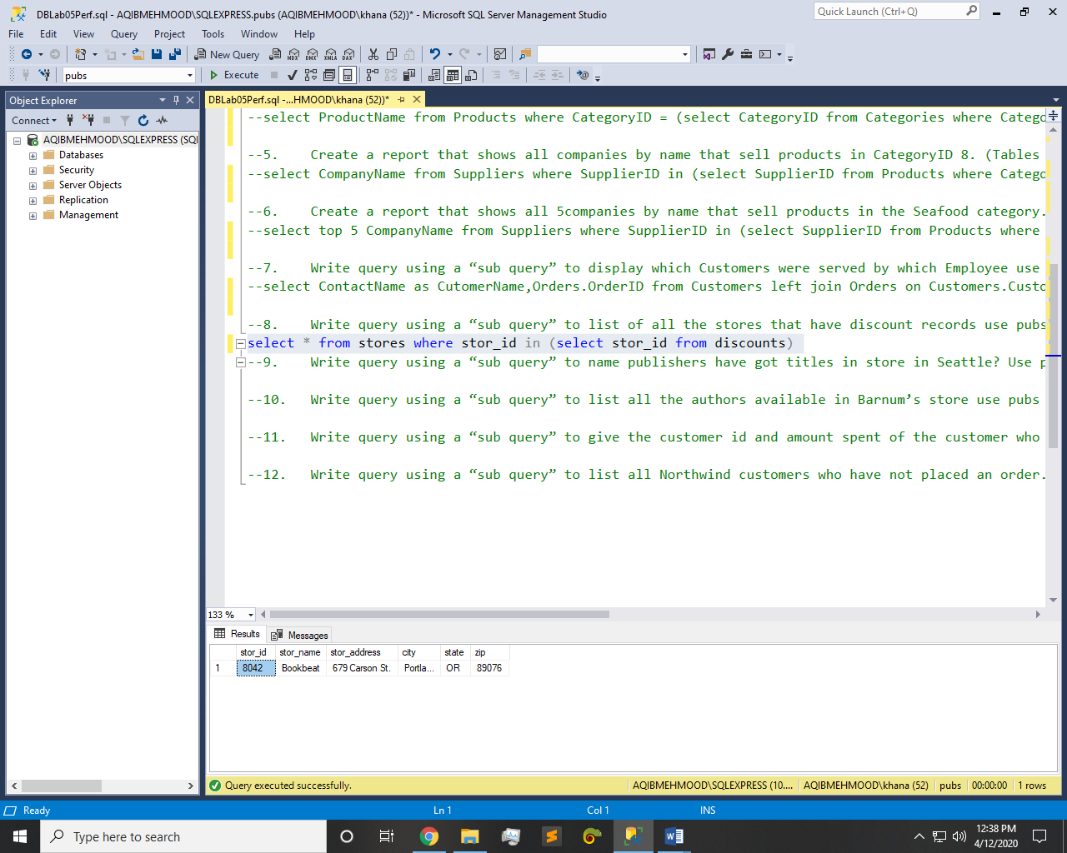

Q9: -

Query:-

select pub_name from publishers where publishers.pub_id in (select pub_id from titles where titles.title_id in (select sales.title_id from sales where sales.stor_id = (select stores.stor_id from stores where stores.city='Seattle')))

Result:-

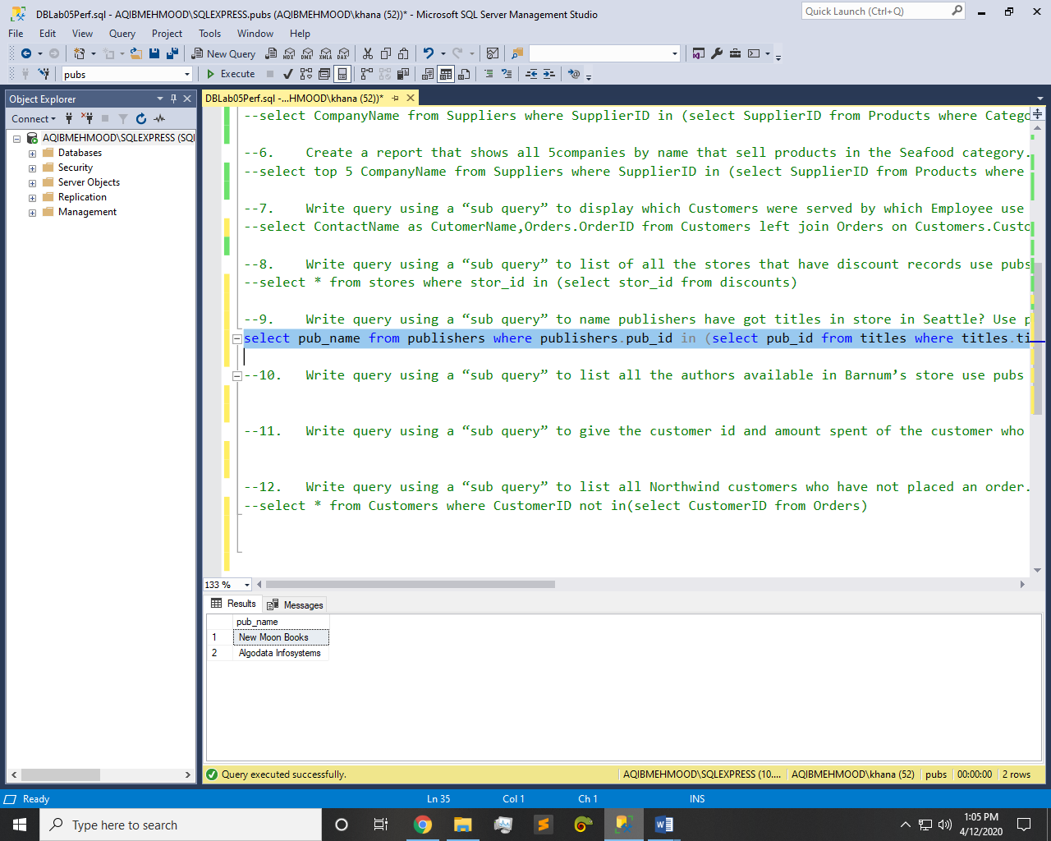

Q10: -

Query:-

select * from authors where authors.au_id in (select au_id from titleauthor where title_id in (select title_id from titles where titles.title_id in (select sales.title_id from sales where sales.stor_id = (select stores.stor_id from stores where stores.stor_name='Barnum''s'))))

Result:-

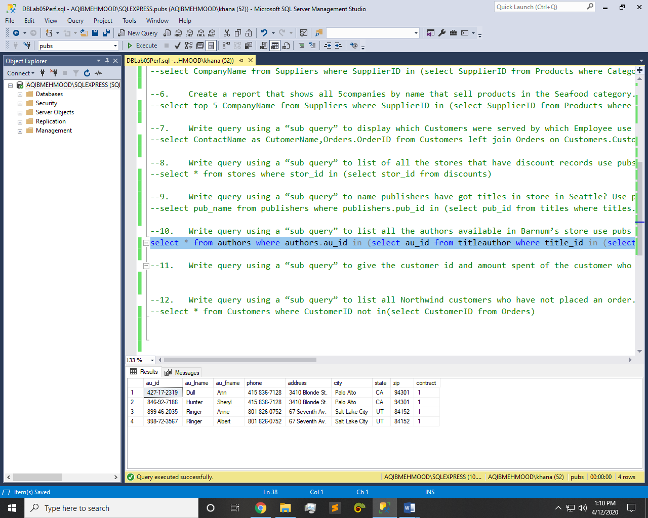

Q11: -

Query:-

select CustomerID,Freight from Orders where Freight =(select MAX(Freight) as amount from Orders)

Result:-

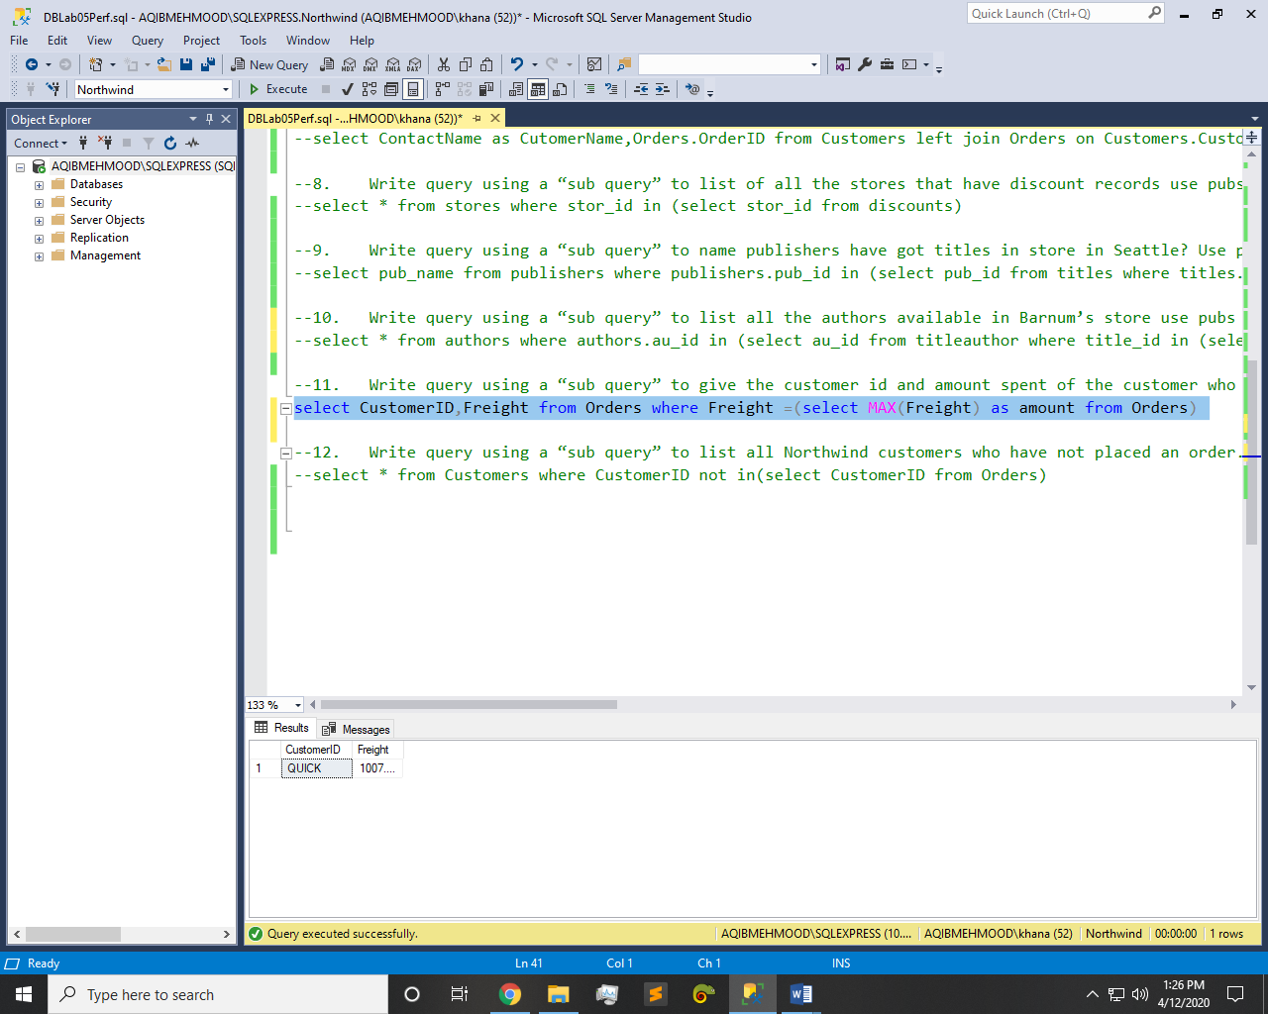

Q12: -

Query:-

select * from Customers where CustomerID not in(select CustomerID from Orders)

Result:-

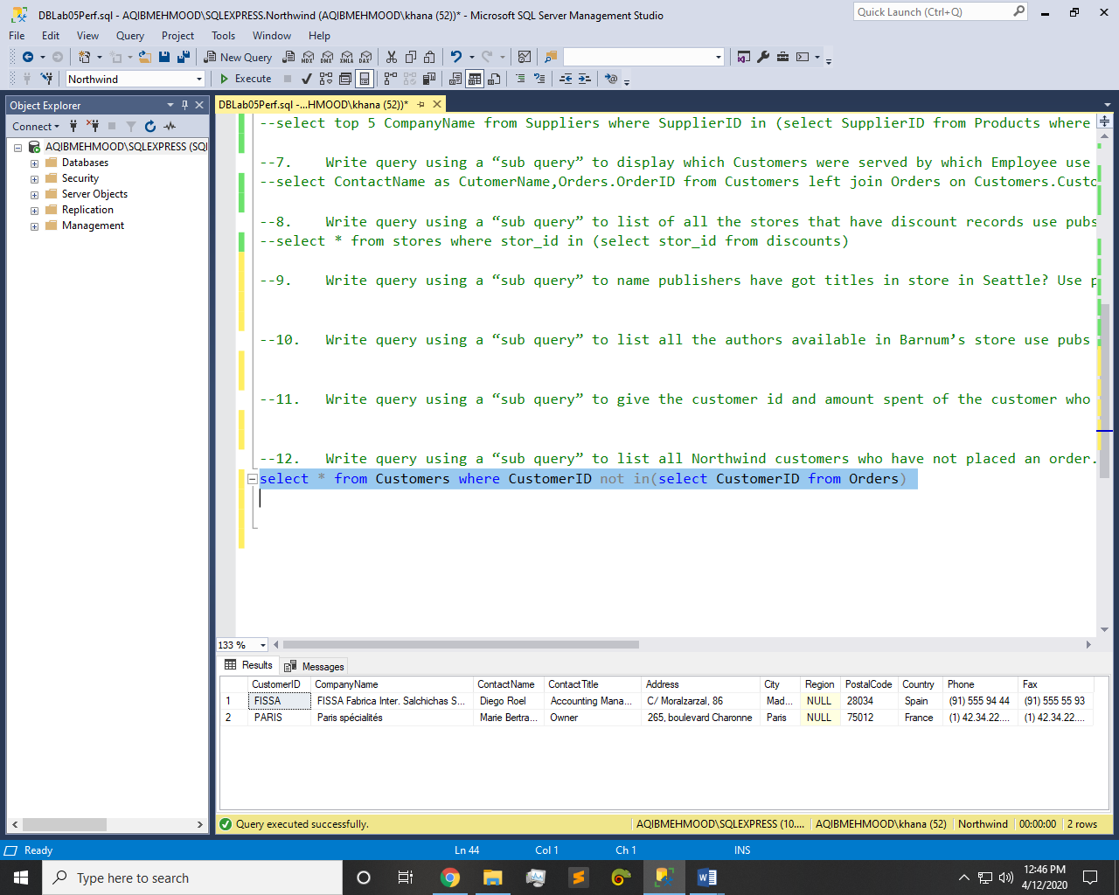

~~~~~~**/**THE END**/**~~~~~~