Q1: - Create **Department** table based on the following design:

Query:-

create database lab6

create table Department(

deptno decimal(2,0),

dname varchar(14) null,

loc varchar(13) null

)

Result:-

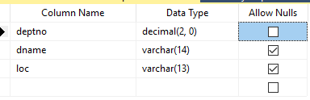

Q2: - Create **Employee** table based on the following design:

Query:-

create table Employee(

empno decimal(4,0) primary key not null,

ename varchar(10) not null,

job varchar(9) null,

mgr decimal(4,0) null,

hiredate date null

)

Result:-

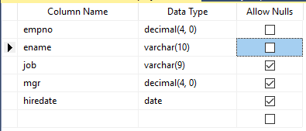

Q3: -

Query:-

alter table Employee

add sal money null,

comm money null,

deptno decimal(2,0) null

Result:-

Q4: - Drop Column loc from **Department** table

Query:-

alter table Department

drop column loc

Result:-

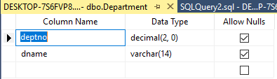

Q5: - Delete all record from **Employee** table

Query:-

truncate table Employee

Result:-

https://lh4.googleusercontent.com/r7IdXRuhyWYlcl2Dg6DoL1QLejMEyVwtXz0RibmrS0cJR5S7Jp9eegXHTD2MbbHY6SeiH-PAH8_iNafFtA22AkFsIc5OkaZUGGTkPOCiJTi8ZVyej9dFNiFYkOspS6W4h0-Eeirl

Q6: - Drop **Department** Table.

Query:-

drop table Department

Result:-

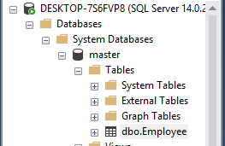

Q7: - Create a database Name persons.

Query:-

create database persons

Result:-

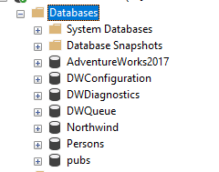

Q8: - Create table name student and add fields (id, First Name, last Name, Enrollment Number, semester)

Query:-

create table student(

id int primary key not null,

FirstName varchar(40),

LastName varchar(40),

EnrlNum int,

Semester varchar(10)

)

Result:-

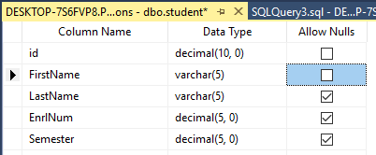

Q9: - Use Drop statement to drop student table.

Query:-

drop table student

Result:-

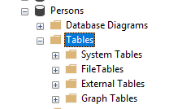

Q10: - Use Drop statement to drop the database persons.

Query:-

drop database persons

Result:-

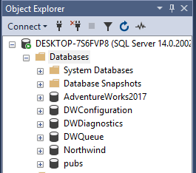

Q11: - Solve the Queries given below according to the following tables given below:

Query:-

Apply Not Null Constraint on all columns .

create table tbl_order(

order_id int not null,

customer_id int not null,

order_details varchar not null,

order_date date not null,

required_date date not null

)

create table tbl_customer(

customer_id int not null,

firstName varchar(40) not null,

lastName varchar(40) not null,

city varchar(20) not null,

address varchar not null

)

**Result:**

https://lh3.googleusercontent.com/zlfwQeKRiN_WgqyTVyO2PLMxXo445HauczENRdUAEWwu-ANd6l1RZpnb523mUW_eJhWGJ7NwItTIA3j_K9ooICI4AVUnN7Qm2i0Lktd5IkHTD06uY1467eB_UsLHtO1o8AxWvurQ

Apply primary key constraint in OrderID and customer ID.

alter table tbl_order

add constraint pk_cont2 primary key(order_id)

alter table tbl_customer

add constraint pk_cont3 primary key(customer_id)

**Result:**

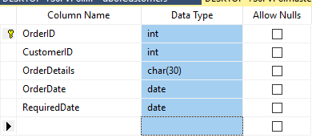

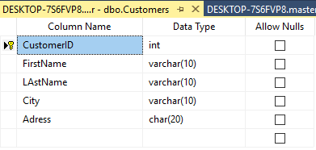

Apply foreign key constraint on Customer _ID in Order table.

alter table tbl_order

add constraint fk_const foreign key (customer_id) references tbl_customer(customer_id)

**Result:**

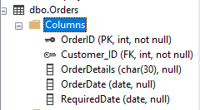

Apply check constraint on city (allow Karachi, Islamabad, Lahore only).

alter table tbl_customer

add constraint chk_city check (city='karachi' and city ='islamabad' and city='lahore')

**Result:**

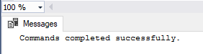

Set the default value of City as ‘Karachi’.

alter table tbl_customer

add constraint def_city default 'karachi' for city

**Result:**

https://lh4.googleusercontent.com/iNyBdStfug4sdZt8qDhc9BuN2e2_h7qeJ7xvfrMXCgnkRBu2BodggYGxRVG6t5piH4c56sY8KBjOtHlOEq-reCUtI4-vdczvUKaQH3ie48d0dLO6S_-1tDd6cGwM8CX3_H8QDgeR

Add CNIC column in Customer table with unique constraint.

alter table tbl_customer

add CNIC varchar(13) unique

**Result:**

https://lh6.googleusercontent.com/nxhhoU1nsR-WwOy_h4dXCeaFrcWToonEk0zFm5xqa1aJCr5Ohl-vS-XIltSp6uvQFDGE7qvLTYzq5IgKCKGbAY_dwFMKubOt1I9cjgEBkEmqSqneowSm1mq6f7qclMoqyOnAiUeI

Q12: - Create the following tables given in diagram with constraints (PK-FK relationship).

Query:-

create table product (

maker varchar(10) not null,

model varchar(50) primary key,

type varchar(50) not null

)

create table pc (

code int primary key,

model varchar(50) foreign key references product(model) not null,

speed smallint not null,

ram smallint not null,

hd real not null,

cd varchar(10) not null,

price money null

)

create table laptop(

code int primary key not null,

model varchar(50) foreign key references product(model) not null,

speed smallint not null,

ram smallint not null,

hd real not null,

price money null,

screen tinyint not null

)

create table printer(

code int primary key not null,

model varchar(50) foreign key references product(model) not null,

color char(1) not null,

type varchar(10) not null,

price money null

)

Result:-

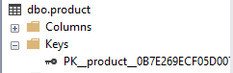      

           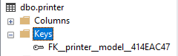

Q13: - Create database Authorization pagh

Query:-

create database Authorization_pagh

Result:-

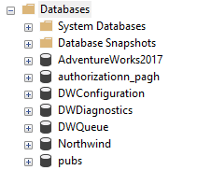

Q14: - Add a column ‘Address’ in Starsin table in database Authorization pagh.

CREATE TABLE StarsIn (

movieTitle char(30),

movieYear int,

starName char(30)

);

Query:-

create table StarsIn(

movieTitle char(30),

movieYear int,

starName char(30),

address varchar(225)

)

Result:-

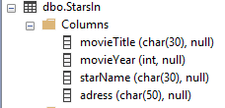

Q15: - Drop column networth from Movieexec table in database authorization pagh.

CREATE TABLE MovieExec (

name char(30),

address char(30),

cert int,

netWorth int

);

Query:-

CREATE TABLE MovieExec (

name char(30),

address char(30),

cert int,

netWorth int

);

alter table MovieExec

drop column networth

Result:-

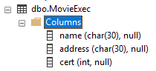

Q16: - Create table(Student) that record student Registration number, Name, Address, Cell number and Gender.(Assumed appropriate datatype for above field) in database Student info.

Query:-

create database student_info

create table student(

reg_no int primary key,

fname varchar(50) not null,

lname varchar(50) null,

address varchar not null,

cell varchar(11),

gender varchar

)

Result:-

