Q1: - Insert the following values to table Stores

Query:-

create table Stores(

Store_id varchar(4) primary key,

Store_name varchar(40) not null,

Store_address varchar(225) not null,

city varchar(40) not null,

state varchar(225) not null,

zip int not null

)

insert into Stores values('TST1','Test 1 store','1234 Anywhere street','here','NY',00319)

insert into Stores values('TST2','Test 2 store','567 Anywhere street','there','NY',00313)

insert into Stores values('TST3','Test 3 store','1234 Anywhere street','here','NY',00319)

select * from Stores

Result:-

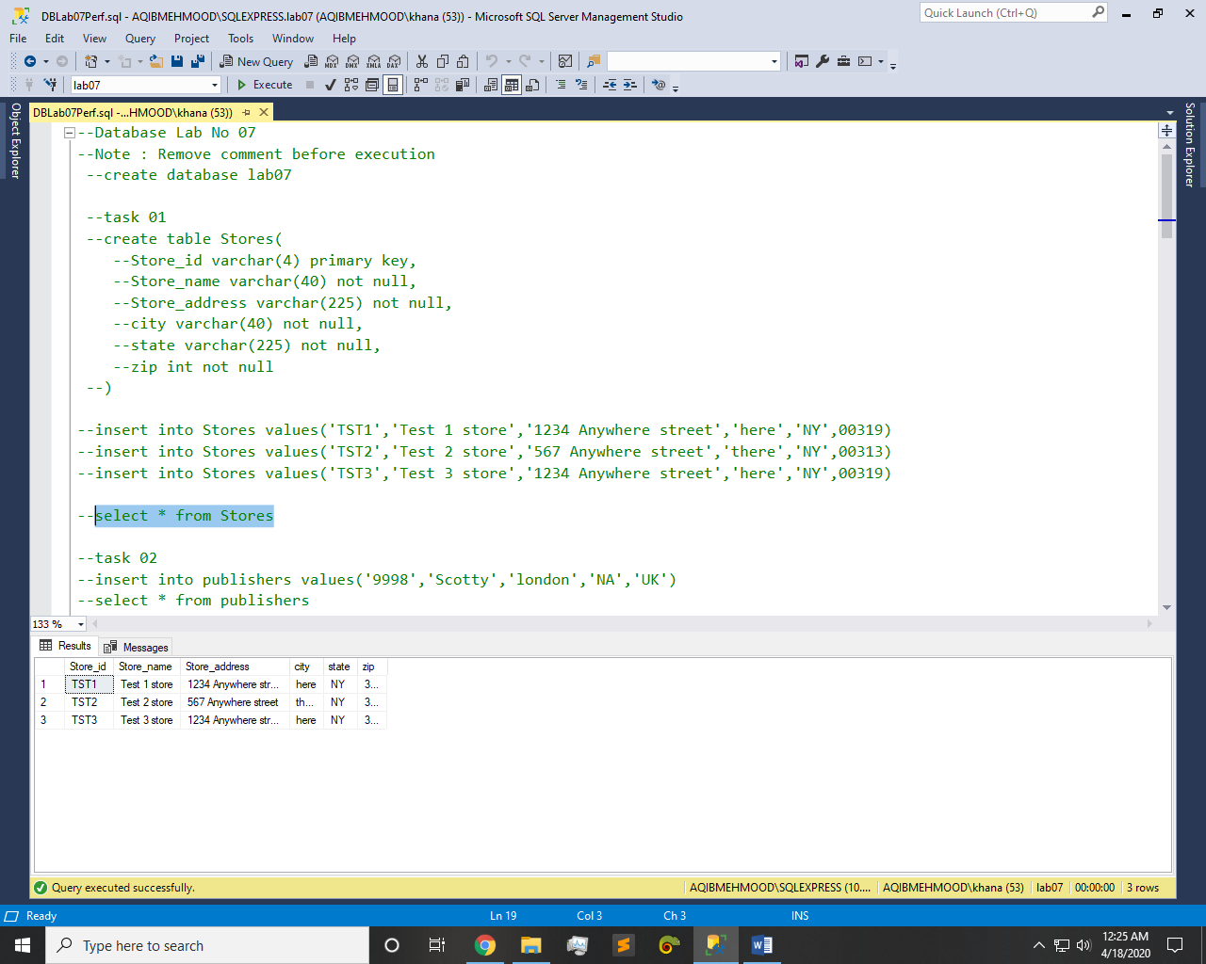

Q2: - Add a new publisher whose name is Scotty and is in London UK.

Query:-

insert into publishers values('9998','Scotty','london','NA','UK')

select * from publishers

Result:-

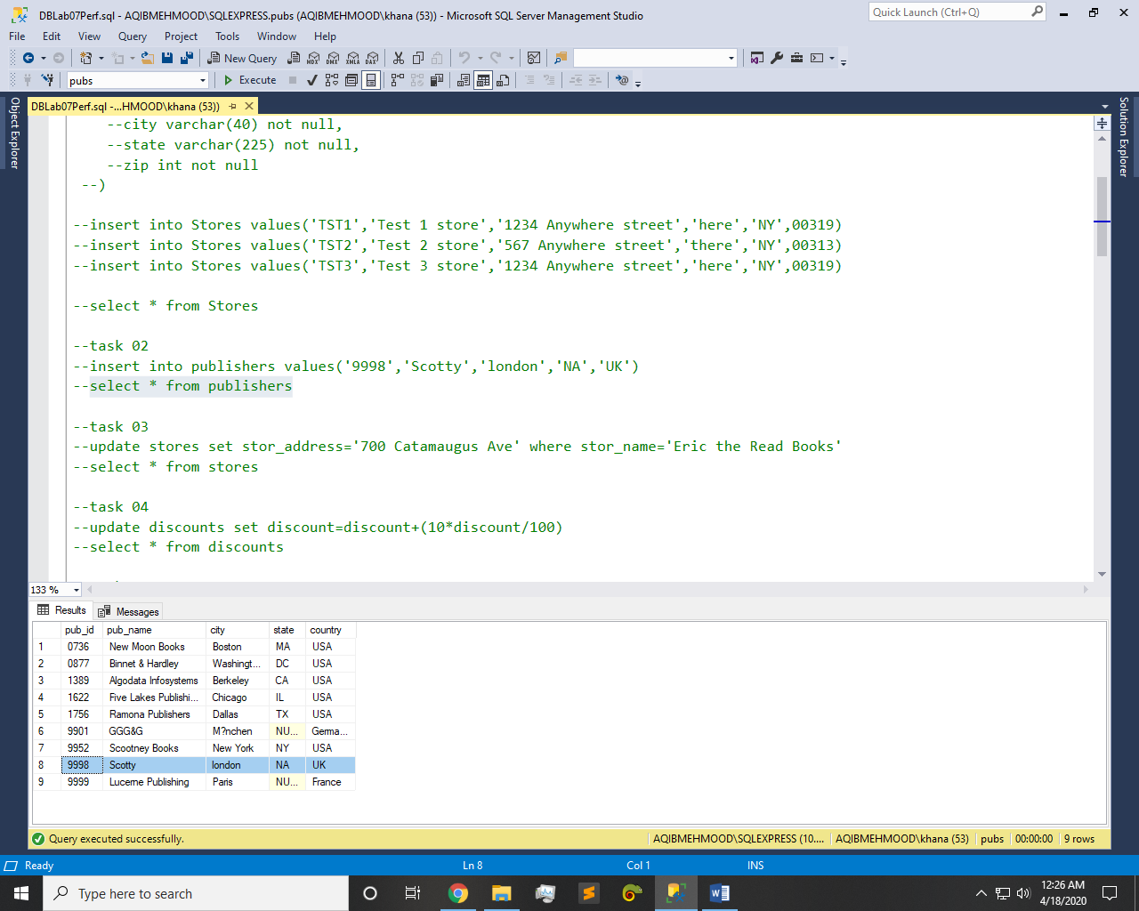

Q3: - Update address of “Eric the Read Books” to “700 Catamaugus Ave”.

Query:-

update stores set stor_address='700 Catamaugus Ave' where stor_name='Eric the Read Books'

select * from stores

Result:-

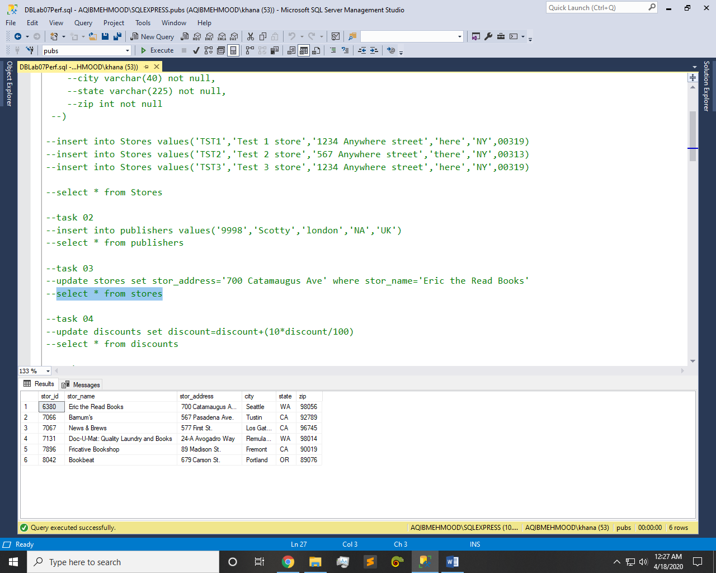

Q4: - Increment all discounts by 10%.

Query:-

update discounts set discount=discount+(10*discount/100)

select * from discounts

Result:-

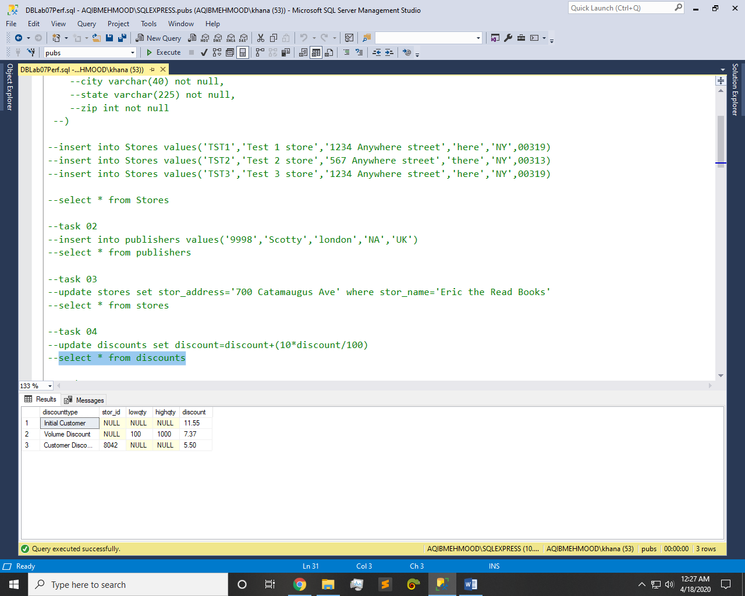

Q5: - Delete employee whose id is “VPA30890F”.

Query:-

delete employee where emp_id='VPA30890F'

select * from employee

Result:-

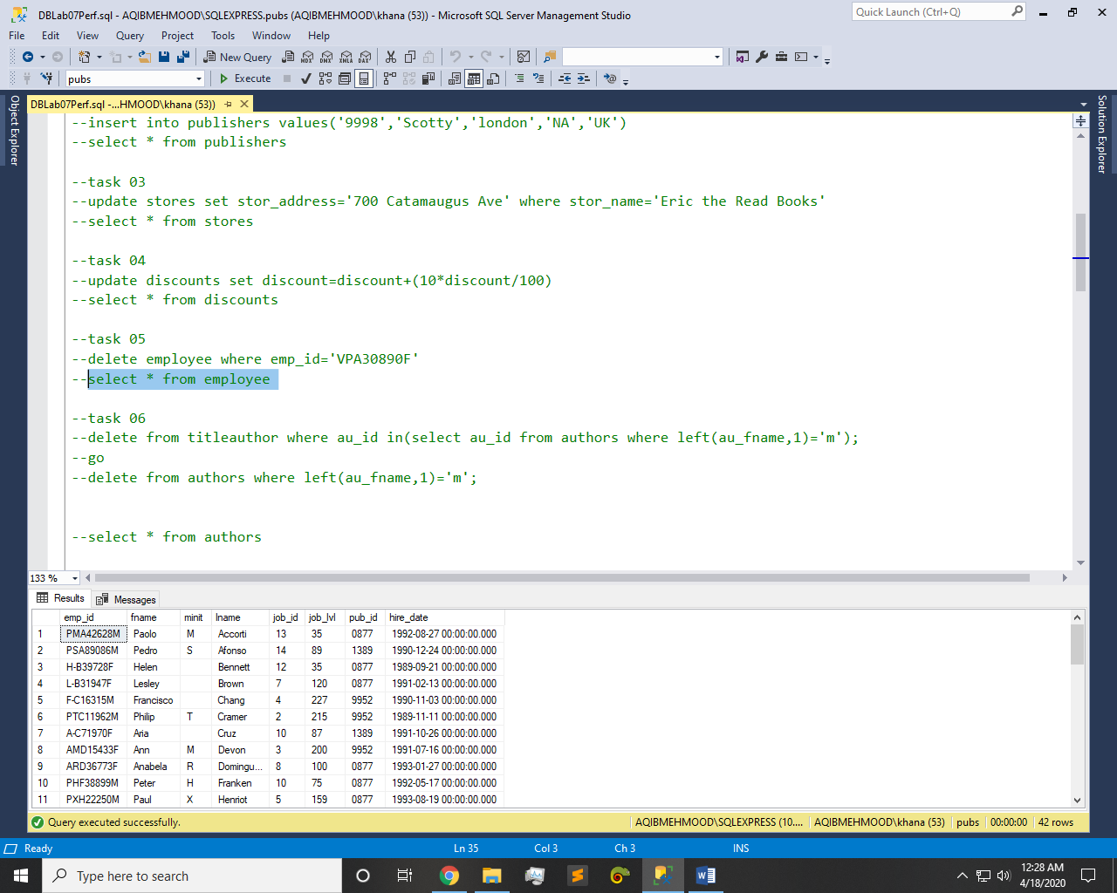

Q6: - Delete all Authors whose first name starts with M.

Query:-

delete from titleauthor where au_id in(select au_id from authors where left(au_fname,1)='m');

go

delete from authors where left(au_fname,1)='m';

select * from authors

Result:-

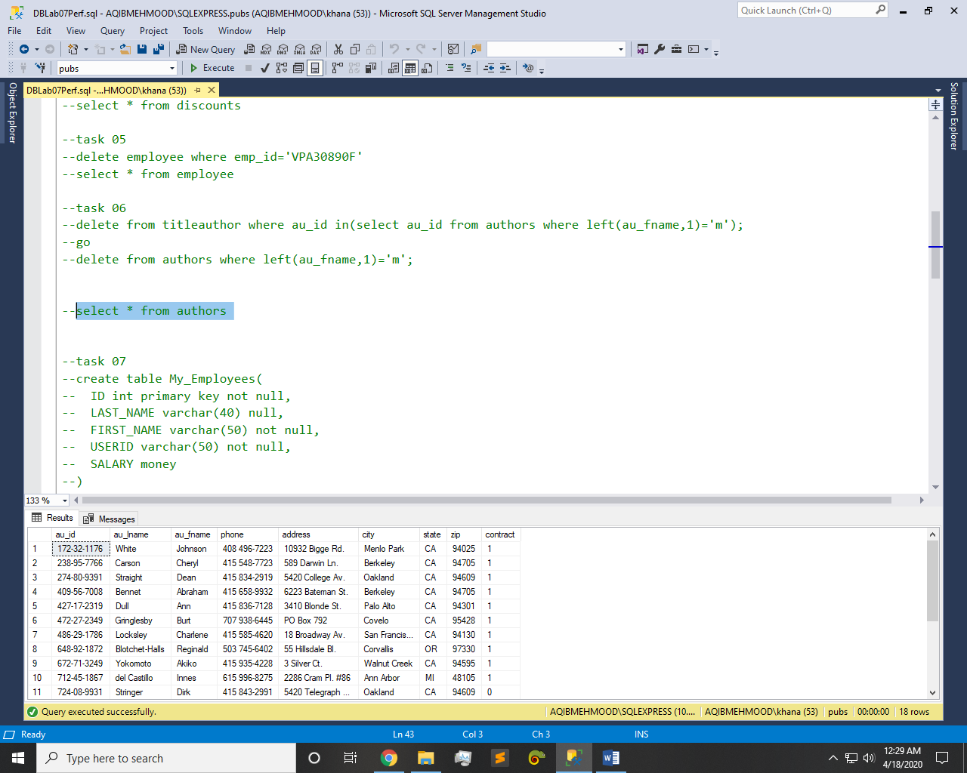

Q7: - Create table My_Employees with following Columns:

Query:-

create table My_Employees(

ID int primary key not null,

LAST_NAME varchar(40) null,

FIRST_NAME varchar(50) not null,

USERID varchar(50) not null,

SALARY money

)

Result:-

Q8: - Insert these 5 records in above mentioned table My_Employees.

Query:-

insert into My_Employees values(1,'Patel','Ralph','rpatel',895)

insert into My_Employees values(2,'Dancs','Betty','bdancs',860)

insert into My_Employees values(3,'Biri','Ben','bbiri',1100)

insert into My_Employees values(4,'Newman','Chad','cnewman',750)

select * from My_Employees

Result:-

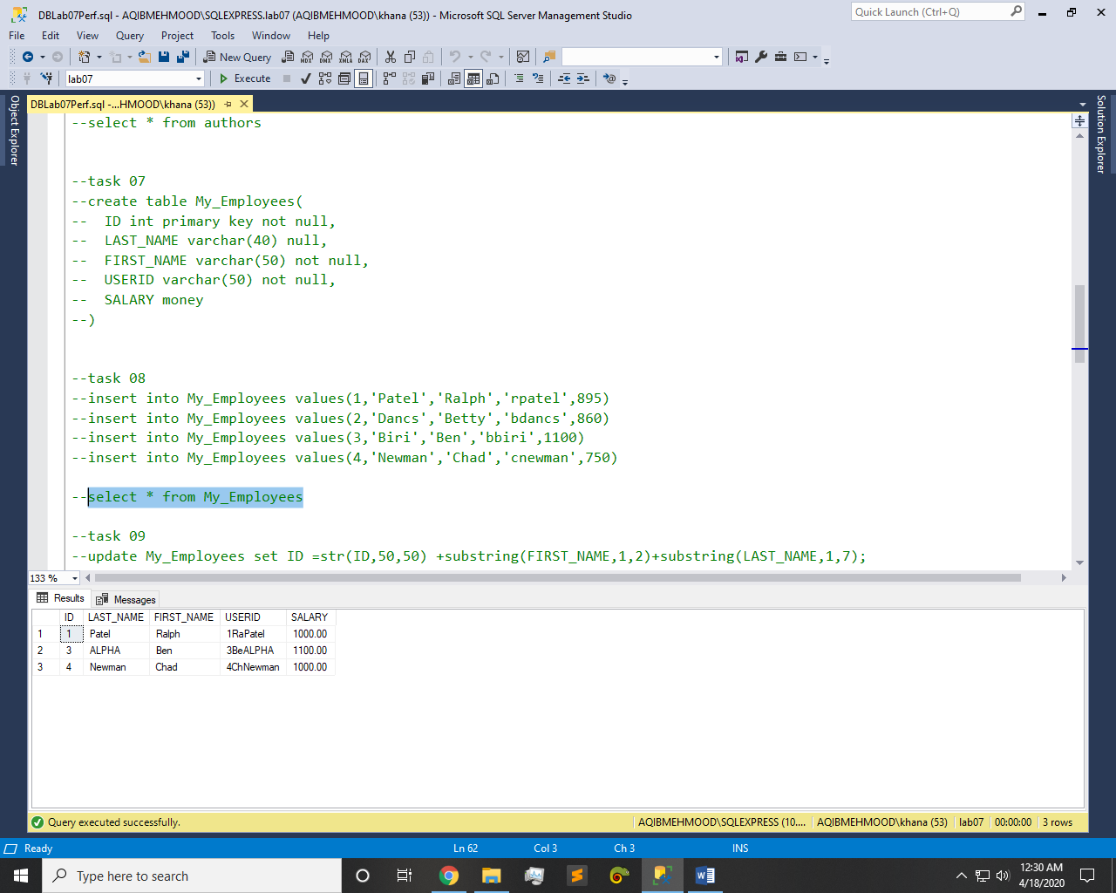

Q9: - Concatenate ID, first two letters of the FIRST_NAME and first seven characters of the LAST_NAME to produce the USERID in employee table

Query:-

update My_Employees set ID =str(ID,50,50) +substring(FIRST_NAME,1,2)+substring(LAST_NAME,1,7);

select * from My_Employees

Result:-

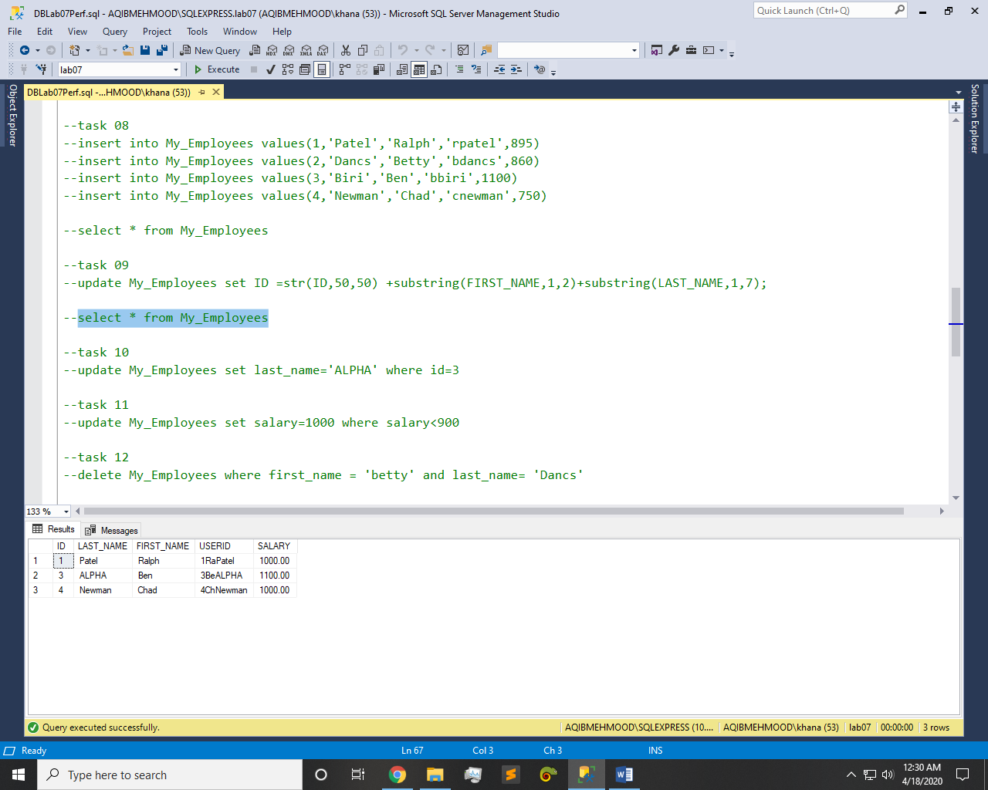

Q10: - Change the LAST_NAME of employee 3 to ALPHA

Query:-

update My_Employees set last_name='ALPHA' where id=3

Result:-

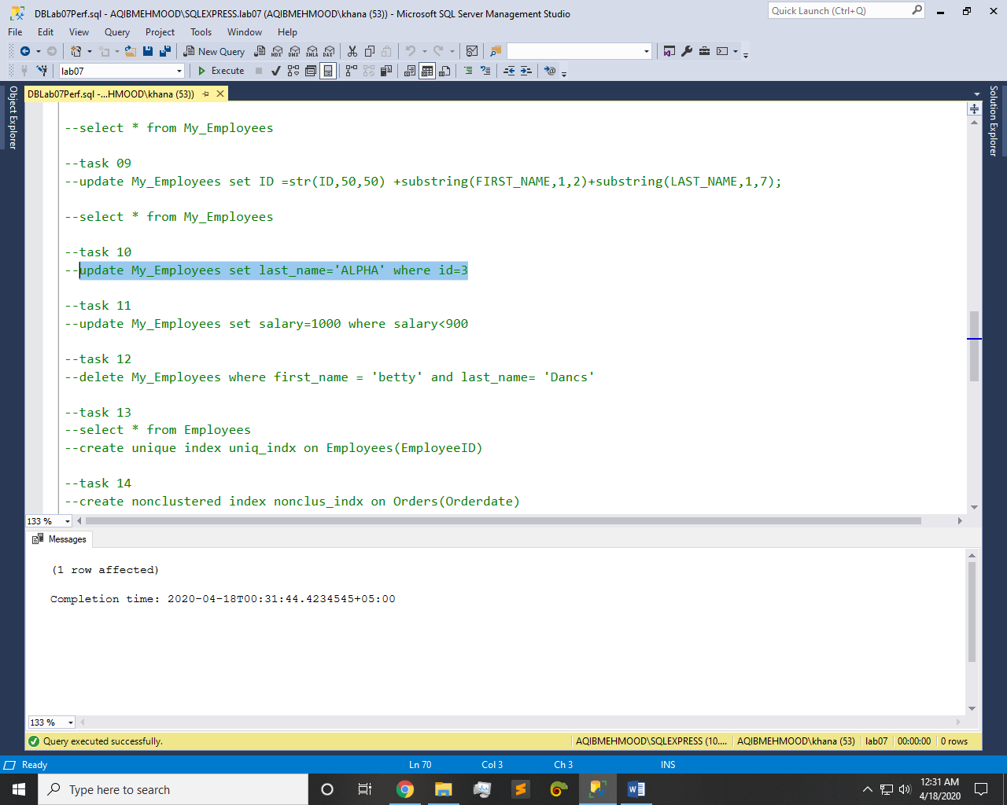

Q11: - Change the salary to 1000 for all employees with a SALARY less than 900.

Query:-

update My_Employees set salary=1000 where salary<900

Result:-

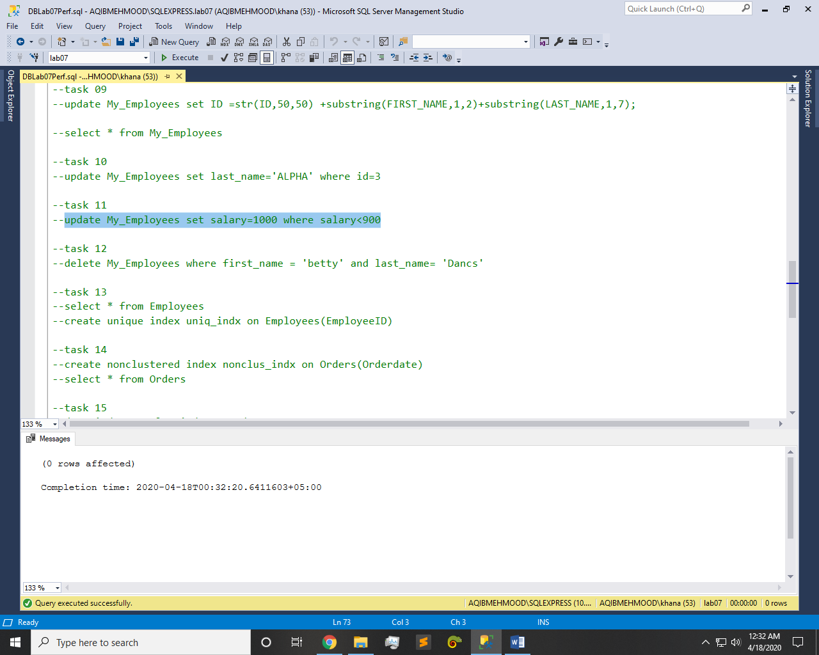

Q12: - Delete Betty Dancs from the My_Employees Table.

Query:-

delete My_Employees where first_name = 'betty' and last_name= 'Dancs'

Result:-



Q13: - Create a unique index on the order table using EmployeeID (Use Northwind)

Query:-

select * from Employees

create unique index uniq_indx on Employees(EmployeeID)

Result:-

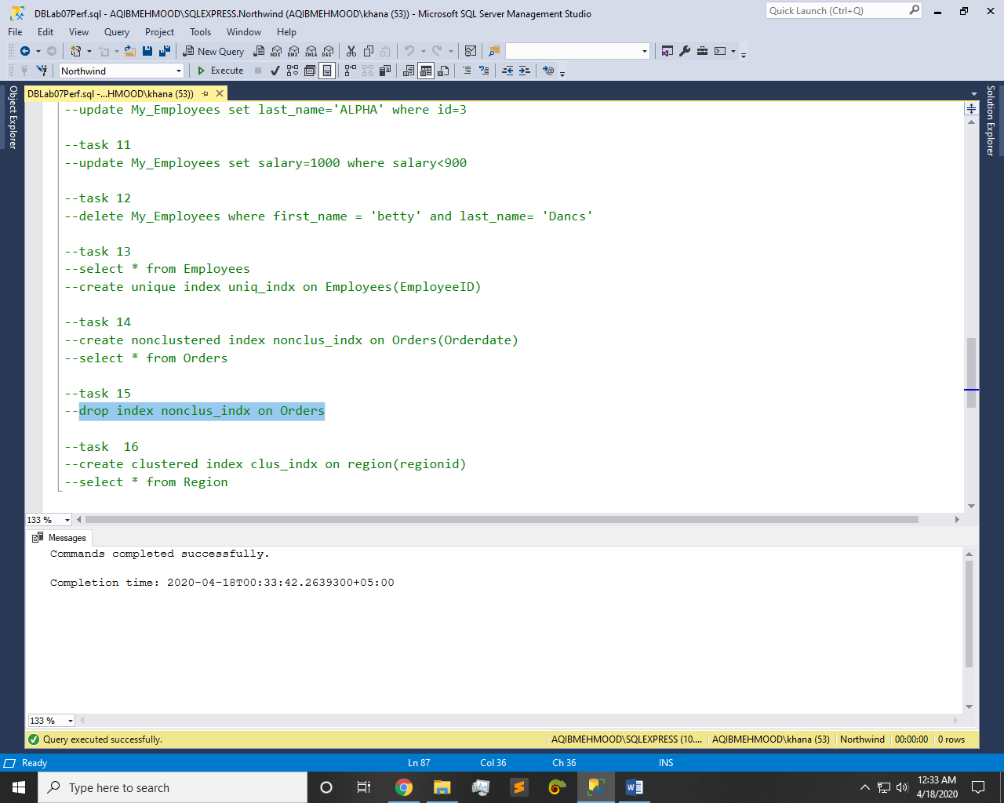

Q14: - Create a non-clustered index on the OrderDate column of the Orders table (Use Northwind)

Query:-

create nonclustered index nonclus_indx on Orders(Orderdate)

select * from Orders

Result:-



Q15: - Delete the index you created in Task # 14 (Use Northwind)

Query:-

drop index nonclus_indx on Orders

Result:-



Q16: - Create a clustered index on the region table using regionid (Use Northwind)

Query:-

create clustered index clus_indx on region(regionid)

select * from Region

Result:-

