Q1: - Add a view called Managers in the Northwind database that shows only employees that supervise other employees.

Query:-

create view Managers as select distinct e1.FirstName+ ' ' +e1.LastName as Supervisor from Employees as e1,Employees as e2 where e1.ReportsTo=e2.EmployeeID

select * from managers

Result:-

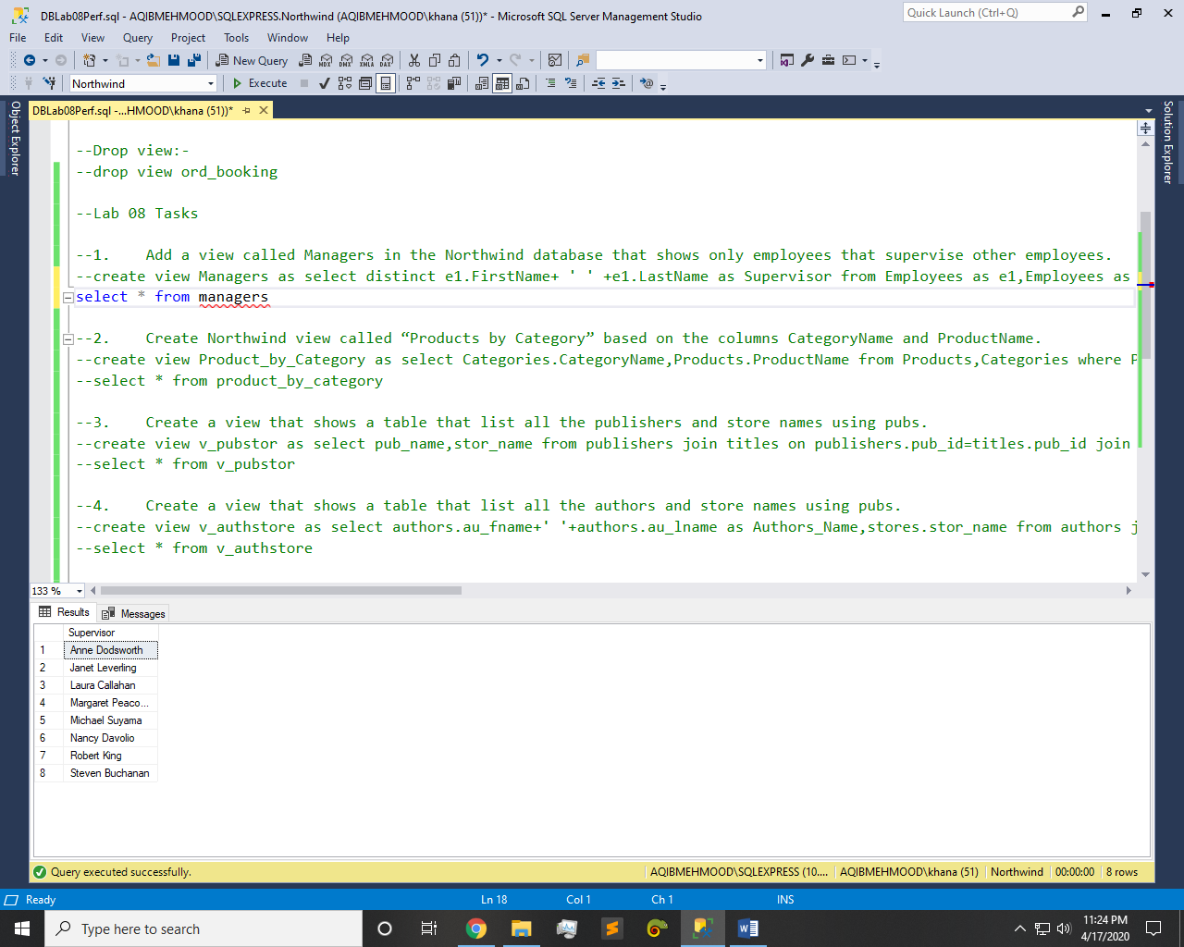

Q2: - Create Northwind view called “Products by Category” based on the columns CategoryName and ProductName.

Query:-

create view Product_by_Category as select Categories.CategoryName,Products.ProductName from Products,Categories where Products.CategoryID=Categories.CategoryID

select * from product_by_category

Result:-

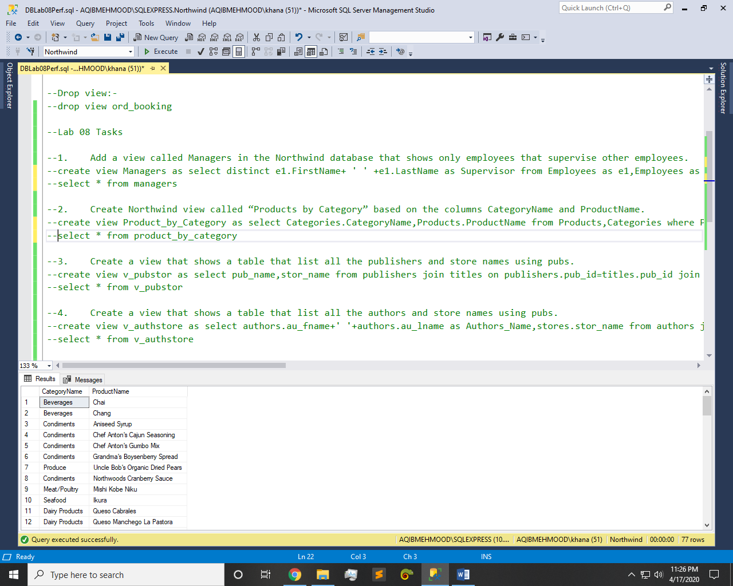

Q3: - Create a view that shows a table that list all the publishers and store names using pubs.

Query:-

create view v_pubstor as select pub_name,stor_name from publishers join titles on publishers.pub_id=titles.pub_id join sales on sales.title_id=titles.title_id join stores on stores.stor_id=sales.stor_id

select * from v_pubstor

Result:-

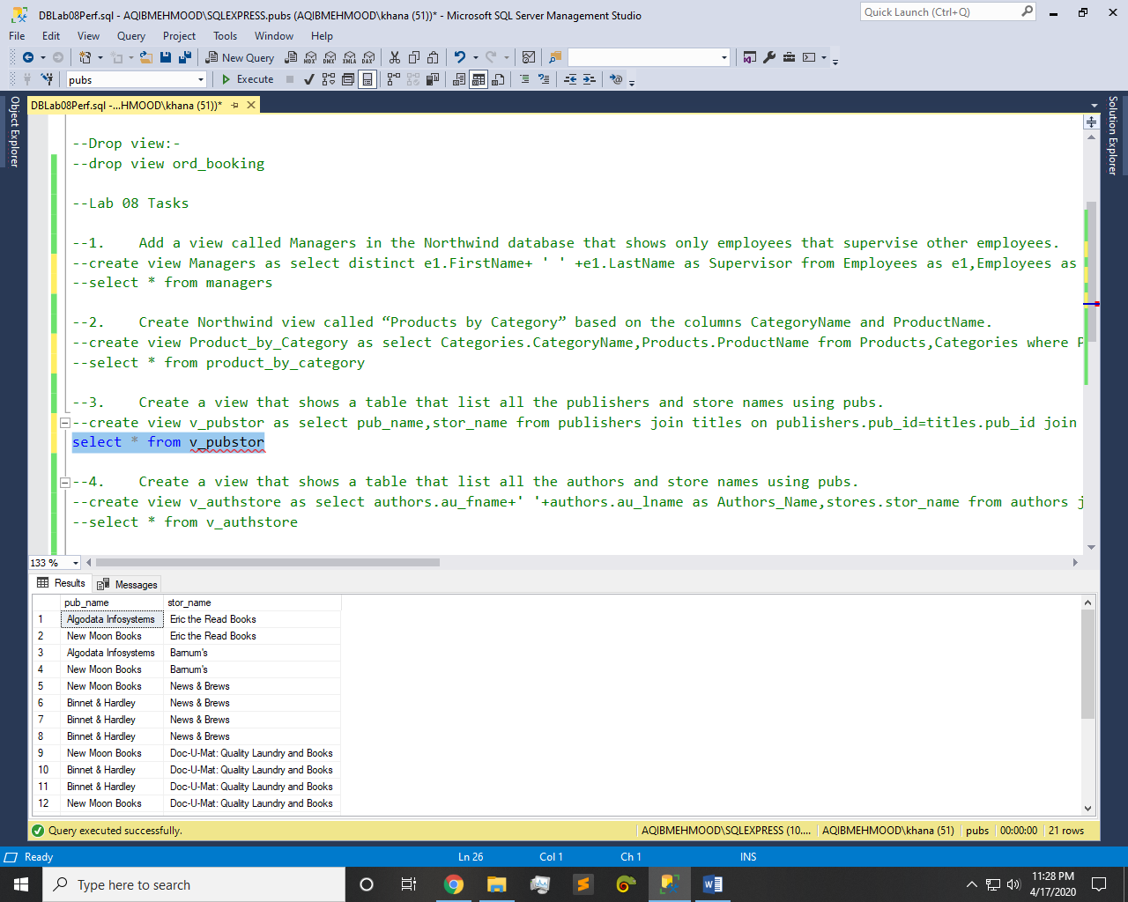

Q4: - Create a view that shows a table that list all the authors and store names using pubs.

Query:-

create view v_authstore as select authors.au_fname+' '+authors.au_lname as Authors_Name,stores.stor_name from authors join titleauthor on authors.au_id=titleauthor.au_id join titles on titleauthor.title_id=titles.title_id join sales on titles.title_id=sales.title_id join stores on sales.stor_id=stores.stor_id

select * from v_authstore

Result:-

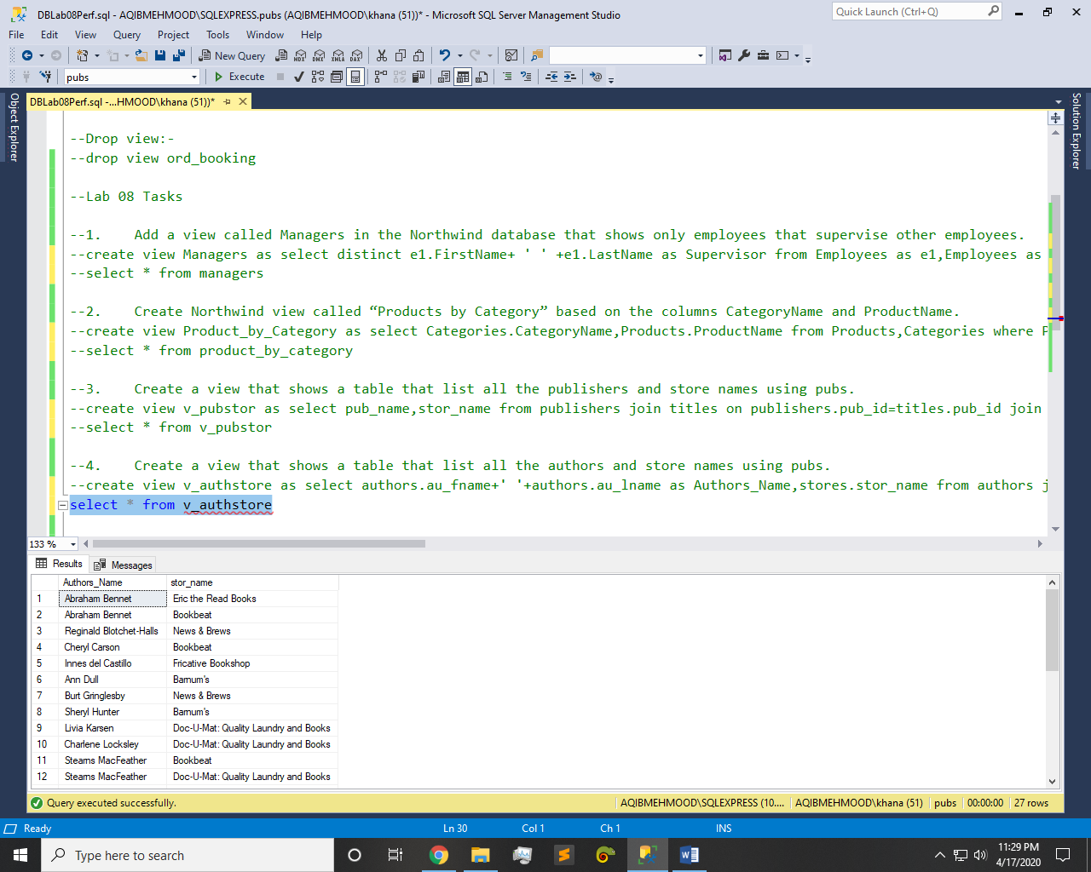

Q5: - Create a view the amount total amount spend by customers.

Query:-

create view v_total_amo as select [Order Details].OrderID,SUM(UnitPrice) as Total_amount from [Order Details] group by OrderID

select * from v_total_amo

Result:-

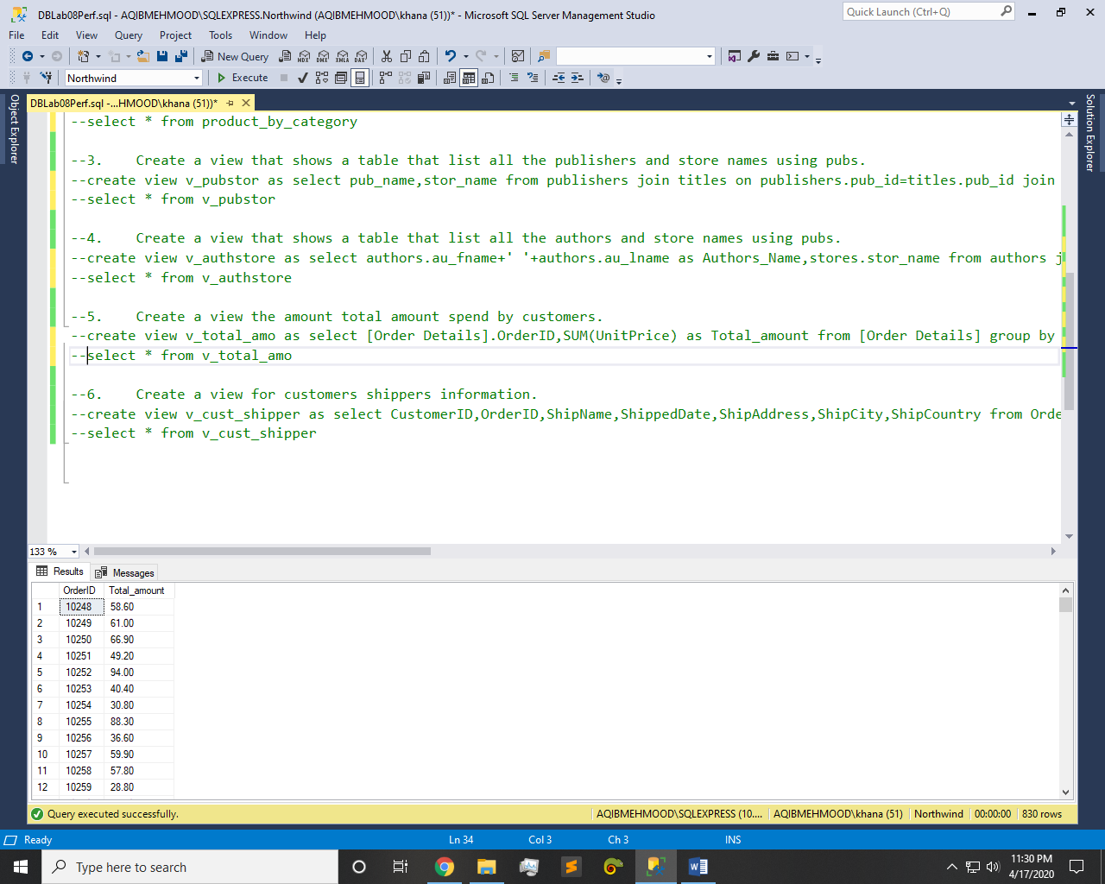

Q6: - Create a view for customers shippers information.

Query:-

create view v_cust_shipper as select CustomerID,OrderID,ShipName,ShippedDate,ShipAddress,ShipCity,ShipCountry from Orders

select * from v_cust_shipper

Result:-

