Q1: You are working on an application that have utility to turn flashlight of smartphone On/Off and have a requirement to add ringtones and effects for flashlight in an application, Implement Decorator pattern for adding ringtone functionality in an application that have a basic functionality of flashlight only. Decorate an application with ringtones and flashlight effects using Decorator

Code:-

Main:-

IFlashLight flash_obj = new FlashLight();

IFlashLight ring_obj = new Ringtone(new FlashLight());

IFlashLight obj_1 = new Ringtone(new FlashLight());

FLEffect effect_obj = new FLEffect();

Ringtone ringtone_obj = new Ringtone();

Console.WriteLine("Basic Functionality of Flash Light:");

flash_obj.basic_function();

Console.WriteLine("\nAfter decorating with rigntone:");

ringtone_obj.new_basic_function();

Console.WriteLine("\nAfter decorating with flashlight effect:");

effect_obj.new_basic_function();

Interface:-

interface IFlashLight

{

void basic_function();

}

------------------------------------------------------------------------

class FLEffect : FLDecorator

{

public FLEffect() { }

public FLEffect(IFlashLight decorated_function)

{

this.decorated_function = decorated_function;

}

public void new_basic_function()

{

//decorated_function.basic_function();

set_FL_effect();

}

private void set_FL_effect()

{

Console.WriteLine("Flash Light has been added.\n");

}

}

------------------------------------------------------------------------

class Ringtone : FLDecorator

{

public Ringtone() { }

public Ringtone(IFlashLight decorated_function)

{

this.decorated_function = decorated_function;

}

public void new_basic_function()

{

//decorated_function.basic_function();

set_rigntone();

}

public void set_rigntone()

{

Console.WriteLine("Rigntone has been added.\n");

}

}

------------------------------------------------------------------------

class FlashLight : IFlashLight

{

public FlashLight() { }

public void basic_function()

{

Console.WriteLine("Basic Functionality -> only flash light.");

}

}

------------------------------------------------------------------------

abstract class FLDecorator : IFlashLight

{

public IFlashLight decorated_function;

public FLDecorator() { }

public FLDecorator(IFlashLight decorated_function)

{

this.decorated_function = decorated_function;

}

public void basic_function()

{

decorated_function.basic_function();

}

}

Output:-

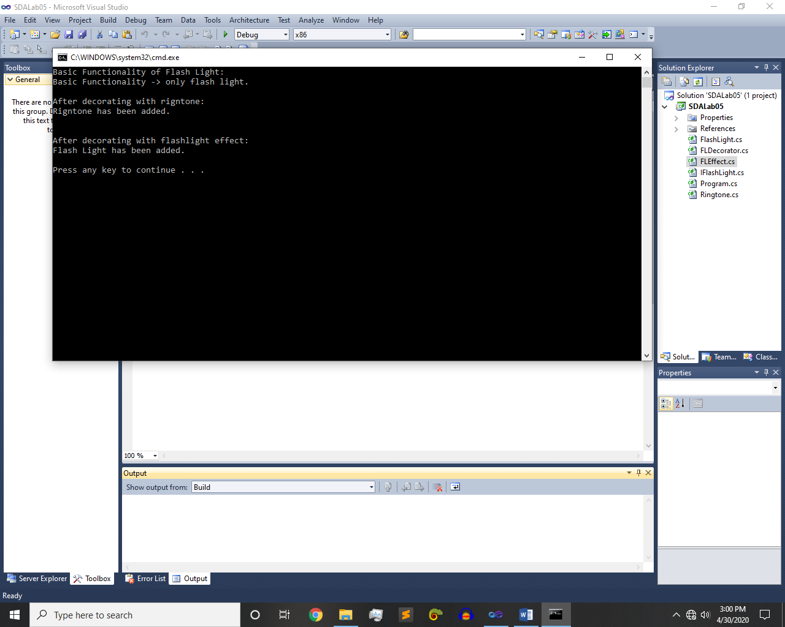

~~~~~~**/**THE END**/**~~~~~~