Q: You are working on a project where you get data from third party webapi/service in XML format. You are creating charts from that data for creating a chart you need data in JSON format in order to make them compatiable you need to convert xml data into json but limitation is you can’t modify third party webservice/api you have to make Adapter that returns data in JSON by using adapter pattern

Code:-

Main:-

XmlAdaptee adapte = new XmlAdaptee();

ITarget target = new JsonAdapter(adapte);

Console.WriteLine("Adaptee interface is incompatible with the client");

Console.WriteLine("So by using adapter client can call its method");

Console.WriteLine("\nAfter using Adapter Design Pattern, we get the requested data below");

Console.WriteLine(target.GetRequest());

Console.WriteLine("So we get the converted data..\n");

-----------------------------------------------------------------------------------------

interface ITarget

{

string GetRequest();

}

-----------------------------------------------------------------------------------------

class XmlAdaptee

{

public string GetSpecificRequest()

{

return "We have to convert the XML data into JSON";

}

}

-----------------------------------------------------------------------------------------

class JsonAdapter : ITarget

{

private readonly XmlAdaptee _adaptee;

public JsonAdapter(XmlAdaptee _adaptee)

{

this._adaptee = _adaptee;

}

public string GetRequest()

{

return this._adaptee.GetSpecificRequest();

}

}

Output:-

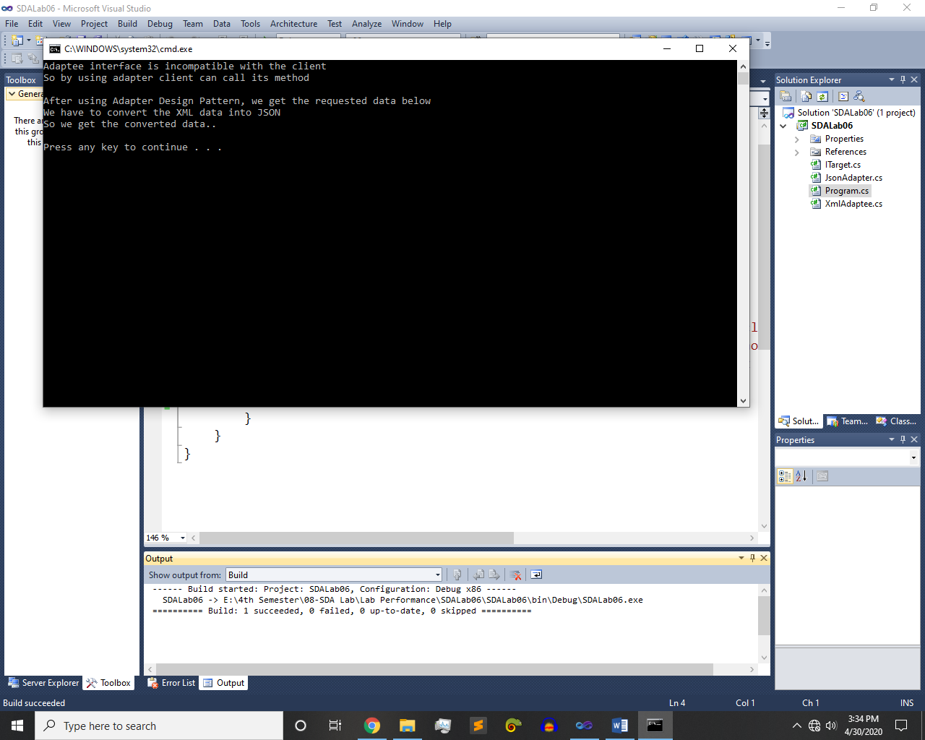

~~~~~~**/**THE END**/**~~~~~~