Q: Implement Chain of Responsibility Design pattern on Processing Scenario. Consider that there are multiple processors having multiple responsibilities to handle (ex: media player file is played by media player handler, calculation is carried out by calculation handler, etc…) initiate handling for opening internet browser and notepad by creating multiple handlers with different responsibilities.

Code:-

Main:-

Processing obj_internet = new InternetBrowser();

Processing obj_notpad = new Notepad();

Processing obj_media = new MediaPlayer();

Processing obj_calc = new Calculator();

Console.WriteLine("What do you want to open:\n Select one from following:");

Console.WriteLine("1-Internet Browser\n2-Notepad\n3-MediaPlayer\n4- Calculator");

int inp = int.Parse(Console.ReadLine());

if (inp == 1)

{

obj_internet.ProcessRequest(inp);

}

else if (inp == 2)

{

obj_notpad.ProcessRequest(inp);

}

else if (inp == 3)

{

obj_media.ProcessRequest(inp);

}

else if (inp == 4)

{

obj_calc.ProcessRequest(inp);

}

else

{

Console.WriteLine("Invalid Input");

}

----------------------------------------------------------------------------------------------------

abstract class Processing

{

public Processing() { }

protected Processing NextLogger;

public Processing(Processing NextLogger)

{

this.NextLogger = NextLogger;

}

public abstract void ProcessRequest(int input);

}

----------------------------------------------------------------------------------------------------

class InternetBrowser : Processing

{

public override void ProcessRequest(int input)

{

if (input.Equals(1))

{

Console.WriteLine("Your Requested Browser is opening");

Console.WriteLine("Welcome to Firefox");

}

else

{

Console.WriteLine("Sorry Try again");

}

}

----------------------------------------------------------------------------------------------------

class Notepad : Processing

{

public override void ProcessRequest(int input)

{

if (input.Equals(2))

{

Console.WriteLine("Notepad is Opening");

Console.WriteLine("Now you can write content");

}

else

{

Console.WriteLine("Sorry Try again");

}

}

----------------------------------------------------------------------------------------------------

class Calculator : Processing

{

public override void ProcessRequest(int input)

{

if (input.Equals(4))

{

Console.Write("Calculator : ");

Console.WriteLine("You can perform calculation");

}

else

{

Console.WriteLine("Sorry Try again");

}

}

}

----------------------------------------------------------------------------------------------------

class Calculator : Processing

{

public override void ProcessRequest(int input)

{

if (input.Equals(4))

{

Console.Write("Calculator : ");

Console.WriteLine("You can perform calculation");

}

else

{

Console.WriteLine("Sorry Try again");

}

}

----------------------------------------------------------------------------------------------------

Output:-

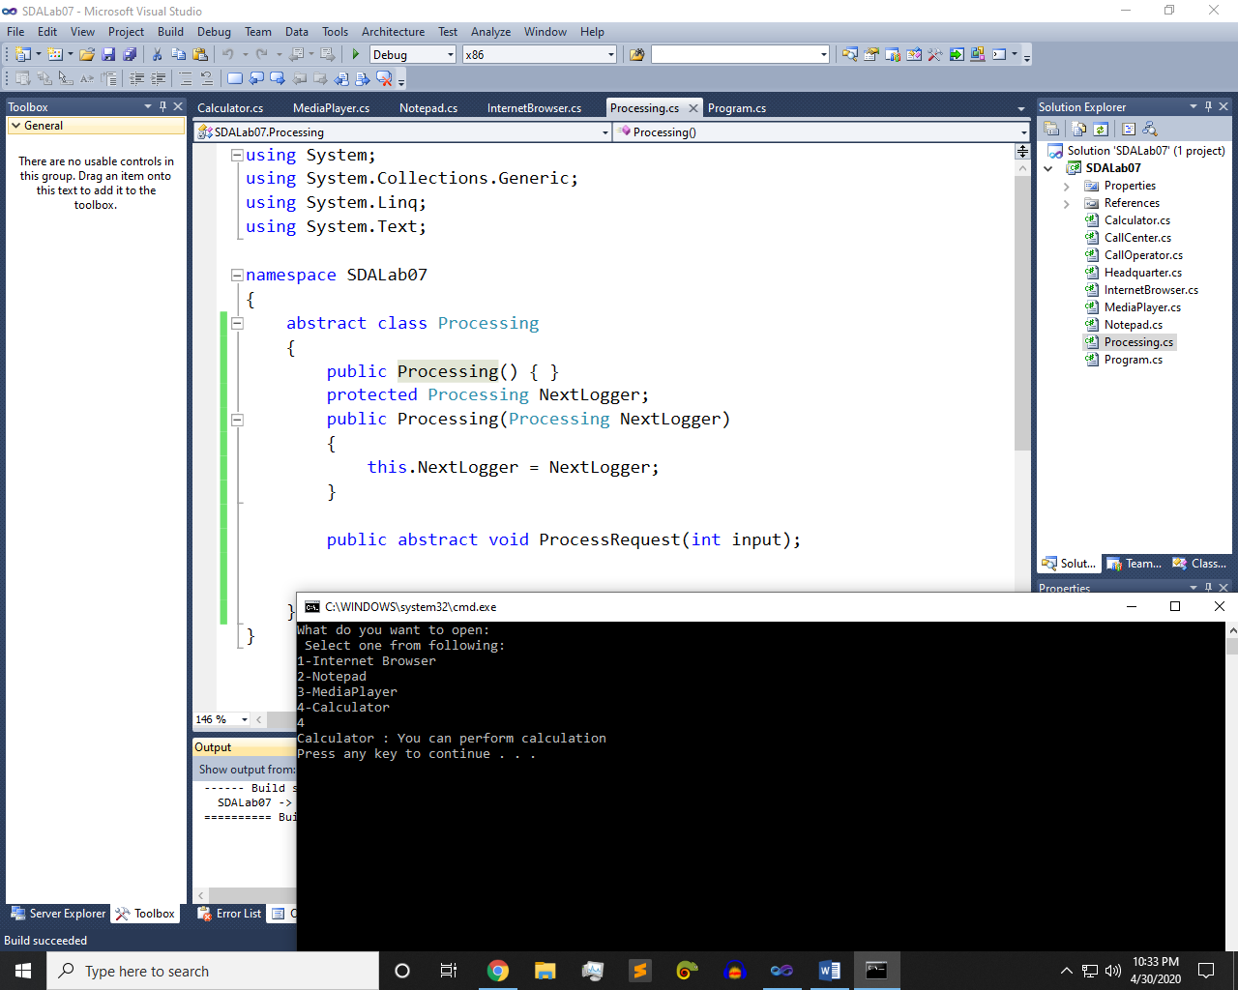 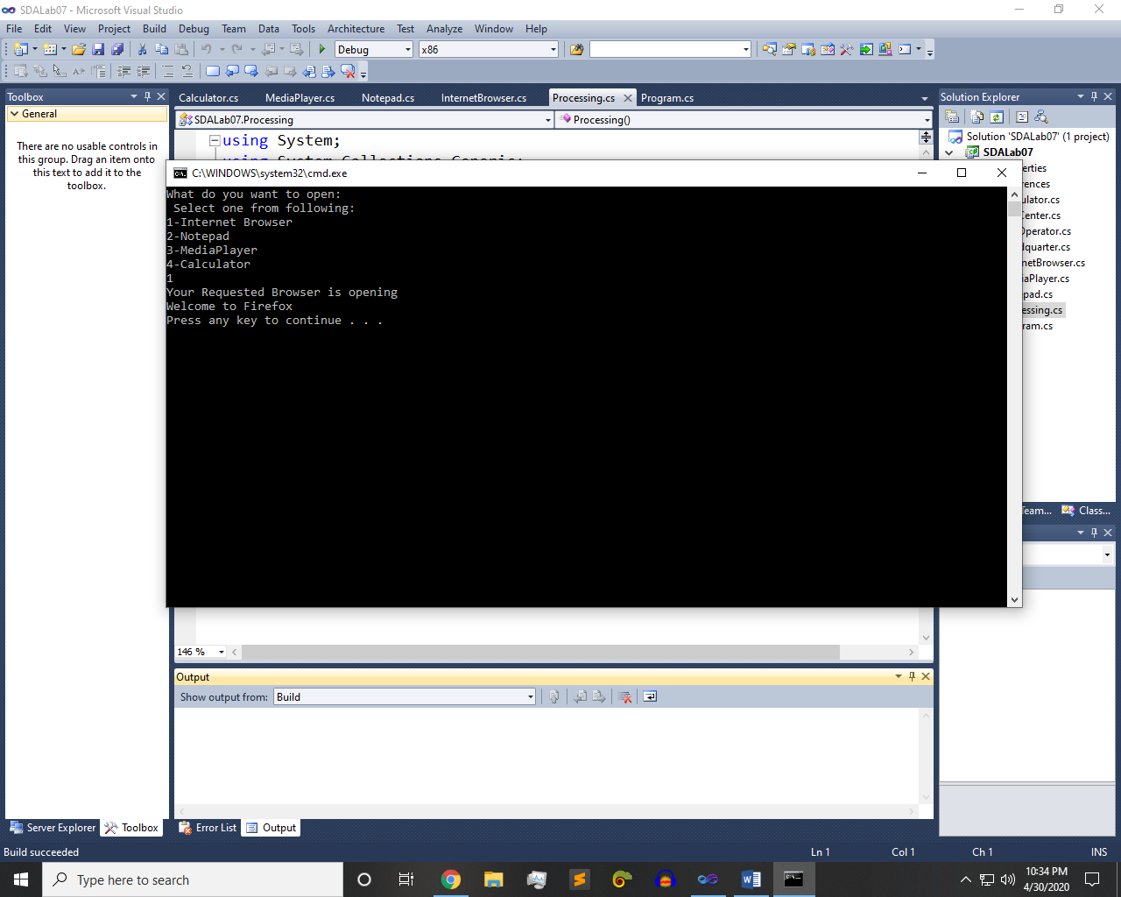

Q: Implement COR on call center scenario.

Code:-

Main:-

CallCenter asher = new CallOperator();

CallCenter head = new Headquarter();

asher.SetSuccessor(head);

Console.WriteLine("Please Select one from following:");

Console.WriteLine("1-Greeting\n2-Call Center Head Quarter\n3-Availing Offers");

int inp = int.Parse(Console.ReadLine());

if (inp==1)

{

asher.ProcessRequest(inp);

}

else if (inp == 2)

{

asher.ProcessRequest(inp);

}

else if (inp==3)

{

asher.ProcessRequest(inp);

}

else

{

Console.WriteLine("Invalid Input");

}

----------------------------------------------------------------------------------------------------

abstract class CallCenter

{

protected CallCenter successor;

public void SetSuccessor(CallCenter successor)

{

this.successor = successor;

}

public abstract void ProcessRequest(int input);

}

----------------------------------------------------------------------------------------------------

class CallOperator : CallCenter

{

public override void ProcessRequest(int input)

{

if (input.Equals(1))

{

Console.WriteLine("You are welcome to call center\nHow may i help you");

}

else if (input.Equals(2))

{

Console.WriteLine("Your call is transferring to HeadQuarter.");

Headquarter head = new Headquarter();

head.ProcessRequest(1);

}

else if (input.Equals(3))

{

Console.WriteLine("To avail this offer Your balance is low sorry Recharge and Try again");

}

}

}

----------------------------------------------------------------------------------------------------

class Headquarter : CallCenter

{

public override void ProcessRequest(int input)

{

if (input.Equals(1))

{

Console.WriteLine("You are connected to head quarter");

Console.WriteLine("Welcome to Call Center HeadQuarter");

}

else

{

Console.WriteLine("Sorry Try again");

}

}

}

Output:-

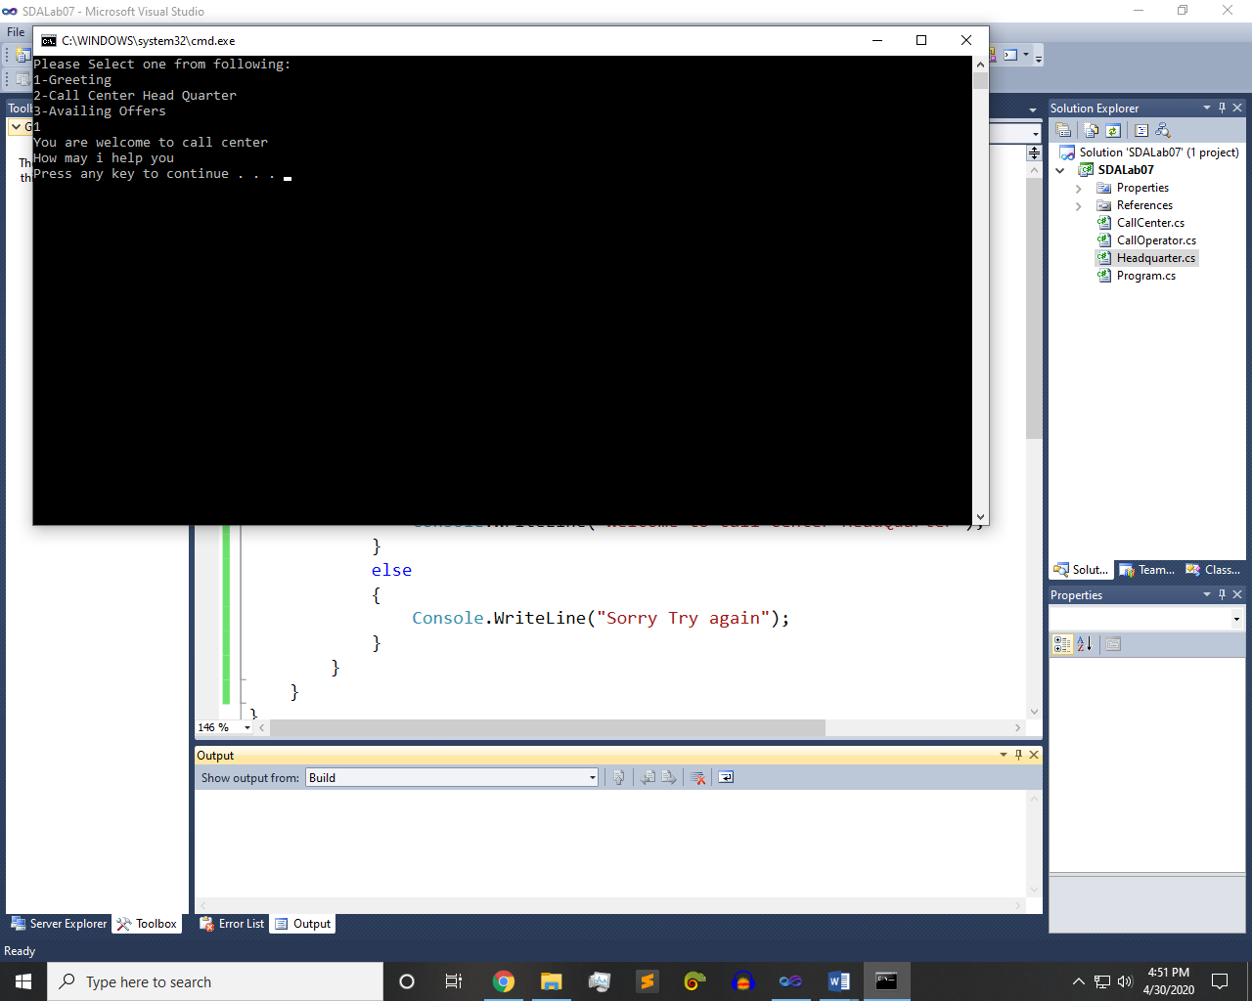 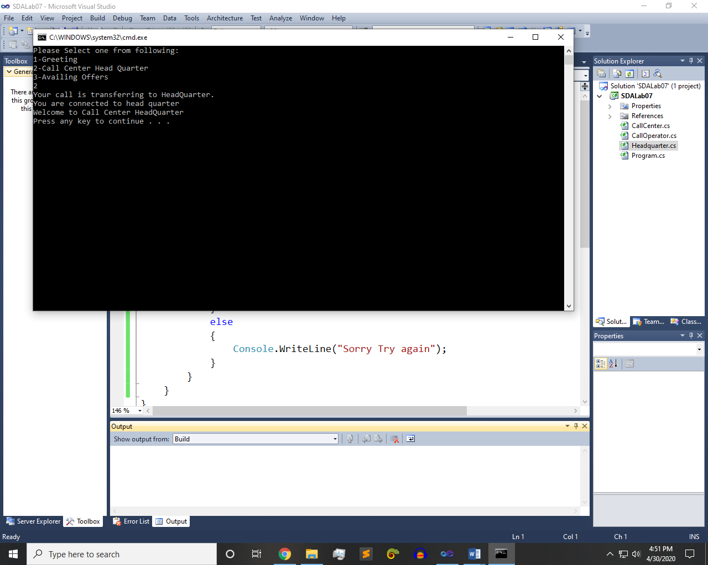

~~~~~~**/**THE END**/**~~~~~~