Q: Design Facebook login page using html, css and javascript -> the page takes username and password and with javascript alert message will be displayed.

**Code:-**

<!DOCTYPE html>

<html>

<head>

<title>SDAL12</title>

<style type="text/css">

body{

background-color: #E9EBEE;

text-align: center;

}

header{

background-color: #365899;

color: white;

padding: 1px;

margin-bottom: 50px;

}

.btn{

background-color: #365899;

color: white;

border-style: none;

border-radius: 3px;

padding: 10px 75px

}

.btn:hover{

cursor: pointer;

}

a{

text-decoration: none;

}

.inner p{

font-size: 20px;

}

input{

padding: 5px;

}

</style>

<script type="text/javascript">

function btn_click() {

// body...

var pass = document.getElementById("user_pass").value;

var get_name = document.getElementById("user_name").value;

if (get_name == "AqibAwan" && pass == "aqib")

{

alert("Successfully Log In");

}

else

{

alert("Invalid User Name or Password");

}

}

</script>

</head>

<body>

<header>

<h1>

facebook

</h1>

</header>

<div class="container">

<div class="inner">

<p>Log in to Facebook</p>

<form>

<input type="text" name="username" placeholder="Enter user name" id="user_name">

<br>

<br>

<input type="password" name="userpass" placeholder="Enter password" id="user_pass">

<br>

<br>

<button class="btn" type="button" name="btn_login" onclick="btn_click()">Log In</button>

<br>

<br>

<a href="https://www.facebook.com/login/" target="_blank">Forgetten account?</a>

<a href="https://www.facebook.com/login/" target="_blank"> Sign up for Facebook</a>

<br>

</form>

</div>

</div>

</body>

</html>

**Output:-**

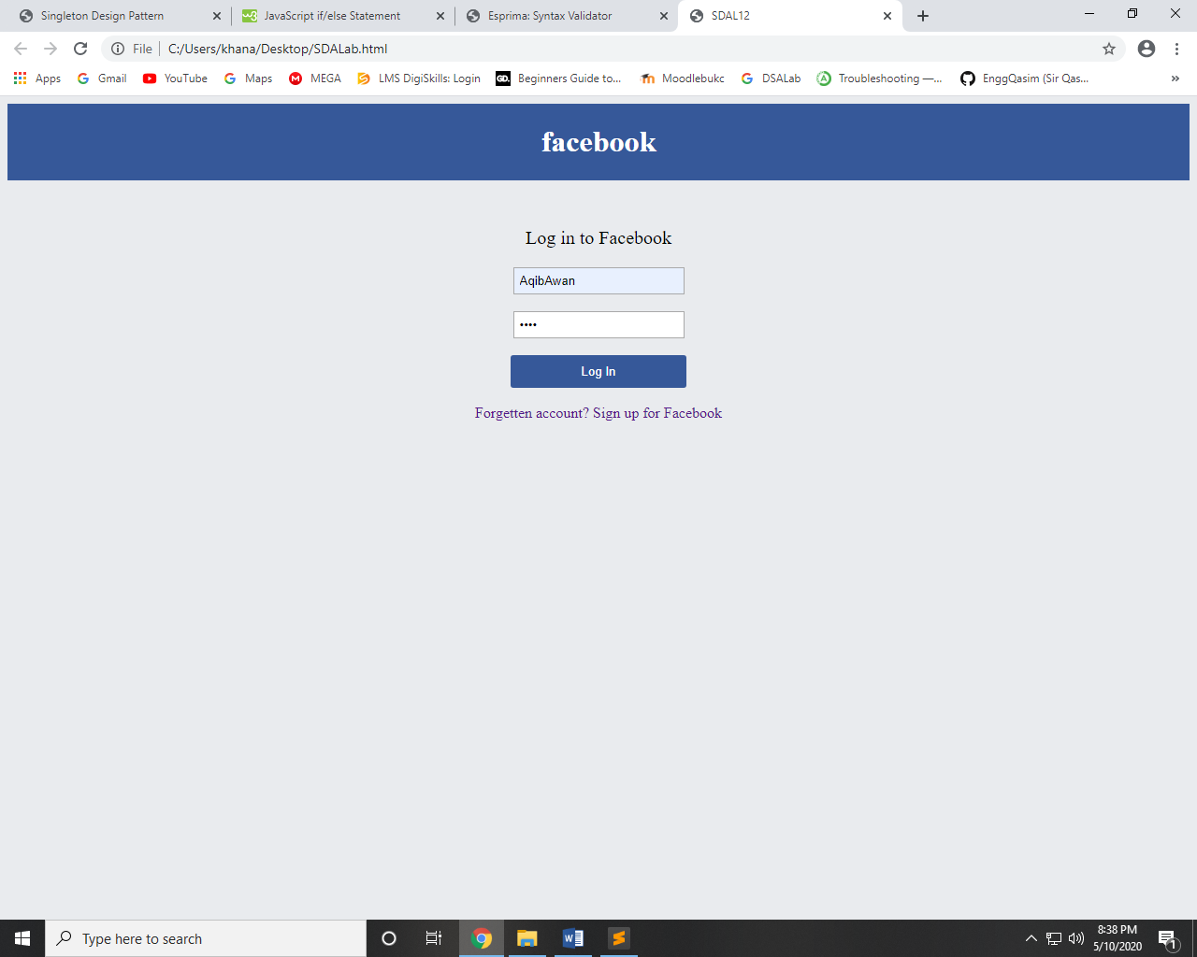 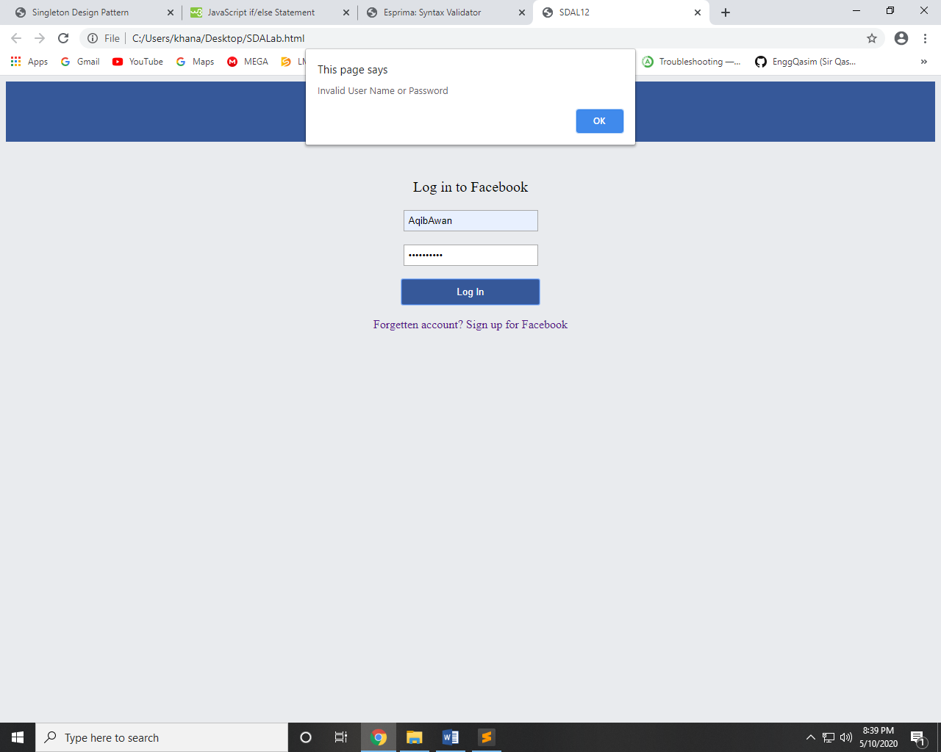

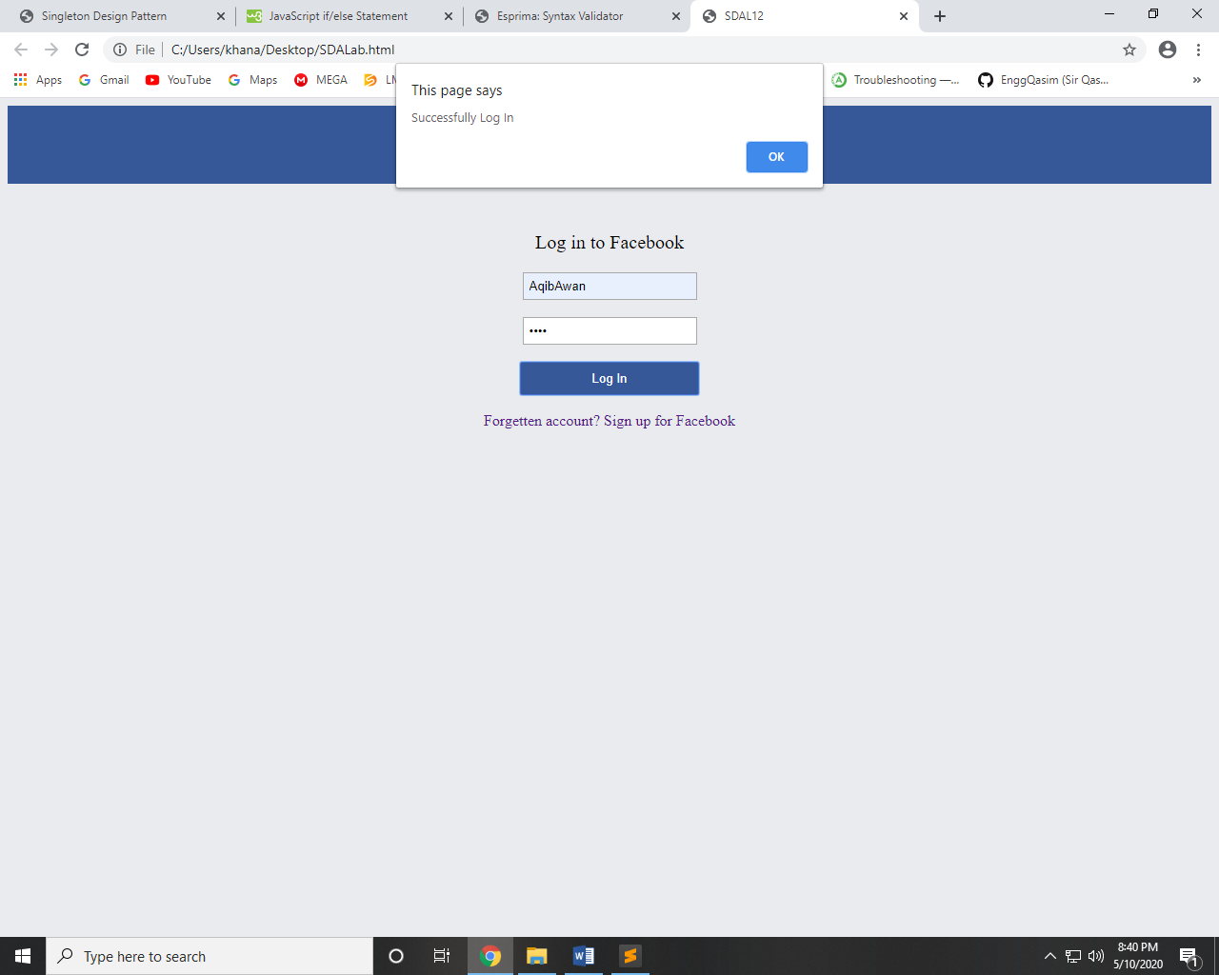

~~~~~~**/**THE END**/**~~~~~~