
Bahria University, Lahore Campus
Department of Computer Sciences
Lab Manual 01
(Fall 2026)

Course: | Operating System Lab | Date:
Course Code: | CSL -320 | Max Marks: 10
Faculty’s Name: | Amarah Abdullah | Lab Instructor:

CLO Statement | CLO No.
Demonstrate the knowledge in applying system software and tools available in modern operating systems. | CLO-2

Objective(s):
To understand basic concepts of Operating System.

Tool(s) used:
Ubuntu

Introduction to Operating System
Operating system is software which performs executive functions. It provides services and controls sharing of information to the users. We have batch processing, Multi-Programming, Multitasking and Multithreading operating systems. Modern operating systems for desktop and laptop environments use operating systems like Windows, LINUX and Solaris.
They have layered architecture, Kernel being the lowest to provide hardware abstraction to upper layers of operating system, utilities and User interface. The windows and Linux operating systems are shown in the figure 1 and 2.

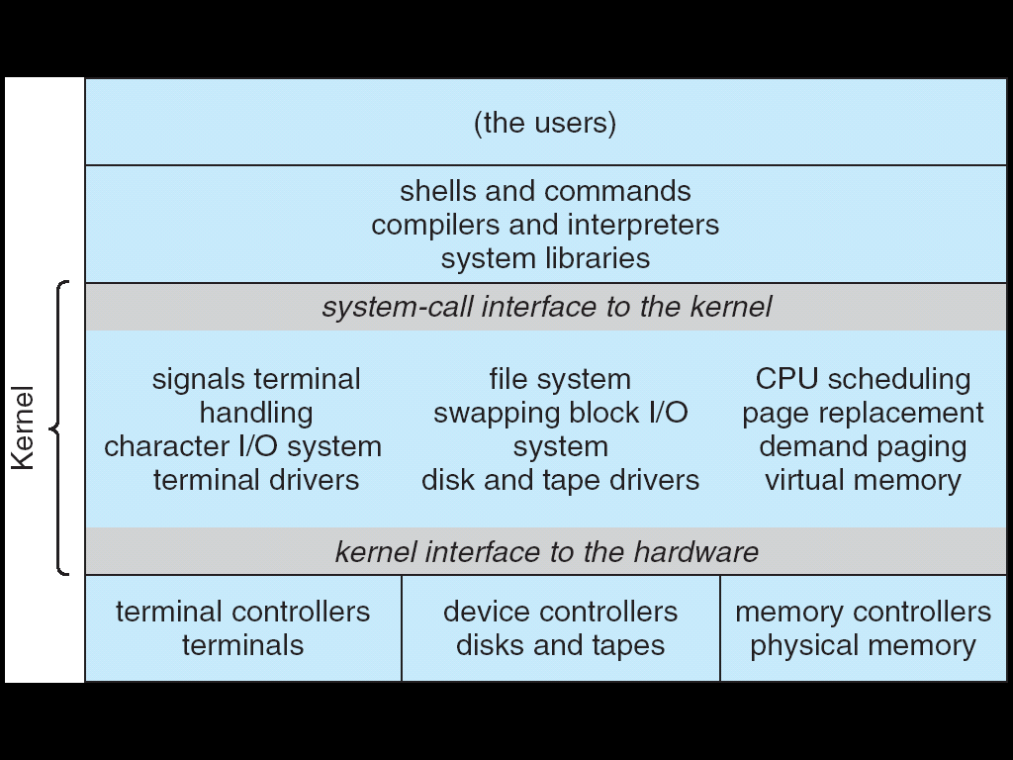
Figure 1 Linux Operating System
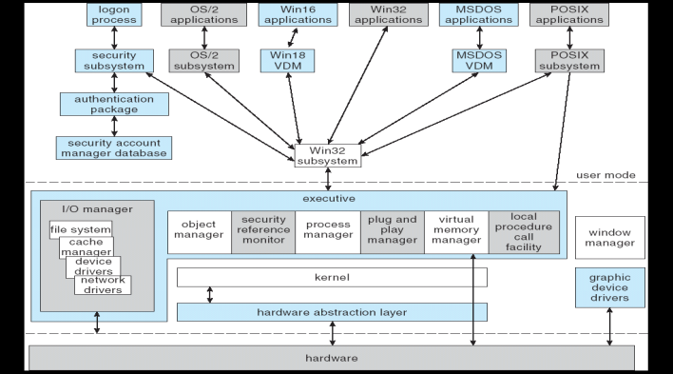
Figure 2 Windows Operating System

Windows and Mac OS are predominantly found on personal computing devices such as desktop and laptop computers. Other operating systems, such as Symbian, are found on small devices such as phones and PDAs, while mainframes and supercomputers found in major academic and corporate labs use specialized operating systems such as AS/400 and the Cray OS. Linux, which began its existence as a server OS and has become useful as a desktop OS, can also be used on all of these devices.

Introduction to LINUX
We will use LINUX operating system for most of our lab work to be able to learn how the operating systems software is developed to implement various algorithms. Linux is a generic term referring to Unix-like computer operating systems based on the Linux kernel. Their development is one of the most prominent examples of free and open source software collaboration; typically all the underlying source code can be used, freely modified, and redistributed by anyone.
The name "Linux" comes from the Linux kernel, originally written in 1991 by Linus Torvalds. The rest of the system usually comprises components such as the Apache HTTP Server, the X Window System, the K Desktop Environment, and utilities and libraries from the GNU operating system (announced in 1983 by Richard Stallman).
Many quantitative studies of free / open source software focus on topics including market share and reliability, with numerous studies specifically examining Linux. The Linux market is growing rapidly, and the revenue of servers, desktops, and packaged software running Linux was expected to exceed $35.7 billion by 2008.

LINUX File System
A file system is the methods and data structures that an operating system uses to keep track of files on a disk or partition; that is, the way the files are organized on the disk. The word is also used to refer to a partition or disk that is used to store the files or the type of the file system.
The difference between a disk or partition and the file system it contains is important. A few programs (including, reasonably enough, programs that create file systems) operate directly on the raw sectors of a disk or partition; if there is an existing file system there it will be destroyed or seriously corrupted. Most programs operate on a file system, and therefore won't work on a partition that doesn't contain one (or that contains one of the wrong type). Before a partition or disk can be used as a file system, it needs to be initialized, and the bookkeeping data structures need to be written to the disk. This process is called making a file system. Figure 3 shows the typical LINUX file system.
Linux uses a single hierarchical directory structure. Everything starts from the root directory, represented by /, and then expands into sub-directories instead of having so-called 'drives'. The filenames are case sensitive.
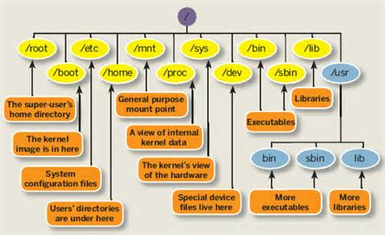
Figure 3 LINUX File Systems

/bin | Directory contains several useful commands that are used by both the system administrator as well as non-privileged users.
/boot | Directory contains the system. Map file as well as the Linux kernel. Lilo places the boot sector backups in this directory.
/ dev | hda1, hda2 etc, which represent the various partitions on the first master drive of the system. /dev/cdrom and /dev/fd0 represent your CDROM drive and your floppy drive. One important characteristic of the Linux file system is that everything is a file or a directory.
/etc | Directory contains all the configuration files for the system.
/home | Contains user home directories, which can be found under /home/username.
/lib | Contains all the shared libraries that are required by system programs.
/lost+found | Linux should always go through a proper shutdown. Sometimes your system might crash or a power failure might take the machine down. Either way, at the next boot, a lengthy filesystem check using fsck will be done. Fsck will go through the system and try to recover any corrupt files that it finds. The result of this recovery operation will be placed in this directory.
/mnt | This directory usually contains mount points or sub-directories where you mount your floppy and your CD.
/opt | This directory contains all the software and add-on packages that are not part of the default installation.
/proc | This is a special directory on your system.
/root | We talked about user home directories earlier and well this one is the home directory of the user root.
/tmp | This directory contains mostly files that are required temporarily.
/usr | This is one of the most important directories in the system as it contains all the user binaries. /usr/src/linux contains the source code for the Linux kernel.
/var | This directory contains spooling data like mail and also the output from the printer daemon. The above content briefs about Linux and the file system of Linux.

Development of LINUX
The Linux kernel was first made available in 1991 after a student named Linus Torvalds finished developing it as an alternative to the MINIX Operating system. MINIX was an operating system based off of UNIX, which was developed in 1969 and had become a popular OS within the education environment and industry. The Linux kernel was free to use and it was quickly taken up by developers around the world. It wasn’t long before there were several distributions of operating systems running with the Linux kernel. One of the especially notable projects was the GNU project, which was started by Richard Stallman in the mid 80’s. Richard Stallman wanted to help start a community that was built around the idea of free and open software. Stallman decided the best place to start was with an Operating system, and by 1990 he had completed most of the GNU project with the exception of the kernel. Thus, when the Linux kernel was made available, the GNU suite of software was pieced together with the kernel to form the GNU/Linux operating system. This combined package would go on to be the back bone to many other Linux distributions. By the end of 1994, Linux version 1.0.0 had been released and the world had begun to take notice of the ever growing number of distributions.

LINUX popularity and evolution of distributions
As the Linux kernel and its distributions continued to improve and grow in popularity, larger companies began to offer more and more support for the free OS and the idea of free software in general. From 1994-1997, Linux began to be picked up in mainstream publications such as wired magazine as well as gain notice from tradeshows.
The year 1998 was especially fruitful for Linux, with support beginning to come from the Google search engine in May and software for Linux from companies such as Informix and Oracle in July. It was also announced during that Intel and Netscape had invested money into the Red Hat company (the Red Hat distribution was one of the earlier Linux distributions and would go on to be the back bone to many popular distributions and even end up on board of a submarine). With more and more improvements on the software, and the release of such notable desktop environments as KDE and Gnome in the late 90’s and early 2000’s, Linux was beginning to really take hold of the computer industry.

Understanding Virtual Machines
A virtual machine is a software computer that, like a physical machine, runs an operating system and applications. A virtual machine uses the physical resources of the physical machine on which it runs, which is called the host system. Virtual machines have virtual devices that provide the same functionality as physical hardware, but with the additional benefits of portability, manageability, and security. A virtual machine has an operating system and virtual resources that you manage in much the same way that you manage a physical computer. For example, you install an operating system in a virtual machine in the same way that you install an operating system on a physical computer. You must have a CD-ROM, DVD, or ISO image that contains the installation files from an operating system vendor.

Preparing to Create a New Virtual Machine
You use the New Virtual Machine wizard to create a new virtual machine in Workstation. The wizard prompts you to make decisions about many aspects of the virtual machine. You should make these decisions before you start the New Virtual Machine wizard.

Selecting a Virtual Machine Configuration
When you start the New Virtual Machine wizard, the wizard prompts you to select a typical or custom configuration.

Typical Configuration
If you select a typical configuration, you must specify or accept defaults for a few basic virtual machine settings.
- How you want to install the guest operating system.
- A name for the virtual machine and a location for the virtual machine files.
- The size of the virtual disk and whether to split the disk into multiple virtual disk files.
- Whether to customize specific hardware settings, including memory allocation, number of virtual processors, and network connection type.
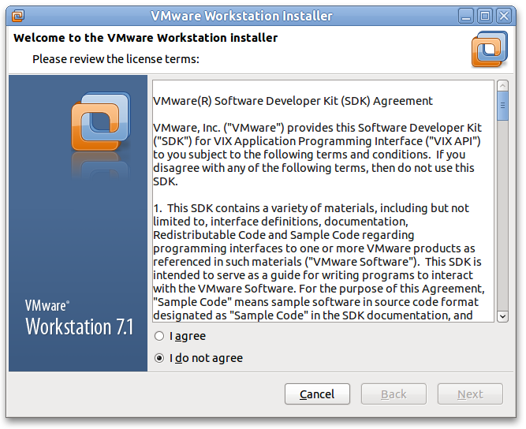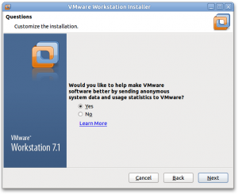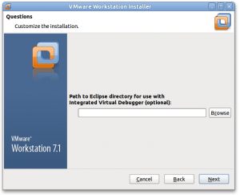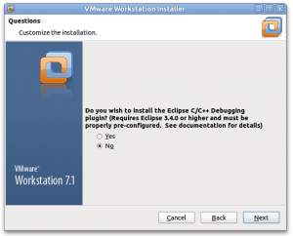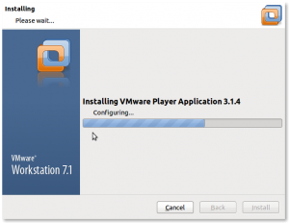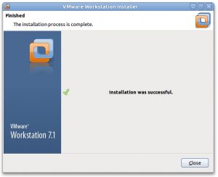

UNIX OPERATING SYSTEM
An operating system is the program that controls all the other parts of a computer system - both the hardware and the software. Most importantly, it allows you to make use of the facilities provided by the system. Example of operating system are Windows XP, Windows NT, UNIX, Linux, ..etc.
UNIX is an operating system which was first developed in the 1960s, and has been under constant development ever since. By operating system, we mean the suite of programs which make the computer work. It is a stable, multi-user, multi-tasking system for servers, desktops and laptops.
UNIX systems also have a graphical user interface (GUI) similar to Microsoft Windows which provides an easy to use environment. However, knowledge of UNIX is required for operations which aren't covered by a graphical program, or for when there is no windows interface available, for example, in a telnet session.

Different Versions of Unix
There are many different versions of UNIX, although they share common similarities. The most popular varieties of UNIX are:
Sun Solaris,
GNU/Linux, and
MacOS X.

UBUNTU Operating System
Ubuntu is a Debian-based Linux operating system for personal computers, tablets and smartphones, where Ubuntu Touch edition is used; and also runs network servers, usually with the Ubuntu Server edition, either on physical or virtual servers (such as on mainframes) or with containers, that is with enterprise-class features; runs on the most popular architectures, including server-class ARM-based.

Ubuntu Minimum Requirements
The minimum requirements for the current (20) release of Fedora are:
1GHz Processor
1 GB
10 GB free disc space
DVD drive or USB port (-for installation media)

Installation of UBUNTU
The installation system is easy to use even if you lack previous knowledge of Linux or computer networks. If you select default options, Ubuntu provides a complete desktop operating system, including productivity applications, Internet utilities, and desktop tools. Ubuntu Workstation is a reliable, user-friendly, and powerful operating system for your laptop or desktop computer. It supports a wide range of developers, from hobbyists and students to professionals in corporate environments.

Installing VMware Tools
The following are general steps used to start the VMware Tools installation in most VMware products. Certain guest operating systems may require different steps, but these steps work for most operating systems. Links to more detailed steps for different operating systems are included in this article. Make sure to review the VMware documentation for the product you are using.

To install VMware Tools in most VMware products
- Power on the virtual machine.
- Log in to the virtual machine using an account with Administrator or root privileges.
- Wait for the desktop to load and be ready.
- Click Install/Upgrade VMware Tools. There are two places to find this option:
- Right-click on the running virtual machine objects and choose Install/Upgrade VMware Tools.
- Right-click on the running virtual machine objects and click Open Console. In the Console menu click VM and click Install/Upgrade VMware Tools.
Note: In ESX/ESXi 4.x, navigate to VM > Guest > Install/Upgrade VMware Tools. In Workstation, navigate to VM > Install/Upgrade VMware Tools.

- Based on the operating system you specified when creating the virtual machine, the correct ISO CD-ROM image containing VMware Tools is mounted to the virtual CD-ROM of the virtual machine.

- To verify the operating system you have selected, perform one of the following:
- Right-click the running virtual machine object and choose Edit Settings > Options > General Options > Guest Operating System and Version.
- Right-click the running virtual machine objects and clicks Open Console. In the Console menu click VM > Edit Settings >Options> General Options > Guest Operating System and Version.

