

**Data Ware House(DWH)**

**Project Report**

**Name:** Muhammad Aqib

**Roll Number:** 14I-0224

**Section:** A

**Project Overview:**

This is a semester project of course Data Ware House (DWH), in which we have to build a running prototype of a whole DWH and to implement the concepts of DWH which we studied in class and lab. Example (creating tables, creating star schema, populating tables through INSERT, implementing INLJ on those tables and processing OLAP queries on our whole Data Ware House.

**DWH Schema:**

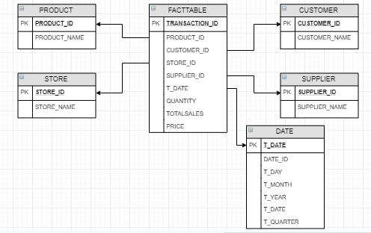

**INLJ Algorithms:**

* **ProductINLJ:**

DECLARE

CURSOR cursorProduct IS

SELECT T.PRODUCT_ID ,M.PRODUCT_NAME

FROM TRANSACTIONS T, MASTERDATA M

WHERE T.PRODUCT_ID = M.PRODUCT_ID

ORDER BY (T.TRANSACTION_ID);

TYPE productR IS TABLE OF cursorProduct%ROWTYPE INDEX BY BINARY_INTEGER;

productRecord productR;

BEGIN

OPEN cursorProduct;

LOOP

FETCH cursorProduct BULK COLLECT INTO productRecord LIMIT 50;

EXIT WHEN productRecord.COUNT = 0;

FOR iter IN 1 .. productRecord.COUNT

LOOP

DECLARE

CUR INTEGER;

BEGIN

SELECT COUNT(*) INTO CUR FROM "PRODUCT" WHERE PRODUCT_ID=productRecord (iter).PRODUCT_ID;

IF NOT CUR > 0 THEN

Insert into "PRODUCT" (PRODUCT_ID,PRODUCT_NAME)

values (productRecord (iter).PRODUCT_ID,productRecord (iter).PRODUCT_NAME);

END IF;

END;

END LOOP;

END LOOP;

CLOSE cursorProduct;

END;

* **CustomerINLJ:**

DECLARE

CURSOR cursorCustomer IS

SELECT CUSTOMER_ID, CUSTOMER_NAME

FROM TRANSACTIONS T

ORDER BY (T.TRANSACTION_ID);

TYPE customerR IS TABLE OF cursorCustomer%ROWTYPE INDEX BY BINARY_INTEGER;

customerRecord customerR;

BEGIN

OPEN cursorCustomer;

LOOP

FETCH cursorCustomer BULK COLLECT INTO customerRecord LIMIT 50;

EXIT WHEN customerRecord.COUNT = 0;

FOR iter IN 1 .. customerRecord.COUNT

LOOP

DECLARE

CUR INTEGER;

BEGIN

SELECT COUNT(*) INTO CUR FROM "CUSTOMER" WHERE CUSTOMER_ID=customerRecord (iter).CUSTOMER_ID;

IF NOT CUR > 0 THEN

Insert into "CUSTOMER" (CUSTOMER_ID,CUSTOMER_NAME) values (customerRecord (iter).CUSTOMER_ID,customerRecord (iter).CUSTOMER_NAME);

END IF;

END;

END LOOP;

END LOOP;

CLOSE cursorCustomer;

END;

* **StoreINLJ:**

SET SERVEROUTPUT ON;

DECLARE

CURSOR cursorStore IS

SELECT STORE_ID, STORE_NAME

FROM TRANSACTIONS T;

TYPE storeR IS TABLE OF cursorStore%ROWTYPE INDEX BY BINARY_INTEGER;

storeRecord storeR;

BEGIN

OPEN cursorStore;

LOOP

FETCH cursorStore BULK COLLECT INTO storeRecord LIMIT 50;

EXIT WHEN storeRecord.COUNT = 0;

FOR iter IN 1 .. storeRecord.COUNT

LOOP

DECLARE

CUR INTEGER;

BEGIN

SELECT COUNT(*) INTO CUR FROM "STORE" WHERE STORE_ID=storeRecord (iter).STORE_ID;

IF NOT CUR > 0 THEN

dbms_output.put_line(storeRecord (iter).STORE_ID);

Insert into "STORE" (STORE_ID,STORE_NAME)

values (storeRecord (iter).STORE_ID,storeRecord (iter).STORE_NAME);

END IF;

END;

END LOOP;

END LOOP;

CLOSE cursorStore;

END;

* **SupplierINLJ:**

DECLARE

CURSOR cursorSupplier IS

SELECT M.SUPPLIER_ID,M.SUPPLIER_NAME

FROM MASTERDATA M

ORDER BY (M.SUPPLIER_ID);

TYPE supplierR IS TABLE OF cursorSupplier%ROWTYPE INDEX BY BINARY_INTEGER;

supplierRecord supplierR;

BEGIN

OPEN cursorSupplier;

LOOP

FETCH cursorSupplier BULK COLLECT INTO supplierRecord LIMIT 50;

EXIT WHEN supplierRecord.COUNT = 0;

FOR iter IN 1 .. supplierRecord.COUNT

LOOP

DECLARE

CUR INTEGER;

BEGIN

SELECT COUNT(*) INTO CUR FROM "SUPPLIER" WHERE SUPPLIER_ID=supplierRecord (iter).SUPPLIER_ID;

IF NOT CUR > 0 THEN

Insert into "SUPPLIER" (SUPPLIER_ID,SUPPLIER_NAME)

values (supplierRecord (iter).SUPPLIER_ID,supplierRecord (iter).SUPPLIER_NAME);

END IF;

END;

END LOOP;

END LOOP;

CLOSE cursorSupplier;

END;

* **DateINLJ:**

DECLARE

CURSOR cursorDate IS

SELECT T_DATE

FROM TRANSACTIONS T

ORDER BY (T.PRODUCT_ID);

TYPE dateR IS TABLE OF cursorDate%ROWTYPE INDEX BY BINARY_INTEGER;

dateRecord dateR;

BEGIN

OPEN cursorDate;

LOOP

FETCH cursorDate BULK COLLECT INTO dateRecord LIMIT 50;

EXIT WHEN dateRecord.COUNT = 0;

FOR iter IN 1 .. dateRecord.COUNT

LOOP

DECLARE

CUR INTEGER;

BEGIN

SELECT COUNT(*) INTO CUR FROM "DATE" WHERE T_DATE=dateRecord (iter).T_DATE;

IF NOT CUR > 0 THEN

Insert into "DATE" (T_DATE, T_DAY,T_YEAR,T_MONTH,T_QUARTER)

values (dateRecord (iter).T_DATE, EXTRACT(DAY from dateRecord (iter).T_DATE),

EXTRACT(YEAR from dateRecord (iter).T_DATE),

EXTRACT(MONTH from dateRecord (iter).T_DATE),

TO_CHAR(dateRecord (iter).T_DATE, 'Q'));

END IF;

END;

END LOOP;

END LOOP;

CLOSE cursorDate;

END;

* **FactTableINLJ:**

SET SERVEROUTPUT ON;

DECLARE

CURSOR cursorFactTable IS

SELECT T.TRANSACTION_ID,T.PRODUCT_ID, T.CUSTOMER_ID, T.T_DATE, T.QUANTITY, T.STORE_ID, M.SUPPLIER_ID,M.PRICE

FROM TRANSACTIONS T, MASTERDATA M

WHERE T.PRODUCT_ID = M.PRODUCT_ID

ORDER BY (T.TRANSACTION_ID);

TYPE factTableR IS TABLE OF cursorFactTable%ROWTYPE INDEX BY BINARY_INTEGER;

factTableRecord factTableR;

BEGIN

OPEN cursorFactTable;

LOOP

FETCH cursorFactTable BULK COLLECT INTO factTableRecord LIMIT 50;

EXIT WHEN factTableRecord.COUNT = 0;

FOR iter IN 1 .. factTableRecord.COUNT

LOOP

DECLARE

CUR INTEGER;

BEGIN

Insert into "FACTTABLE" (TRANSACTION_ID,PRODUCT_ID, CUSTOMER_ID, SUPPLIER_ID, STORE_ID, T_DATE, PRICE, QUANTITY, TOTALSALES)

Values (factTableRecord (iter).TRANSACTION_ID, factTableRecord (iter).PRODUCT_ID, factTableRecord (iter).CUSTOMER_ID,

factTableRecord (iter).SUPPLIER_ID, factTableRecord (iter).STORE_ID,

factTableRecord (iter).T_DATE, factTableRecord (iter).PRICE,

factTableRecord (iter).QUANTITY, factTableRecord (iter).PRICE*factTableRecord (iter).QUANTITY);

END;

END LOOP;

END LOOP;

CLOSE cursorFactTable;

END;

**OLAP Queries and their Output:**

* **Query-1:**

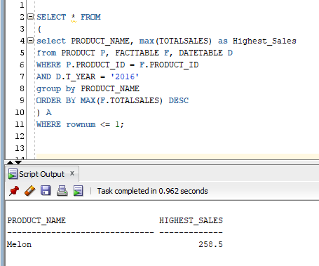

* **Query-2:**

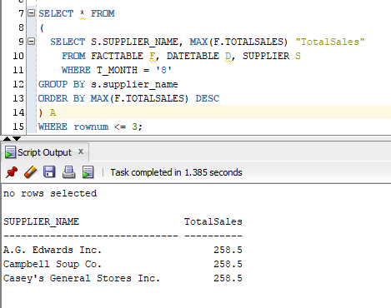

* **Query-3:**

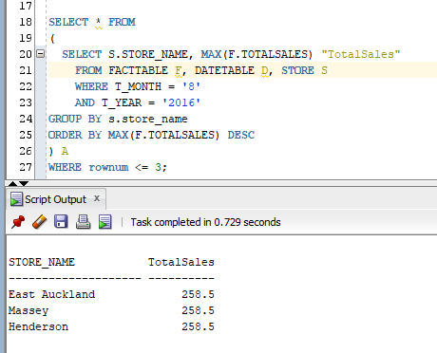

* **Query-4:**

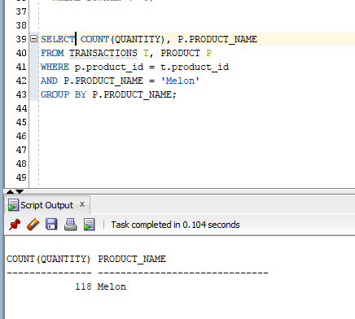

* **Query-5:**

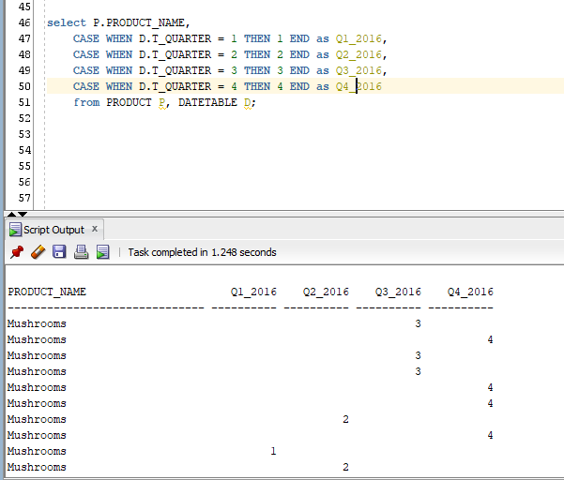

**Summaray:**

From the very first day our instructor was telling us that the core objective of this course is that you will learn what Data Ware House is and how to build and use a Data ware House. At the end of the semester every student will come to know how to build a Data ware House on his/her own. To be honest, after studying DWH and doing practical work in labs, most of the students are aware what is DWH and how to build one. I have done this whole project step by step as instructed and I have learned how to make tables in DWH, how to populate those tables, how to build a Schema with those tables, how to load tables in DWH, how to use DWH in our daily life efficiently by processing the OLAP queries and most important I have come to known a lot of new tools trending in industries these days for example (ORACLE, SQL Developer, SQL Server Management Studio, SQL Server Data Tools). It was a tough and challenging project but if we see the learning perspective, it was a lot more fruitful. I am sure this hard work will pay off and it will benefit us in the industries we will be going. At the end I will say a huge Thank You to our Instructors who made all this possible and taught us such challenging courses and made us expert so we can excel in the industries by doing such challenging projects. Thank You.