

Course Name: Computer Graphics Fundamentals
Project Title: [Insert Project Title]
Team Members: [Insert Names and group]
Instructor: Nazira Shaimerdenova
Date of Submission: [Insert Date]

Table of Contents
- Introduction
- Literature Review/Background
- Project Description
  - 2.1 Objective
  - 2.2 Problem Statement
  - 2.3 Scope
- Technical Implementation
  - 3.1 Tools and Technologies Used
  - 3.2 Development Process
  - 3.3 Algorithms and Techniques
- Graphics and Rendering
  - 4.1 2D/3D Rendering Techniques
  - 4.2 Lighting and Shading
  - 4.3 Texturing and Animation
- Testing and Evaluation
  - 5.1 Testing Methodology
  - 5.2 Performance Evaluation
  - 5.3 Issues and Debugging
- Conclusion and Future Work
- References
- Appendix (if needed)

1. Introduction
Provide an overview of the project, its motivation, and why it is relevant to computer graphics. Explain the purpose and expected outcomes of the project.
- Literature Review
Provide a Literature review for your project, use credible sources from Q1-Q2 journals, Use at least 15 sources for your literature review.
3. Project Description
3.1 Objective
State the main objective of the project and what it aims to accomplish.
3.2 Problem Statement
Define the problem the project is addressing and why it is important.
3.3 Scope
Outline the scope of the project, including what is included and excluded from the final implementation.
3. Technical Implementation
3.1 Tools and Technologies Used
List and describe the programming languages, libraries, and frameworks used (e.g., OpenGL, Vulkan, DirectX, C++, Python, etc.).
3.2 Development Process
Describe how the project was developed, including software development methodologies, version control strategies, and teamwork approach.
3.3 Algorithms and Techniques
Discuss any mathematical and algorithmic techniques implemented in the project, such as transformation matrices, rasterization, shading models, etc.
4. Graphics and Rendering
4.1 2D/3D Rendering Techniques
Explain how the graphics are generated, including rendering techniques used.
4.2 Lighting and Shading
Describe the lighting models used (e.g., Phong, Blinn-Phong, PBR) and their impact on visual quality.
4.3 Texturing and Animation
Explain any texture mapping techniques, procedural textures, and animation techniques applied.
5. Testing and Evaluation
5.1 Testing Methodology
Describe how the project was tested, including unit testing, integration testing, and user testing.
5.2 Performance Evaluation
Analyze the performance of the graphics application, including FPS (frames per second), memory usage, and rendering efficiency.
5.3 Issues and Debugging
Document the challenges faced during development and how they were resolved.
6. Conclusion and Future Work
Summarize the outcomes of the project and discuss potential improvements and future developments.
7. References
Cite all relevant books, websites, and academic papers used in the project.
8. Appendix (if needed)
Include any additional documentation, source code snippets, or diagrams relevant to the project.
P.S. Formatting of the figures
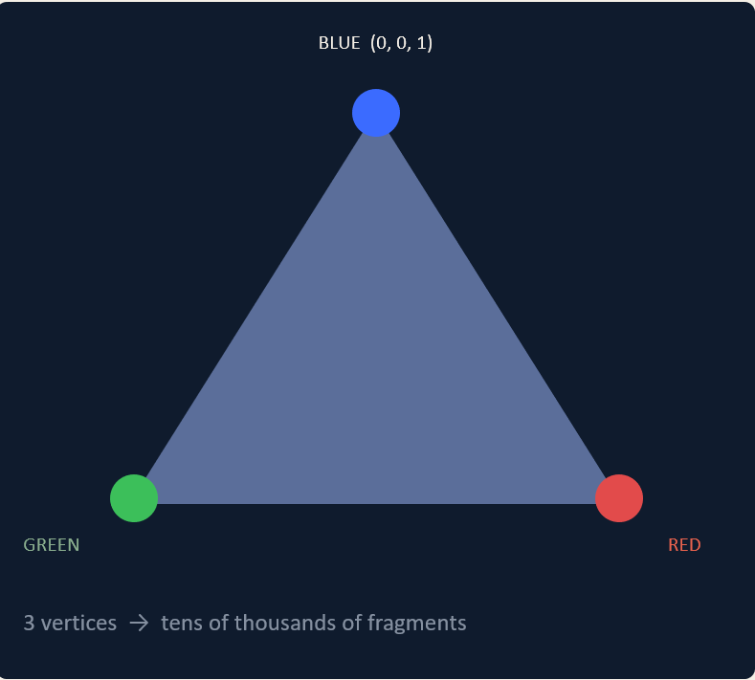
Fig.1 Triangle
After a figure don’t forget to add an in-text citation to the figure: Figure 1 illustrates the …..

