# JAVA编程进阶上机报告



**学 院 智算学部**

**专 业 软件工程**

**班 级 软工二班**

**学 号 3018216072**

**姓 名 李青颖**

**一、实验要求**

1. **需求描述：**

某计算机组装公司主要销售各类组装计算机，计算机一般由CPU、内存、主板、硬盘等组件构成。具体组件信息如下：

|  |  |  |
| --- | --- | --- |
| 组件名 | 组件品牌 | 组件属性 |
| CPU | Intel、AMD | Name，coreNum，price |
| 内存 | Samsung, Kingston | Name, volume, price |
| 硬盘 | Seagate, WestDigitals | Name, volume, price |
| 主板 | Asus、Gigabyte | Name，speed, price |

每个组件都有自己的工作方式，简单起见，每个组件的工作内容为打印“组件名+work”。

1. **实现功能：**

具体要求：

1. 针对每个组件的每个品牌，设计一个类，并画成整体的类图
2. 设计计算机类（Computer.java），由上述四类组件组装而成，包括计算机的名称、计算机的描述（包括各个组件名）以及总价格等
3. 设计计算机销售主类（ComputerStore.java），包括3个由不同组件组装在一起的计算机实例，可实现计算机商品一览表，可展示每台计算机的描述、价格、工作等。
4. 设计时基于抽象类和接口，要尽可能的实现高内聚、低耦合。

**设计思路：每个品牌都有一个接口，每个品牌各有一个对应的类，其中computer类里面有三个函数，分别代表三个设备，而computerstore类负责将这三个设备的一览表打印出来。**

**类图如下：**

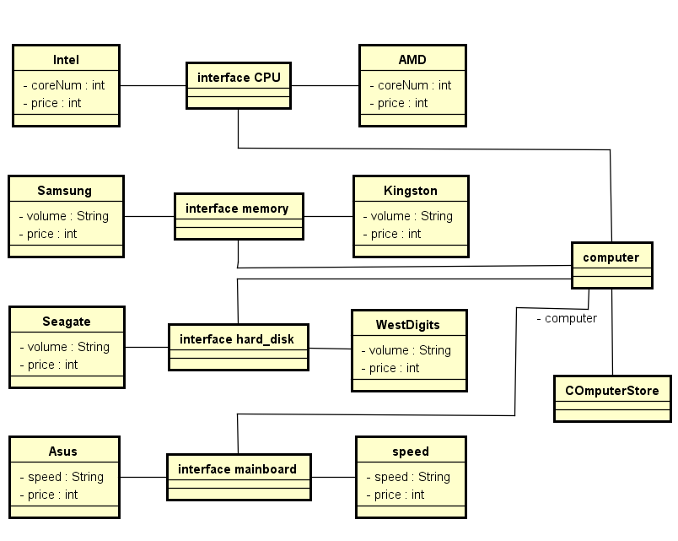

二、源代码

**public** **interface** CPU {

String ***Name*** = "CPU";

**static** **void** work() {}

}

**public** **interface** memory {

String ***Name*** = "内存";

}

**public** **interface** hard_disk {

String ***Name*** = "硬盘";

}

**public** **interface** mainboard {

String ***Name*** = "主板";

}

**public** **class** AMD **implements** CPU {

**int** coreNum = 1001;

**int** price = 1000;

**void** work() {

System.***out***.print(**this**.Name + " work ");

}

}

**public** **class** Asus **implements** mainboard {

String speed = "2666MHZ";

**int** price = 1200;

**void** work() {

System.***out***.print(**this**.Name + " work ");

}

}

**public** **class** Gigabyte **implements** mainboard {

String speed = "1066MHZ";

**int** price = 500;

**void** work() {

System.***out***.print(**this**.Name + " work ");

}

}

**public** **class** Intel **implements** CPU {

**int** coreNum = 1002;

**int** price = 2000;

**void** work() {

System.***out***.print(**this**.Name + " work ");

}

}

**public** **class** Kingston **implements** memory {

String volume = "16GB";

**int** price = 700;

**void** work() {

System.***out***.print(**this**.Name + " work ");

}

}

**public** **class** Samsung **implements** memory {

String volume = "8GB";

**int** price = 400;

**void** work() {

System.***out***.print(**this**.Name + " work ");

}

}

**public** **class** Seagate **implements** hard_disk {

String volume = "1T";

**int** price = 500;

**void** work() {

System.***out***.print(**this**.Name + " work ");

}

}

**public** **class** WestDigitals **implements** hard_disk {

String volume = "2T";

**int** price = 800;

**void** work() {

System.***out***.print(**this**.Name + " work ");

}

}

**public** **class** Computer {

**void** com1() {

String Name = "computer1";

Intel in = **new** Intel();

Samsung sam = **new** Samsung();

Seagate swa = **new** Seagate();

Asus as = **new** Asus();

**int** price = in.price + sam.price + swa.price + as.price;

System.***out***.print("\n" + in.Name + " " + in.price + "\n");

in.work();

System.***out***.print("\n" + sam.Name + " " + sam.price + "\n");

sam.work();

System.***out***.print("\n" +swa.Name + " " + swa.price + "\n");

swa.work();

System.***out***.print("\n" + as.Name + " " + as.price + "\n");

as.work();

System.***out***.print("\n" + Name + " " + price);

}

**void** com2() {

String Name = "computer2";

AMD amd = **new** AMD();

Samsung sam = **new** Samsung();

Seagate swa = **new** Seagate();

Gigabyte gig = **new** Gigabyte();

**int** price = amd.price + sam.price + swa.price + gig.price;

System.***out***.print("\n" + amd.Name + " " + amd.price + "\n");

amd.work();

System.***out***.print("\n" + sam.Name + " " + sam.price + "\n");

sam.work();

System.***out***.print("\n" +swa.Name + " " + swa.price + "\n");

swa.work();

System.***out***.print("\n" + gig.Name + " " + gig.price + "\n");

gig.work();

System.***out***.print("\n" + Name + " " + price);

}

**void** com3() {

String Name = "computer3";

Intel in = **new** Intel();

Kingston kin = **new** Kingston();

WestDigitals swa = **new** WestDigitals();

Asus as = **new** Asus();

**int** price = in.price + kin.price + swa.price + as.price;

System.***out***.print("\n" + in.Name + " " + in.price + "\n");

in.work();

System.***out***.print("\n" + kin.Name + " " + kin.price + "\n");

kin.work();

System.***out***.print("\n" +swa.Name + " " + swa.price + "\n");

swa.work();

System.***out***.print("\n" + as.Name + " " + as.price + "\n");

as.work();

System.***out***.print("\n" + Name + " " + price);

}

}

**public** **class** ComputerStore {

**public** **static** **void** main(String[] args) {

// **TODO** Auto-generated method stub

//Computer com = null;

Computer com = **new** Computer();

com.com1();

com.com2();

com.com3();

}

}

**三、实验结果**

CPU 2000

CPU work

内存 400

内存 work

硬盘 500

硬盘 work

主板 1200

主板 work

computer1 4100

CPU 1000

CPU work

内存 400

内存 work

硬盘 500

硬盘 work

主板 500

主板 work

computer2 2400

CPU 2000

CPU work

内存 700

内存 work

硬盘 800

硬盘 work

主板 1200

主板 work

computer3 4700