Author: Alex Quel Lien
Portfolio

This app is intended to be used for my personal site.
A preview of the site's current homepage follows:

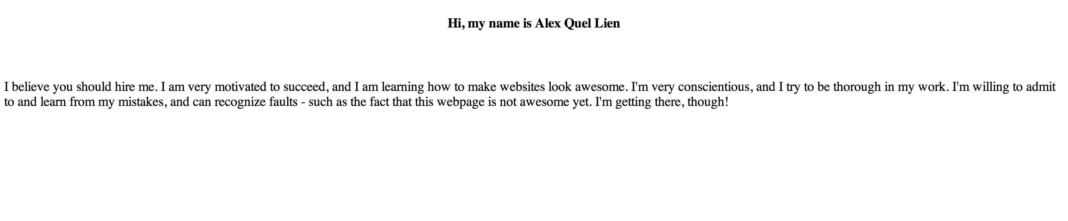

This page will change in the future.

