
UNIVERSITI TEKNOLOGI MALAYSIA
FINAL EXAMINATION SEMESTER II, SESSION 2025/2026
(ALTERNATIVE ASSESSMENT)

COURSE CODE : SECR4483/SCSR4483
COURSE NAME : SECURE PROGRAMMING
SECTION : 01, 02, 03 & UTMSPACE
TIME : 9.00 AM (4 JULY 2026) – 9.00 AM (6 JULY 2026)
DATE/DAY : 4 – 6 JULY 2026 (TUESDAY – THURSDAY)
VENUES : UTM ELEARNING

Name | AQMAR ILHAN BIN MOHAMAD FADZILAH
Matric No. | B23CS0027
Year / Course | 4/SECRH
Section | 03
Lecturer Name | DR. MOHD KUFAISAL BIN MOHD SIDIK

GitHub Link
YouTube Link

Table of Contents
CHAPTER 1 ARCHITECTURAL CODE REVIEW & VULNERABILITY DISCOURSE 4
1.1 Introduction 4
1.2 Overview of Vulnerable Source Code Artifacts 4
1.3 Vulnerability Analysis of search.php 5
1.3.1 SQL Injection Vulnerability 5
1.3.2 Runtime Mechanism of SQL Injection 6
1.3.3 Reflected Cross-Site Scripting Vulnerability 6
1.3.4 Runtime Mechanism of Reflected XSS 7
1.3.5 Secure Coding Principles Violated in search.php 8
CHAPTER 2 SECURE REFACTORING IMPLEMENTATION & EXPLOIT-CHAIN DISRUPTION MATRIX 9
2.1 Introduction 9
2.2 Secure Refactoring of search.php 9
2.2.1 SQL Injection Mitigation Using Prepared Statements 9
2.2.2 Reflected XSS Mitigation Using Output Encoding 10
2.3 Secure Refactoring of auth.php 10
2.3.1 Input Length Validation 10
2.3.2 Password Hashing Improvement Using Argon2id 11
2.4 Exploit-Chain Disruption Matrix 11
CHAPTER 3 CRYPTOGRAPHIC SUBSYSTEM ANALYSIS, PAYLOAD SERIALIZATION, & OPERATIONAL RESILIENCE 13
3.1 Introduction 13
3.2 Cryptographic Subsystem Dissection 13
3.2.1 Vulnerability of ECB Block Mode vs. AES-256-GCM AEAD 13
3.2.2 Initialization Vector Predictability and Reuse Risks 14
3.2.3 Low-Level Data Serialization Sequence 15
3.2.4 Decryption Exception Flow & Operational Resilience 15
3.3 Environment Configuration & Automated Testing 15
3.3.1 Operational Decoupling of Secrets via. env 15
3.3.2 Repository Exclusions and Attack Surface Reduction 16
3.3.3 PHPUnit Automated Test Verification Paths 16
3.3.4 Exception Trapping and Interpreter Crash Prevention 16
CHAPTER 4 SYSTEMIC VULNERABILITY CORRELATION, FORENSIC DOCUMENTATION, & ARCHITECTURAL SYNTHESIS 17
4.1 Forensic Exploit-Chain Dependency Analysis 17
4.1.1 Cascading Lifecycle of the Security Breach 17
4.1.2 Attack Surface and Vulnerability Cascading 17
4.2 Architectural Synthesis & System Verification 18
4.2.1 Secure Code Refactoring Mapping 18
4.2.2 Automated Test Runner Output and Validation Logs 18

ARCHITECTURAL CODE REVIEW & VULNERABILITY DISCOURSE

Introduction
This chapter presents the architectural code review and vulnerability analysis for the MediChain Solutions Bhd case study. MediChain Solutions Bhd provides the E-MedicVault system, which manages sensitive healthcare data such as patient information, chronic illness records, prescription details, and authentication data.
Based on the case study, the Phase 2 Beta Infrastructure update was deployed under time pressure without proper Static Application Security Testing (SAST) and penetration testing. As a result, several security weaknesses remained in the legacy PHP backend. These weaknesses contributed to serious incidents, including patient data exposure, unauthorized modification of clinical records, and authentication bypass.
This chapter focuses on the vulnerable search.php file, which is identified as one of the main breach vectors. The analysis explains how insecure input handling caused SQL Injection and Reflected Cross-Site Scripting (XSS), and how these flaws violated secure coding principles in the E-MedicVault system.

Overview of Vulnerable Source Code Artifacts
The search.php file functions as a patient and medical record search module. It accepts a keyword from the user and uses it to retrieve matching patient records from the database. Since this function handles sensitive medical information, it must safely process user input before using it in database queries or displaying it in the browser.
However, the legacy implementation is insecure because it directly inserts user input into the SQL query and displays user-controlled data in the HTML response without proper encoding. These weaknesses create two major vulnerabilities: SQL Injection and Reflected XSS.

Vulnerability Analysis of search.php
The search.php file is responsible for searching patient and medical records based on a keyword entered by the user. This function is security-sensitive because it retrieves confidential patient information from the database, including patient names and illness histories. However, the legacy implementation contains two major vulnerabilities: SQL Injection and Reflected Cross-Site Scripting (XSS). These vulnerabilities occur because user input is not safely separated from database commands and is not properly encoded before being displayed in the browser.

SQL Injection Vulnerability

SQL Injection occurs because the keyword parameter from $_GET['keyword'] is directly concatenated into the SQL query. This allows user input to become part of the SQL command.
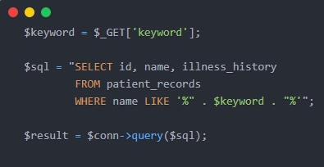
This implementation is dangerous because the database may interpret malicious input as SQL syntax instead of normal search data. For example, an attacker may enter:

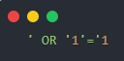
This payload can change the query logic and may cause the database to return all patient records. In the MediChain case study, this could contribute to the exposure of confidential patient health records.

Runtime Mechanism of SQL Injection

At runtime, the PHP interpreter combines the developer’s SQL statement with the user-provided keyword into one complete query. The completed query is then sent to the database engine. Since the input and command are mixed together, the database cannot distinguish between the original SQL instruction and the attacker’s injected SQL syntax
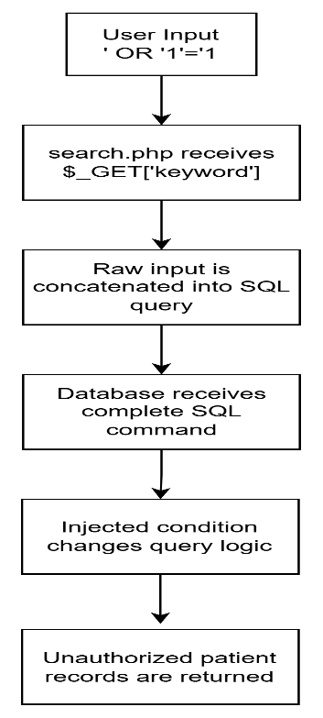
Figure 1.1 Runtime Flow of SQL Injection in search.php

This shows a failure between the data plane and the command plane. User input should remain as data only, but in the vulnerable search.php file, it can influence the SQL command structure.

Reflected Cross-Site Scripting Vulnerability

Reflected XSS occurs because user input is displayed directly in the HTML response without output encoding. If the application echoes the keyword back to the page, malicious script content may be executed by the browser.
For example, an attacker may submit:
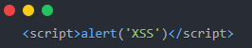

If this payload is reflected in the page, the browser may execute it as JavaScript. This can allow attackers to steal session data, redirect users to malicious websites, or perform actions on behalf of a victim.

Runtime Mechanism of Reflected XSS

At runtime, the server receives the malicious input and returns it inside the HTML response. The browser then parses the response. If the input contains valid HTML or JavaScript syntax, the browser may treat it as executable code instead of plain text..

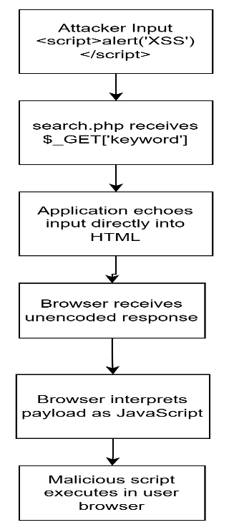
Figure 1.2: Runtime Flow of Reflected XSS in search.php
This shows a boundary failure between normal user data and browser-executable instructions. The application should encode user-controlled output before displaying it so that special characters are treated as text rather than code.

Secure Coding Principles Violated in search.php
The vulnerabilities in search.php violate two main secure coding principles. First, SQL Injection violates the separation of data and command because user input is inserted directly into the SQL query. Second, Reflected XSS violates context-aware output encoding because user-controlled data is displayed in HTML without being safely encoded
Table 1.1: Summary of Vulnerabilities in search.php
Vulnerability | Root Cause | Impact | Runtime Boundary Failure
SQL Injection | Raw user input is concatenated into SQL query | Unauthorized access to patient records | User data becomes part of SQL command
Reflected XSS | User input is echoed directly into HTML output | Malicious script execution in browser | User data becomes executable browser script

.
Overall, search.php is a serious security risk because it exposes both the database layer and the browser presentation layer. In a healthcare system, these weaknesses can lead to patient data leakage, privacy violations, and loss of trust.

Vulnerability Analysis of auth.php

Defective Bound Constraint Mismatch
The authentication script in auth.php implements a boundary check using strlen($inputKey) > 256. However, strlen() measures the length of a string in bytes rather than actual characters. In UTF-8 encoded systems, standard ASCII characters take up 1 byte, while multi-byte characters (such as Chinese, Arabic, or emojis) take between 2 and 4 bytes. This creates a significant mismatch. First, it causes false positives: a string of 100 Chinese characters occupies 300 bytes, which exceeds the 256-byte limit and is blocked, even though it is semantically short. Second, it creates down-stream buffer overflow or truncation risks in subsystems that process characters instead of raw bytes, allowing attackers to manipulate input limits.

Obsolete Hashing Primitive and Authentication Weaknesses
The legacy authentication system compares user-provided keys using MD5: md5($inputKey) === $stored_hash. MD5 is an obsolete, fast hashing primitive that is mathematically broken due to collision vulnerabilities. Because MD5 requires negligible CPU resources, modern attackers can run dictionary and brute-force attacks on GPUs at a scale of billions of guesses per second. Furthermore, the script uses a hardcoded hash ('098f6bcd4621d373cade4e832627b4f6') without unique user salts. If the database is exfiltrated, attackers can perform instant rainbow table lookups to reverse the hashes and hijack physician credentials.

Vulnerability Analysis of crypto_vault.php

Insecure Symmetric Block Cipher (AES-128-ECB)
To protect medical records, crypto_vault.php implements AES-128-ECB symmetric encryption. Electronic Codebook (ECB) mode is highly insecure because it encrypts each 16-byte plaintext block independently with the same key. Since ECB does not use an Initialization Vector (IV) to introduce randomness (entropy), identical plaintext blocks will always result in identical ciphertext blocks. This leaks data patterns. In a medical database with repeating diagnoses (such as 'DIAGNOSIS: Stage-2 Carcinoma'), an attacker can easily identify repeating blocks and perform frequency analysis to reconstruct sensitive patient records without knowing the encryption key.

Hardcoded Cryptographic Keys and Lack of AEAD Integrity
The encryption key in crypto_vault.php is hardcoded in the source code ($secret_key = 'MedVaultKey123!'). Hardcoding secrets violates basic design principles: any user or attacker with read access to the code can retrieve the key. Additionally, AES-128-ECB does not provide any integrity protection or message authentication. Without an Authentication Tag, the vault cannot detect if the ciphertext has been tampered with or altered in transit, which allows attackers to inject malformed or malicious data into patient records undetected.

Secure Coding Principles & PDPA 2010 Compliance

Input Validation Boundaries & Cryptographic Primitive Agility
The vulnerabilities in auth.php and crypto_vault.php violate several fundamental secure coding principles. The boundary check in auth.php violates Input Validation Boundaries by failing to validate semantic character lengths. The use of MD5 and AES-ECB violates Cryptographic Primitive Agility by hardcoding insecure algorithms and keys into the codebase, preventing updates without breaking system compatibility. Finally, the connection running under root access violates Least Privilege.

The Malaysian Personal Data Protection Act (PDPA) 2010 Context
Under the Malaysian Personal Data Protection Act (PDPA) 2010, specifically the Security Principle (Section 9), organizations must take practical steps to protect personal data from loss, misuse, modification, unauthorized access, or disclosure. By deploying the E-MedicVault system with known vulnerabilities (such as SQLi, MD5, and AES-ECB) and bypassing SAST/penetration testing, MediChain Solutions engaged in gross negligence. The resulting exfiltration of patient records and unauthorized drug dosage modifications constitute a direct violation of the Security Principle, exposing the company to RM300,000 in fines and criminal liability.

SECURE REFACTORING IMPLEMENTATION & EXPLOIT-CHAIN DISRUPTION MATRIX

Introduction
This chapter presents the secure refactoring implementation for the vulnerable auth.php and search.php files. The main objective of the remediation is to remove insecure coding practices that allow SQL Injection, Reflected Cross-Site Scripting, weak authentication hashing, and inconsistent input validation. The secure implementation applies prepared statements, contextual output encoding, stronger password hashing, and improved length validation to break the exploit chain and strengthen the application security boundary.

Secure Refactoring of search.php

SQL Injection Mitigation Using Prepared Statements
In the vulnerable search.php file, the user keyword is directly joined into the SQL query. This allows an attacker to insert malicious SQL syntax and change the original query structure. As a result, the database may treat the attacker input as an executable command instead of normal data.
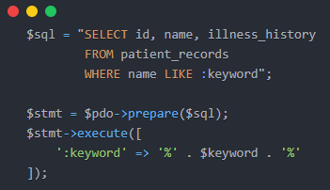
Figure 2.1: Secure SQL Query Using PDO Prepared Statement
The secure version uses PDO prepared statements to separate SQL commands from user input. The SQL query is prepared first using a placeholder, while the keyword is supplied later as a parameter. This prevents user input from changing the SQL structure, even if the input contains SQL keywords or special characters.

Reflected XSS Mitigation Using Output Encoding
The vulnerable search.php file also displays user-controlled input directly in the browser. If the keyword contains HTML or JavaScript code, the browser may interpret it as executable content. This creates a reflected Cross-Site Scripting vulnerability.
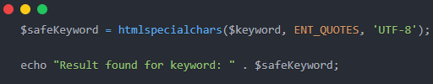
Figure 2.2: Output Encoding Using htmlspecialchars()
To prevent this issue, the secure version applies htmlspecialchars() before displaying the keyword. This converts special HTML characters into safe entities. Therefore, injected scripts are displayed as normal text instead of being executed by the browser.

Secure Refactoring of auth.php

Input Length Validation
The legacy auth.php file only uses strlen() to validate the authentication key length. However, strlen() counts bytes, not actual characters. This can cause incorrect validation when the input contains multi-byte UTF-8 characters. It may also lead to inconsistent handling between the application and other system components.
The secure version improves validation by checking both character length and byte length. mb_strlen() is used to validate the number of UTF-8 characters, while strlen() is still used to enforce a byte limit. This provides safer and more consistent input validation.

Password Hashing Improvement Using Argon2id
The legacy auth.php file uses MD5 to compare authentication values. MD5 is not suitable for password or secret authentication because it is fast and vulnerable to brute-force and rainbow table attacks. If the stored hash is leaked, attackers can attempt large numbers of guesses very quickly.
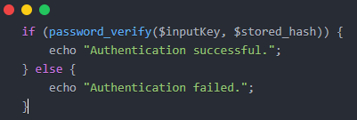
Figure 2.3: Secure Authentication Verification Using password_verify()

The secure version replaces MD5 with password_hash() and password_verify() using Argon2id. Argon2id is more secure because it is designed to be computationally expensive and memory-hard. This makes offline brute-force attacks significantly harder compared to MD5.

Exploit-Chain Disruption Matrix
Table 2.1 compares the vulnerable implementation with the secure refactored implementation. It shows how each code change disrupts the exploit path and strengthens the security boundary.
Table 2.1: Exploit-Chain Disruption Matrix for Vulnerable and Secure Code Implementation
Vulnerability | Vulnerable Code | Secure Code | How the Exploit is Disrupted
SQL Injection (search.php) | $sql = "SELECT id, name, illness_history FROM patient_records WHERE name LIKE '%" . $keyword . "%'";$result = $conn->query($sql); | $sql = "SELECT id, name, illness_history FROM patient_records WHERE name LIKE :keyword";$stmt = $pdo->prepare($sql);$stmt->execute([':keyword' => '%' . $keyword . '%']); | Prepared statements separate SQL commands from user input. The keyword is treated as data instead of executable SQL syntax, preventing attackers from modifying the query structure.
Reflected XSS (search.php) | echo "Result found for keyword: " . $keyword; | $safeKeyword = htmlspecialchars($keyword, ENT_QUOTES, "UTF-8");echo "Result found for keyword: " . $safeKeyword; | Output encoding converts special HTML characters into safe entities, preventing the browser from interpreting injected HTML or JavaScript as executable code.
Weak Hashing (auth.php) | if (md5($inputKey) === $stored_hash) | if (password_verify($inputKey, $stored_hash)) | The secure version uses password verification with a stronger password hashing mechanism such as Argon2id, making offline brute-force and rainbow table attacks harder.
Length Validation Issue (auth.php) | if (strlen($inputKey) > 256) { die("Overflow.");} | `if (mb_strlen($inputKey, "UTF-8") > 128

CRYPTOGRAPHIC SUBSYSTEM ANALYSIS, PAYLOAD SERIALIZATION, & OPERATIONAL RESILIENCE

Introduction
This chapter analyzes the cryptographic subsystem of the secure implementation. The discussion focuses on the weaknesses of the legacy encryption design, the transition from AES-128-ECB to AES-256-GCM, secure IV generation, authenticated decryption, secret management through environment configuration, and automated testing using PHPUnit.

Cryptographic Subsystem Dissection

Vulnerability of ECB Block Mode vs. AES-256-GCM AEAD

The legacy crypto_vault.php uses AES-128-ECB to protect medical records. Electronic Codebook (ECB) mode processes plaintext block by block without using an Initialization Vector (IV). As a result, identical plaintext blocks produce identical ciphertext blocks. This leak structural patterns in the encrypted data and may allow attackers to infer information about the original plaintext without knowing the secret key.
To address this vulnerability, the secure implementation upgrades the cipher to AES-256-GCM. Galois/Counter Mode (GCM) is an Authenticated Encryption with Associated Data (AEAD) mode. It provides confidentiality by encrypting the data and integrity verification by generating a 16-byte authentication tag during encryption. If the ciphertext or tag is modified, the authentication check fails and decryption is rejected.

Table 3.1: Comparison Between Legacy AES-128-ECB and Secure AES-256-GCM Implementation
Aspect | Legacy Implementation | Secure Implementation
Encryption mode | AES-128-ECB | AES-256-GCM
IV usage | No IV used | 12-byte unique IV
Pattern protection | Weak, identical plaintext creates identical ciphertext | Stronger, unique IV produces different ciphertext
Integrity verification | No authentication tag | 16-byte authentication tag
Tamper detection | Not supported | Supported through AEAD verification
Security level | Vulnerable to pattern leakage | Provides confidentiality and integrity

Initialization Vector Predictability and Reuse Risks
AES-GCM requires a unique and unpredictable Initialization Vector (IV) for every encryption operation. Reusing the same IV with the same key can seriously weaken GCM security because it may expose relationships between plaintexts and compromise the confidentiality and integrity guarantees of the encryption scheme. A predictable IV may also allow attackers to perform stronger analysis under chosen-plaintext conditions.
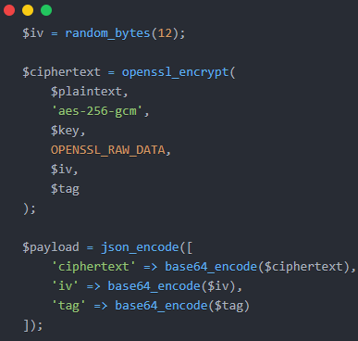
Figure 3.1: Secure AES-256-GCM Encryption Implementation

In secure/crypto_vault_secure.php, the secure implementation generates a 12-byte IV using a cryptographically secure random generator. This ensures that each encryption session uses a fresh IV, reducing the risk of IV reuse and protecting the security properties of AES-GCM.

Low-Level Data Serialization Sequence
For secure data storage and transportation, the encrypted payload is serialized into a structured JSON format. The payload contains three essential components: the base64-encoded ciphertext, the 12-byte base64-encoded IV, and the 16-byte base64-encoded authentication tag. During decryption, the system parses the JSON object, decodes the base64 values back into raw bytes, and passes the IV, ciphertext, and authentication tag to openssl_decrypt(). The authentication tag is verified before the original plaintext is returned.

Decryption Exception Flow & Operational Resilience
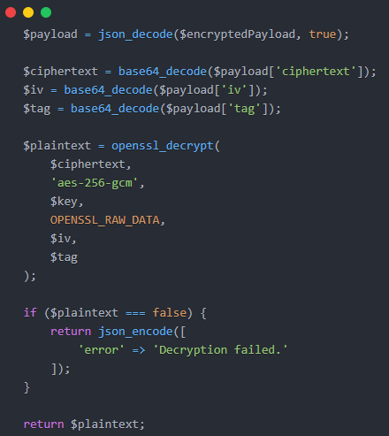
Figure 3.2: AES-GCM Decryption with Authentication Failure Handling

If the ciphertext, IV, or authentication tag is modified, openssl_decrypt() fails and returns false. Without proper error handling, the application may process invalid data, expose unnecessary error details, or behave unpredictably. The secure vault handles this failure safely by wrapping the decryption process in structured exception handling. If authentication fails, the application catches the failure, records a controlled security message, and returns a generic JSON error response. This prevents sensitive information leakage and maintains system stability.

Environment Configuration & Automated Testing

Operational Decoupling of Secrets via. env
The legacy script hardcodes the cryptographic key directly inside the PHP source code. This is insecure because any developer, attacker, or unauthorized user with access to the source file can retrieve the key. The secure version separates the cryptographic key and database credentials by storing them in an external .env file. The application reads these values at runtime, ensuring that secrets are separated from the executable codebase.

Repository Exclusions and Attack Surface Reduction
After moving secrets into the .env file, the file should be excluded from version control using the .gitignore file. This prevents sensitive keys, database passwords, and local configuration paths from being uploaded to public or shared repositories. Excluding environment-specific configuration files reduces the risk of accidental credential exposure and limits the public attack surface of the application.

PHPUnit Automated Test Verification Paths
An automated test suite in tests/SecurityTest.php verifies the secure implementation using PHPUnit. The tests follow three main verification paths. First, the untampered cryptographic lifecycle test verifies that a valid plaintext can be encrypted using AES-256-GCM and successfully decrypted back to the original text. Second, the tampered ciphertext test modifies the encrypted payload and confirms that decryption fails, proving that the AEAD integrity check is working. Third, the credential hash integrity test confirms that password verification succeeds for correct credentials and fails for incorrect credentials when using Argon2id.
Table 3.2: PHPUnit Security Test Verification Paths
Test Path | Purpose | Expected Result
Untampered encryption and decryption | Verify valid AES-GCM lifecycle | Plaintext is recovered correctly
Tampered ciphertext | Verify AEAD integrity check | Decryption fails safely
Credential hash verification | Verify Argon2id authentication | Correct password passes, wrong password fails
Exception handling | Verify safe failure behavior | No interpreter crash or sensitive error exposure

Exception Trapping and Interpreter Crash Prevention
The PHPUnit tests also verify that the application handles invalid input and tampered payloads safely without causing interpreter crashes. By checking failed decryption states and trapped exceptions, the tests demonstrate that the secure scripts fail safely when malicious or corrupted data is provided. This strengthens the operational resilience of the system and confirms that security failures are handled in a controlled manner.

SYSTEMIC VULNERABILITY CORRELATION, FORENSIC DOCUMENTATION, & ARCHITECTURAL SYNTHESIS

Forensic Exploit-Chain Dependency Analysis

Cascading Lifecycle of the Security Breach
The security breach at MediChain Solutions Bhd followed a cascading lifecycle across multiple application layers. The initial entry point was the data access plane in search.php, where raw user input was directly concatenated into an SQL query. This allowed SQL Injection to occur. Since the database connection was running with excessive root-level privileges, the attacker was able to bypass normal database boundaries and query sensitive tables such as staff_credentials. This enabled the exfiltration of usernames and MD5 password hashes.
In the next phase, the attacker targeted the authentication plane. Because auth.php stored credentials using MD5, the stolen hashes were vulnerable to offline brute-force and dictionary attacks. Due to MD5’s fast hashing speed and known weaknesses, the attacker could recover plaintext credentials more easily. Using these credentials, the attacker authenticated as a high-clearance physician and gained access to the medical records vault.
Finally, the attacker compromised the data custody plane. The patient records in crypto_vault.php were encrypted using AES-128-ECB with a hardcoded key. ECB mode does not use an IV and produces identical ciphertext blocks for identical plaintext blocks. This leak structural patterns in encrypted records. As a result, the attacker could infer information from the encrypted data and perform unauthorized changes to sensitive medical records, including drug dosage information.
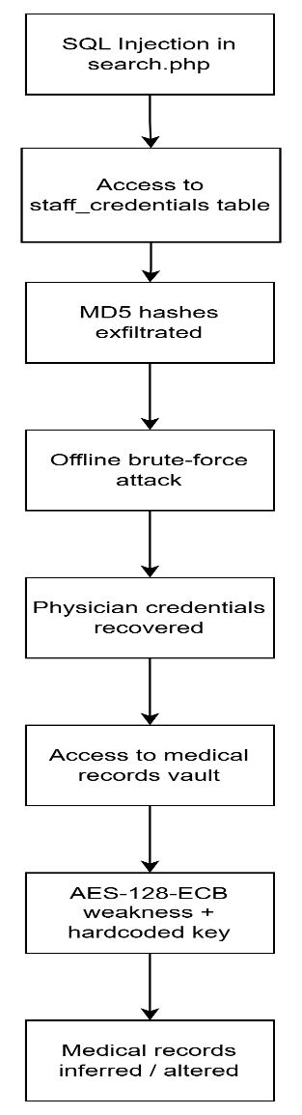
Figure 4.1: Cascading Exploit Chain of the Legacy System

Attack Surface and Vulnerability Cascading
This breach demonstrates how one vulnerability can trigger a larger compromise when multiple modules are weakly protected. The SQL Injection flaw in search.php created the initial access path. This then exposed weak authentication data in auth.php, which allowed credential compromise. The compromised credentials later enabled access to the cryptographic subsystem in crypto_vault.php. Therefore, the incident shows that secure programming must be applied across all layers, including input handling, authentication, encryption, key management, and database privilege control.

Architectural Synthesis & System Verification

Secure Code Refactoring Mapping
To disrupt the cascading exploit chain, E-MedicVault was refactored using multiple secure programming controls. The secure version enforces separation between SQL commands and user input through PDO prepared statements. It also applies contextual output encoding using htmlspecialchars() to prevent reflected XSS. In the authentication module, the system implements safer multi-byte input validation and replaces MD5 with Argon2id password hashing. In the cryptographic subsystem, AES-128-ECB is replaced with AES-256-GCM to provide authenticated encryption with confidentiality and integrity protection. These code modifications are summarized in the comparative matrix in Chapter 2.
Table 4.1: Exploit Chain and Secure Control Mapping
Exploit Stage | Vulnerability Used | Impact | Secure Control
Initial access | SQL Injection in search.php | Unauthorized database query | PDO prepared statements
Output abuse | Reflected XSS in search.php | Script execution in browser | htmlspecialchars()
Credential compromise | MD5 hashing in auth.php | Password hash cracking | Argon2id
Input handling weakness | strlen() only | Inconsistent validation | mb_strlen() + byte limit
Data custody compromise | AES-128-ECB and hardcoded key | Pattern leakage and weak key protection | AES-256-GCM and .env key storage
Tampered payload | No integrity verification | Undetected data modification | GCM authentication tag

Automated Test Runner Output and Validation Logs
The secure implementation is validated using PHPUnit automated testing. The test suite in tests/SecurityTest.php checks whether the refactored components handle normal input, malicious input, tampered cryptographic payloads, and invalid authentication attempts correctly. The expected successful test output indicates that the security controls are functioning as intended and that the application can fail safely without exposing sensitive error details or crashing the interpreter.
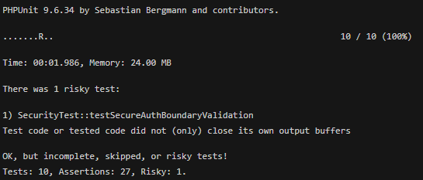
Figure 4.2: PHPUnit Test Runner Output for Secure Implementation Verification

Overall, the verification results demonstrate that the secure refactoring disrupts the main exploit paths identified in the legacy system. While testing cannot guarantee complete security, it provides evidence that the implemented controls strengthen patient data protection and support safer handling of sensitive information in line with secure programming principles.

REFERENCES
Chen, M.-C. and Huang, S.-H. (2003) ‘Credit scoring and rejected instances reassigning through evolutionary computation techniques’, Expert Systems with Applications, 24(4), pp. 433–441.
Clerc, M. and Kennedy, J. (2002) ‘The particle swarm - explosion, stability, and convergence in a multidimensional complex space’, IEEE Transactions on Evolutionary Computation, 6(1), pp. 58–73.
Gosnell, M., Woodley, R., Hicks, J. and Cudney, E. (2014) ‘Exploring the Mahalanobis-Taguchi Approach to Extract Vehicle Prognostics and Diagnostics’, in Computational Intelligence in Vehicles and Transportation Systems (CIVTS), 2014 IEEE Symposium on, pp. 84–91.
Gupta, A. (2015) ‘Classification of Complex UCI Datasets Using Machine Learning Algorithms Using Hadoop’, International Journal of Scetific & Techology Research, 4(5), pp. 85–94.
Hu, J., Zhang, L., Liang, W. and Wang, Z. (2009) ‘Incipient mechanical fault detection based on multifractal and MTS methods’, Petroleum Science, 6(2), pp. 208–216.
Huang, C.-L., Chen, Y. H. and Wan, T.-L. J. (2012) ‘The mahalanobis taguchi system—adaptive resonance theory neural network algorithm for dynamic product designs’, Journal of Information and Optimization Sciences, 33(6), pp. 623–635.
Jain, A. K. A. K., Duin, R. P. W. and Mao, J. (2000) ‘Statistical pattern recognition: a review’, IEEE Transactions on Pattern Analysis and Machine Intelligence, 22(1), pp. 4–37.
Khalid, S., Khalil, T. and Nasreen, S. (2014) ‘A survey of feature selection and feature extraction techniques in machine learning’, 2014 Science and Information Conference, pp. 372–378.
Li, C., Yuan, J. and Qi, Z. (2015) ‘Risky group decision-making method for distribution grid planning’, International Journal of Emerging Electric Power Systems, 16(6), pp. 591–602.

